Aemilianum College Inc.

School Portal Update
Section Advisers, College Grade Approval and Login Security Alerts
User guide and feature overview
Prepared: November 7, 2026
For: School administrators, the Registrar’s Office, and faculty

About the screenshots
All screenshots in this guide were taken from the working system using sample names and records. No real student, guardian or staff information is shown.

Contents
1. What’s new 3
2. Section advisers (JHS and SHS) 4
2.1 Assigning an adviser (Registrar or Admin) 4
2.2 The adviser’s page: My Advisory Class 5
2.3 Sending a class suspension notice 6
2.4 Uploading grades as an adviser 8
3. College grade approval 9
3.1 What the college teacher sees 9
3.2 Approving grades (Registrar or Admin) 9
3.3 What the student sees 11
3.4 Approval rules 11
4. Login security alerts 13
4.1 Text message alerts 13
4.2 Email alerts (staff) 13
4.3 Requirements and settings 14
5. Quick reference 15

1. What’s new
This update adds three features to the school portal:
Feature | Who uses it | What it does
Section advisers (Junior and Senior High School) | Registrar, Admin, Advisers | Each JHS and SHS section can have a class adviser. The adviser can upload grades for every subject of their section and text class suspension notices to their students and guardians.
College grade approval | College teachers, Registrar | College grades uploaded by teachers are held as Pending approval. Students only see them after the Registrar approves (posts) them.
Login security alerts | All accounts | Staff and students are notified by text (and staff also by email) whenever someone signs in to their account or fails to.

2. Section advisers (JHS and SHS)
A section adviser is a teacher assigned to one Junior High School or Senior High School section for a school year. Advisers keep all their normal teacher access and gain two extra abilities for their advisory class:
- Upload grades in every subject for the students of their section.
- Send class suspension notices by text message to the section’s students and their guardians.

2.1 Assigning an adviser (Registrar or Admin)
- In the side menu, open Advisers. The list shows every section adviser for the school year you are viewing.
- Click Assign Adviser.
- Choose the teacher, the education level (Junior or Senior High School), the year level and the section, then confirm the school year.
- Click Assign.
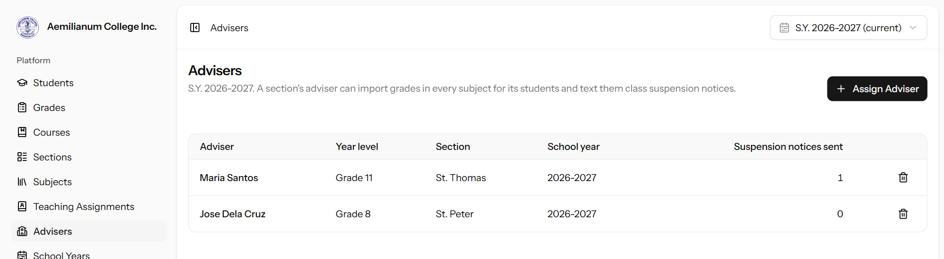
Figure 1. The Advisers page lists each section’s adviser and how many suspension notices they have sent.
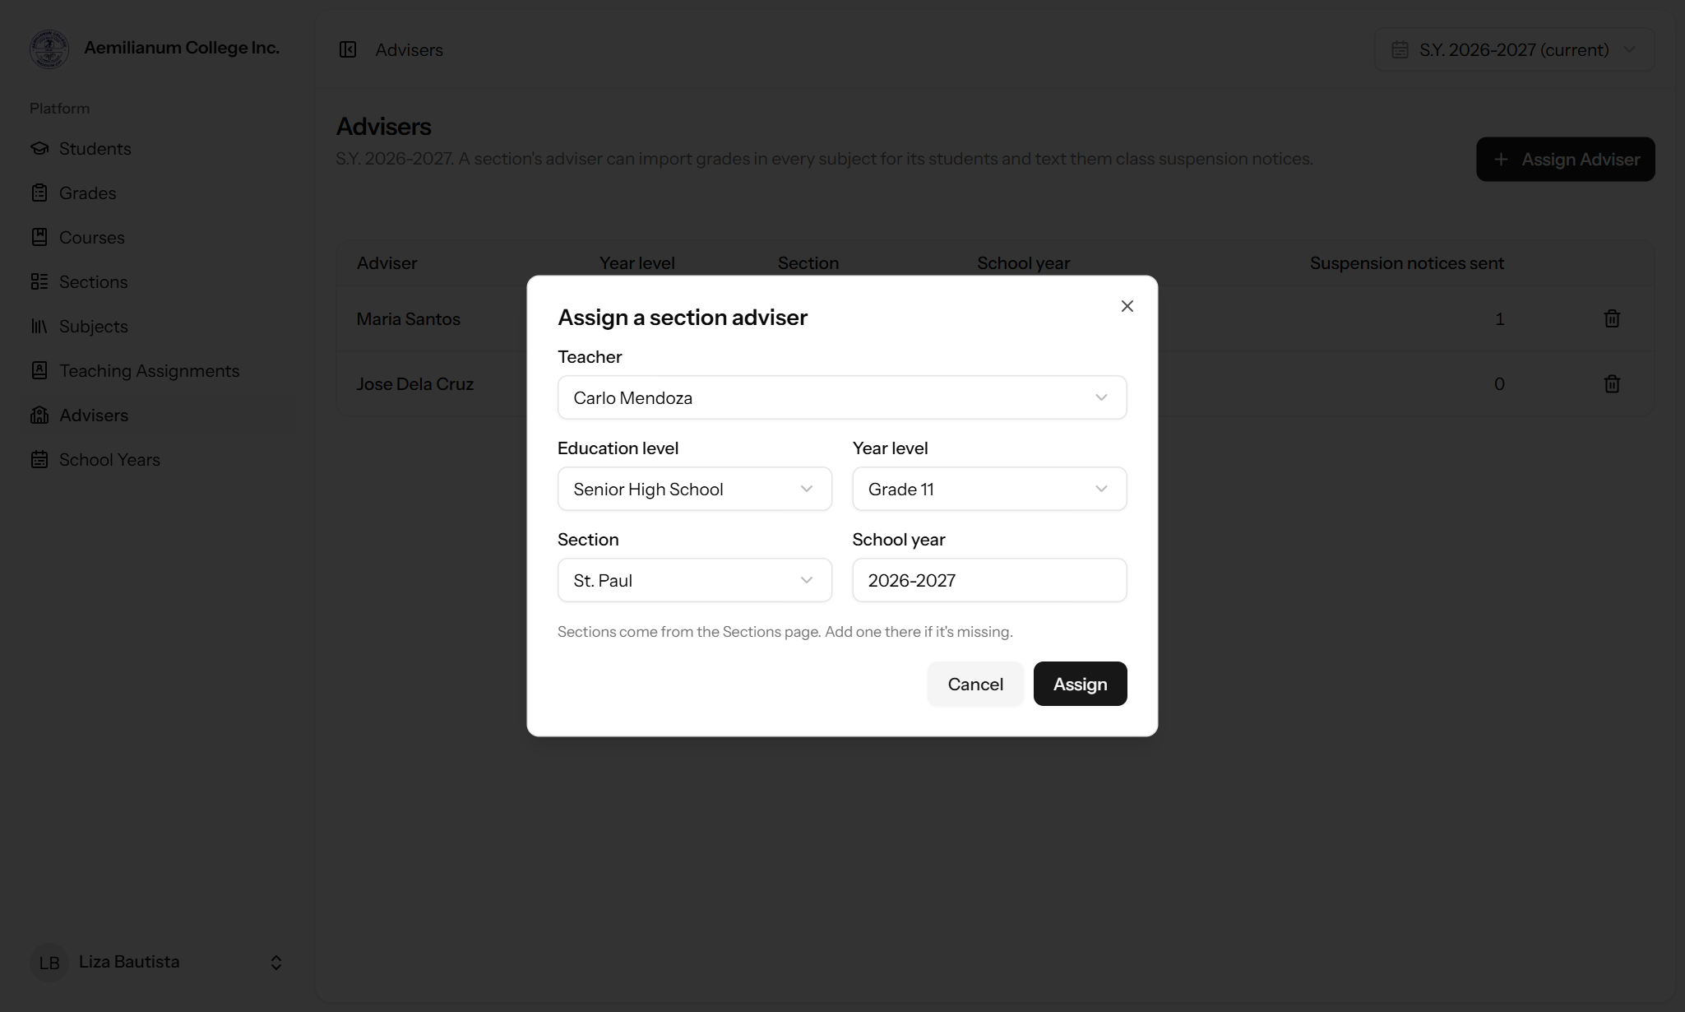
Figure 2. Assigning a teacher as the adviser of Grade 11 – St. Paul.
Good to know
Each section can have one adviser per school year. To change advisers, remove the current one first using the trash icon.
Sections come from the Sections page. If a section is missing from the list, add it there first.
Only users with the Teacher role can be advisers.

2.2 The adviser’s page: My Advisory Class
When a teacher is assigned as an adviser, a new My Advisory Class item appears in their side menu. It shows their section, the number of active students, the suspension notice form and the notices sent so far.
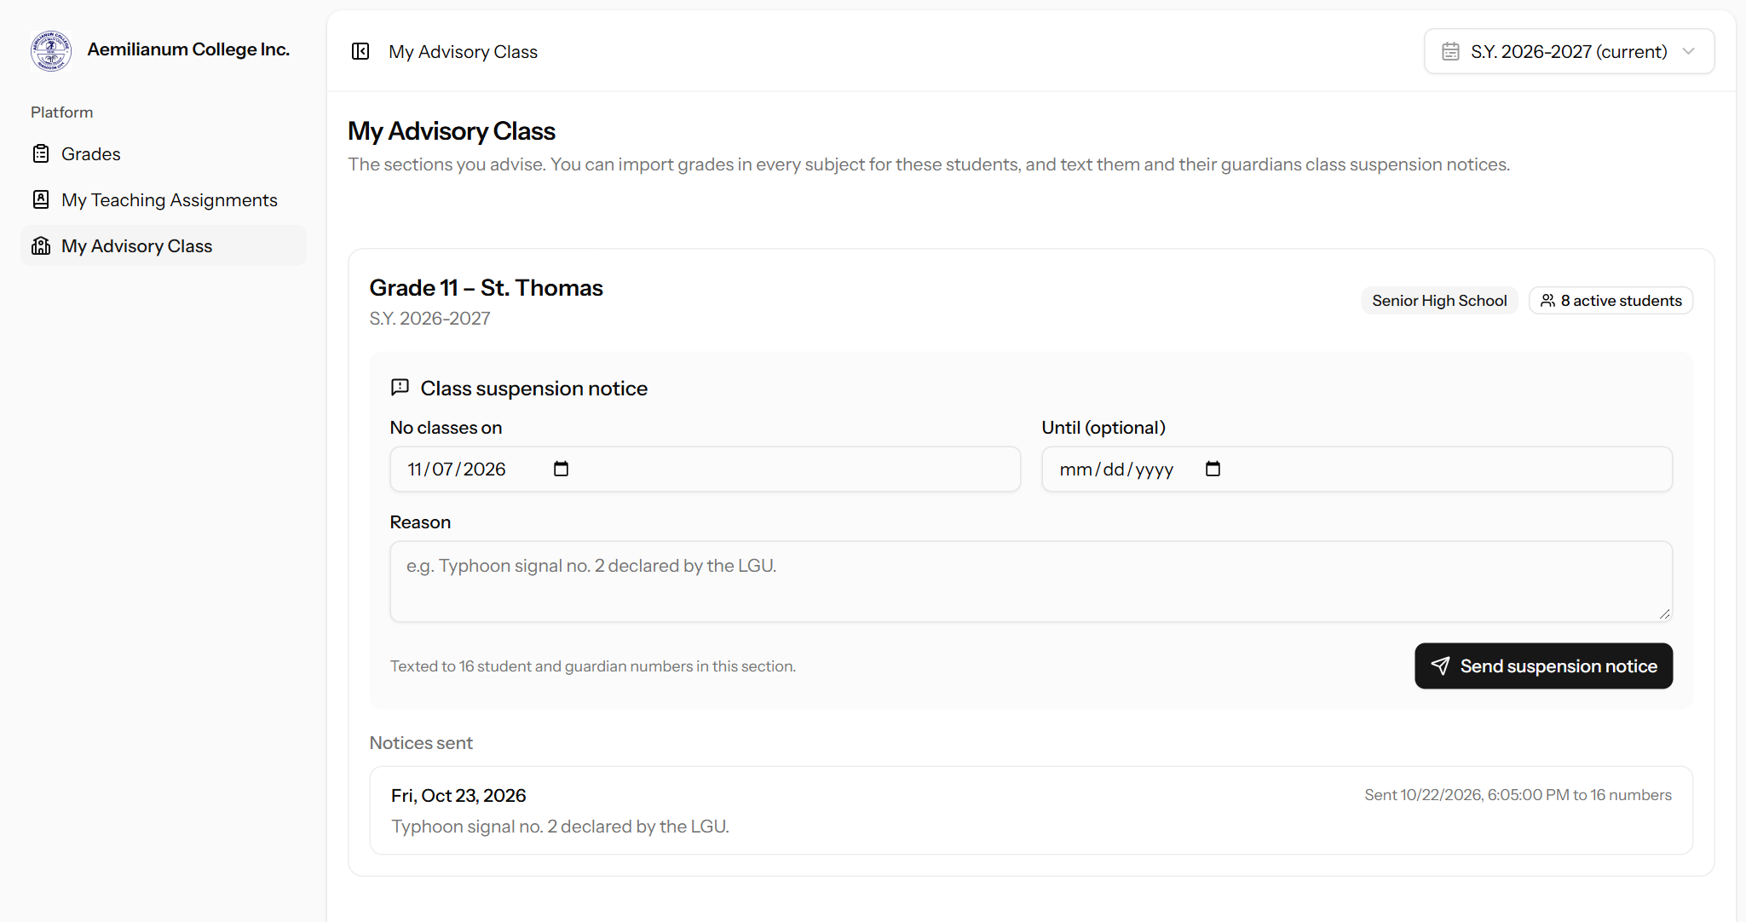
Figure 3. A Senior High School adviser’s page for Grade 11 – St. Thomas.
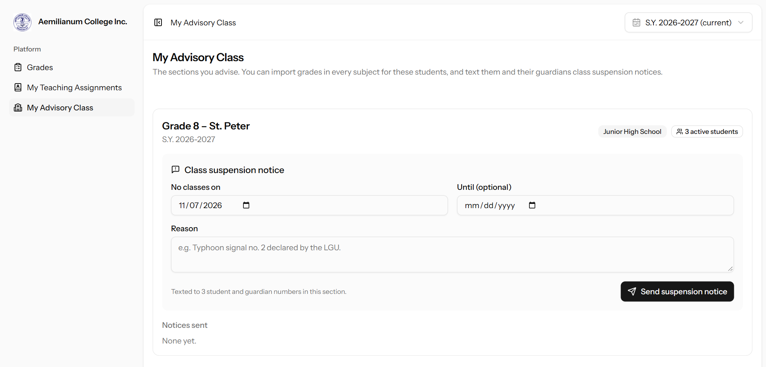
Figure 4. Junior High School sections work the same way (Grade 8 – St. Peter).

2.3 Sending a class suspension notice
- Open My Advisory Class.
- Under Class suspension notice, set the date with no classes. For a suspension of several days, also set the last day under Until (optional).
- Type the reason (up to 160 characters), for example the typhoon signal or the LGU announcement.
- Click Send suspension notice. A confirmation shows how many numbers will be texted.
- Click Send now. The text goes out right away and the notice is added to Notices sent.
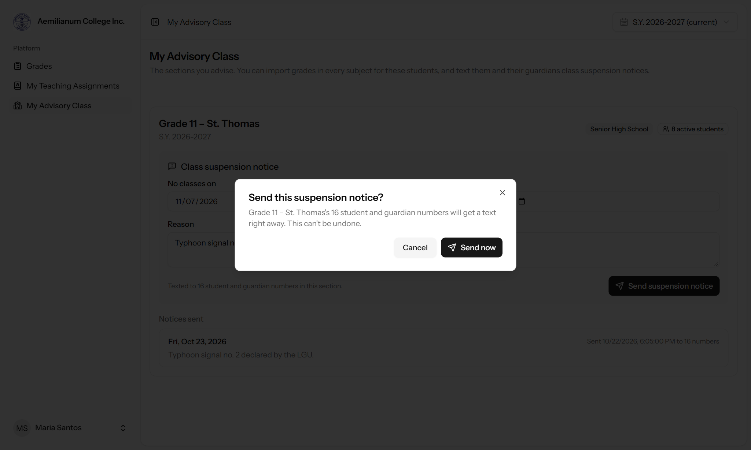
Figure 5. The confirmation step prevents notices from being sent by accident.
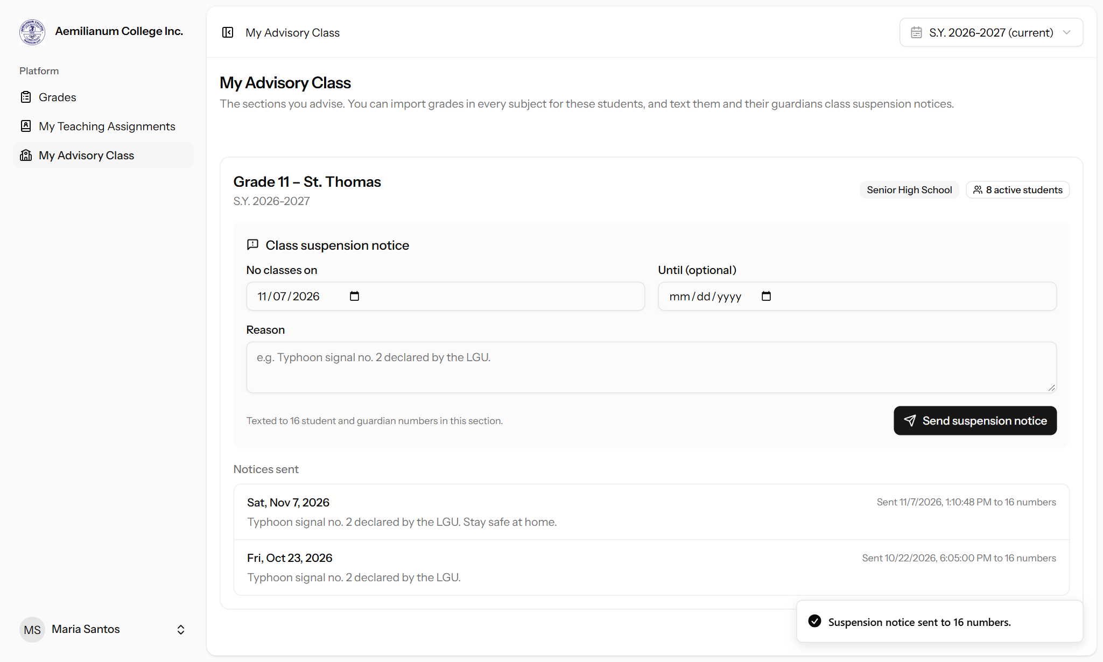
Figure 6. After sending: a confirmation message and the notice in the history list.
Each student and guardian receives a text message like this:
CLASS SUSPENSION: Grade 11 – St. Thomas has no classes on Sat, Nov 7, 2026.
Reason: Typhoon signal no. 2 declared by the LGU. Stay safe at home.
- Maria Santos, Class Adviser

Who receives the notice
All active students enrolled in the section for the current school year, and their guardians.
Each phone number is texted only once, even if it is listed for more than one person.
Students or guardians without a phone number on file will not receive the text.
Notices can only be sent for the current school year, and the date cannot be in the past.

2.4 Uploading grades as an adviser
Advisers upload grades from the Grades page, the same way subject teachers do. The difference is that an adviser can upload any subject for students in their advisory class.
- Open Grades and click Import grades.
- Under Your advisory class, download the template. It already lists the section’s students.
- Fill in the subject and the term grades for each row, then upload the file.
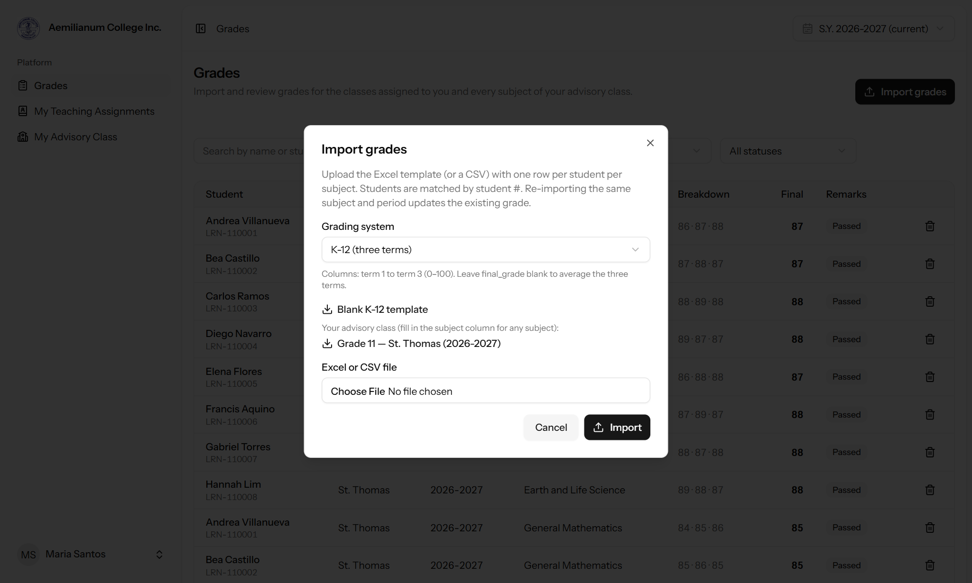
Figure 7. The import window offers a ready-made class list for the adviser’s section.
Good to know
Junior and Senior High School grades uploaded by advisers are posted to students right away. They do not need Registrar approval.
Rows for students outside the adviser’s section are rejected and listed in the import summary.

3. College grade approval
College grades uploaded by teachers now go through the Registrar before students can see them. This gives the Registrar’s Office a final check on every college grade before it is posted.
Who uploads | Grade type | Visible to students
College teacher | College | After Registrar approval
Registrar or Admin | College | Right away
Subject teacher or adviser | JHS / SHS (K-12) | Right away

3.1 What the college teacher sees
After a college teacher uploads grades, each one is marked Pending approval, and a banner tells the teacher how many are waiting for the Registrar.
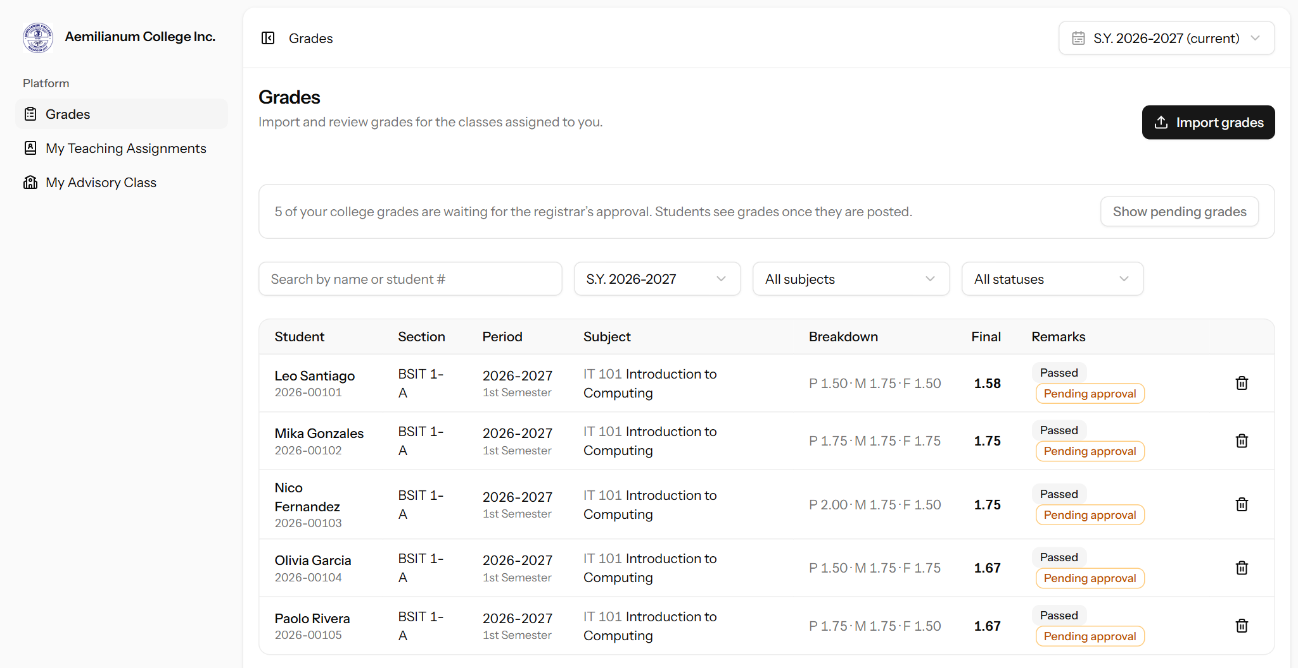
Figure 8. A college teacher’s grades waiting for the Registrar’s approval.

3.2 Approving grades (Registrar or Admin)
- Open Grades. A banner shows how many college grades are waiting for approval.
- Set the status filter to Waiting for approval (or click Show pending grades on the banner). Use the school year, subject and search filters to narrow the list if needed.
- Tick the grades to approve. The box in the header selects every pending grade on the page.
- Click Approve selected. To approve one grade, click the check mark on its row. When there are more pending grades than fit on one page, Approve all approves every pending grade that matches the filters.
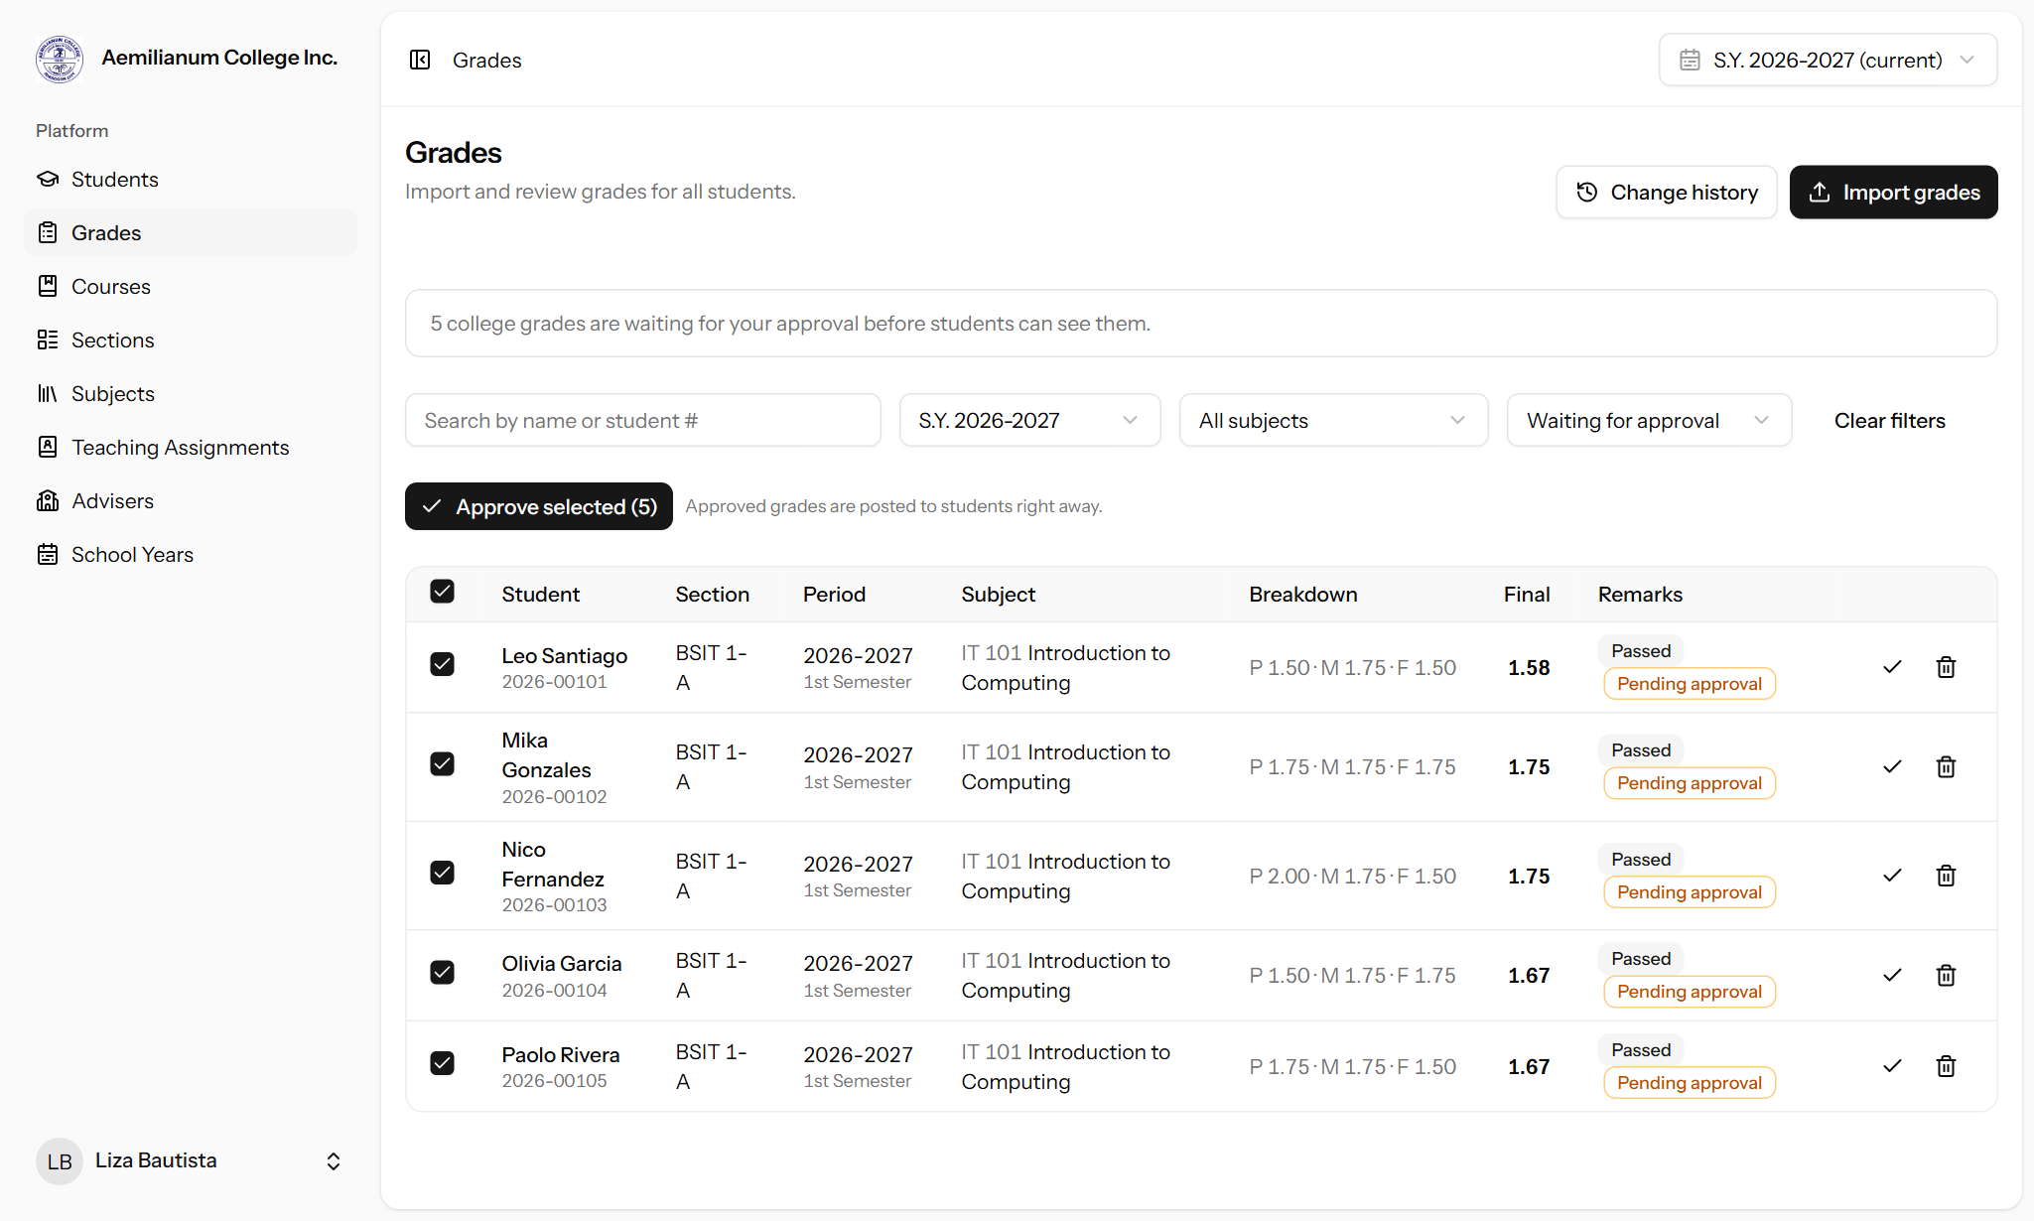
Figure 9. The Registrar’s view of pending college grades, ready to approve.
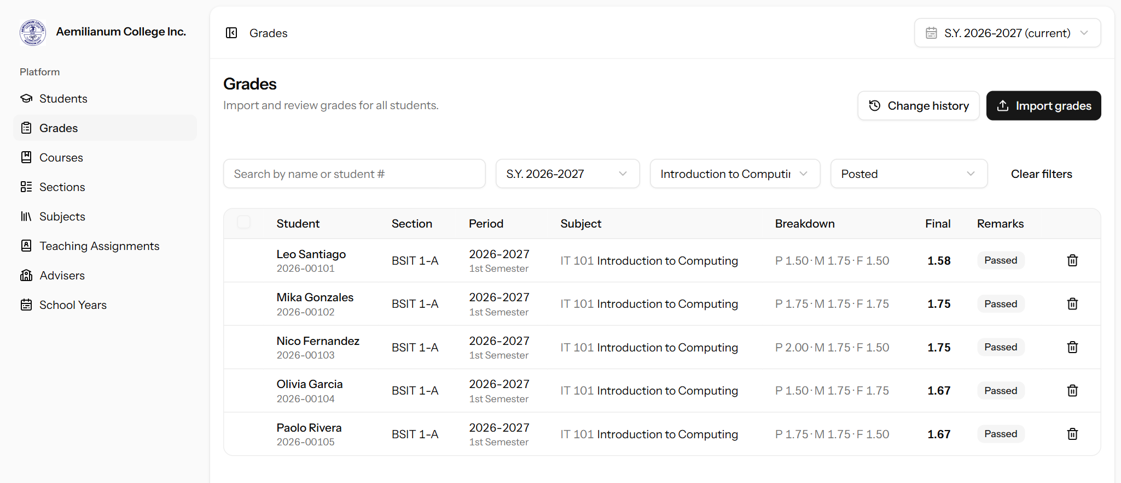
Figure 10. After approval the grades are marked as posted (filtered by Posted).

3.3 What the student sees
Students only see posted grades in the Student Portal. In the example below, the Introduction to Computing grade appears only after the Registrar approves it.
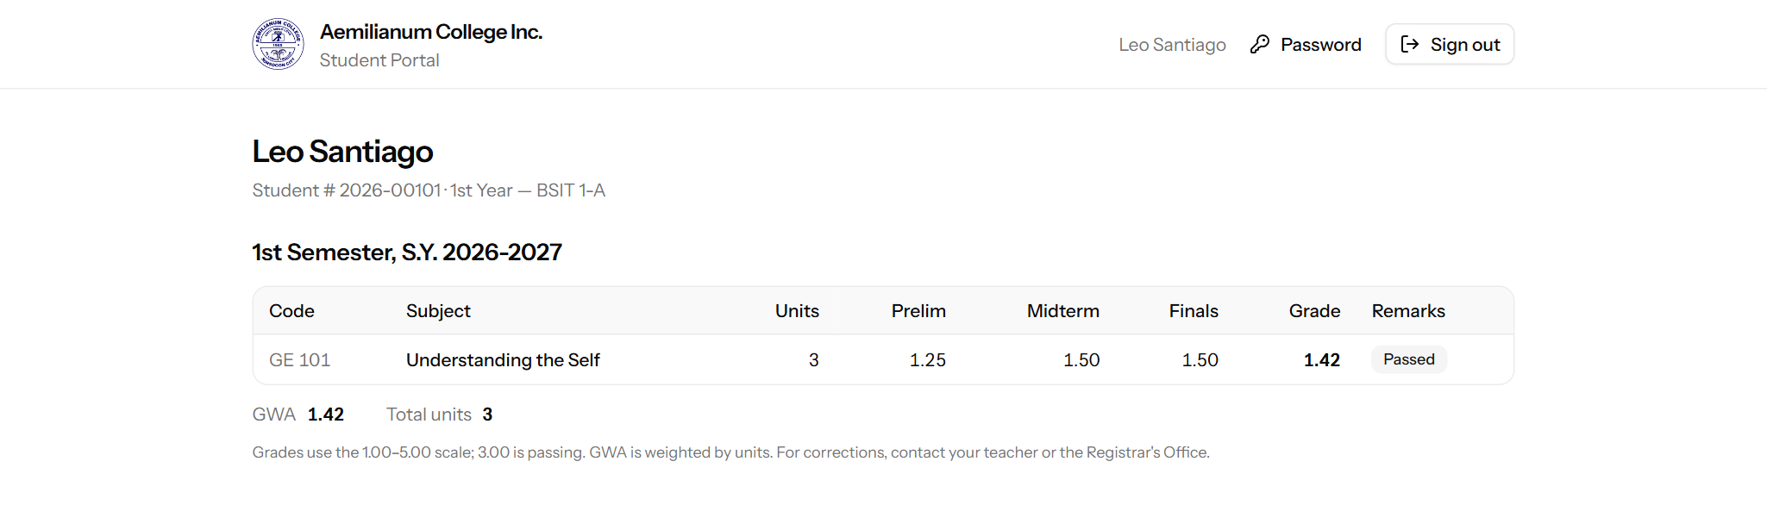
Figure 11. Before approval: the pending Introduction to Computing grade is hidden.
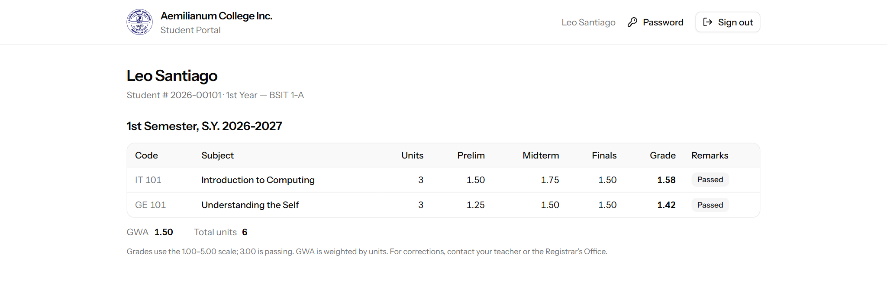
Figure 12. After approval: the grade is posted and included in the GWA.

3.4 Approval rules
- If a teacher changes a college grade that is already posted, the changed grade goes back to Pending approval until the Registrar approves it again. Re-uploading the same values does not.
- Teachers cannot delete a college grade once it is posted. They should ask the Registrar’s Office.
- Every approval is recorded in Grades › Change history with who approved it, when, and from which IP address.
- All grades already in the system before this update were marked as posted, so nothing students could see before has been hidden.
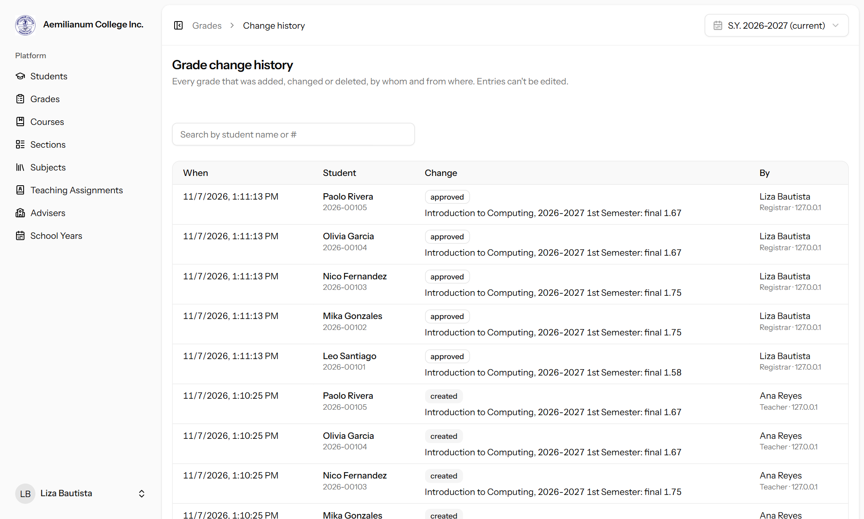
Figure 13. The change history records each approval next to the original upload.

4. Login security alerts
To protect every account, the portal now notifies the account owner whenever someone signs in to their account or tries to. If the owner did not sign in, they know right away to change their password and report it.
Event | Who is notified | How
Successful sign-in | The account owner | Staff: email and text. Students: text.
Wrong password | The account owner | Staff: email and text. Students: text. Sent at most once every 15 minutes per account, so repeated guessing does not flood the owner’s phone.
Correct password but wrong two-factor code (staff) | The account owner | Email and text marked urgent: someone knows the password and it should be changed right away.

Each alert includes the date and time (Philippine time), the device and browser, and the IP address of the sign-in.

4.1 Text message alerts
Example of a sign-in alert:
ACI Security: New sign-in to your account on Nov 7, 2026 1:12 PM, Chrome on Windows, IP 112.198.74.21. Not you? Change your password now and tell the school admin.

Example of a failed sign-in alert for a student:
ACI Security: Failed sign-in attempt on your account 2026-00101 on Nov 7, 2026 1:12 PM, Chrome on Android, IP 49.145.10.88. If this keeps happening, tell the school admin.

Text messages do not contain links, because Philippine mobile networks often block texts with links.

4.2 Email alerts (staff)
Staff accounts also receive an email with a Review account security button that opens their security settings.
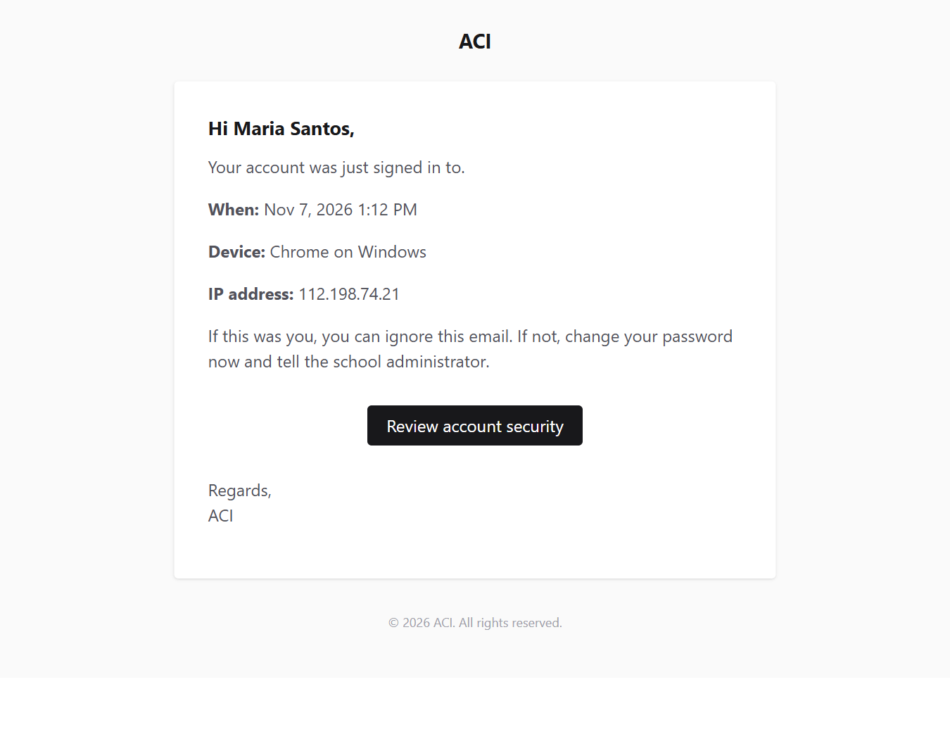
Figure 14. Email sent when a staff member signs in.
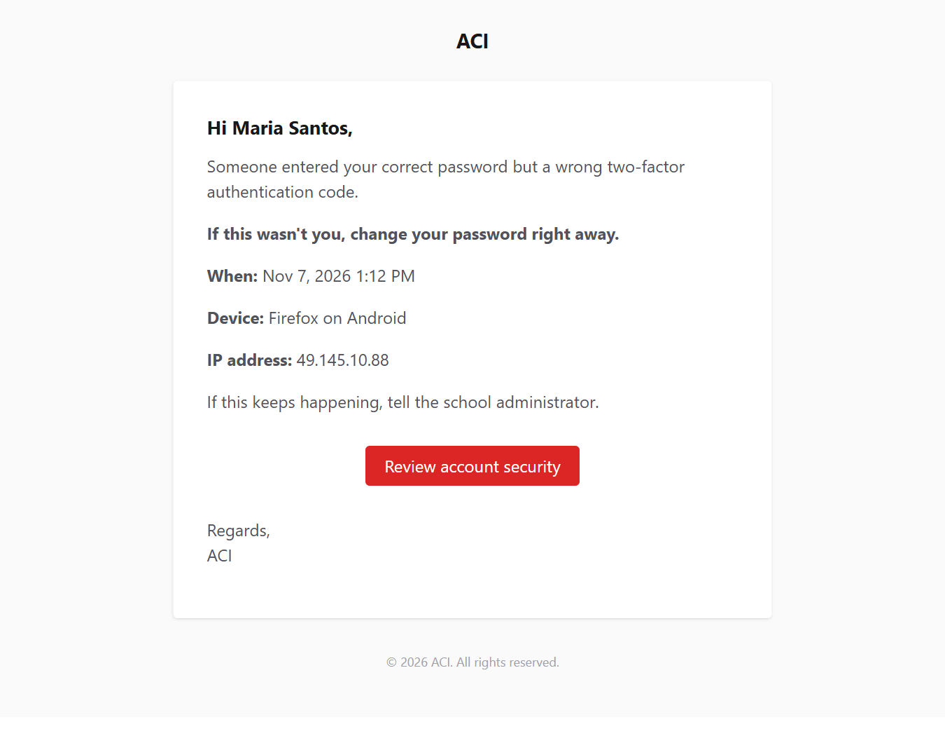
Figure 15. Urgent email when the correct password is used with a wrong two-factor code.

4.3 Requirements and settings
- Text alerts go to the phone number saved on the account. Accounts without a phone number receive email only (staff) or no alert (students).
- Students do not have email addresses in the portal, so they receive text alerts only.
- Every sign-in uses one SMS credit per account with a phone number. If credits are a concern, sign-in alerts can be switched off while keeping failed-attempt alerts on. This is a server setting your developer can change.
- Returning users who stay signed in with “Remember me” are not alerted again each visit.

5. Quick reference
I want to… | Go to
Assign or remove a section adviser | Advisers (Registrar / Admin)
Send a class suspension notice | My Advisory Class (Adviser)
Upload grades for my advisory class | Grades › Import grades (Adviser)
See which college grades are still waiting | Grades, status filter Waiting for approval
Approve college grades | Grades › Approve selected (Registrar / Admin)
See who approved or changed a grade | Grades › Change history (Registrar / Admin)

