USER HANDBOOK · BY ROLE

Who sees what in One Click PT Notes
One Click PT Notes is shared by everyone on a home-health PT team, but the app looks different depending on your role — some people bill, some manage staff, some just document care. This guide walks each role through what they'll actually see, screen by screen.

Signing in
- Go to the sign-in page and enter your email and password (or use Sign in with a passkey if one's set up for your account).
- If your account has two-factor authentication turned on, you'll be asked for a code from your authenticator app.
- First time signing in, or after a password reset, you may need to verify your email before the app lets you past the dashboard.
- Forgot your password? Use Forgot your password? on this screen to get a reset link by email.
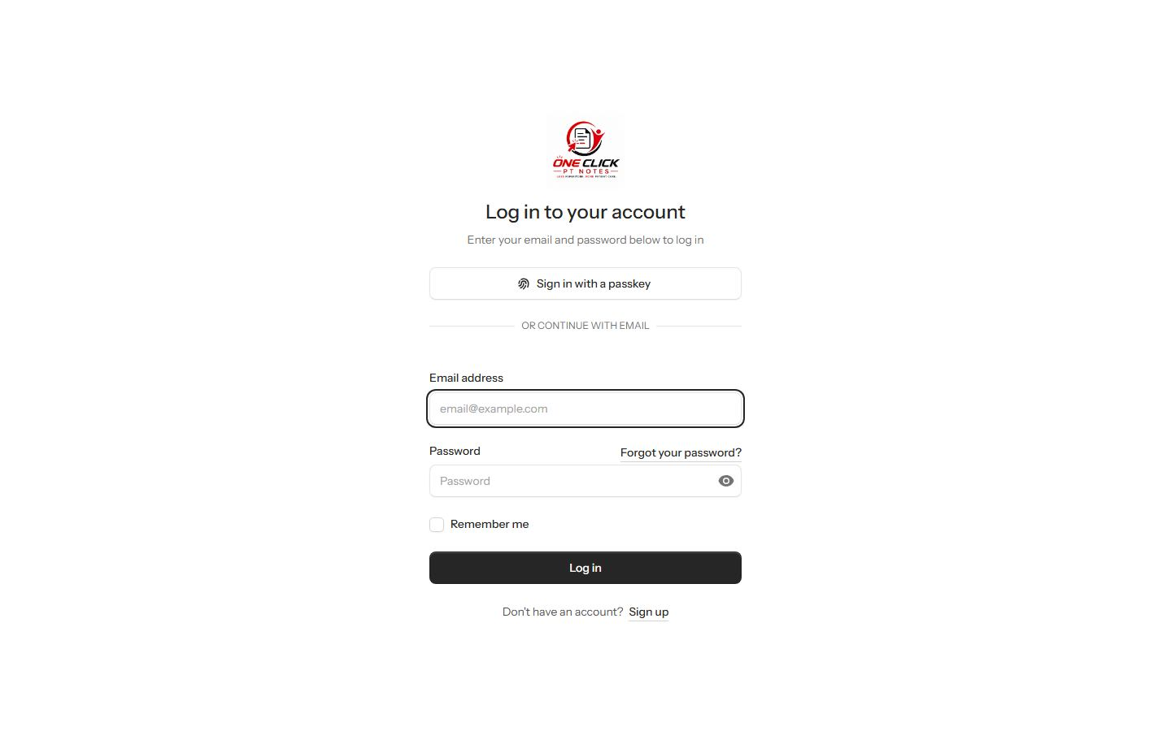
Sign inEmail/password or passkey, with a link to reset a forgotten password.

Roles at a glance
Seven roles exist in the system today. Everyone — regardless of role — can view the patient roster, open a patient's chart, schedule a visit, and write and sign a clinical note; the permissions below only control who can edit patient records, delete a note, touch billing, or manage other staff.
Heads up — Office Manager and Corporate Secretary both have permission to view staff accounts, so the sidebar shows them an Admin panel link. Clicking it currently lands on a 403 page — the admin section itself is restricted to the Admin role specifically. If your team wants those roles to actually reach it, that's a one-line fix worth asking for; until then, treat the link as inactive for those two roles.
Role | Edit patients | Delete notes | Billing | Manage staff | Admin panel
Admin | Yes | Yes | Yes | Yes | Yes
Office Manager | Yes | Yes | Yes | Yes | Link shown, blocked
Biller | Yes | Yes | Yes | No | No
PT Assistant | Yes | Yes | Yes | No | No
Staff | Yes | Yes | No | No | No
Corporate Secretary | No | No | No | View only | Link shown, blocked
Team Member (default) | No | No | No | No | No

Admin
Full run of the system: every clinical record, every invoice, and the only role that can actually open the admin panel to manage staff, roles, and permissions.
Permissions: users.view users.manage roles.view roles.manage permissions.view permissions.manage patients.manage notes.manage invoices.manage
Can do
- Add, edit patients; assign doctor, insurer, HHA, PT Assistant
- Write, sign and delete any clinical note
- Create, send and mark invoices paid
- Manage staff accounts, roles and permissions
- Read the full audit log
Nothing restricted
- The Admin role has no gated screens — everything below is reachable.
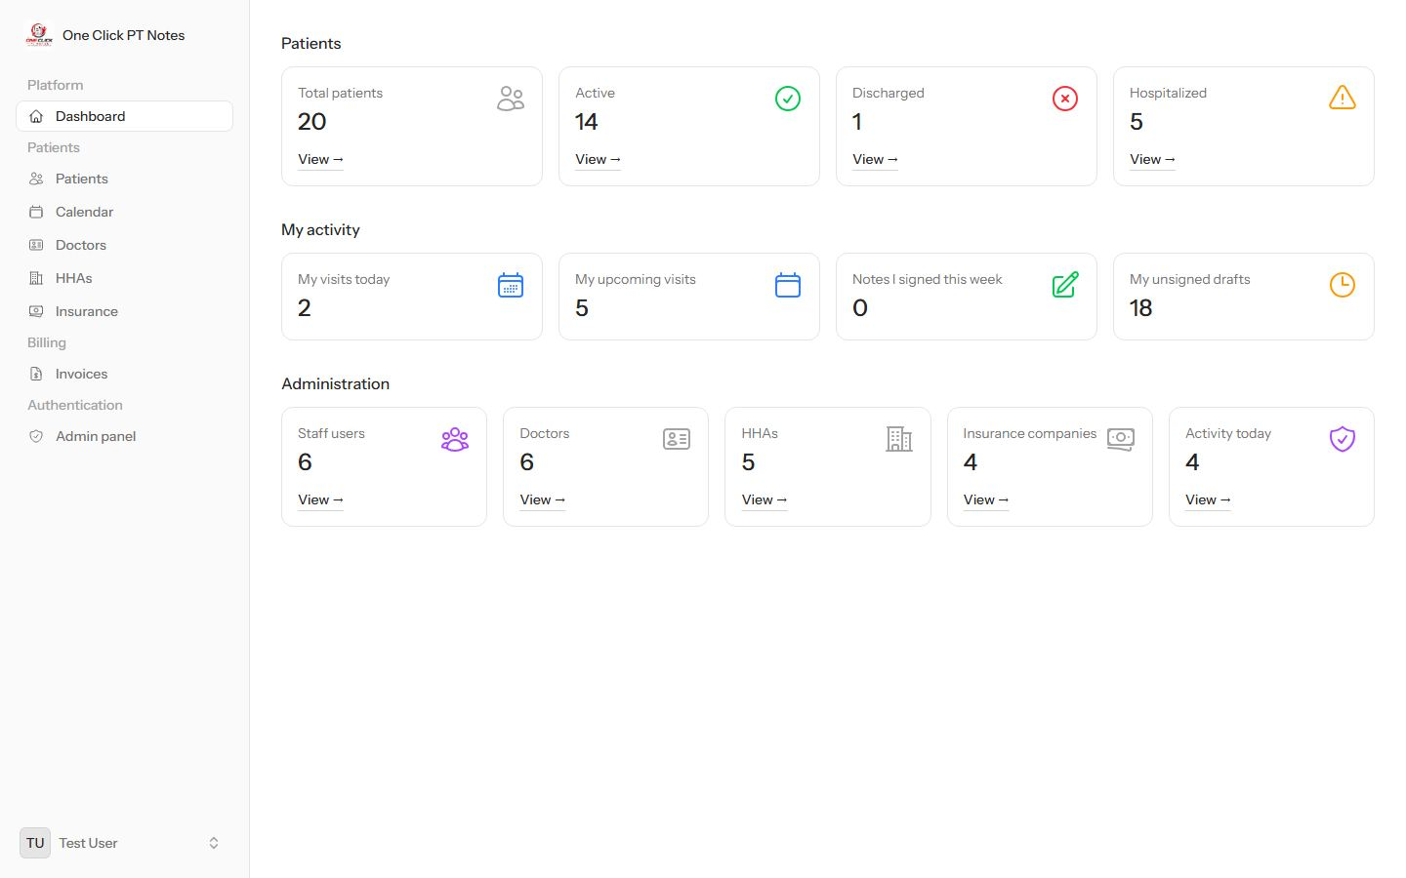
DashboardPractice-wide patient counts, your own visit/note activity, and — only visible to roles with staff-viewing rights — an Administration panel of staff, doctor, agency and audit counts.
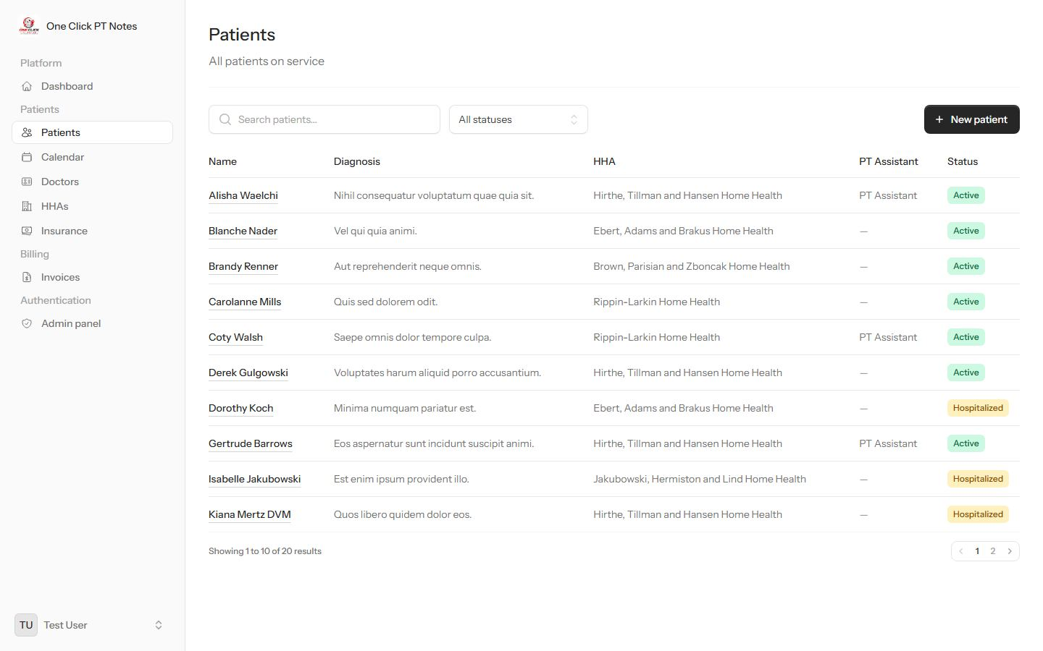
PatientsThe full roster, searchable and filterable by status, with a New patient button.
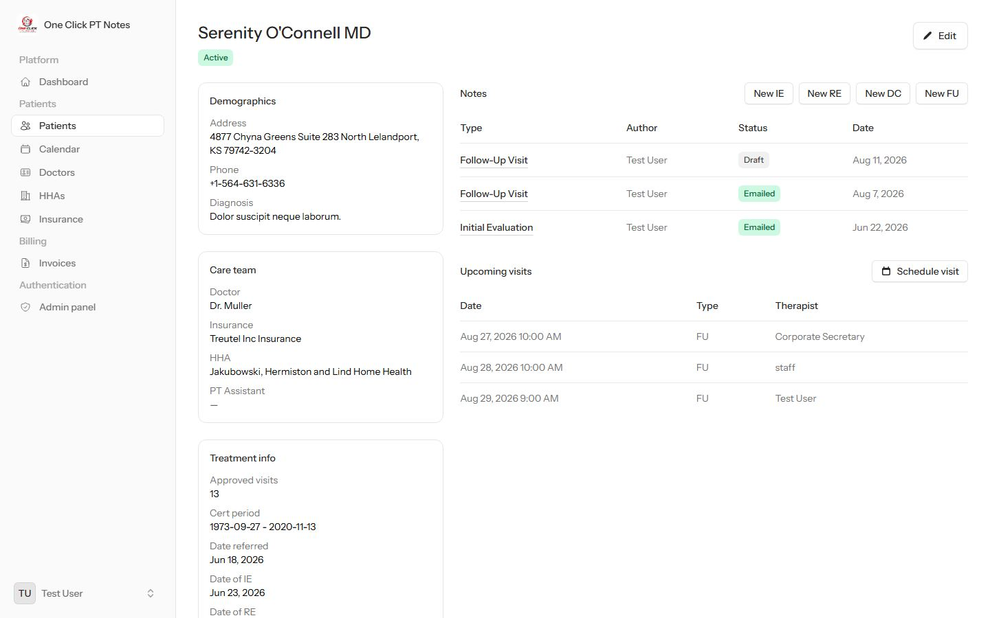
Patient profileDemographics, care team, treatment info, note history and upcoming visits, with Edit, Schedule visit and per-type New note buttons.
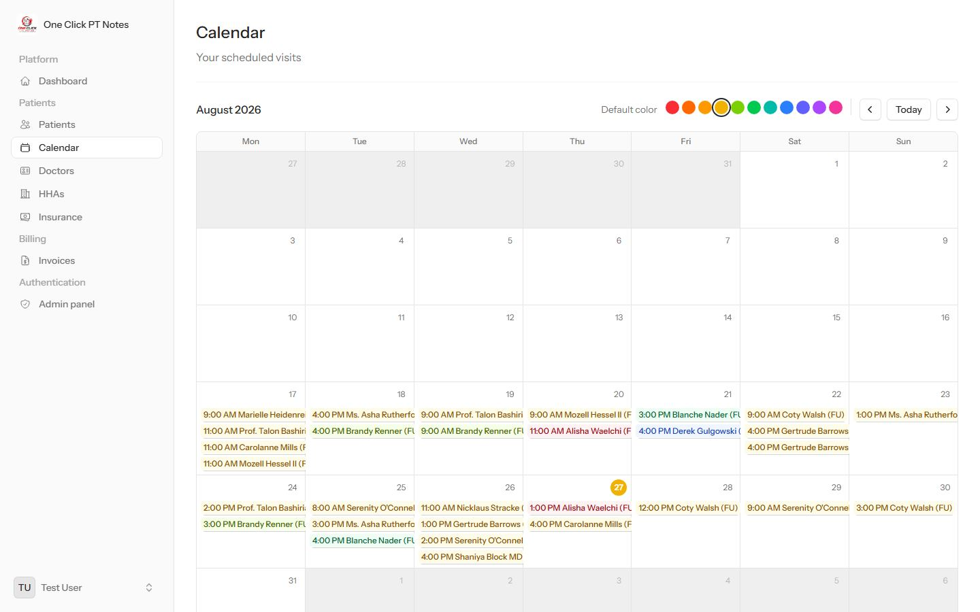
CalendarYour own scheduled visits on a month grid — each therapist only ever sees their own. Dots are per-patient color tags you can recolor from here.
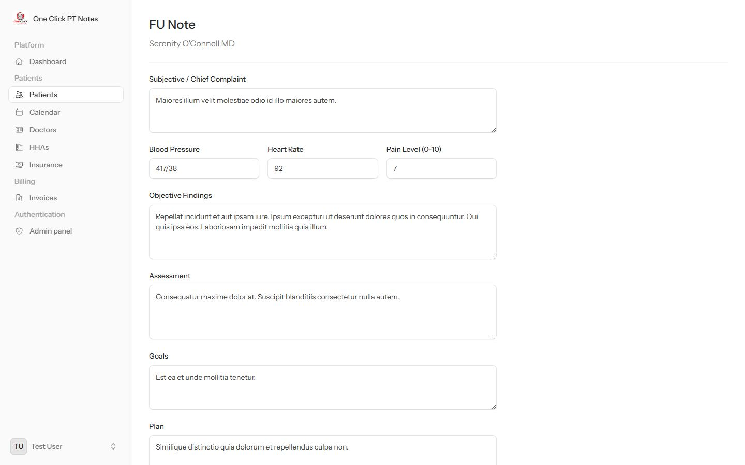
New noteClinical documentation form (vitals, findings, assessment, plan), prefilled from the patient's prior note where relevant. Scroll down for the staff + patient signature pads that finish the note.
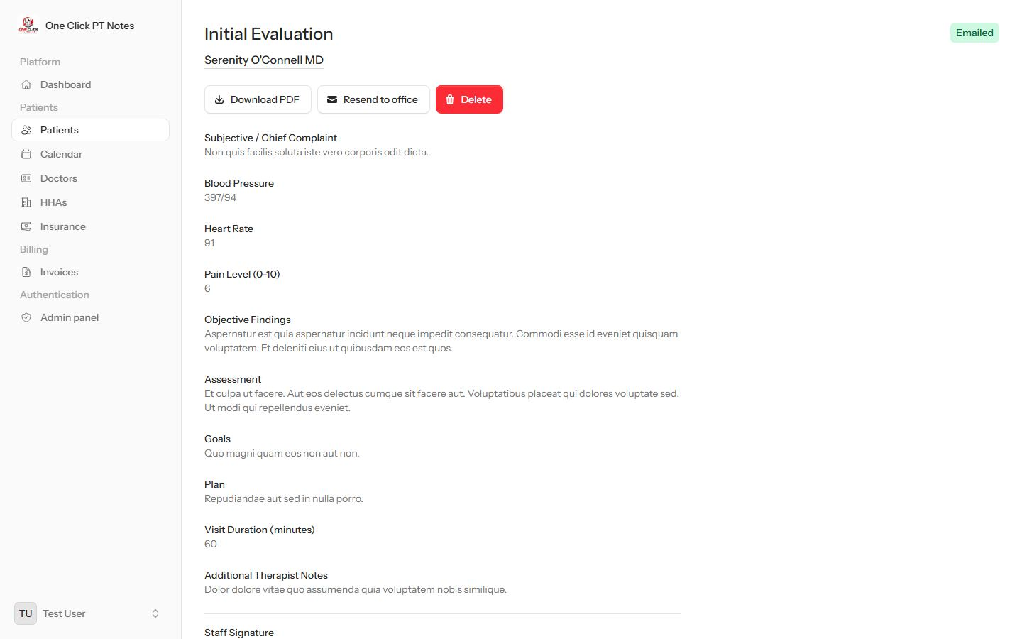
Note detailSigned & emailed notes show a status pill, Download PDF, Resend to office, and — because this role has delete rights — a Delete button.
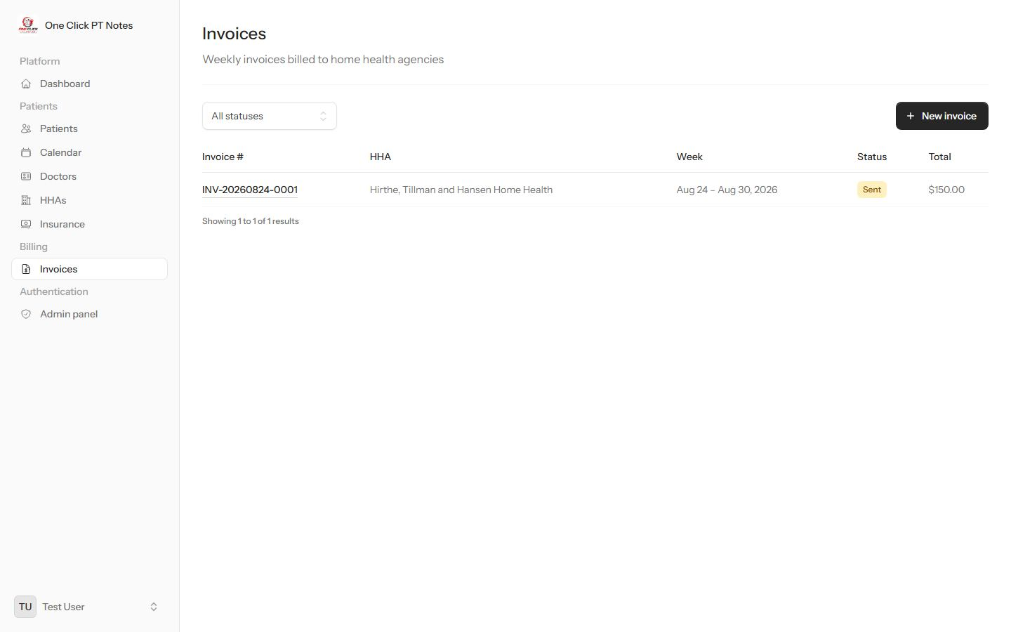
InvoicesEvery weekly invoice, filterable by status, with a New invoice button.
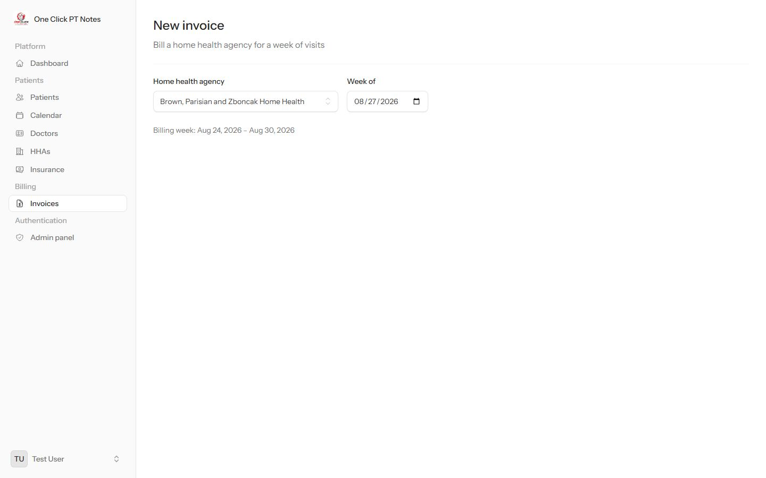
New invoicePick a home health agency and a week — the app works out the Mon–Sun range and lists your own unbilled visits for that agency to select.
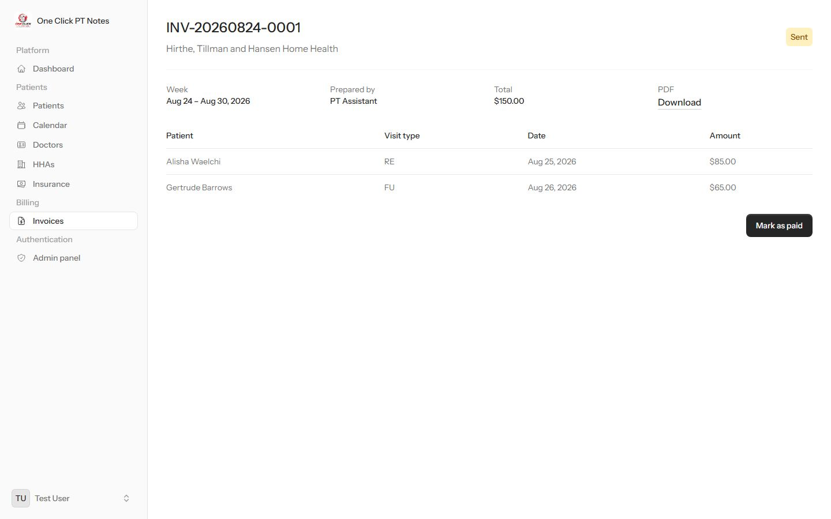
Invoice detailLine items with visit type and rate, a PDF download, and status actions (Mark as paid once sent).
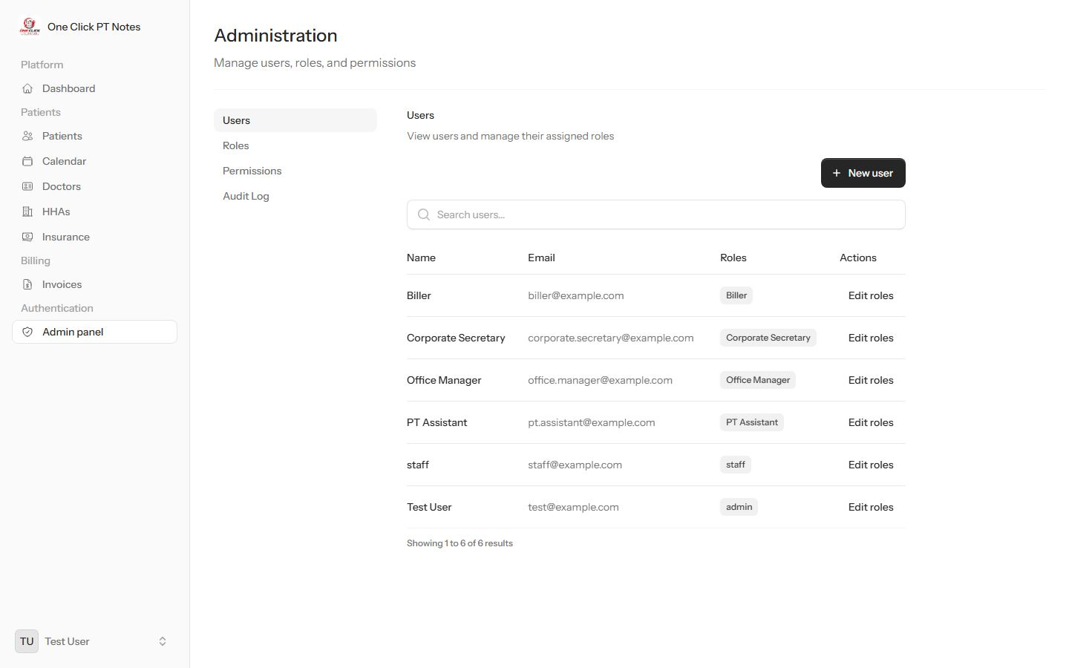
Admin → UsersEvery account and its assigned role, with New user and Edit roles per row.
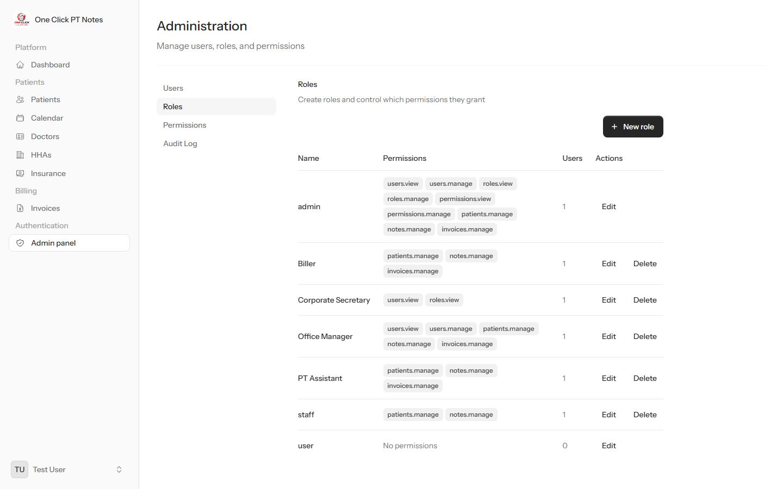
Admin → RolesWhat each role can do, at a glance — this is where the matrix above comes from.
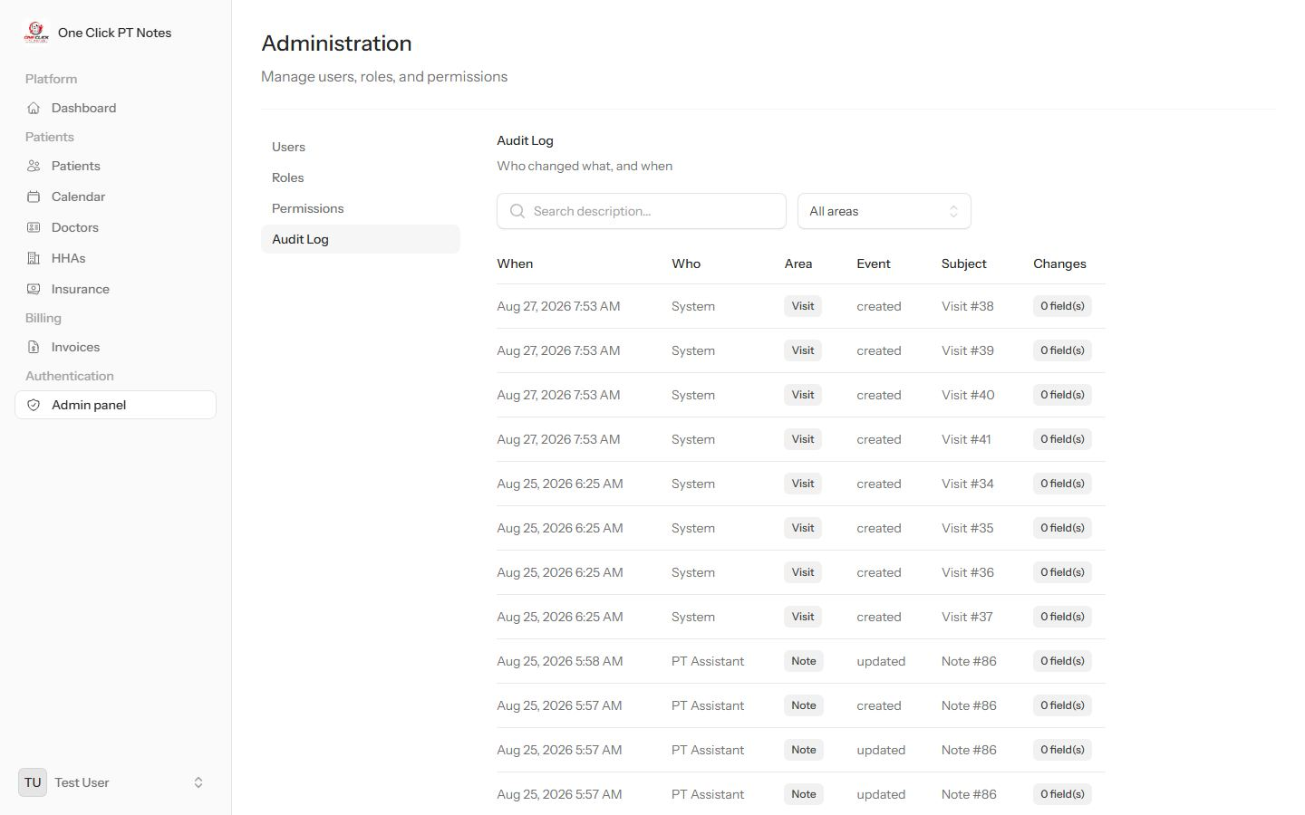
Admin → Audit LogWho changed what and when, across patients, notes, visits, invoices and staff — searchable by area.
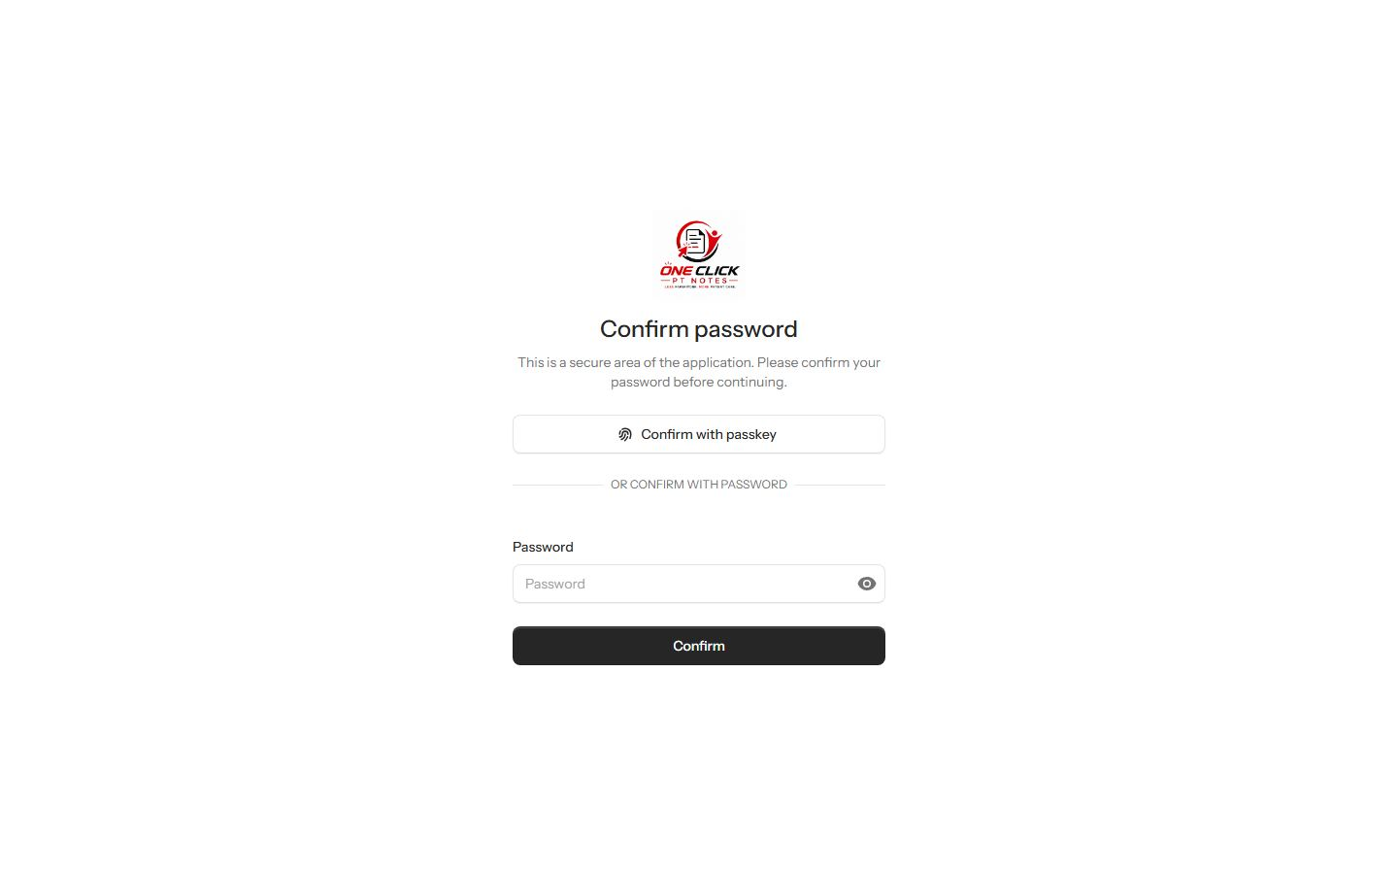
Settings → SecurityRe-enter your password (or confirm with a passkey) before reaching 2FA and passkey management — this gate applies to every role.

Office Manager
Runs day-to-day operations: full clinical access, billing, and hiring/managing staff accounts — everything short of the admin panel itself.
Permissions: patients.manage notes.manage users.view users.manage invoices.manage
Can do
- Everything on the Patients, Calendar and Billing pages
- Delete notes
- See staff accounts and their roles on the dashboard
Can't do
- Actually open the Admin panel — see the callout below
Sidebar shows a link the role can't use — the Admin panel item appears because this role can view staff, but the panel itself only opens for the Admin role. Clicking it 403s.
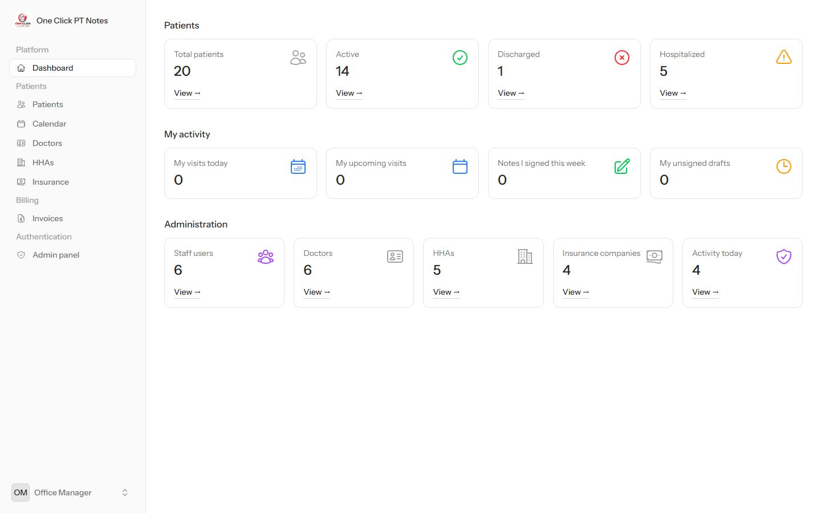
DashboardSame patient and activity cards as Admin, plus the Administration panel — because this role can view staff too.
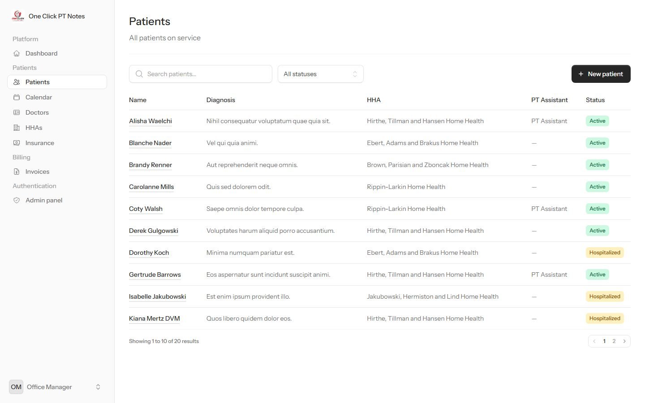
PatientsNew patient is available — this role can edit patient records.
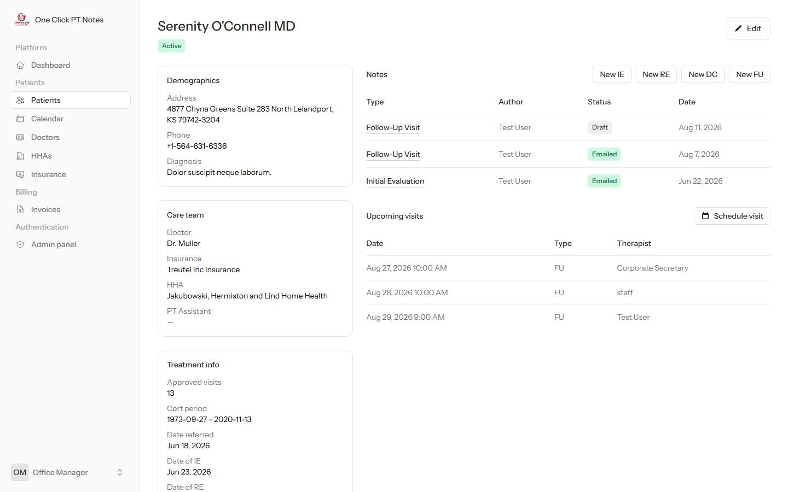
Patient profileFull edit access, same as Admin.
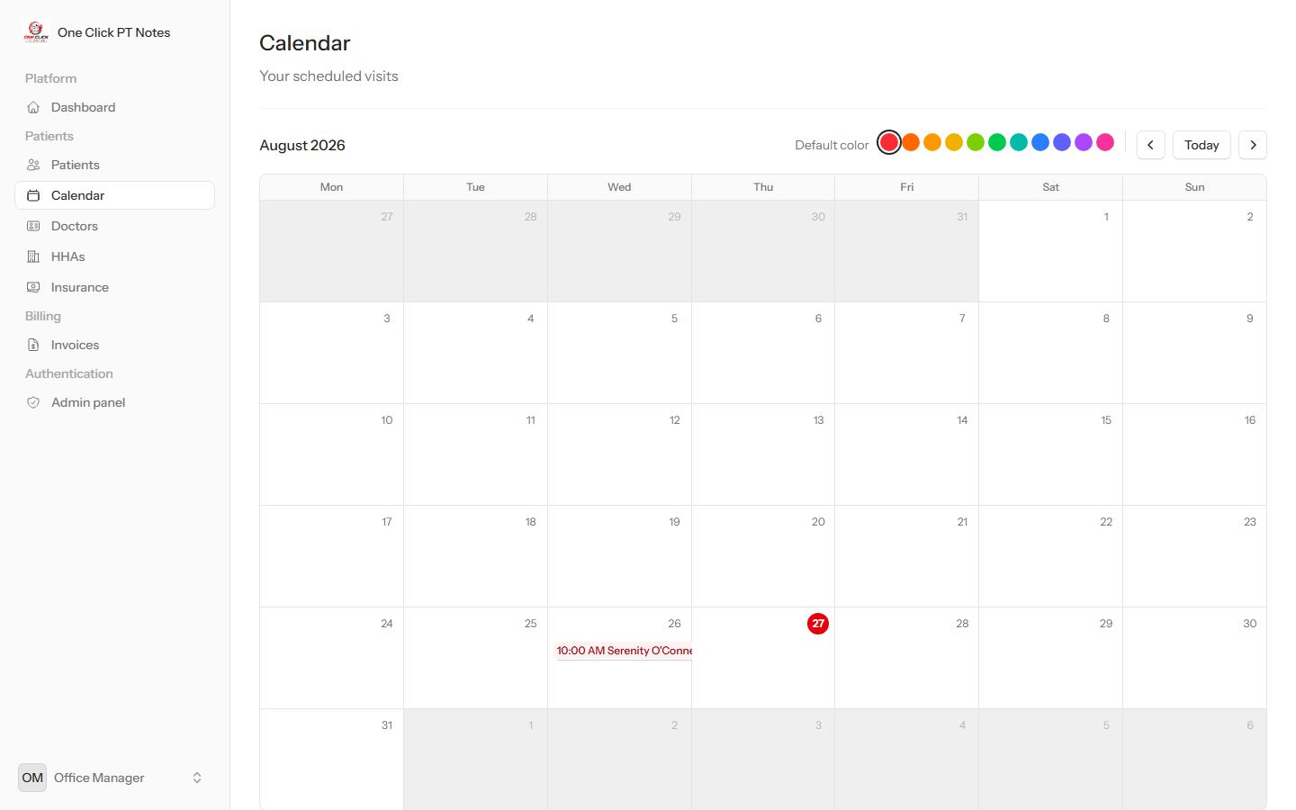
CalendarThis role's own scheduled visits only.
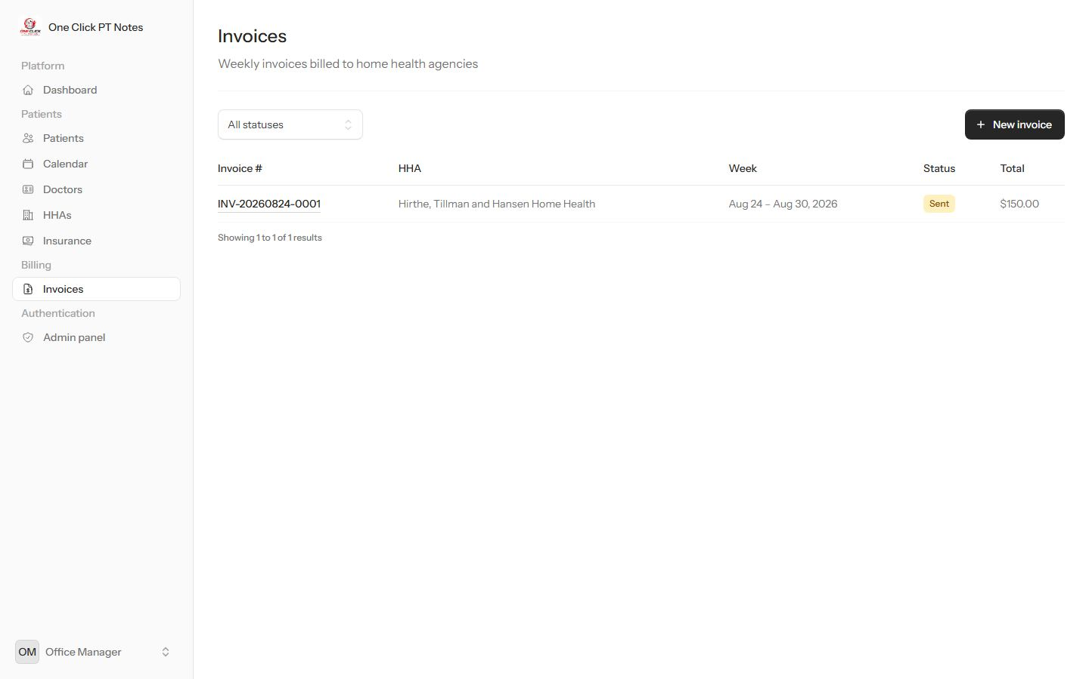
InvoicesFull billing access — create, view and mark invoices sent/paid.

Admin panel link → 403What actually happens when this role clicks the sidebar's Admin panel item.

Biller
Focused on getting agencies invoiced: the same clinical visibility as Staff, plus the Billing section — no staff management, no admin.
Permissions: patients.manage notes.manage invoices.manage
Can do
- Edit patients, delete notes
- Build, send and collect on weekly invoices
Can't do
- See or manage staff accounts
- Open the admin panel — no link shown at all
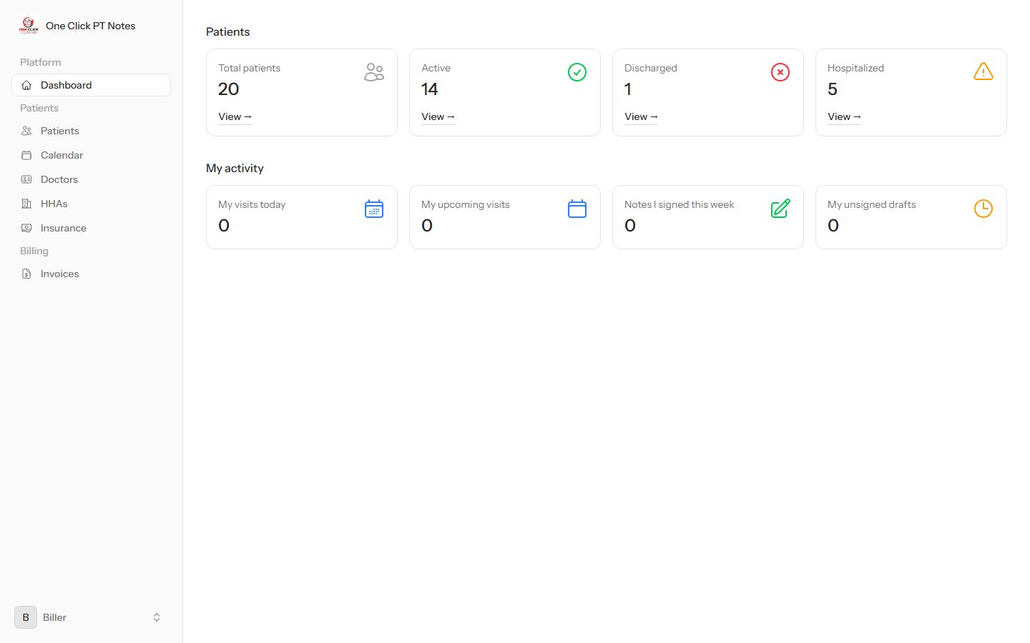
DashboardNo Administration section — this role can't view staff, so the sidebar has no Admin panel link either.
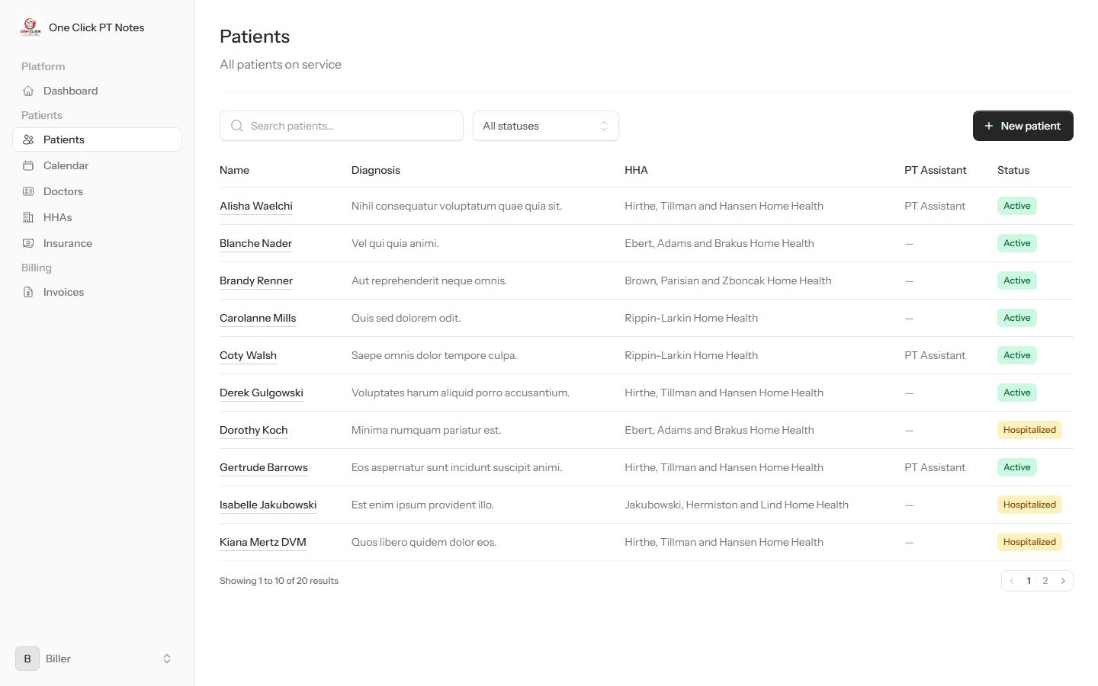
PatientsFull roster with edit rights.
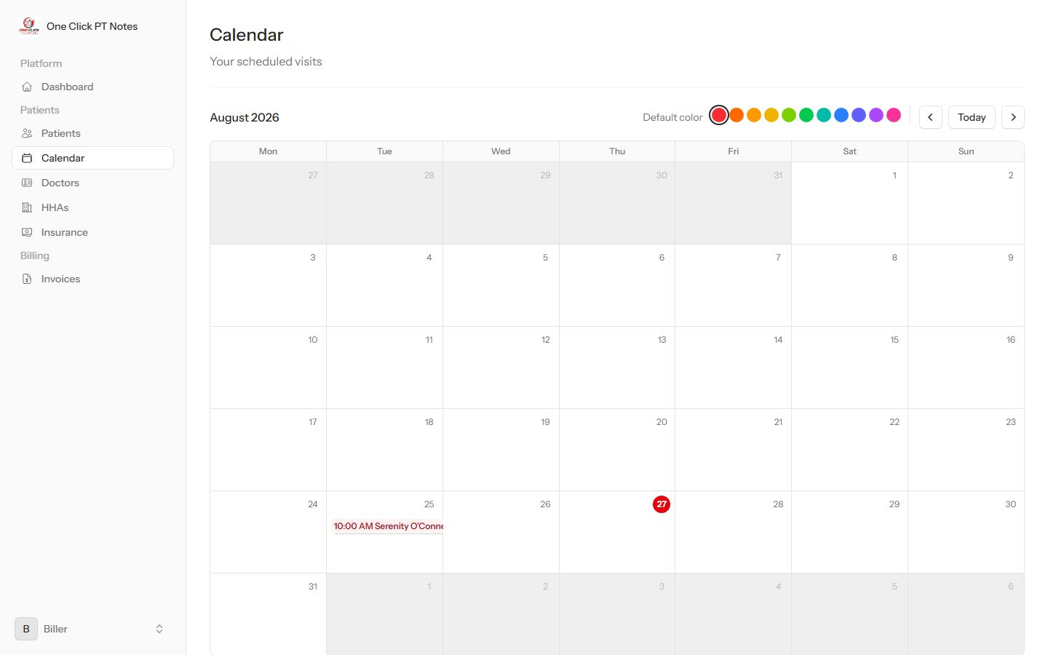
CalendarOwn visits only.
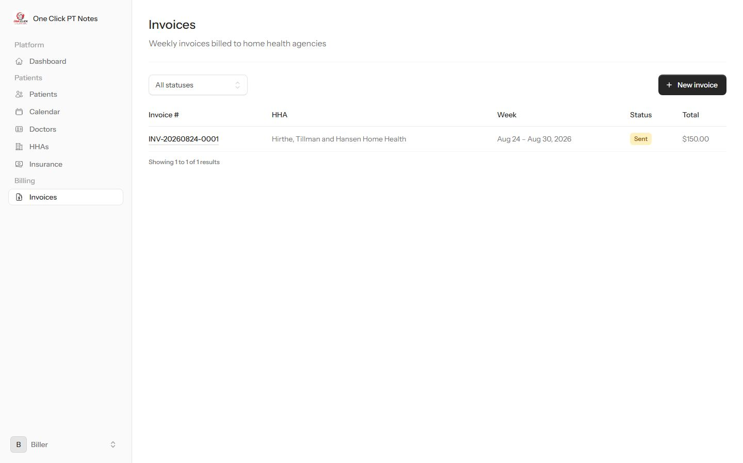
InvoicesThe reason this role exists — full billing access.
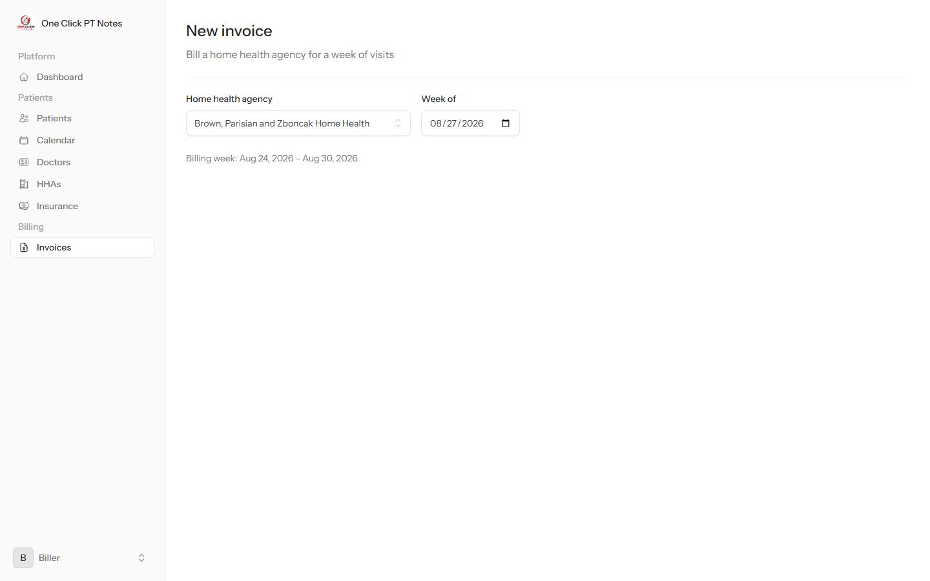
New invoiceSame weekly-invoice builder as Admin: pick an agency and week, select eligible visits.

PT Assistant
Delivers and documents care in the field, and can also invoice for it. This is also the role the PT Assistant dropdown on a patient's chart picks from.
Permissions: patients.manage notes.manage invoices.manage
Can do
- Edit patients, delete notes, manage invoices
- Be assigned to patients as their care-team PT Assistant
Can't do
- See or manage staff accounts, or open the admin panel
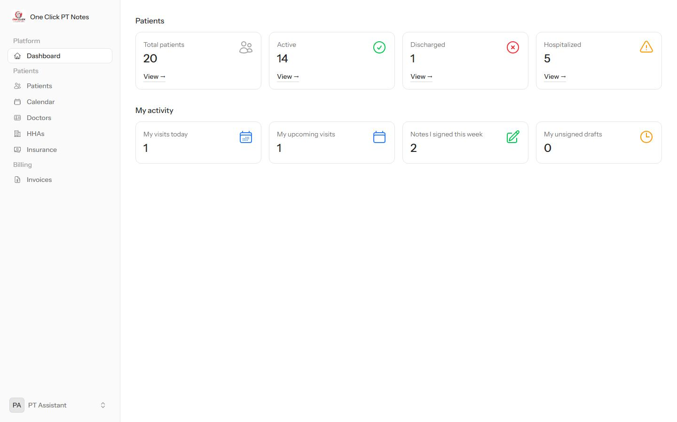
DashboardPersonal visit and note activity, plus Billing — no Administration section.
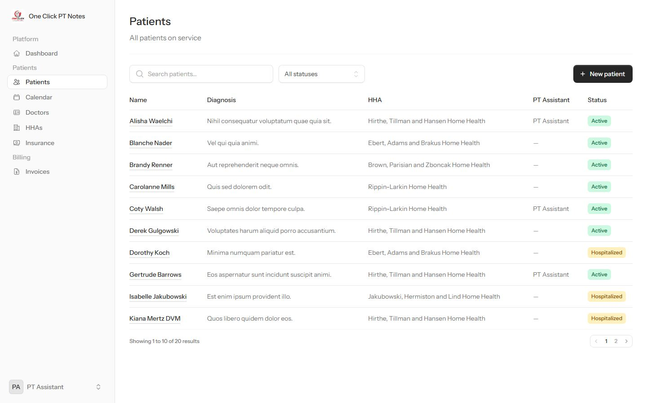
PatientsFull roster with edit rights; the PT Assistant column shows which patients are assigned to this role.
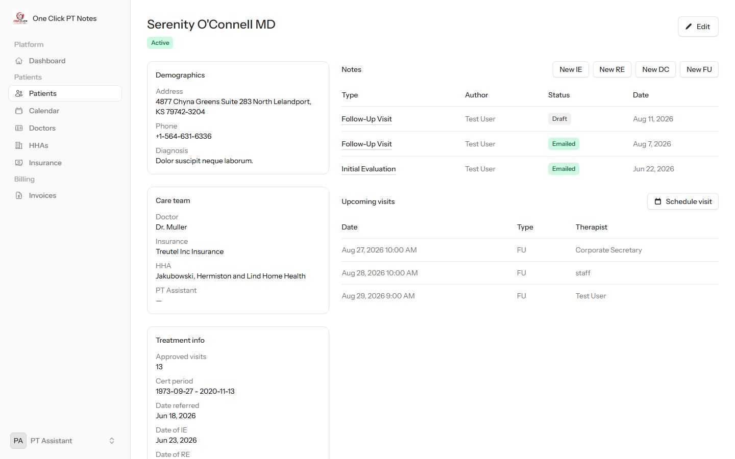
Patient profileSame documentation tools as every clinical role.
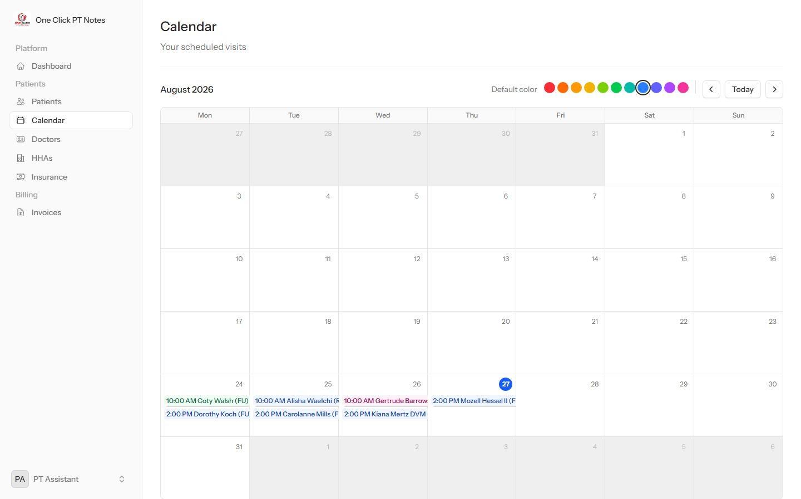
CalendarThis role's own scheduled visits.
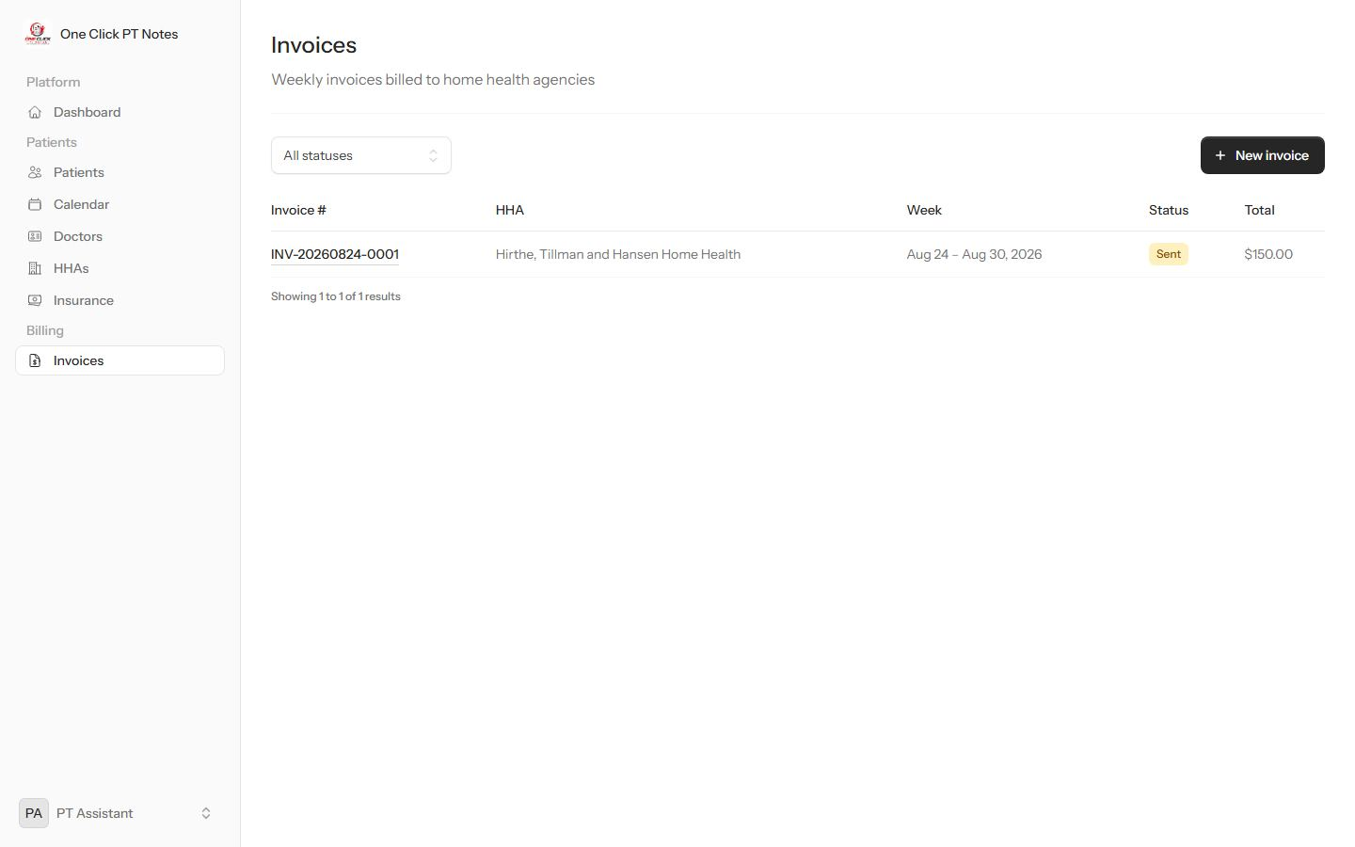
InvoicesCan build and manage weekly invoices, same as Biller and Office Manager.

Staff
The baseline clinical role — full patient and note documentation, no billing, no admin.
Permissions: patients.manage notes.manage
Can do
- Edit patients
- Delete notes
- Everything every role can: view the roster, schedule visits, write and sign notes
Can't do
- Open the Invoices or Admin sections — neither link appears, and the URL 403s if visited directly
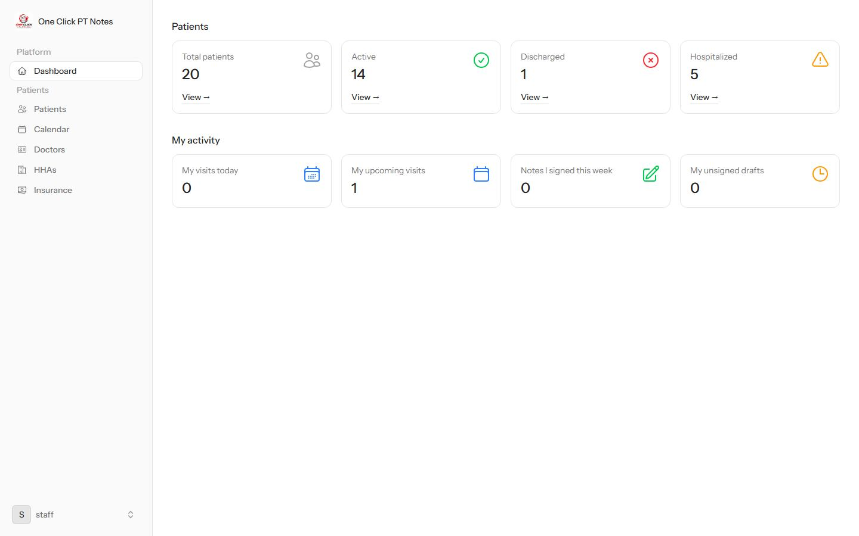
DashboardPatients and My activity only — no Billing group, no Administration section.
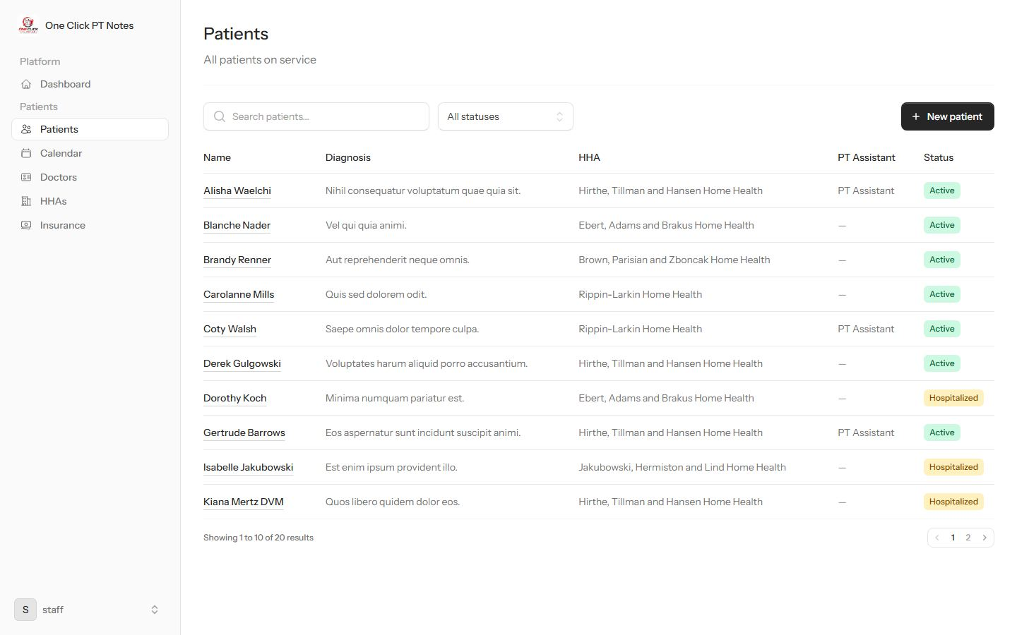
PatientsNew patient is still available — this role does hold patients.manage.
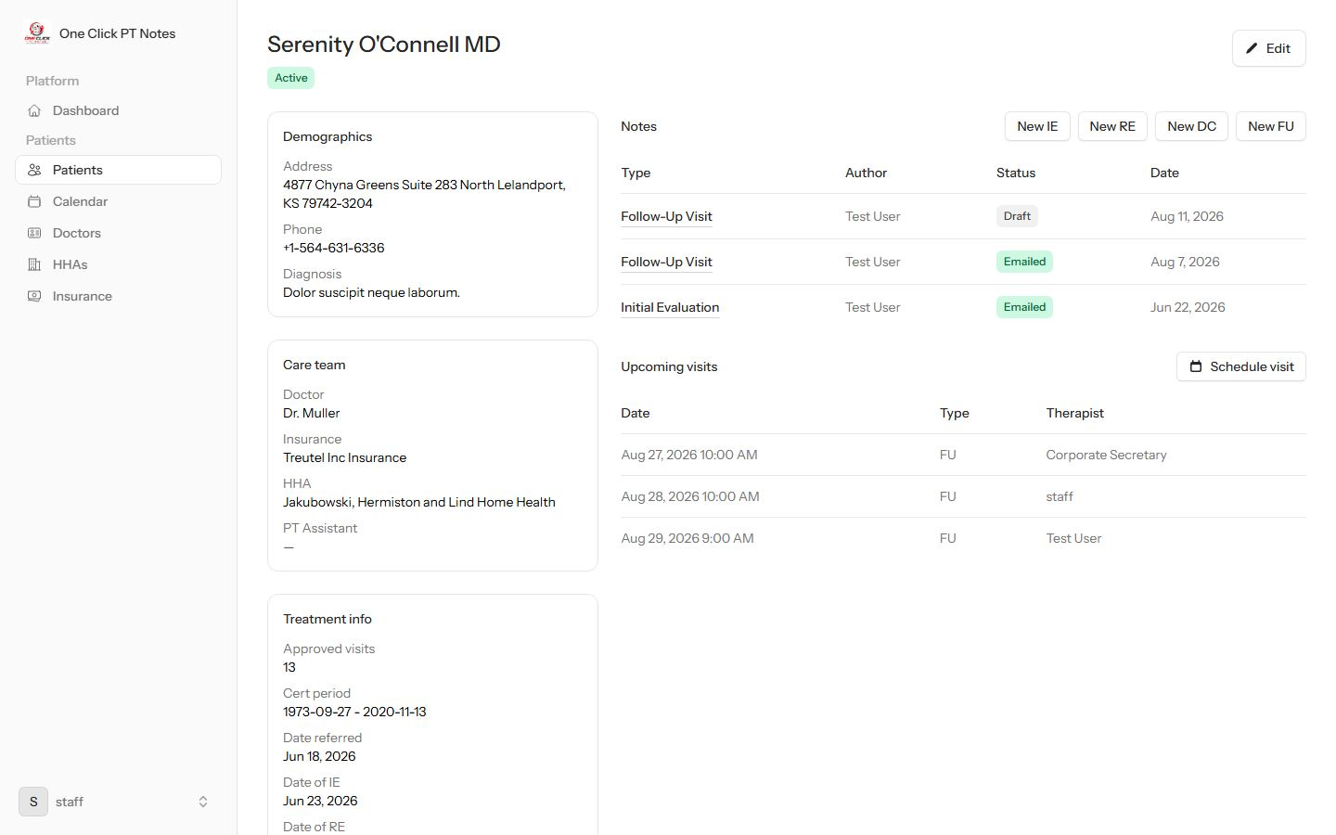
Patient profileFull documentation tools.
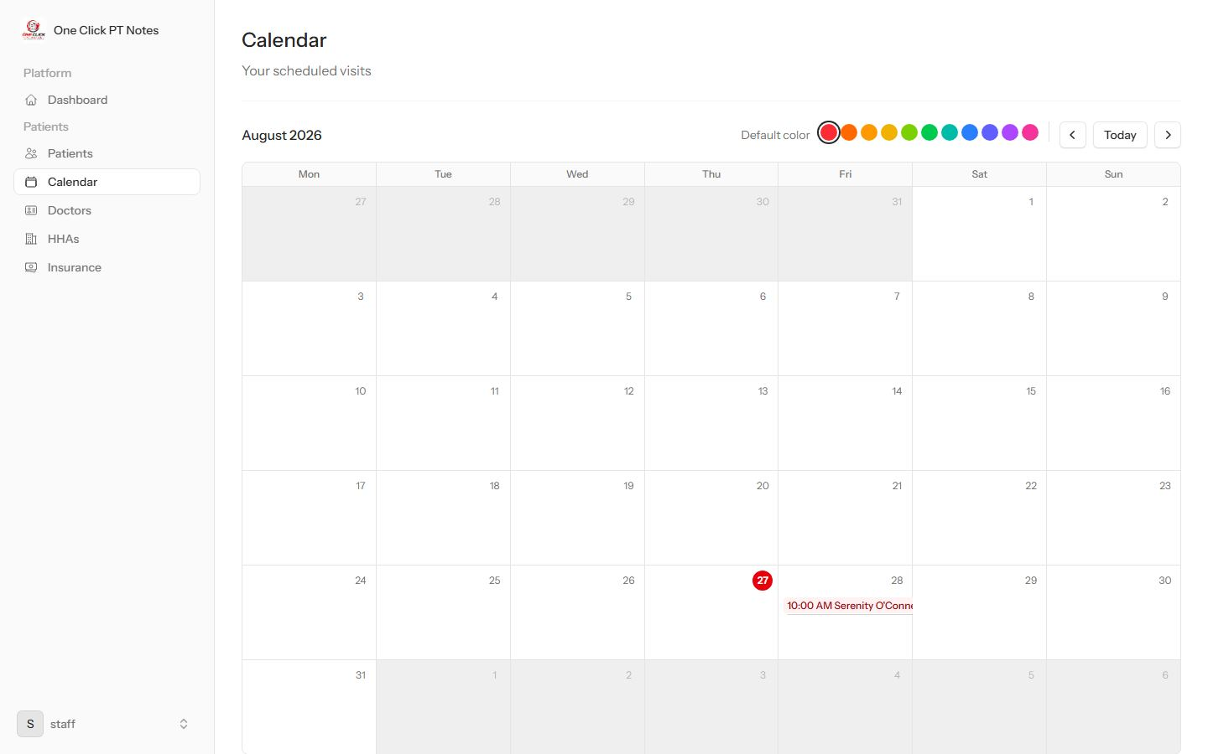
CalendarOwn visits only.
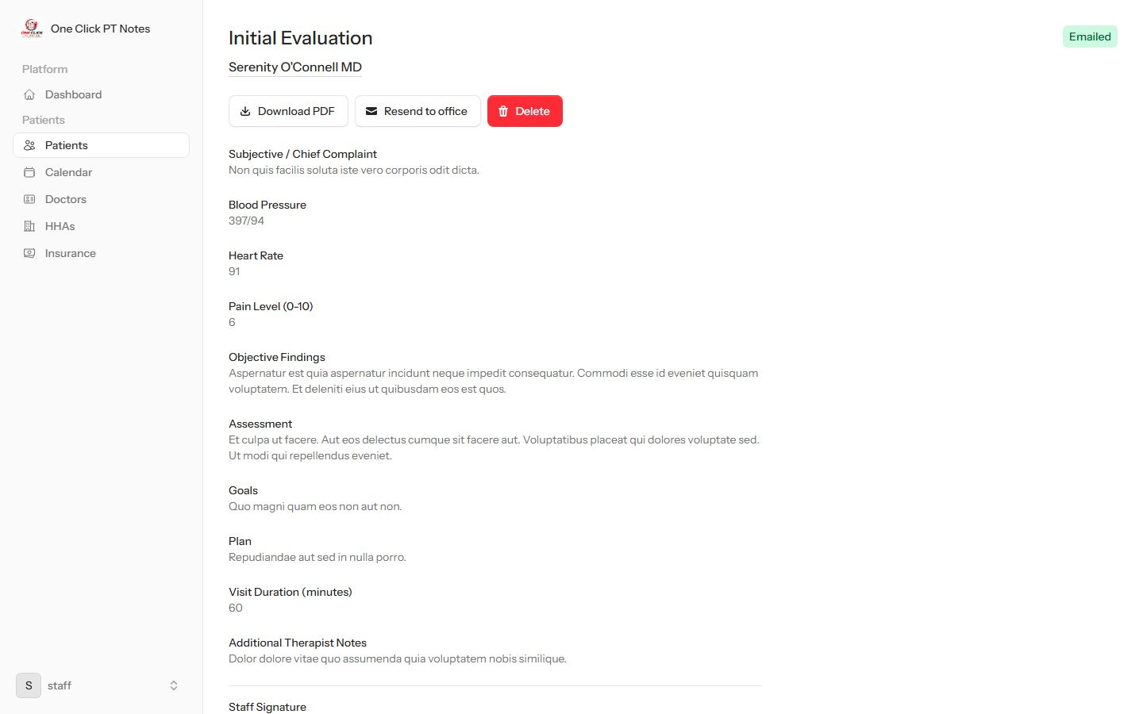
Note detailDownload and resend are there, but no Delete button — this role lacks notes.manage.

/invoices → 403There's no sidebar link, and visiting the URL directly is blocked too.

Corporate Secretary
Oversight only — can see the patient roster and the staff/role structure, but can't edit clinical records or manage anyone.
Permissions: users.view roles.view
Can do
- View the patient roster and every chart, read-only
- Schedule a visit and write/sign a note — that's open to everyone, not permission-gated
- See staff accounts and roles on the dashboard
Can't do
- Add or edit a patient record — no New patient button
- Delete a note
- Touch billing — no Invoices link at all
Same dead link as Office Manager — this role also sees the Admin panel item (it holds users.view), and it also 403s when clicked, since the panel is restricted to the Admin role specifically.
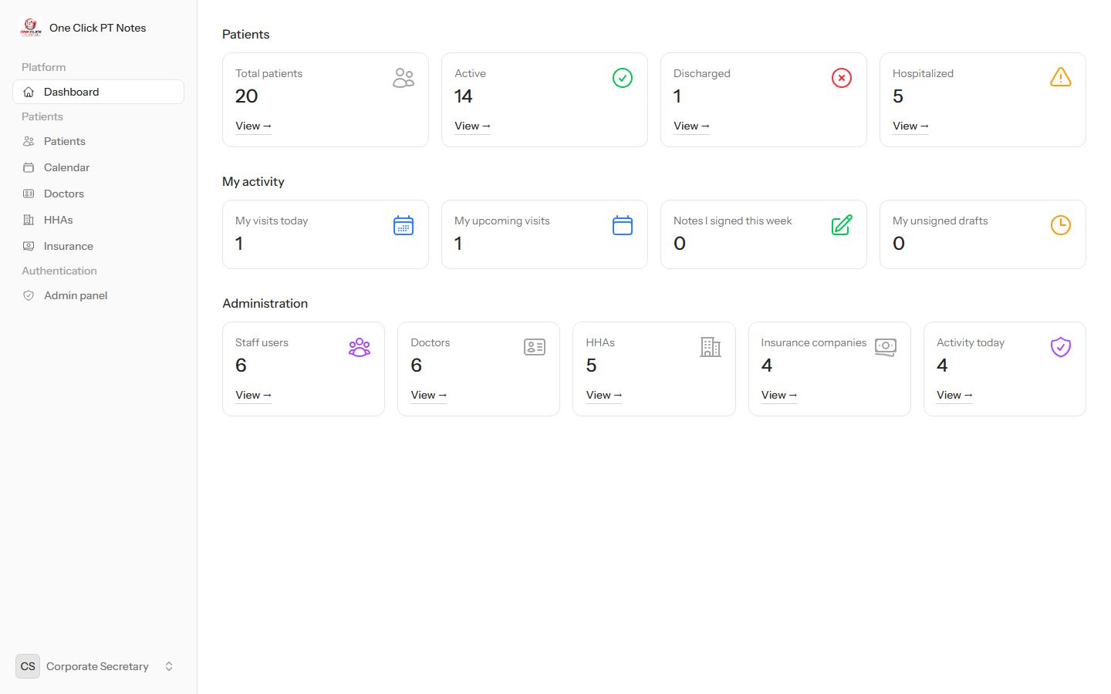
DashboardSees the Administration panel (staff counts, audit activity) but no Billing group.
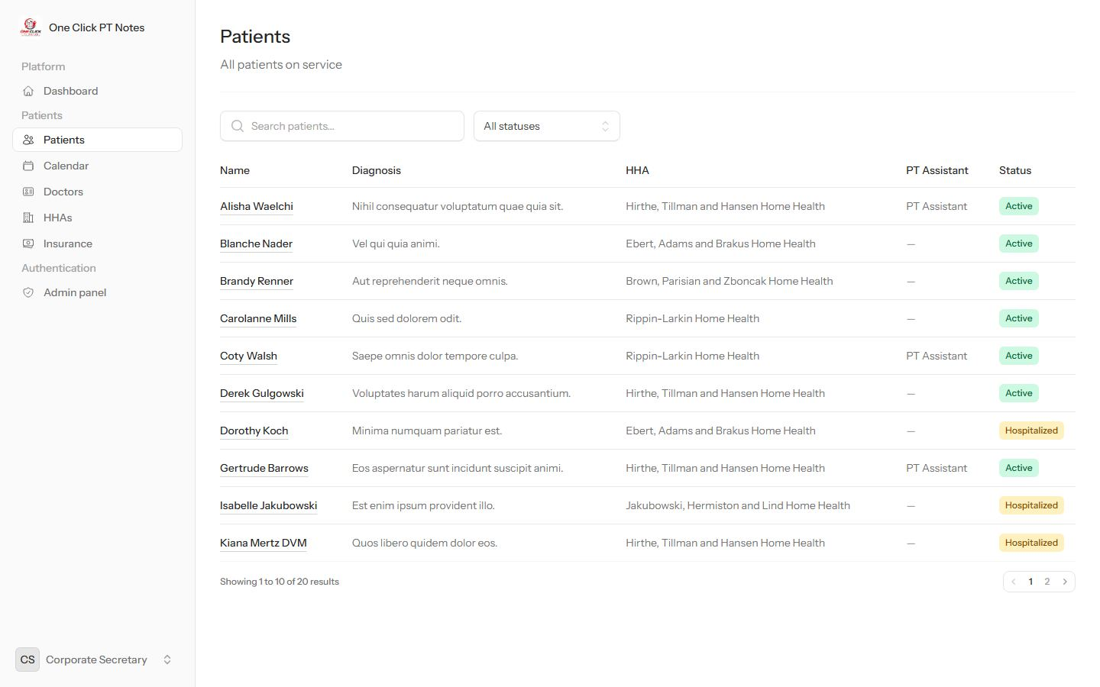
PatientsNo New patient button — this role can browse but not edit the roster.
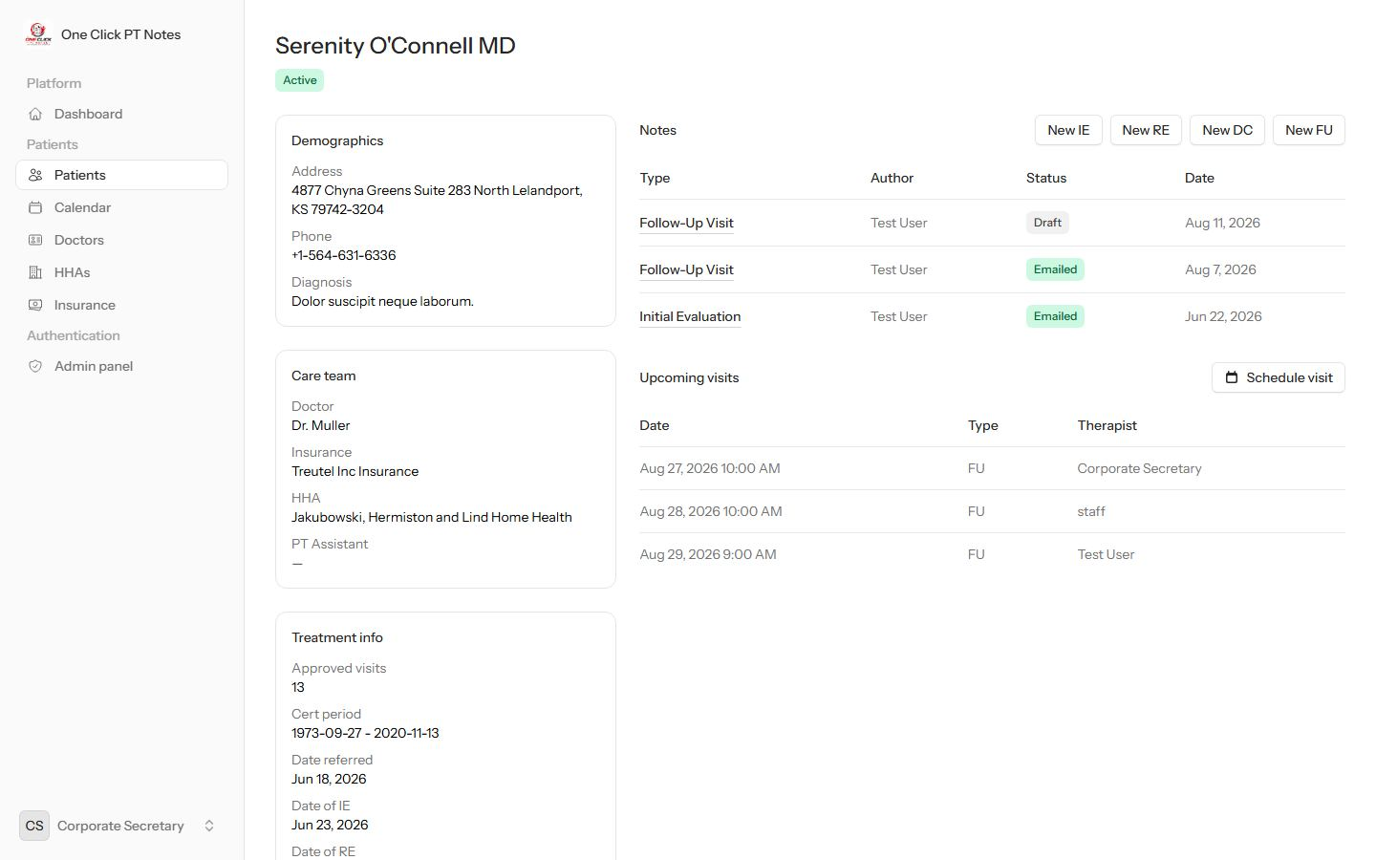
Patient profileNo Edit button on the profile card, but Schedule visit and note-creation are still there for everyone.

Admin panel link → 403The link shows in the sidebar; the page itself refuses this role.

Team Member (default role, internally called user)
What a brand-new self-registered account gets before anyone assigns it a real role — read access to clinical data, and enough to schedule a visit or write a note, nothing else.
Permissions: No permissions assigned
Can do
- View the patient roster and every chart, read-only
- Schedule a visit for a patient
- Write and sign a clinical note — note authoring isn't permission-gated for any role
Can't do
- Add or edit a patient record
- Delete a note
- See Billing or Admin — neither link appears
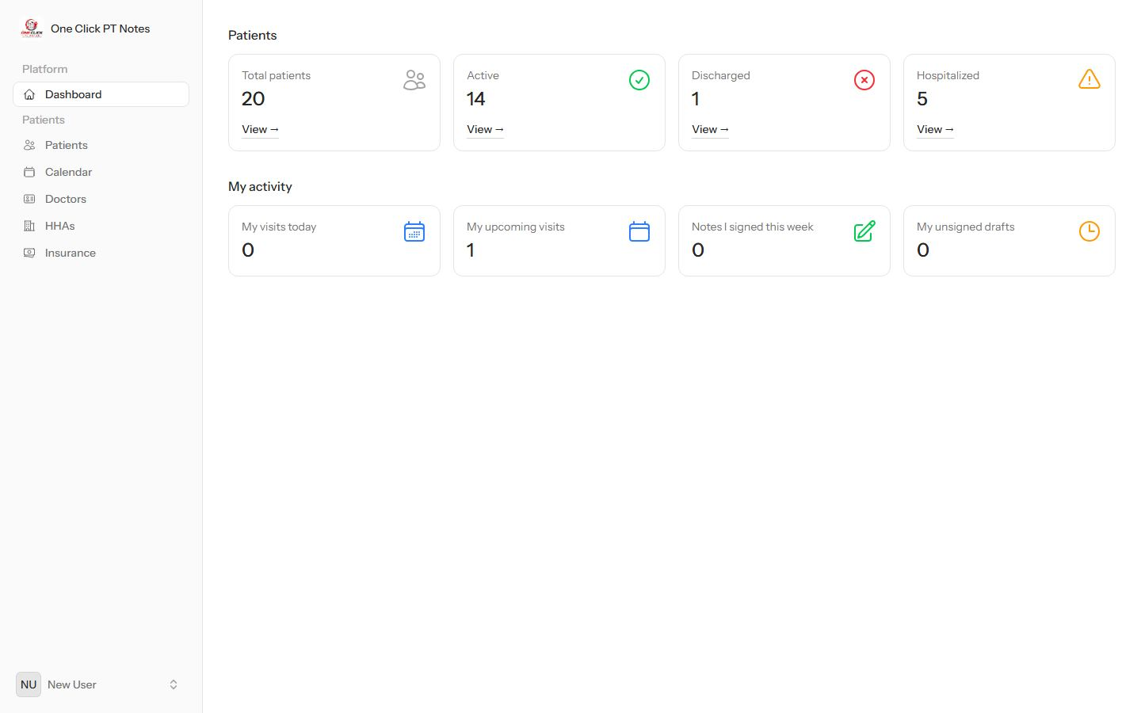
DashboardJust Patients and My activity — the narrowest view in the app.
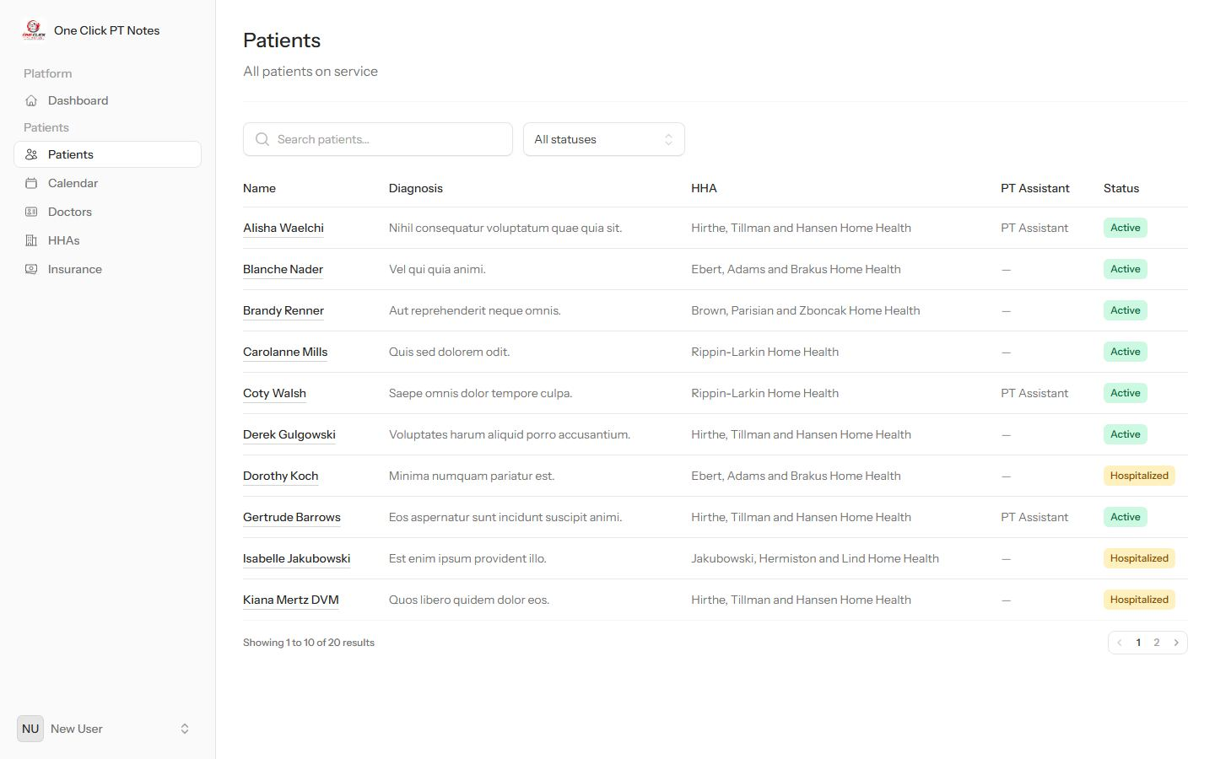
PatientsBrowsable, but no New patient button.
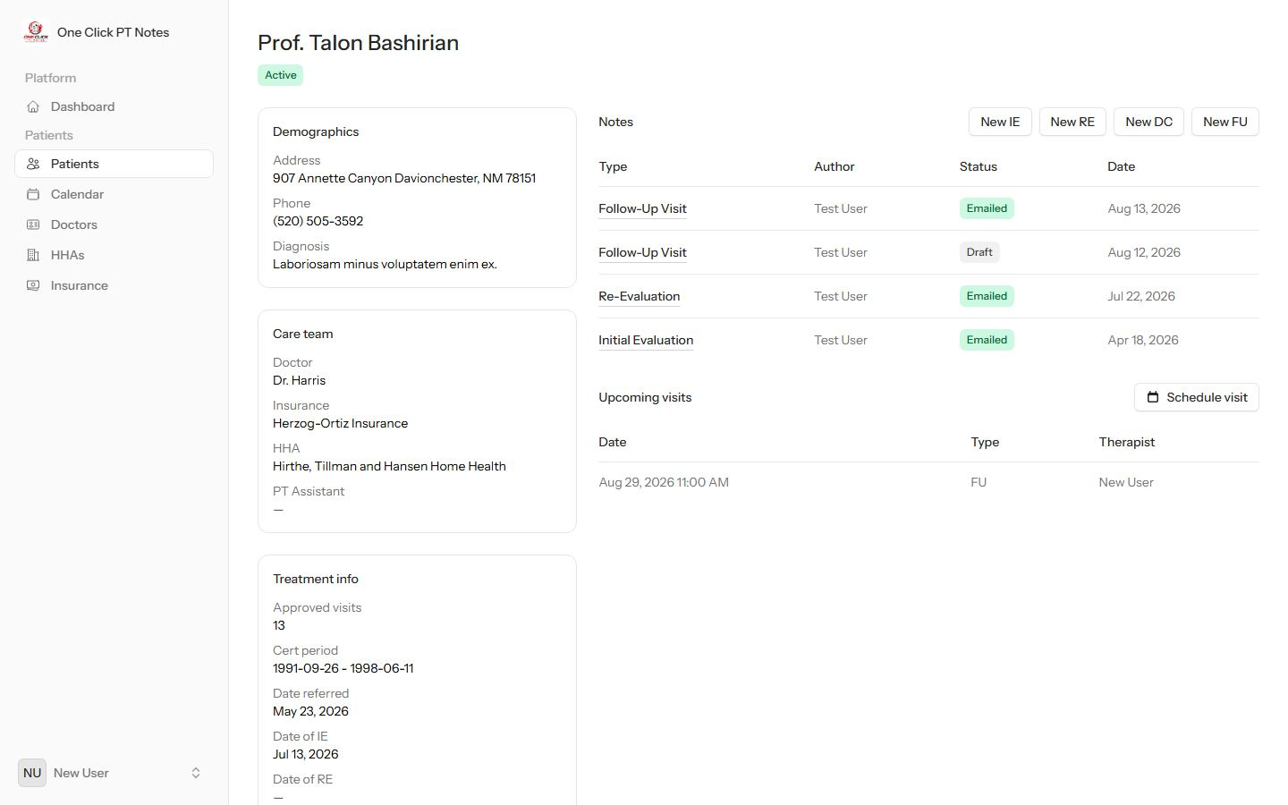
Patient profileNo Edit button, but Schedule visit and New IE/RE/DC/FU note buttons are still there — anyone can document care.
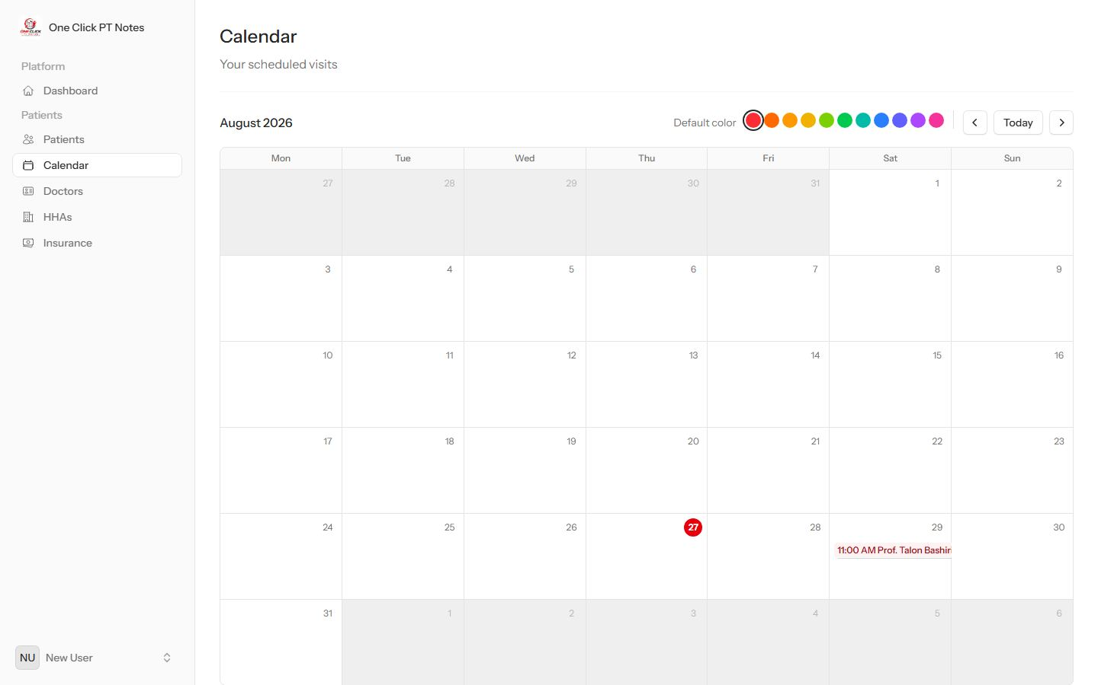
CalendarOwn scheduled visits, same as every role.

Captured directly from the running app, signed in as one seeded account per role — not mockups. Re-check against the app after any permission changes.

