Purchase Order: Does Entering Quantity Auto-Increment Stock?
Short answer: No — not automatically from the ordered quantity. Stock only increases when the "Received Units" value is set. This is intentional, modeling a separate ordered-vs-received workflow.

Screenshot: Create Purchase form
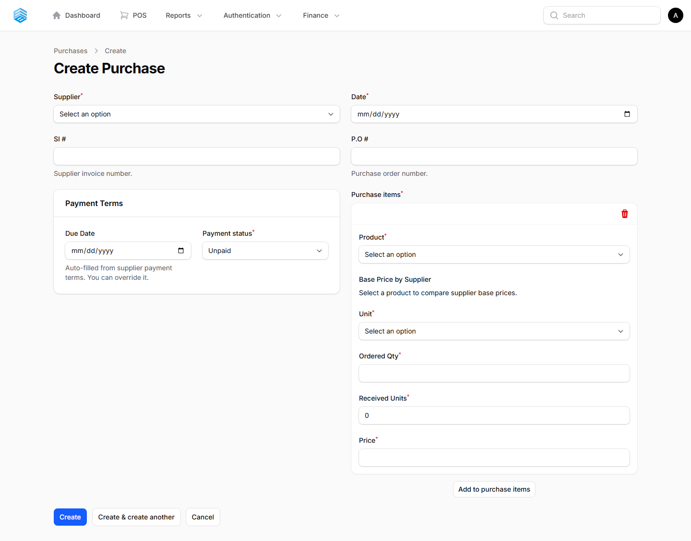
The purchase item line has two distinct quantity fields: "Ordered Qty" and "Received Units." Only "Received Units" affects inventory stock.

How it works (app/Models/PurchaseItem.php)
Event | Condition | Effect on stock
Purchase item created | quantity_received > 0 | Inventory.quantity is incremented by the received amount; an "in" movement is logged.
Purchase item updated | quantity_received changes on an existing item | Inventory.quantity is adjusted by the difference (increment or decrement); movement logged as an adjustment.
Purchase item deleted | quantity_received > 0 | The previously received amount is subtracted back out of Inventory.quantity; an "out" movement is logged.

Key takeaway
Simply entering an "Ordered Qty" on a purchase order line does NOT touch product stock. Stock (the Inventory record) only moves when "Received Units" is set to a value greater than 0, and it moves by exactly that amount. This lets the system distinguish between what was ordered and what has actually arrived and been received into stock.
Source: app/Models/PurchaseItem.php, booted() model event hooks (created / updated / deleted).

