Sales Incentives Guide
Recording sales rep incentives and paying them through payroll or separately
Updated: October 7, 2026 | System: tri-e.online

1. What Sales Incentives Does
TOS now keeps a record of every incentive given to a sales representative. When you record an incentive, you choose how it will be paid:
Payout | What happens | Best for
Add to payroll | TOS adds the amount to the rep's next payroll automatically. It shows in the Incentive column of the payroll and payslip. | Regular monthly sales incentives
Release separately | The incentive is handed over on its own (cash, cheque or transfer). You mark it as released once it has been paid. | Special or one-time incentives, or reps without a payroll setup

Each incentive also has a status, so you can always see which incentives are still owed and which have been paid.

2. Opening Sales Incentives
On the Home page, click the Sales Incentives card. It sits next to Cash Advances in the HR & Payroll group.
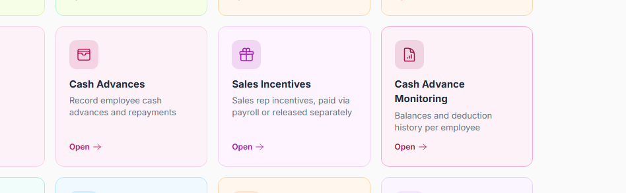
Figure 1. The Sales Incentives card on the Home page

3. Recording an Incentive
- Open Sales Incentives and click New Sales Incentive.
- The Reference Number (INC-…) is filled in automatically.
- Set the Date. For payroll payouts, this decides which payroll picks it up (see section 4).
- Select the Sales Representative.
- Enter the Amount and a Description, for example “October 2026 sales incentive — ₱1.05M collected (hardware)”.
- Choose the Payout: Add to payroll or Release separately.
- Add Notes if needed, then click Create.
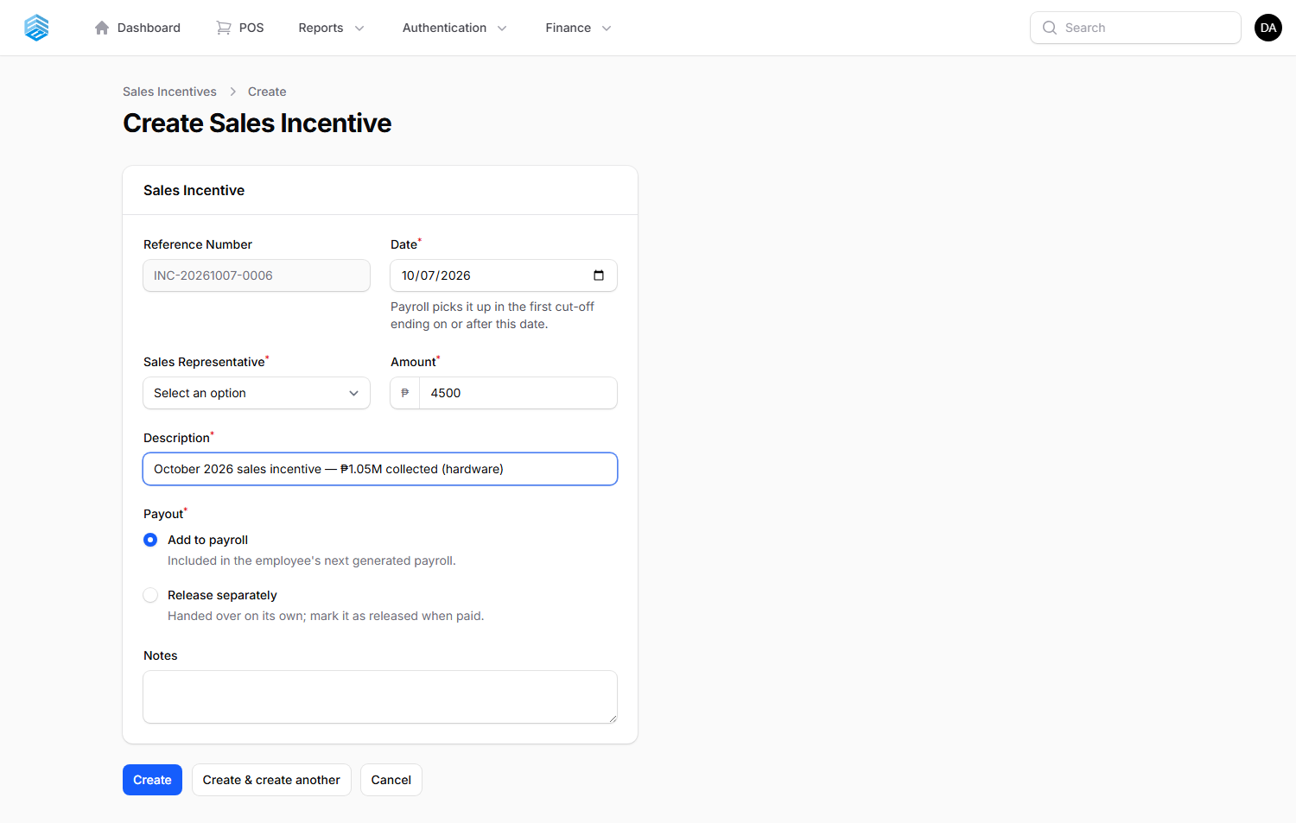
Figure 2. Recording a ₱4,500 sales incentive to be added to payroll
Tip: write the month and the sales figure in the Description. It appears on the list and helps when checking the incentive later.

4. Paying Through Payroll
There is no extra step. Generate the payroll the usual way (Payroll → Generate Payroll). For every employee in the payroll, TOS automatically:
- Finds that employee's incentives set to Add to payroll that are still Pending.
- Includes only incentives dated on or before the last day of the cut-off.
- Adds them to the Incentive column and to the employee's gross pay.
- Changes the incentive's status to In Payroll and shows the payroll number beside it.
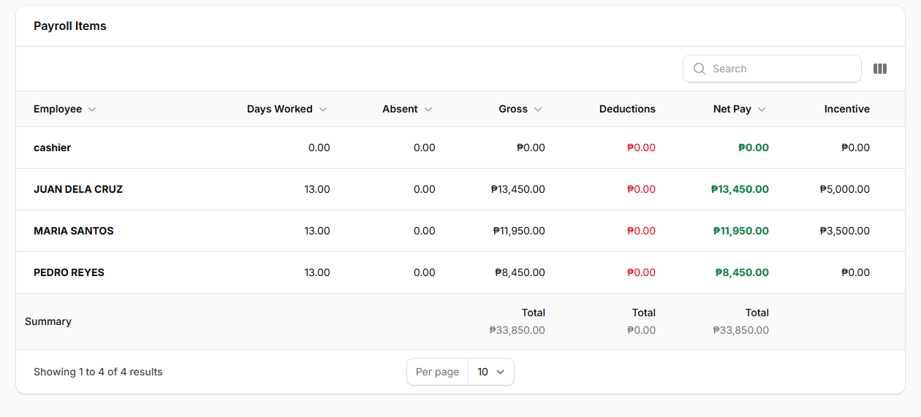
Figure 3. Payroll for Oct 1–15: Juan's ₱5,000 and Maria's ₱3,500 incentives are included in their gross pay
Example: an incentive dated October 20 is not included in the October 1–15 payroll. It stays Pending and is picked up by the October 16–31 payroll.
The payroll PDF (Export to PDF) also has an Incentive column, so the amount shows on the printed payroll.

5. Releasing an Incentive Separately
Incentives set to Release separately are not added to payroll. After you hand the money to the sales rep:
- Open Sales Incentives and find the incentive. It shows as Pending.
- Click Mark Released on that row.
- Check the amount and the name in the confirmation, then click Confirm.
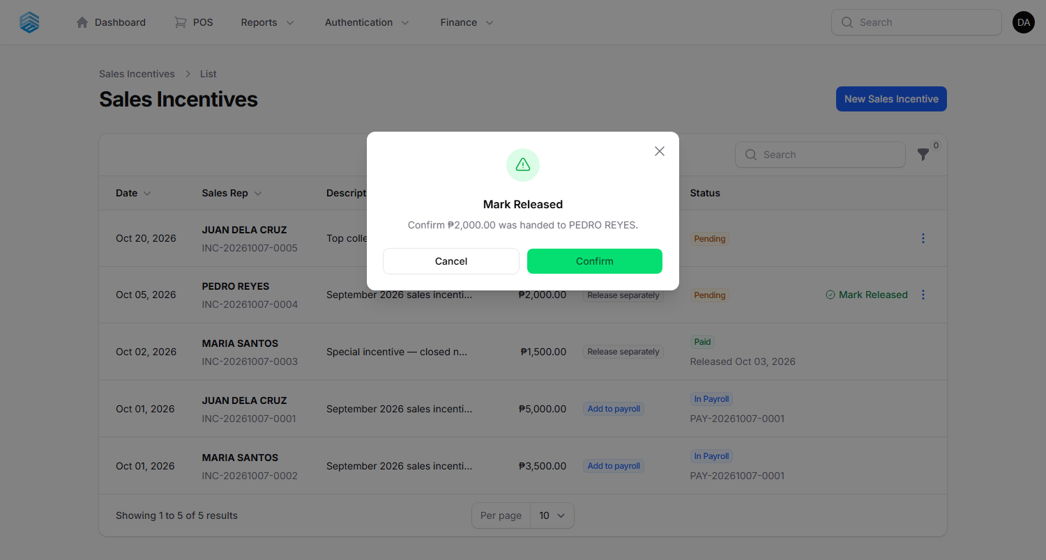
Figure 4. Confirming that ₱2,000 was handed to Pedro Reyes
The status changes to Paid and shows the release date. TOS also records who marked it as released.

6. Tracking Incentives
The Sales Incentives list shows every incentive with its date, sales rep, reference number, amount, payout and status.
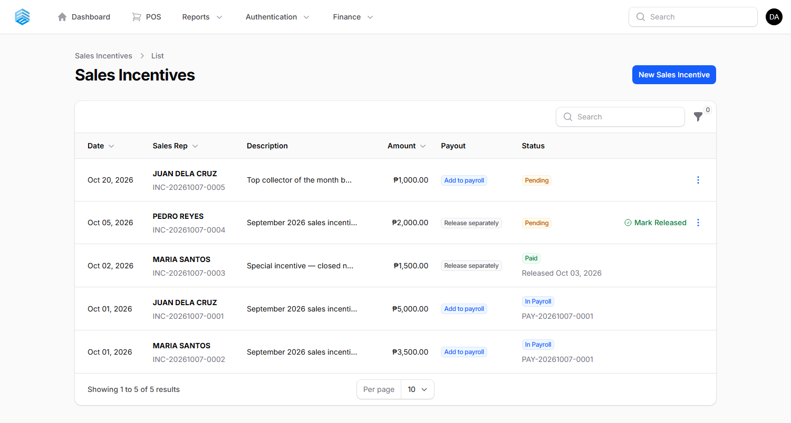
Figure 5. Sales Incentives list with each status
Status | Meaning
Pending | Not paid yet. Payroll incentives are waiting for a payroll whose cut-off covers their date. Separate incentives are waiting to be marked as released.
In Payroll | Included in a payroll that has not been paid yet. The payroll number is shown under the status.
Paid | The payroll was marked as paid, or the incentive was released separately (the release date is shown).

Use the Search box to find a rep's name or a reference number. Use the filter button to show only one sales rep or one payout type.

7. Editing, Deleting and Cancelled Payrolls
- A Pending incentive can be edited or deleted from the ⋮ menu at the end of its row.
- Once an incentive is In Payroll or Paid, it is locked and the ⋮ menu is hidden. This keeps payslips and release records correct.
- If a payroll is cancelled or deleted, its incentives go back to Pending automatically. They can be edited again and will be picked up by the next payroll you generate.

8. Notes
- Payroll only includes employees who have an Employee Compensation record. If a sales rep has no compensation record, choose Release separately for their incentives.
- Incentives are added to gross pay. They do not change the SSS, PhilHealth or Pag-IBIG deductions, which are based on the employee's compensation.
- Only the Super Admin can use Sales Incentives at first. To give another role access, go to Roles and tick the Incentive permissions (View Any, View, Create, Update, Delete).
- For now, incentive amounts are entered by hand. Automatic computation from monthly sales targets and brackets is planned for a later update.

