TOS System Update
Biometric Attendance Sync and Delivery DR Number
Release date: October 5, 2026 | System: tri-e.online

1. Summary of Changes
Area | What changed
Biometric attendance | Punches from the ZKTeco device at the store are now sent automatically to tri-e.online through the store PC, every 5 minutes.
Sync Attendance button | New button on the Attendances page that asks the store PC to send the latest punches within about a minute.
Automatic employees | Users enrolled on the biometric device are created in Employees automatically, with their Biometric PIN filled in.
Delivery DR # | Deliveries have a new DR # field. Staff can type the number from the printed DR booklet, or leave it blank to auto-generate one.

2. Biometric Attendance

2.1 How it works
The biometric device at the store is only connected to the store's local network, so the website cannot reach it directly. A small program on the store PC bridges the two:
- Device records each face or fingerprint scan (a “punch”).
- Store PC reads the punches and the list of enrolled users from the device over the local network.
- tri-e.online receives them, links each punch to the employee with the same Biometric PIN, and creates the attendance record.
Punches are never deleted from the device. If the store PC or the internet is down, nothing is lost; the next sync sends everything that was missed.

2.2 Registering the device (one time)
- Log in to tri-e.online and open Attendance Management → Biometric Devices.
- Click New, enter the Serial Number (sticker on the unit or Menu → System Info), a Name, and keep Active on. Click Create.
- Open the device again. In the Local Bridge Access section, copy the Bridge API Token. It is needed when setting up the store PC.
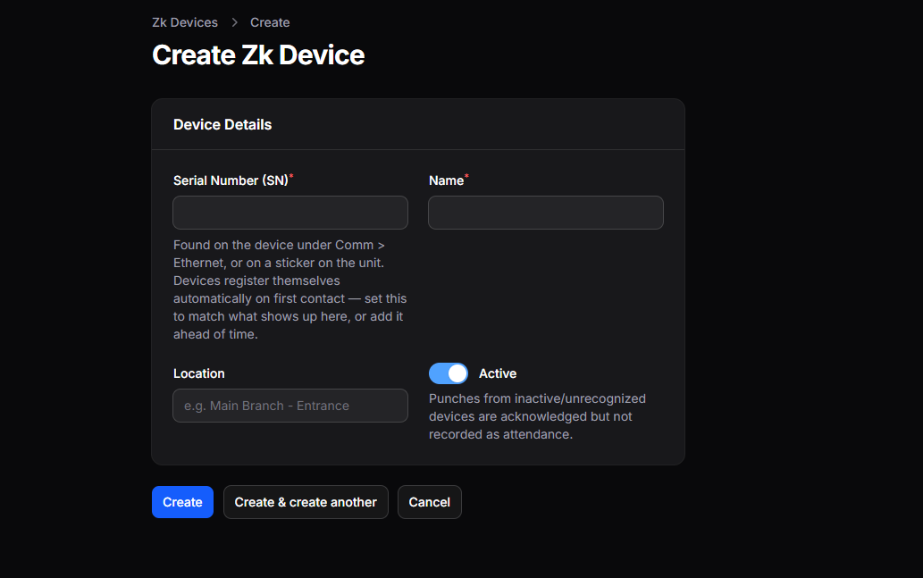
Figure 1. Registering the biometric device
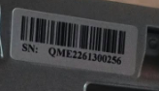
Figure 2. Serial number sticker on the device

2.3 Setting up the store PC (one time)
- Copy the TOS-Bridge.zip package to the store PC and extract it (for example to C:\TOS-Bridge).
- Double-click install.bat. It installs Python if needed and everything else the program requires.
- When asked, enter the device IP address (on the device: Menu → Comm → Ethernet) and paste the Bridge API Token.
- The installer runs a test sync and shows the result, then schedules the program to run automatically.
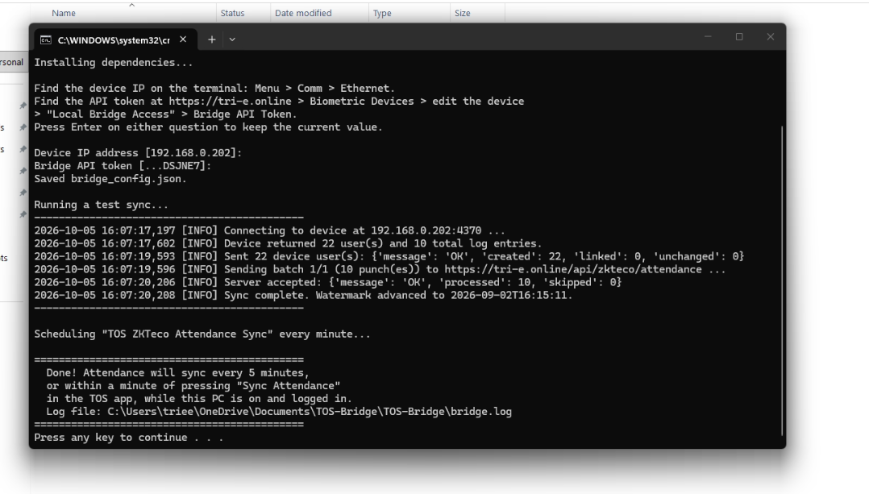
Figure 3. install.bat on the store PC after a successful setup
A successful test shows lines like these:
Message | Meaning
Device returned 22 user(s) and 10 total log entries | The store PC can read the device.
Sent 22 device user(s): created 22 | Employees were created on the website.
Server accepted: processed 10, skipped 0 | Punches were received by the website.
To stop the automatic sync, run uninstall.bat in the same folder.

2.4 Employees created from the device
Every user enrolled on the device becomes an employee in Attendance Management → Employees, with the device user number as the Biometric PIN.
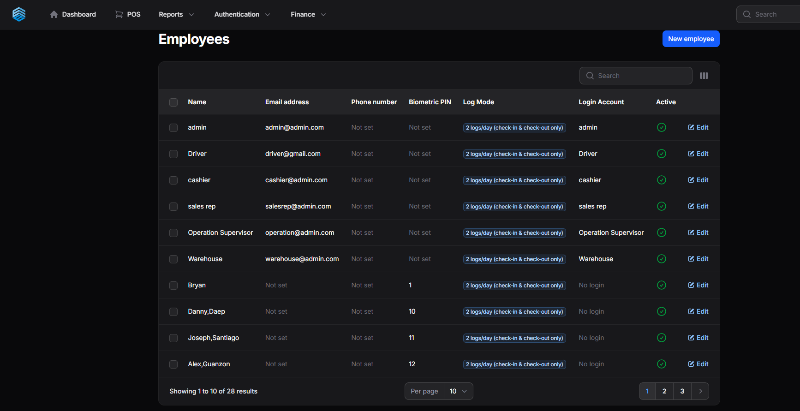
Figure 4. Employees created from the device, with their Biometric PIN
- If an employee with exactly the same name exists and has no PIN yet, the PIN is added to that employee instead of creating a duplicate.
- An employee who already has a PIN is never changed, so manual corrections stay.
- Users with no name on the device are created as “Device User N” and can be renamed.
- Names are copied as stored on the device (for example “Danny,Daep”) and can be edited on the website.
- New employees default to 2 logs/day. Change it to 4 logs/day for staff who also punch out and in for a break.

2.5 Sync Attendance button
On the Attendances page, click Sync Attendance to get the newest punches right away instead of waiting for the next 5-minute sync. Wait about one minute, then refresh the page.
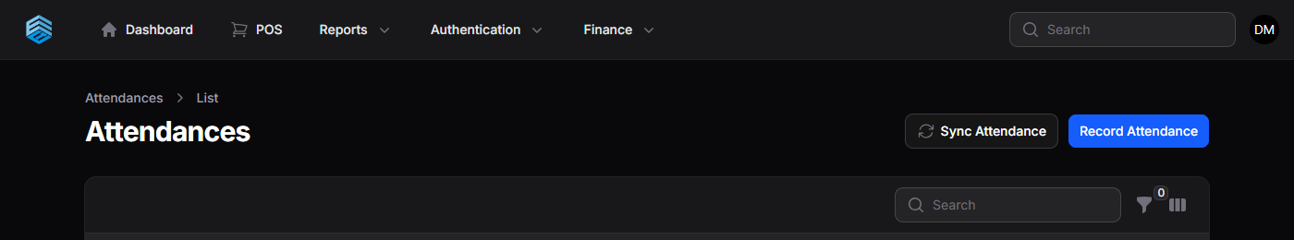
Figure 5. Sync Attendance button on the Attendances page
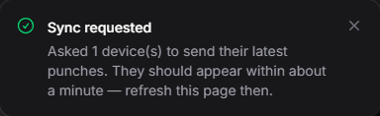
Figure 6. Message shown after clicking Sync Attendance
The button also re-links punches that arrived before an employee's Biometric PIN was set.

2.6 How time in, time out and status are computed
Item | Rule
Time In | First punch of the day (4 logs/day: first check-in punch).
Time Out | Last punch of the day. Empty until the person punches a second time.
Total Hours | Time Out minus Time In. In 4 logs/day mode, the break is subtracted.
Late | Time In after 9:10 AM (9:00 AM shift start plus 10 minutes grace).
Half Day | Fewer than 4 hours worked.
Present | Otherwise.
Attendance entered by hand (Record Attendance) is never overwritten by device punches. To let the device take over a day, delete the manual record and click Sync Attendance.

2.7 Store PC requirements
- The PC must be turned on and logged in to Windows. After a restart, syncing resumes automatically once someone logs in.
- Turn off sleep mode: Settings → System → Power → Screen and sleep → “When plugged in, put my device to sleep after” → Never.
- The PC needs internet access and must be on the same network as the device.
- The device clock must be correct (Menu → System → Date/Time), otherwise punches are saved under the wrong date.
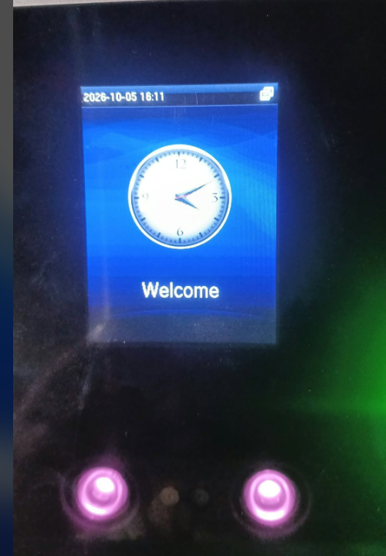
Figure 7. Device home screen showing the correct date and time

2.8 Troubleshooting
Check the Last Seen column on the Biometric Devices page, and the file bridge.log in the bridge folder on the store PC.
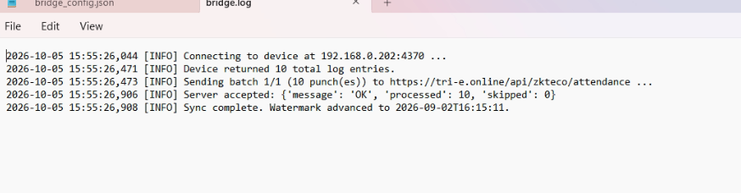
Figure 8. bridge.log on the store PC after a successful sync
Symptom or log message | What to do
Invalid token / 401 | Run install.bat again and paste the token from the Biometric Devices page.
Could not read attendance from the device | Check the device is on, the network cable, and the IP address.
Punches received but not in Attendances | Check the employee's Biometric PIN matches their user number on the device.
Time Out empty | The person punched only once that day.
Last Seen is old | The store PC is off, asleep, logged out, or offline.

3. Processing Attendance into Payroll
- Employee Compensations: create a record for each employee with daily rate, pay period, days off, government contributions, late deduction and allowance. Only employees with a compensation record are included in payroll.
- Review Attendances for the cutoff: fix missing time-outs, file and approve leaves in Leave Requests, and add any missing days with Record Attendance.
- Payrolls → New: choose the pay period type and dates, then click Create. The payroll is calculated automatically.
- Open the payroll, add overtime or bonuses if any, then Approve, Mark Paid, and Export PDF for payslips.
Notes:
- Overtime is not calculated from punches; enter it on the payroll.
- Days with no punch have no record, so “Days absent” shows 0. Pay is still correct because it is based on days worked.
- A day with only one punch counts as a full day; fix missing time-outs before running payroll.
- Work on an employee's day off is currently not paid by the payroll. The rule for rest-day pay is still to be decided.

4. Delivery DR Number

4.1 Entering the DR #
On Deliveries → New or Edit, the Delivery Details section has a new optional DR # field.
- Typed by hand: enter the number from the printed DR booklet given to the customer. It is saved exactly as typed.
- Left blank: the system generates a DR # automatically from the month, day and time (Philippine time).
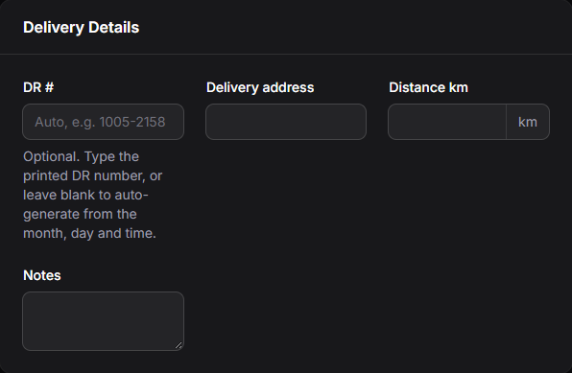
Figure 9. DR # field on the delivery form

4.2 Automatic DR # format
Format: MMDD-HHMM (month, day, hour, minute in 24-hour time).
Situation | DR # | Printed as
October 5, 9:48 PM | 1005-2148 | DR-1005-2148
Another delivery in the same minute | 1005-2148-2 | DR-1005-2148-2
Typed from booklet | 0457 | DR-0457

4.3 Where the DR # appears
- Deliveries list: new DR # column. Type a DR number in the search box to find a delivery.
- View Delivery: shown under Customer & Order Details.
- Printed Delivery Receipt: shown at the top right in place of the system number.
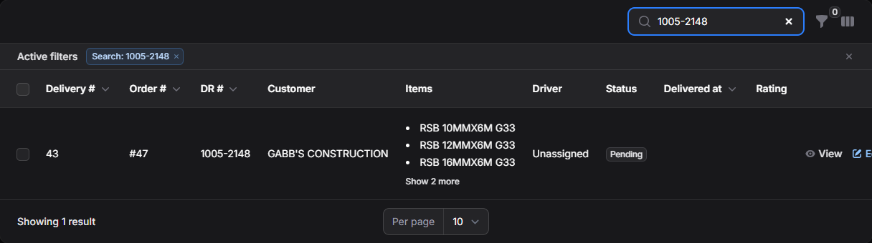
Figure 10. Searching the Deliveries list by DR #
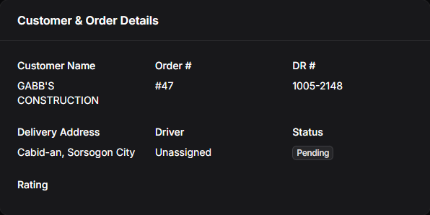
Figure 11. DR # on the View Delivery page
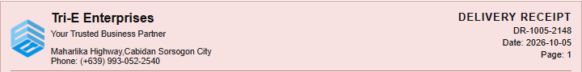
Figure 12. DR # on the printed Delivery Receipt

4.4 Rules
- Each DR # can be used only once. Entering a number already used shows an error, which helps catch typing mistakes.
- Clearing a typed DR # and saving gives the delivery an automatic number.
- Older deliveries get a DR # (based on their original date and time) the next time they are edited.

5. Deployment Checklist (for the administrator)
Upload these files to tri-e.online, then run php artisan migrate on the server.
Feature | Files
Sync button and device users | app/Http/Controllers/Api/ZkBridgeController.php  app/Services/ZkAttendanceService.php  app/Models/ZkDevice.php  app/Filament/Resources/Attendances/Pages/ListAttendances.php  routes/zkteco.php
DR number | app/Models/Delivery.php  app/Filament/Resources/Deliveries/DeliveryResource.php  resources/views/deliveries/receipt-print.blade.php
Database migrations | 2026_10_05_100000_add_sync_requested_at_to_zk_devices_table.php  2026_10_05_110000_add_dr_number_to_deliveries_table.php
Store PC | TOS-Bridge.zip (zkteco_bridge.py, install.bat, configure.py, uninstall.bat)

