Correcting a Closing Amount
How to request and approve a fix for a register that was closed with the wrong cash count

When to use this
Use this when a register session is already closed but the closing cash count is wrong. The most common case is forgetting to enter the count, so the register closed at ₱0.00 and the whole expected amount shows as a shortage.
You can correct any past session, even one from an earlier month. The session keeps its original closing date, so that day’s reports are fixed.
Who does what
Cashier: requests the correction on their own session.
Manager: approves or rejects it. Nothing changes until a manager approves.

Part 1 — Cashier: request a correction
- From the Home page, open the Cash Register card.
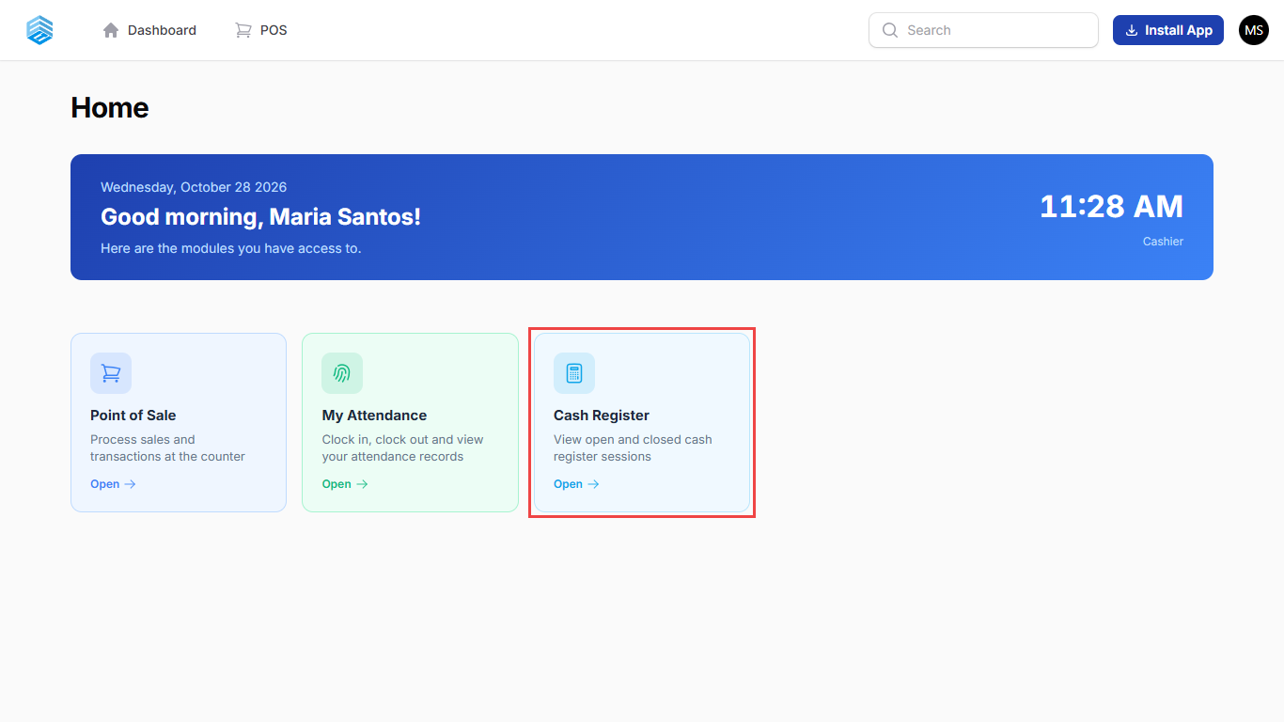
If you don’t see the Cash Register card, ask your administrator to give your role access to it.
- Find the session with the wrong closing amount and click it. You only see your own sessions. In this example, Aug 14 was closed at ₱0.00 and shows a ₱6,000.00 shortage.
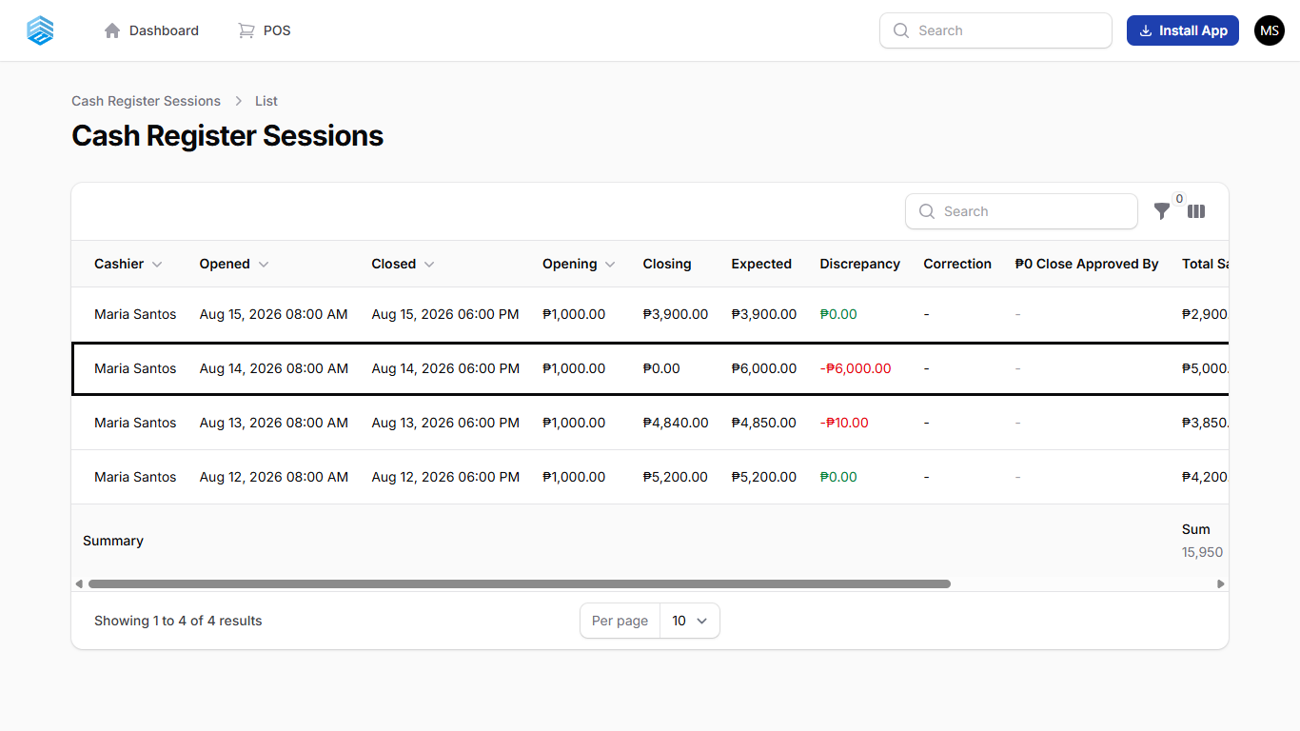
- Click Request Correction at the top right.
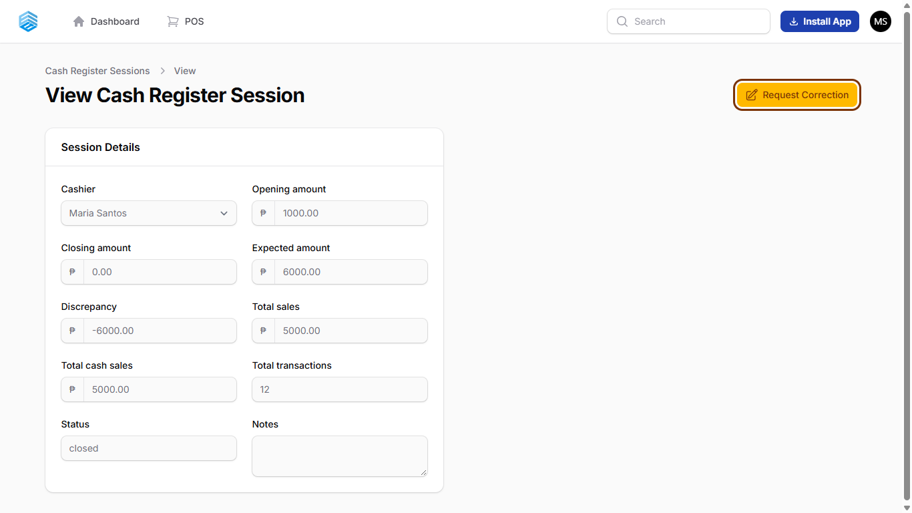
- Enter the cash you actually counted under Actual cash counted. Explain what happened under Reason, then click Submit.
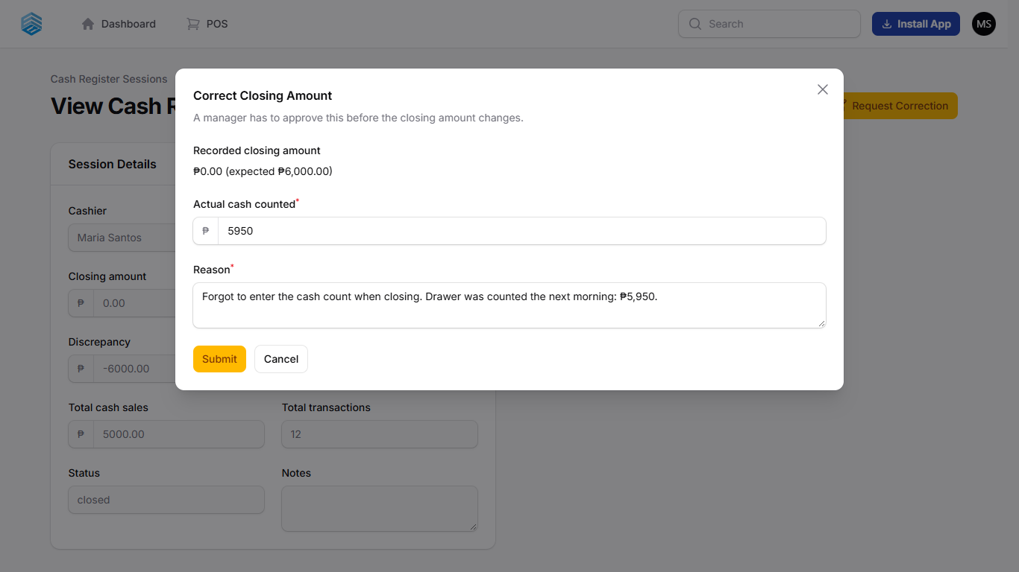
Write a clear reason: the manager reads it before approving.
- The request is sent. The session now shows Pending in the Correction column until a manager reviews it. The closing amount does not change yet.
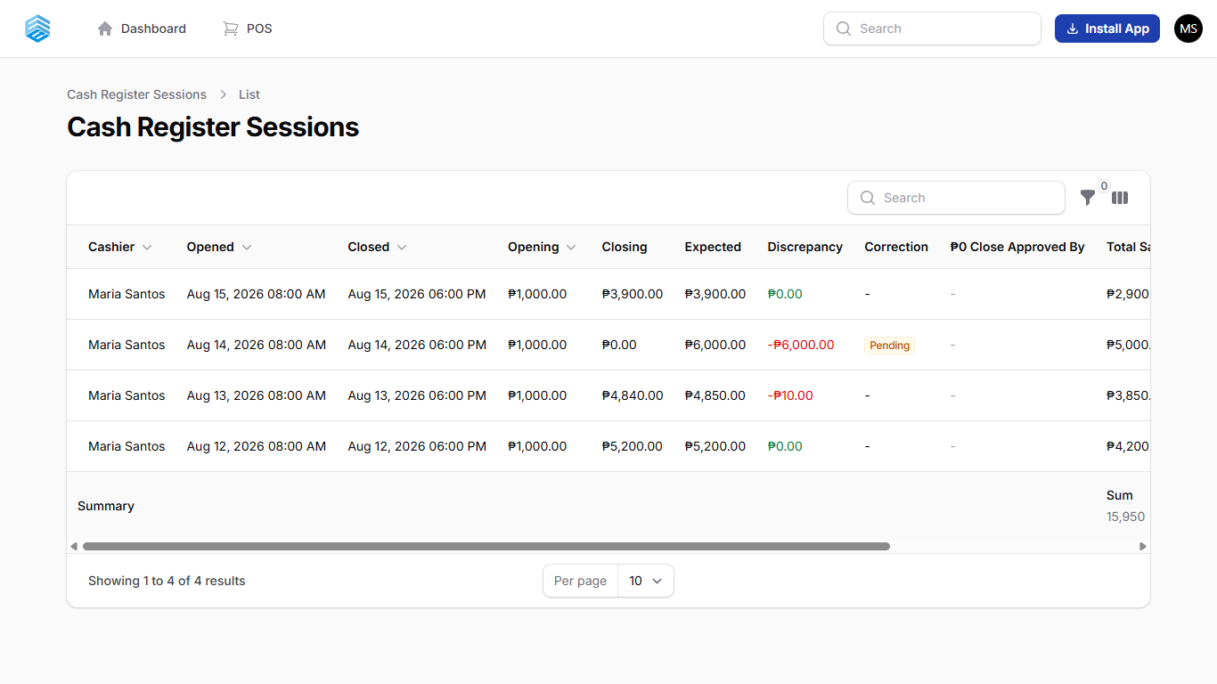

Part 2 — Manager: approve or reject
- Open Cash Register from the Home page. To see only sessions waiting for review, click the filter icon, tick Pending closing correction, and click Apply filters.
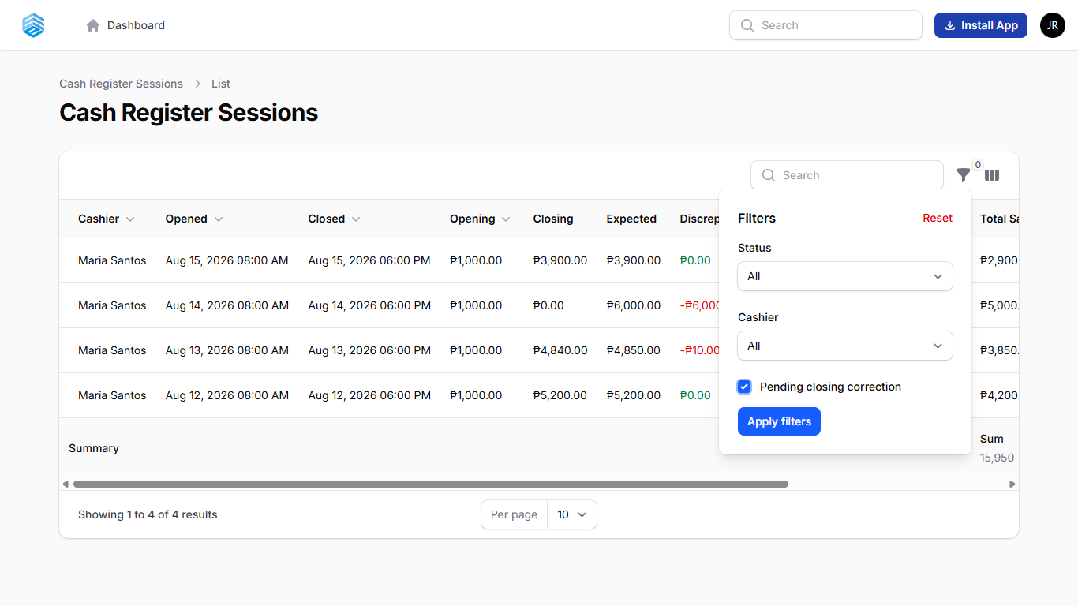
- Click the session, then click Approve Correction or Reject Correction. The approval box shows who asked, the old and new amounts, and their reason. Click Confirm to approve.
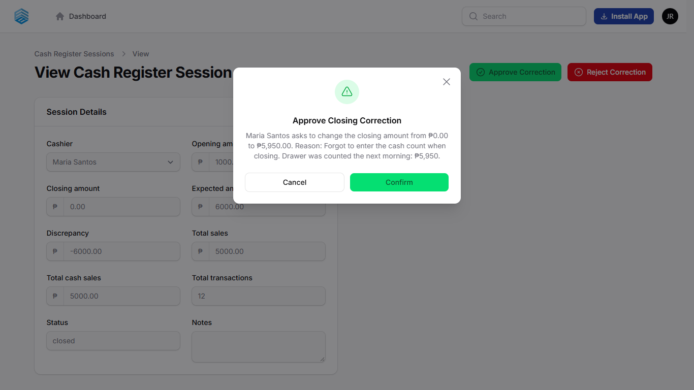
If you reject, you can enter a reason. The cashier can then submit a new request.
- After approval, the closing amount is replaced and the short/over is recalculated. Here Aug 14 now shows ₱5,950.00 closing and a ₱50.00 shortage instead of ₱6,000.00.
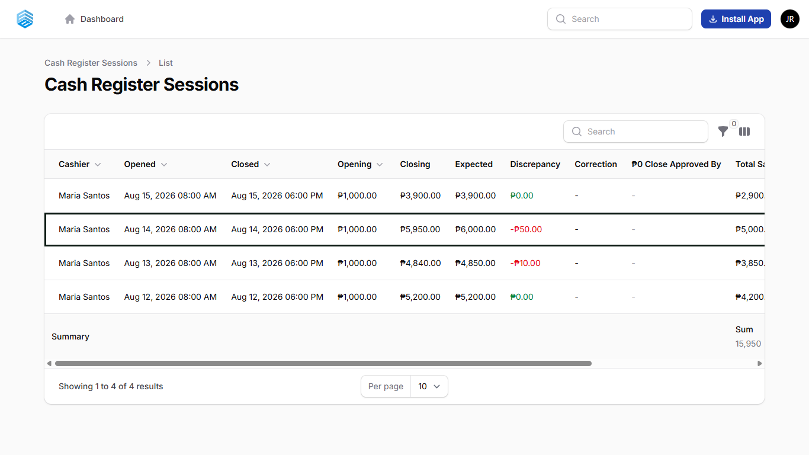

Good to know
- A session can have only one pending request at a time.
- When a manager requests a correction on any session, it is applied immediately with no approval step.
- The original amount, the new amount, who requested it and who approved it are all saved in the Audit Log.
- The expected amount and the closing date are never changed, only the counted cash and the short/over.

