Cash Advance Guide
Regular and Emergency cash advances in TOS
Updated: October 5, 2026 | System: tri-e.online

1. Cash Advance Rules
TOS now applies the company's cash advance (CA) policy automatically. Every CA is one of two types:
 | Regular | Emergency
When to use | Normal cash advance | Urgent needs (hospital, calamity, etc.)
Maximum amount | One cut-off's salary | One cut-off's salary × 8 cut-offs
How it is paid back | Deducted in full on the next payroll (one-time deduction) | Equal deductions over up to 2 months (8 weekly cut-offs)
Deduction per payroll | Whole amount | Amount ÷ 8, never more than one cut-off's salary
Salary per cut-off = daily rate × working days in the pay period. For weekly pay, that is daily rate × (7 − days off). Example: ₱500/day with Sunday off = ₱500 × 6 = ₱3,000 per week.

2. Before You Start: Employee Compensation
The limits are computed from the employee's compensation. Make sure each employee has a record under Payroll → Employee Compensation with the correct Daily Rate, Pay Period and Day(s) Off Per Week.
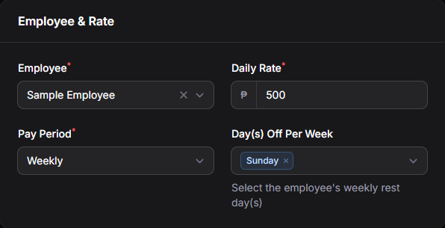
Figure 1. Employee Compensation: daily rate, pay period and days off
If an employee has no compensation record, the Cash Advance form still saves, but it cannot check the limit and shows a reminder to add one.

3. Creating a Regular Cash Advance
- Go to Payroll → Cash Advances and click New.
- Select the Employee. The form shows the employee's Limit for this employee.
- Leave Type as Regular.
- Enter the Amount. Deduction per Payroll fills in automatically with the same amount.
- Enter the Purpose (optional) and click Create.
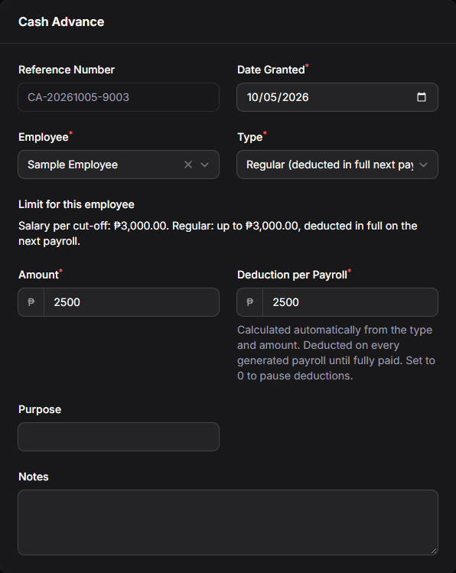
Figure 2. Regular CA of ₱2,500: the whole amount is deducted on the next payroll

If the amount is too high
A Regular CA cannot be more than one cut-off's salary. The form will not save and shows an error, suggesting the Emergency type for larger amounts.
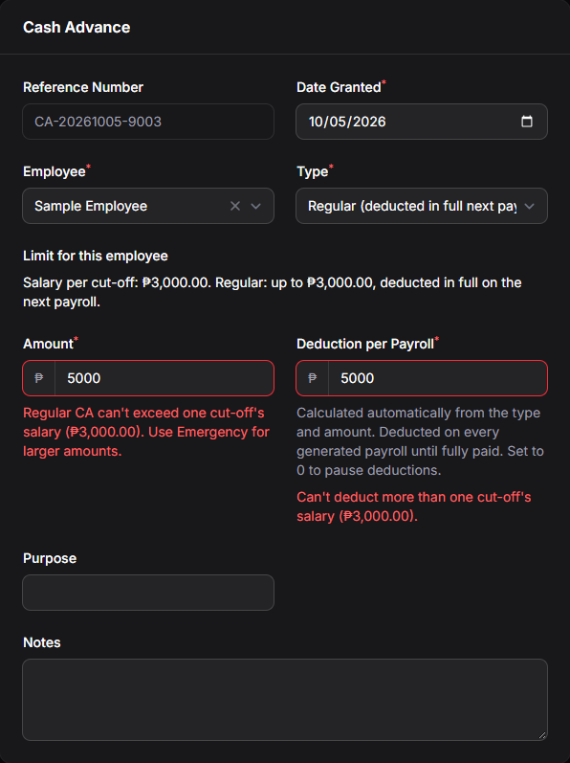
Figure 3. Regular CA of ₱5,000 is blocked because the weekly salary is ₱3,000

4. Creating an Emergency Cash Advance
- Go to Payroll → Cash Advances and click New.
- Select the Employee.
- Change Type to Emergency (up to 2 months).
- Enter the Amount. Deduction per Payroll is calculated automatically as equal payments over 8 cut-offs.
- Enter the Purpose (for example, “Hospital bill”) and click Create.
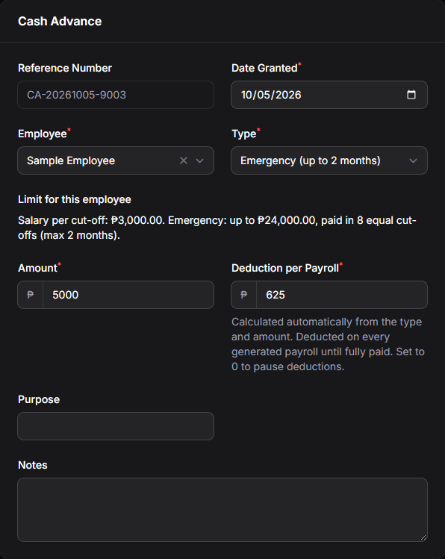
Figure 4. Emergency CA of ₱5,000: ₱625 deducted per cut-off for 8 cut-offs

5. Examples
Employee: ₱500/day, weekly pay, Sunday off → salary per cut-off ₱3,000.
Type | Amount | Allowed? | Deduction per payroll | Paid off in
Regular | ₱2,500 | Yes | ₱2,500 | 1 cut-off
Regular | ₱3,000 | Yes | ₱3,000 | 1 cut-off
Regular | ₱5,000 | No – use Emergency | – | –
Emergency | ₱5,000 | Yes | ₱625 | 8 cut-offs
Emergency | ₱12,000 | Yes | ₱1,500 | 8 cut-offs
Emergency | ₱24,000 | Yes (maximum) | ₱3,000 | 8 cut-offs
Emergency | ₱30,000 | No – over ₱24,000 | – | –

6. Tracking Cash Advances
The Cash Advances list shows every CA with its Type, amount, deduction per payroll, amount paid, Balance and Status (Outstanding or Fully Paid).
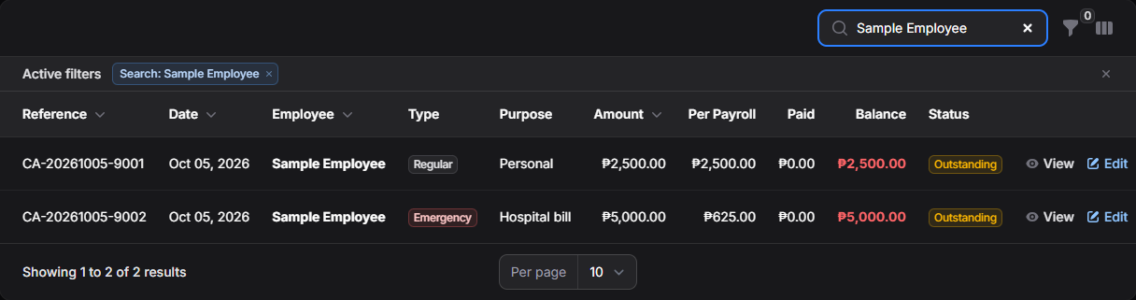
Figure 5. Cash Advances list with the new Type column

Repayments
Open a CA to see its repayment history. Deductions made by payroll are listed automatically. If the employee pays back in cash, click Record Repayment to enter it.
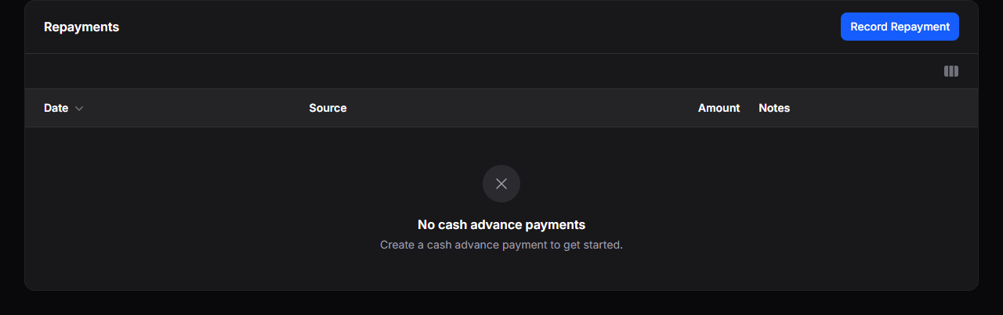
Figure 6. Repayments section of a cash advance

7. How Payroll Deducts Cash Advances
- Each payroll deducts the Deduction per Payroll of every outstanding CA, oldest first.
- The last deduction is reduced automatically to whatever balance is left.
- Deductions never make the payslip negative. If the salary for a cut-off is too low, the rest stays on the balance for the next payroll.
- Once the balance reaches zero, the CA shows Fully Paid and deductions stop.

8. Notes
- Existing cash advances created before this update are marked Regular, and their deductions are unchanged.
- Deduction per Payroll can still be edited by hand, but never above one cut-off's salary. Set it to 0 to pause deductions.
- Salary per cut-off is the gross pay (before deductions). Semi-monthly employees use 13 working days per cut-off and 4 cut-offs for Emergency.

