
UNEP Hotel Management System
User Guide
Reservations · Front Desk · Housekeeping & Maintenance · Inventory · Human Resources
Department of Hospitality & Tourism Management
University of Northeastern Philippines · Iriga City, Camarines Sur
Version 1.0 · October 2026
Contents
1. Introduction 4
1.1 Who should read what 4
2. Getting started 5
2.1 Signing in 5
2.2 Roles and what each one can open 5
2.3 The dashboard and menu 6
2.4 Messages, colours and signing out 7
2.5 Demo accounts (training copy only) 8
3. The public website 9
3.1 Home page and rooms 9
3.2 Virtual tour 10
3.3 Booking online 12
4. Front desk and reservations 14
4.1 Finding reservations 14
4.2 Creating a walk-in or phone reservation 14
4.3 Confirming an online booking (assigning a room) 15
4.4 Checking a guest in 16
4.5 The folio: charges and payments 16
4.6 Checking a guest out 17
4.7 Editing or cancelling a reservation 17
4.8 Guests 17
4.9 Room board and room types 18
5. Housekeeping and maintenance 21
5.1 Keeping room status up to date 21
5.2 Work orders 21
5.3 Reporting an issue 21
5.4 Working on and resolving a request 22
6. Inventory 24
6.1 Stock items 24
6.2 Receiving, issuing and recounting stock 25
6.3 Adding items and categories 26
7. Human resources 28
7.1 Employees 28
7.2 Departments 29
7.3 Shift roster 30
8. Administration 31
8.1 Staff accounts 31
9. Rules the system enforces 33
10. Troubleshooting 34
Appendix: status colours 34

If the page numbers above are not shown, right-click the table and choose Update Field.

1. Introduction
The UNEP Hotel Management System runs the day-to-day operations of the training hotel of the University of Northeastern Philippines Department of Hospitality & Tourism Management. It brings together five areas of work in one place:
- Reservations and front desk — bookings, room assignment, check-in, billing (the folio) and check-out.
- Housekeeping and maintenance — the live room board and work orders for repairs.
- Inventory — stock levels, deliveries, issues and low-stock alerts.
- Human resources — employee records, departments and the weekly shift roster.
- A public website — where guests view rooms, take a virtual tour and book online.

1.1 Who should read what
Each staff member only sees the parts of the system that match their role. Use this table to find the chapters that apply to you.
Your role | Read these chapters
Everyone | 2 Getting started, 9 Rules the system enforces, 10 Troubleshooting
Front Desk (agents, night auditors, HTM trainees) | 4 Front desk and reservations
Maintenance / Housekeeping | 5 Housekeeping and maintenance
Inventory (storekeeper) | 6 Inventory
Human Resources | 7 Human resources
Administrator | All chapters, especially 8 Administration
Guests and marketing staff | 3 The public website

2. Getting started

2.1 Signing in
The staff portal is reached from the Staff login link at the top-right of the public website, or directly at /login.
- Open the hotel website and click Staff login.
- Enter the email address and password given to you by the administrator.
- Tick Keep me signed in only on a computer that is not shared.
- Click Sign in. You are taken to your dashboard.
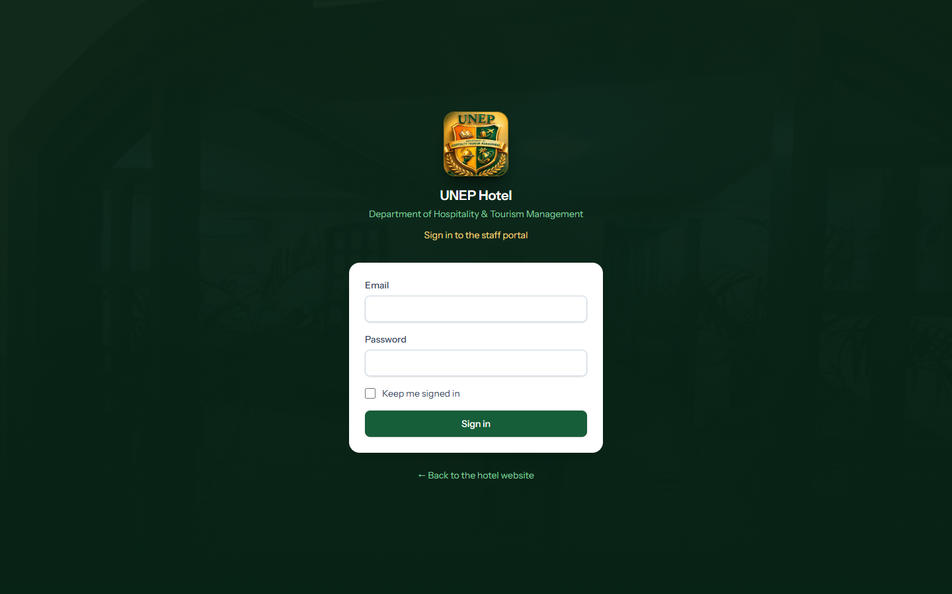
Figure 1. The staff login page
Important: If you see "These credentials do not match our records", check your email and password. After five wrong attempts you must wait one minute. Disabled accounts cannot sign in — ask the administrator.

2.2 Roles and what each one can open
Role | Modules in the menu
Admin | Everything: Front Office, Inventory, Maintenance, Human Resources and Staff Accounts
Front Desk | Reservations, Guests, Rooms (room board) and Room Types
Maintenance | Work Orders, plus the Rooms board to mark rooms clean or under repair
Inventory | Stock Items and Categories
Human Resources | Employees, Departments and Shift Roster

2.3 The dashboard and menu
After signing in you land on the Dashboard. The left-hand menu lists only the modules your role can use. The cards at the top give a summary of today; click any card link to jump to the details.
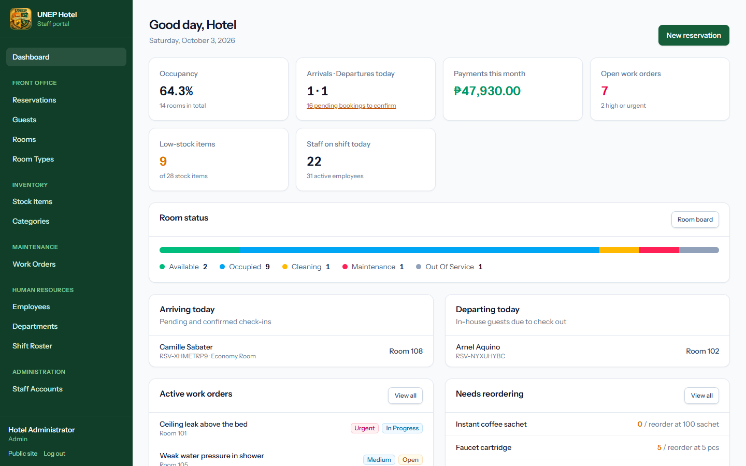
Figure 2. The administrator dashboard: occupancy, arrivals and departures, payments, work orders, low stock and staff on shift
Lower down, the dashboard shows the live room status bar, today's arrivals and departures, active work orders and items that need reordering.
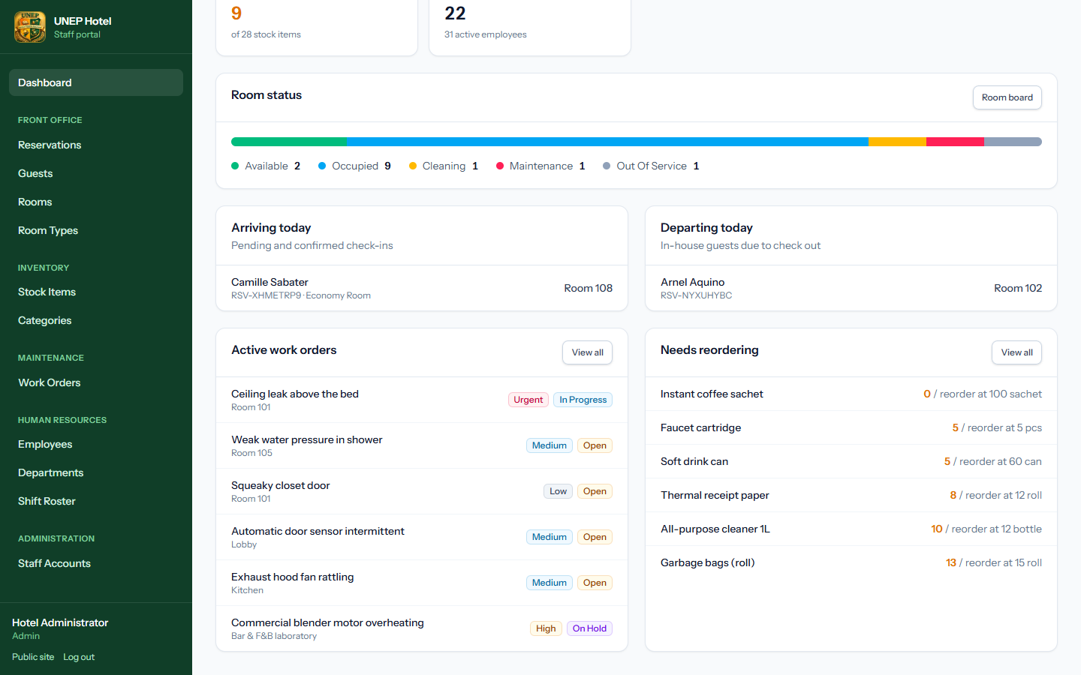
Figure 3. Lower part of the dashboard
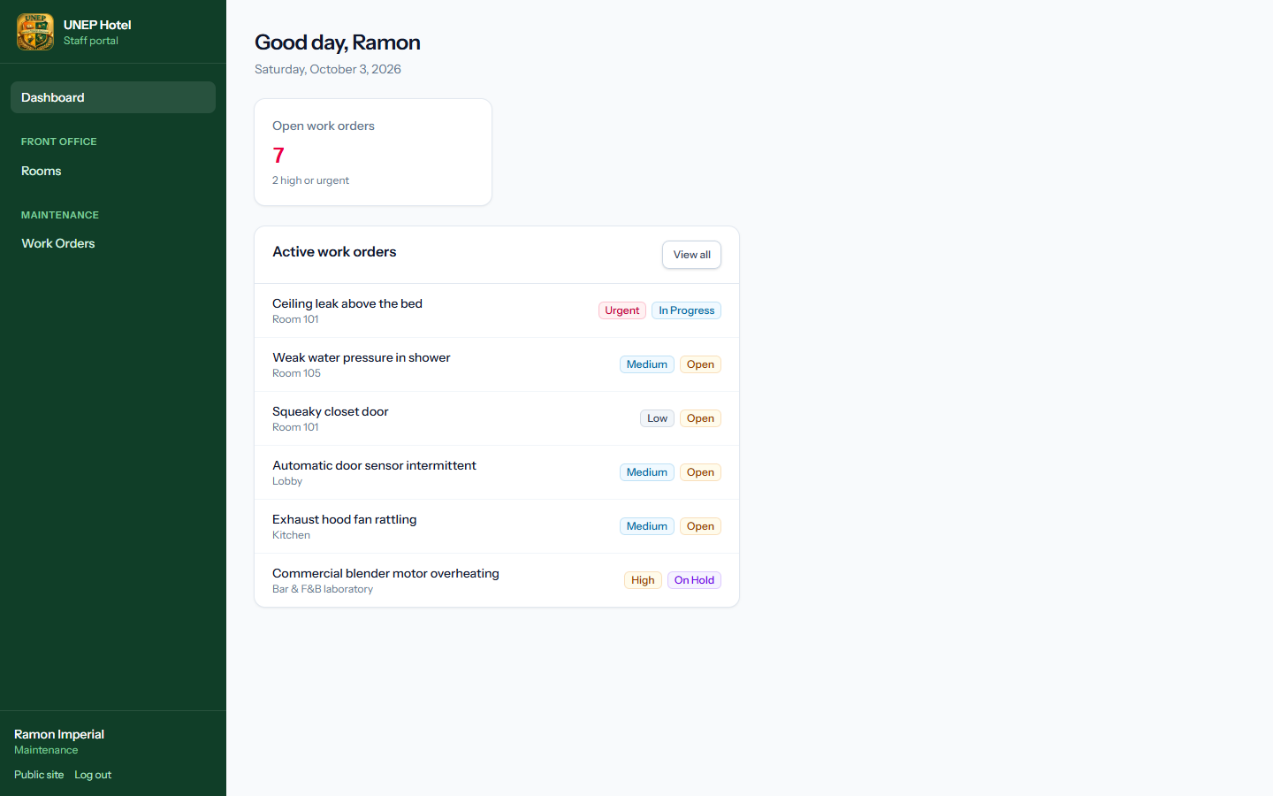
Figure 4. The same dashboard for a Maintenance user — only maintenance information and menu items are shown

2.4 Messages, colours and signing out
- A green message in the bottom-right corner confirms an action was saved. A red message explains why an action was refused.
- Red text under a form field explains what to correct before saving again.
- Coloured badges show statuses (see the Appendix for the full list).
- To finish, click Log out at the bottom of the left-hand menu.

2.5 Demo accounts (training copy only)
The training copy of the system comes with these demo logins. Every demo account uses the password password.
Email | Name | Role
admin@hotel.test | Hotel Administrator | Admin
frontdesk@hotel.test | Marites Obias | Front Desk (supervisor)
nightaudit@hotel.test | Jerome Volante | Front Desk (night auditor)
trainee@hotel.test | Princess Sabater | Front Desk (HTM student trainee)
maintenance@hotel.test | Ramon Imperial | Maintenance (chief engineer)
housekeeping@hotel.test | Liza Badiola | Maintenance (executive housekeeper)
inventory@hotel.test | Arnel Tria | Inventory (storekeeper)
hr@hotel.test | Rowena Nacional | Human Resources
inactive@hotel.test | Former Clerk | Disabled — cannot sign in
Important: Before the system is used with real guests, the administrator must change every demo password or delete the demo accounts (see chapter 8).

3. The public website
Guests use the public website to learn about the hotel and to book a stay. No account is needed.

3.1 Home page and rooms
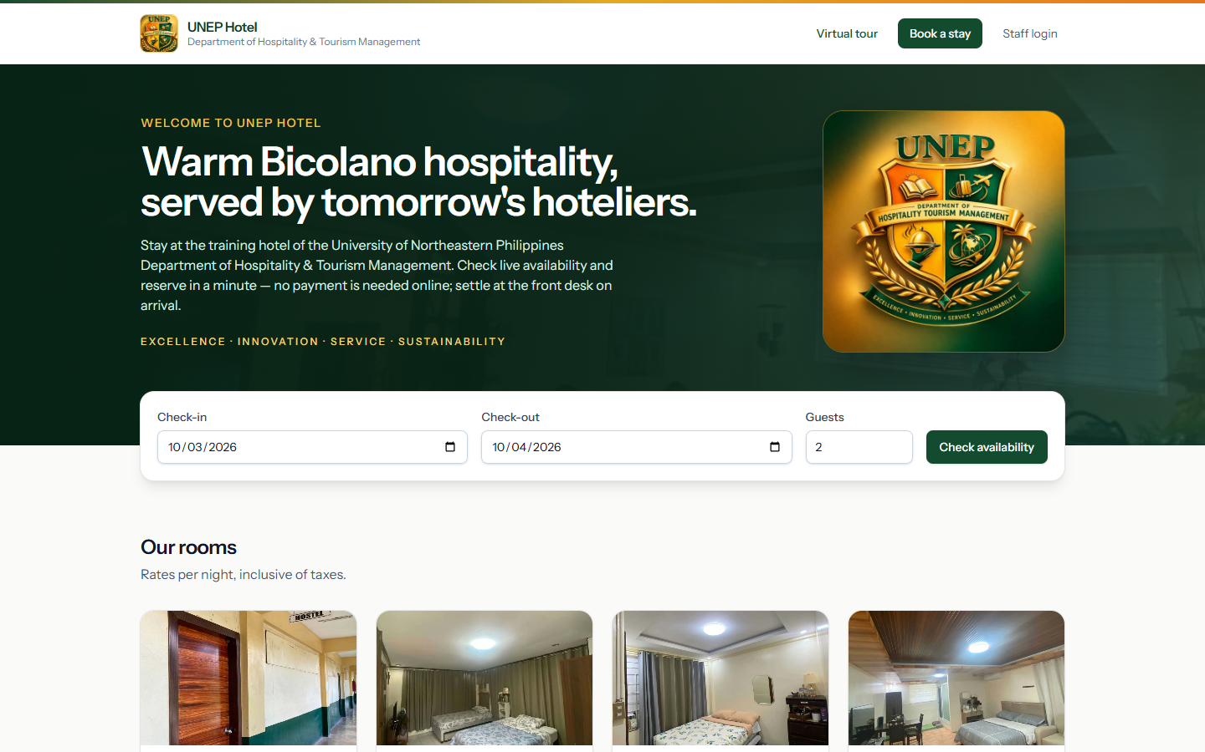
Figure 5. The home page with the availability search box
Under the search box guests see every room type with its photo, nightly rate, capacity and amenities. Walk through this room opens the virtual tour at that room.
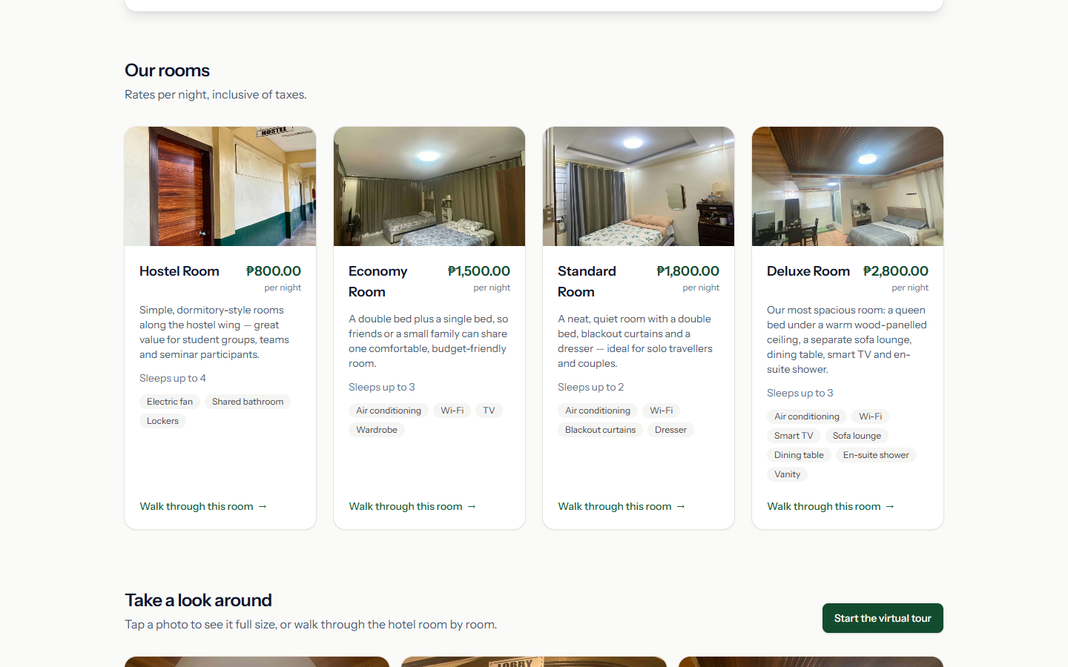
Figure 6. Room types with rates and amenities
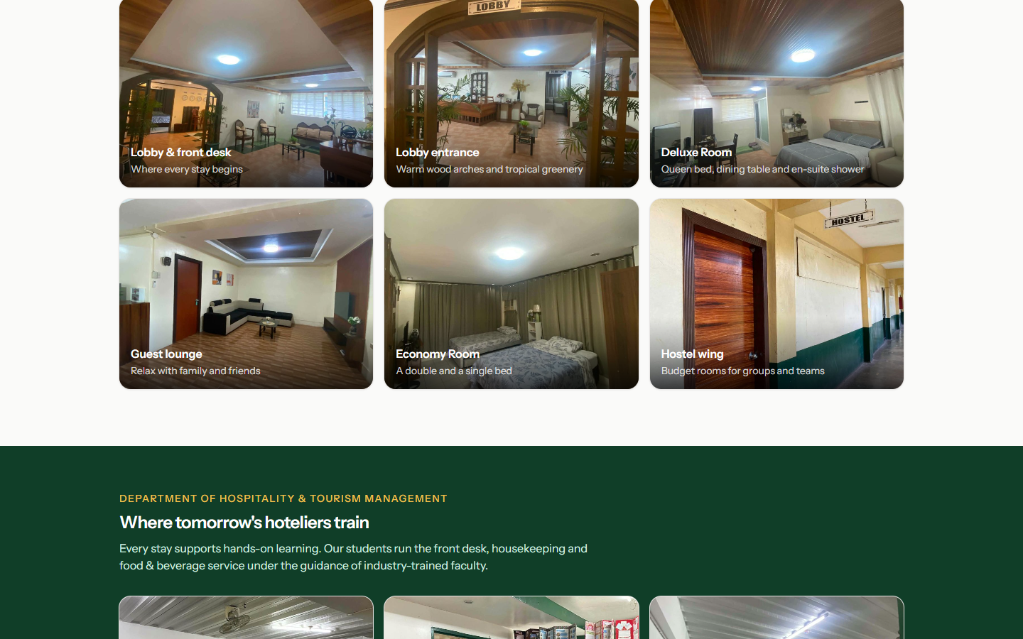
Figure 7. Photo gallery — click any photo to view it full size

3.2 Virtual tour
The virtual tour lets guests walk through the hotel from their browser.
- Drag the picture to look around. Use Ctrl + mouse wheel or pinch to zoom.
- Click a labelled door (for example "Economy Room →") to walk into the next area.
- Hover or tap a gold dot to see what it is (bed, shower, front desk…).
- Use the list on the right to jump straight to any room or training facility. The button at the bottom-right switches to full screen.
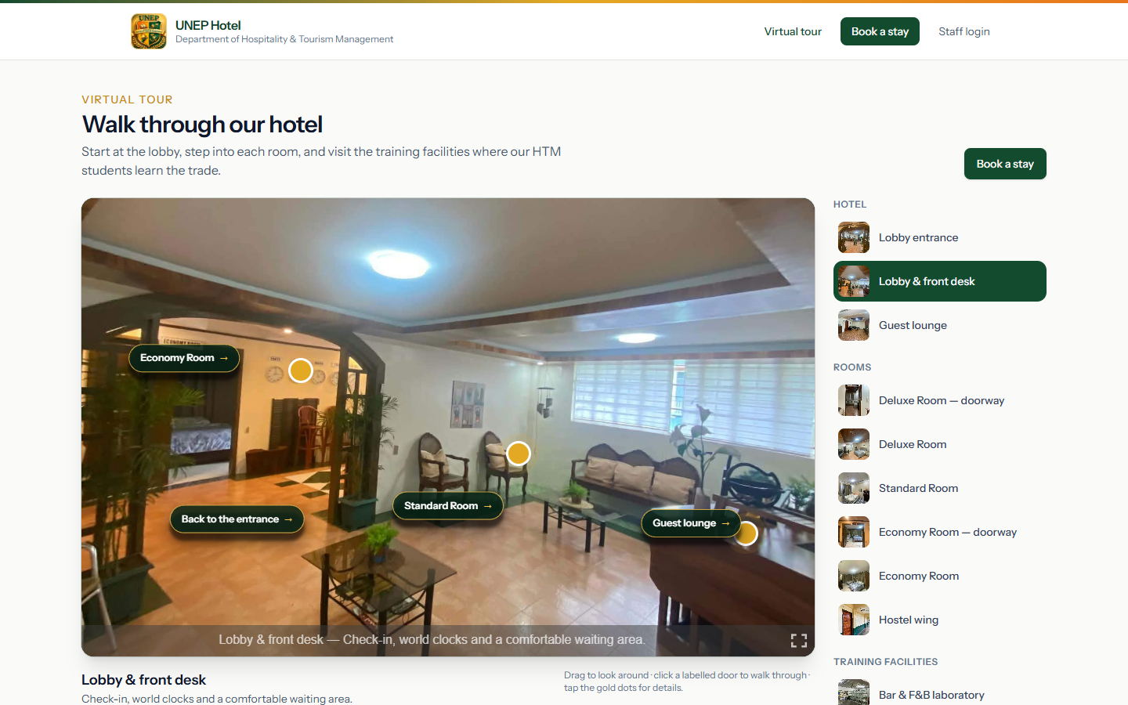
Figure 8. Virtual tour — the lobby, with labelled doors and gold information dots
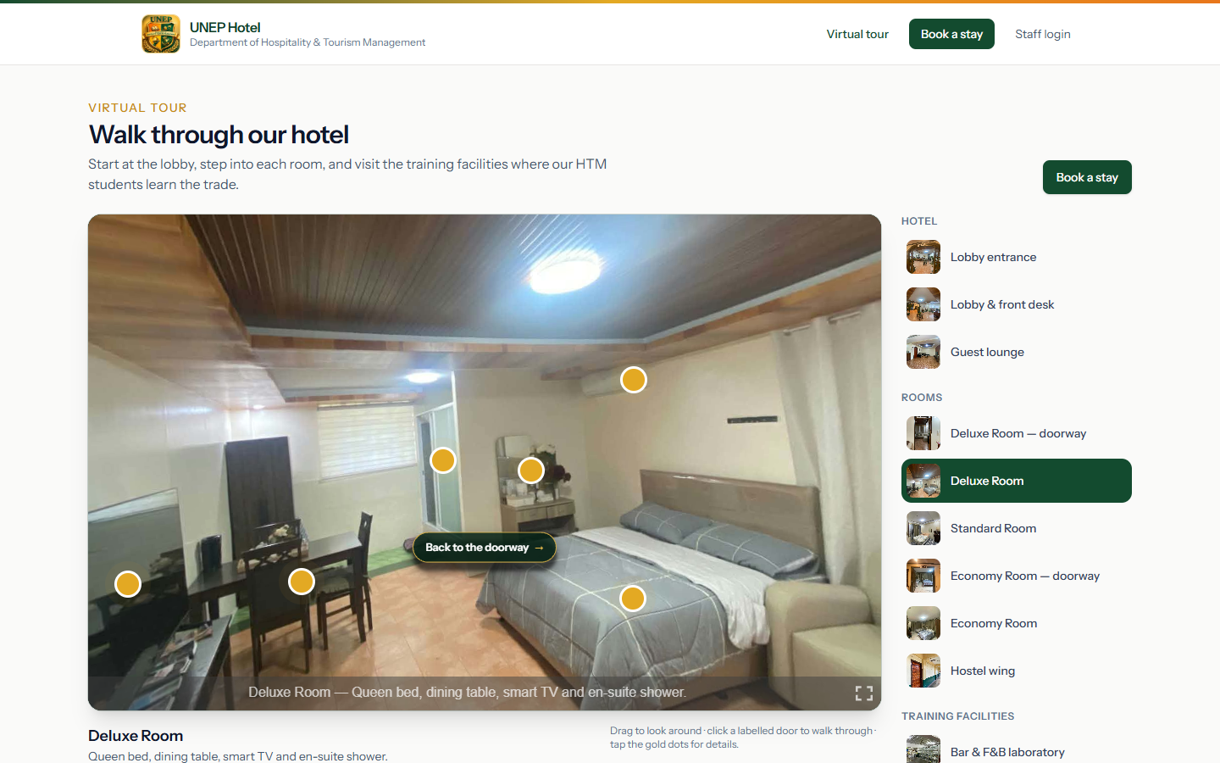
Figure 9. Virtual tour — inside the Deluxe Room

3.3 Booking online
- On the home page or Book a stay, choose the check-in and check-out dates and the number of guests, then click Check availability.
- The results list only the room types that are free for those dates and can fit the party. Click Select on the room you want.
- Fill in your name, email and mobile number, the number of adults and children, and any special requests.
- Click Reserve now. The confirmation page shows your booking reference (for example RSV-PKIOTSFC). Keep it for check-in.
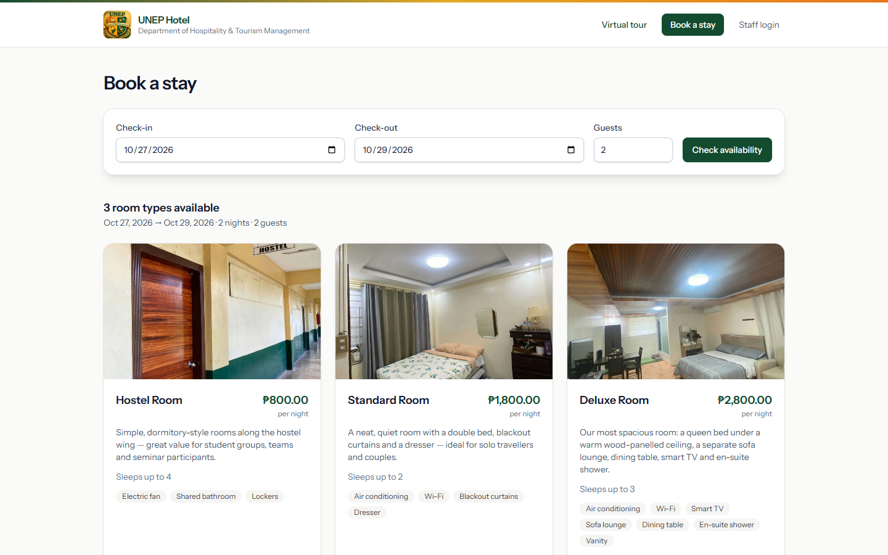
Figure 10. Availability results for the chosen dates
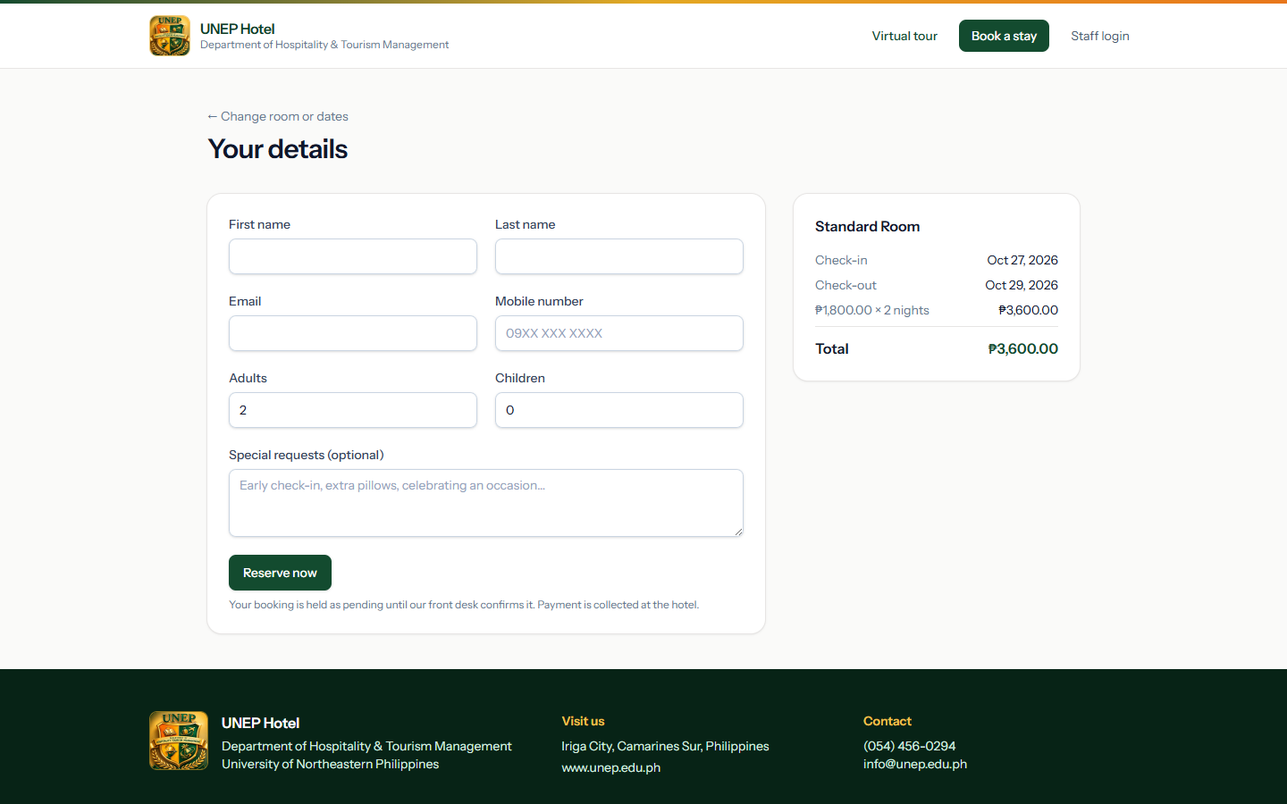
Figure 11. Guest details form with the price summary
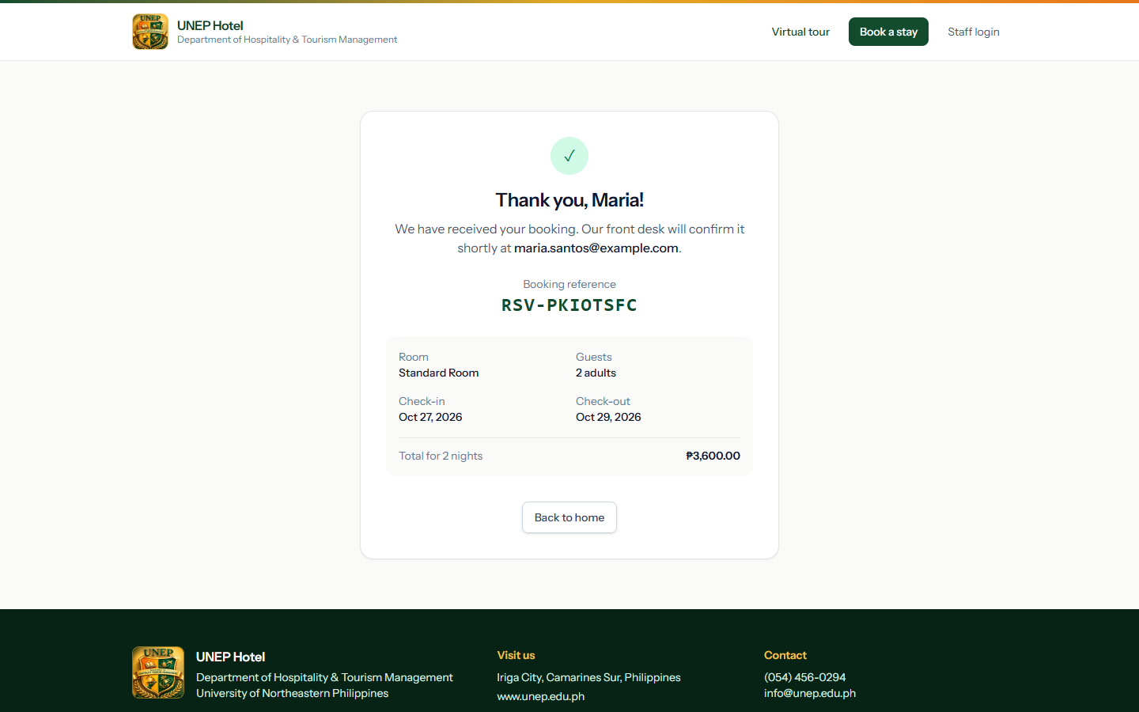
Figure 12. Booking confirmation with the booking reference
Note: Online bookings are held as Pending until the front desk assigns a room. No payment is taken online — the guest settles at the front desk.

4. Front desk and reservations
This chapter is for Front Desk staff and administrators. It follows a guest from booking to check-out.

4.1 Finding reservations
Open Reservations in the menu. Use the search box (booking code or guest name), the status filter, or the date filter to show everyone staying on a given night.
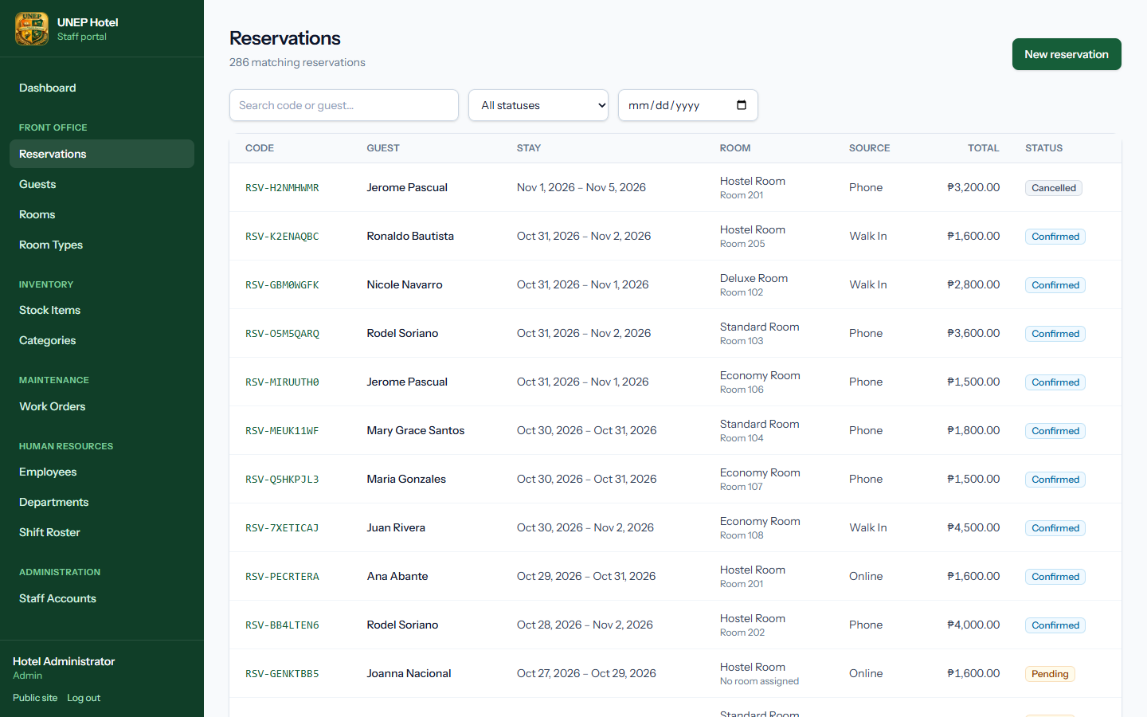
Figure 13. The reservations list with search and filters

4.2 Creating a walk-in or phone reservation
- Click New reservation (on the dashboard or the Reservations page).
- Enter the guest's first name, last name, email and phone. To book a returning guest, open their profile under Guests and click New reservation there instead — their details are filled in for you.
- Choose the room type, the check-in and check-out dates, and the number of adults and children. The price is calculated as you type.
- Choose the booking source (Walk In or Phone) and click Create reservation.
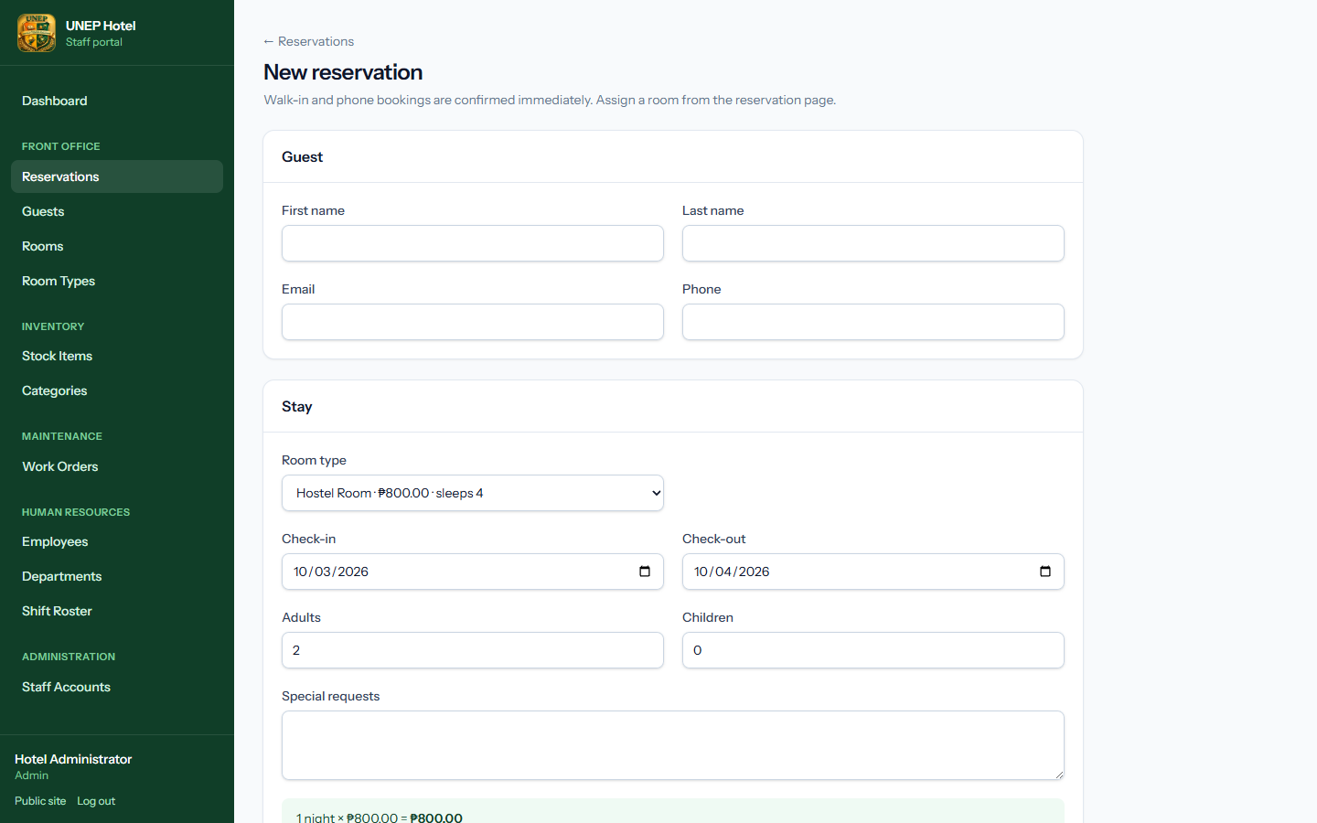
Figure 14. New reservation form with live price estimate
Note: The system refuses the booking if no room of that type is free for the whole stay, or if there are more guests than the room sleeps.

4.3 Confirming an online booking (assigning a room)
Online bookings arrive as Pending and appear on the dashboard as "pending bookings to confirm". To confirm one:
- Open the reservation from the dashboard link or the Reservations list (filter Status = Pending).
- In the Room panel on the right, pick a free room from the list.
- Click Assign & confirm. The status changes to Confirmed.
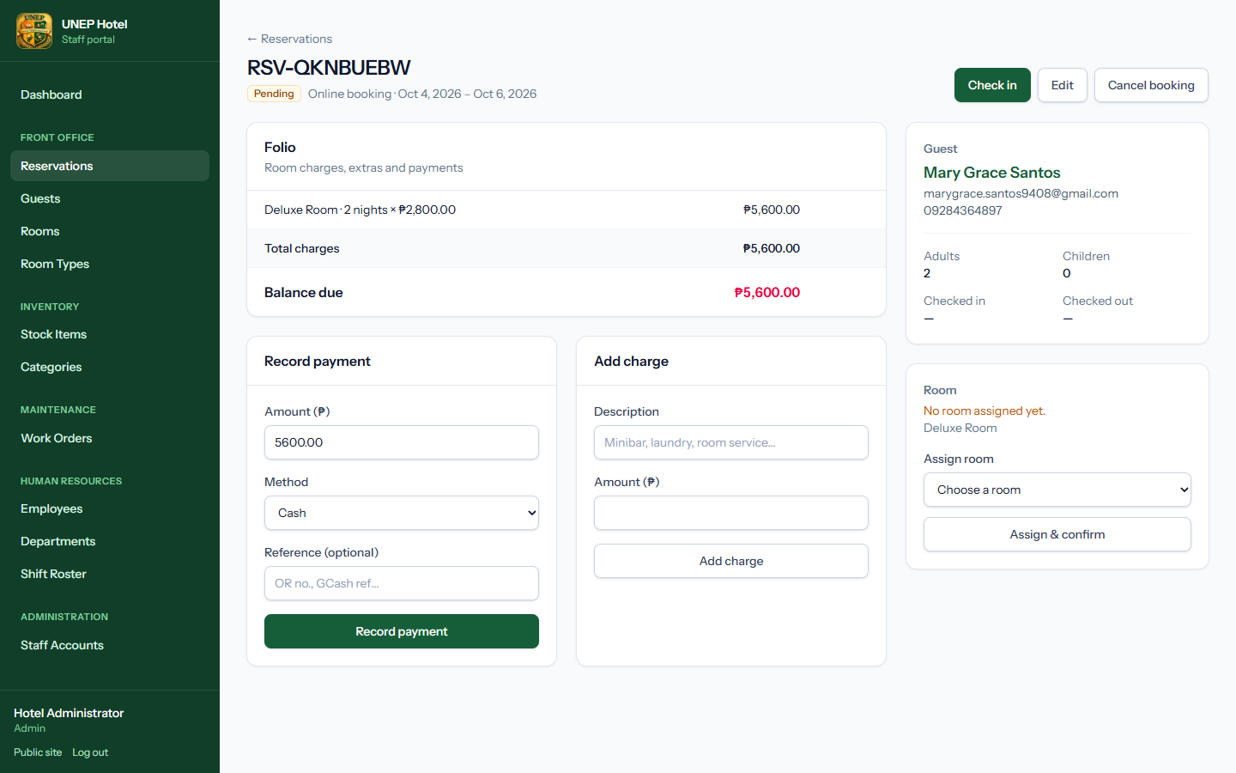
Figure 15. A pending online booking waiting for a room

4.4 Checking a guest in
- Open the reservation and make sure a room is assigned.
- Check the room badge shows Available. If it shows Cleaning, ask housekeeping to mark it clean first (chapter 5).
- Click Check in. The reservation becomes Checked In and the room becomes Occupied.
Tip: Check-in is refused if the stay starts on a later date, if the room is not ready, or if the stay has already ended (a no-show). For a no-show, edit the dates or cancel the booking.

4.5 The folio: charges and payments
The Folio on the reservation page lists the room charge, any extra charges, all payments and the Balance due.
- Add charge — enter a description (Minibar, Laundry, Late check-out…) and the amount.
- Record payment — enter the amount, choose Cash, Card, GCash or Bank Transfer, and add the OR number or reference. The amount is pre-filled with the balance.
- Use Remove or Void to undo a charge or payment entered by mistake. This is only possible while the stay is open.
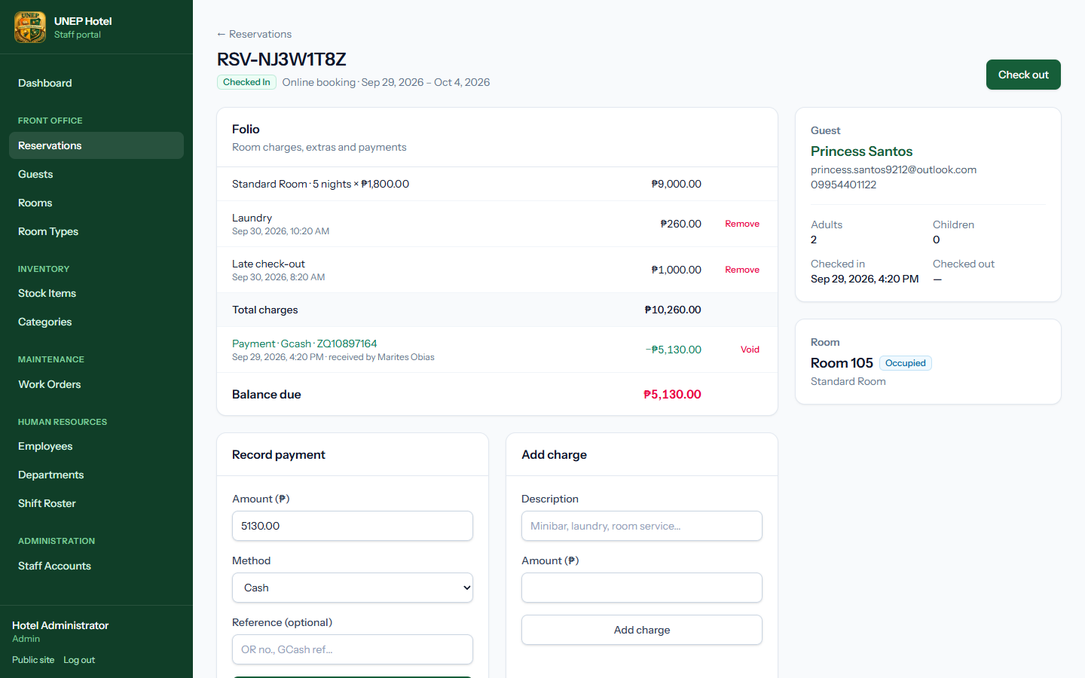
Figure 16. A checked-in reservation with its folio, payment and charge forms

4.6 Checking a guest out
- Open the reservation and make sure the Balance due is ₱0.00. Record any remaining payment first.
- Click Check out and confirm.
- The reservation becomes Checked Out and the room is sent to Cleaning for housekeeping.
Important: Check-out is refused while any balance remains. After check-out the folio is locked and can no longer be changed.

4.7 Editing or cancelling a reservation
- Edit (Pending or Confirmed only) changes dates, room type, room or party size. The total is recalculated automatically.
- Cancel booking (Pending or Confirmed only) releases the room for other guests.

4.8 Guests
Guests lists every guest profile. Open a profile to see contact details, ID information and the full stay history.
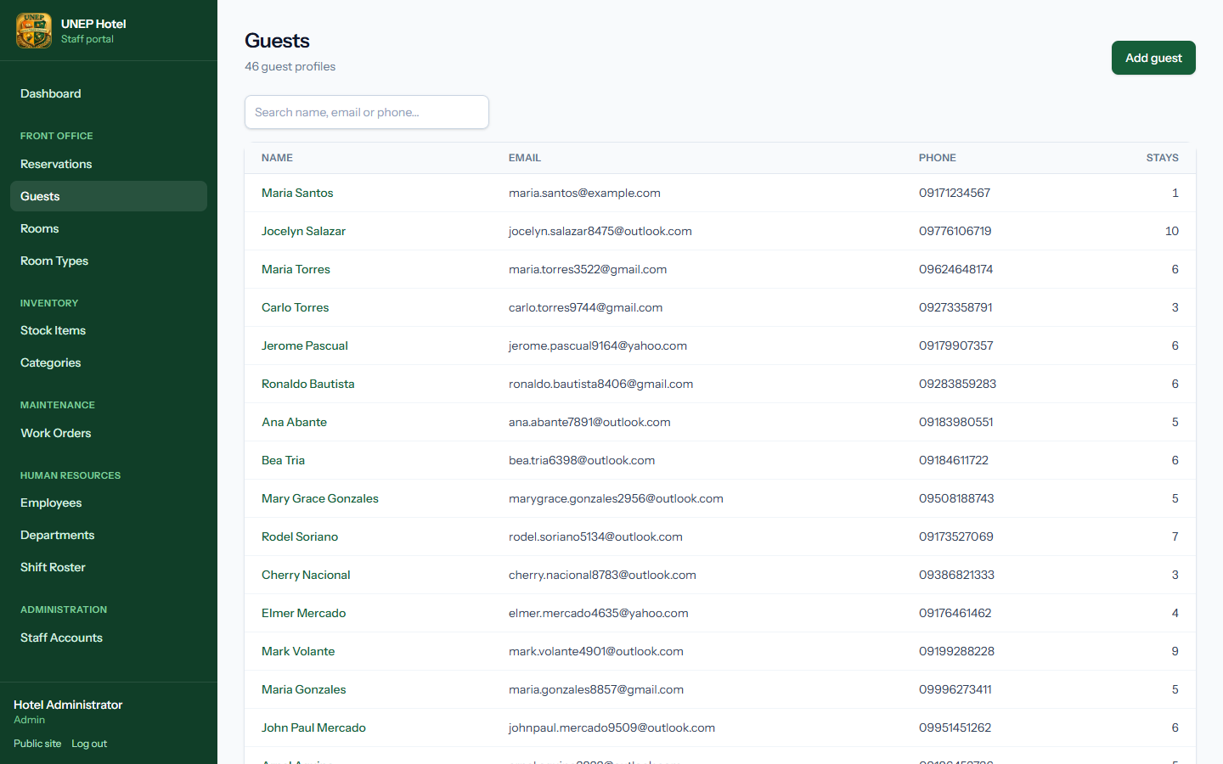
Figure 17. The guest list with search
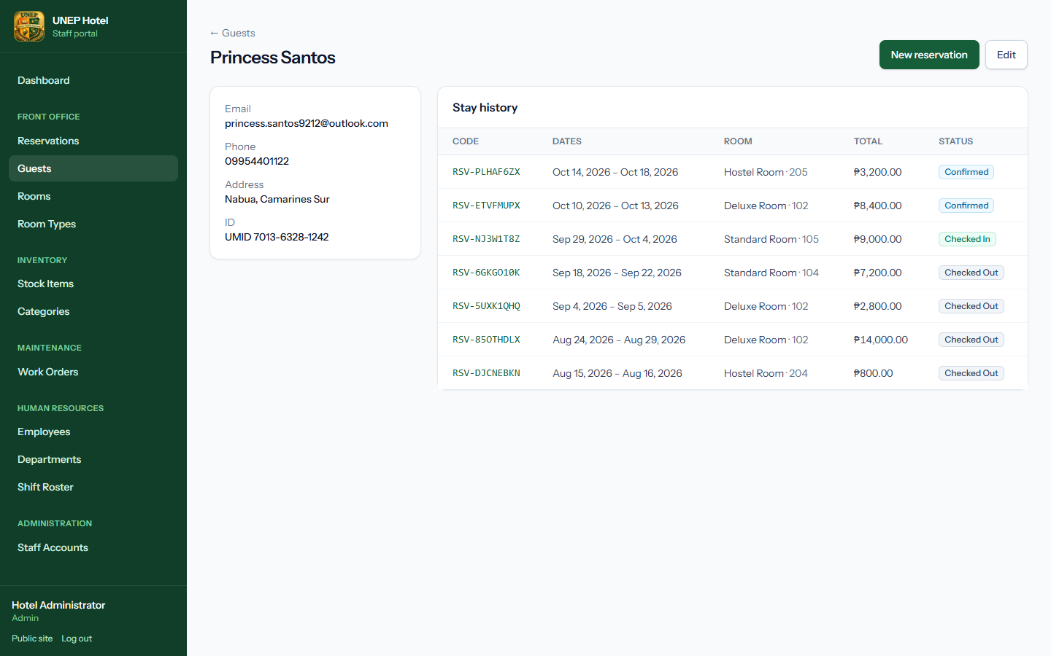
Figure 18. A guest profile with stay history

4.9 Room board and room types
Rooms shows every room by floor with its live status. Quick buttons let you mark a room clean, send it for cleaning or return it to service. Report issue opens a maintenance work order for that room.
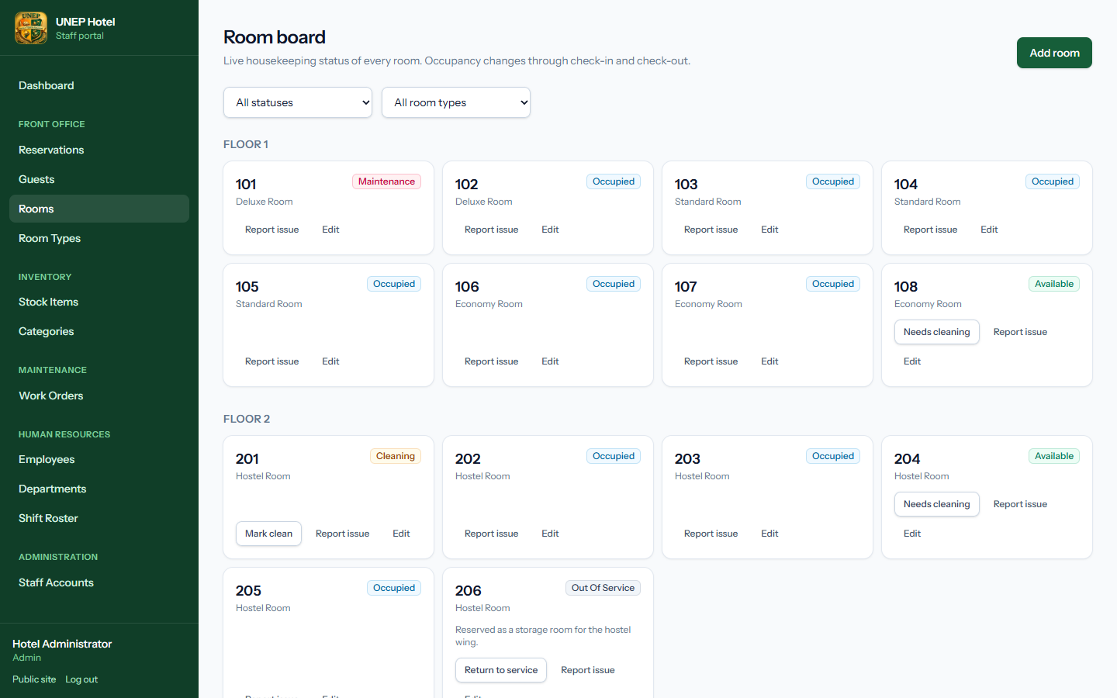
Figure 19. The room board
Room Types sets the name, nightly rate, capacity, amenities and photo shown on the public website.
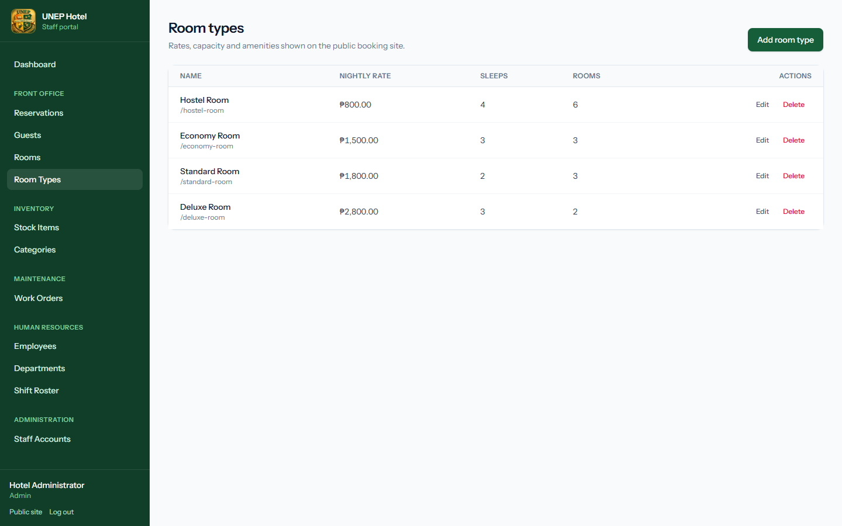
Figure 20. Room types
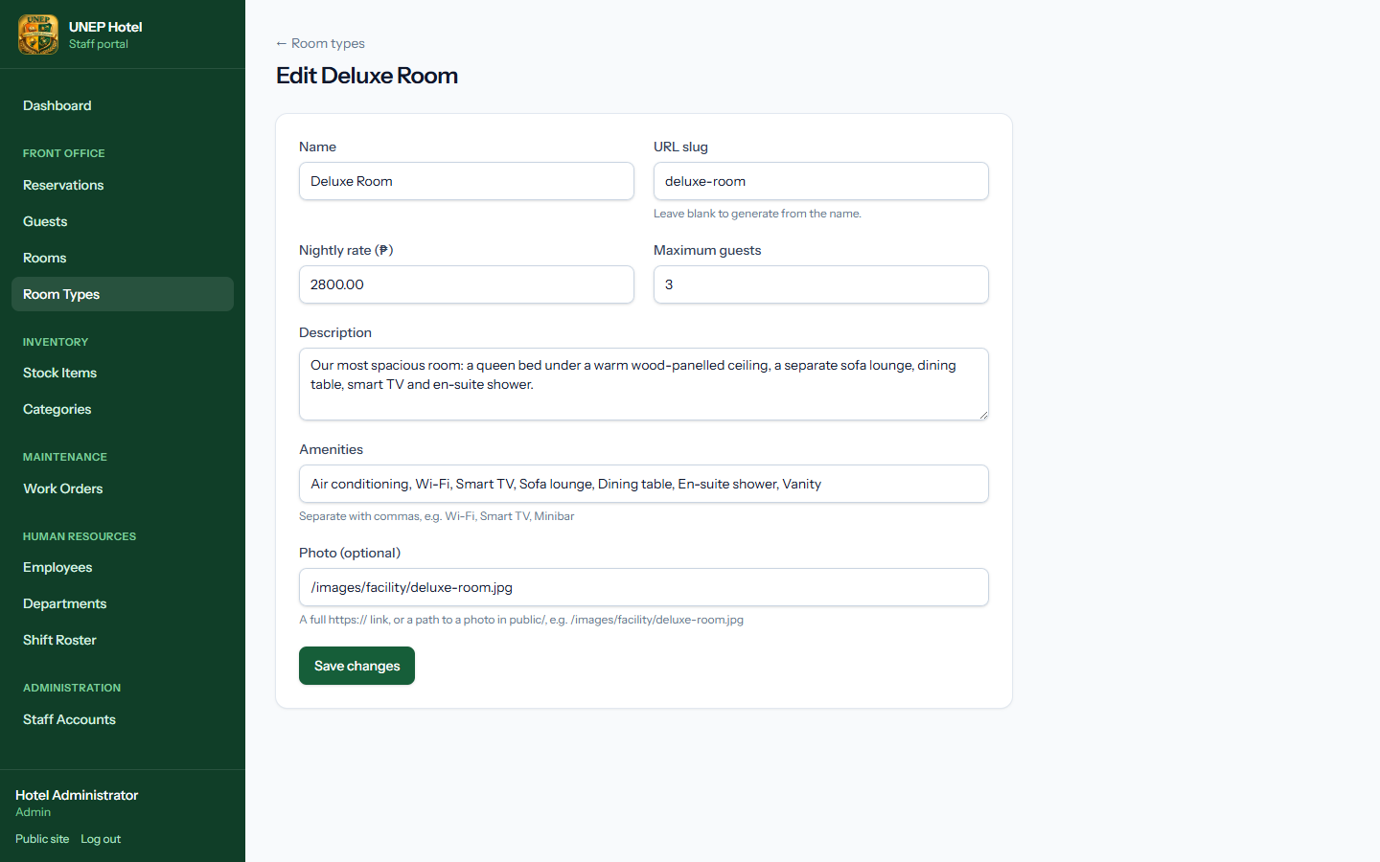
Figure 21. Editing a room type
Note: A room becomes Occupied only through check-in. You cannot change the type of a room that has upcoming bookings assigned to it.

5. Housekeeping and maintenance
This chapter is for Maintenance and Housekeeping staff. Maintenance users see the Rooms board and Work Orders.

5.1 Keeping room status up to date
- Open Rooms. Rooms that guests have just left show Cleaning.
- When a room has been cleaned and inspected, click Mark clean. It becomes Available and can be checked in.
- Use Needs cleaning or Return to service as required.

5.2 Work orders
Work Orders lists every maintenance request. Open requests are shown first, the most urgent at the top. Filter by status or priority.
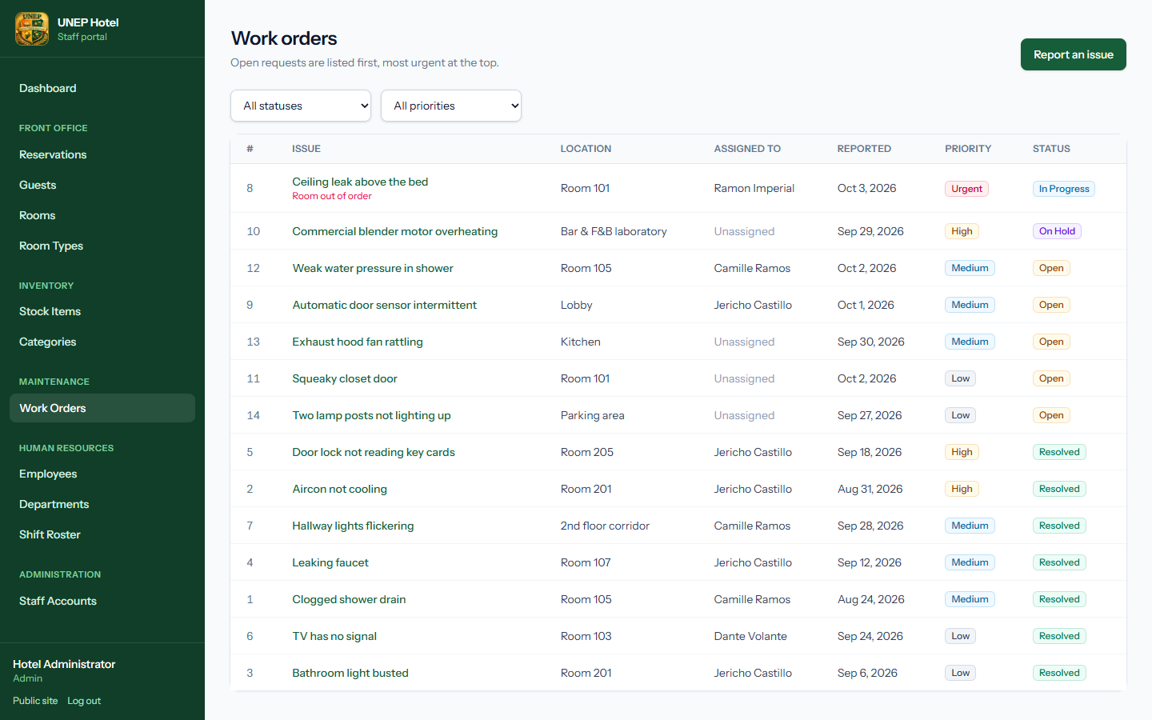
Figure 22. The work order list

5.3 Reporting an issue
- Click Report an issue (or Report issue on a room card on the room board).
- Describe the problem in What's wrong?, then choose the room — or type another location such as Lobby or Kitchen.
- Set the priority and, if known, assign a technician.
- Tick Take the room out of order if guests must not use the room until it is fixed. The room status changes to Maintenance automatically.
- Click Submit work order.
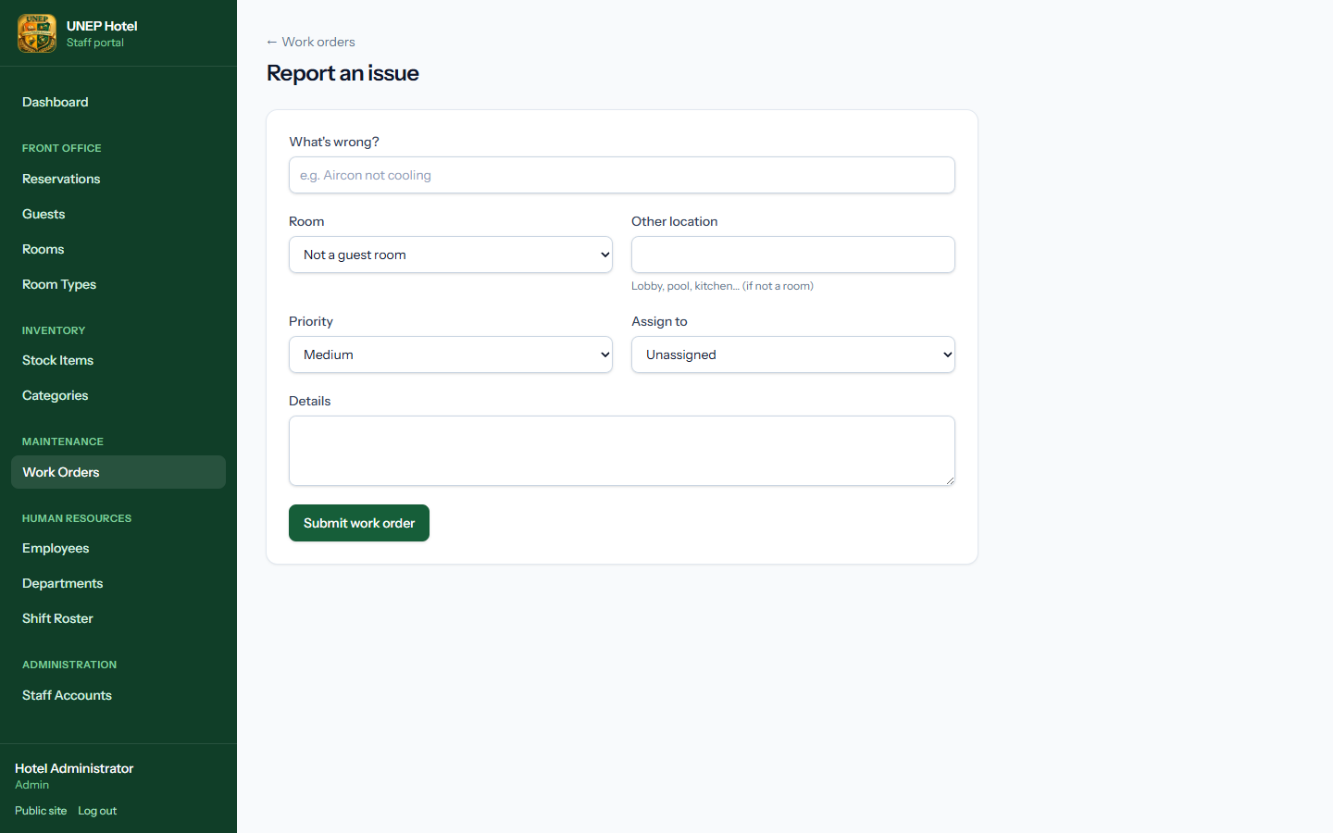
Figure 23. Reporting a new issue

5.4 Working on and resolving a request
Open a work order to see its details, who reported it and who is assigned. Use Issue part to take spare parts from inventory — the stock level is reduced automatically and the part is recorded on the job.
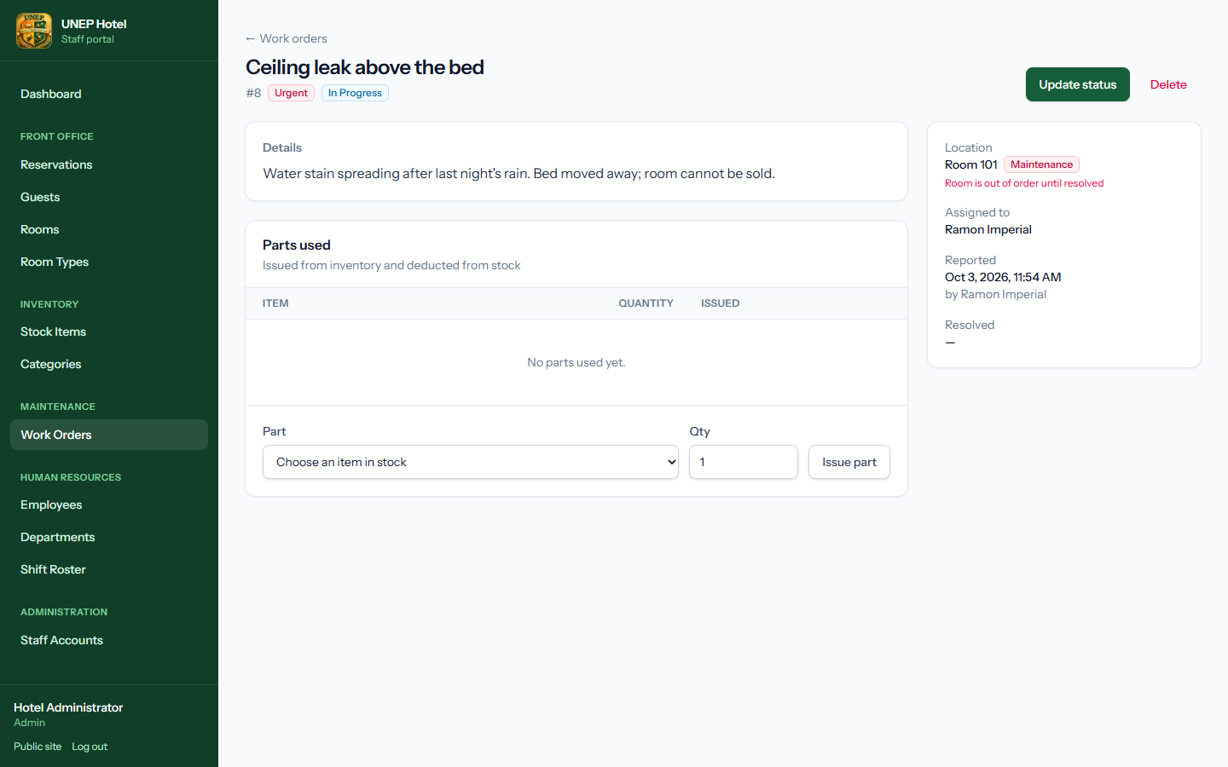
Figure 24. A work order with the parts used
- Click Update status.
- Change the status to In Progress, On Hold, Resolved or Cancelled.
- When resolving, describe what was done in Resolution notes.
- Click Save changes. When the last open request for a room is closed, the room returns to Available automatically.
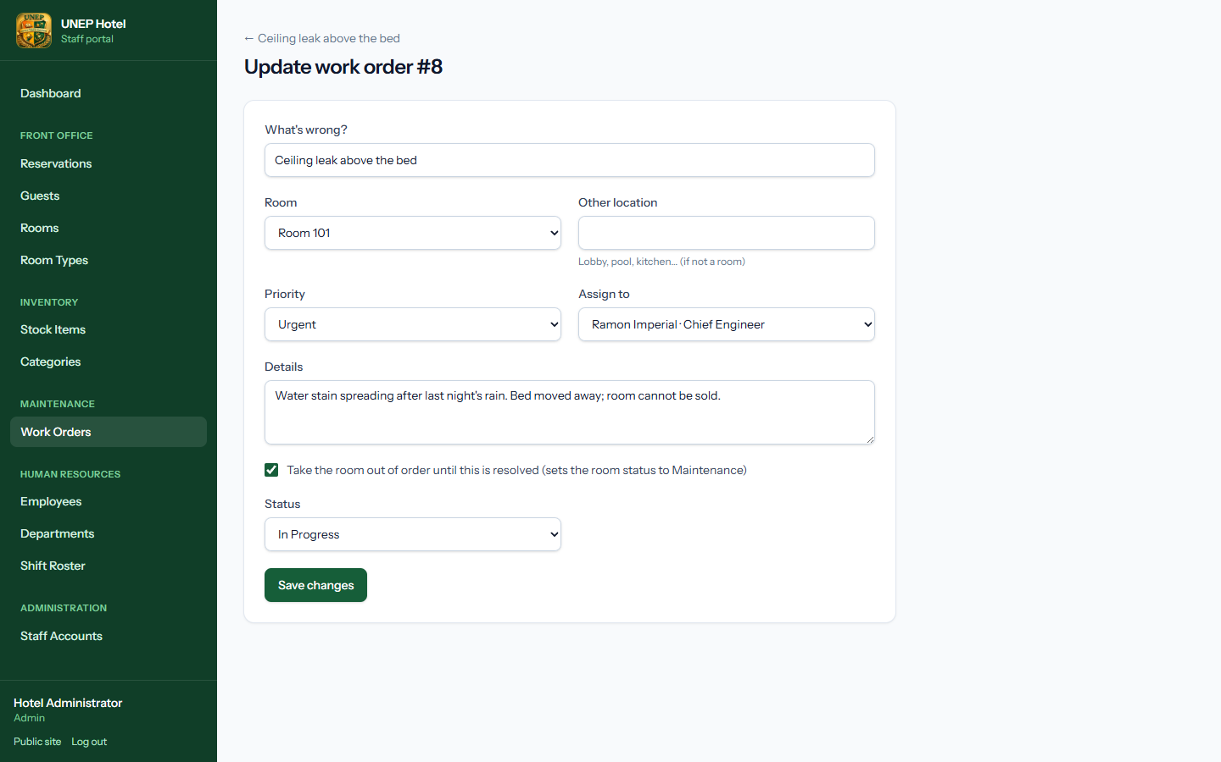
Figure 25. Updating the status of a work order

6. Inventory
This chapter is for the storekeeper and administrators.
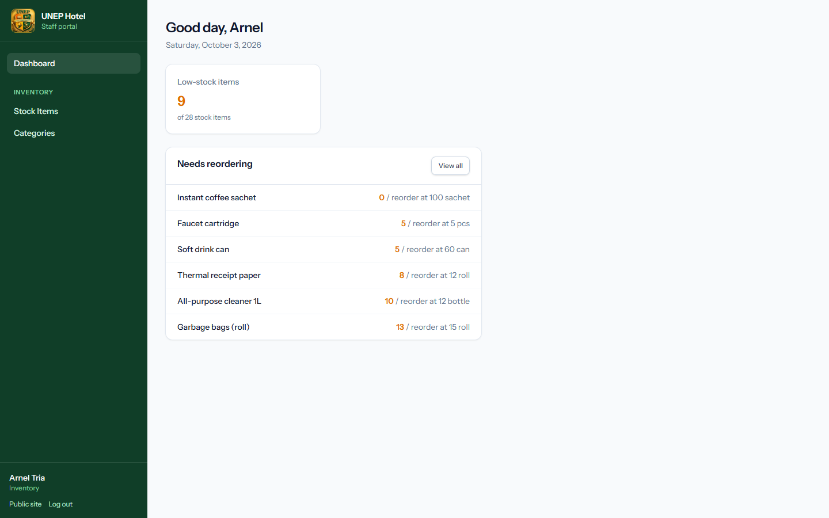
Figure 26. The Inventory user's dashboard with low-stock alerts

6.1 Stock items
Stock Items lists every item with its quantity on hand, reorder level, unit cost and stock value. Items at or below their reorder level are marked Low. Tick Low stock only to see what needs ordering.
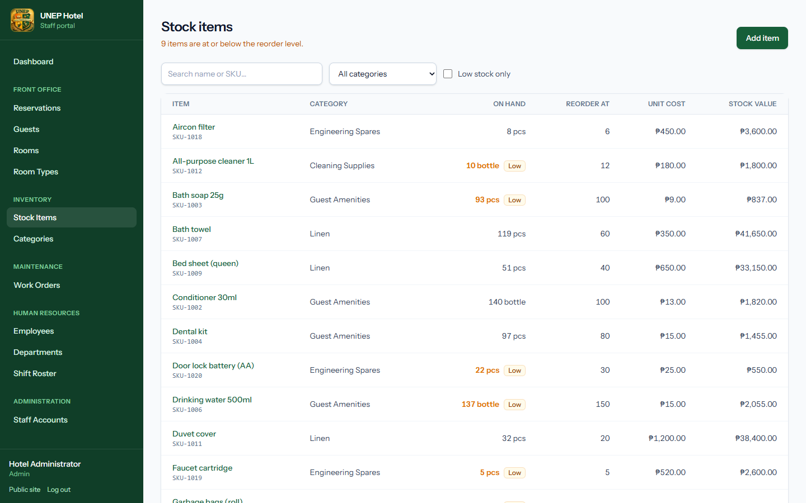
Figure 27. Stock items with low-stock flags

6.2 Receiving, issuing and recounting stock
Quantities only change through stock movements, so there is always a full history. Open an item and use Update stock:
Movement | When to use it | Quantity to enter
In | A delivery arrives | The quantity received
Out | Stock is issued to housekeeping, the bar or a department | The quantity issued
Adjustment | After a physical count | The counted quantity on hand — the system records the difference
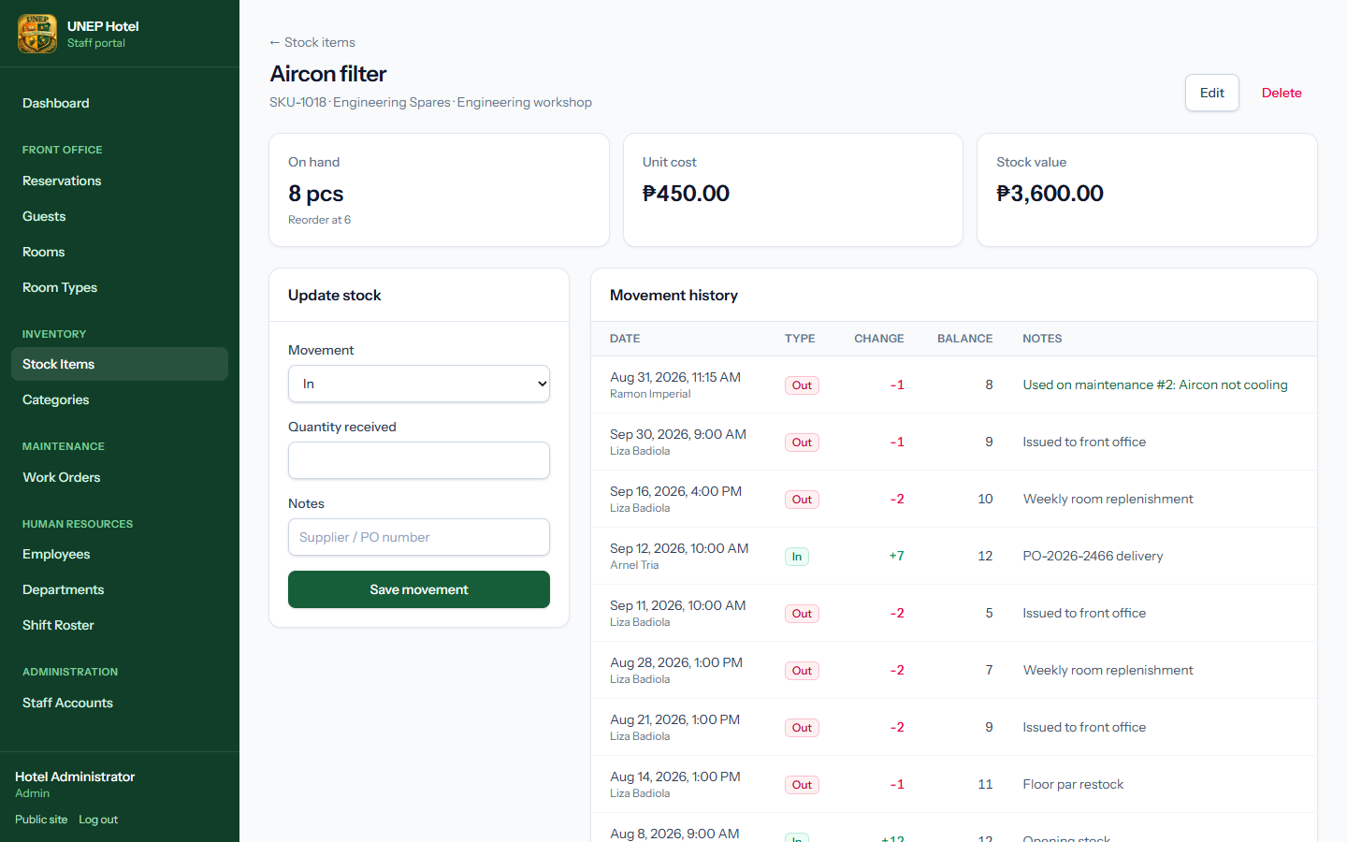
Figure 28. An item with its movement history, including parts used on maintenance
Note: The system refuses to issue more than is on hand. Items that were used on maintenance work orders cannot be deleted, so their history is kept.

6.3 Adding items and categories
Click Add item, fill in the name, SKU, category, unit, reorder level and unit cost, and an optional opening quantity (recorded as the first stock-in). Manage categories under Categories.
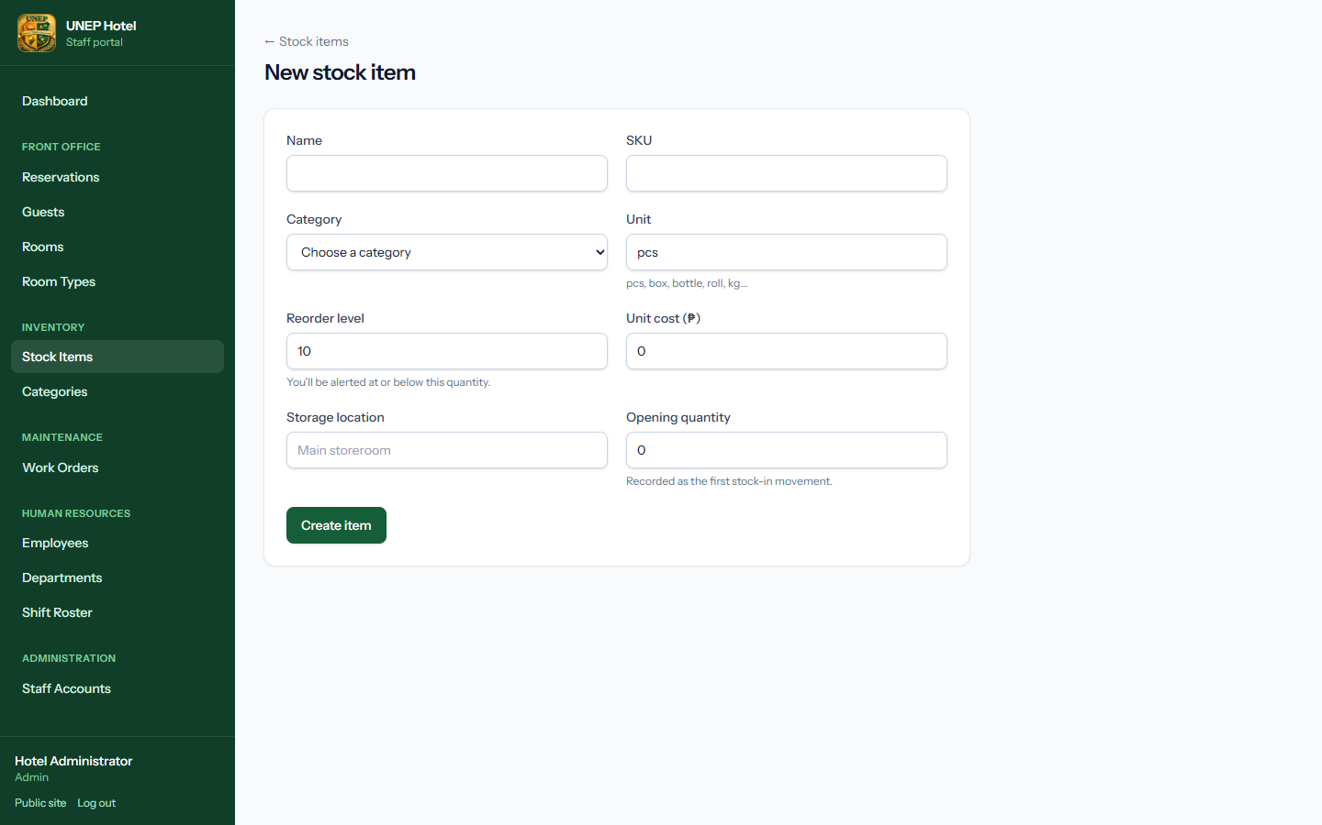
Figure 29. Adding a stock item
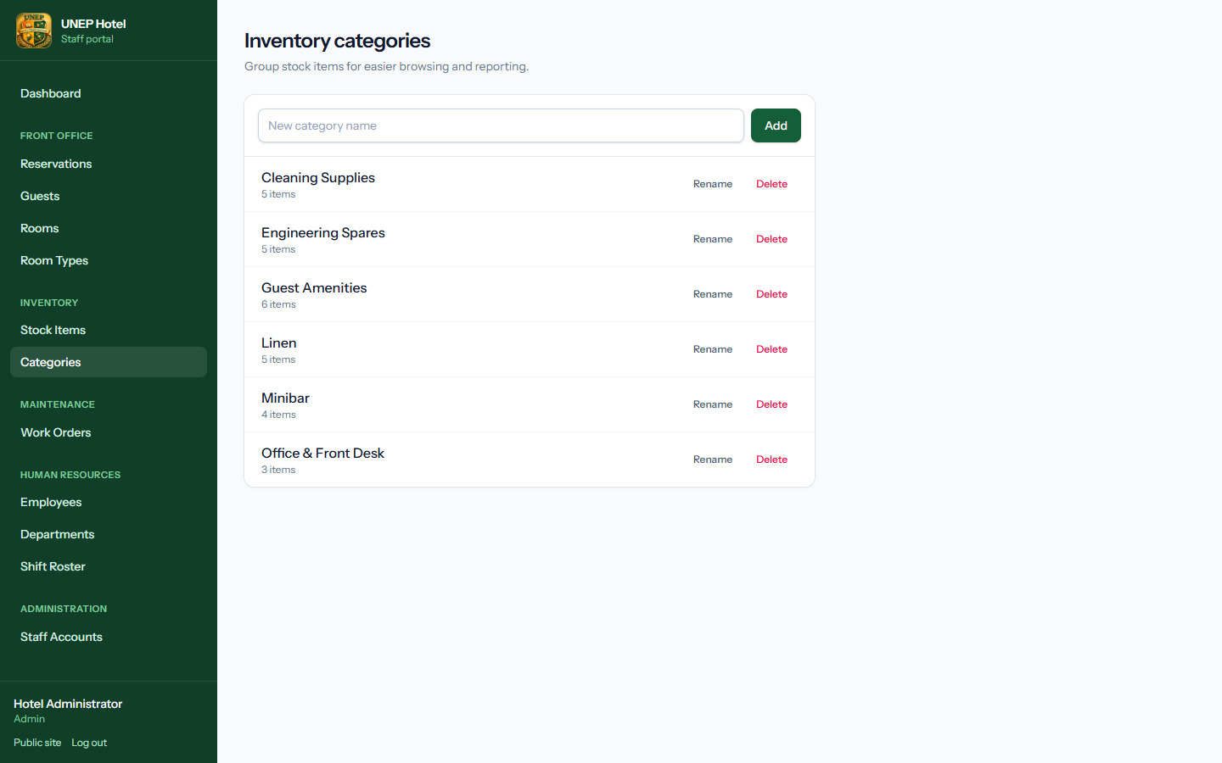
Figure 30. Inventory categories

7. Human resources
This chapter is for Human Resources staff and administrators.

7.1 Employees
Employees lists all staff with their department, position, hire date and status (Active, On Leave or Terminated). Search by name, employee number or position.
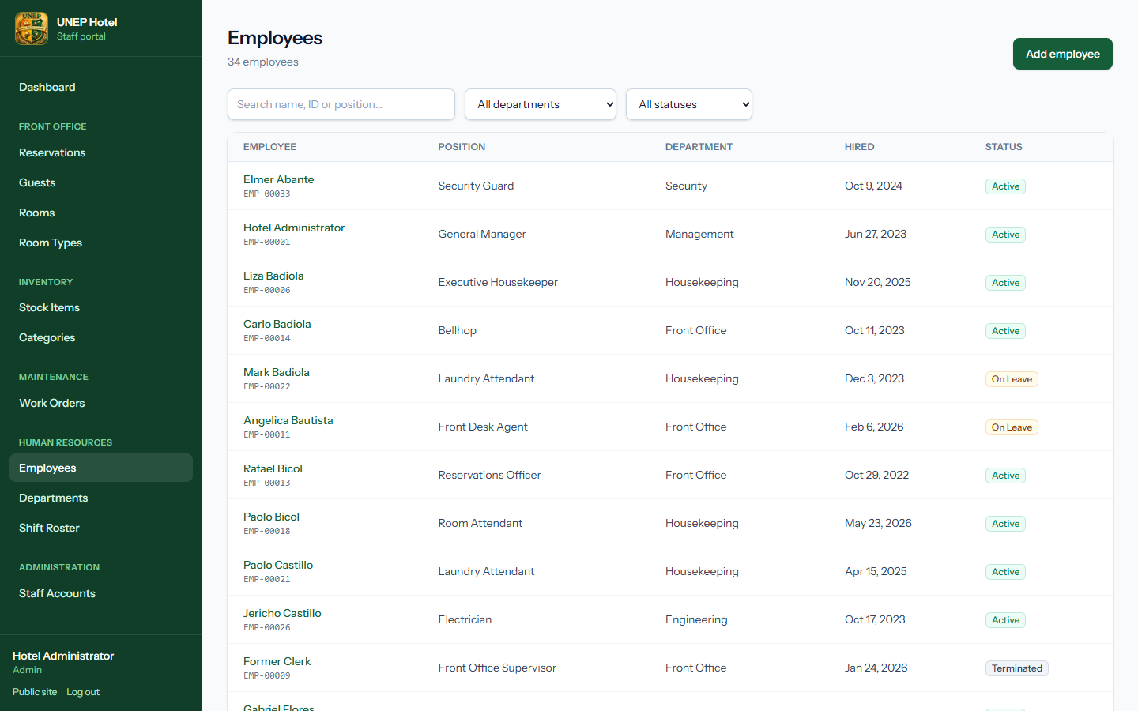
Figure 31. The employee list
Open an employee to see their details, upcoming shifts and any open maintenance work orders assigned to them. An employee can be linked to a staff login under Linked staff login.
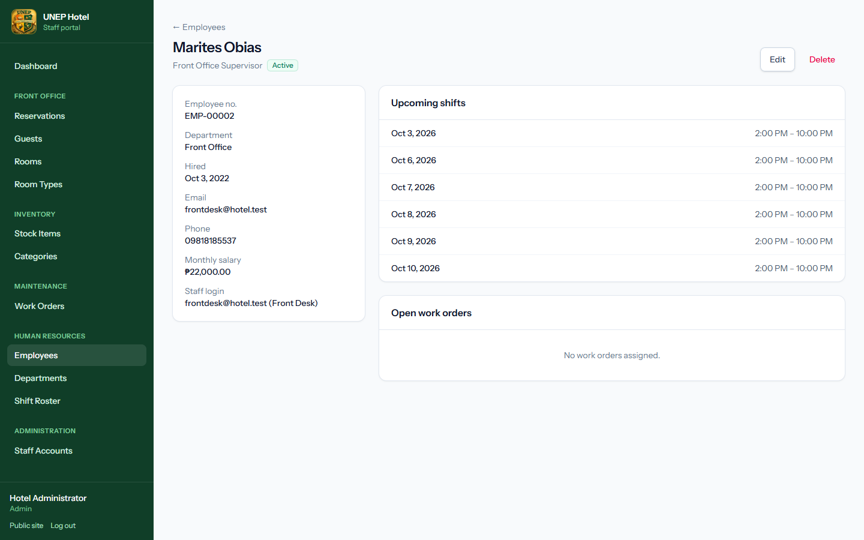
Figure 32. An employee profile

7.2 Departments
Add, rename or delete departments. A department that still has employees cannot be deleted.
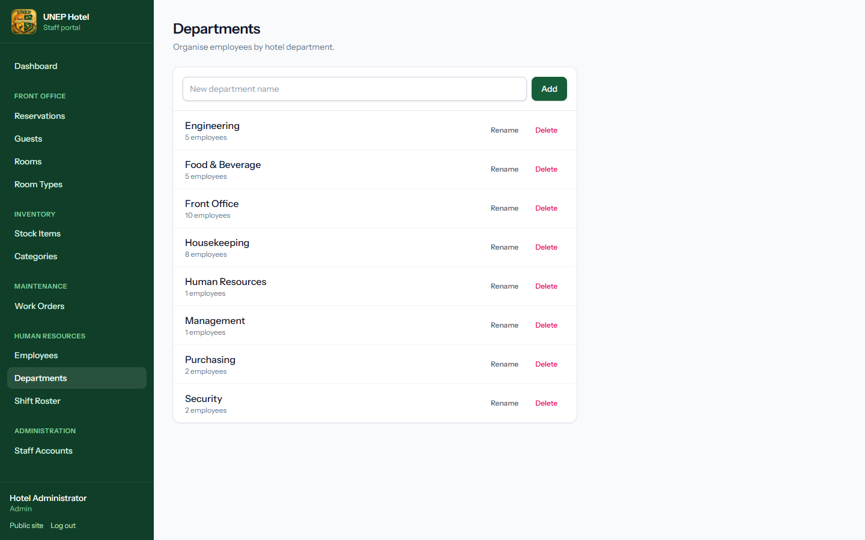
Figure 33. Departments

7.3 Shift roster
- Open Shift Roster. Use Previous, This week and Next to move between weeks. Today is outlined in green.
- In Schedule a shift, choose the employee, date, start and end times, then click Add shift.
- To remove a shift, hover over it and click Remove.
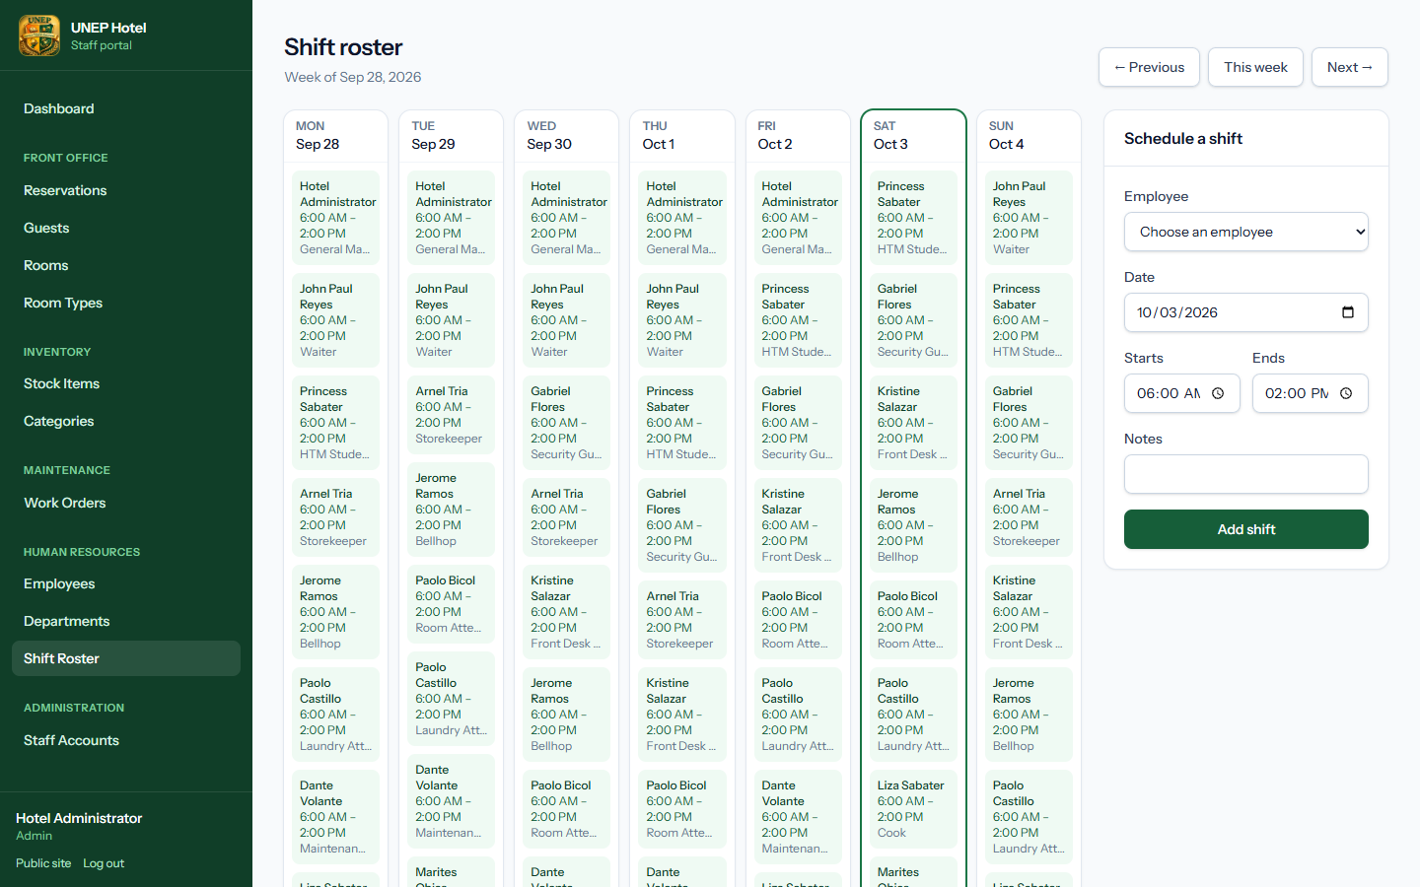
Figure 34. The weekly shift roster
Note: An employee can only have one shift per day. Night shifts may end the following morning (for example 22:00 to 06:00).

8. Administration
Only administrators can manage staff accounts.

8.1 Staff accounts
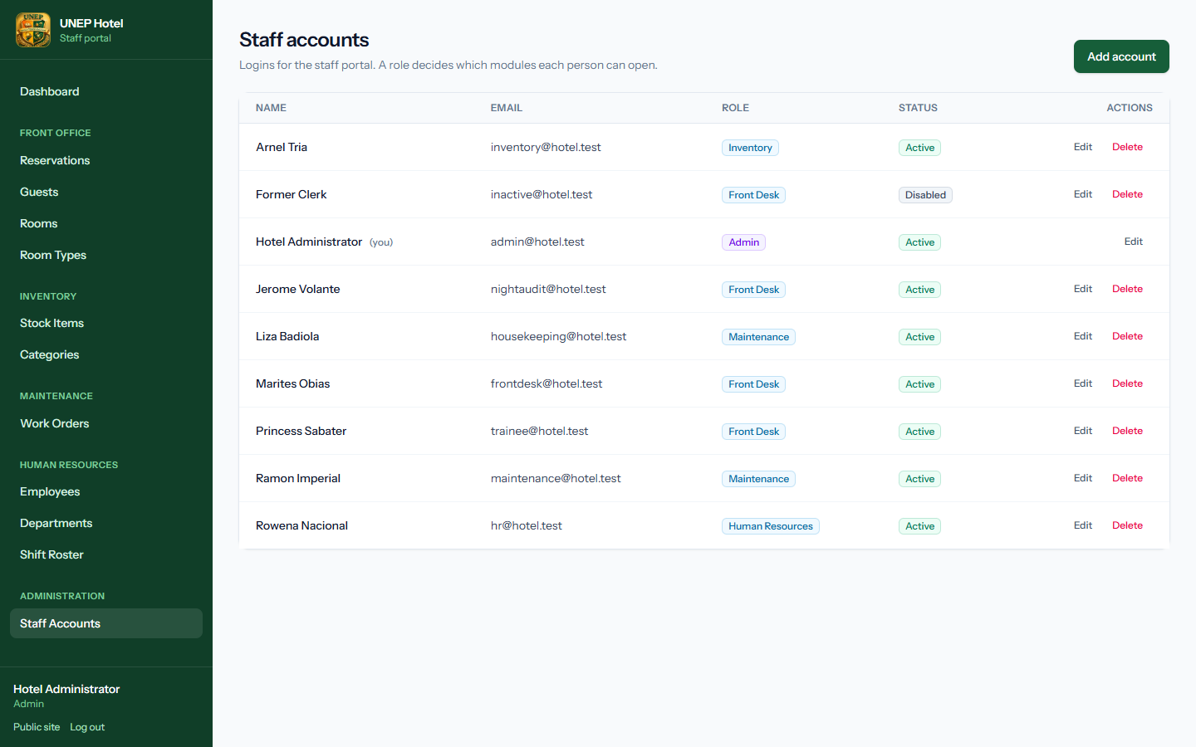
Figure 35. Staff accounts
- Click Add account, or Edit next to an existing account.
- Enter the name and email, and choose the role — the description under the field explains what that role can open.
- Set a password (at least 8 characters) and confirm it. When editing, leave the password blank to keep the current one.
- Untick Account is active to stop someone signing in without deleting their history. They are signed out on their next click.
- Click Save changes.
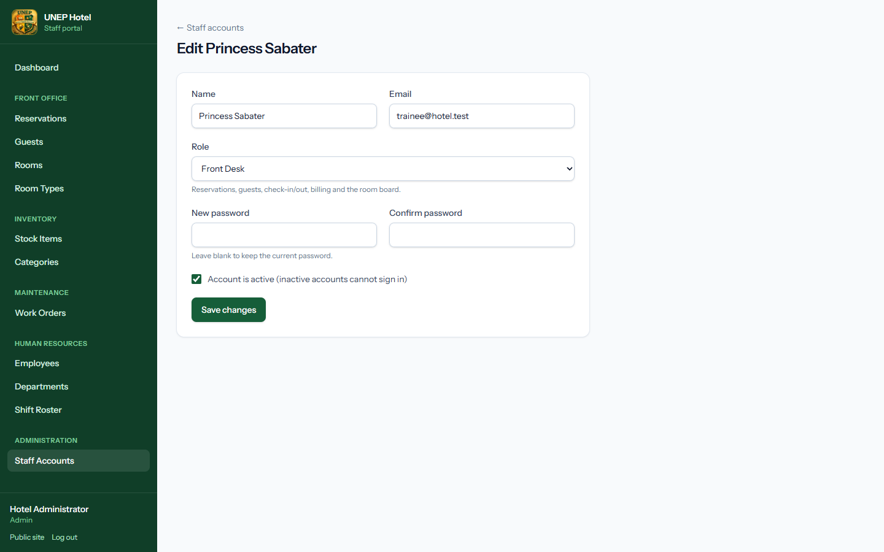
Figure 36. Editing a staff account
Important: You cannot remove your own administrator role, deactivate yourself, or delete your own account. This prevents the hotel being locked out.

9. Rules the system enforces
The system checks these rules automatically. If an action is refused, the red message explains which rule applies.
Area | Rule
Bookings | A room type can only be booked when at least one room of that type is free for every night of the stay.
Bookings | A new stay may start on the same day another guest checks out.
Bookings | The number of adults and children cannot exceed the room type's capacity.
Check-in | Requires an assigned, Available room, on or after the check-in date and before the check-out date.
Check-out | Requires a zero balance. The room is then set to Cleaning.
Folio | Charges and payments are locked once a reservation is checked out or cancelled.
Rooms | Occupied is set only by check-in and cleared only by check-out.
Rooms | A room's type cannot change while bookings are assigned to it.
Maintenance | A blocking work order puts the room into Maintenance; closing the last one returns it to Available.
Inventory | Stock cannot go below zero. Items used on work orders cannot be deleted.
Shifts | One shift per employee per day.
Accounts | Inactive accounts cannot sign in; administrators cannot lock themselves out.

10. Troubleshooting
Problem | What to do
"No room is available for the selected dates" | All rooms of that type are booked. Try other dates or another room type, or check for old Pending bookings that should be cancelled.
Check-in says the room is not ready | The room is Cleaning or under Maintenance. Ask housekeeping to mark it clean, or assign another room.
Check-out is refused | There is still a balance. Record the payment, then check out.
I cannot see a module in the menu | Your role does not include it. Ask the administrator to change your role.
"Only 5 bottle of … in stock" | You tried to issue more than is on hand. Record the delivery first, or issue a smaller amount.
I was signed out suddenly | Your account may have been deactivated, or your session expired. Sign in again or contact the administrator.
The virtual tour is blank | The tour needs a modern browser with WebGL (Chrome, Edge, Firefox or Safari). Refresh the page or try another browser.

Appendix: status colours
Status | Meaning
Available (green) | Room is clean and ready to sell
Occupied (blue) | A guest is checked in
Cleaning (amber) | Guest has left; housekeeping needed
Maintenance (red) | Room is out of order for repairs
Out of Service (grey) | Room is not in use (renovation, storage)
Pending (amber) | Online booking waiting for a room to be assigned
Confirmed (blue) | Booking confirmed, guest not yet arrived
Checked In (green) / Checked Out (grey) | Guest is in house / stay finished
Open, In Progress, On Hold, Resolved | Stages of a maintenance work order
Low, Medium, High, Urgent | Work order priority

