GGHI HR Portal — User Guide
For: Employees, Approvers (Department Heads, Managers, HR, Medical Director, CEO)
Covers: Leave requests, overtime, time corrections, trip tickets, payslips, and approvals.

1. Logging In
- Go to the portal login page.
- Sign in with your Employee Code and password (given by HR).
- On first login, you may be asked to change your password — do this immediately and keep it private.
- Forgot your password? Contact HR/Admin to have it reset — there is no self-service reset.
The portal works on desktop and mobile (phone/tablet). On mobile, use the bottom navigation bar; on desktop, use the sidebar.
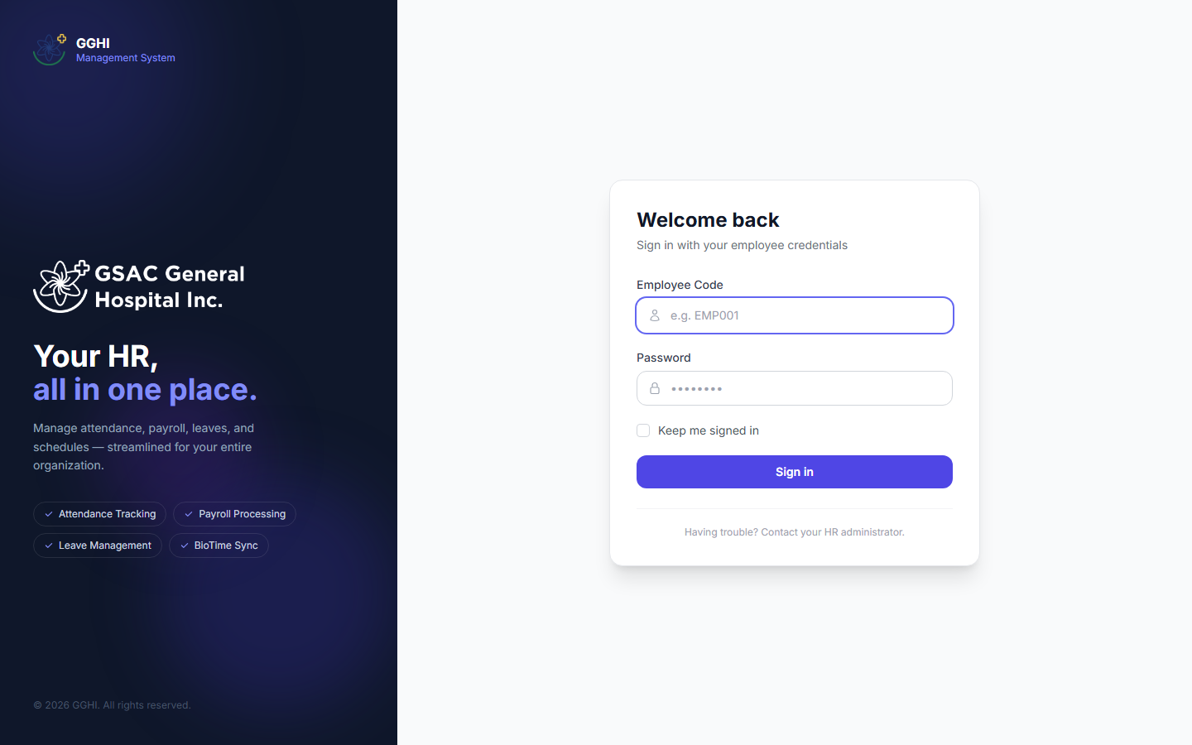
Login page

2. Roles at a Glance
Role | What they do
Employee | Files leave, overtime, time correction, and trip ticket requests. Views own payslips and attendance.
Department Head / Manager | Everything an employee can do, plus approves leave/time-correction/trip-ticket requests at Step 1.
HR Admin | Approves at Step 2, manages employees, payroll, schedules, and all HR records.
Approver (Medical Director) | Approves leave/time-correction requests at the final step (Step 3).
Super Admin (CEO) | Final approver (Step 3) plus full system access.
Head Nurse | Manages the Nursing duty roster; otherwise uses the app like a regular employee.

Your role determines what you see in the sidebar/menu — you won't see options you don't have access to.

PART A — For Employees

A.1 Dashboard
Your dashboard shows a snapshot of your leave balances, recent attendance, and quick links to file requests.
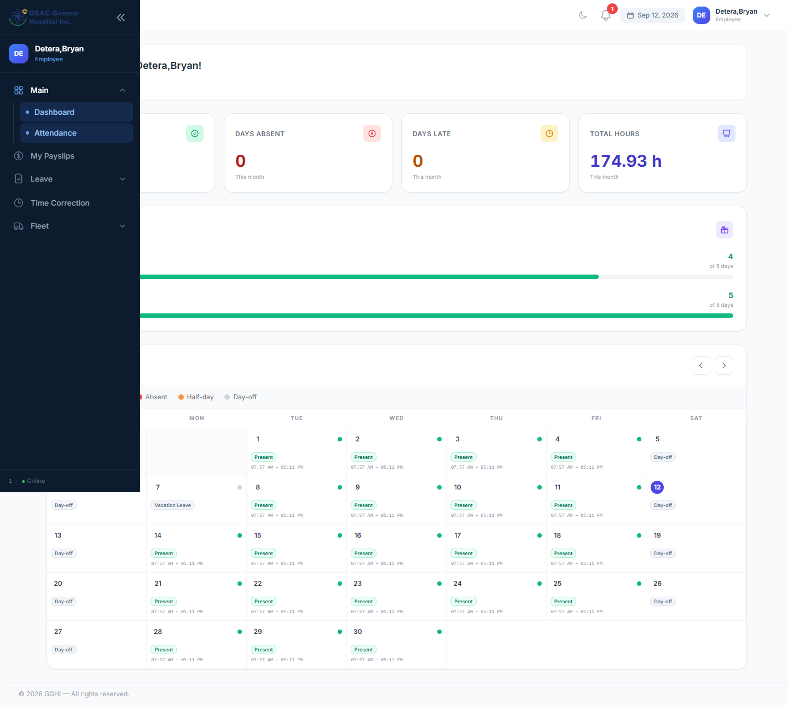
Employee dashboard

A.2 Filing a Leave Request
Menu: Leave → Request Leave
- Check My Leave Balances at the top of the page — shows remaining days per leave type (VL, SL, EL, etc.) for the current year.
- Select a Leave Type. Your remaining credit for that type appears below the dropdown.
- Toggle Half Day if you only need part of a day off (deducts 0.5 day).
- Pick your Start Date (and End Date, if not half-day). The system shows the total working days that will be deducted (Sundays and your day-off are excluded automatically).
- Enter a Reason.
- Click Submit Request.
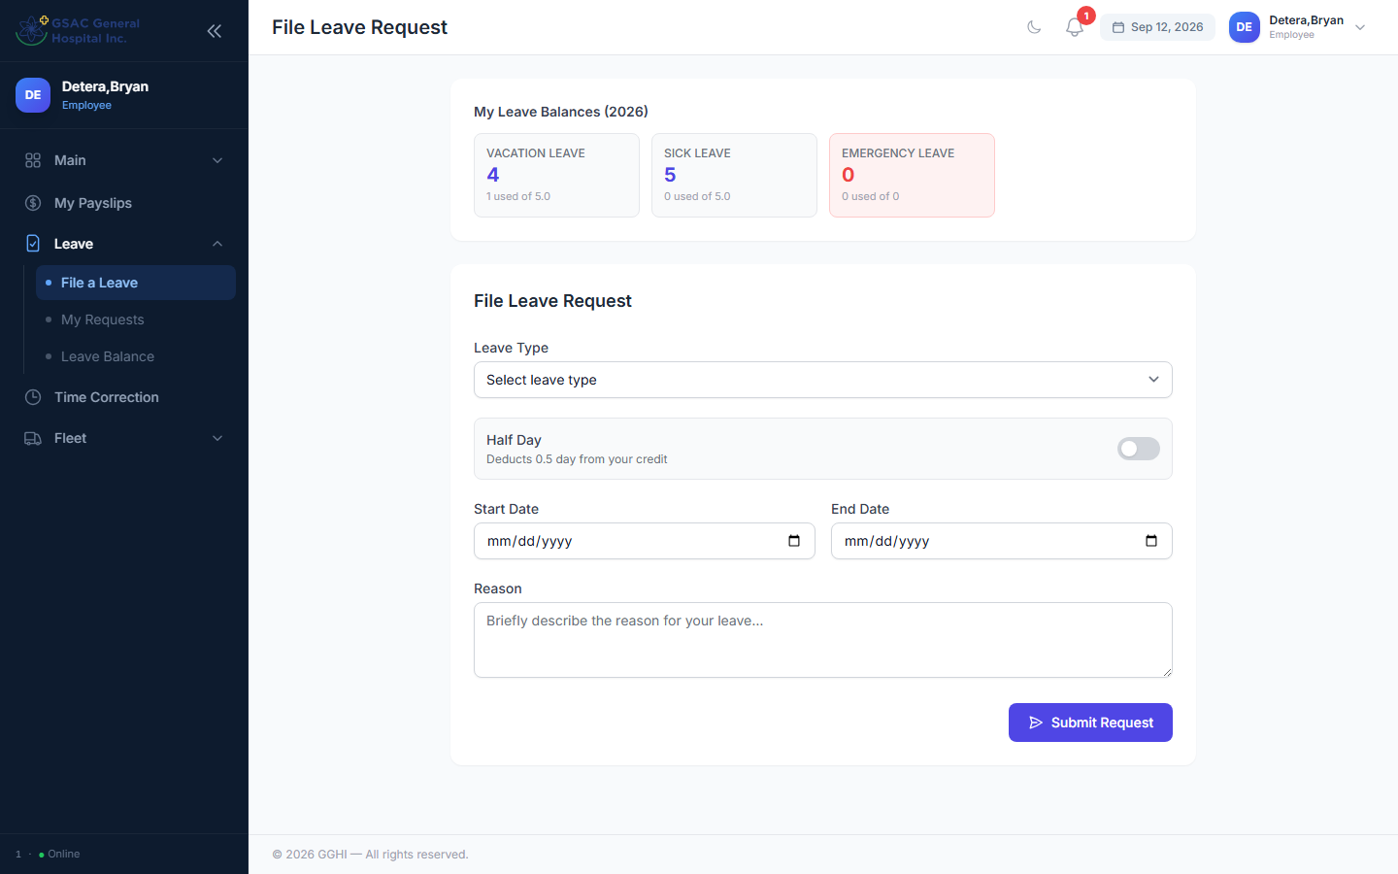
Leave request form

Your request now enters the approval chain (see [A.6](#a6-tracking-approval-status)).
Cancelling: Go to Leave → My Requests. You can cancel a request only while it's still Pending.
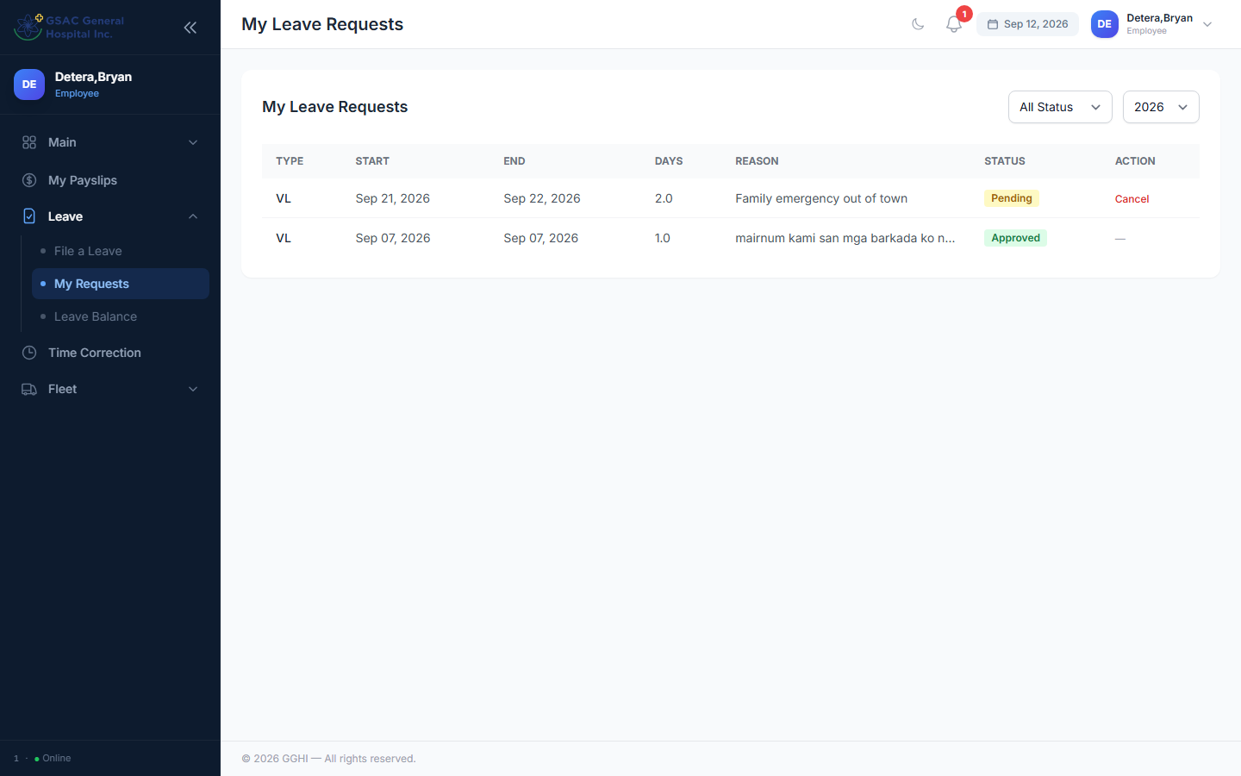
My leave requests

A.3 Filing Overtime
Menu: Overtime → Request Overtime
- Enter the Date of Overtime.
- Enter Requested OT Hours (0.5–8 hours).
- Give a Reason/Purpose.
- Submit. Your OT list below the form shows status, and the Approved Hours may differ from what you requested (approvers can adjust it).
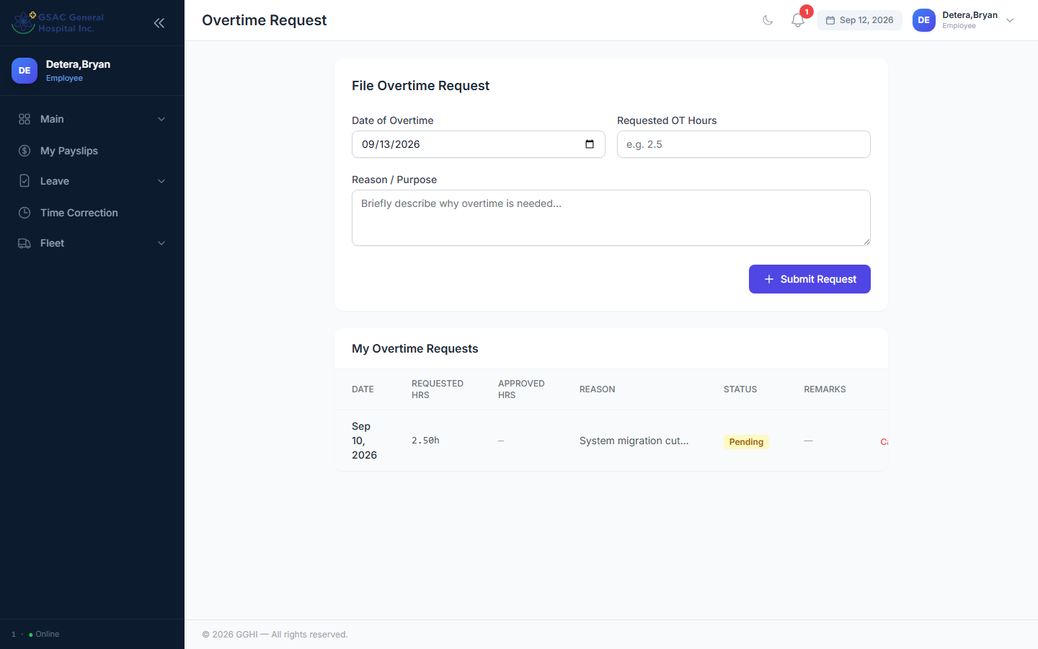
Overtime request form

You can Cancel a pending OT request from the same page.

A.4 Requesting a Time Correction
Use this when your biometric time-in/out was missed or wrong (forgot to tap, device error, etc.).
Menu: Attendance → Time Correction
- Pick the Date to Correct (cannot be a future date).
- Fill in only the time field(s) that need fixing — AM Time In/Out, PM Time In/Out. Leave the rest blank to keep your original biometric punch.
- Give a Reason.
- Submit. Once approved, the corrected time is reflected in your attendance and used for payroll — it also flows through the same approval chain as leave.
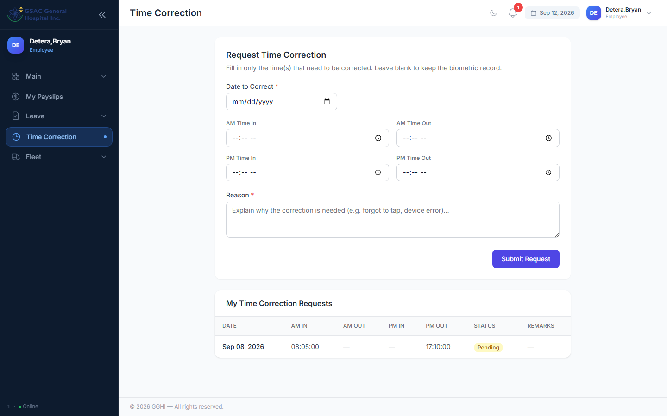
Time correction request form

A.5 Filing a Trip Ticket (Vehicle/Driver Request)
Menu: Fleet → Request Trip Ticket
- Fill in origin/destination, departure date-time, purpose, and number of passengers/details as prompted.
- Submit — it goes through a 3-step approval: Immediate Head → HR Officer → Fleet (Fleet assigns the actual vehicle/driver at the final step).
- Track status at Fleet → My Trip Tickets, where you'll also see the assigned Vehicle/Driver once scheduled.
- You can Cancel while still pending.
- Once your trip is approved, "Mark Returned" is handled by the Fleet/HR office when the vehicle comes back — you don't need to do this yourself.
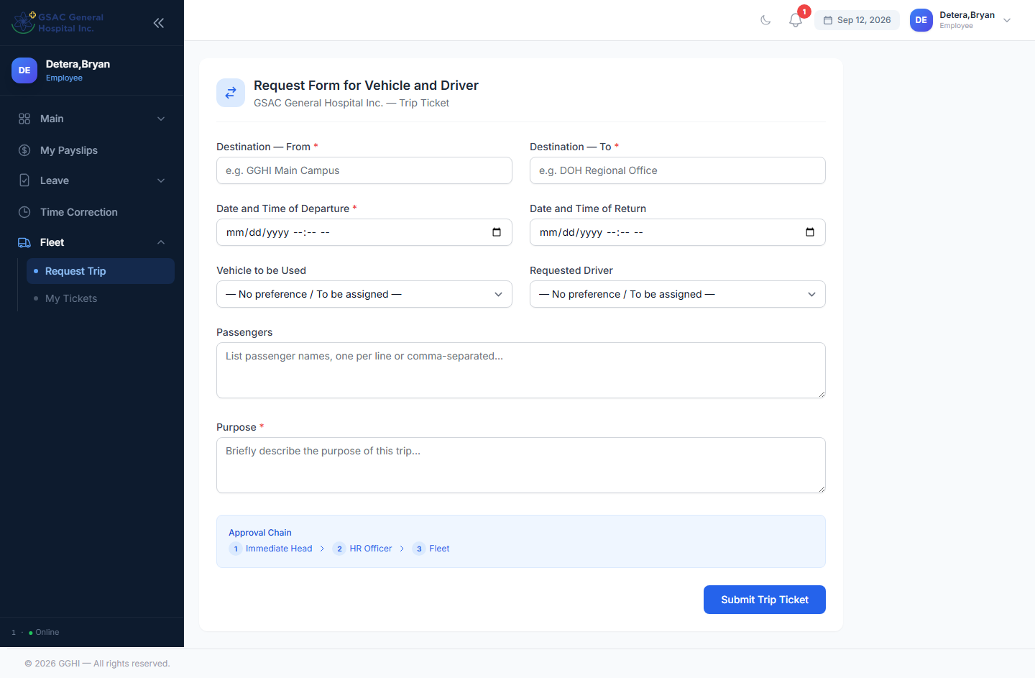
Trip ticket request form

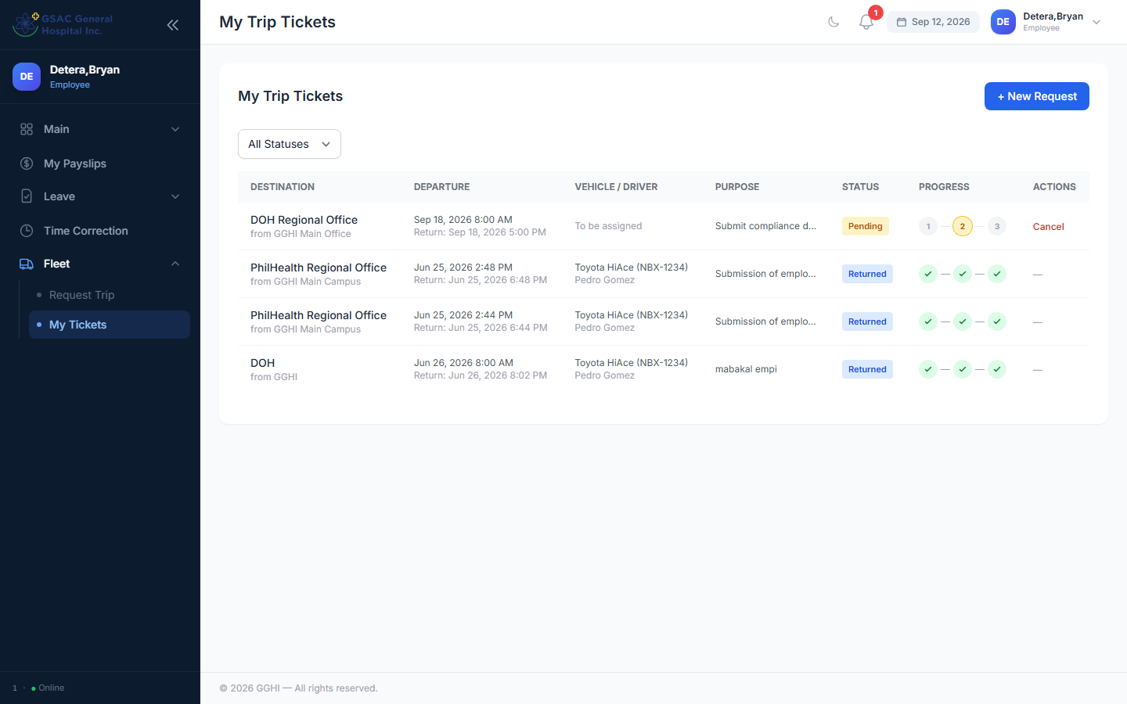
My trip tickets

A.6 Tracking Approval Status
Every leave, time-correction, and trip-ticket list shows an approval progress chain:
- Grey circle = not yet reached
- Amber/highlighted circle = currently awaiting action at this step
- Green check = approved at this step
- Red X = rejected — the request stops here
The leave/time-correction chain is:
- Department Head / Manager
- HR
- CEO / Medical Director
*(Managers and Department Heads filing their own leave skip straight to Step 3 — HR is bypassed for their own requests.)*
The trip ticket chain is:
- Immediate Head
- HR Officer
- Fleet (vehicle/driver assignment)

A.7 Viewing Payslips
Menu: Payslips
- Lists all your finalized/processed payslips by payroll period.
- Click Download to get a PDF copy of any payslip.
- If a payslip isn't listed yet, payroll for that period hasn't been processed by HR — check back after the cutoff.
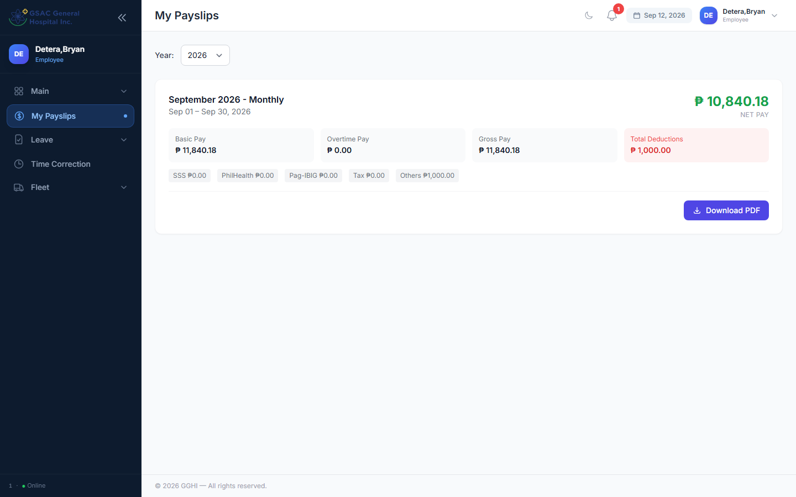
Payslips page

A.8 Viewing Attendance
Your dashboard/attendance calendar shows daily status: Present, Late, Absent, Half-day, Incomplete, Day-off, or the name of an approved leave. If something looks wrong, file a Time Correction ([A.4](#a4-requesting-a-time-correction)) rather than waiting for payroll to fix it — corrections after payroll is finalized can't be applied retroactively.

A.9 Profile
Menu: Profile — update your contact/cell number (used for SMS approval notifications) and change your password.

PART B — For Approvers
Everything in Part A also applies to you for your own requests. This section covers approving other employees' requests.

B.1 Where to Approve
Request type | Menu (approver view)
Leave | Admin → Leave Approvals
Time Correction | Admin → Time Corrections
Trip Ticket | Admin → Fleet Requests
Overtime | Admin → Overtime *(HR/Super Admin only)*

Each page shows a banner telling you which step you act at, e.g. *"You are HR — Step 2 of 3."* You will only see the Approve/Reject buttons on requests that are currently waiting at your step; requests at other steps show "Not your step."
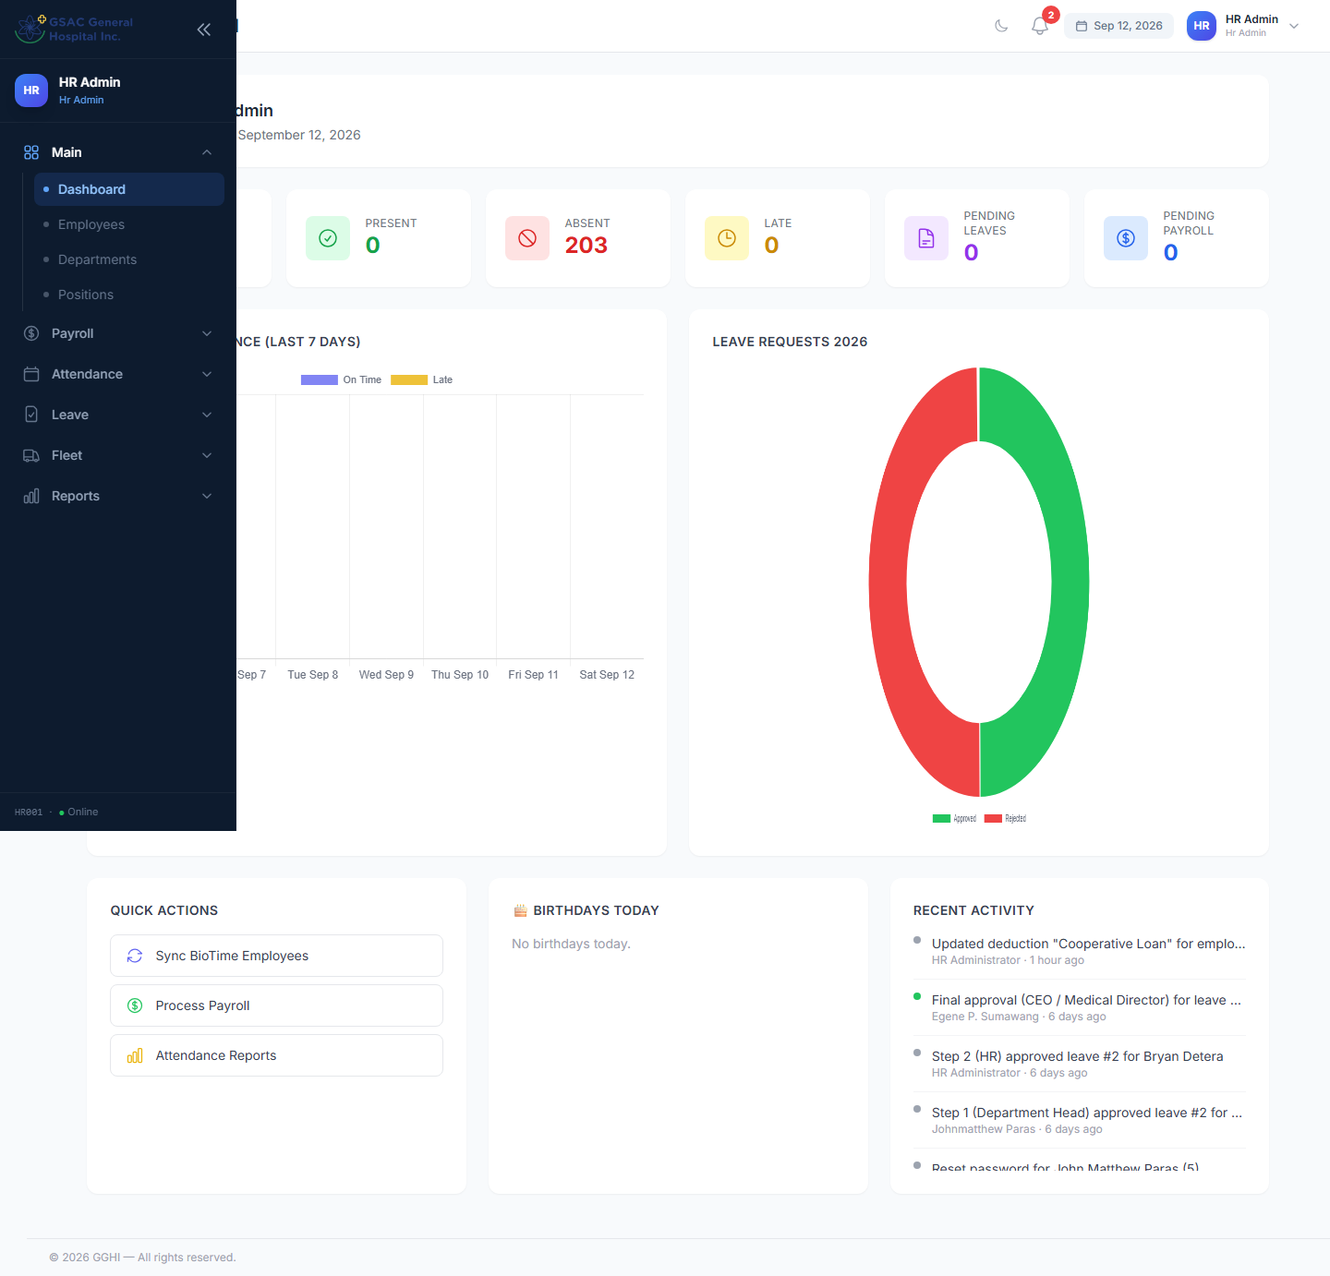
Admin dashboard

B.2 Approving or Rejecting a Leave Request
- Open Admin → Leave Approvals. Use the filters (status, leave type, department, employee search) to narrow the list.
- Review the employee, leave type, dates, days, and reason.
- Click Approve or Reject.
- Approve: optional remarks, then confirm. If you're not the final step, it automatically forwards to the next approver.
- Reject: remarks are required. Rejecting at any step stops the request immediately — it does not continue up the chain.
- On final approval, the leave credit is deducted from the employee's balance automatically, and (if the employee has a cell number on file) an SMS notification is sent.
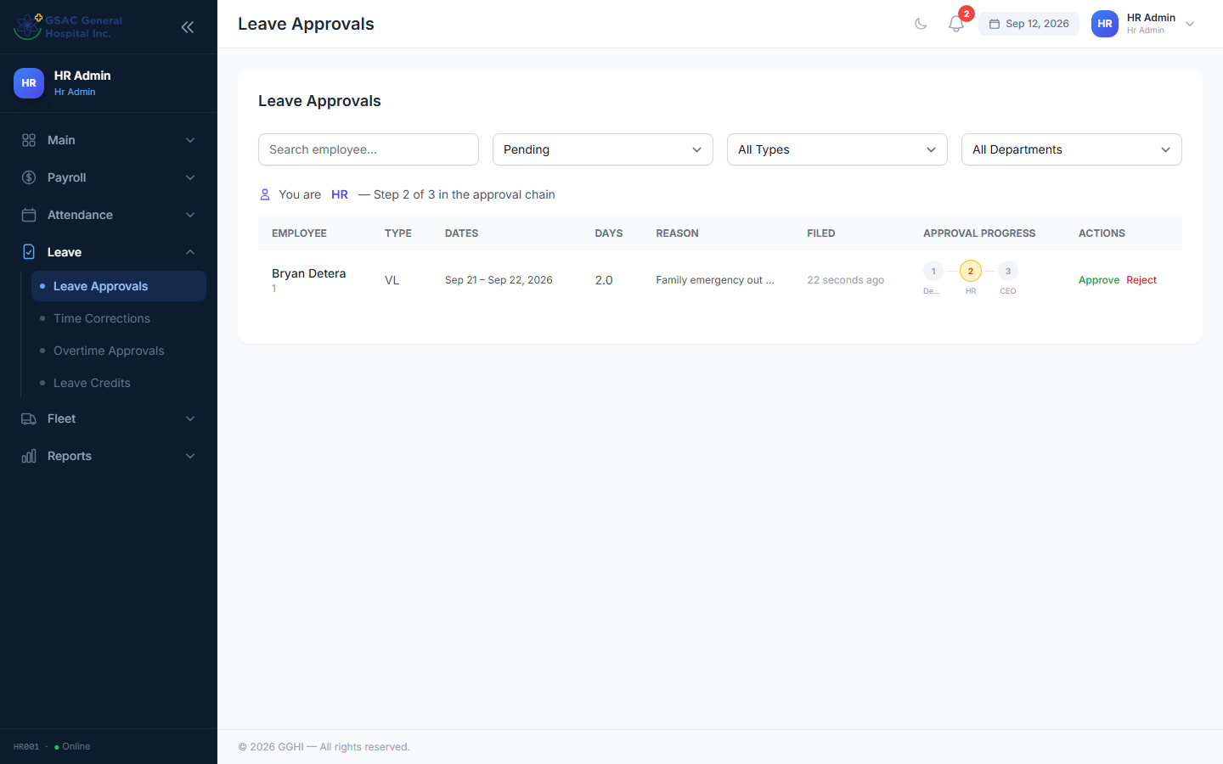
Leave approvals page

B.3 Approving Time Corrections
Same flow as leave: Admin → Time Corrections, review the AM/PM in/out values being requested against the biometric record, then Approve/Reject with remarks. Approved corrections immediately affect that day's computed attendance (hours, lateness, status) and any payroll not yet finalized for that period.
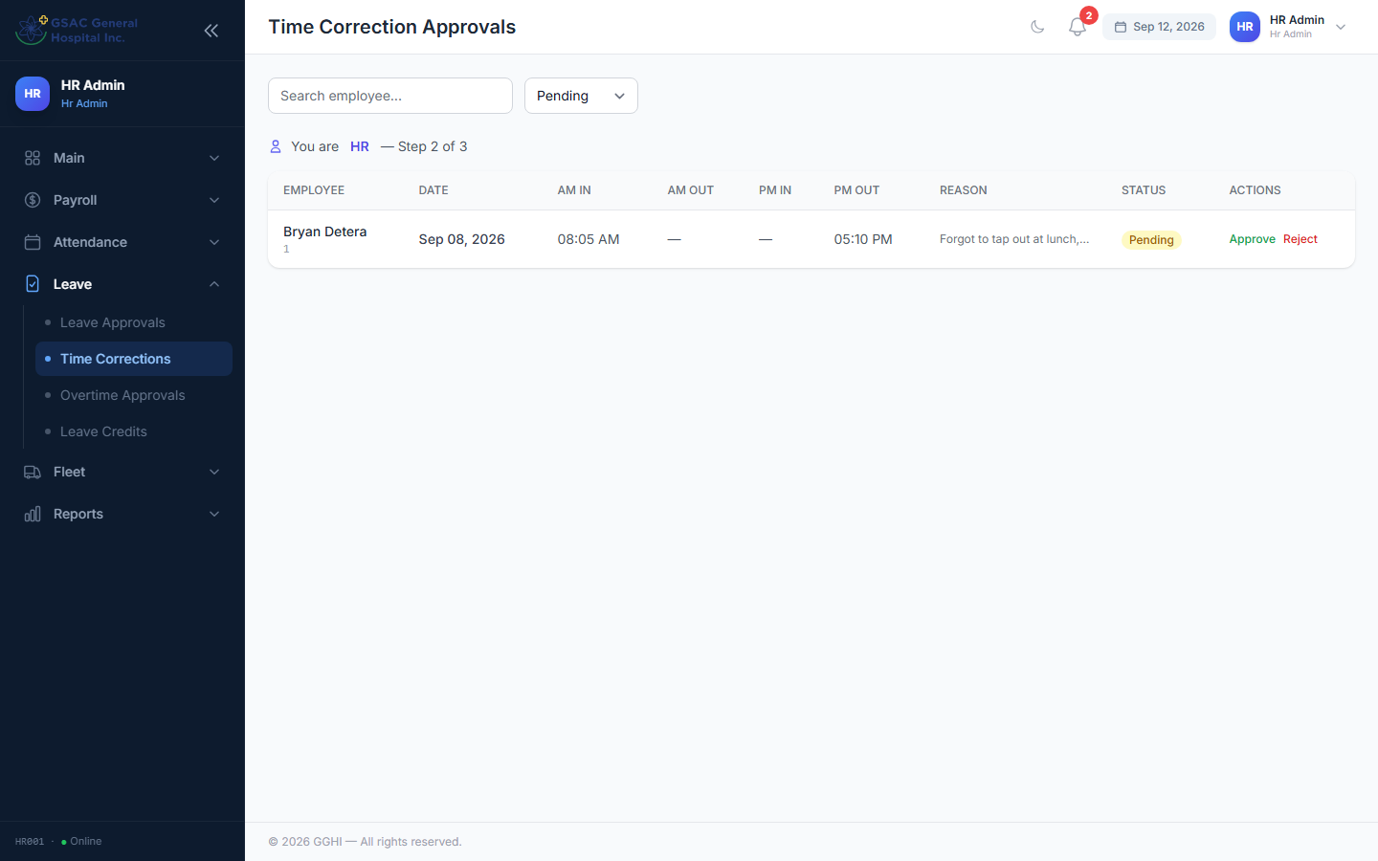
Time correction approvals page

B.4 Approving Trip Tickets
Admin → Fleet Requests
- Steps 1–2 (Immediate Head, HR) simply approve or reject like leave requests.
- Step 3 (Fleet) is special: when approving, you can optionally assign a Vehicle and Driver right in the approval modal. Leaving them blank keeps "to be assigned" and someone can assign later by editing the ticket.
- Once a trip is approved and completed, use Mark Returned on the approved ticket to close it out (marks the vehicle available again).
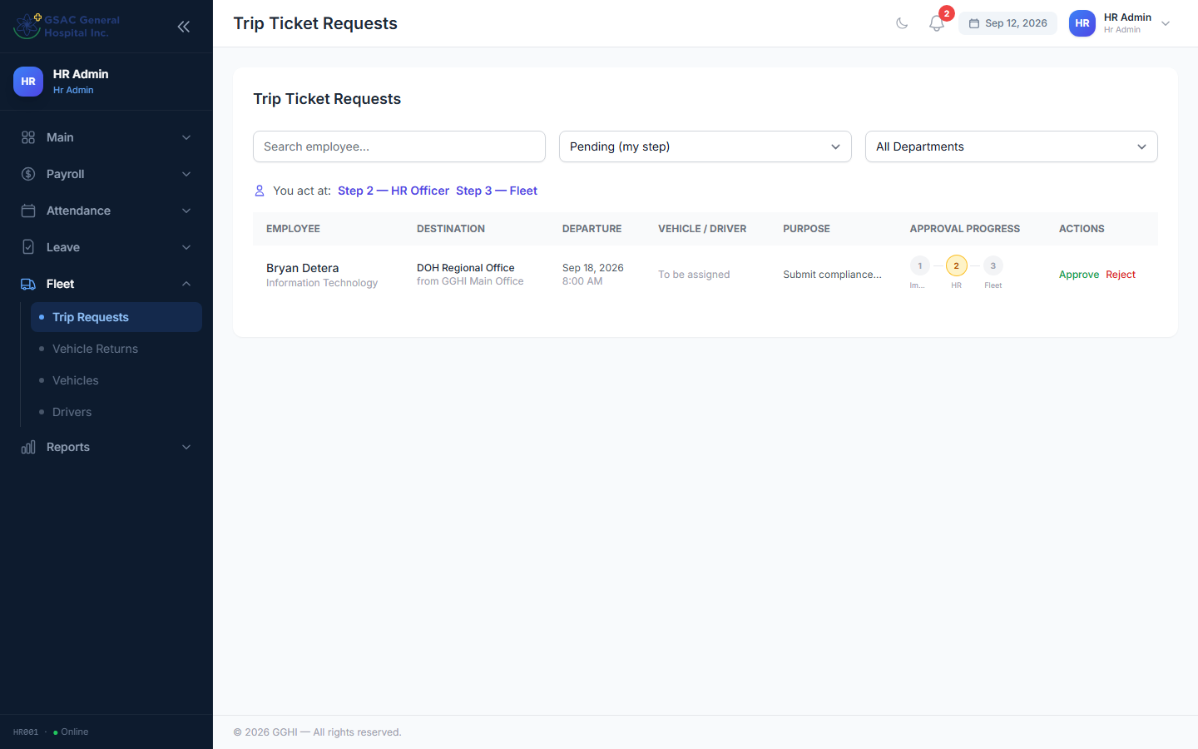
Trip ticket approvals page

B.5 Approving Overtime *(HR / Super Admin)*
Admin → Overtime — review requested hours and reason, then Approve (you may adjust the Approved Hours down from what was requested) or Reject with remarks.
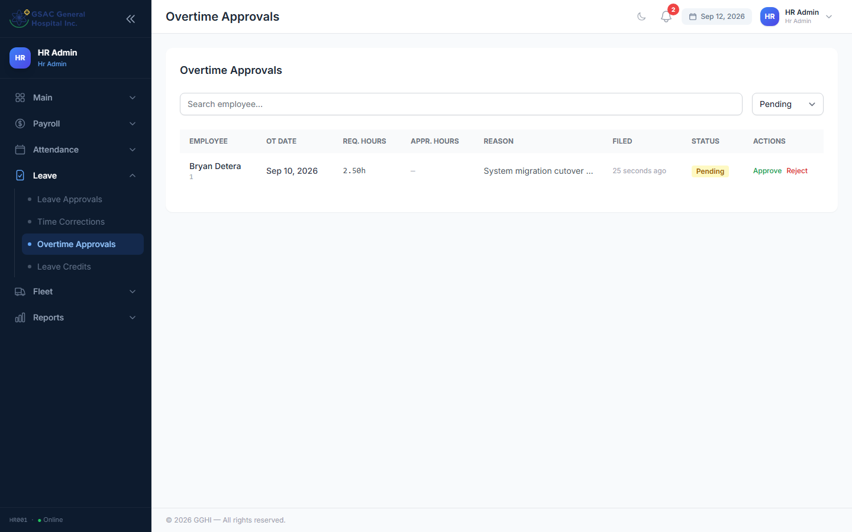
Overtime approvals page

B.6 Manager / Department Head Approving Their Own Team
As a Step-1 approver, you'll typically only see requests from employees in your reporting line. Filing your own leave/trip-ticket request automatically skips Step 1 and goes straight to HR/final approval, since you can't approve yourself.

B.7 HR Admin — Additional Responsibilities
If you're an HR Admin, you also manage (via the Admin sidebar):
- Employees, Departments, Positions — records and org structure
- Schedules & Day-offs — shift templates and rest-day assignment
- Payroll & Salary — periods, payslip generation, salary rates, deductions (loans, SSS, PhilHealth, Pag-IBIG, etc.)
- Holidays — company-wide holiday calendar (auto-applied to attendance)
- Leave Credits — yearly credit allocation and monthly accrual
- Biometrics — BioTime/ZKTeco device sync and punch logs
- Reports — attendance, late, leave, overtime, and payroll reports (exportable to Excel/PDF/print)

B.8 Super Admin — Full Access
Super Admins have all HR Admin capabilities plus:
- User Accounts (create/deactivate logins, reset passwords, change roles)
- Roles & Permissions

3. Common Questions
Q: My leave shows "Not your step" even though I'm an approver.
A: The request hasn't reached your step yet, or it's already past it. Check the progress chain on the request to see where it currently sits.
Q: I rejected a request by mistake.
A: Rejections can't be undone from the portal. Ask the employee to file a new request, or have an HR Admin correct the record directly.
Q: The wrong time-in shows on my attendance.
A: File a Time Correction ([A.4](#a4-requesting-a-time-correction)) rather than waiting — approvers cannot edit raw biometric punches, only approve a correction on top of them.
Q: Can I file leave/trip tickets for someone else?
A: No — each employee files their own requests from their own account. HR can create records manually only in exceptional cases.
Q: Why is my payslip not showing yet?
A: Payslips only appear once HR has generated (and usually finalized) the payroll period. Contact HR if a period is overdue.

*Questions not covered here? Contact your HR Admin.*

