GGHI HR PORTAL
Complete User Guide
GSAC General Hospital Inc.
Version 3.0 · August 27, 2026
Covers: Employee & Payroll Management · Deductions · Leave, Overtime & Time Correction · Fleet / Trip Tickets · Biometrics · Shift Schedules · Nursing Duty Roster · Roles & Permissions · with screenshots

Table of Contents
Right-click here and choose “Update Field” to generate the table of contents.
📌 Note: This table of contents updates automatically in Microsoft Word. Right-click anywhere on it and choose "Update Field" (or press F9) to refresh section names and page numbers.

1. Getting Started

1.1 Logging In
Open your browser and go to the HR Portal URL provided by your administrator.
On the login page, enter your Employee Code (e.g. 2026-001) and your password, then click Sign In.
📌 Note: Your Employee Code is your username — not your email address.
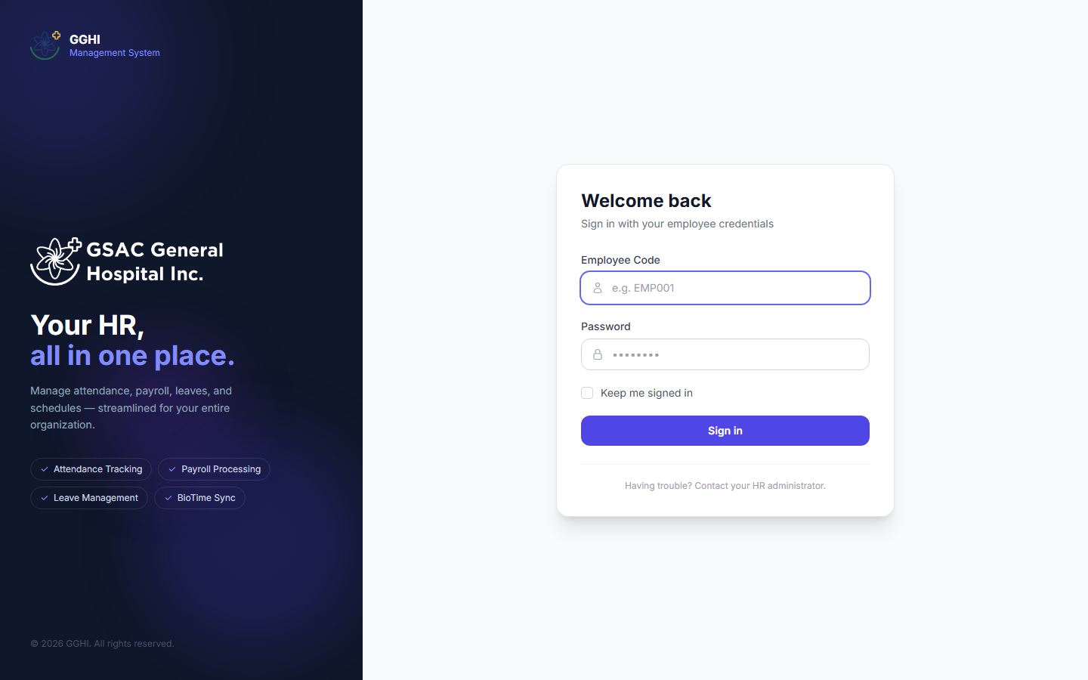
Figure 1. The GGHI HR Portal login screen.

1.2 First Login
If it is your first time logging in, use the temporary password provided by your administrator. You will be prompted to update your password via the Profile page.

1.3 Navigating the System
After logging in you will see the sidebar on the left. The items shown depend on your role. A typical HR Admin / Super Admin sidebar includes:
- Main — Dashboard, Employees, Departments, Positions
- Payroll — Payroll processing, Salary Setup, Deductions
- Attendance — Schedules, Day Offs, Holidays, Biometrics
- Leave — Leave Approvals, Time Corrections, Overtime Approvals, Leave Credits
- Fleet — Trip Requests, Vehicle Returns, Vehicles, Drivers
- Reports — Attendance, Late, Leave, Payroll, Overtime reports
- Administration — User Accounts, Roles & Permissions (Super Admin only)
Employees, managers, department heads, approvers, security guards, and the head nurse each see a smaller, role-specific menu — see Section 2 for the full breakdown.
📌 Note: On mobile, use the bottom navigation bar for quick access to the most-used pages.
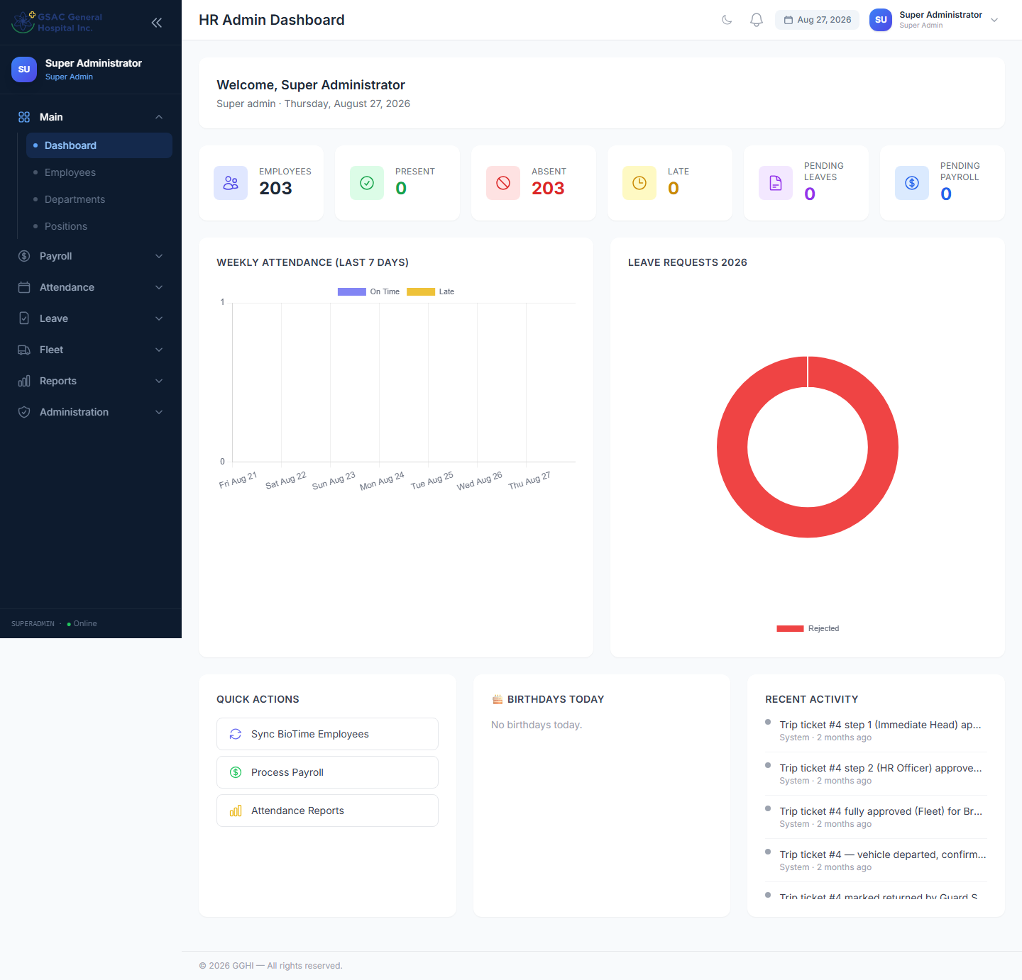
Figure 2. Admin / Super Admin dashboard — attendance, leave, and payroll summary at a glance.
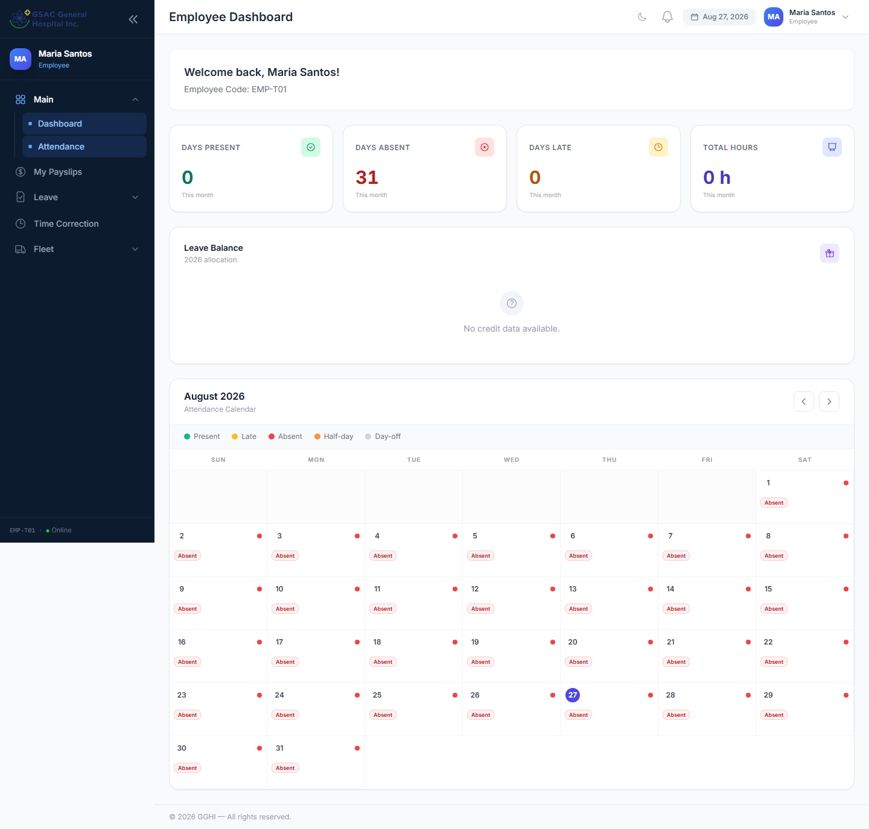
Figure 3. Employee dashboard — a simplified, role-specific view.

1.4 Dark Mode
Click the moon/sun icon in the top-right header to toggle between light and dark mode. Your preference is saved automatically.

1.5 Logging Out
Click your name/avatar in the top-right corner of the screen, then select Logout.

2. User Roles & Access
Each user account has a single role that controls which pages and actions they can access. Two layers keep this in sync: the visible role on the account (used for the sidebar) and a matching permission role behind the scenes (used to actually enforce access). Both are set together whenever an account is created or edited — you never manage them separately.
Role | Who | What They Can Do
super_admin | CEO | Full access to everything, including Roles & Permissions and User Accounts. Also a Step-3 (final) approver for leave, overtime, and trip tickets.
hr_admin | HR Staff | Employees, Payroll, Schedules, Day Offs, Holidays, Leave Credits, Deductions, Biometrics, Reports, Fleet (vehicles/drivers). Step-2 leave approver and Step 2–3 trip-ticket approver.
department_head | Department Head | Step-1 approver for other staff’s leave, time corrections, and trip tickets. Also has their own leave/payslip/trip-ticket self-service menu.
manager | Manager | Same access as Department Head — Step-1 approver plus personal self-service menu.
approver | Medical Director | Step-3 (final) approver for leave and time corrections; can view reports.
head_nurse | Head Nurse (Nursing) | Manages the Nursing Duty Roster (assigns nurses to shifts day-by-day). Also has the standard employee self-service menu (leave, payslips, overtime, trip tickets). Does not have leave/trip-ticket approval powers.
security_guard | Security Guard | Logs vehicle departures and returns on the Vehicle Returns page only.
employee | Regular Staff | File leave, file overtime, file trip tickets, file time corrections, view payslips, view attendance.

📌 Note: Roles are assigned by the Super Admin under Administration → User Accounts (for department_head, approver, security_guard, and head_nurse) or via Employees → Create Account (for employee, hr_admin, manager, super_admin). See Section 3.4 for the exact difference.

3. Employee Management
Access: Sidebar → Main → Employees (HR Admin and Super Admin only)

3.1 Viewing Employees
The employee list shows all active employees by default. Use the filters at the top to:
- Search by name or employee code
- Filter by department
- Toggle between Active / Inactive / All employees
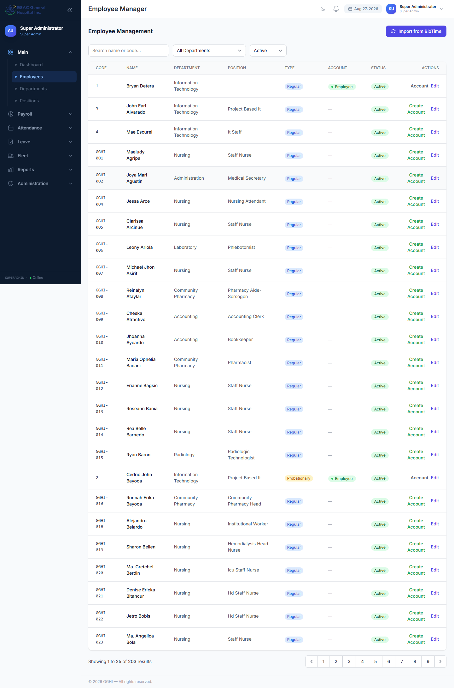
Figure 4. Employee Management — search, filter, and manage employee records.

3.2 Editing an Employee
Click Edit next to any employee to open the edit modal. You can update:
Field | Description
First Name / Last Name | Employee’s legal name
Cell Number | Mobile number for SMS leave notifications (e.g. 09171234567)
Department / Position | Assigns the employee’s department and job title
Employment Type | Regular or Probationary — affects the working-week pattern (see Note below) and, for Nursing staff, the required-hours payroll quota (Section 11.7)
Weekly Rest Day | Which day is automatically assigned as a day-off
Hire Date / Date of Birth | Reference dates used in reports
Active / Inactive | Inactive employees are excluded from payroll and most lists

📌 Note: Regular employees follow a Monday–Friday work week (Saturday and Sunday excluded from payroll). Probationary employees follow Monday–Saturday (Sunday only excluded). The Weekly Rest Day setting determines which days are automatically assigned as day-offs when using the Auto-generate feature in Day Off Management.

3.3 Creating a User Account (Employee, HR Admin, Manager, Super Admin)
To allow an employee to log in to the system:
- Find the employee in the list
- Click Create Account (or Account if one already exists)
- Set the role — employee, hr_admin, manager, approver, or super_admin
- Set a temporary password (minimum 6 characters)
- Click Create — the employee can now log in using their Employee Code + password
📌 Note: To reset a password later, click Account → Reset Password.

3.4 Creating Department Head, Approver, Security Guard, or Head Nurse Accounts
Employee Management’s Create Account role list does not include department_head, approver, security_guard, or head_nurse. For those roles, go to Sidebar → Administration → User Accounts (Super Admin only) instead:
- Go to Administration → User Accounts
- Click Add User
- Enter the Name, Employee Code, and password
- Select the Role (department_head, approver, security_guard, or head_nurse, plus all standard roles)
- Click Save
📌 Note: For a head_nurse account specifically, make sure the matching employee record’s Department is set to exactly "Nursing" — that is how the Duty Roster (Section 13) knows which staff to list.

3.5 Importing from BioTime
Click Import from BioTime at the top of the Employees page to sync employee records from the biometric system. This runs in the background and updates automatically.

4. Leave Management

4.1 How the Approval Chain Works
Every leave request goes through a sequential approval chain depending on who filed it:
Filed by | Step 1 | Step 2 | Step 3 (Final)
Regular Employee | Department Head / Manager | HR | CEO / Medical Director
Department Head | (skipped — own request) | HR | CEO / Medical Director
Manager | (skipped) | (skipped) | CEO / Medical Director

The request only reaches the next approver after the previous one acts. If rejected at any step, the chain stops immediately.

4.2 Filing a Leave Request (Employee)
Access: Sidebar → My Leave → File a Leave
- Select Leave Type from the dropdown (Vacation Leave, Sick Leave, etc.)
- Toggle Half Day if applicable (deducts 0.5 day)
- Set the Start Date and End Date
- Enter a Reason (minimum 10 characters)
- Click Submit Request
Your current leave balances are shown at the top of the form.
📌 Note: Department Heads, Managers, and the Head Nurse also have this form under My Leave in their sidebar.
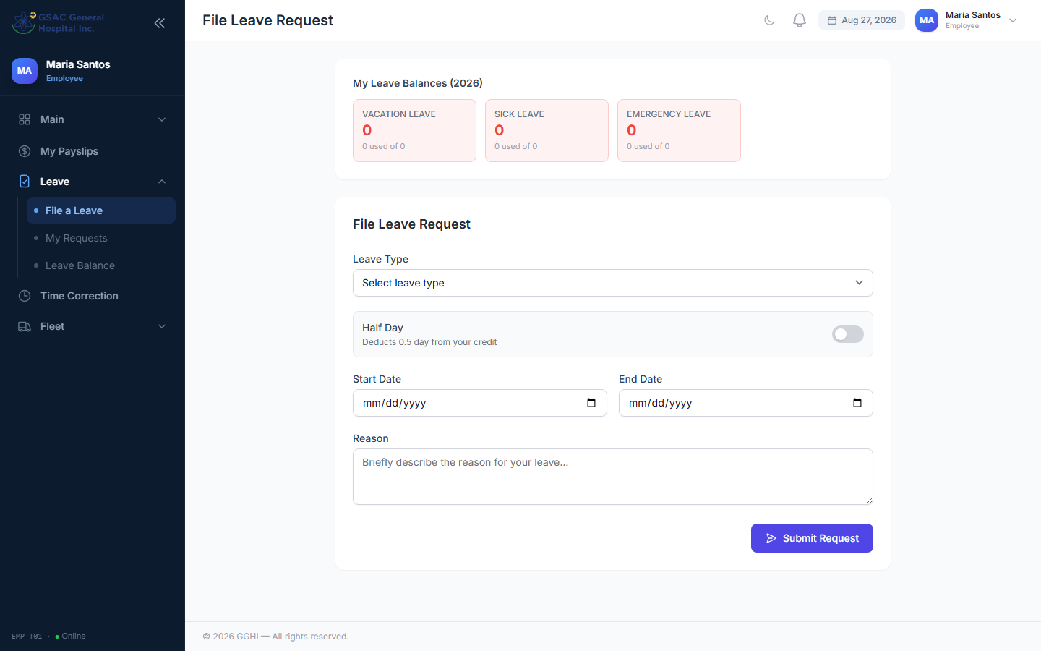
Figure 5. Filing a leave request as an employee.

4.3 Approving or Rejecting Leave (Approver)
Access: Sidebar → Leave → Leave Approvals
When the Pending filter is selected, you will only see requests that are waiting for YOUR approval step. Click:
- Approve — to advance the request to the next step (or fully approve at the final step)
- Reject — to reject the request (reason is required)
📌 Note: You cannot approve requests that are at a different step than yours. "Not your step" will be shown instead.
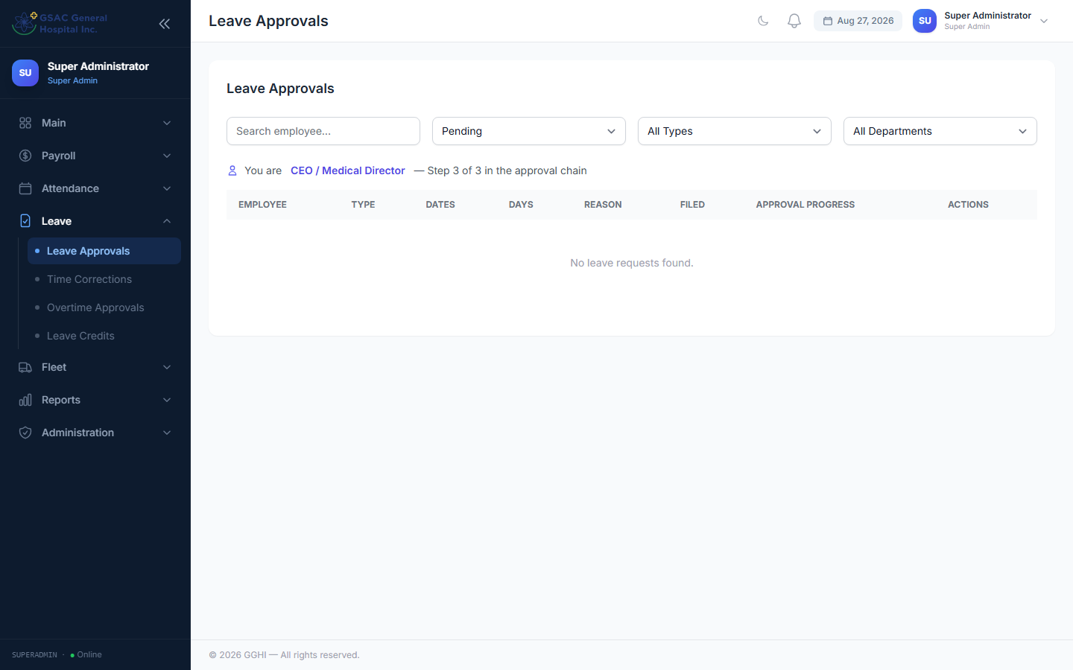
Figure 6. Leave Approvals — requests pending at the current approver's step.

4.4 Leave Credits
Access: Sidebar → Leave → Leave Credits (HR Admin only)
HR can assign the number of leave credits per employee per year. Once a leave is fully approved, the credits are automatically deducted.
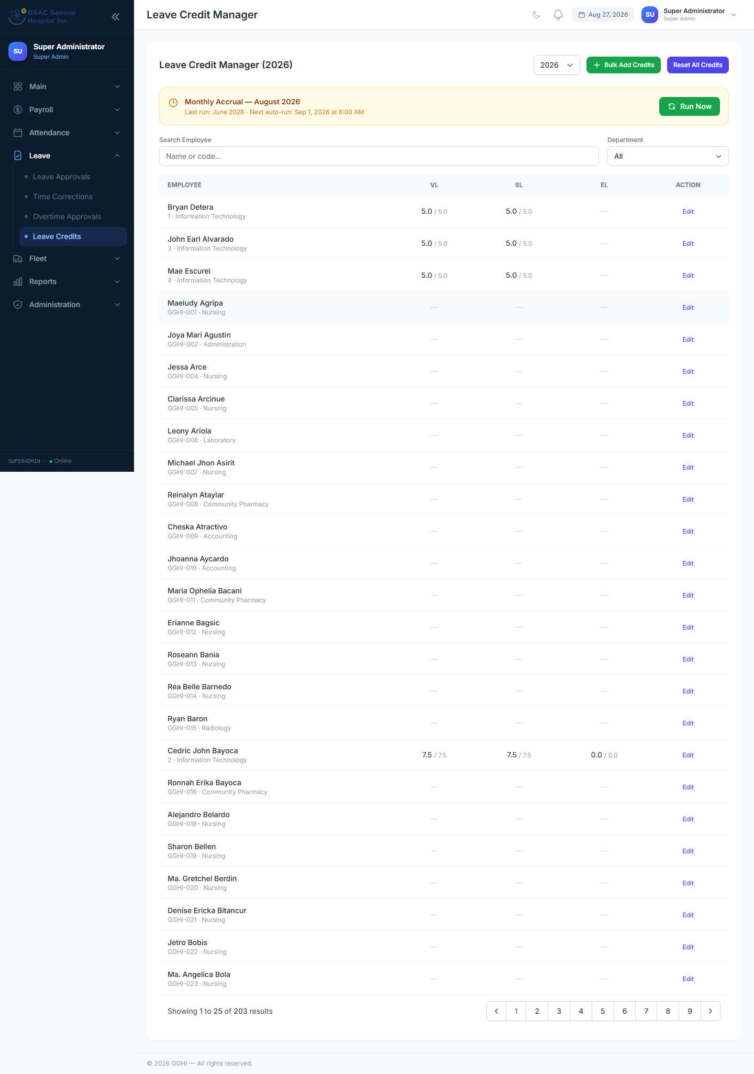
Figure 7. Leave Credits — assigning yearly leave credits per employee.

4.5 Leave Report
Access: Sidebar → Reports → Leave
Shows a summary of all leave requests with filters for Year, Leave Type, Department, and Status. Can be exported to Excel or printed.
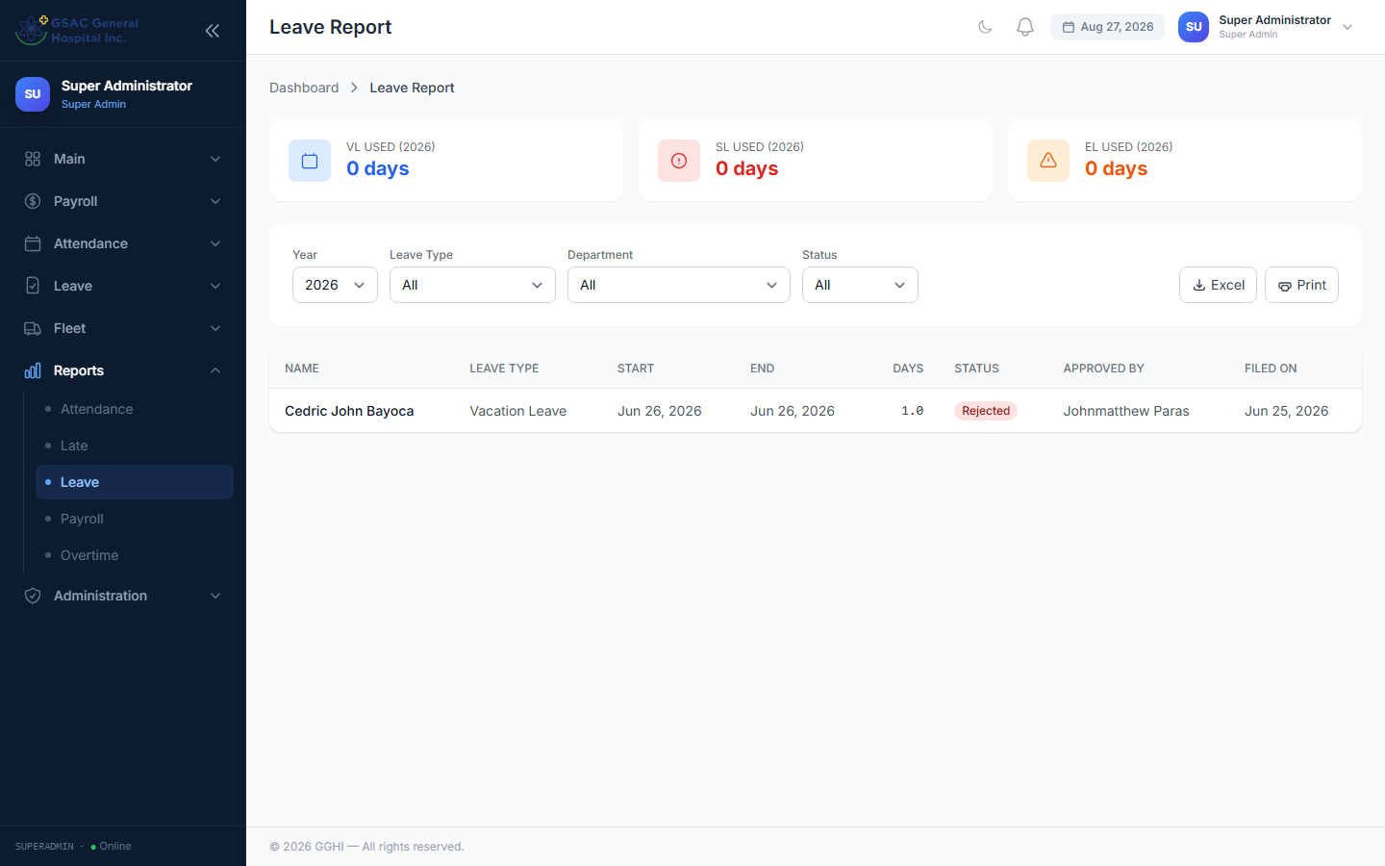
Figure 8. Leave Report with Year, Leave Type, Department, and Status filters.

4.6 Leave in Attendance
When a leave request is finally approved, the attendance report will automatically show the leave type name (e.g. "Vacation Leave") for those dates instead of "Absent".

5. Overtime Management

5.1 Filing an Overtime Request (Employee)
Access: Sidebar → Overtime (or Payroll → Overtime Request, depending on your role)
- Set the Date for the overtime (must be today or a future date)
- Enter the Requested Hours (0.5 to 8 hours)
- Enter a Reason (minimum 5 characters)
- Click Submit
Your last 20 overtime requests, with their status, are listed below the form. You may cancel a request while it is still Pending.
📌 Note: Only one pending or approved OT request is allowed per date. Submit a new request only after a previous one for that date is rejected or cancelled.
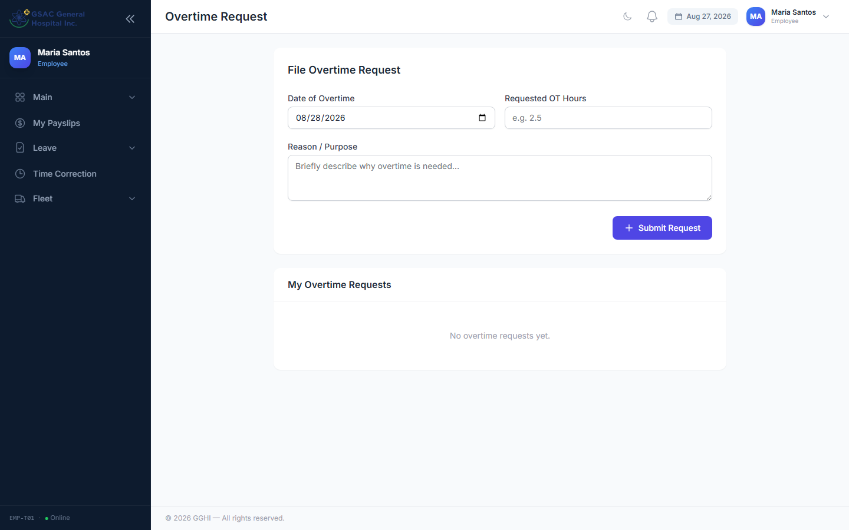
Figure 9. Filing an overtime request as an employee.

5.2 Approving or Rejecting Overtime (HR Admin / Super Admin)
Access: Sidebar → Leave → Overtime Approvals
- Approve — confirms the request and lets you adjust the Approved Hours if different from what was requested (e.g. approve only 4 of the 6 hours requested)
- Reject — denies the request (reason is required)
Use the Status and search filters at the top to narrow the list.
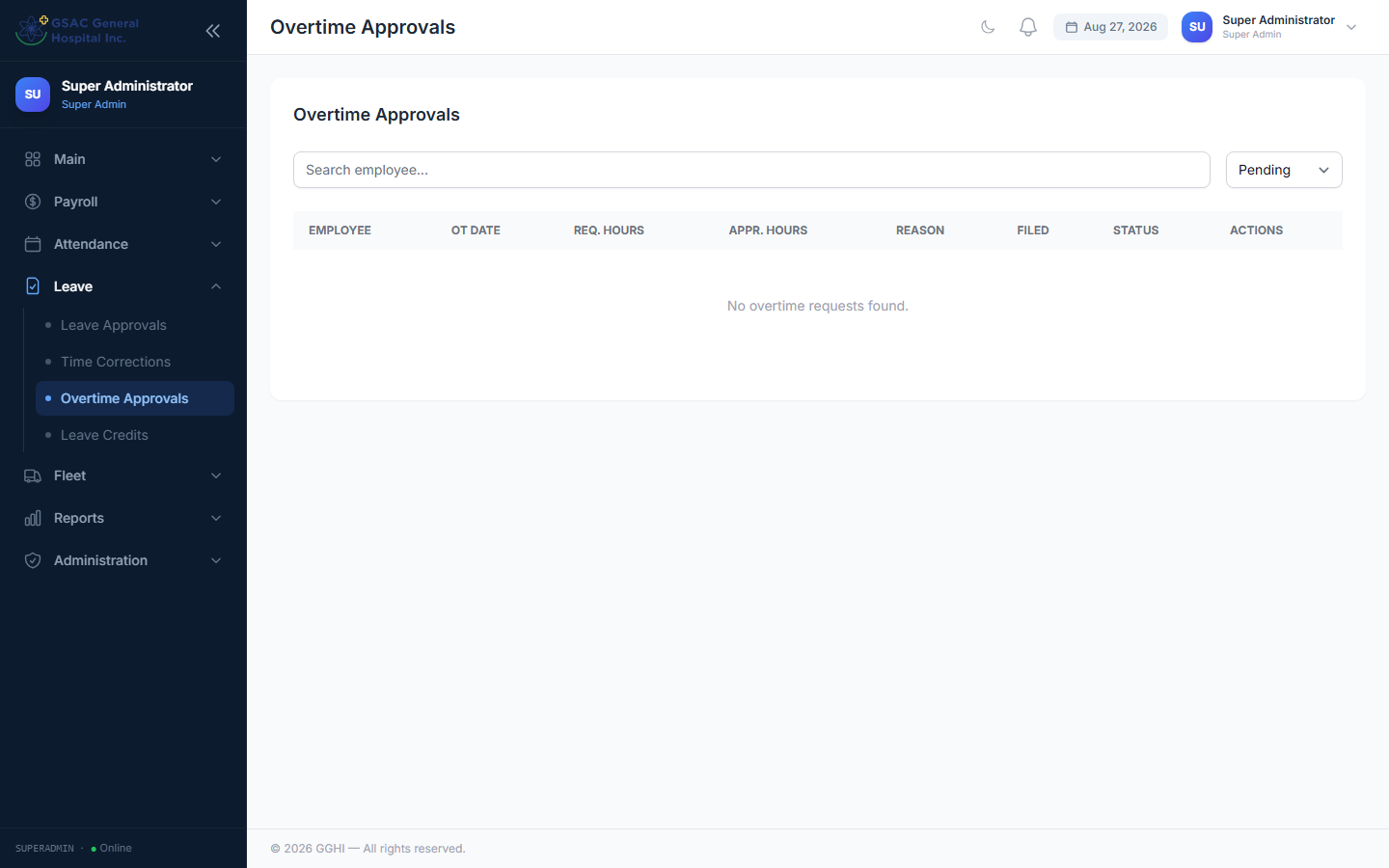
Figure 10. Overtime Approvals — review and adjust approved hours.

5.3 Overtime Report
Access: Sidebar → Reports → Overtime
Shows summary cards (total, pending, approved, requested hours, approved hours) and a filterable, paginated list by Year, Month, Department, and Status.
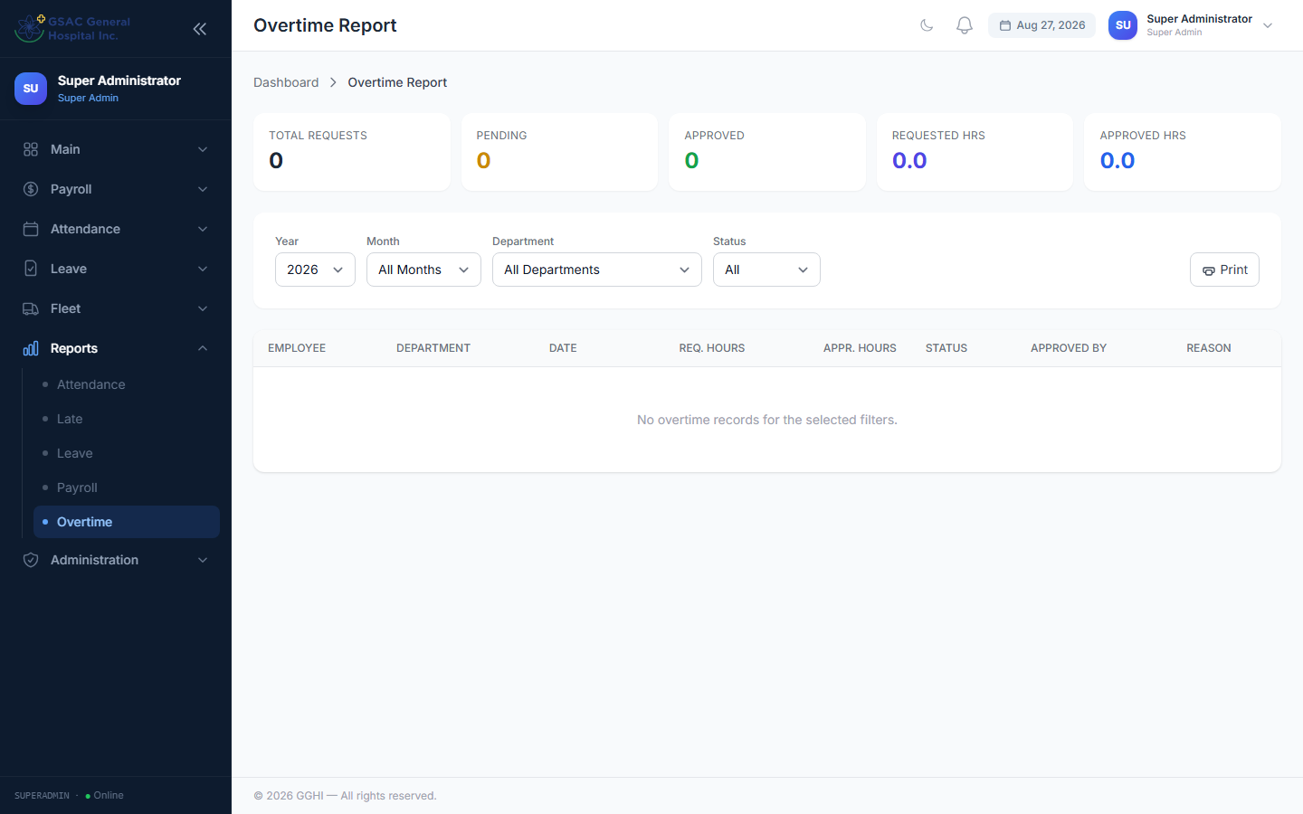
Figure 11. Overtime Report summary cards and filterable list.

5.4 How Overtime Affects Payroll
Only approved OT requests are paid — raw attendance beyond scheduled hours is never automatically counted as overtime. Approved OT hours are paid at 1.25× the hourly rate and added to the payslip’s gross pay (see Section 11).

6. Day Off Management
Access: Sidebar → Attendance → Day Offs (HR Admin and Super Admin only)
Day offs are individual rest days assigned to specific employees. They appear as "Day-off" in the attendance report and are not counted as absent days in payroll.

6.1 Auto-generate Standard Day Offs (Recommended)
Click the green Auto-generate button at the top of the page. Set a date range (e.g. the whole month) and click Generate.
The system reads each employee’s schedule and creates the correct day offs.
📌 Note: Already-assigned day offs are skipped. Run this once at the start of each month.

6.2 Adding a Single Day Off
Click Add Day Off, search for the employee, select the date and type, and click Save.

6.3 Recurring Day Offs
Click Add Day Off → switch mode to Recurring. Select the day(s) of the week and a date range. The system creates day off records for every matching weekday within the range.

6.4 Bulk Assign
Click Bulk Assign to assign recurring day offs to an entire department at once. Select the department, day(s), and date range.
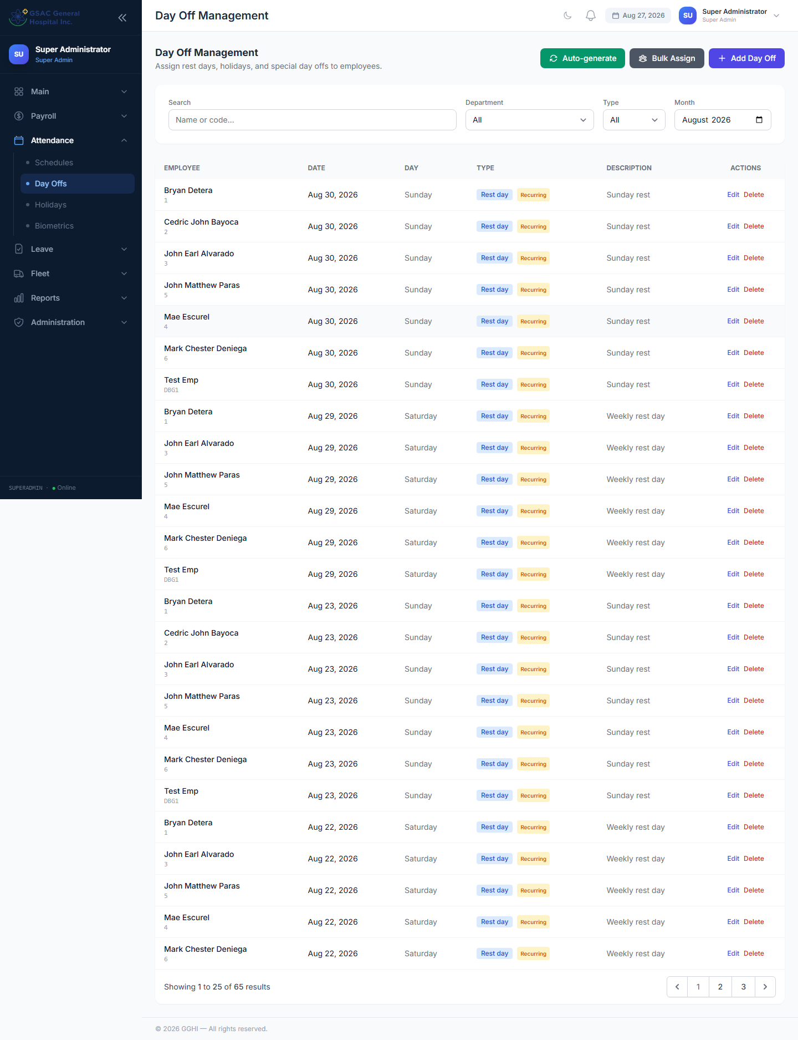
Figure 12. Day Off Management — auto-generate, add, or bulk-assign day offs.

7. Holiday Management
Access: Sidebar → Attendance → Holidays (HR Admin and Super Admin only)
Holidays are company-wide. One record applies to ALL employees automatically — no need to create per-employee records.

7.1 Adding a Holiday
Click Add Holiday and fill in the date, name, type (Regular Holiday / Special Non-Working Day), and whether it repeats every year (Recurring).

7.2 Holidays in Attendance
When attendance is processed for a holiday date, the status column will show the holiday name (e.g. "Christmas Day") instead of "Absent". Holiday days are excluded from the absent count in payroll.

7.3 Priority Order in Attendance
When processing a day, the system checks in this order:
- Holiday (company-wide) → shows holiday name
- Day-off (individual) → shows "Day-off"
- Approved Leave → shows leave type name (e.g. "Vacation Leave")
- Biometric punch records (plus any approved Time Correction) → shows Present / Late / Half-day / Incomplete
- Nothing found → shows "Absent"
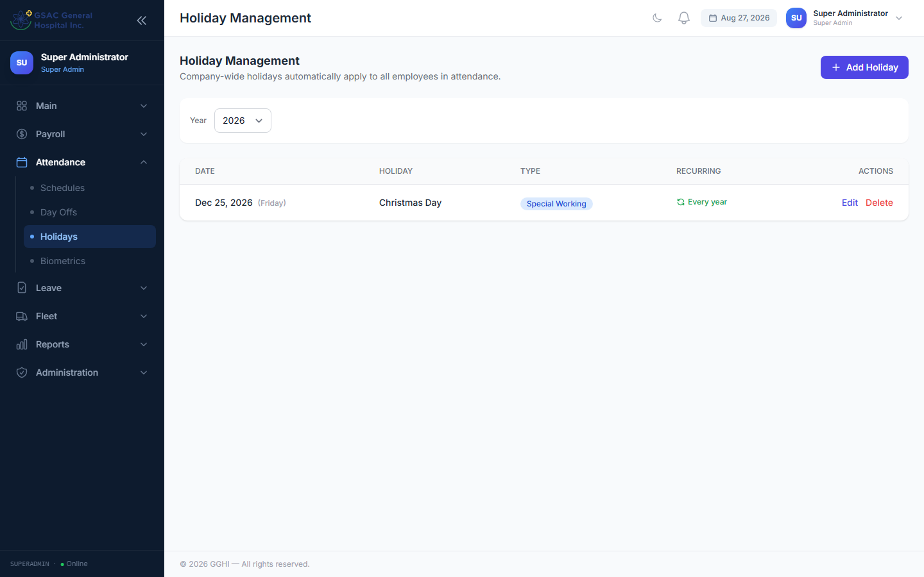
Figure 13. Holiday Management — company-wide holidays.

8. Attendance Reports
Access: Sidebar → Reports → Attendance

8.1 Viewing the Report
The report shows daily attendance for each employee within the selected date range. Use the filters at the top:
- From / To — date range (defaults to current month)
- Department — filter by a specific department
- Employee — search and select a specific employee
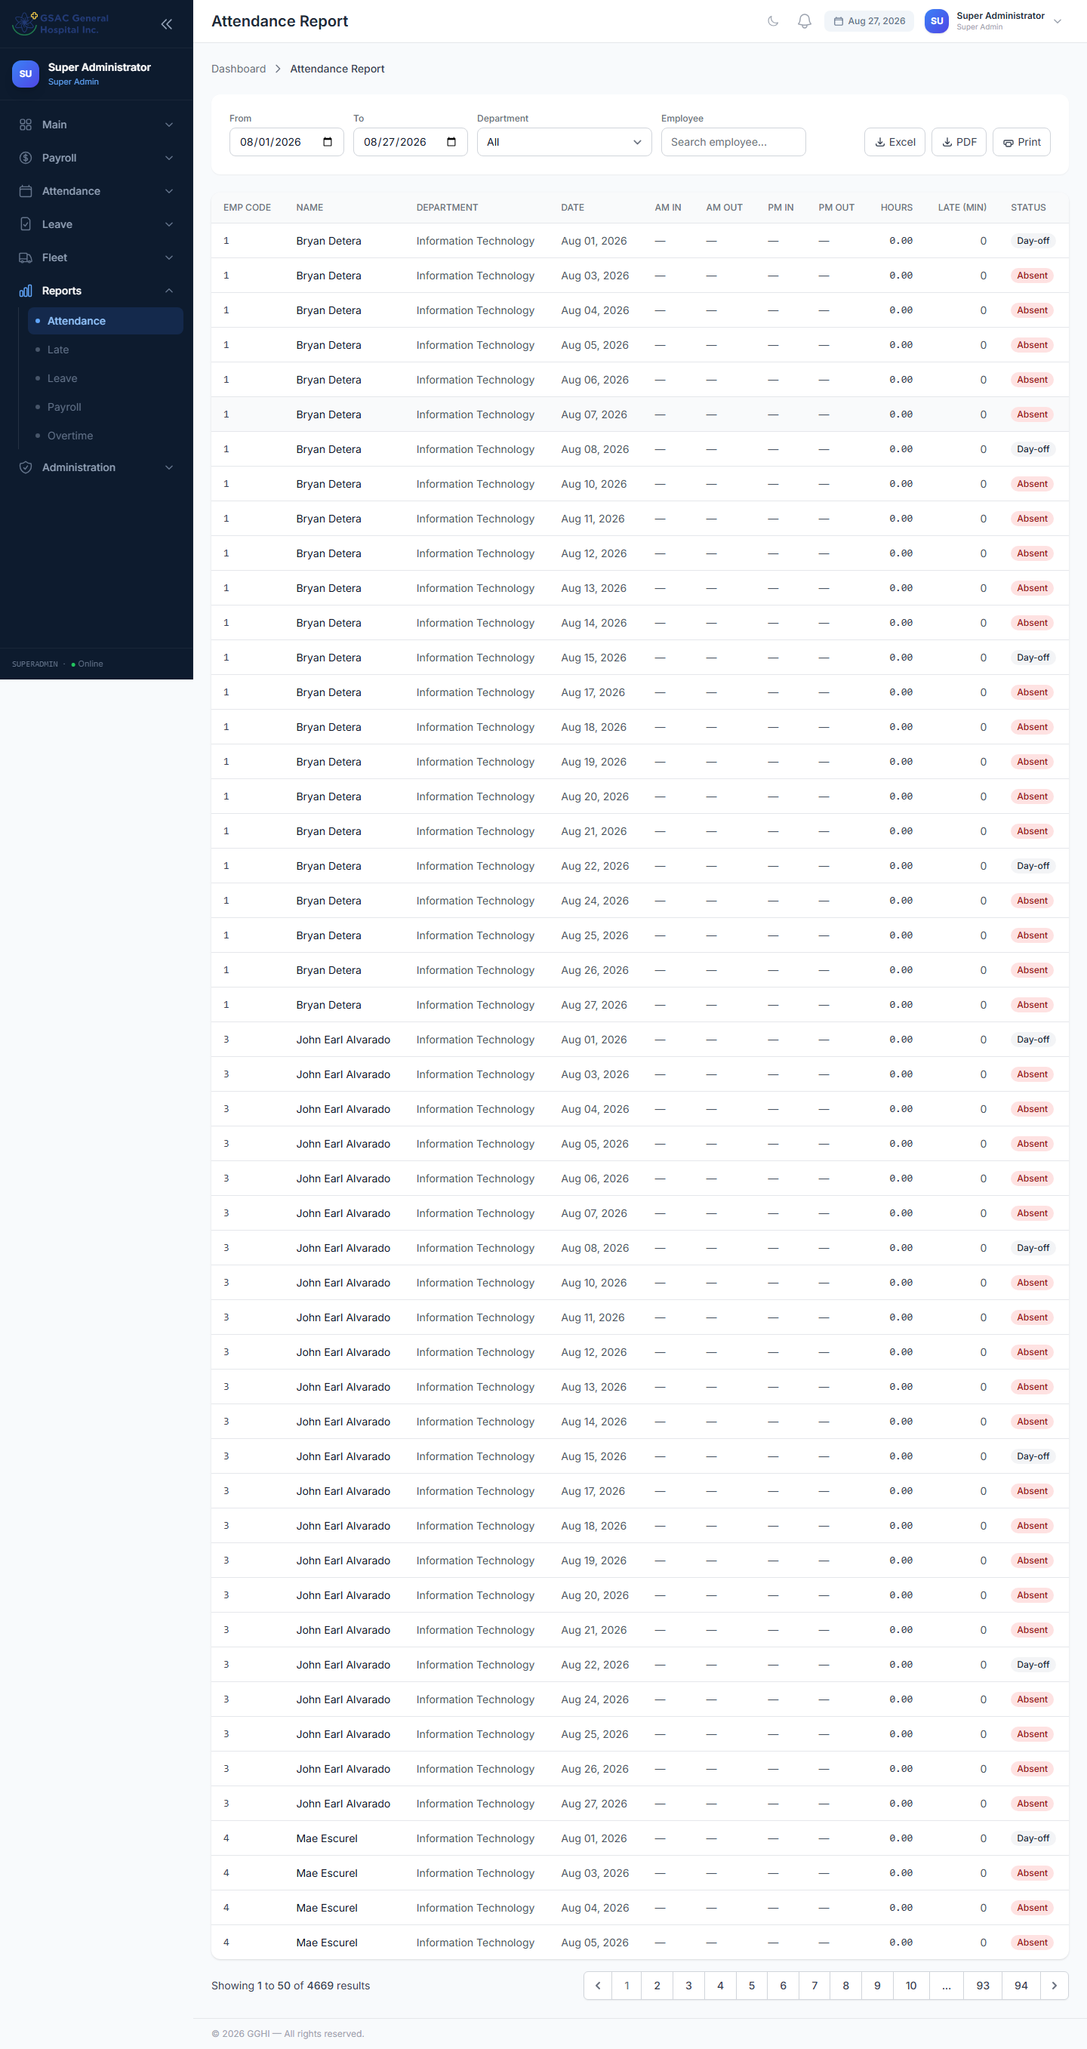
Figure 14. Attendance Report with date range, department, and employee filters.

8.2 Late Report
Access: Sidebar → Reports → Late
A focused view listing only employees who were late, with total late minutes for the selected period — useful for spotting recurring tardiness.
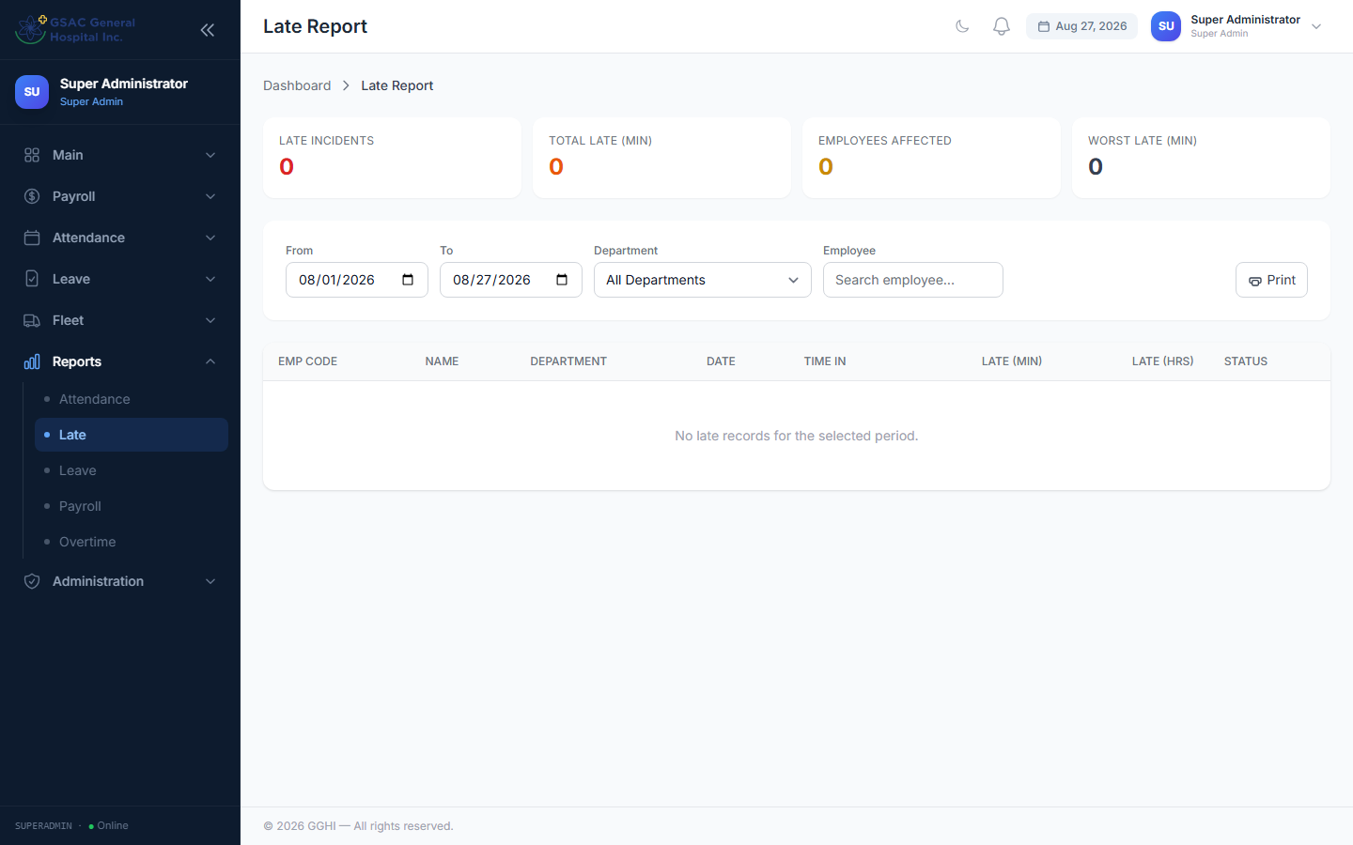
Figure 15. Late Report — employees with late punches and total late minutes.

8.3 Exporting
- Excel — downloads a .xlsx file of the current filtered report
- PDF — downloads a landscape PDF
- Print — opens the browser print dialog

9. Time Correction
Time Correction allows employees to request a fix for an incorrect or missing biometric punch. All corrections go through the same 3-step approval chain as leave requests before they take effect in attendance.

9.1 How to File a Time Correction (Employee)
Go to Sidebar → Attendance → Time Correction and fill in the form.
📌 Note: You only need to fill in the slot(s) that need correcting. Leave all other fields blank — the system will keep the original biometric record for those slots.
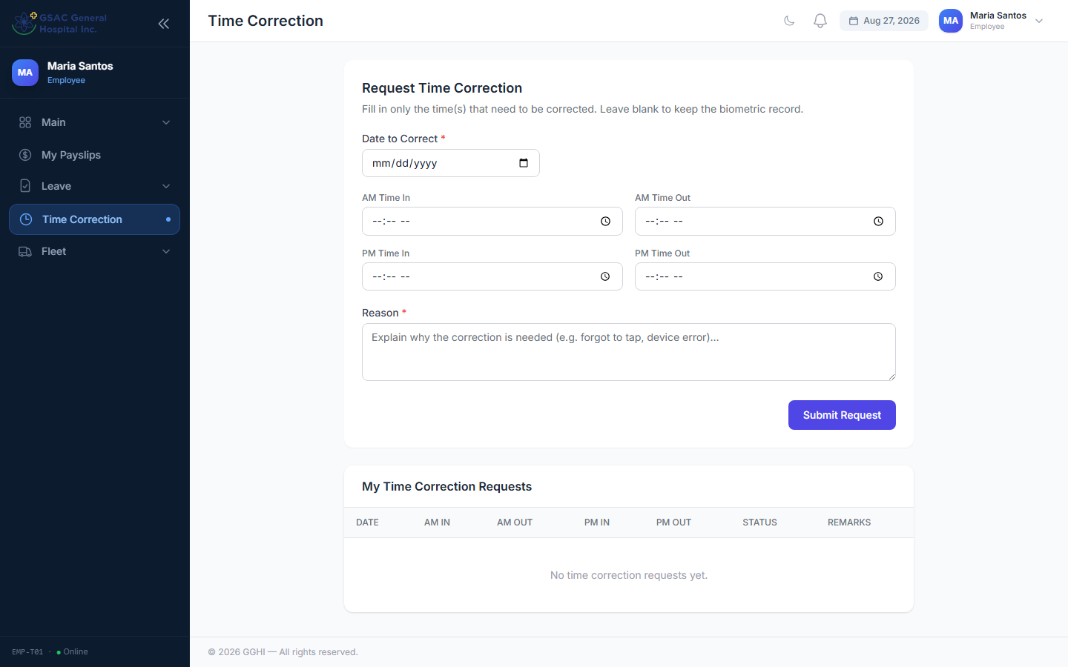
Figure 16. Filing a time correction request as an employee.

9.2 Approval Chain
Time corrections follow the same 3-step approval chain as leave requests (Department Head/Manager → HR → CEO/Medical Director).
📌 Note: A pending or rejected correction has NO effect on attendance. The correction only applies after it is fully approved at the final step.

9.3 Approving / Rejecting Time Corrections (Approver)
Access: Sidebar → Leave → Time Corrections
The page works identically to Leave Approvals — use the Pending filter to see requests waiting at your step, then Approve or Reject (a reason is required to reject).
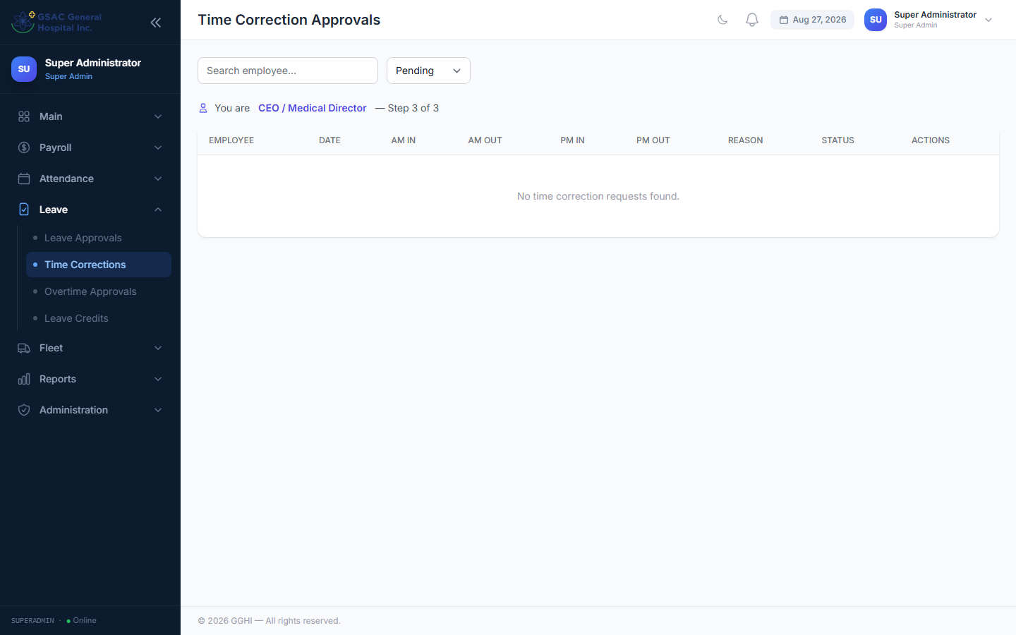
Figure 17. Time Corrections approval queue.

9.4 How Corrections Affect Attendance
Once fully approved, the correction is automatically merged with the biometric record:
- Corrected slots override the corresponding biometric punch
- Blank slots in the correction keep the original biometric value
- Hours worked, late minutes, and attendance status are recalculated using the corrected times
- The correction is visible in the Attendance Report immediately after approval

10. Fleet & Trip Tickets

10.1 How the Approval Chain Works
Every trip ticket request goes through up to three steps:
Step | Approver | What Happens
1 | Immediate Head (Manager / Department Head) | Approves that the trip is a legitimate business need
2 | HR Officer | Certifies driver fitness / availability
3 | Fleet (HR Admin or Super Admin) | Schedules the vehicle and driver, or denies the request

Requests filed by a Manager or Department Head skip Step 1 (start at Step 2). Requests filed by HR Admin or Super Admin skip straight to Step 3.

10.2 Requesting a Trip (Employee / Manager / Department Head / HR / Super Admin)
Access: Sidebar → Fleet → Request Trip
- Enter Destination From and Destination To
- Set the Departure Date/Time and expected Return Date/Time
- Select a Vehicle and Driver (if already known/available)
- Enter number of Passengers and the Purpose of the trip
- Click Submit
Track your submitted requests under Fleet → My Tickets.
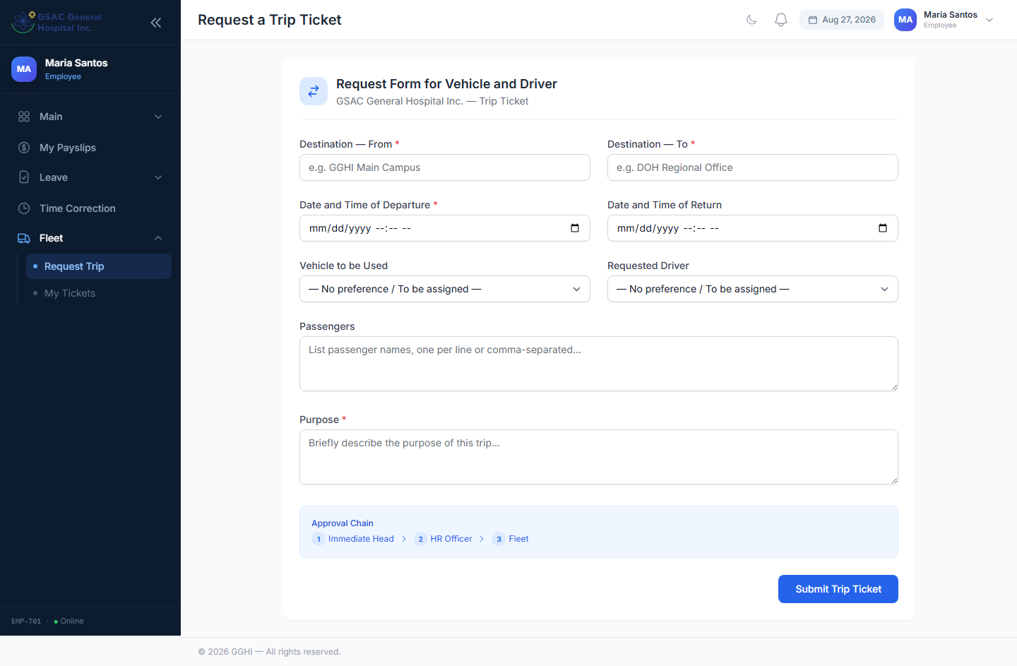
Figure 18. Requesting a vehicle trip ticket.

10.3 Approving Trip Requests
Access: Sidebar → Fleet → Trip Requests
Works the same way as Leave Approvals — the Pending filter only shows tickets waiting at your step. Approve to move it forward, or Reject with a reason.
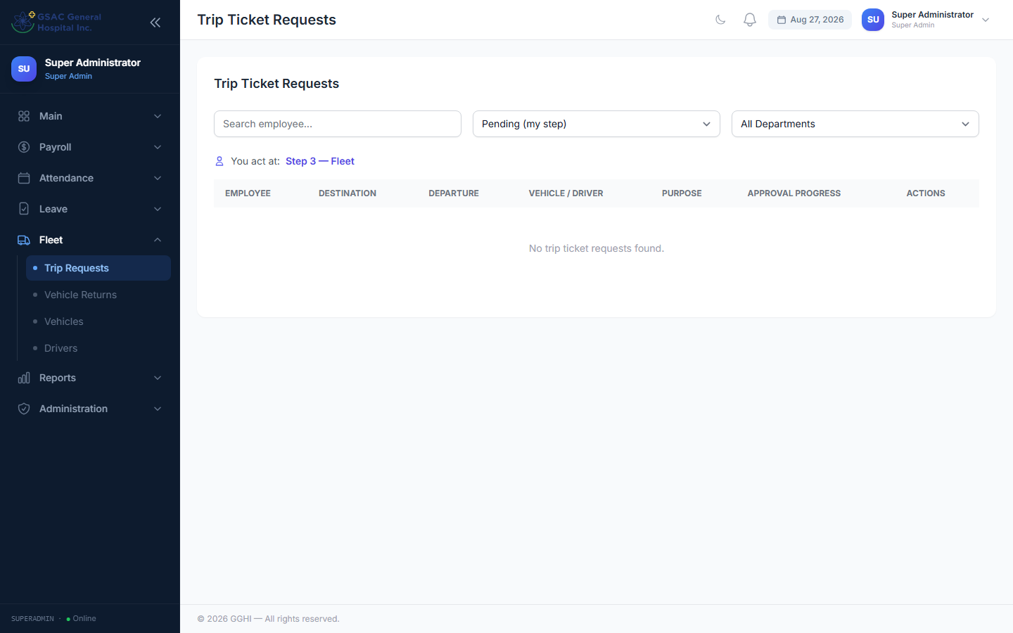
Figure 19. Trip Requests approval queue.

10.4 Vehicle Returns (Security Guard)
Access: Sidebar → Vehicle Returns (Security Guard, HR Admin, and Super Admin)
The Security Guard logs each vehicle as it departs and again when it returns:
- Ready to Depart — approved tickets waiting to leave the compound
- Currently Out — vehicles that have departed but not yet returned
- Recent Returns — a log of completed trips, with any return remarks
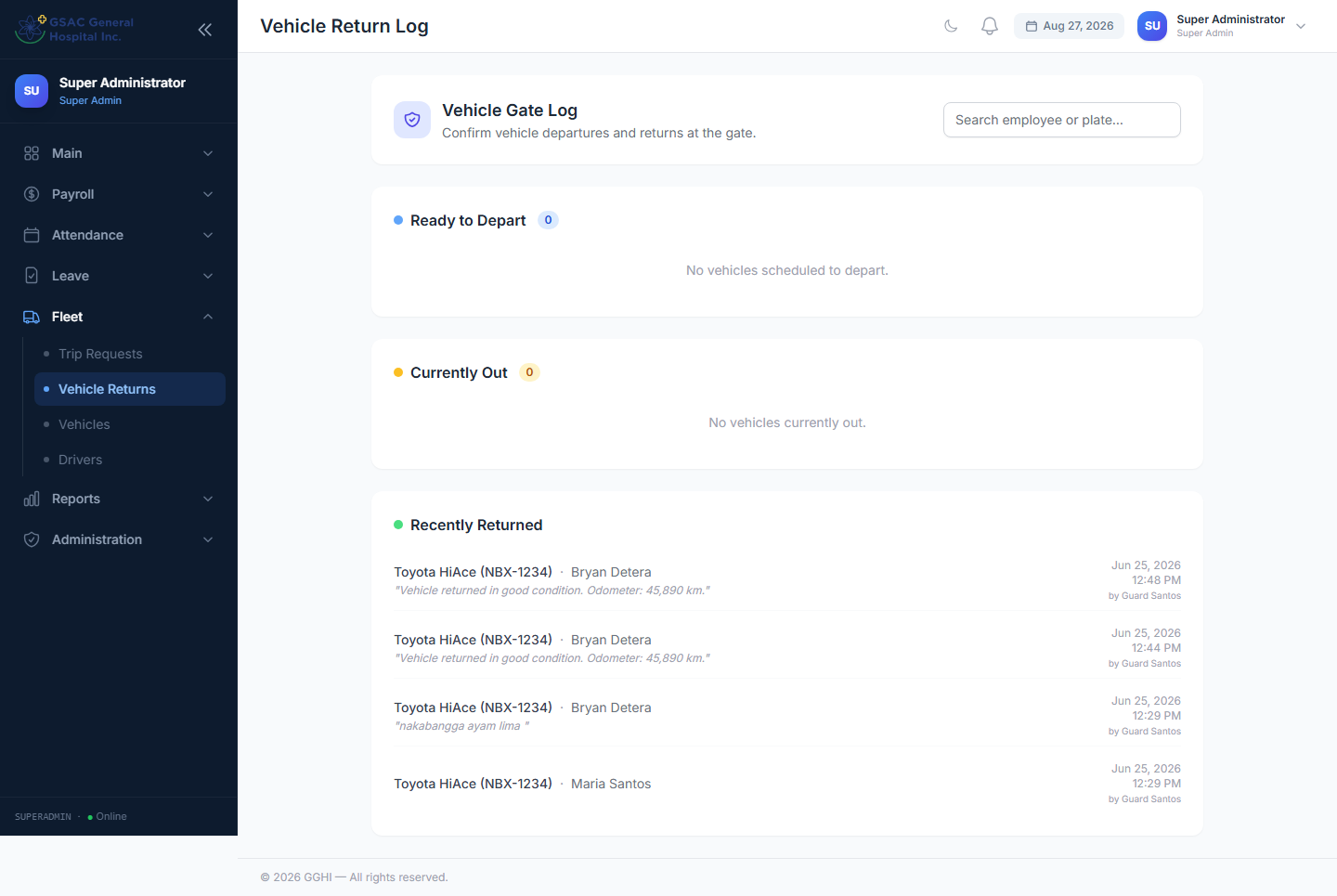
Figure 20. Vehicle Returns — Security Guard view of departures and returns.

10.5 Managing Vehicles and Drivers
Access: Sidebar → Fleet → Vehicles / Drivers (HR Admin and Super Admin only)
Add, edit, or deactivate the vehicles and drivers available for trip ticket assignment.
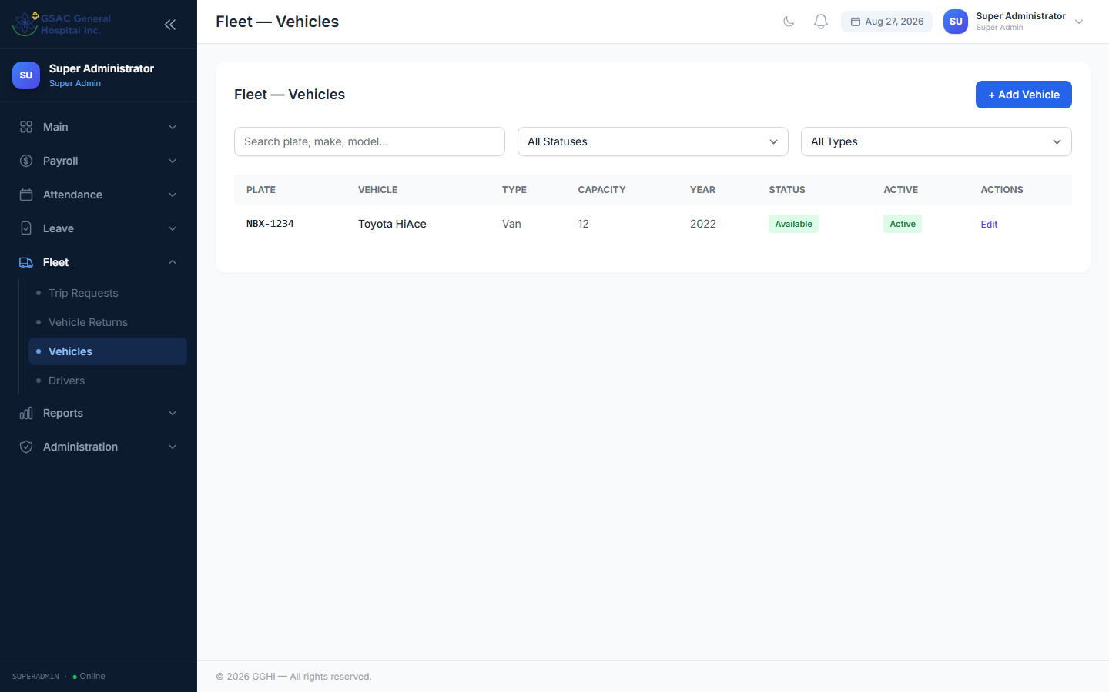
Figure 21. Fleet Vehicles management.
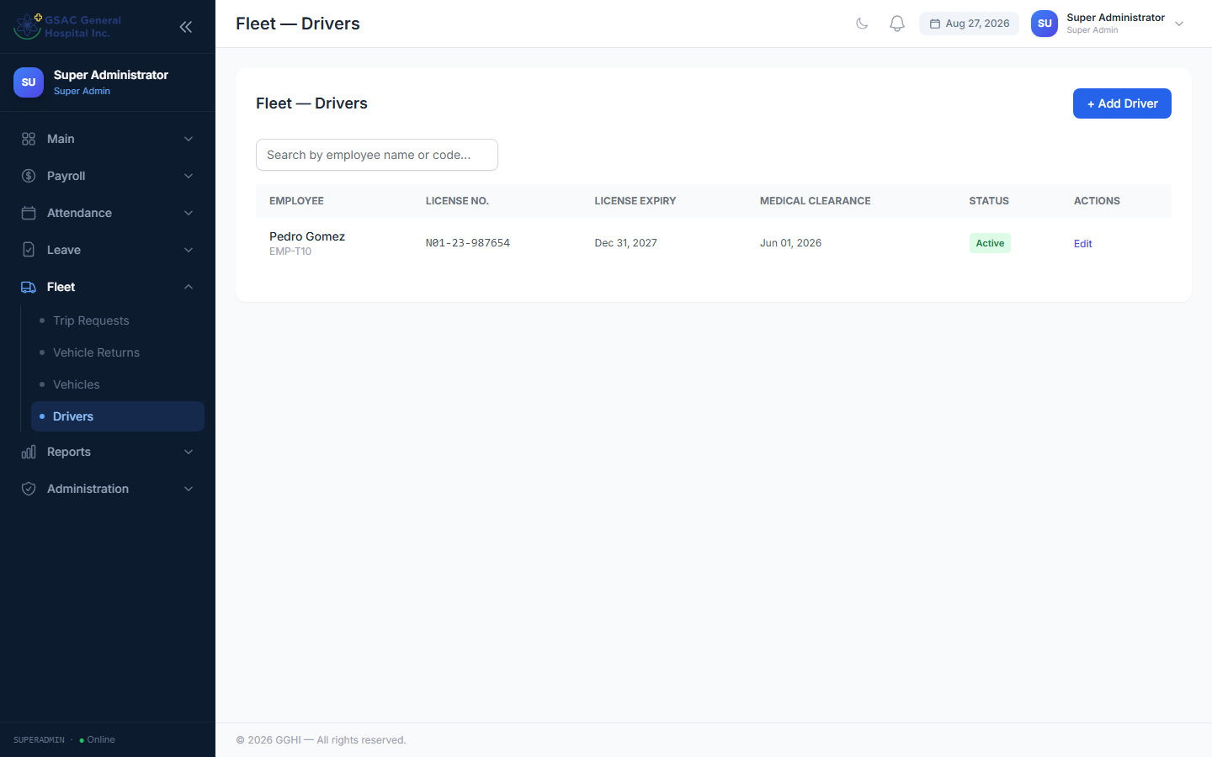
Figure 22. Fleet Drivers management.

11. Payroll Processing
Access: Sidebar → Payroll → Payroll (HR Admin and Super Admin only)
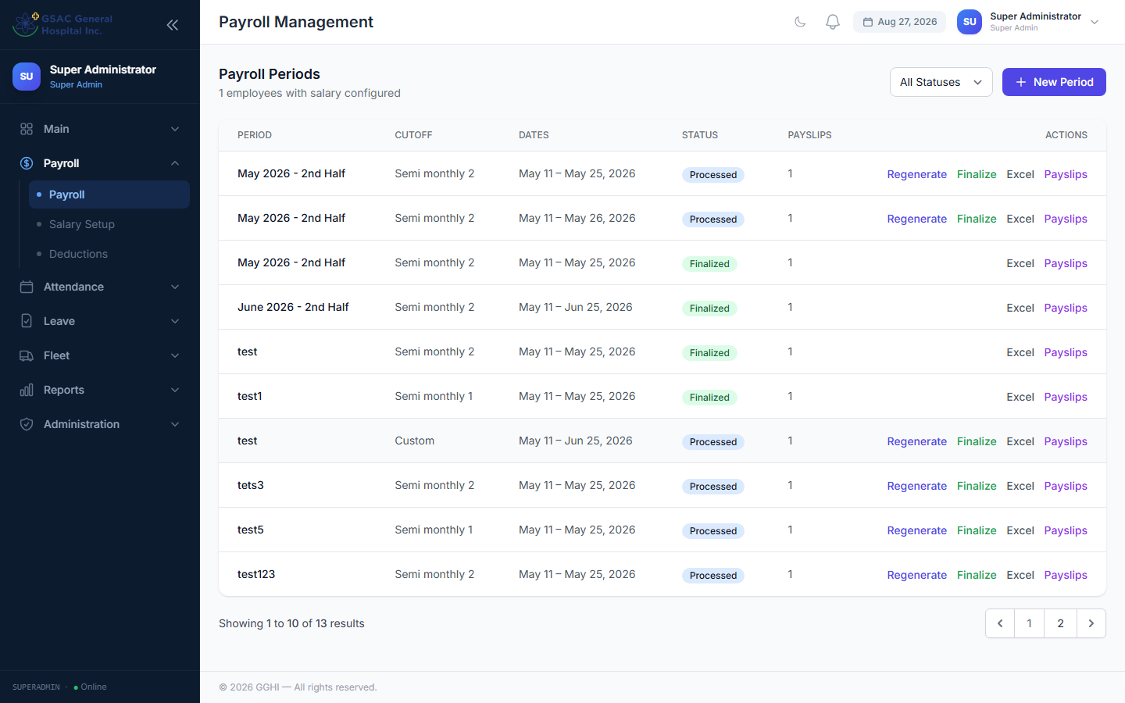
Figure 23. Payroll Processing — create periods, generate, and finalize payslips.

11.1 How Payroll Works (Standard Staff)
- Working days = scheduled working days in the period (excluding Sundays for regular staff, plus Saturdays for regular — Saturday counts for probationary; day-offs and holidays are always excluded)
- Days present = days with biometric punch records (or an approved time correction)
- Days absent = working days − days present − approved leave days
- Absent deduction = absent days × 8 hours × hourly rate
- Late/undertime deductions = late/undertime hours × hourly rate
- Overtime pay = approved OT hours × hourly rate × 1.25
📌 Note: Day-offs and holidays are NOT counted as absences. Employees are paid for their full scheduled working days minus any actual absences.

11.2 Creating a Payroll Period
Click Create New Period and select the type: 1st Half (1st–15th), 2nd Half (16th–end of month), Monthly, or Custom. The period name is auto-filled but can be edited. Click Create Period.

11.3 Generating Payslips
Once the period is created, click Generate Payslips. The system processes all active employees with salary setups in the background.
📌 Note: Refresh the page after a few seconds to see the processing status update to "Processed".

11.4 Finalizing Payroll
After reviewing all payslips, click Finalize to lock the payroll period. Finalized payroll cannot be regenerated.
📌 Note: Only periods with status "Processed" can be finalized.

11.5 Salary Setup
Access: Sidebar → Payroll → Salary Setup
Set the basic salary, daily rate, hourly rate, and allowances (hazard pay, rice allowance, medical allowance, commodity allowance, other allowance) for each employee.
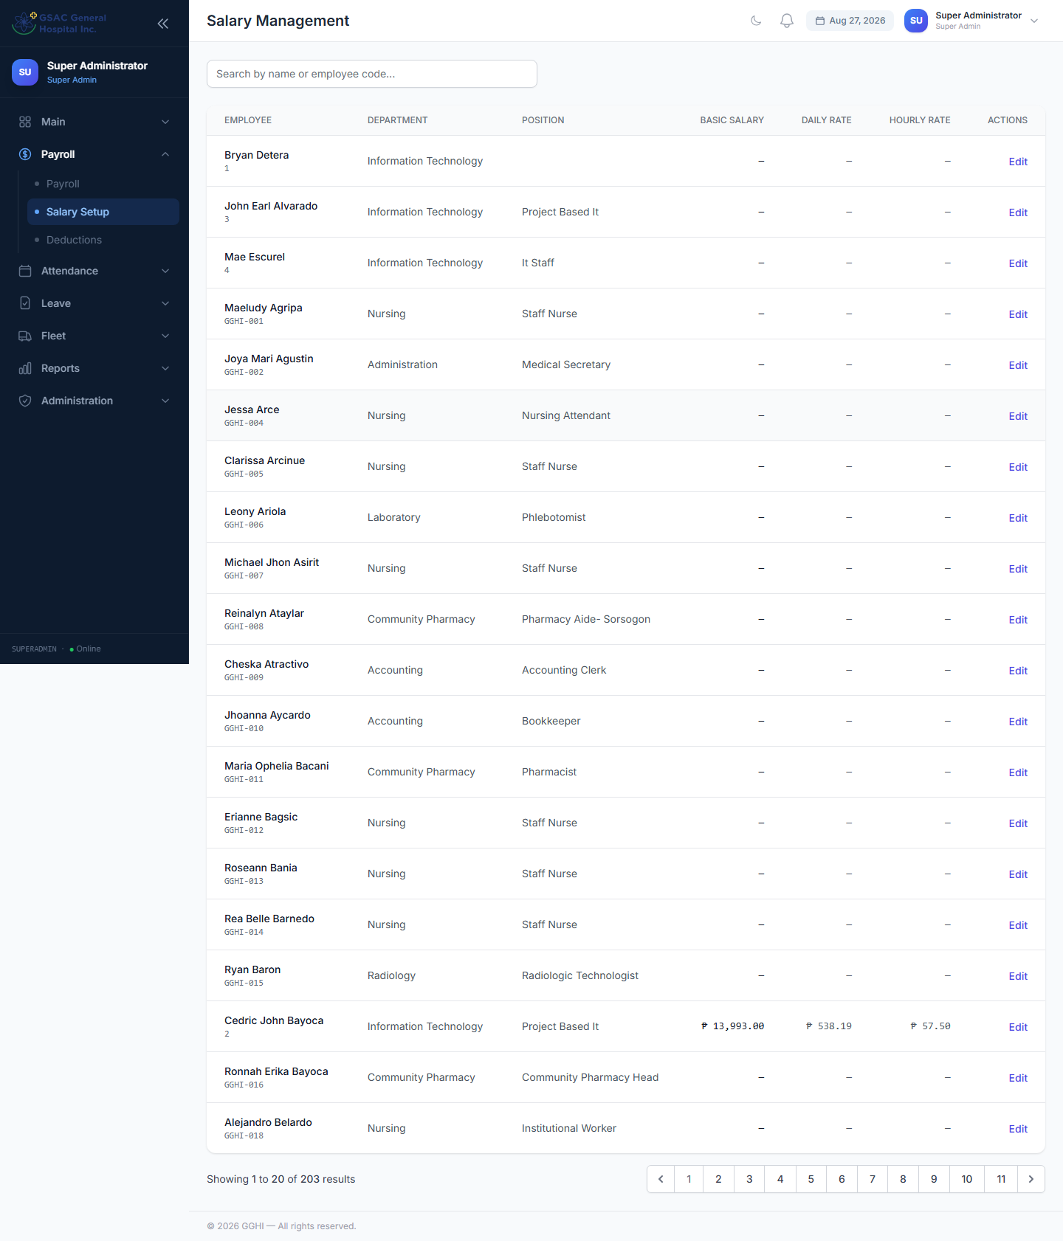
Figure 24. Salary Setup — basic salary, rates, and allowances per employee.

11.6 Employee Payslips
Employees view their own payslip history at Sidebar → Payslips, and can download any payslip as a PDF. HR Admin and Super Admin can download or regenerate any employee’s payslip PDF directly from the Payroll page.
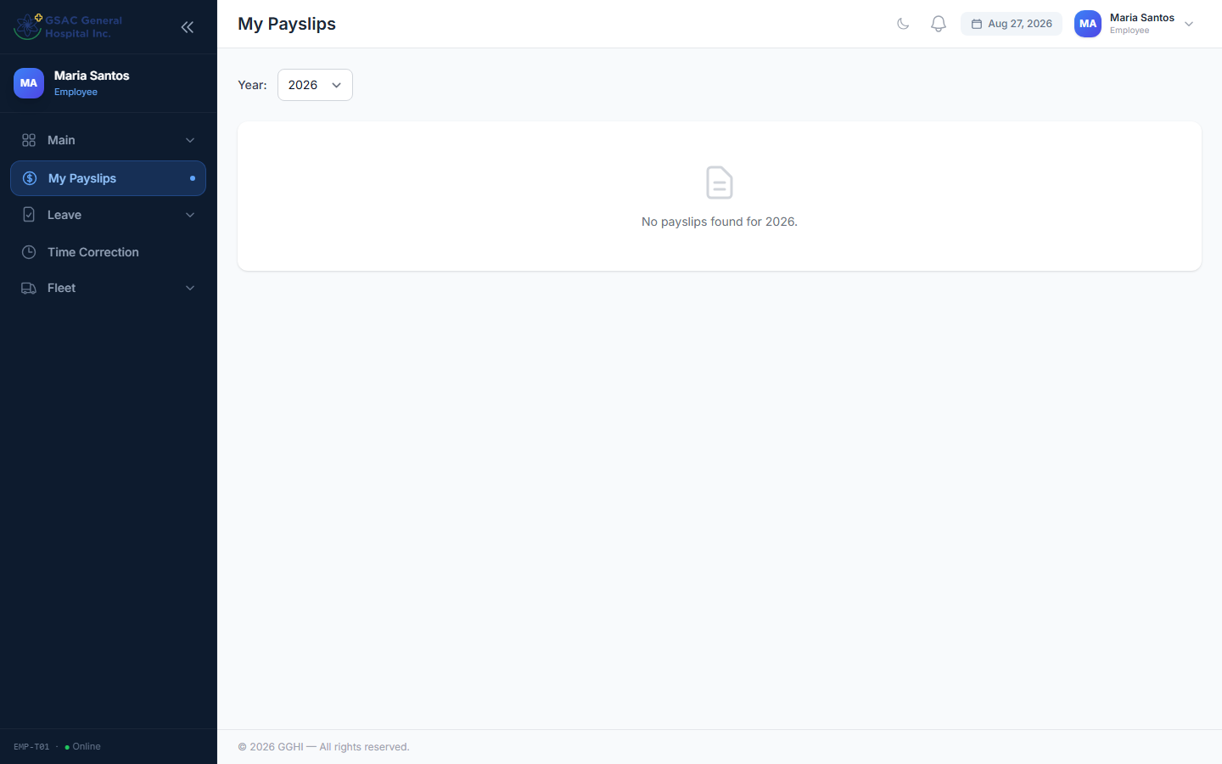
Figure 25. Employee payslip history, with PDF download.

11.7 Required-Hours Payroll Rule for Nursing Staff
Nursing staff (Department = "Nursing") rotate across 8, 9, 12, and 13-hour shifts, so the standard "scheduled weekdays" calculation used for office staff does not apply to them. Instead, each nurse is held to a fixed required-hours quota per cutoff:
Employment Type | Normal Cutoff | 2nd-Half Cutoff of a 31-Day Month
Regular | 88 hours | 96 hours
Probationary | 104 hours | 112 hours

The higher figure applies only to the 2nd-half cutoff (16th–end of month) when that month has 31 days — the extra day 31 adds one more 8-hour shift to the quota. The 1st-half cutoff always uses the normal figure.
Basic pay is based on the required-hours quota. If a nurse’s total clocked hours for the cutoff (plus approved leave, credited at 8 hours/day) fall short of the quota, the shortfall is deducted at the hourly rate — the same way absent days are deducted for office staff.
📌 Note: This rule is applied automatically during payslip generation based on the employee’s Department and Employment Type — no extra setup is needed beyond making sure both fields are set correctly on the employee record.

12. Biometrics Management
Access: Sidebar → Attendance → Biometrics (HR Admin and Super Admin only)
This page connects the HR Portal to the biometric time-clock device (ZKTeco) used for attendance.
- Test Connection — verifies the portal can reach the configured device
- Sync Users — pulls the list of enrolled users from the device and matches them to employee records
- Sync Attendance — pulls new punch logs from the device into the portal
- Recent Sync Logs — shows the history and result of each sync run
If a device user does not match an existing employee automatically, use the account-matching action next to that user to link it manually.
📌 Note: Run Sync Attendance regularly (or confirm your scheduled sync job is running) so attendance and payroll always reflect the latest punches.
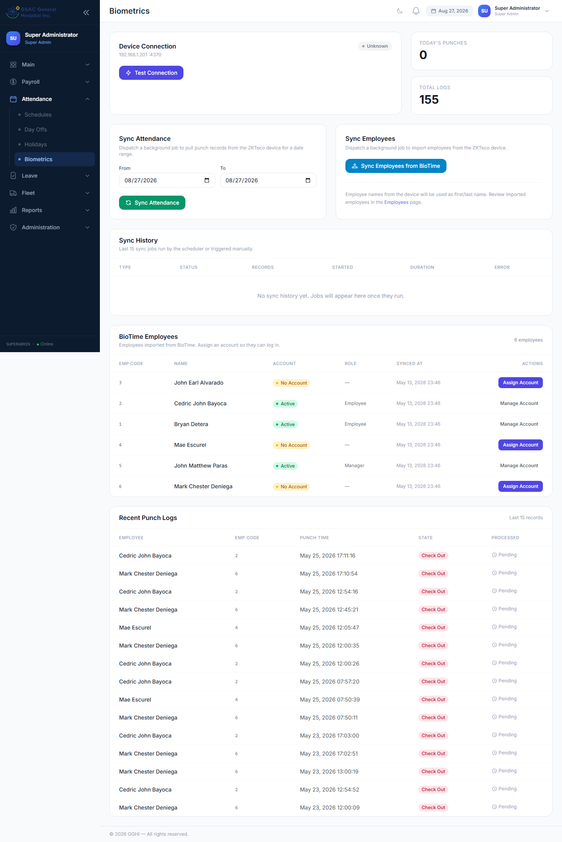
Figure 26. Biometrics — sync users and attendance from the ZKTeco device.

13. Nursing Duty Roster (Head Nurse)
Access: Sidebar → Duty Roster (Head Nurse role only; also reachable by Super Admin)
The Duty Roster is a day-by-day scheduling grid for the Nursing department. Unlike the Schedules page (which assigns one shift template to an employee for a date range), the Duty Roster lets the Head Nurse assign a different shift to each nurse for each individual date — the way hospital shift rotations actually work.

13.1 Reading the Grid
Rows are active nurses (Department = "Nursing"); columns are the dates of the selected month. Use the arrow buttons to move between months. Each cell shows one of three states:
Cell Shows | Meaning
A shift name (blue = day shift, purple = night shift) | The nurse is assigned to that shift template on that date
OFF | The nurse has been explicitly marked off duty that date
— (dash) | Not yet scheduled — no decision has been made for that date

13.2 Assigning a Shift
- Click any cell for the nurse and date you want to set
- Choose a shift from the dropdown (only active Nursing shift templates are listed), or choose "OFF (no shift)" to mark the nurse off duty
- Click Save
📌 Note: The Head Nurse assigns nurses to shift templates that HR/Admin has already set up under Attendance → Schedules. The Head Nurse cannot create or edit the shift templates themselves.

13.3 Clearing a Cell
Open the cell and click Clear to remove the assignment entirely, reverting it back to "not scheduled" (the dash). This is different from marking a nurse OFF — use Clear when a date simply has not been planned yet.

13.4 What the Roster Does Not Do (Yet)
The Duty Roster is currently a planning tool only. It does not yet cross-check actual biometric punches against the assigned shift, and it is separate from the required-hours payroll quota described in Section 11.7 — payroll is still driven by actual attendance records, not by what is planned on the roster.

14. Roles & Permissions and User Accounts

14.1 User Accounts
Access: Sidebar → Administration → User Accounts (Super Admin only)
Create or edit login accounts for any role, including the roles not offered on the Employee Management page — department_head, approver, security_guard, and head_nurse. You can also activate/deactivate accounts and reset passwords here.
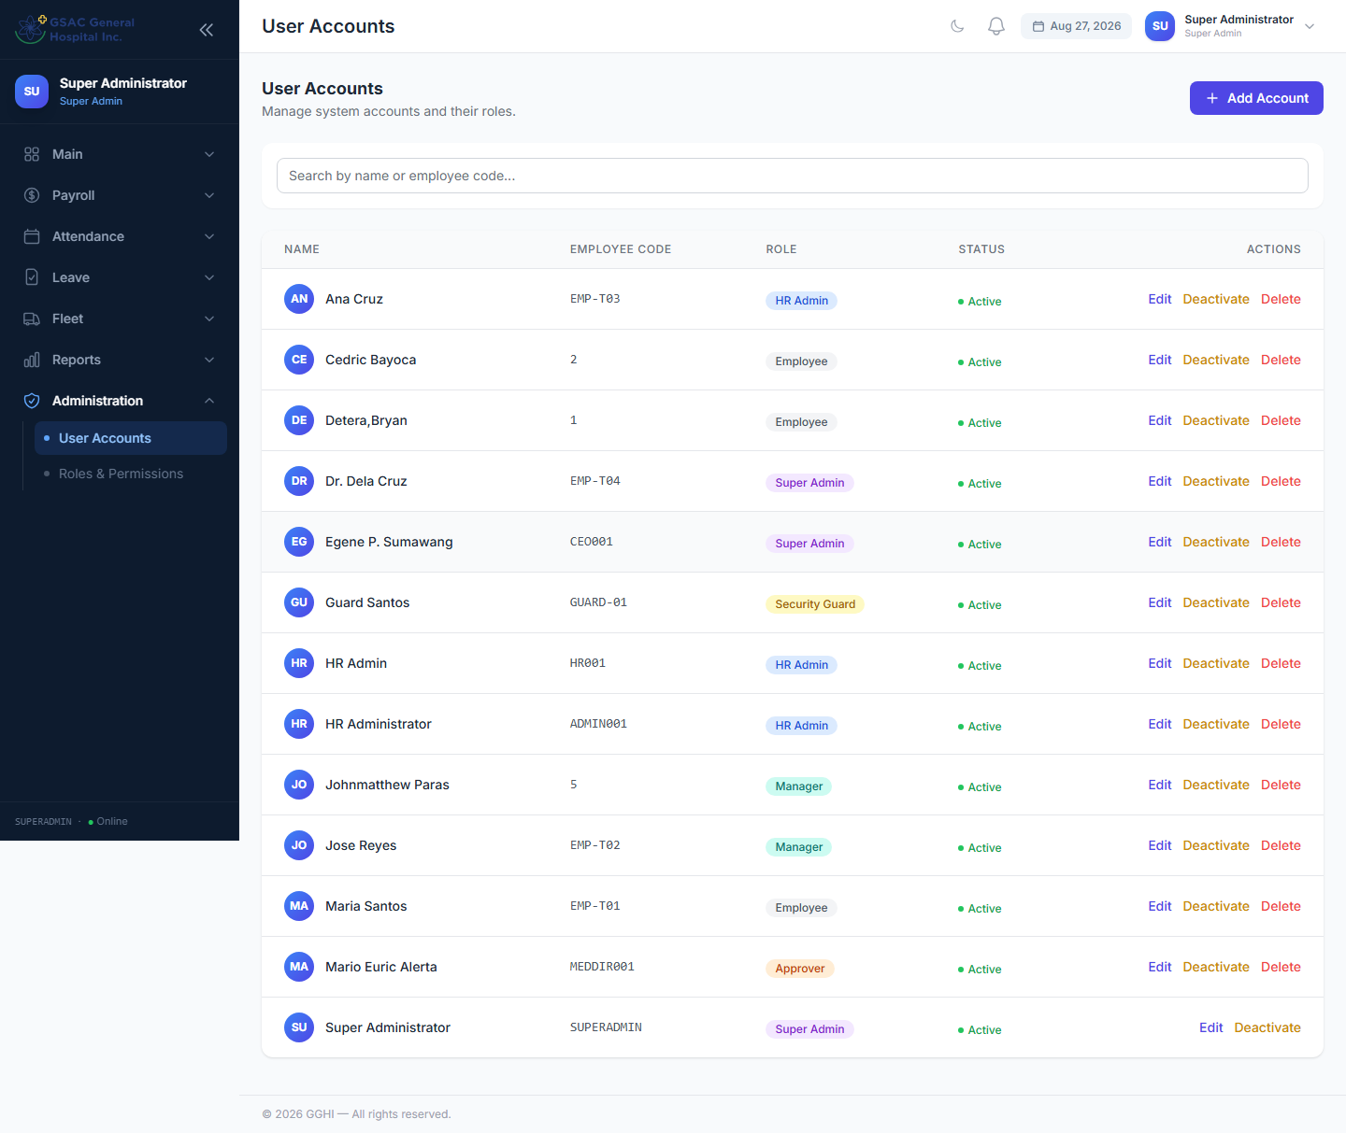
Figure 27. User Accounts — create and manage login accounts for any role.

14.2 Managing Roles
Access: Sidebar → Administration → Roles & Permissions (Super Admin only)
The left panel shows all roles. Click a role to view and edit its assigned permissions. Use the checkboxes to grant or remove permissions, then click Save Permissions.
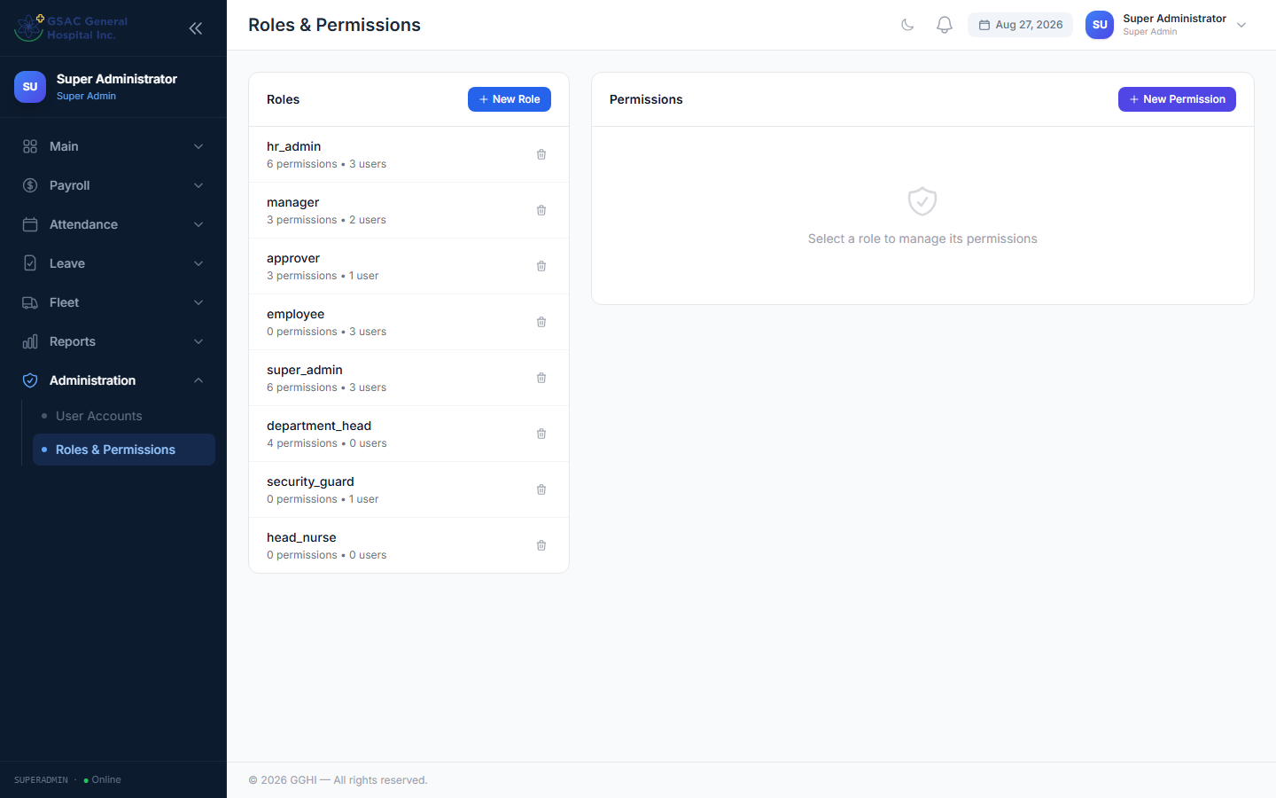
Figure 28. Roles & Permissions — assign fine-grained permissions per role.

14.3 Creating New Roles
Click Create Role, enter a role name, then assign permissions. Note: a brand-new role created here grants fine-grained permissions, but pages that check for a specific role name in the URL (like the Duty Roster) will still need that role name added to the relevant route by a developer before the new role can access it.

15. SMS Notifications

15.1 How It Works
The system sends an SMS to the employee’s registered cell number automatically when:
- Their leave request is APPROVED (final step only)
- Their leave request is REJECTED (at any step)
The SMS comes from "GGHI HR" and includes the leave type, dates, and status.

15.2 Setting Up Cell Numbers
Go to Employees → Edit an employee → enter the mobile number in the Cell Number field. Accepted formats: 09171234567, 639171234567, or +639171234567.
📌 Note: SMS is silently skipped if the employee has no cell number on file. No error is shown.

15.3 SMS Examples
Approved:
"GGHI HR: Hi Juan, your Vacation Leave request (Jun 26, 2026 - Jun 26, 2026) has been APPROVED. Thank you."
Rejected:
"GGHI HR: Hi Juan, your Vacation Leave request (Jun 26, 2026 - Jun 26, 2026) has been REJECTED. Reason: Insufficient staffing."

16. Frequently Asked Questions
Q: Why does the leave approvals page show no requests?
A: The Pending filter only shows requests waiting at YOUR approval step. If you are HR (step 2), you will only see requests that have already been approved by the Department Head. Switch the Status filter to "All" to see everything.
Q: An employee shows as Absent even though they were on approved leave.
A: The leave must be FULLY APPROVED (all 3 steps) before it reflects in attendance. If the leave is still pending at any step, the attendance report will show Absent until the final approval is given.
Q: How do I add a national holiday like Christmas or New Year?
A: Go to Attendance → Holidays → Add Holiday. Enter the date (e.g. Dec 25), name (Christmas Day), type (Regular Holiday), and check "Recurring every year". This will automatically apply every December 25 in future years.
Q: Why is an employee's payslip showing absent deductions on their day off?
A: Make sure the day off is recorded in Attendance → Day Offs before generating payslips. Alternatively, run the Auto-generate button at the start of each month.
Q: What is the difference between a Day Off and a Holiday?
A: A Day Off is assigned to a specific employee (their personal rest day). A Holiday is company-wide and applies to all employees automatically.
Q: Can an employee view their own payslip?
A: Yes. Go to Sidebar → Payslips to view all payslip history and download any payslip as a PDF.
Q: How do I reset an employee's password?
A: Go to Employees → click Account next to the employee → enter a new password under Reset Password → click Reset. Inform the employee of their new password.
Q: Why can't I see the Roles & Permissions page?
A: This page is only available to users with the super_admin role. HR admins do not have access to this page.
Q: How do I create a Head Nurse account?
A: Go to Administration → User Accounts (Super Admin only) and create a new account with the head_nurse role. Make sure the matching employee record's Department is set to "Nursing" so the Duty Roster lists the correct staff.
Q: Why doesn't a nurse show up on the Duty Roster?
A: The Duty Roster only lists employees whose Department is exactly "Nursing" and who are marked Active. Check both fields on the employee's record under Employee Management.
Q: Does marking a nurse OFF on the Duty Roster affect their pay?
A: Not directly. The Duty Roster is a planning tool; payroll for Nursing staff is still driven by actual biometric attendance compared against the required-hours quota (Section 11.7), not by what is marked on the roster.
Q: An SMS was not sent after approving a leave.
A: Check that the employee has a cell number saved in their profile. Also verify the SMS API key is configured in the system settings, and check the application logs for any errors.
Q: I submitted a time correction but my attendance still shows Absent.
A: The time correction must be FULLY APPROVED before it affects attendance. Check the status under Attendance → Time Correction.
Q: Can I file more than one overtime request for the same date?
A: No — only one pending or approved OT request is allowed per date. If a previous request was rejected or cancelled, you may submit a new one for that date.

17. Deductions Management
Access: Sidebar → Payroll → Deductions (HR Admin and Super Admin only)
Deductions Management assigns recurring per-cutoff deductions to individual employees — government contributions, company/agency loans, benefit-related deductions (e.g. HMO, uniform), and any other deduction. Each assignment is built from a Deduction Type.

17.1 Deduction Types and Categories
Click Manage Types to view or edit the list of reusable deduction types. Each type has a code, a name, and a category: government, loan, benefit, or other. Only ACTIVE types appear in the “Add Deduction” dropdown — a type must be switched to Active before it can be assigned to an employee.

17.2 Assigning a Deduction to an Employee
- Click Add Deduction
- Search for and select the employee
- Choose the Deduction Type (e.g. an SSS Loan, a Pag-IBIG MP2 savings deduction, Cash Advance)
- Enter the Amount per Cutoff and choose the Cutoff Schedule (1st, 2nd, or both)
- For loan-category types, also enter the Remaining Balance — required so the loan can be tracked down to ₱0.00
- Click Save
📌 Note: Loan-type deductions (SSS Loan, Pag-IBIG Fund Loan, Cooperative Loan, Cash Advance, etc.) require a Remaining Balance. Savings-type deductions (e.g. Pag-IBIG MP2 Savings, Cooperative Savings) and other non-loan categories do not.

17.3 Managing Existing Deductions
Use the Search, Type, Department, and Status filters to find a specific deduction. Deactivate stops a deduction from being applied to future payroll runs without deleting its history; Delete removes the record entirely.
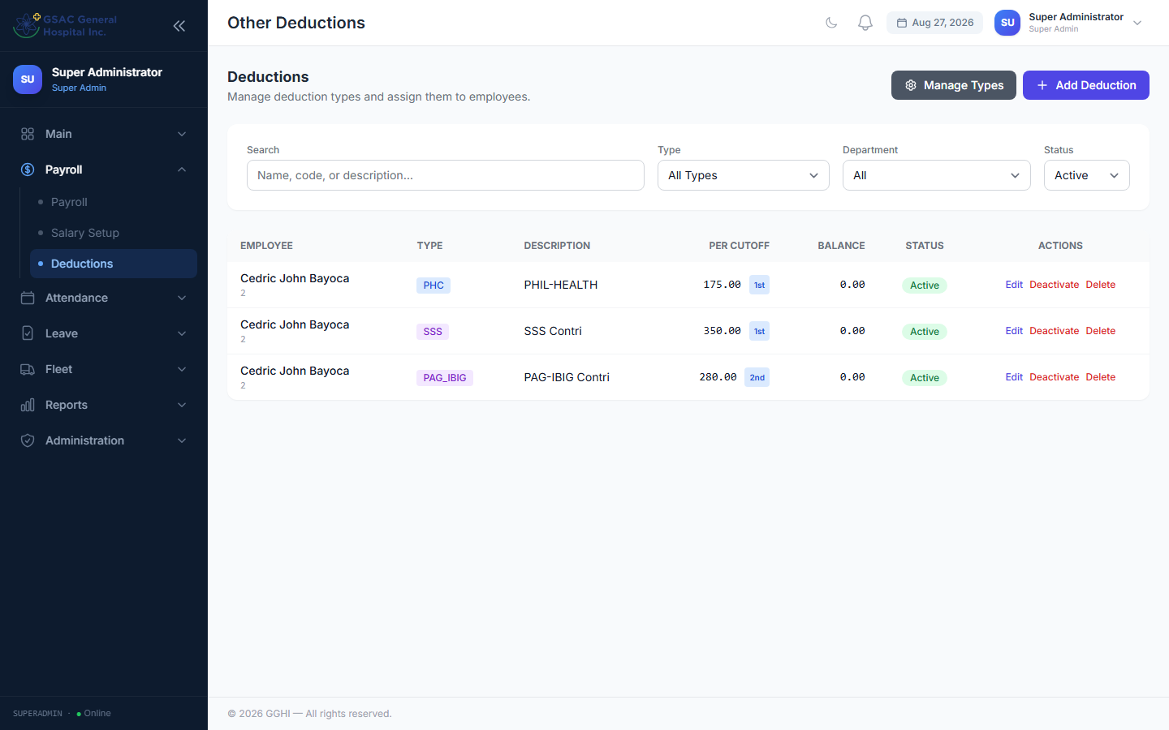
Figure 29. The Deductions page — assigned deductions with type, amount, balance, and status.

18. Shift Schedules
Access: Sidebar → Attendance → Schedules (HR Admin and Super Admin only)
Schedules assign a shift template (e.g. a fixed 8-hour office shift, or an 8/9/12/13-hour nursing shift) to an employee for a date range. This is different from the Nursing Duty Roster (Section 13), which lets the Head Nurse assign a different shift per nurse per individual date.
- Click Add Schedule, select the employee, the shift template, and the date range, then Save
- Edit or deactivate an existing schedule from the list
📌 Note: An employee's active schedule determines their expected working hours for payroll and late/undertime calculations.
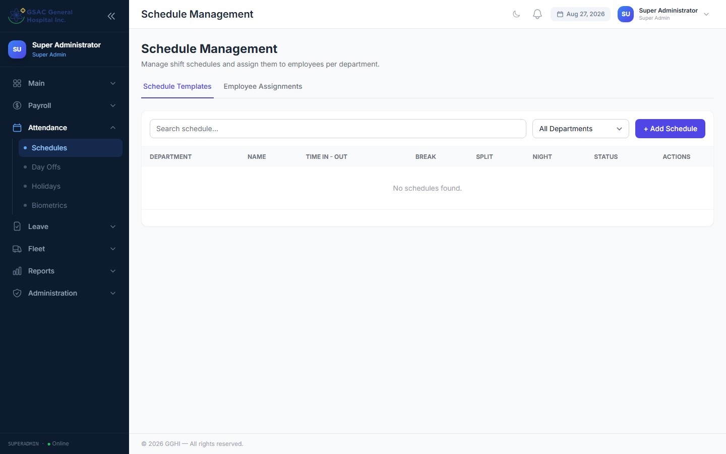
Figure 30. Shift Schedules — assigning shift templates to employees for a date range.

19. Departments & Positions
Departments and Positions are the two reference lists used throughout the system — on the employee record, in report filters, and (for the “Nursing” department specifically) to drive the Duty Roster in Section 13.

19.1 Departments
Access: Sidebar → Main → Departments (HR Admin and Super Admin only)
Add, rename, or deactivate departments. Deactivating a department does not affect employees already assigned to it.
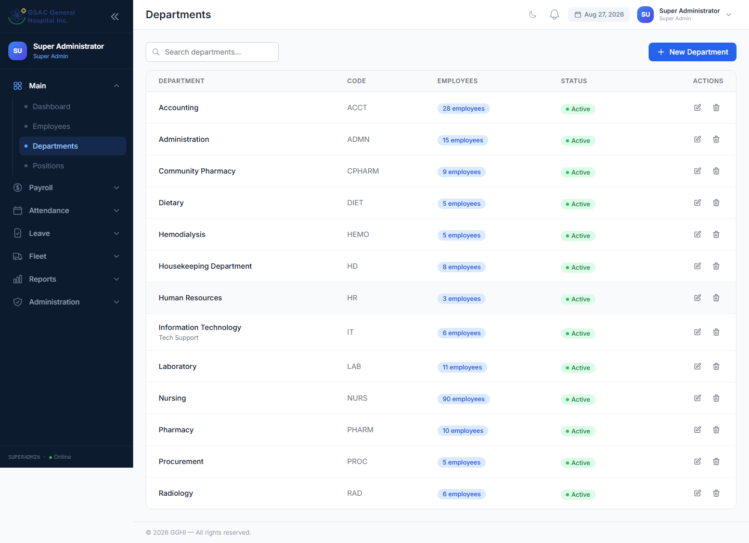
Figure 31. Departments — the list of departments used across the system.

19.2 Positions
Access: Sidebar → Main → Positions (HR Admin and Super Admin only)
Add, rename, or deactivate job positions/titles assigned to employees.
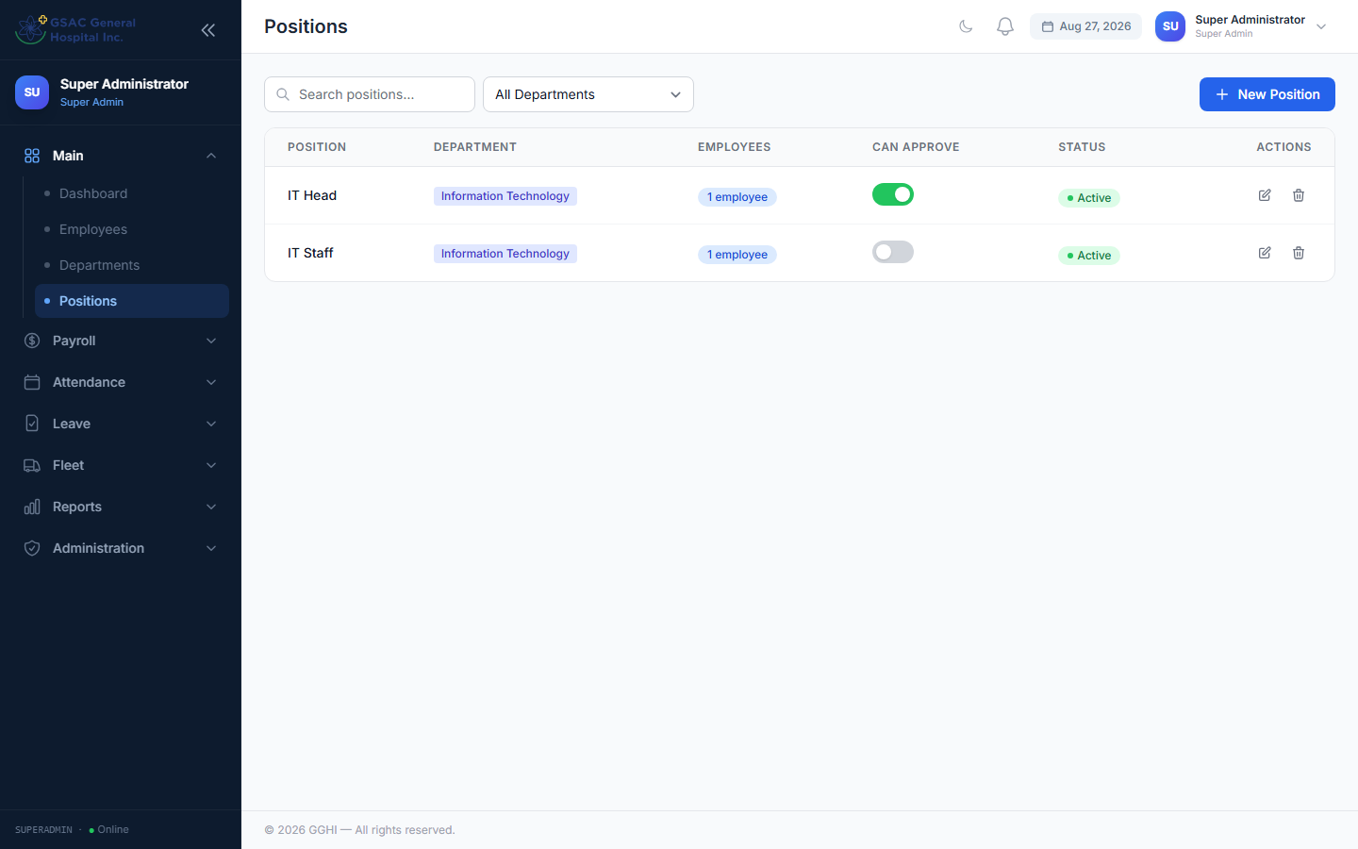
Figure 32. Positions — the list of job positions/titles used across the system.

Quick Reference Card
Print this page and keep it at your desk.

Monthly HR Checklist
- ☐ Start of month: Run Auto-generate Day Offs (Attendance → Day Offs → Auto-generate)
- ☐ Add any public holidays not yet in the system (Attendance → Holidays)
- ☐ Build/confirm the Nursing Duty Roster for the upcoming month (Duty Roster — Head Nurse)
- ☐ Process payroll for the 1st cutoff (1st–15th) on the 16th
- ☐ Process payroll for the 2nd cutoff (16th–end) at month end
- ☐ Review and finalize both payroll periods
- ☐ Export payroll to Excel and submit to accounting
- ☐ Monitor leave credits — top up as needed (Leave → Leave Credits)

Support
For technical issues or questions about the system, contact your IT Department or System Administrator.

