GSAC GENERAL HOSPITAL INC.
HR Portal
Complete user guide for every role

Covers: employees, department heads and managers, HR, the Medical Director, the CEO / Super Admin, the Head Nurse and Security Guards.
Version: October 2026

Note: All screenshots use sample accounts and made-up data. They do not show real employees or real pay.
Contents
Part 1. Getting started 4
1.1 Who uses the portal 4
1.2 Signing in 4
1.3 Finding your way around 5
1.4 Using the portal on your phone 6
1.5 Notifications 7
1.6 Your profile and password 8
1.7 How approvals work 8
Part 2. For all employees 9
2.1 Dashboard and attendance 9
2.2 Filing a leave 10
2.3 Tracking and cancelling your leave 11
2.4 Leave balance 11
2.5 Filing overtime 12
2.6 Requesting a time correction 12
2.7 Swapping a rest day 13
2.8 Requesting a vehicle (trip ticket) 14
2.9 Payslips 15
Part 3. For approvers 16
3.1 Approver dashboard 16
3.2 Where to approve 16
3.3 Approving or rejecting 17
3.4 Time corrections 18
3.5 Rest-day swaps 18
3.6 Trip tickets 18
3.7 Overtime (HR and Super Admin) 19
3.8 Super Admin override 20
Part 4. For the Head Nurse 21
Part 5. For Security Guards 22
Part 6. For HR Admins 24
6.1 Employees 24
6.2 Departments and positions 26
6.3 Schedules 26
6.4 Day offs 27
6.5 Holidays 29
6.6 Biometrics 30
6.7 Leave credits 30
6.8 Salary setup 31
6.9 Deductions 32
6.10 Running payroll 33
6.11 Reports 35
6.12 SMS Center 37
6.13 User accounts 38
6.14 Fleet: vehicles and drivers 39
Part 7. For Super Admins 40
Part 8. Questions and troubleshooting 41

Part 1. Getting started
This part applies to everyone. It explains how to sign in, find your way around and keep your account up to date.

1.1 Who uses the portal
What you see in the menu depends on your role. You will never see options you are not allowed to use.
Role | What they do in the portal | Read
Employee | Files leave, overtime, time corrections, rest-day swaps and trip tickets. Views own attendance and payslips. | Parts 1–2
Department Head / Manager | Everything an employee does, plus Step 1 approval for their team. Sees attendance and leave reports. | Parts 1–3
HR Admin | Step 2 approval and overtime approval. Manages employees, schedules, payroll, reports, SMS and accounts. | Parts 1–3, 6
Approver (Medical Director) | Final approval (Step 3) for leave and time corrections. | Parts 1, 3
Super Admin (CEO) | Final approval, can override any step, and has full system access including roles and permissions. | All parts
Head Nurse | Plans the Nursing duty roster. Otherwise uses the portal like an employee. | Parts 1–2, 4
Security Guard | Logs vehicles leaving and returning at the gate. | Parts 1, 5

1.2 Signing in
- Open the HR portal in your browser.
- Enter your Employee Code and password. HR gives you these, or you receive them by SMS.
- Tick Keep me signed in only on your own device.
- Click Sign in.
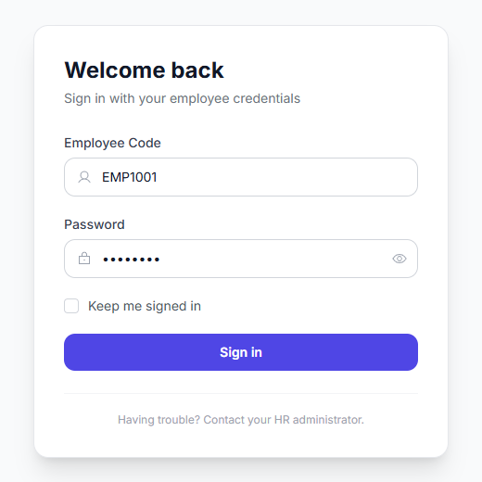
Figure 1. The sign-in page
Tip: Forgot your password? Ask HR to reset it. HR can also text you new login details from the SMS Center.

1.3 Finding your way around
- Left menu (sidebar): your pages, grouped by topic. Click a group (for example Leave) to open it. The double-arrow at the top collapses the menu to icons.
- Top bar: the page title, a light/dark mode switch, the notification bell, today's date and your name.
- Your name (top right): opens My Profile and Sign Out.
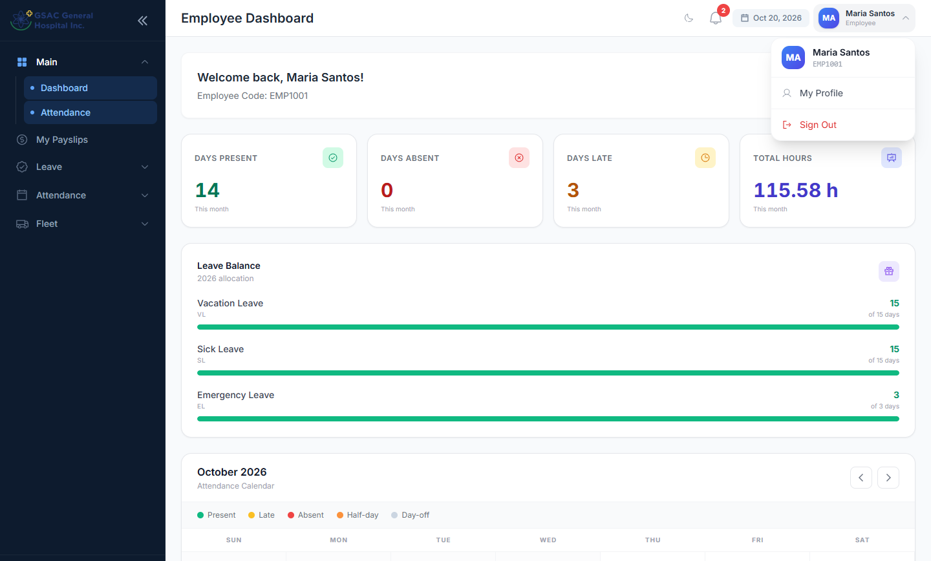
Figure 2. The sidebar, top bar and user menu

1.4 Using the portal on your phone
The portal works in a phone browser. Tap the menu icon (three lines, top left) to open the sidebar. Employees also get a bottom bar with Home, Leave, Requests, Payslips and Profile.
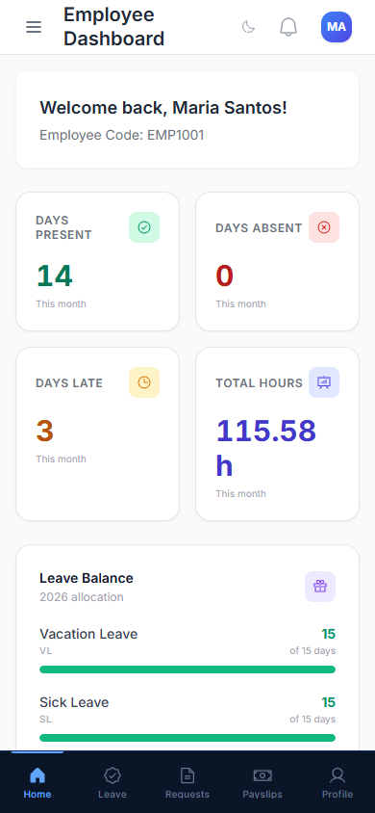 | 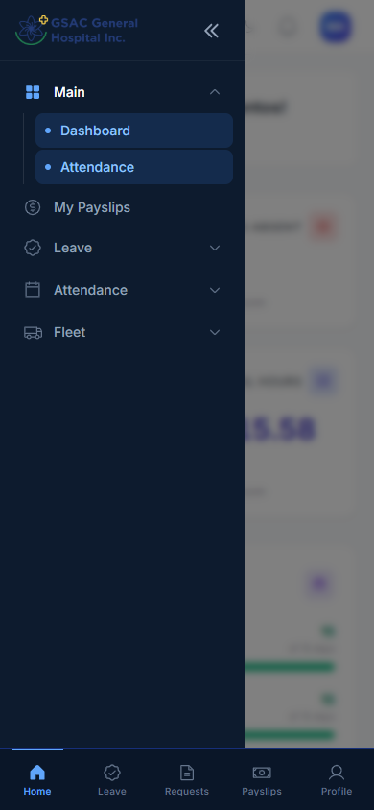
Figure 3. Phone view: dashboard (left) and the opened menu (right)

1.5 Notifications
The bell in the top bar shows a red count when something new happens: a request moves to the next approver, is approved or rejected, or a payslip is ready. Click the bell to read them. Mark all read clears the count.
Final decisions and payslip notices are also sent by SMS if HR has your mobile number. Click Turn on phone notifications to get pop-ups on your phone even when the portal is closed.
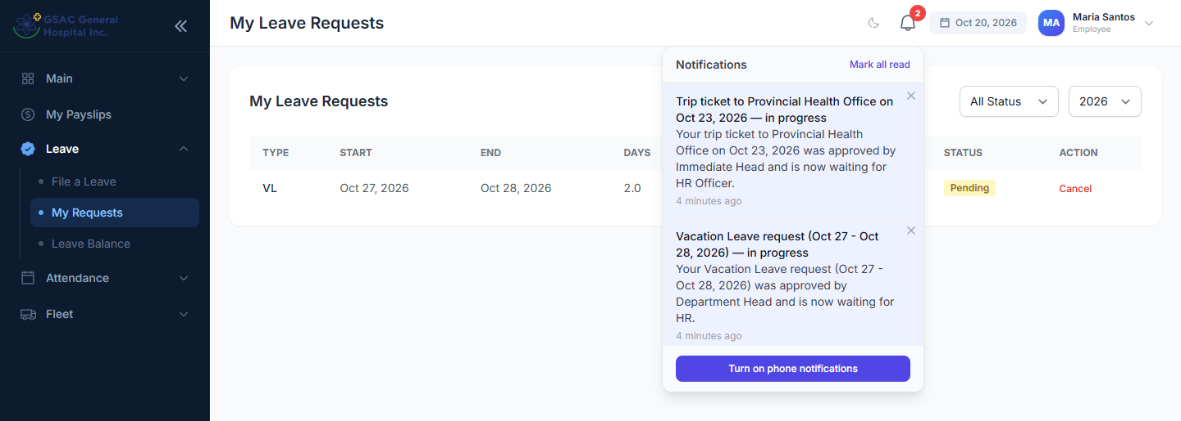
Figure 4. Notifications for a leave request and a trip ticket

1.6 Your profile and password
Menu: your name (top right) → My Profile
Update your name and email, and change your password. To change the password, enter your current password, then the new one twice, and click Save. Ask HR to update your mobile number, since it is used for SMS notices.
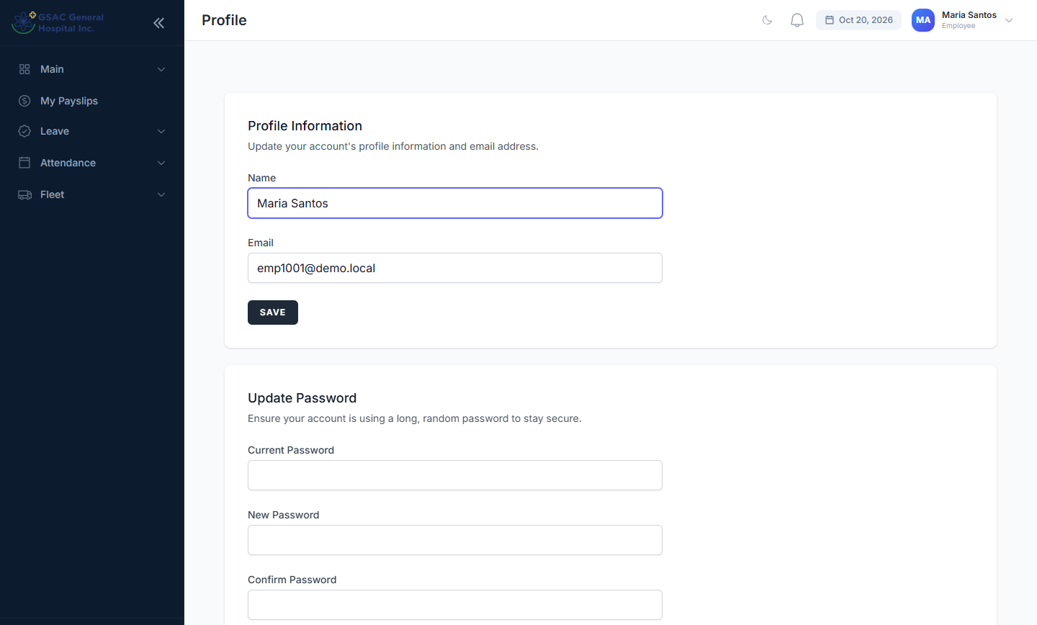
Figure 5. Profile and password page

1.7 How approvals work
Most requests go through several approvers in order. Each list shows an approval progress row of numbered circles:
- Grey: not reached yet.
- Amber: waiting for this approver now.
- Green check: approved at this step.
- Red X: rejected. The request stops there.
Request | Step 1 | Step 2 | Step 3 (final)
Leave, time correction, rest-day swap | Department Head / Manager | HR | CEO / Medical Director
Trip ticket | Immediate Head | HR Officer | Fleet (assigns vehicle and driver)
Overtime | HR / Super Admin (single step) | — | —

Requests filed by a department head start at HR (step 2). Requests filed by a manager go straight to step 3. A Super Admin can approve at any step.

Part 2. For all employees
Everything in this part is available to every staff member, including department heads, managers and the head nurse.

2.1 Dashboard and attendance
Menu: Main → Dashboard
The dashboard shows your days present, absent and late this month, your total hours, and your leave balance.
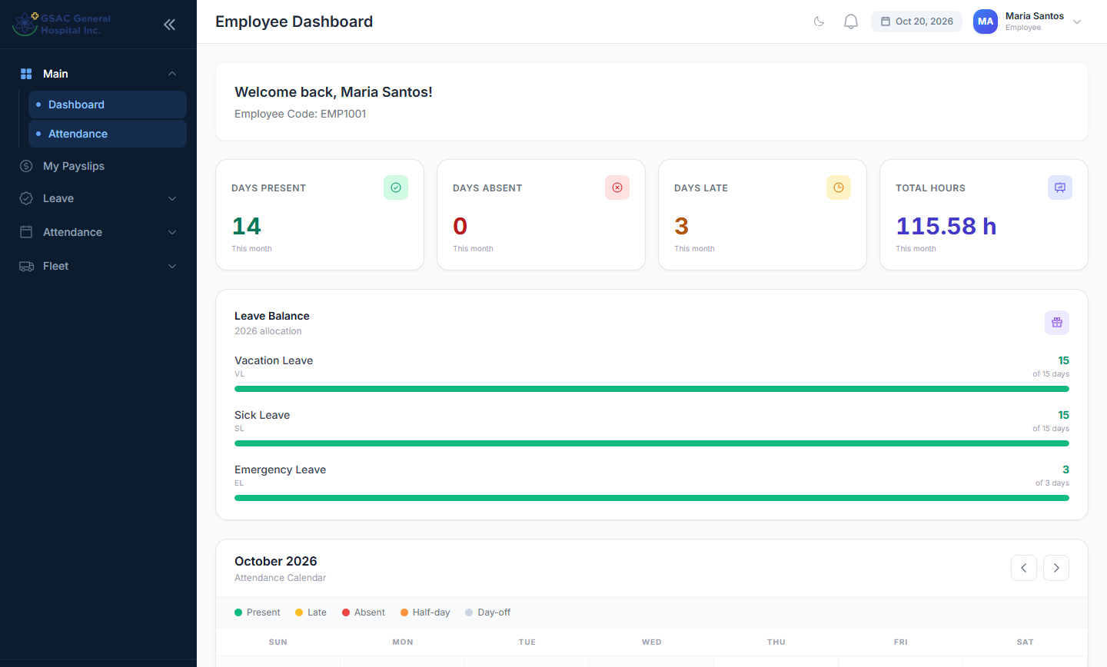
Figure 6. Employee dashboard
Scroll down to the attendance calendar. Each day shows a coloured status: Present, Late, Absent, Half-day, Incomplete (a missing time-out) or Day-off. Approved leave shows the leave name. Use the arrows to change month.
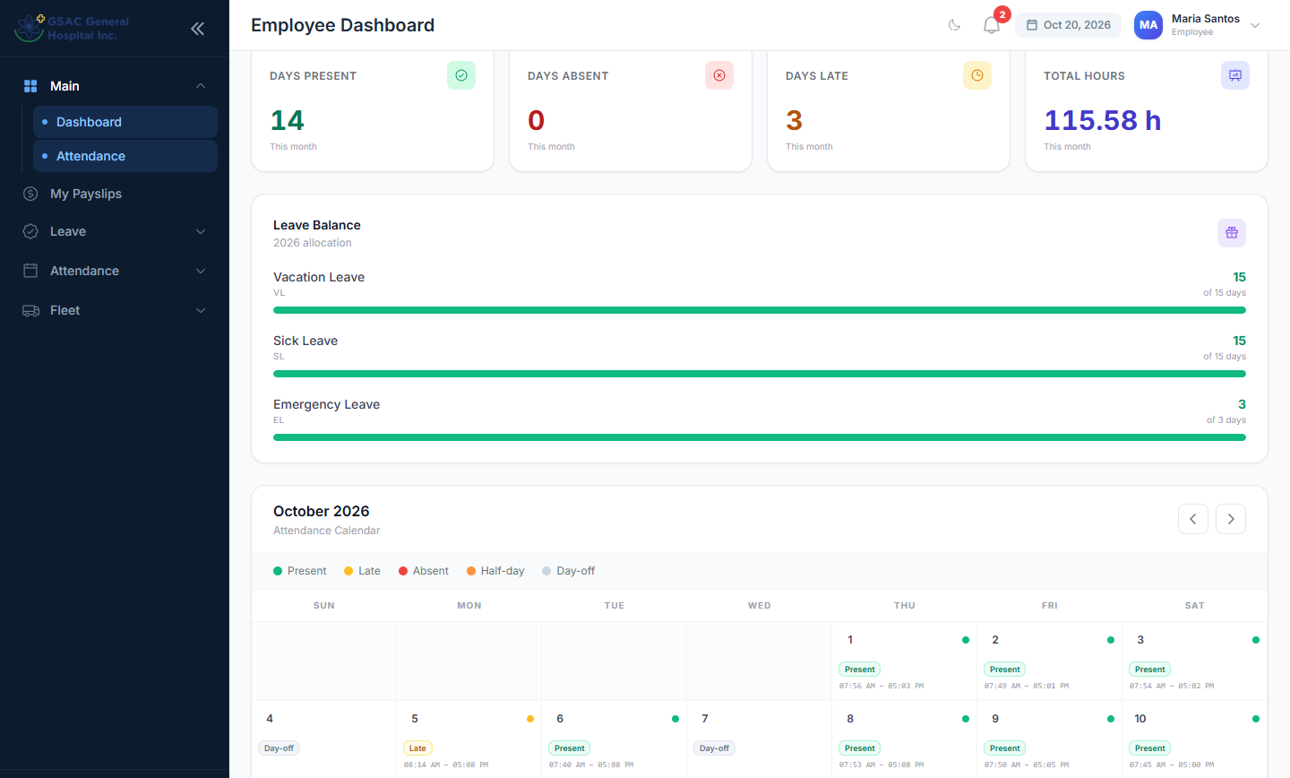
Figure 7. The attendance calendar
Click a day to see your time in and out, hours worked and minutes late. If something is wrong, click Request Time Correction from there.
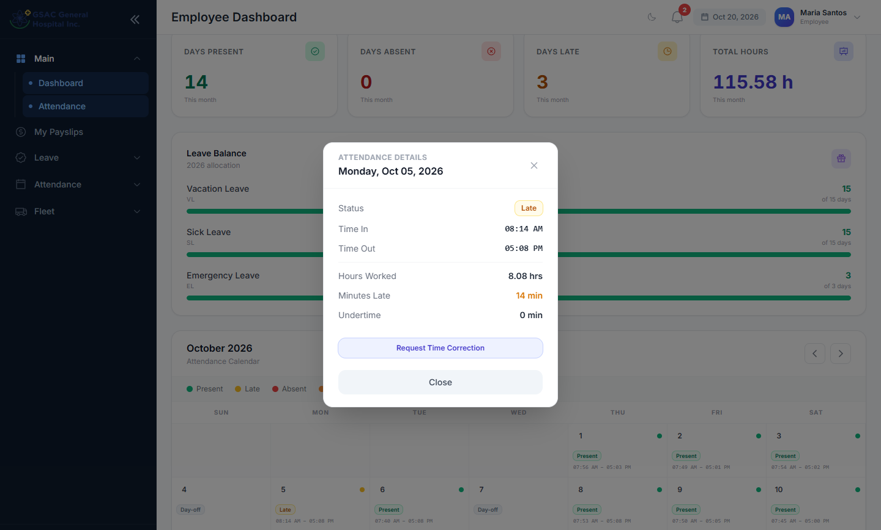
Figure 8. Details for one day, with a shortcut to request a correction

2.2 Filing a leave
Menu: Leave → File a Leave
- Check My Leave Balances at the top: the days left for Vacation, Sick and Emergency Leave this year.
- Choose the Leave Type. Your remaining days for that type appear under the list.
- Turn on Half Day if you only need half a day (uses 0.5 day).
- Pick the Start Date and End Date. The system shows the total working days; Sundays and your weekly rest day are not counted.
- Type a Reason and click Submit Request.
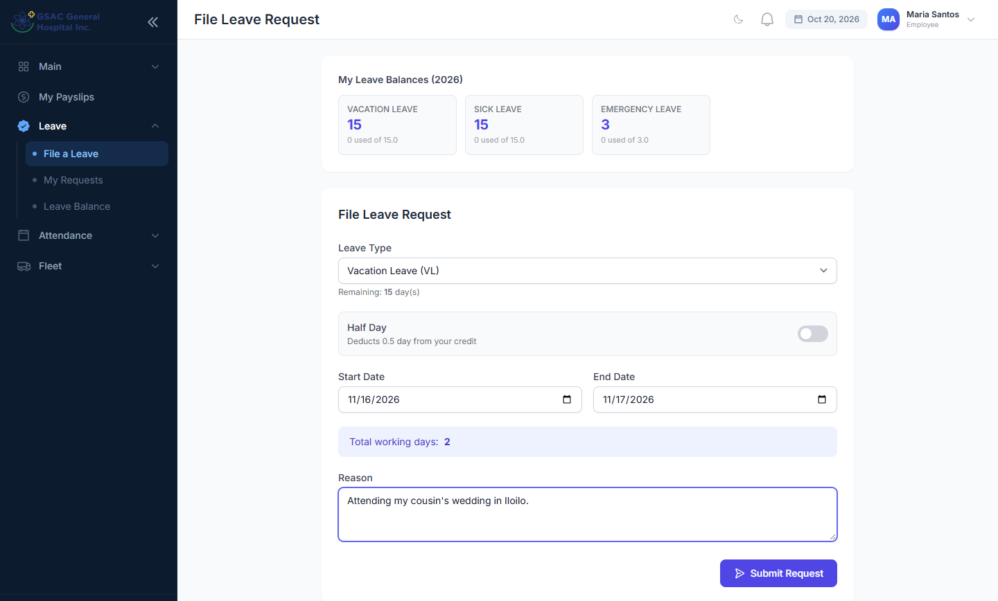
Figure 9. A completed leave request
Important: You cannot file more days than you have left, or dates that overlap another pending or approved leave.

2.3 Tracking and cancelling your leave
Menu: Leave → My Requests
See every leave you filed, its status and where it is in the approval chain. Filter by status or year. Click Cancel to withdraw a request that is still Pending.
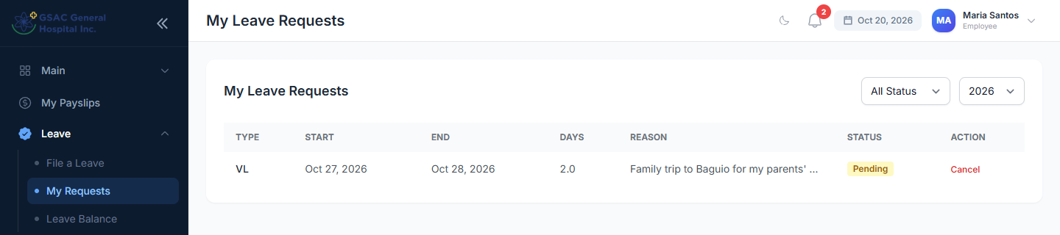
Figure 10. My leave requests

2.4 Leave balance
Menu: Leave → Leave Balance
Shows how many days of each leave type you have left out of this year's allocation.
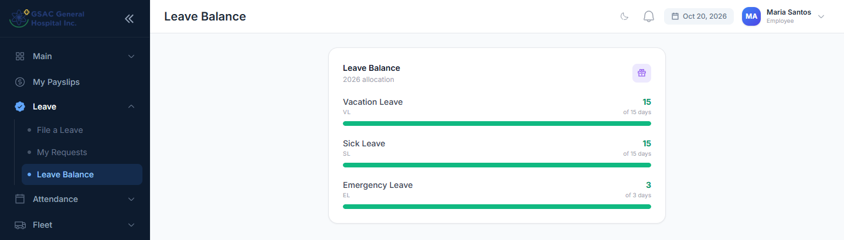
Figure 11. Leave balance

2.5 Filing overtime
Menu: open /overtime/request in the portal (there is no menu link yet, so bookmark the page)
- Enter the Date of Overtime.
- Enter the Requested OT Hours, for example 2 or 2.5.
- Explain the Reason / Purpose and click Submit Request.
Your requests appear below the form. HR may approve fewer hours than you asked for; the Approved Hrs column shows the final number used for pay. You can cancel a request while it is pending.
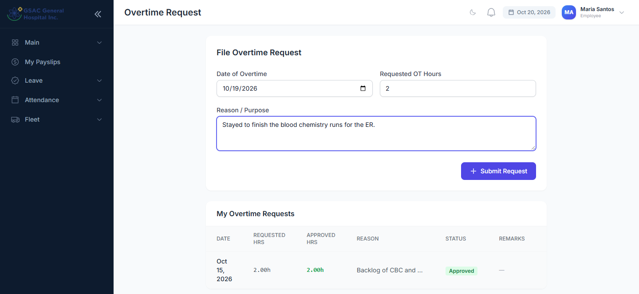
Figure 12. Overtime request form and history

2.6 Requesting a time correction
Menu: Attendance → Time Correction
Use this when the biometric scanner missed a punch or recorded the wrong time.
- Pick the Date to Correct. It cannot be a future date.
- Fill in only the times that are wrong or missing: AM Time In/Out and PM Time In/Out. Blank fields keep the scanner's record.
- Give a Reason and click Submit Request.
Once fully approved, the corrected times are used in your attendance and payroll.
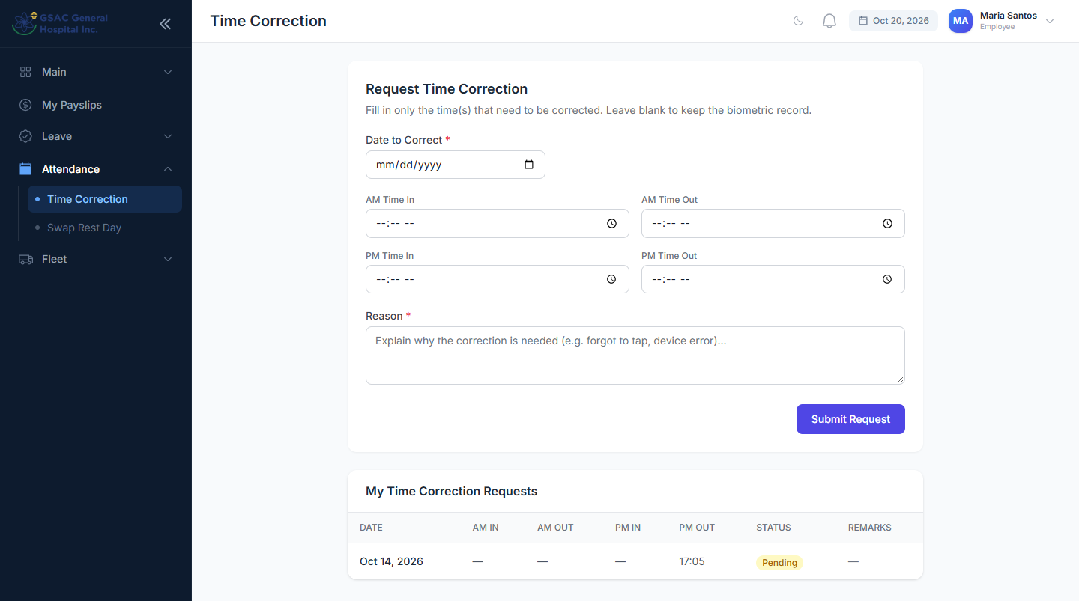
Figure 13. Time correction form and history
Tip: File corrections as soon as you notice them. Changes cannot be applied to a payroll period that HR has already finalized.

2.7 Swapping a rest day
Menu: Attendance → Swap Rest Day
Work on one of your rest days and take a different day off instead.
- Rest day to give up: pick one of your rest days in the next 60 days. You will report for work that day.
- New rest day: pick the date you want off instead. It cannot already be a rest day or a holiday.
- Give a Reason and click Submit Request.
Nothing changes until the request is fully approved. After that, your attendance and payroll treat the old date as a working day and the new date as your day off. Your pay for the period stays the same.
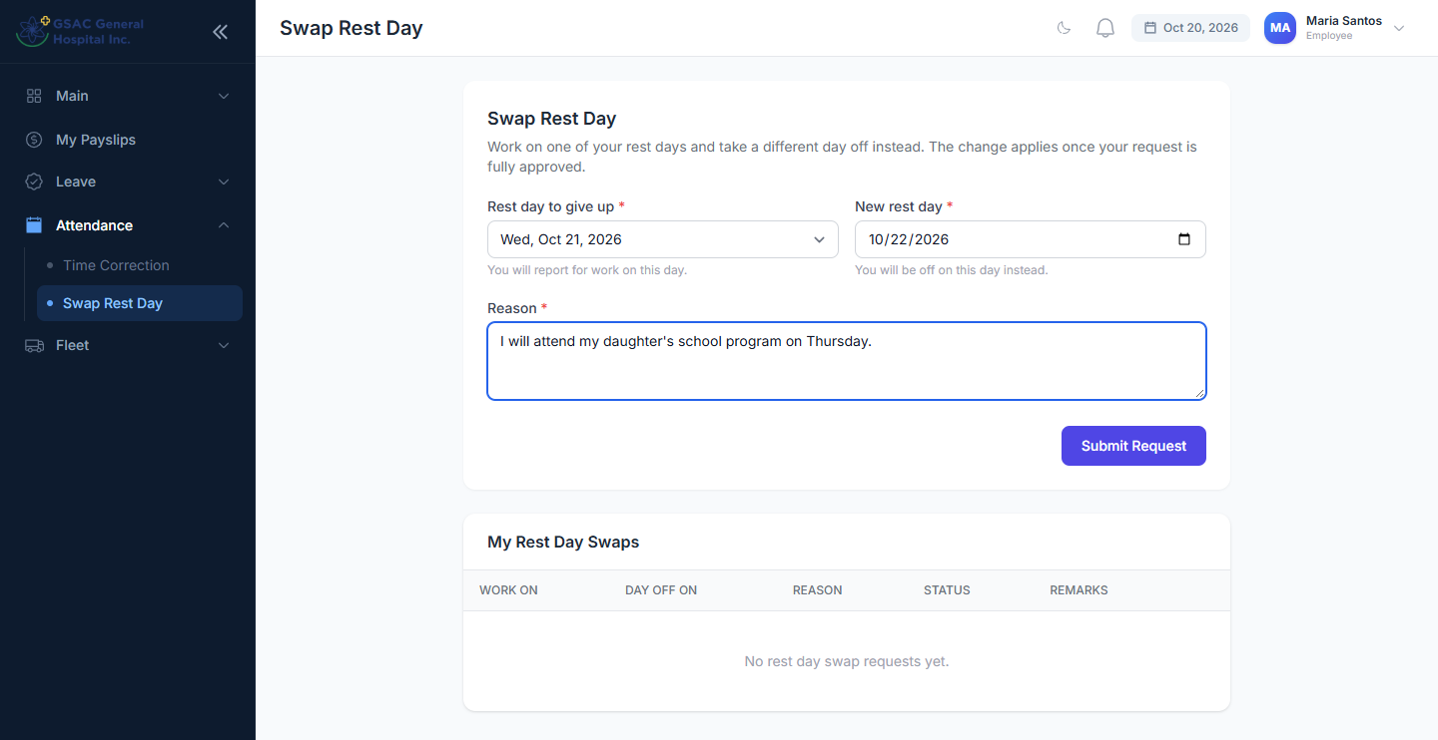
Figure 14. Swap Rest Day request

2.8 Requesting a vehicle (trip ticket)
Menu: Fleet → Request Trip
- Enter Destination From and To, and the date and time of departure and return.
- Optionally choose a preferred vehicle and driver. The Fleet office can change them.
- List the Passengers and the Purpose of the trip.
- Click Submit Trip Ticket. The approval chain is shown at the bottom of the form.
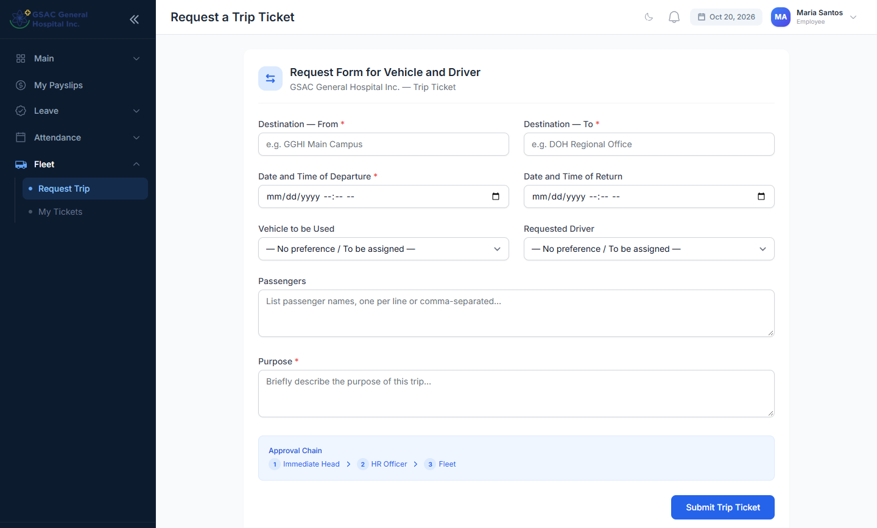
Figure 15. Trip ticket request form
Menu: Fleet → My Tickets
Track your trips and see the assigned vehicle and driver once Fleet schedules them. You can cancel while a ticket is pending. The security guard records when the vehicle leaves and returns.
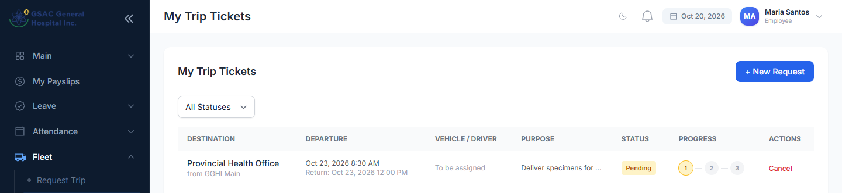
Figure 16. My trip tickets

2.9 Payslips
Menu: My Payslips
Each payroll period shows your net pay, basic pay, overtime, gross pay and deductions (SSS, PhilHealth, Pag-IBIG, tax, loans). Click Download PDF for a printable copy. Use the Year filter for older payslips.
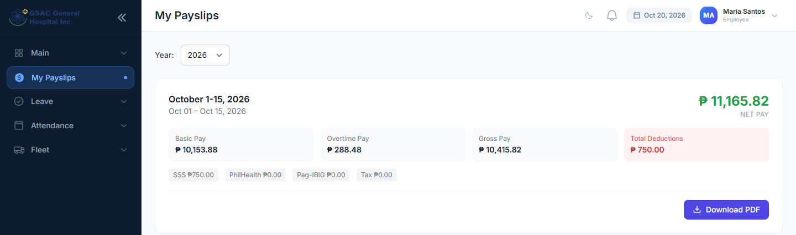
Figure 17. My payslips
Tip: A payslip appears once HR generates payroll for the period. When HR finalizes the period you also get a notification and SMS.

Part 3. For approvers
For department heads, managers, HR, the Medical Director and the CEO / Super Admin. Everything in Part 2 also applies to your own requests.

3.1 Approver dashboard
Menu: Main → Dashboard
Shows today's headcount (present, absent, late), pending leaves and payroll, a weekly attendance chart, this year's leave requests, quick actions and recent activity.
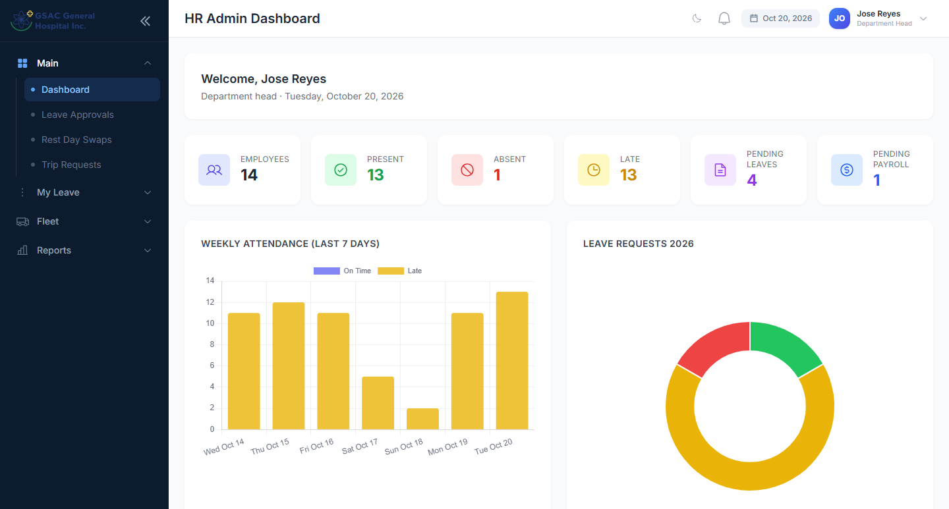
Figure 18. Approver dashboard

3.2 Where to approve
Request | Menu | Who approves
Leave | Leave Approvals | Dept Head → HR → CEO / Medical Director
Time correction | Time Corrections | Dept Head → HR → CEO / Medical Director
Rest-day swap | Rest Day Swaps | Dept Head → HR → CEO / Medical Director
Trip ticket | Trip Requests | Immediate Head → HR Officer → Fleet
Overtime | Overtime Approvals | HR / Super Admin

Each page has a line such as "You are Department Head — Step 1 of 3". The list shows requests waiting at your step. Use the search box and filters to find a request, or set the status filter to see approved and rejected ones.

3.3 Approving or rejecting
The steps are the same on every approval page:
- Find the request and review the employee, dates, days and reason.
- Click Approve or Reject on its row.
- Add remarks. Remarks are optional when approving and required when rejecting.
- Confirm. An approval moves the request to the next approver; at the last step it is final. A rejection stops the request immediately.
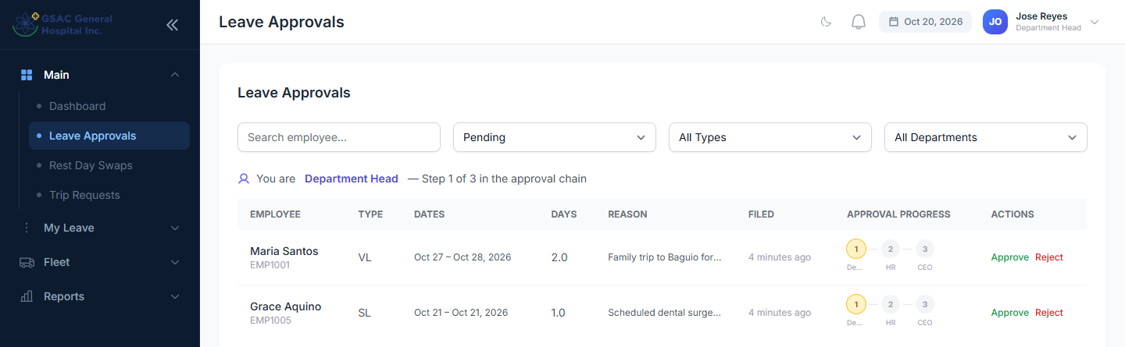
Figure 19. Leave Approvals, Department Head view (step 1)
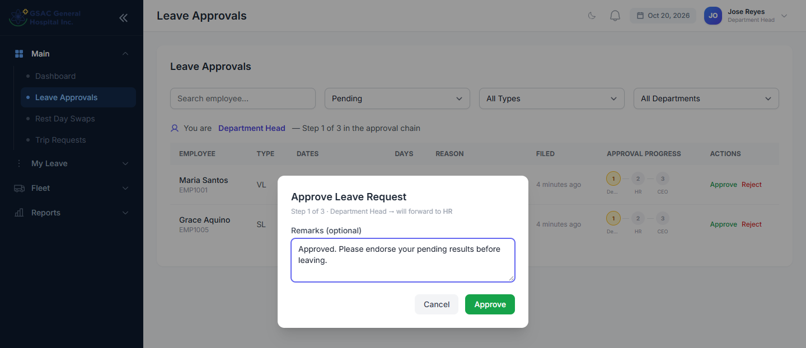
Figure 20. Approving with a remark
On final approval of a leave, the days are deducted from the employee's balance automatically, and the employee is notified in the app and by SMS.
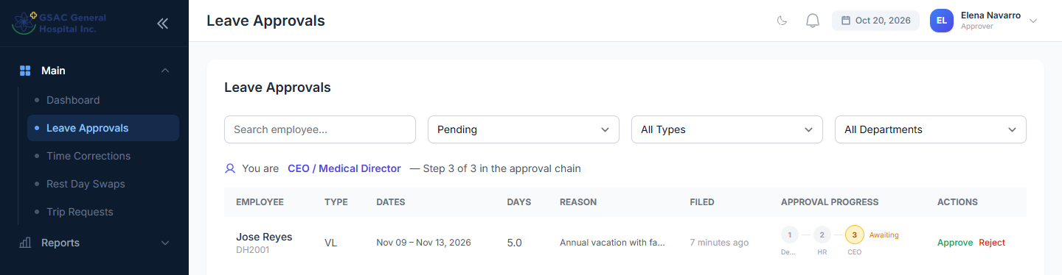
Figure 21. Medical Director view: a request waiting at step 3
Important: A rejection cannot be undone from the portal. The employee must file a new request.

3.4 Time corrections
Menu: Time Corrections
Compare the requested times with what the employee says happened, then approve or reject. Approved times replace the scanner times for that day.
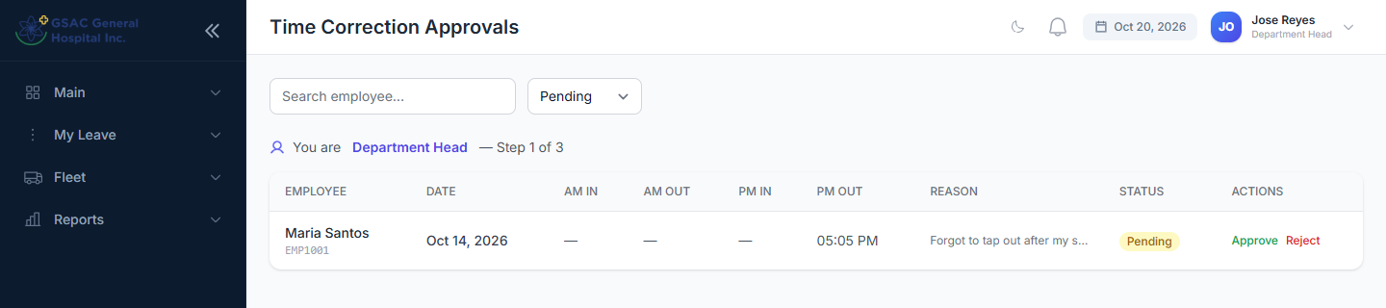
Figure 22. Time correction approvals

3.5 Rest-day swaps
Menu: Rest Day Swaps
Work On is the rest day the employee will work; Day Off On is the new rest day. On final approval the system moves the rest day automatically. If the schedule changed in the meantime (for example the new date became a holiday), approval is blocked with an explanation; reject it so the employee can refile.
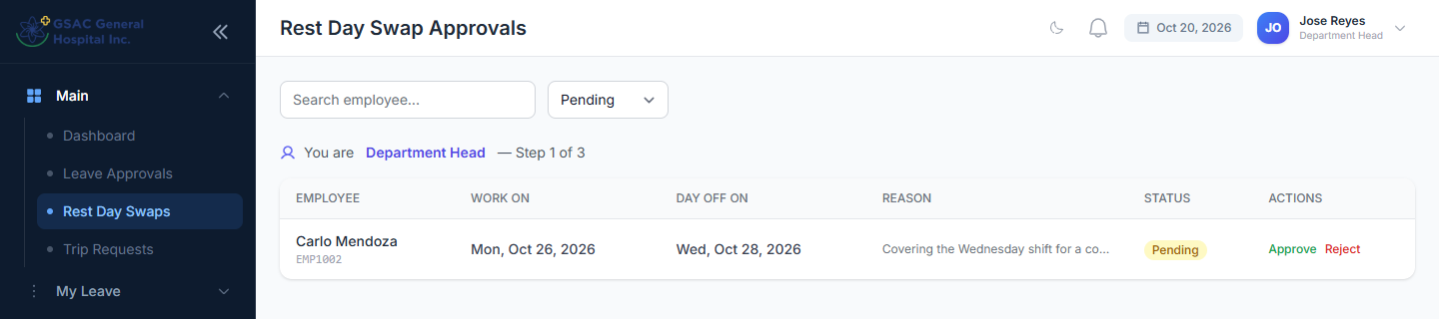
Figure 23. Rest-day swap approvals

3.6 Trip tickets
Menu: Fleet → Trip Requests
The Immediate Head (step 1) and HR Officer (step 2) approve or reject like any other request.
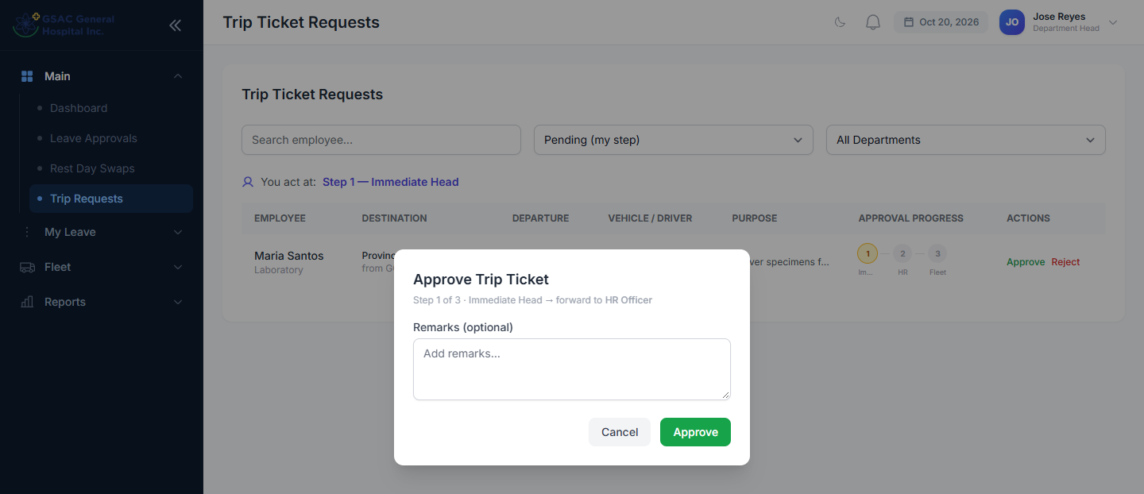
Figure 24. Approving a trip ticket at step 1
At the Fleet step (step 3) the buttons read Schedule and Deny. Scheduling lets you pick the vehicle and driver. Click Confirm Schedule to finish.
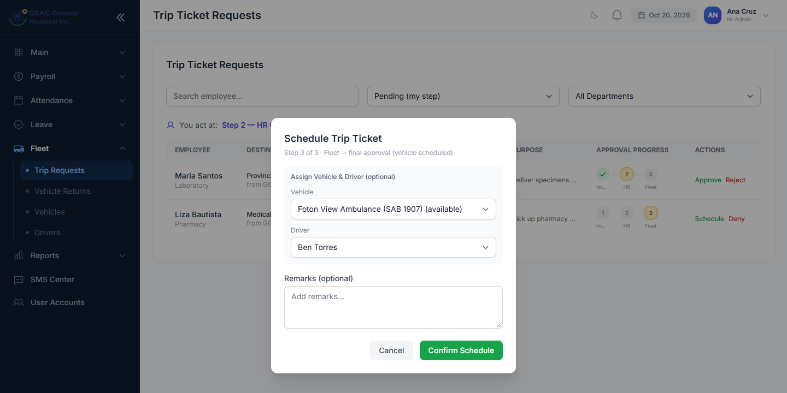
Figure 25. Scheduling a trip: choosing the vehicle and driver

3.7 Overtime (HR and Super Admin)
Menu: Leave → Overtime Approvals
When approving, you can lower the Approved Hours before confirming. Only approved hours are paid, at 125% of the hourly rate.
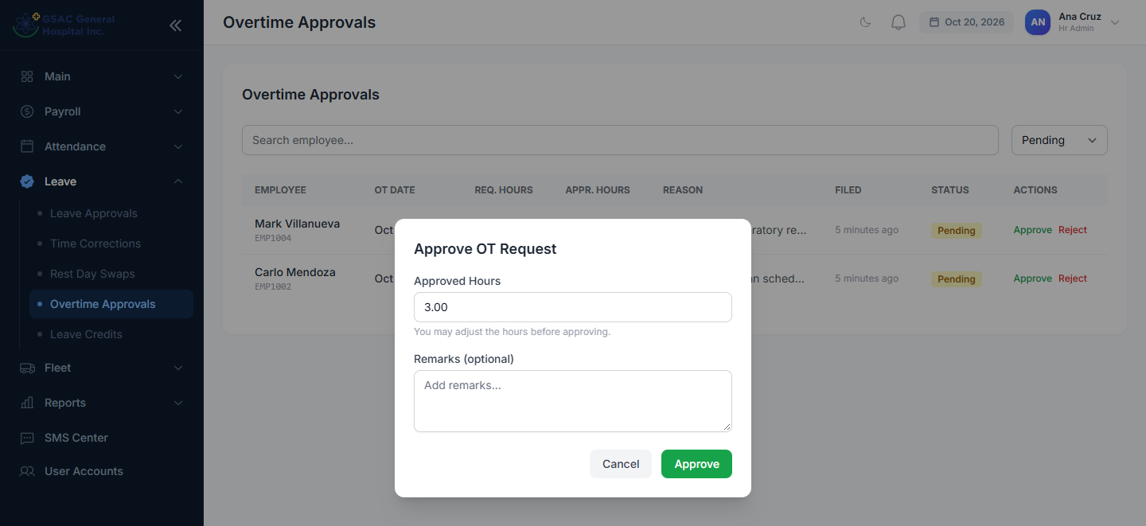
Figure 26. Approving overtime and adjusting the hours

3.8 Super Admin override
A Super Admin sees every pending request. On requests that are not at their own step the button reads Approve (override), which approves all remaining steps at once. Overrides are recorded in the approval history.
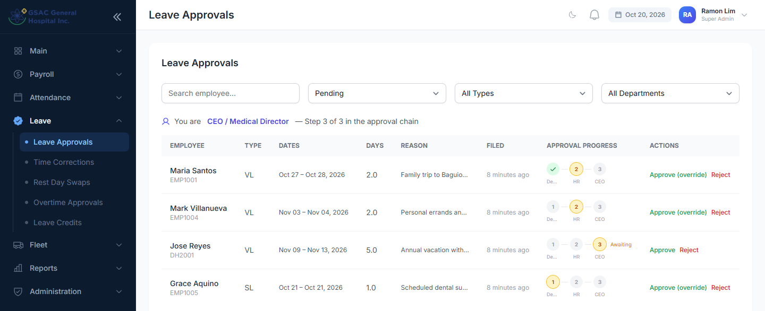
Figure 27. Super Admin view with override buttons

Part 4. For the Head Nurse
Menu: Duty Roster
Nursing staff work rotating shifts, so their schedule is planned day by day on the duty roster instead of a fixed weekly schedule.
- Use the arrows to choose the month. Each row is a nurse; each column is a day.
- Click a cell to open Assign Duty.
- Pick the Shift (for example Nursing Day 12h or Nursing Night 12h), or OFF for a rest day, and click Save. Clear removes the entry.
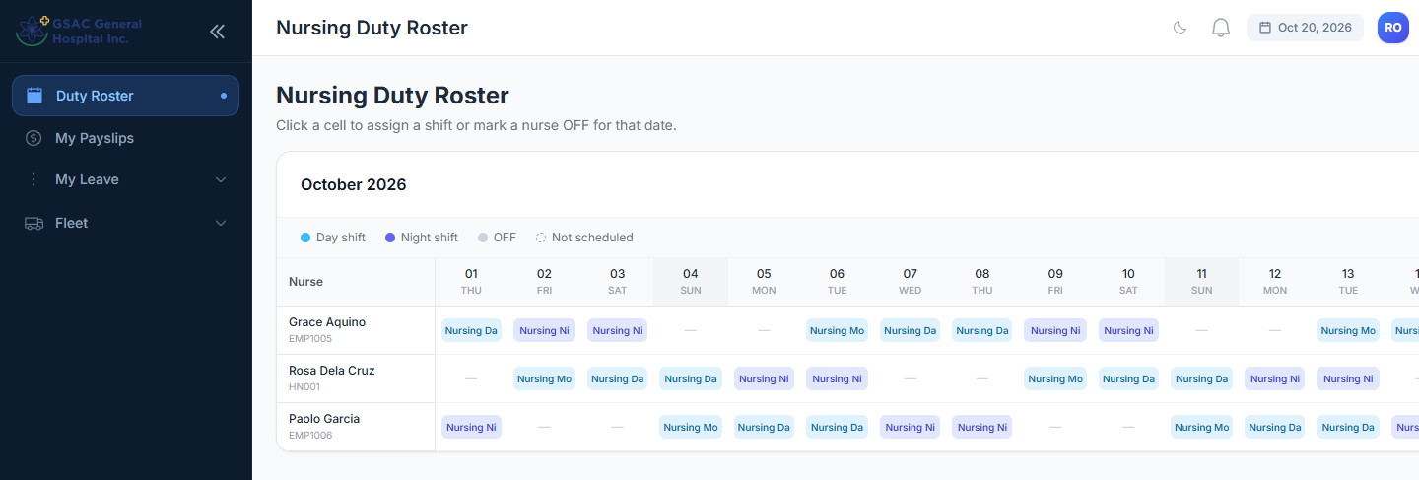
Figure 28. The Nursing duty roster
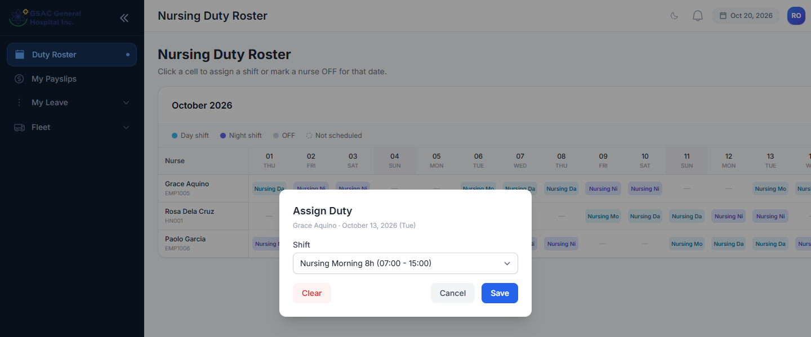
Figure 29. Assigning a shift to a nurse
Tip: Payroll measures nurses against required hours per cutoff, not a fixed number of days, so keep the roster complete.

Part 5. For Security Guards
Menu: Vehicle Returns
The gate log lists approved trips in three groups:
- Ready to Depart: scheduled trips. When the vehicle leaves the gate, click Mark Departed.
- Currently Out: vehicles on a trip. Trips past their expected return are marked OVERDUE.
- Recently Returned: trips already closed.
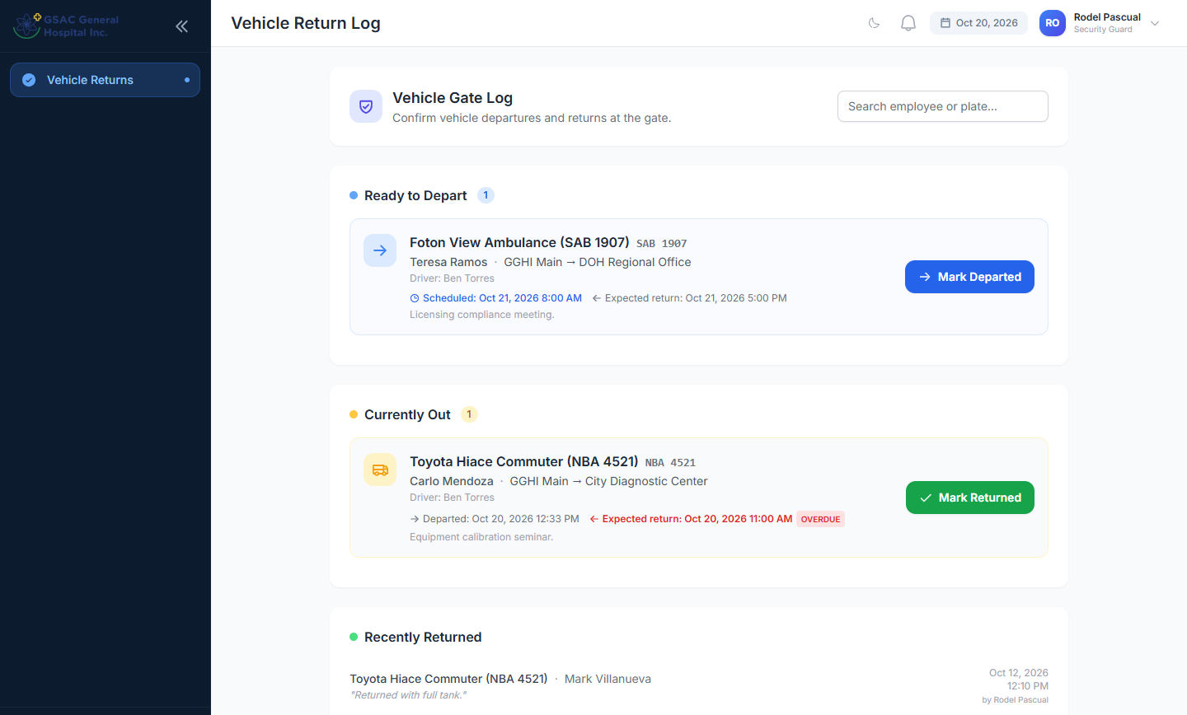
Figure 30. Vehicle gate log
When a vehicle comes back, click Mark Returned, add remarks (condition, odometer, fuel) and click Confirm Return. This frees the vehicle for the next trip.
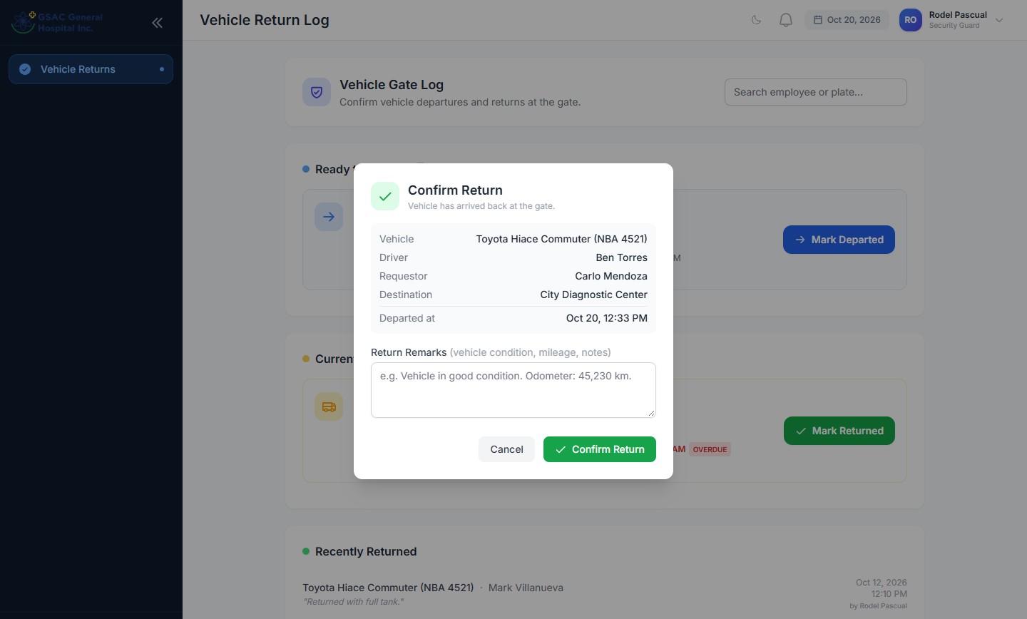
Figure 31. Confirming a vehicle's return

Part 6. For HR Admins
HR Admins have everything in Parts 2 and 3 plus the tools below. Super Admins have all of these too.

6.1 Employees
Menu: Main → Employees
Search, filter by department, and see each employee's department, position, employment type, login account and status. Import from BioTime brings in new employees enrolled on the biometric device.
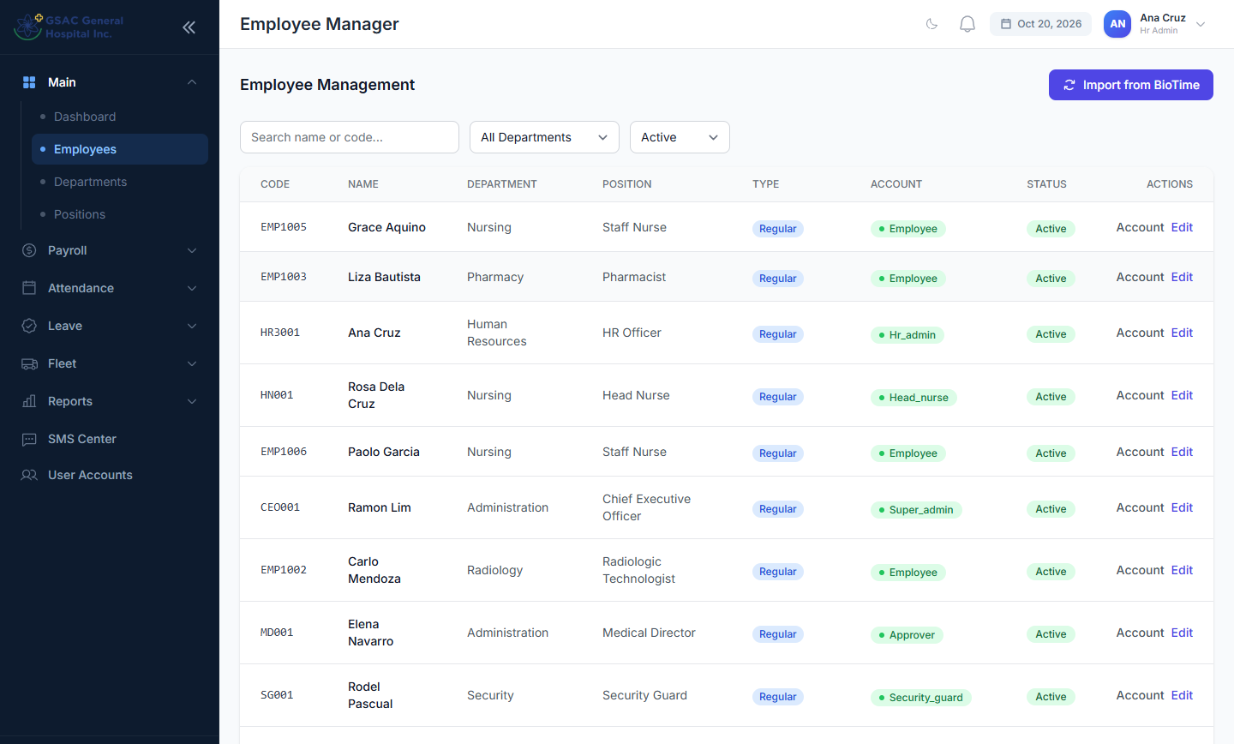
Figure 32. Employee list
Edit opens the employee record: employee code (must match the biometric device), name, mobile number for SMS, department, position, employment type, weekly rest day, date of birth and active status.
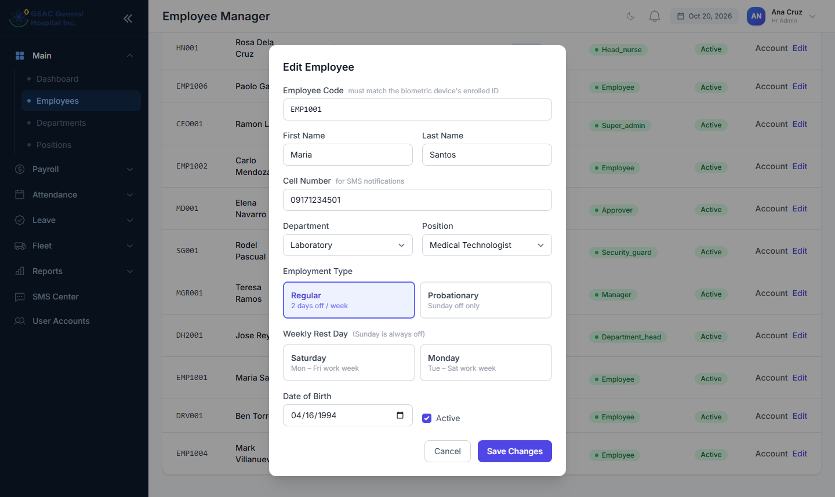
Figure 33. Editing an employee
Account manages the employee's login: change the login code, reset the password, change the role, or deactivate the account.
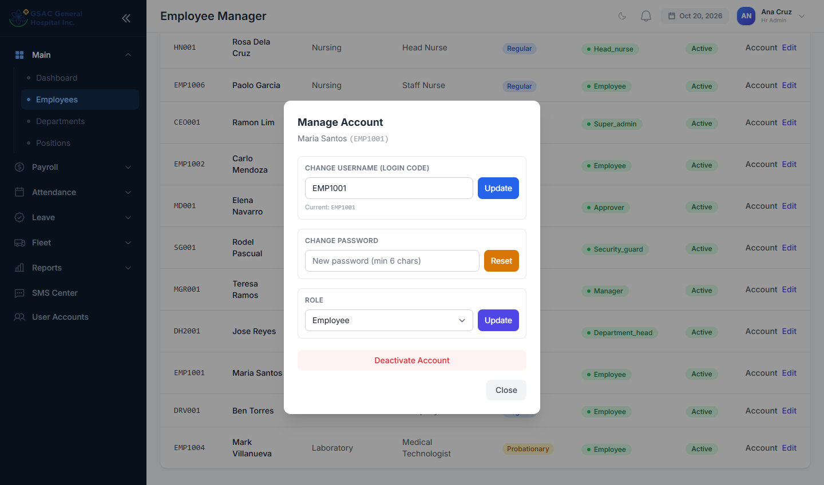
Figure 34. Managing an employee's login account
Tip: Regular employees have Sunday plus one weekly rest day (usually Saturday). Probationary employees have Sunday only.

6.2 Departments and positions
Menu: Main → Departments and Main → Positions
Add, edit or deactivate departments (name, code, description). Positions belong to a department. Turn on Can Approve for positions whose holders approve requests, such as department heads.
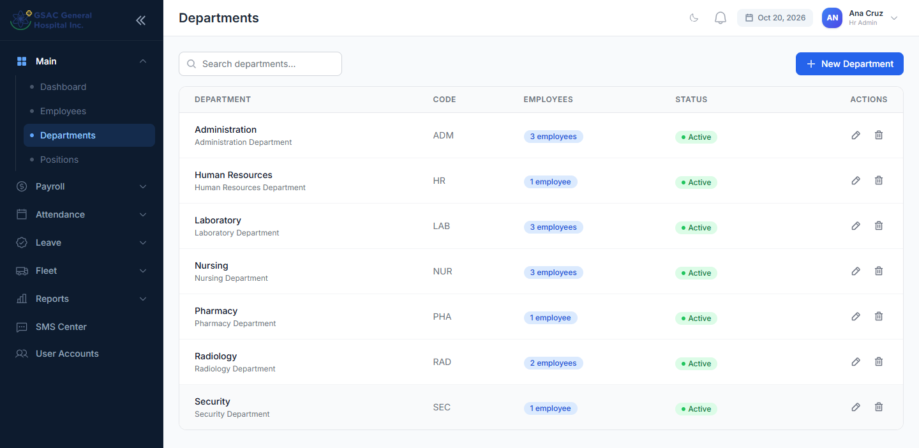
Figure 35. Departments
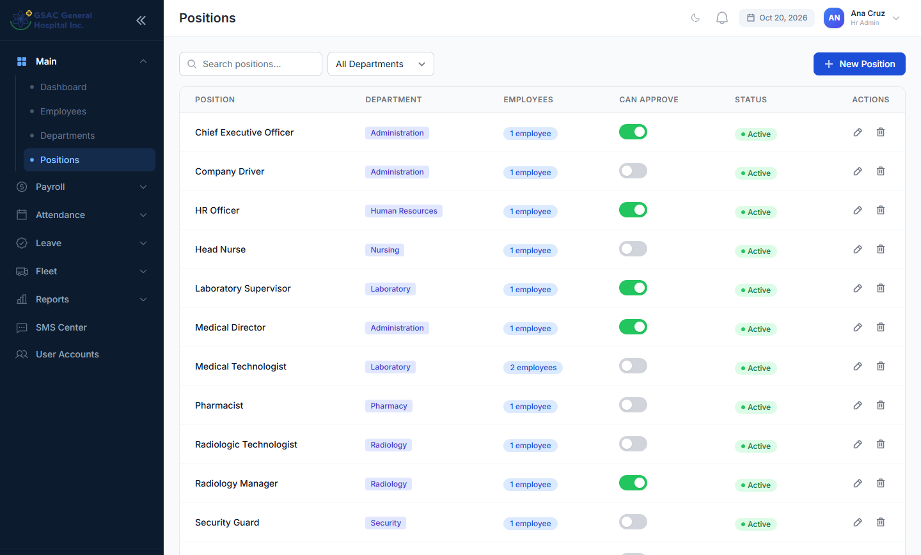
Figure 36. Positions, with the Can Approve switch

6.3 Schedules
Menu: Attendance → Schedules
Schedule Templates define shifts: time in and out, break, split shifts and night shifts. Lateness and undertime are measured against the employee's assigned schedule.
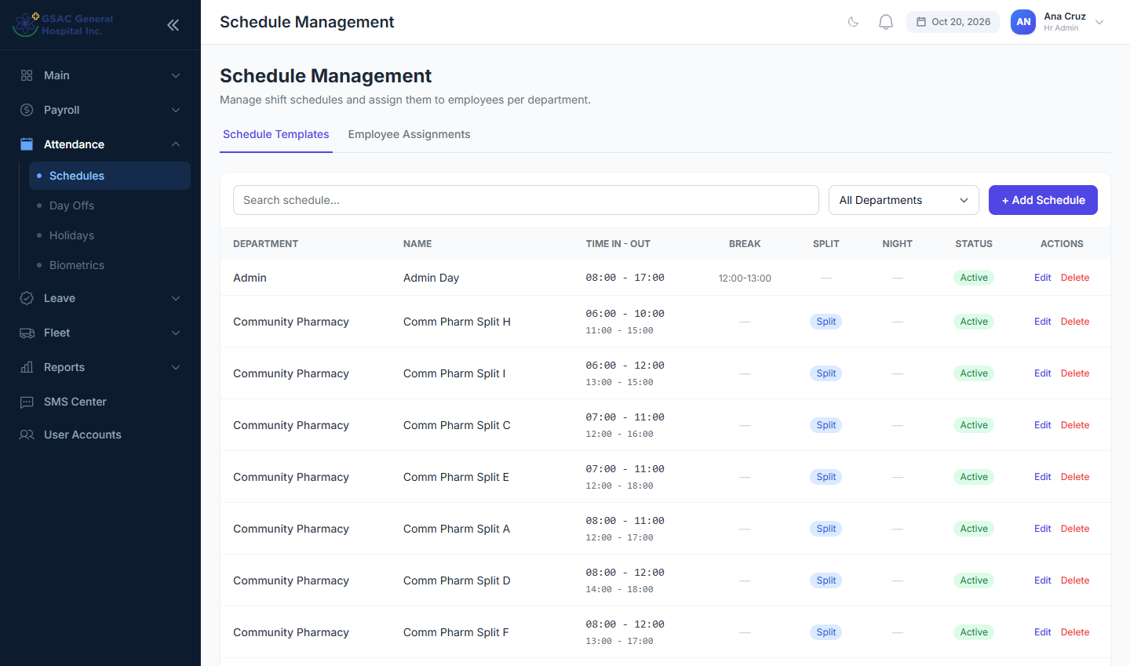
Figure 37. Schedule templates
Employee Assignments links employees to a schedule from a start date. Use Assign Schedule for individuals or Bulk Assign for a whole department.
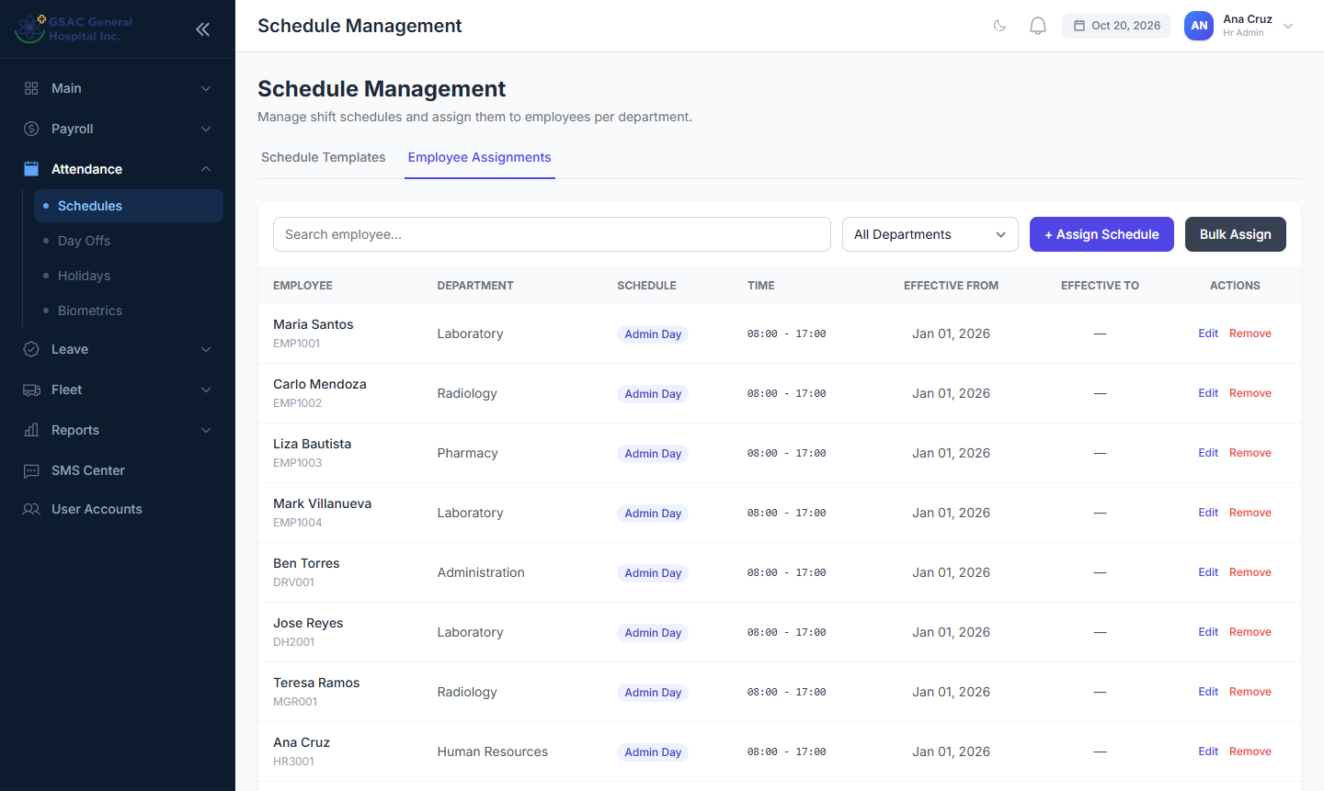
Figure 38. Assigning schedules to employees

6.4 Day offs
Menu: Attendance → Day Offs
Lists every rest day, holiday and special day off by employee. Filter by department, type and month.
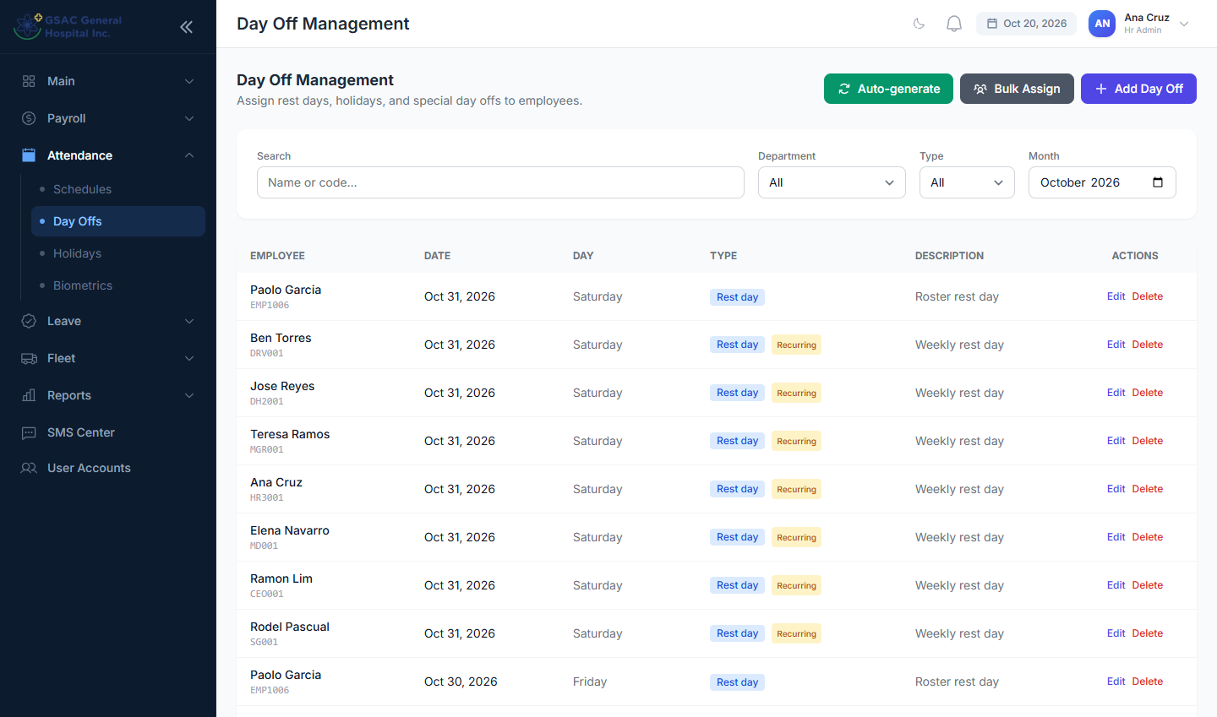
Figure 39. Day Off Management
- Add Day Off: for one or more employees, on a single date or recurring weekly.
- Bulk Assign: recurring rest days for a whole department.
- Auto-generate: creates standard rest days (Sundays plus each employee's weekly rest day) for a date range. Run this at the start of each month.
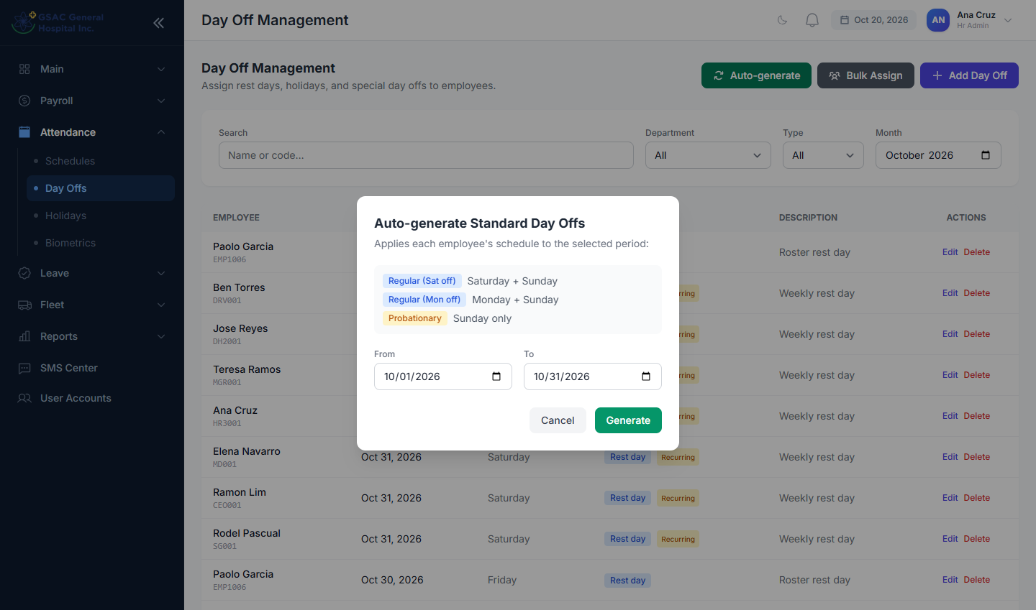
Figure 40. Auto-generating standard day offs

6.5 Holidays
Menu: Attendance → Holidays
Company-wide holidays apply automatically to everyone's attendance and payroll. Click Add Holiday, enter the date, name and type (regular, special non-working or special working), and tick Recurring every year for fixed-date holidays.
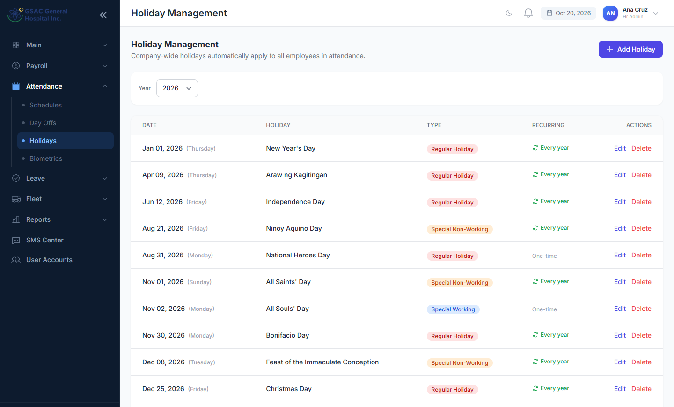
Figure 41. Holiday list
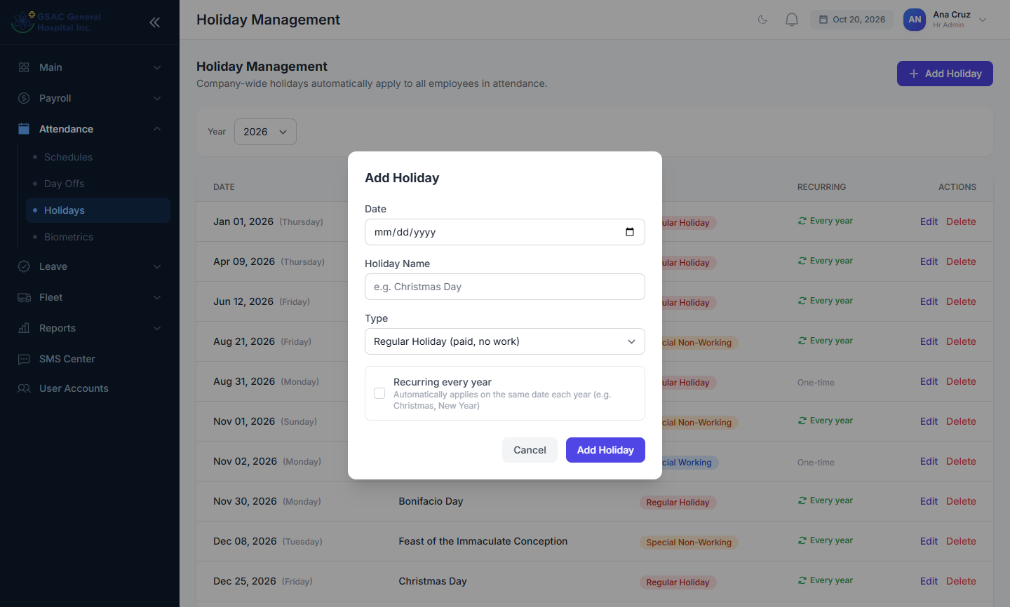
Figure 42. Adding a holiday

6.6 Biometrics
Menu: Attendance → Biometrics
- Test Connection: checks the ZKTeco / BioTime device.
- Sync Attendance: pulls punch records for a date range.
- Sync Employees: imports employees from the device.
- Import Attendance (Excel): uploads the device's export when the server cannot reach the device directly.
Below these are the sync history and the most recent punch logs.
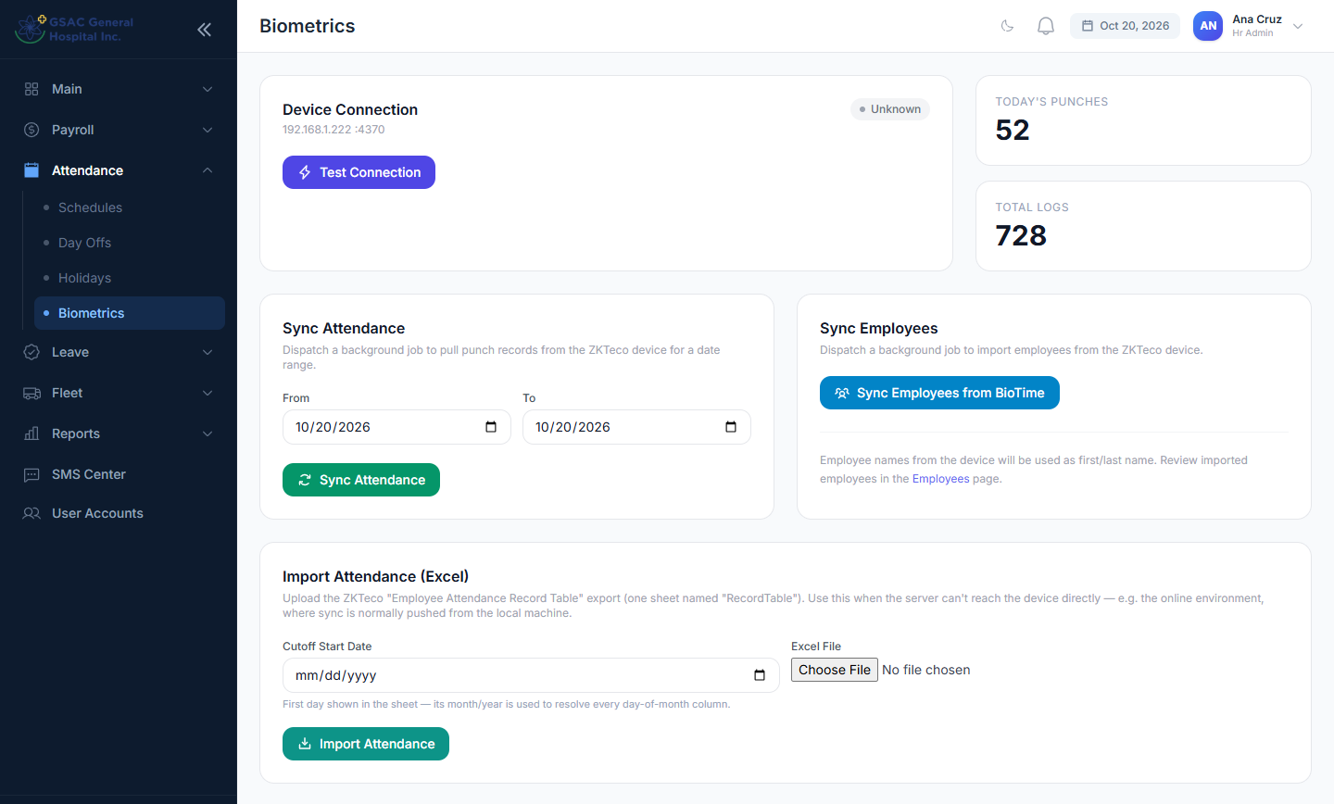
Figure 43. Biometrics

6.7 Leave credits
Menu: Leave → Leave Credits
Shows each employee's remaining Vacation, Sick and Emergency Leave for the year. Edit changes one employee's total or used days. Bulk Add Credits adds days to many employees. Run Now applies this month's accrual. Reset All Credits sets every active employee back to the full allocation, with nothing used, for the selected year.
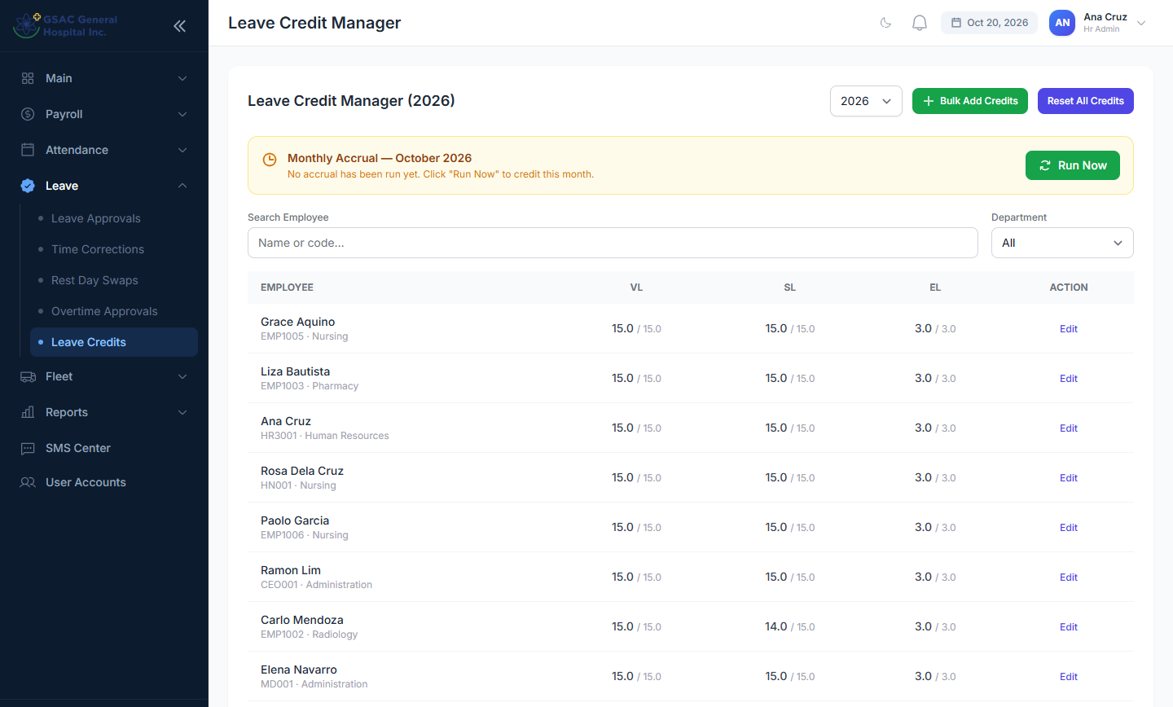
Figure 44. Leave Credit Manager
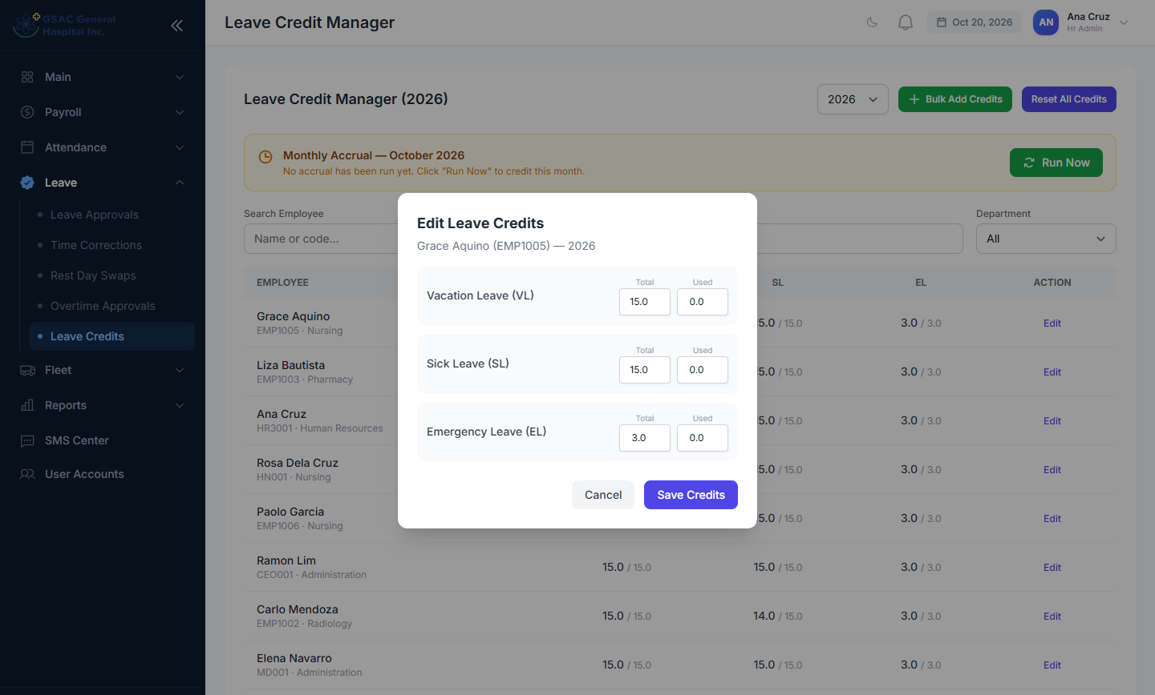
Figure 45. Editing one employee's credits

6.8 Salary setup
Menu: Payroll → Salary Setup
Click Edit on an employee to set the basic monthly salary. Auto computes the daily and hourly rates. Allowances (hazard, rice, laundry/medical, commodity, other) are per cutoff. An employee is included in payroll only after a salary is set.
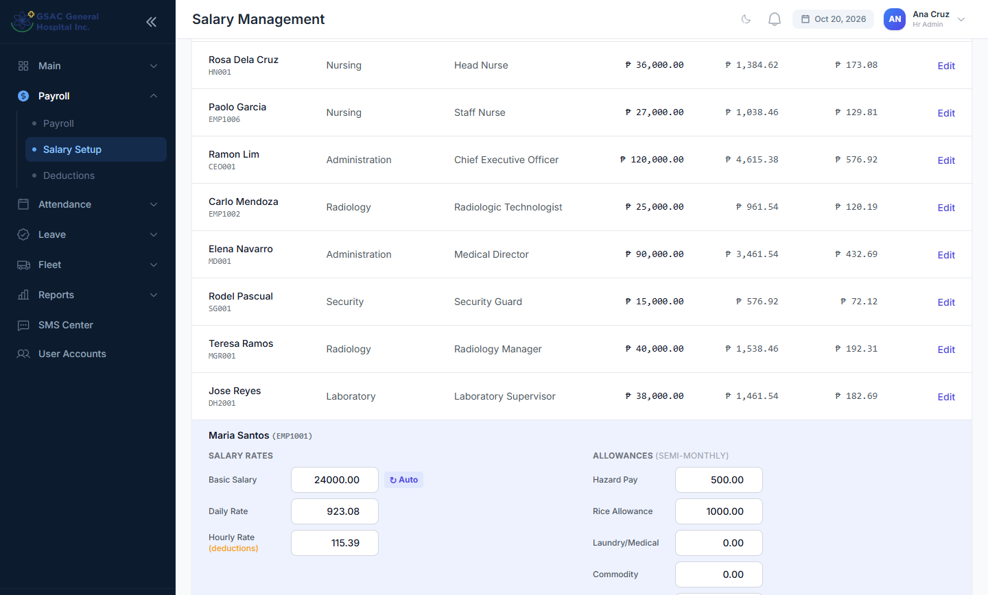
Figure 46. Editing an employee's salary and allowances

6.9 Deductions
Menu: Payroll → Deductions
Recurring deductions such as loans and cash advances. Add Deduction: choose the employee and type, the amount per cutoff, which cutoff to deduct on (both, 1st or 2nd), and the balance. The balance goes down each payroll. Manage Types edits the list of deduction types.
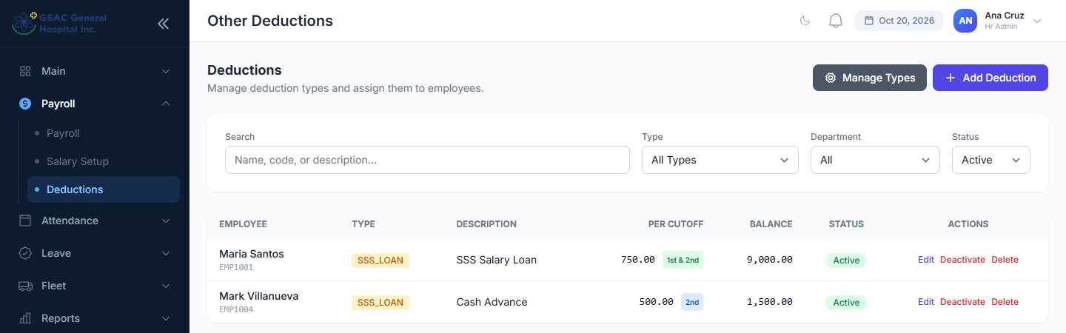
Figure 47. Deductions
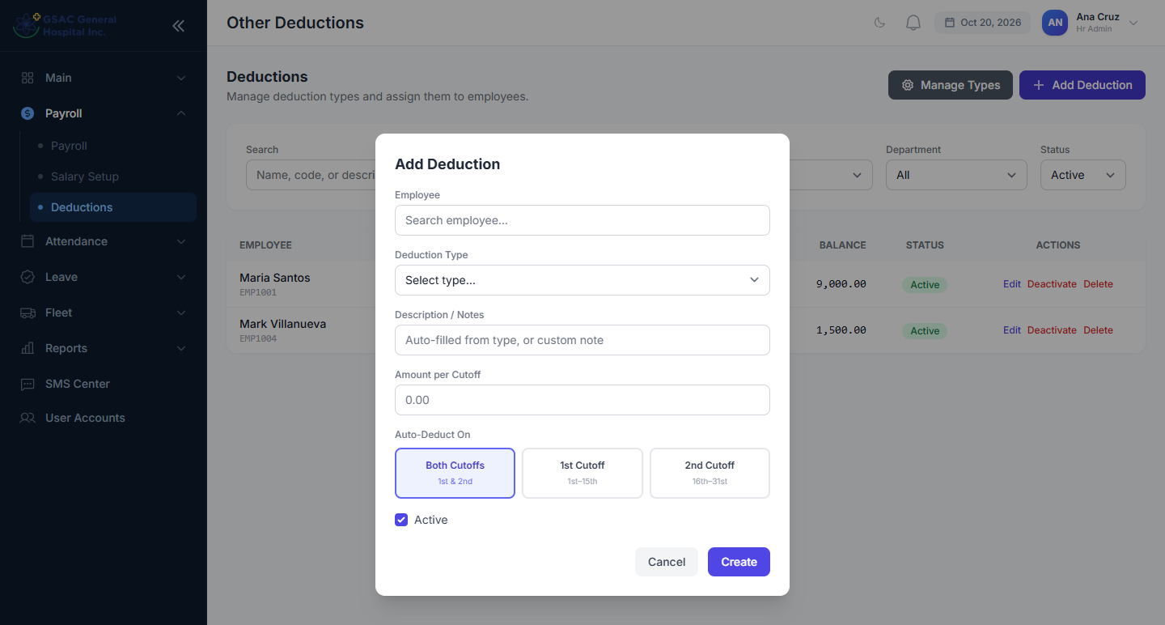
Figure 48. Adding a deduction

6.10 Running payroll
Menu: Payroll → Payroll
- New Period: choose the cutoff (1st, 2nd, monthly or custom). Dates fill in automatically; adjust them if needed and click Create.
- Generate: tick the employees to include (all by default) and click Generate. Payslips are computed from attendance, approved leave, overtime, holidays, day offs and deductions.
- Payslips: review each payslip, and download one if needed. Correct the source data and regenerate if something is wrong.
- Finalize: locks the period so it can no longer be regenerated, and notifies employees that their payslips are ready.
- SMS Payslips / Excel: text employees that payslips are ready, or export the period to Excel.
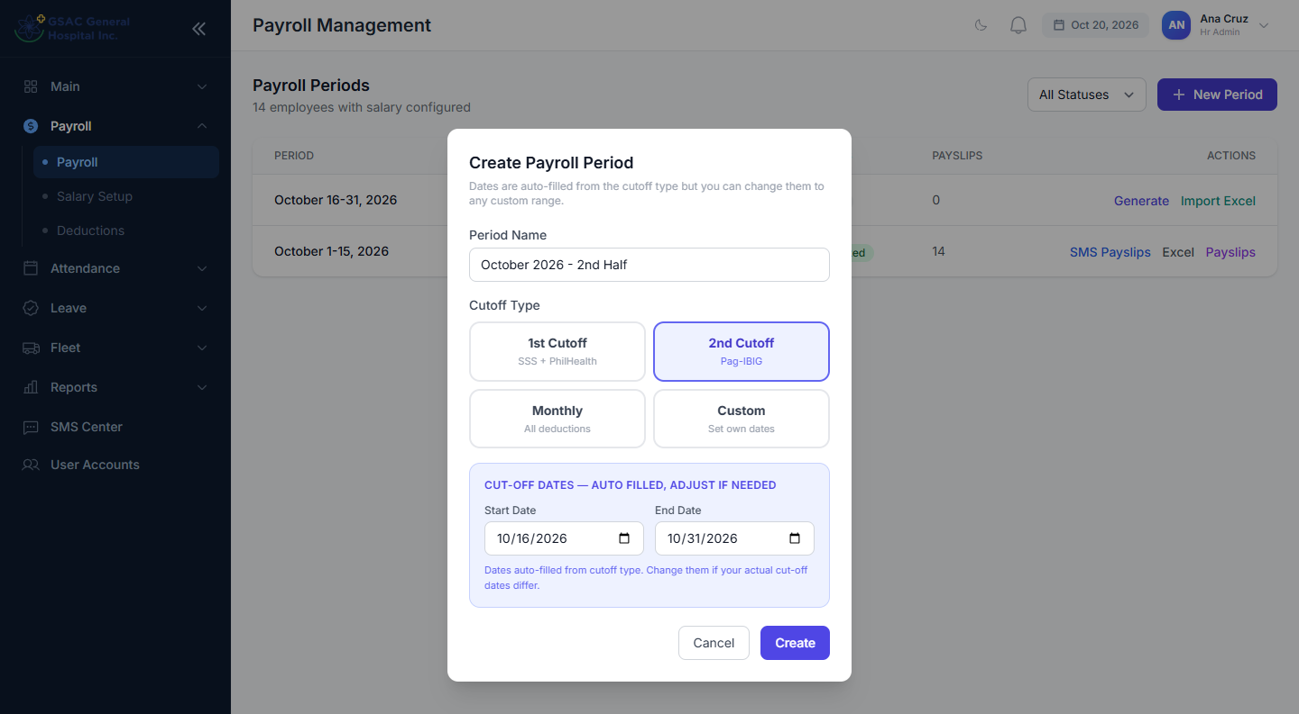
Figure 49. Creating a payroll period
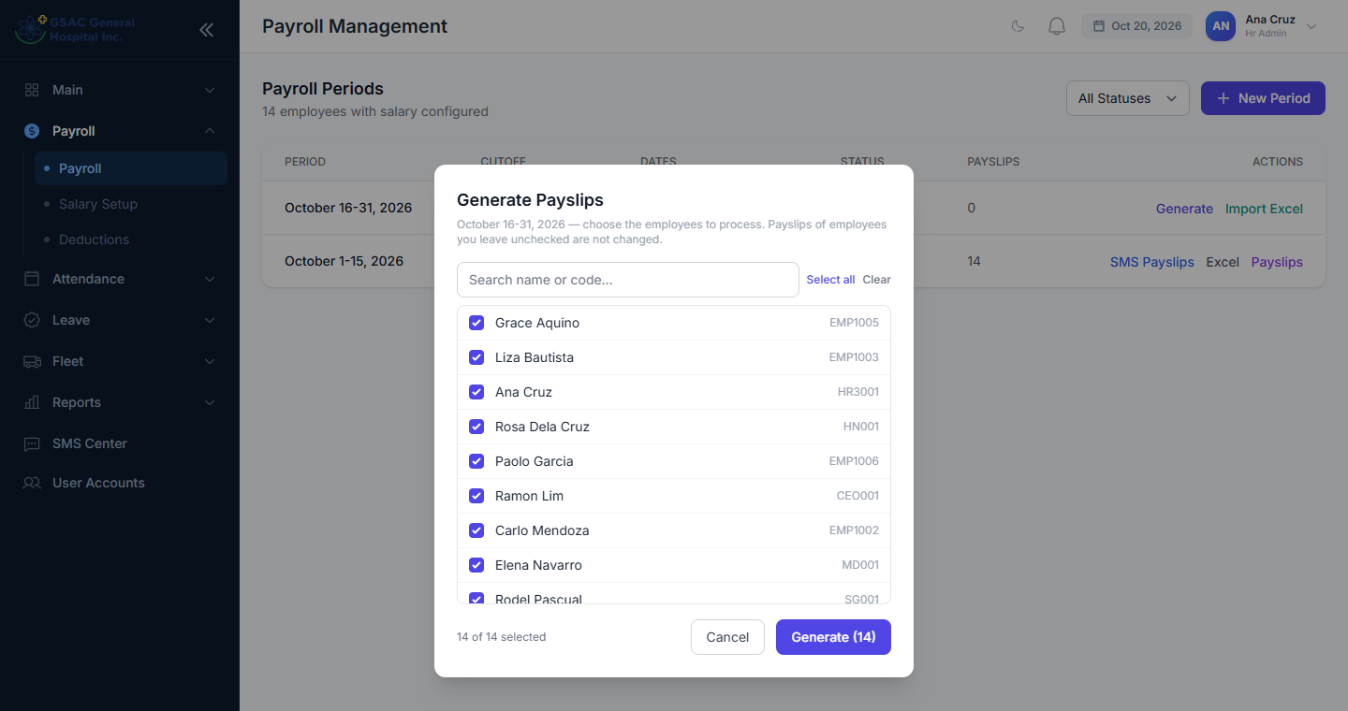
Figure 50. Choosing employees to generate payslips for
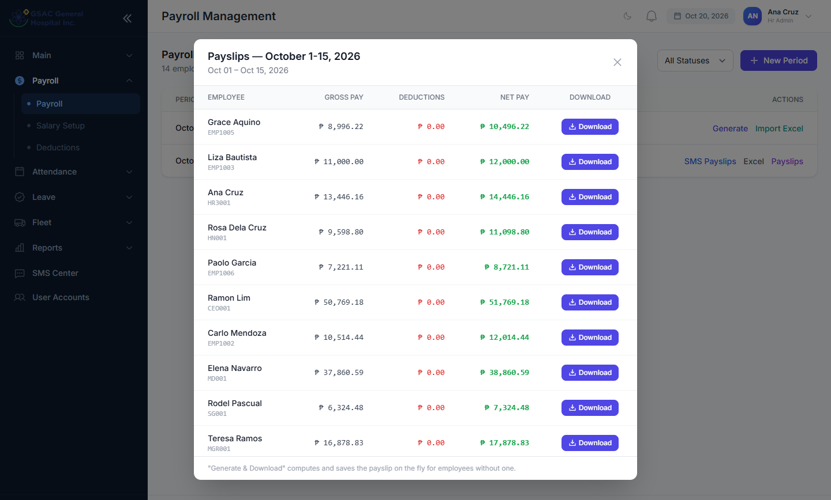
Figure 51. Reviewing payslips for a period
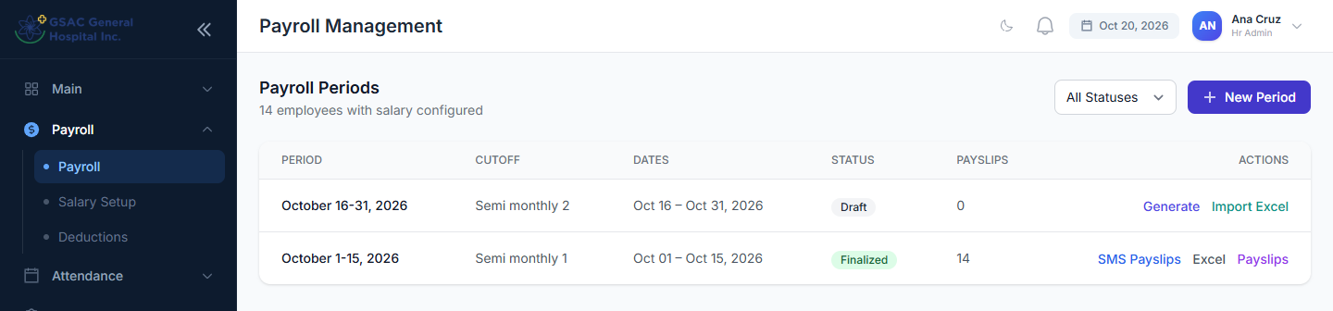
Figure 52. Payroll periods: a draft and a finalized period
Important: A finalized period cannot be regenerated. Make sure time corrections and leave for the period are approved first.

6.11 Reports
Menu: Reports
All reports can be filtered by date and department, and printed. Most also export to Excel or PDF. Department heads and managers see the Attendance and Leave reports.
Report | What it shows
Attendance | Every employee's daily time in/out, hours, minutes late and status for a date range.
Late | Late arrivals only, with totals, number of employees affected and the worst case.
Leave | Leave requests by type, status and department, with days used per leave type.
Payroll | Per-period totals: gross, deductions, net pay, and each employee's breakdown.
Overtime | Requested and approved overtime hours by employee and month.

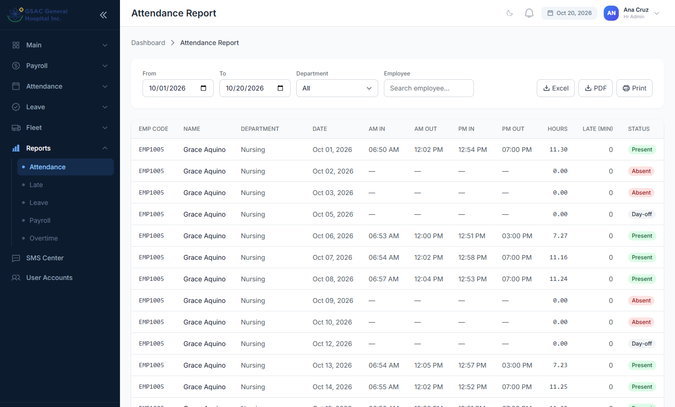
Figure 53. Attendance report
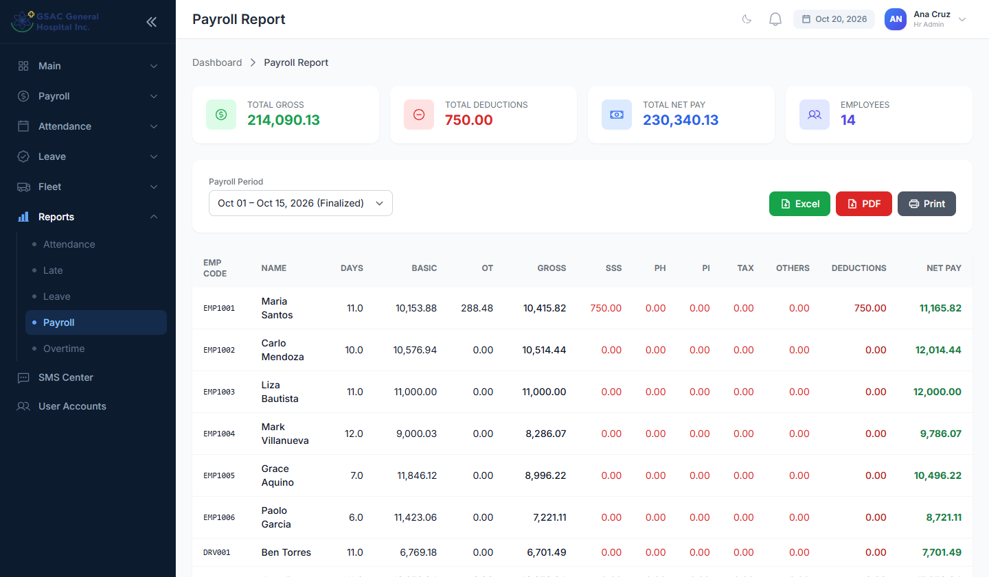
Figure 54. Payroll report

6.12 SMS Center
Menu: SMS Center
- Send Message: an announcement to all employees, a department, selected people or other numbers, as an app notification, an SMS, or both. Use {first_name} to personalize.
- Login Details: texts selected employees a new password with their employee code and the login link.
- Attendance Alerts: texts employees who were late or had no attendance on a chosen day. Rest days, holidays, approved leave and Nursing staff are skipped.
- App Notifications: checks phone-notification setup.
- History: every message sent and whether it was delivered.
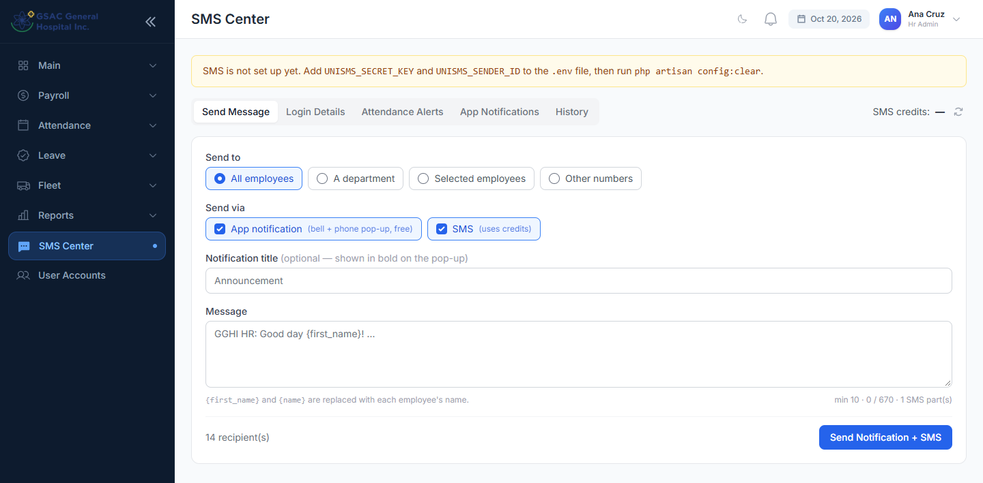
Figure 55. SMS Center: sending a message
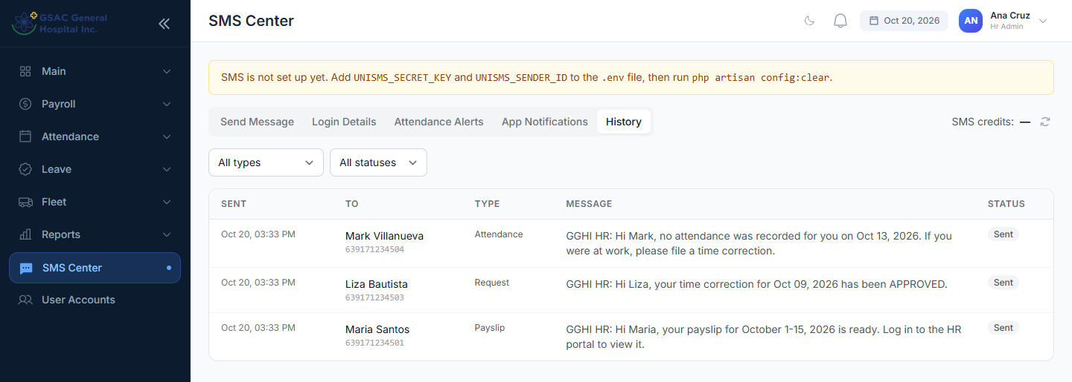
Figure 56. SMS history
Tip: SMS uses prepaid credits (shown at the top right). App notifications are free.

6.13 User accounts
Menu: User Accounts
Lists every login with its role and status. Add Account creates a login for an employee who has none: pick the employee, set the role and a starting password. Edit changes the role or password; Deactivate blocks sign-in without deleting history.
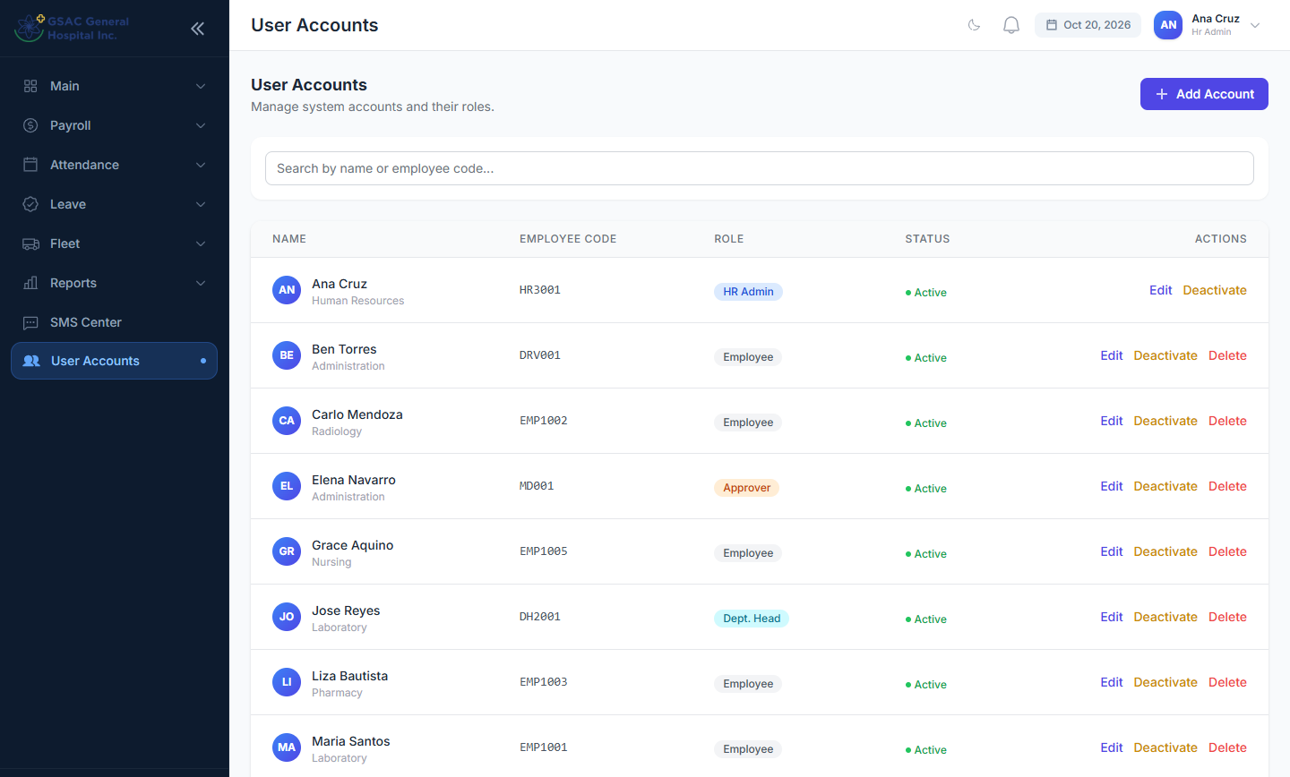
Figure 57. User accounts
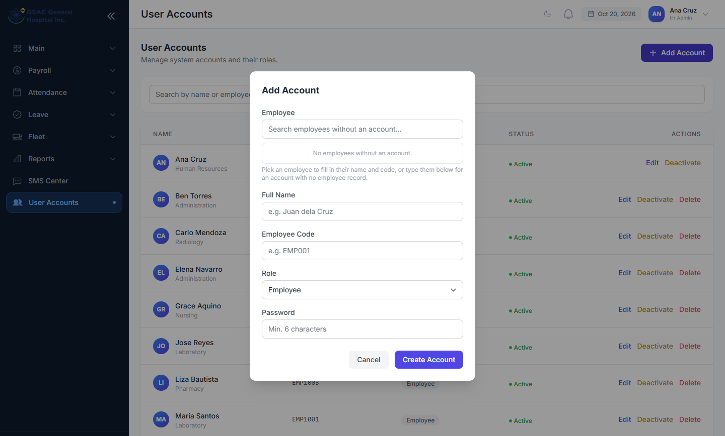
Figure 58. Adding an account

6.14 Fleet: vehicles and drivers
Menu: Fleet → Vehicles and Fleet → Drivers
Keep the vehicle list current: plate number, make and model, type, capacity and status (Available, In use, Under maintenance). Drivers are employees with a licence number, licence expiry and medical clearance date. HR can also use Fleet → Vehicle Returns, the same gate log the guards use.
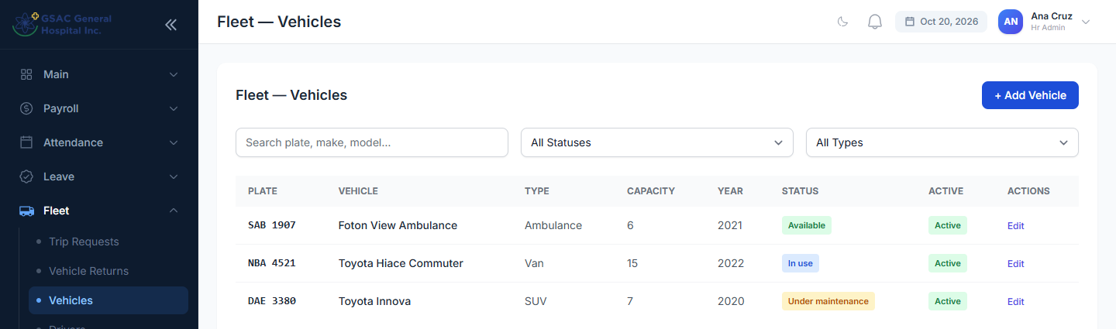
Figure 59. Vehicles
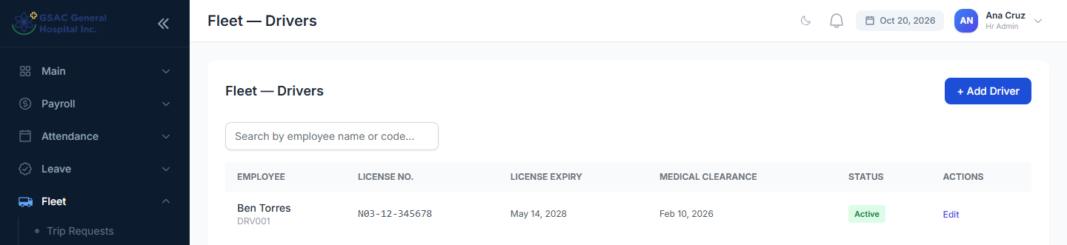
Figure 60. Drivers

Part 7. For Super Admins
A Super Admin can do everything an HR Admin can, plus:
- Approve at any step with an override (see 3.8).
- Roles & Permissions (Administration menu): create roles and permissions and choose what each role may do. Click a role to see and change its permissions.
- Manage User Accounts, including other administrators.
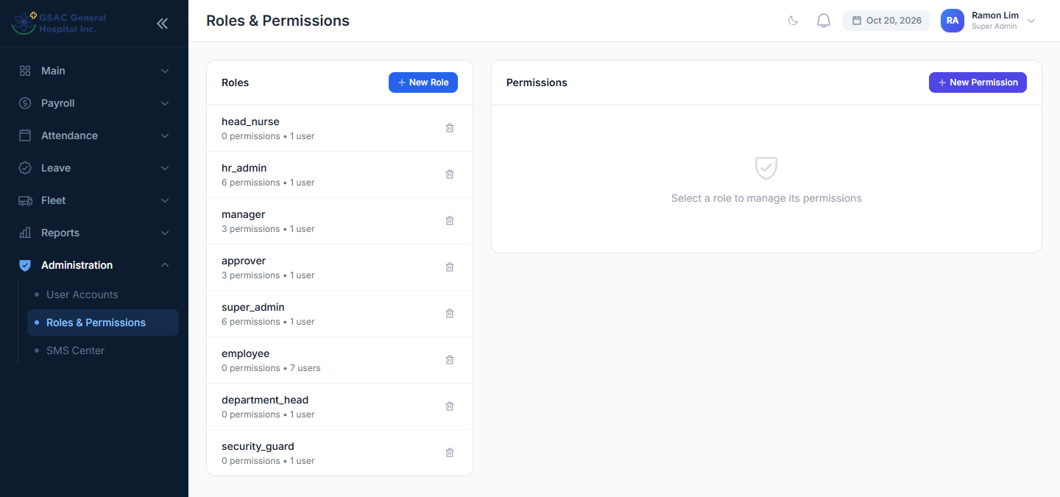
Figure 61. Roles & Permissions
Important: Changing a role's permissions affects every user with that role immediately. Make changes carefully and test with one account first.

Part 8. Questions and troubleshooting
Question | Answer
I can't sign in. | Check your employee code and password. After several wrong tries you must wait a few minutes. If your account was deactivated, contact HR.
I forgot my password. | Ask HR. They can reset it or text you new login details.
A menu item is missing. | Menus depend on your role. Ask HR if you need access.
My time-in is wrong or missing. | File a Time Correction (2.6). Approvers cannot edit raw scanner records.
A request says "Not your step". | It is waiting for another approver. Check the progress circles.
My payslip isn't showing. | HR has not generated payroll for that period yet. Check the Year filter, or ask HR.
Why was I marked absent on a rest day? | Your rest day may not be set up. Ask HR to check your weekly rest day and Day Offs.
I rejected something by mistake. | Rejections cannot be undone. Ask the employee to file again.
Can I file for someone else? | No. Each employee files from their own account.
I'm not receiving SMS. | Ask HR to check your mobile number and that SMS credits are available.

For anything not covered here, contact the HR office.

