GGHI HR PORTAL
Swap Rest Day
Step-by-step user guide for employees and approvers

What this guide covers: how an employee asks to work on a rest day and take a different day off, how each approver reviews the request, and what the system changes once the swap is approved.
Version: October 2026

Note: All screenshots use sample accounts and data. They do not show real employees.
Contents
1. Overview 3
Who uses it 3
Approval flow 3
Rules the system checks 3
2. For employees: requesting a swap 4
3. For approvers: reviewing requests 8
4. What changes after approval 11
5. Messages and what they mean 12
Frequently asked questions 12

1. Overview
Swap Rest Day lets an employee move one of their rest days to another date. The employee works on the original rest day and takes the new date off instead. Nothing changes until the request is fully approved.

Who uses it
Role | What they do | Where in the menu
Employee (incl. managers, department heads, head nurses) | Files a swap request and tracks its status | Attendance → Swap Rest Day (or My Leave → Swap Rest Day)
Department Head / Manager | Step 1 approval | Main → Rest Day Swaps
HR Admin | Step 2 approval | Leave → Rest Day Swaps
CEO / Medical Director | Step 3 (final) approval | Leave → Rest Day Swaps

Approval flow
A swap uses the same three-step approval chain as leave requests and time corrections:
Step | Approver | What happens when they approve
1 | Department Head | Request moves to HR. The employee gets an "in progress" notification.
2 | HR | Request moves to the CEO / Medical Director. Another "in progress" notification.
3 | CEO / Medical Director | Swap is applied. The rest day moves to the new date and the employee is notified by app and SMS.

Shortcuts: Requests filed by a department head start at step 2 (HR). Requests filed by a manager go straight to step 3. A Super Admin can approve at any step, which completes all remaining steps at once.

Rules the system checks
- The day you give up must be one of your rest days (your weekly day off, a Sunday, or a day off HR assigned you).
- The new date must not already be a rest day and must not be a holiday.
- Both dates must be today or later.
- You can only have one pending request per date. The checks run again at final approval.

2. For employees: requesting a swap

Step 1 Sign in
Open the HR portal and sign in with your Employee Code and password.
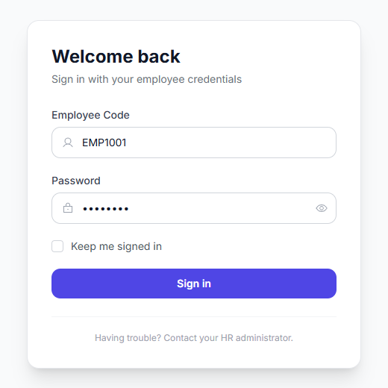
Figure 1. Sign in with your employee code

Step 2 Open Swap Rest Day
In the left menu, open Attendance and click Swap Rest Day. Managers, department heads and head nurses will find it under My Leave.
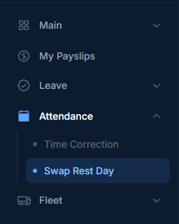
Figure 2. Swap Rest Day in the Attendance menu
The page has two parts: the request form at the top and My Rest Day Swaps, your request history, below it.
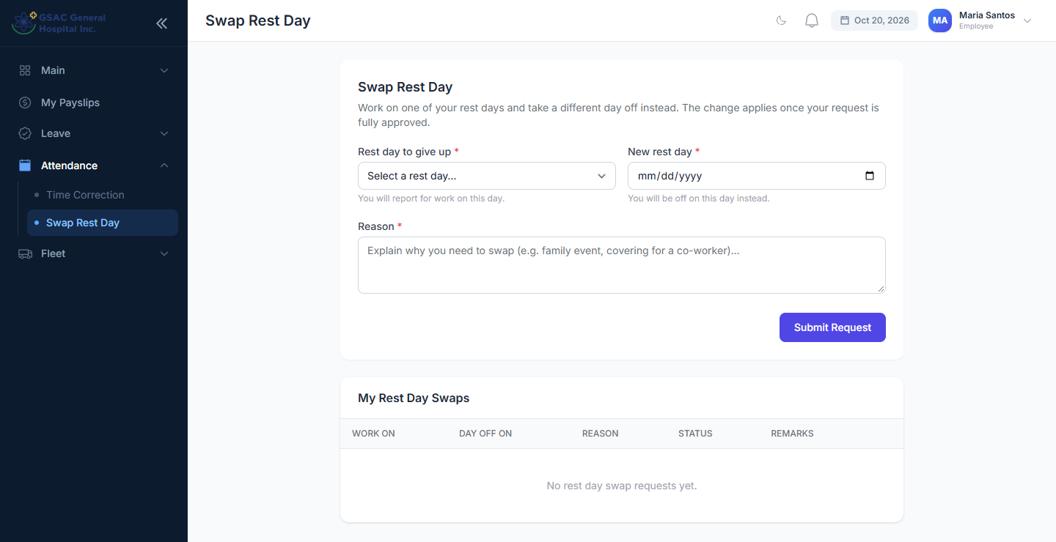
Figure 3. The Swap Rest Day page

Step 3 Fill in the form
- Rest day to give up: pick from the list. It shows only your rest days for the next 60 days. You will report for work on this day.
- New rest day: pick the date you want off instead.
- Reason: explain why you need the swap (at least 10 characters).
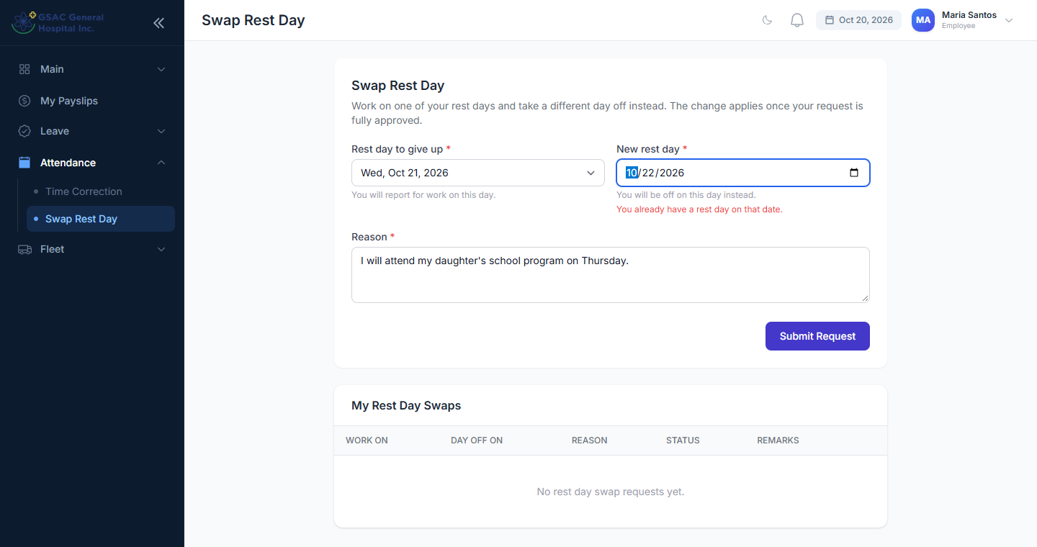
Figure 4. A completed request: work Wed Oct 21, rest Thu Oct 22

Step 4 Submit the request
Click Submit Request. A green message confirms it was sent, and the request appears in My Rest Day Swaps with the status Pending.
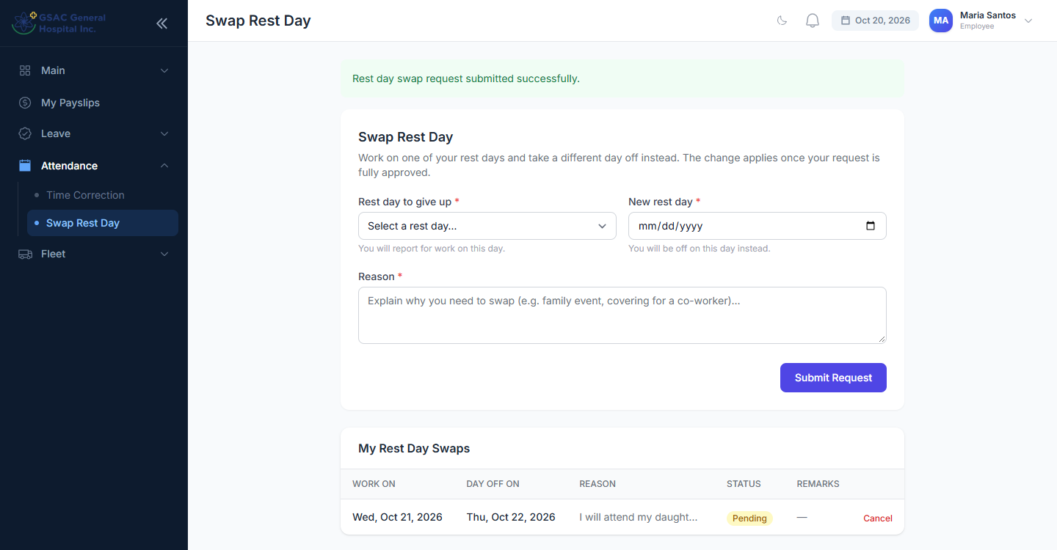
Figure 5. Request submitted and waiting for approval
If something is wrong, a red message appears under the field. In this example the new date is a Sunday, which is already a rest day:
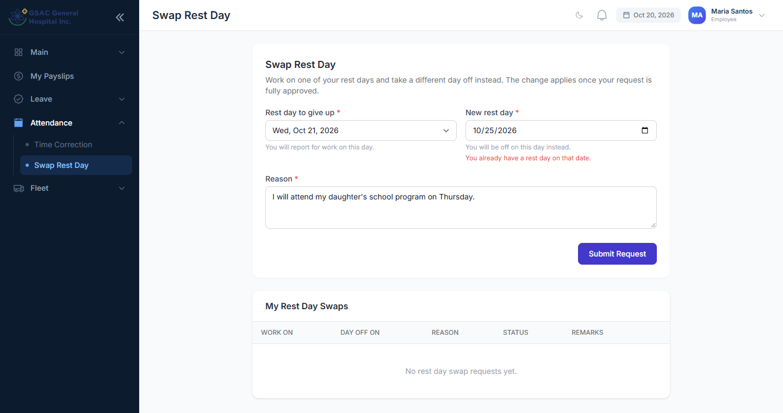
Figure 6. Example error: the new date is already a rest day

Step 5 Track your request
You get a notification (bell icon, top right) each time an approver acts on your request. The final decision is also sent by SMS if your mobile number is on file.
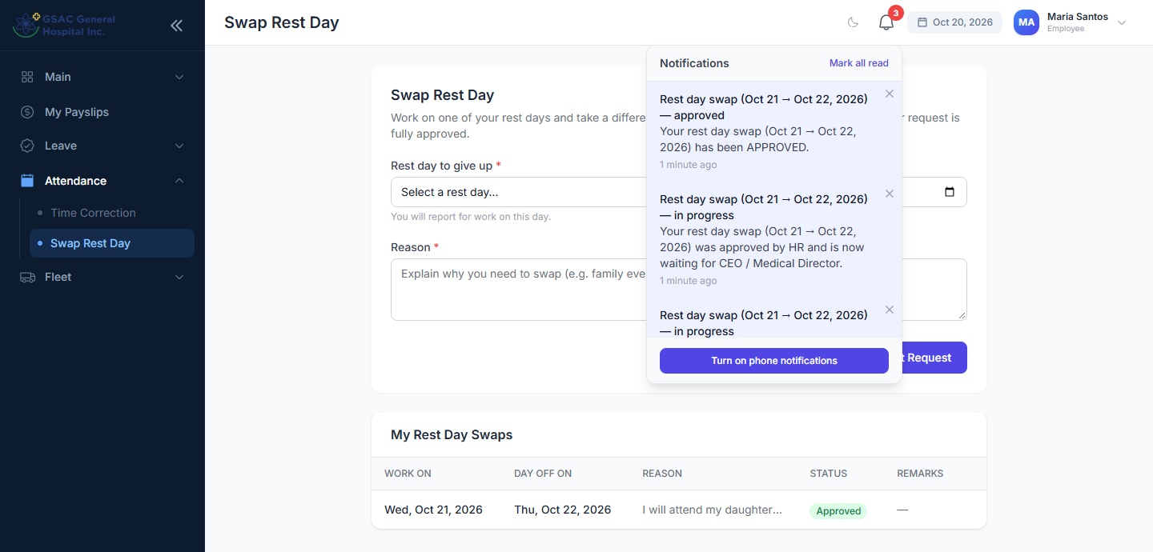
Figure 7. Notifications as the request moves through each step
When the final approver signs off, the status changes to Approved. If an approver rejects it, the status shows Rejected and the Remarks column explains why.
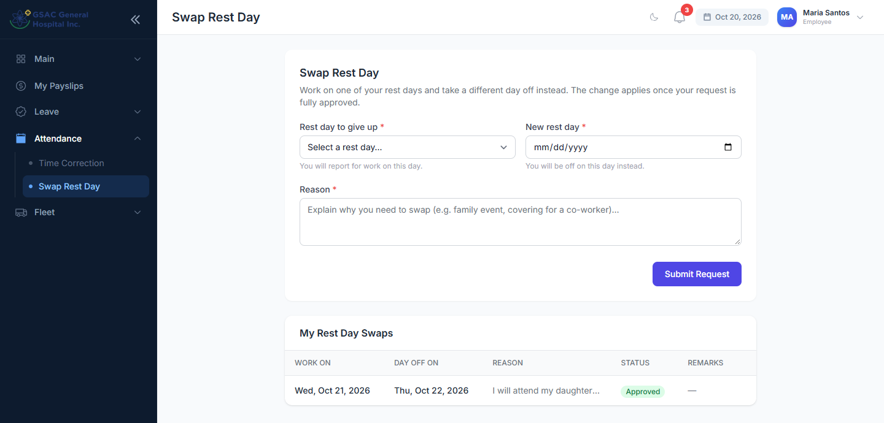
Figure 8. The request after final approval
Changed your mind? While a request is still Pending, click Cancel on its row. Once approved, ask HR to undo it.

3. For approvers: reviewing requests

Step 1 Open Rest Day Swaps
Department heads and managers: Main → Rest Day Swaps. HR, CEO / Medical Director and Super Admin: Leave → Rest Day Swaps.
The list shows the requests waiting at your step. The line above the table tells you which step you are. Each row shows:
- Work On: the rest day the employee will work.
- Day Off On: the date they want off instead.
- Reason: why they need the swap.
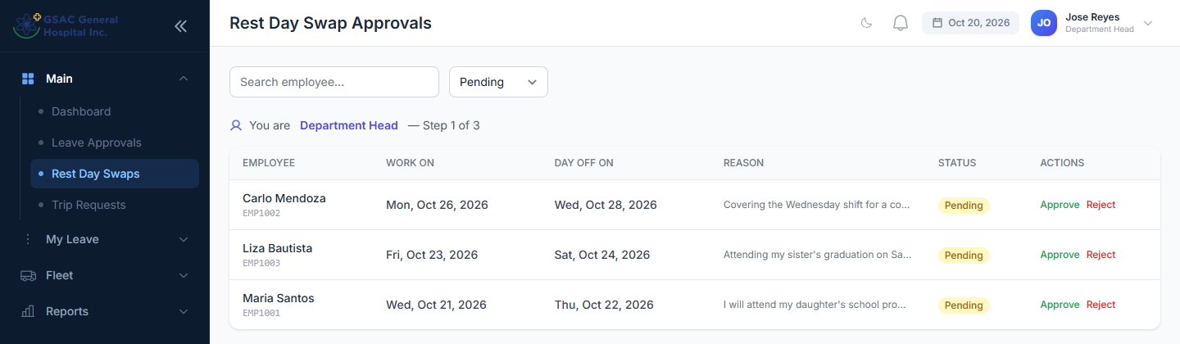
Figure 9. Department Head view: requests waiting at step 1
Tip: Use the search box to find an employee by name or code. Use the status filter to see Approved, Rejected, Cancelled or All requests.

Step 2 Approve a request
Click Approve on the row. Add remarks if you like (optional), then click Approve in the window.
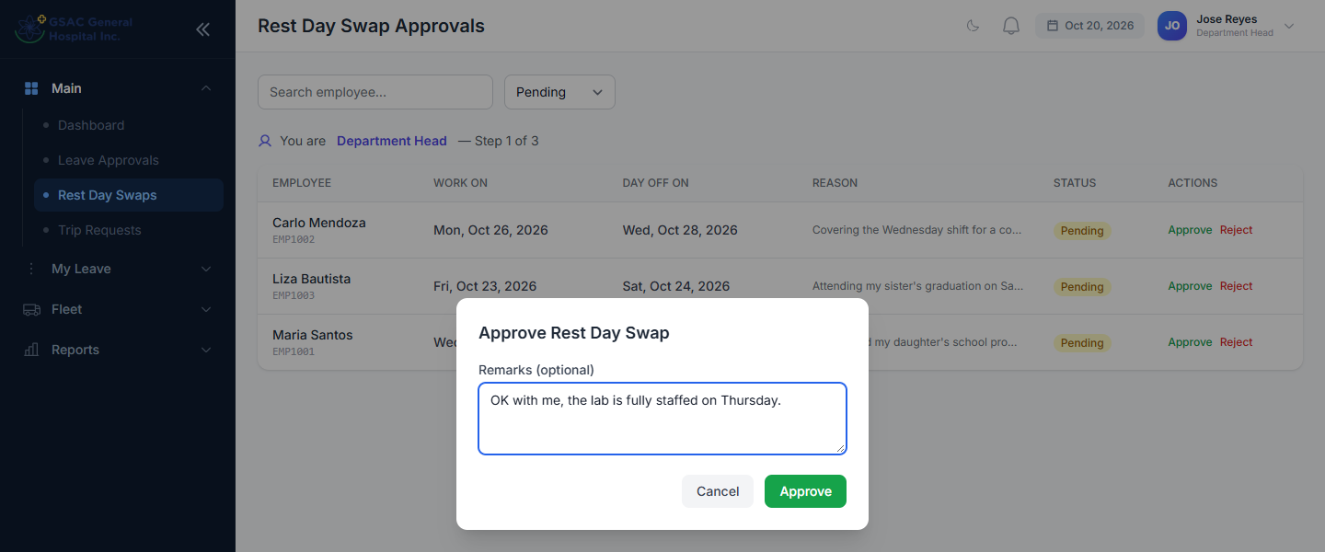
Figure 10. Approving with an optional remark
The request leaves your list and moves to the next approver.
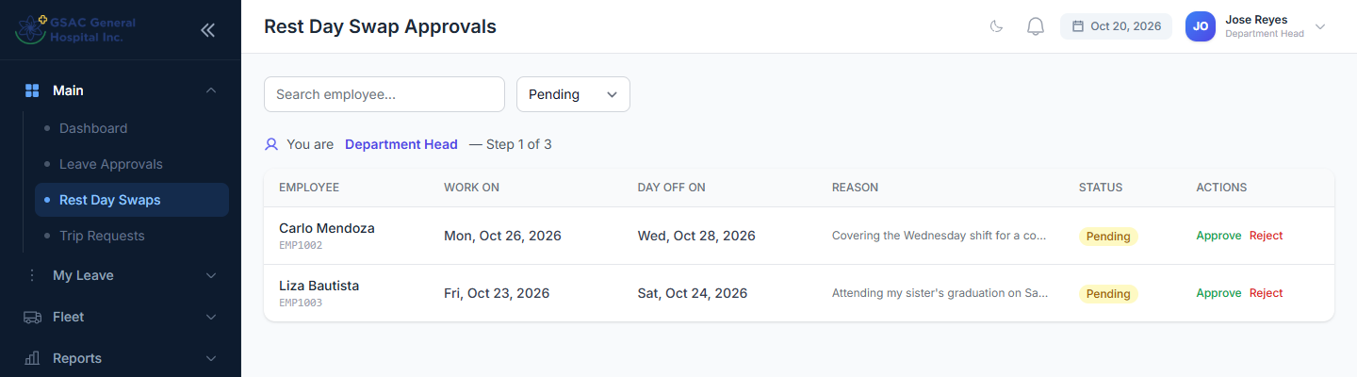
Figure 11. After approval the request moves on to HR

Step 3 Reject a request
Click Reject on the row. A reason is required; the employee sees it in their request history and in the notification.
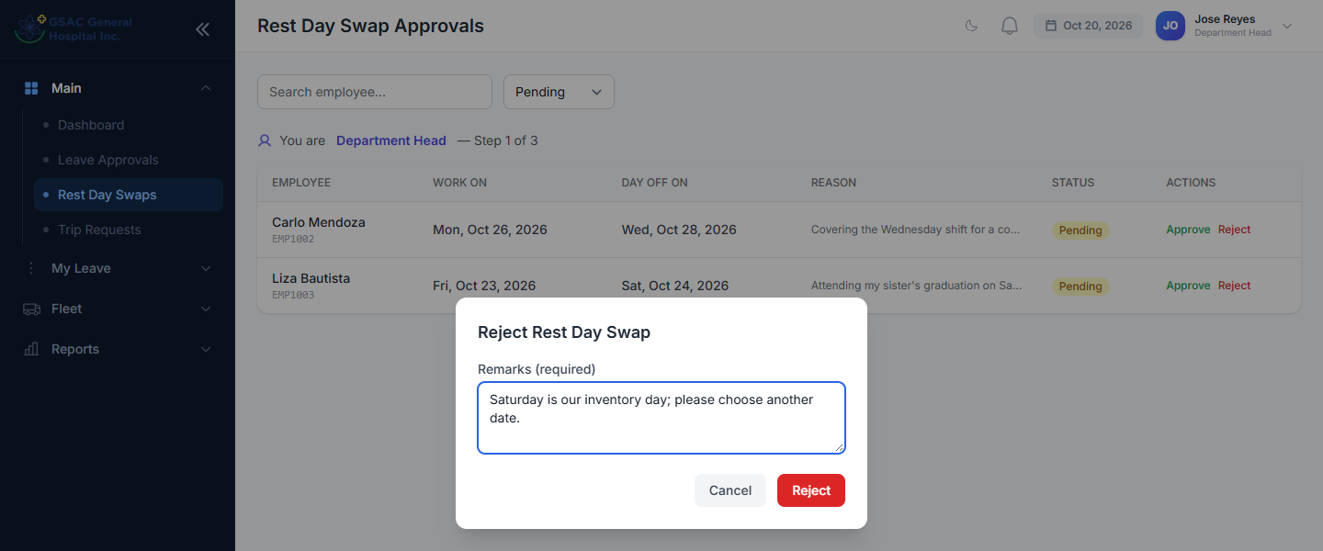
Figure 12. Rejecting requires a reason

Step 4 HR review (step 2)
HR sees requests that the department head has approved. Approve or reject the same way.
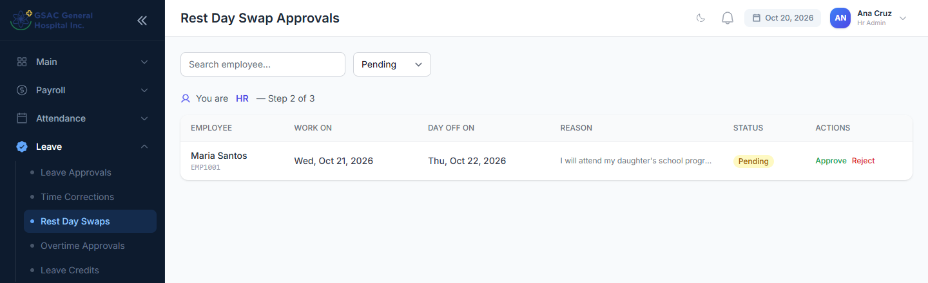
Figure 13. HR view: requests waiting at step 2

Step 5 Final approval (step 3)
The CEO / Medical Director gives final approval. This is the moment the system moves the rest day.
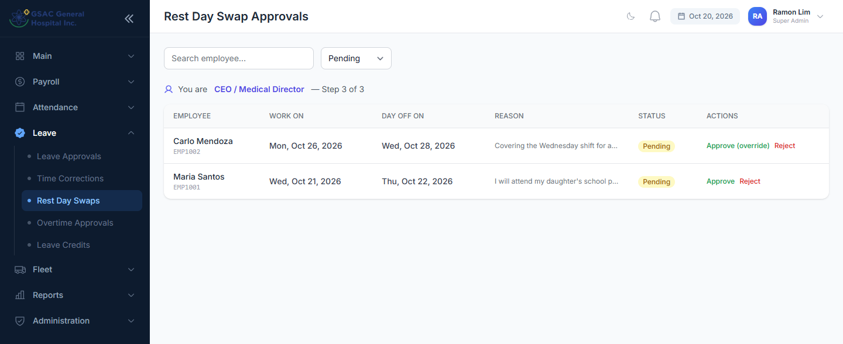
Figure 14. CEO / Medical Director view
Super Admins see every pending request. On requests that are not at their own step the button reads Approve (override), and the window shows a warning that this approves all remaining steps at once.
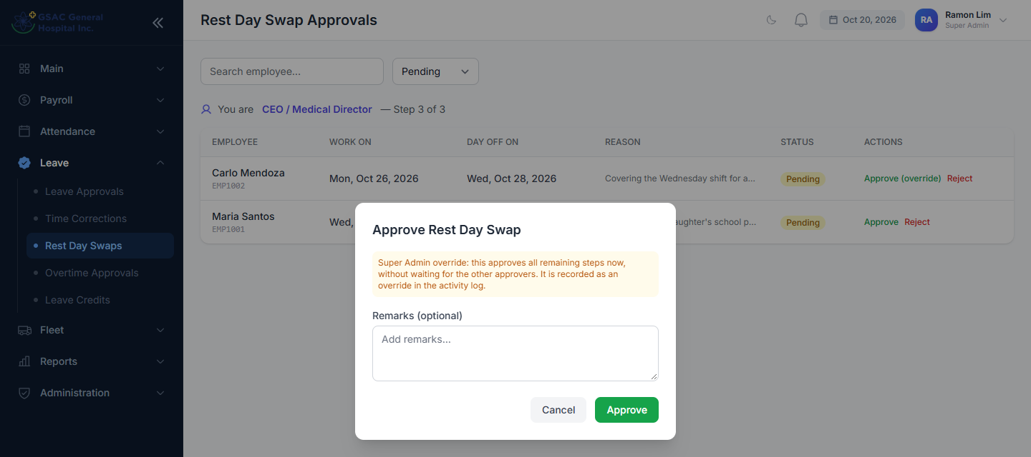
Figure 15. Final approval window (Super Admin)
To review completed swaps later, set the status filter to Approved.
If approval is blocked: At final approval the system checks the dates again. If the new date has since become a rest day or a holiday, or the original day is no longer a rest day, an error is shown and the swap is not applied. Reject the request with a note so the employee can file a new one.

4. What changes after approval
When a swap is fully approved, the system updates the schedule automatically. HR does not need to edit anything by hand.
Area | Original rest day (now a working day) | New date (now a rest day)
Day Offs (HR) | Its day-off record is removed or moved | A rest-day record appears, described as "Swapped from <date>"
Attendance | Expected to report for work. A missed day shows as Absent | Shows as Day-off
Payroll | Counted as a working day | Not counted as a working day
Leave | Filing leave on it uses a leave credit | Treated like any other day off
SMS alerts | Late/absent alerts are sent as usual | No alerts

The total number of working days in the pay period stays the same, so the swap does not change the employee's pay.
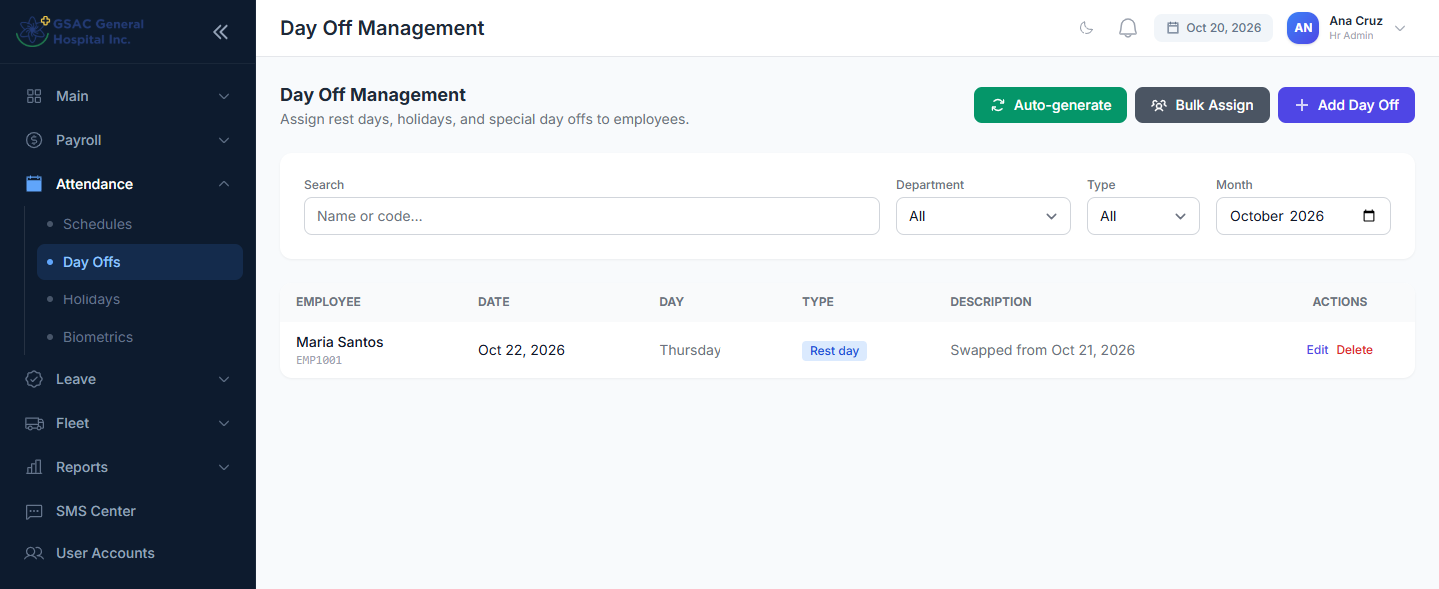
Figure 16. HR → Day Offs shows the moved rest day
Auto-generate is safe: If HR runs Auto-generate in Day Off Management later, it will not re-create a rest day that was swapped away.

5. Messages and what they mean
Message | What it means / what to do
That date is not one of your rest days. | The day you chose to give up is a normal working day. Pick a date from the rest-day list.
You already have a rest day on that date. | The new date is already a day off for you. Choose a working day instead.
That date is a holiday. | Holidays are already non-working days. Choose a different new date.
You already have a pending swap involving one of these dates. | Wait for the earlier request to be decided, or cancel it first.
The new rest day must be a different date. | Both dates are the same. Pick a different new rest day.
The … must be a date after or equal to today. | Swaps can only be filed for today or future dates.
Cannot approve: … | (Approvers) The schedule changed since the request was filed. Reject it with a note.
Reason is required when rejecting. | (Approvers) Type a reason in Remarks before clicking Reject.

Frequently asked questions
Can I swap with a co-worker? Not directly. Each employee files their own request for their own rest day.
My rest day is not in the list. The list shows the next 60 days only. If a rest day is still missing, ask HR to check your weekly day off in your employee record.
Can an approved swap be undone? Not from the app. Contact HR, who can correct it in Day Off Management.
Who gets notified? The employee is notified at every step through the app. The final approval or rejection is also sent by SMS.

