${notes}

Dr. Famiran Ghandali - Gonzales
General Dentistry, Orthodontics, Implant Dentistry #28 - 1 Don Juan Estevez St. Guevara Subd. Legaspi City
Cellphone No.: (+63) 918-633-1795

CERTIFICATION

To Whom It May Concern:

This is to certify that ${patient_name}, ${age} years of age, was examined and treated by the undersigned on ${date_treated}.

Findings: Service Rendered:
${findings} ${treatment_done}
${notes}

Issued upon request of the party concerned, this ${issue_date}, for whatever purpose it may serve.

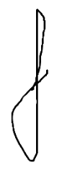
______________D.M.D.
Licensed #:0047299
P.T.R. #7343972

