
TriStellar HRIS
System Overview and User Guide
Employee Management · Timekeeping · Payroll
Version 1.0 | October 31, 2026
Screens shown use sample (demo) data.
Contents
1. Introduction 3
What changed compared with the old systems 3
2. User Roles and Access 4
3. Signing In 5
Navigating the system 5
4. Dashboard 6
5. Employee Management (EMS) 8
5.1 Employee Records 8
5.2 Employee profile 8
5.3 Adding or editing an employee 9
5.4 Departments, branches and shifts 11
6. Timekeeping (TMS) 14
6.1 Time Logs 14
6.2 My Attendance (employees) 15
6.3 Filing a request (employees) 16
6.4 Endorsement by the Department Head 17
6.5 Filings Approval (HR Time Keeper) 18
6.6 Work Hours Summary (WHS) 19
6.7 How attendance is computed 21
6.8 Holidays 22
7. Payroll (PMS) 23
7.1 Payroll Periods 23
7.2 Payroll Register 24
7.3 How pay is computed 26
7.4 Payslip 27
7.5 Loans 27
8. User Accounts 29
9. Cut-off Checklist 30
10. Items for Confirmation 31
Planned next 31

If page numbers do not appear, right-click the table above in Word and choose Update Field.

1. Introduction
TriStellar HRIS is the company's new web-based Human Resource Information System. It brings together the three systems used before — EMS (Employee Management System), TMS (Timekeeping Management System) and PMS (Payroll Management System) — into one application that HR, Finance, Department Heads and employees open in a web browser.
The system follows the existing company process: biometric time logs are uploaded every cut-off, employees file their missing logs and requests, Department Heads and the HR Time Keeper approve them, the Work Hours Summary (WHS) is produced, and payroll is processed and released from it.

What changed compared with the old systems
Before | Now in TriStellar HRIS
Separate EMS, TMS and PMS applications | One system with one login per person
Logs moved from BIS TK to TMS, then cleaned and reprocessed manually | Upload the BIS export once; the WHS is computed automatically and always reflects approved filings
Filings checked in the kiosk, then re-entered in TMS | Employees file online; Dept. Head endorses and HR approves in the same screen
WHS exported per department by hand | WHS per department in one click, with export to Excel (CSV) and print
Per Biyahe and deductions uploaded in PMS, payroll register downloaded and audited repeatedly | Upload files into the payroll period; reprocess any time until finalized
Payslips sent individually through WhatsApp | Employees see their own payslips after payroll is finalized (still printable / PDF)

2. User Roles and Access
Each person signs in with their own account. What they see in the left-hand menu depends on their role, so employees never see other people's records or payroll.
Role | What they can do
Administrator | Everything, including creating staff accounts and assigning roles.
HR Time Keeper | Employee records, time log uploads and Bundy Clock entries, final approval of filings, Work Hours Summary, holidays.
HR Payroll Officer | Employee records, payroll periods, Per Biyahe and other earnings uploads, processing and finalizing payroll, loans.
Finance | Payroll periods and register, uploading deductions, payment advice (ATM / Cash) and payslips.
Department Head | Any employee set as head of a department. Endorses (or denies) the filings of their team before they go to HR.
Employee | Own dashboard, attendance and logs, filing requests, and own payslips (Employee Kiosk).

3. Signing In
Open the system address in any modern browser (Chrome, Edge or Firefox) and sign in with your email and password. Tick Keep me signed in only on your own device. After five wrong attempts in a minute, sign-in is paused briefly to protect accounts.
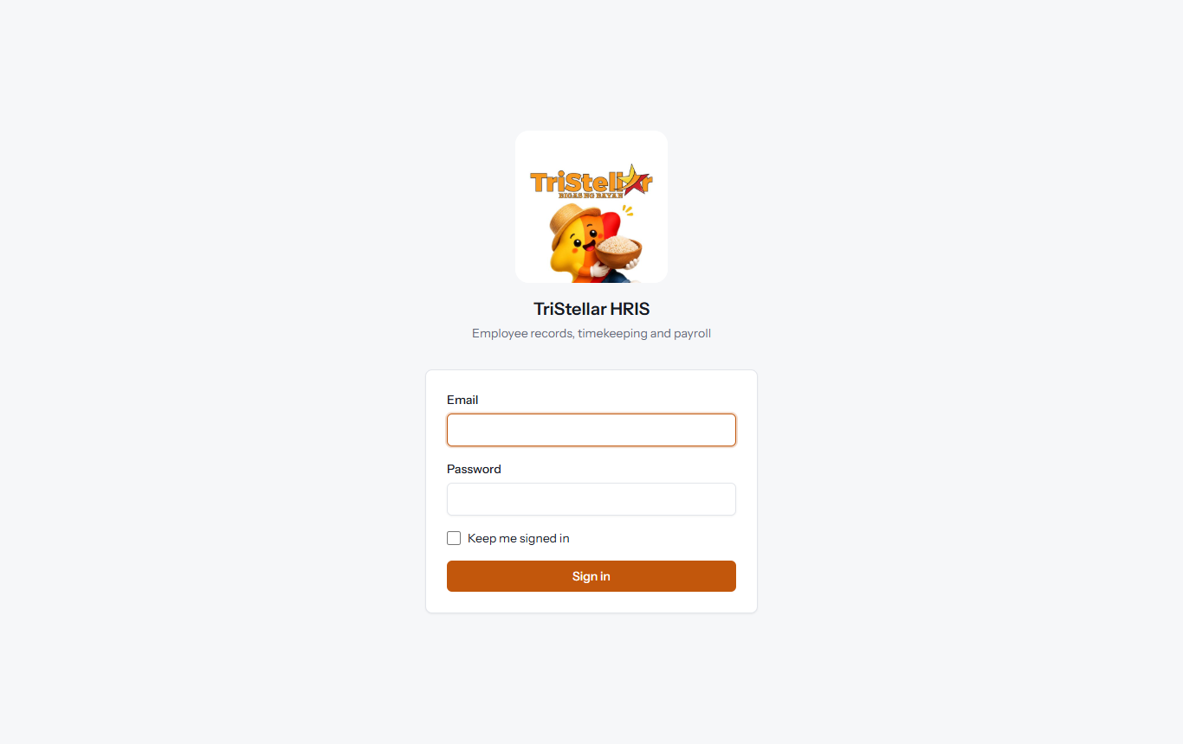
Figure 1. Sign-in page.

Navigating the system
After signing in, the menu on the left groups the screens by module: My Kiosk, Dept. Head, Employees, Timekeeping, Payroll and Administration. Your name and the Log out link are at the bottom of the menu. On a phone, tap Menu at the top to open it.
Messages such as "Payroll processed" or "Filing approved" appear briefly at the bottom-right corner after each action.

4. Dashboard
The Dashboard is the first screen after signing in. HR, Payroll and Finance users see company-wide figures:
- Active employees — current headcount.
- With logs today — employees who have tapped in today (biometric or Bundy Clock).
- Filings awaiting review — requests not yet approved, with a shortcut to the approval screen.
- Latest payroll period — its status (Draft, Processed or Finalized) and a link to the register.
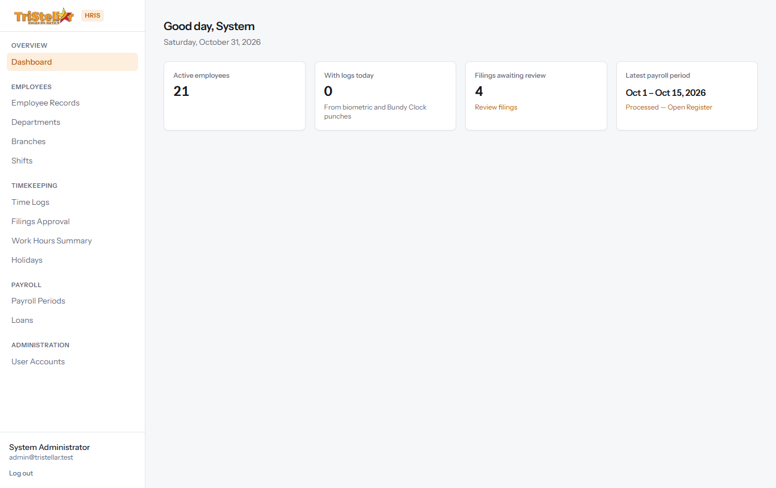
Figure 2. Dashboard for HR and administrators.
Employees see their own information instead: today's punches, how many of their filings are pending, and their latest released payslip.
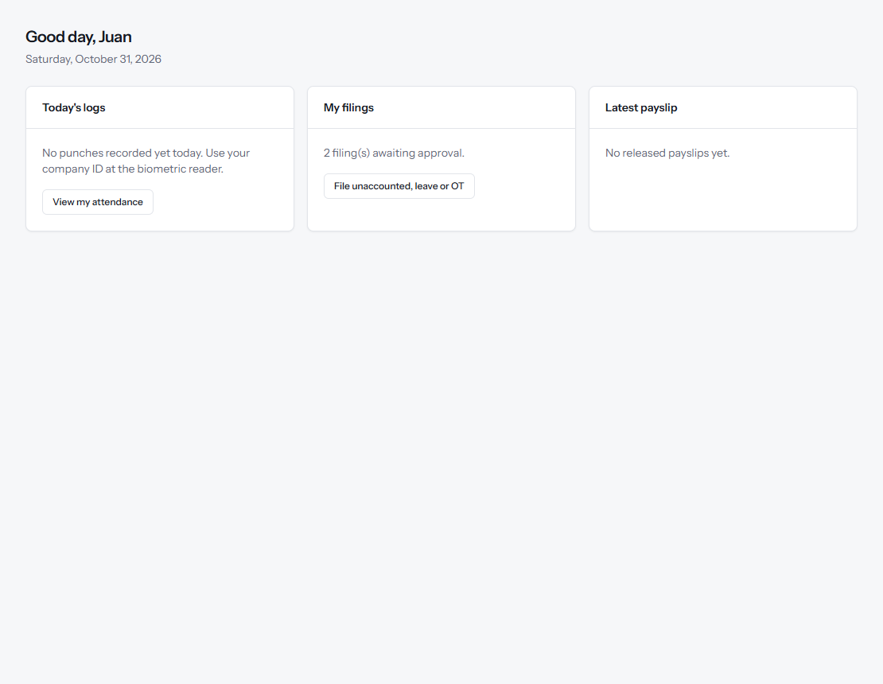
Figure 3. Dashboard for an employee (Employee Kiosk).

5. Employee Management (EMS)

5.1 Employee Records
Employees → Employee Records lists all employees. Search by name or employee number, and filter by department or status (Active, Resigned, Terminated). Click a name to open the full profile.
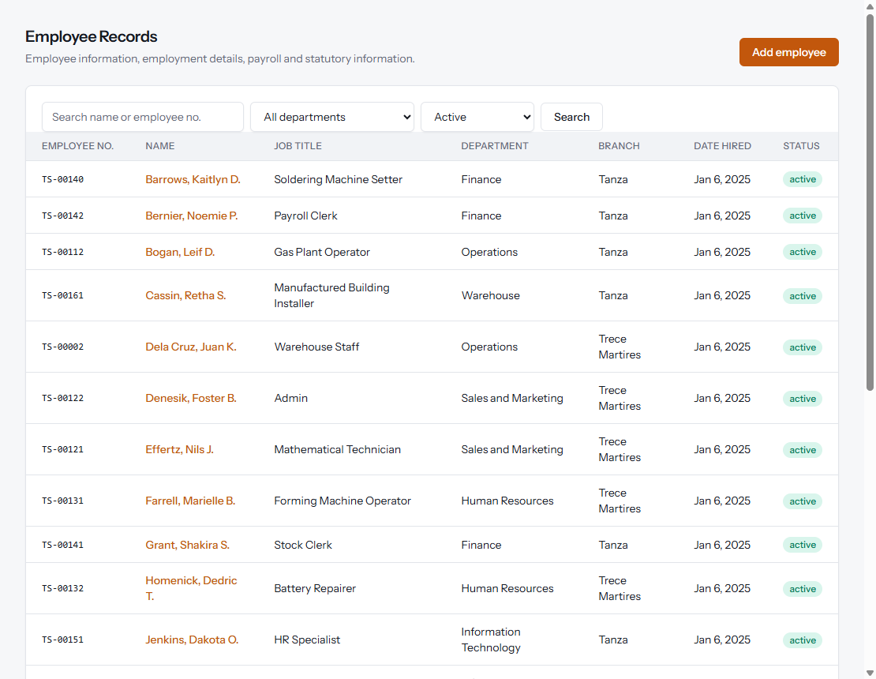
Figure 4. Employee Records list.

5.2 Employee profile
The profile shows employment details, payroll and statutory information, contact and emergency contact, recent filings, loans and recent payslips. From here HR can open the employee's Work hours or Edit record.
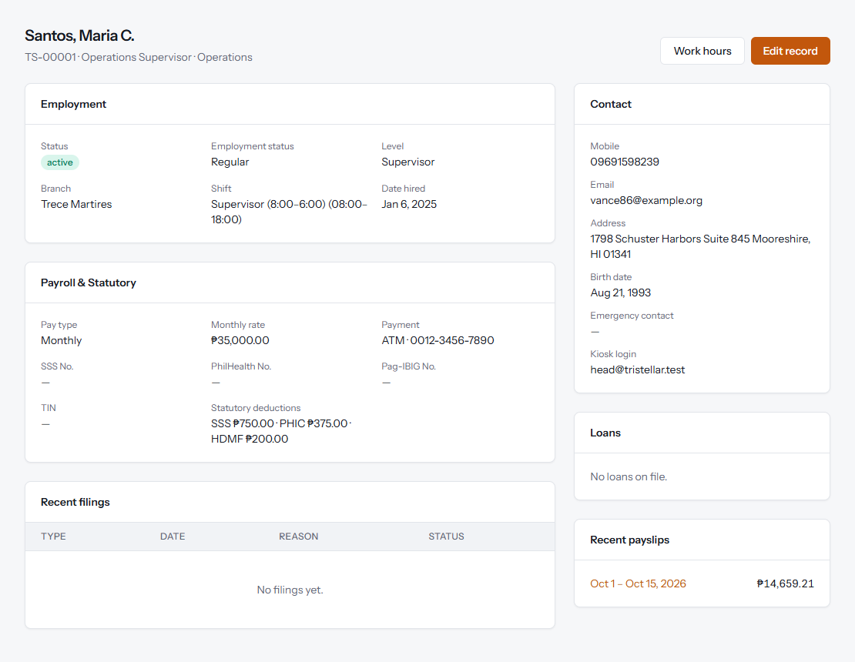
Figure 5. Employee profile.

5.3 Adding or editing an employee
Click Add employee to create a record. The form is divided into sections, matching the old EMS record creation and Employee Maintenance steps:
- Employee Information — name, birth date, gender, civil status, contact details and address.
- Employment — branch, department, job title, level (Rank & File, Supervisor, Manager), shift, employment status, employee status and date hired. A date separated is required when the status is Resigned or Terminated.
- Payroll Information — pay type (Daily, Monthly or Per Biyahe), rate, and payment method (ATM / BDO with account number, or Cash).
- Government & Statutory — SSS, PhilHealth, Pag-IBIG and TIN numbers, and the fixed employee shares. Following company policy, tick Apply statutory deductions only after the employee completes one month; the system also skips contributions during the first month automatically.
- Emergency Contact and Kiosk Access — an optional login email and password so the employee can use the Employee Kiosk.
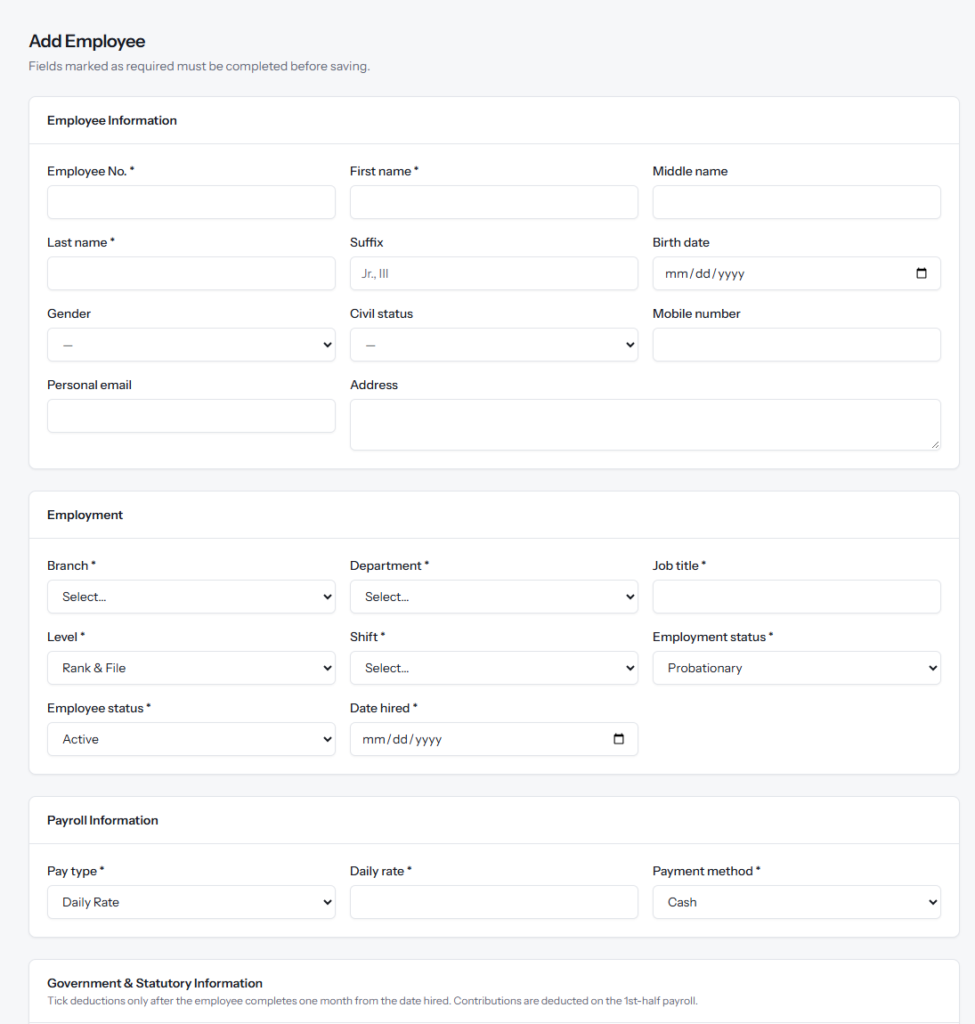
Figure 6. Add Employee form — personal, employment and payroll sections.
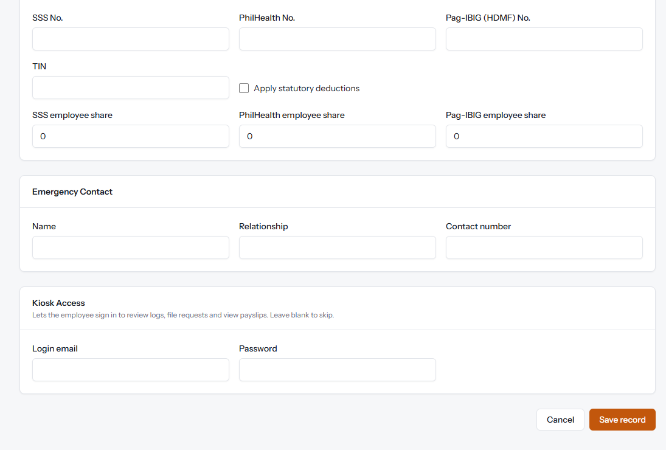
Figure 7. Add Employee form — statutory, emergency contact and kiosk access sections.
Per Biyahe drivers: enter their regular daily rate (e.g. ₱600 for Trece, ₱550 for Tanza). It is the basis for 13th-month pay and contributions; their actual pay comes from the uploaded trips each cut-off.

5.4 Departments, branches and shifts
Departments lists each department with its code, email and Department Head. The head receives their team's filings for endorsement, and the department email is where the Work Hours Summary is sent for confirmation. A department or branch that still has employees cannot be deleted.
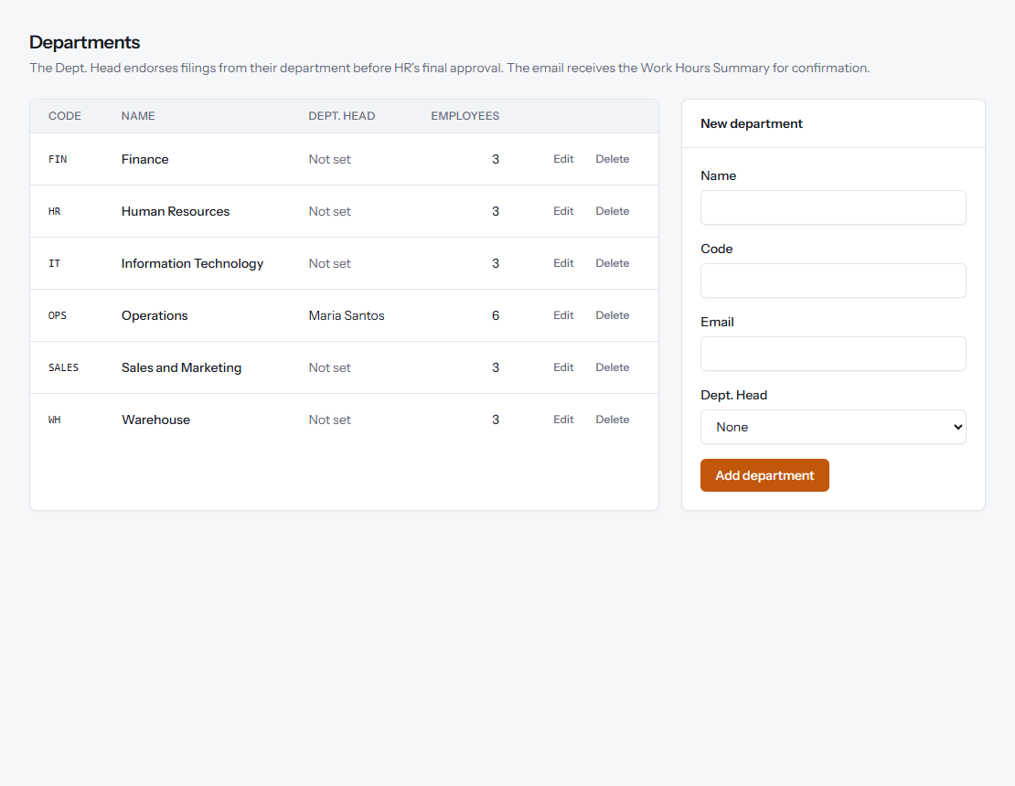
Figure 8. Departments, with the Department Head assignment.
Shifts defines working schedules — start and end time, unpaid break, and work days. Lates, undertime and half days are computed from the employee's shift. The two standard shifts are set up: Rank & File (7:00–4:00) and Supervisor (8:00–6:00), both Monday to Saturday. A half day is half of the paid hours (4 hours and 4.5 hours respectively). Branches (Trece Martires and Tanza) are managed the same way.
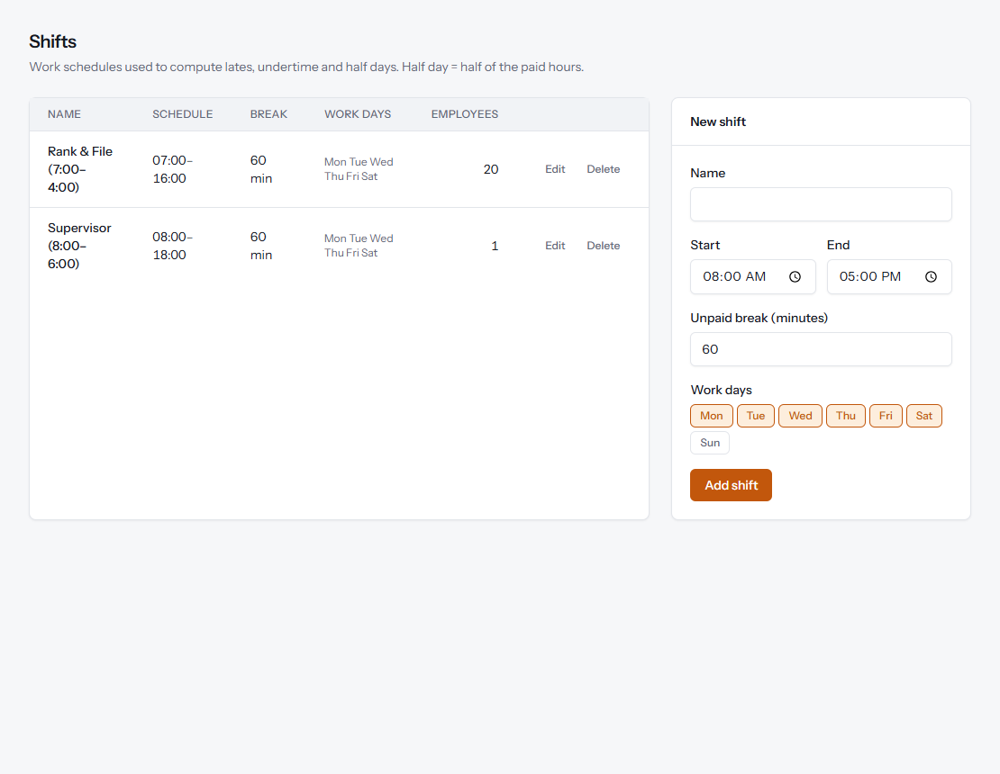
Figure 9. Shifts.

6. Timekeeping (TMS)
Timekeeping follows the same cut-off process as before, now in one place:
- HR Time Keeper uploads the biometric (BIS) logs for the cut-off.
- Employees review their attendance and file missing logs, leaves, overtime, early outs or shift changes.
- The Department Head endorses or denies each filing.
- The HR Time Keeper gives the final approval.
- The Work Hours Summary updates automatically and is sent to Department Heads for confirmation (no reply within the time frame means confirmed).
- Payroll is processed from the confirmed WHS.

6.1 Time Logs
Timekeeping → Time Logs holds every punch. Two ways to add punches:
- Upload BIS time logs — upload the CSV exported from the biometric system (columns: employee number, date and time). Punches already on file are skipped, and unknown employee numbers are listed so they can be checked.
- Bundy Clock entry — when the biometric system is down, HR encodes the Bundy Clock time here. No Unaccounted form is needed (Protocol 1.3). These punches are labelled "Bundy Clock".
The first punch of the day is treated as time-in and the last as time-out.
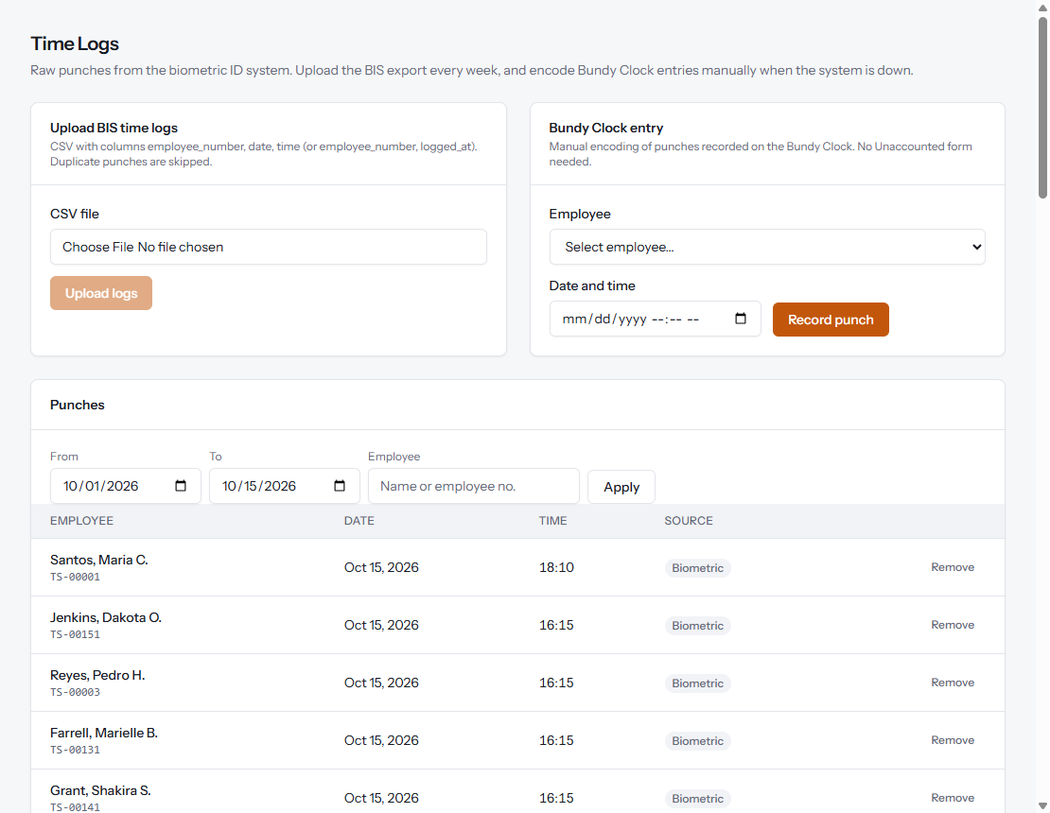
Figure 10. Time Logs: upload, Bundy Clock entry and list of punches.

6.2 My Attendance (employees)
Employees open My Kiosk → My Attendance to review each day of the cut-off: shift, time in and out, late, undertime, overtime and status (Present, Absent, Missing log, On leave, Holiday, Rest day). A reminder appears when there are days with missing logs, so they can file before the 3rd and 18th, 12:00 NN deadline.
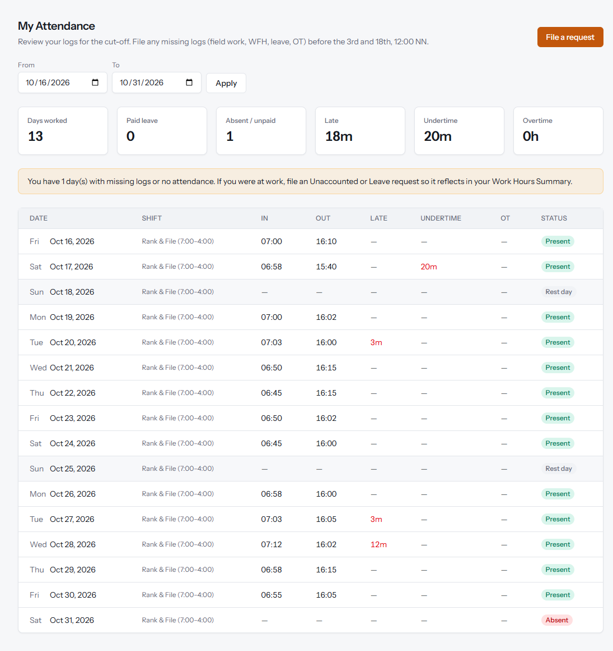
Figure 11. My Attendance, as seen by an employee.

6.3 Filing a request (employees)
Under My Kiosk → My Filings, employees submit one of five request types. The form changes depending on the type:
Filing type | Used for | Details asked
Unaccounted | Missing time-in or time-out (field work, approved WFH, reader offline) | Date, time in and/or time out
Leave | Whole-day or half-day leave | Date range, half day, with pay
Overtime | Work beyond the shift | Date, start and end time
Early Out | Leaving before the end of shift | Date, time out
Shift Change | Working a different schedule for the day | Date, new shift

The list on the left shows every request with its status and any remarks from the approvers. A request can be withdrawn while it is still Pending.
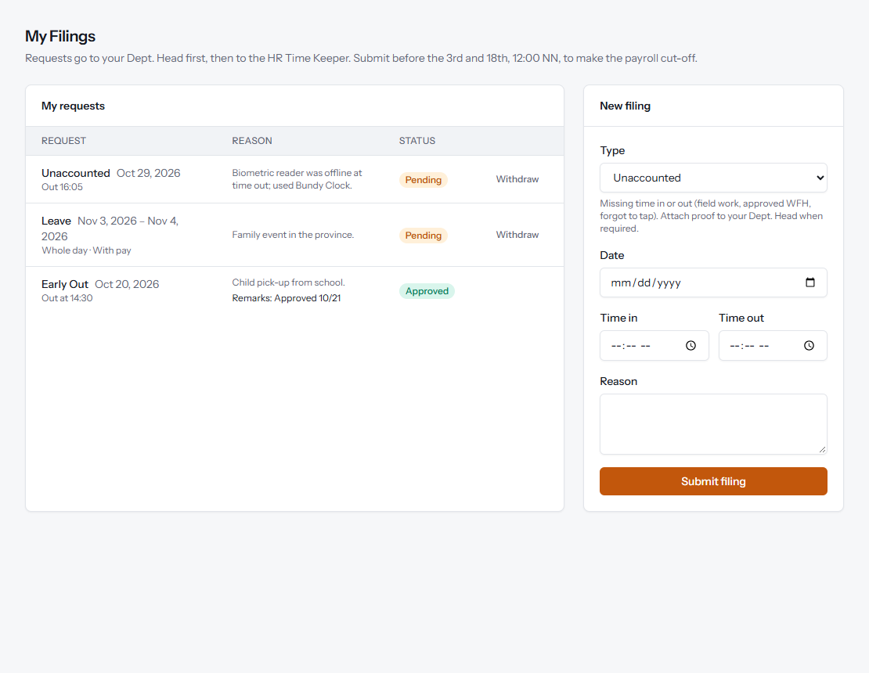
Figure 12. My Filings: new filing form and request history.

6.4 Endorsement by the Department Head
Department Heads see Dept. Head → Endorsements, listing pending filings from their department. Endorse sends the filing to HR; Deny asks for a reason, which the employee will see. Heads cannot endorse their own filings — those go directly to HR.
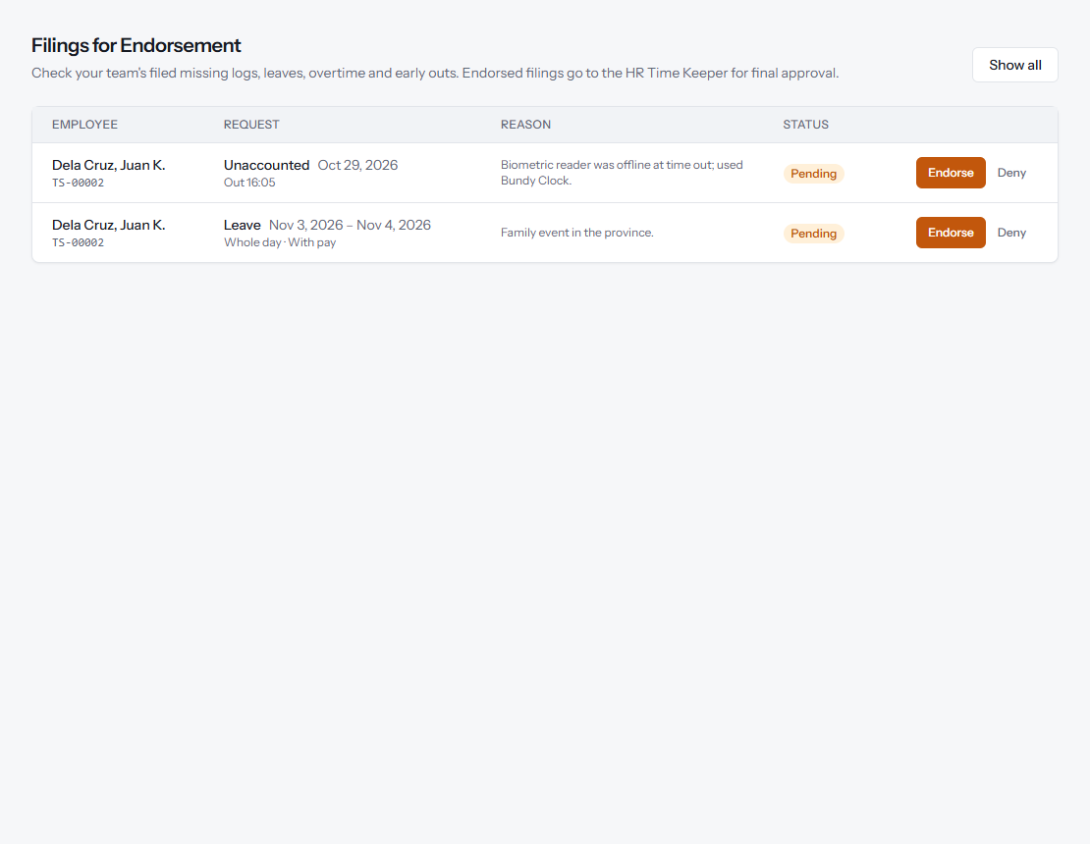
Figure 13. Endorsements screen for a Department Head.

6.5 Filings Approval (HR Time Keeper)
Timekeeping → Filings Approval shows filings awaiting review. Approve and Deny are available only once a filing has been endorsed by the Department Head (or when the department has no head). Filings still waiting for the head show Awaiting Dept. Head.
When approving a leave, HR confirms whether it is with pay. A remarks box is pre-filled with the approval date for HR records, as required by the old TMS procedure. Once approved, the change is immediately reflected in the Work Hours Summary — there is no separate reprocessing step.
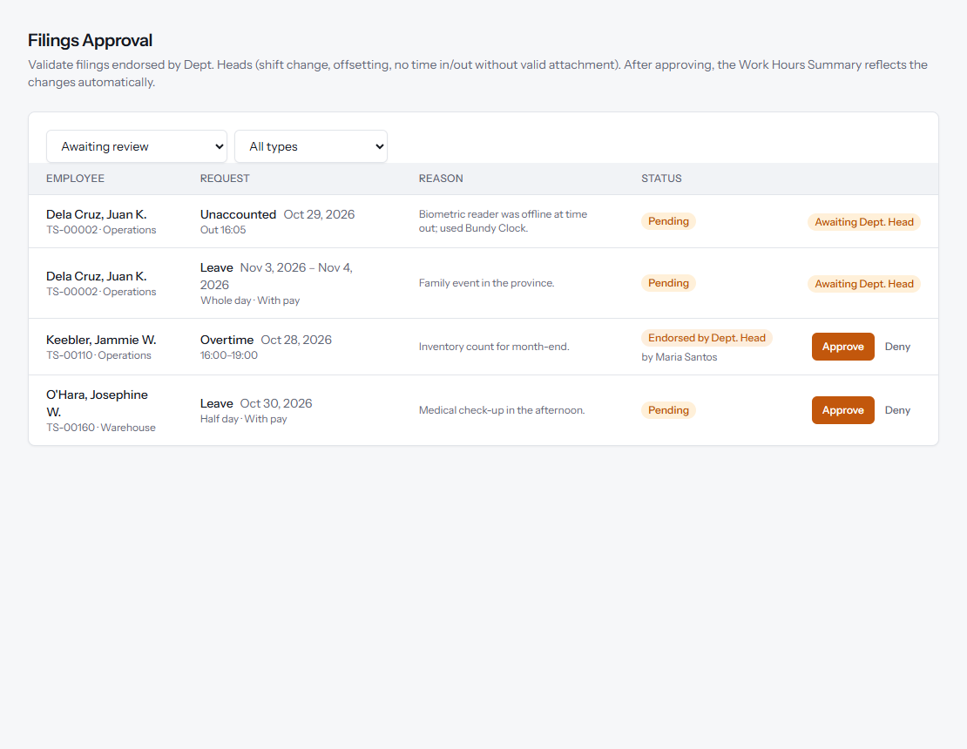
Figure 14. Filings Approval for the HR Time Keeper.

6.6 Work Hours Summary (WHS)
Timekeeping → Work Hours Summary totals, per employee and cut-off: days worked, paid leave, absences / unpaid leave, late, undertime and overtime. Employees with days that still have a missing log are flagged. Filter by department, then use Export CSV (opens in Excel) or Print to send to the Department Head for confirmation.
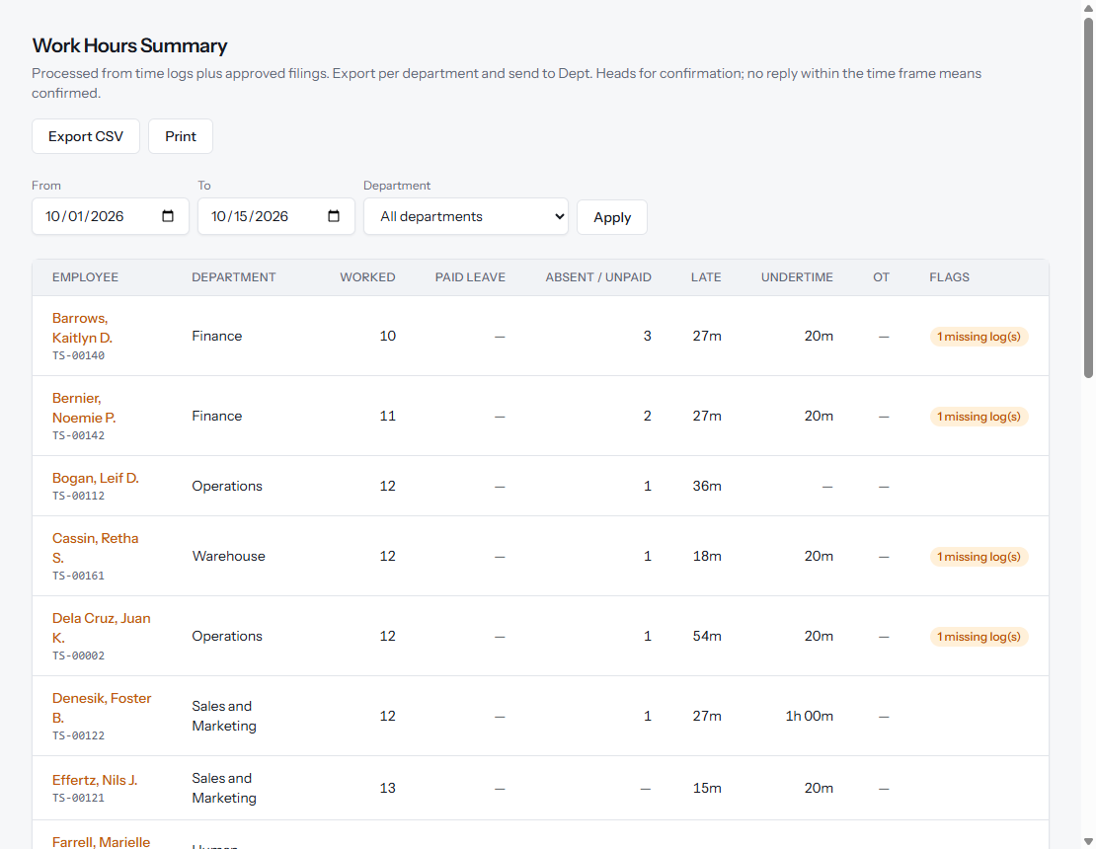
Figure 15. Work Hours Summary per cut-off.
Clicking an employee opens their day-by-day breakdown, identical to what the employee sees in My Attendance.
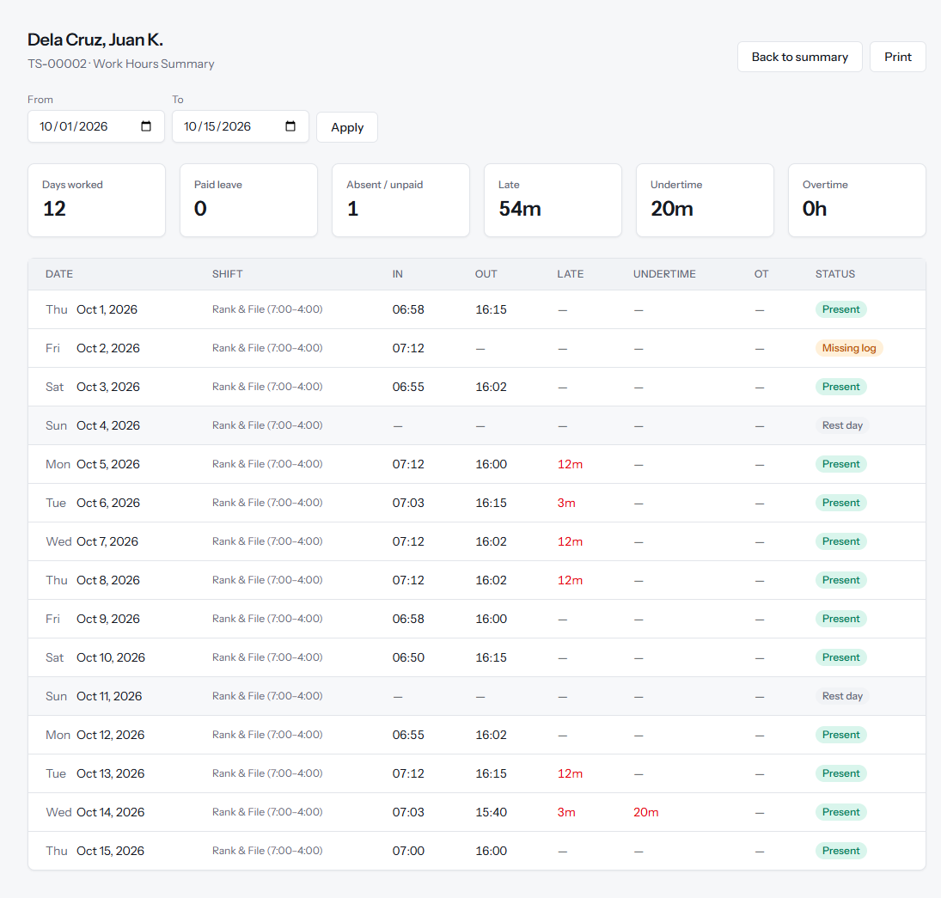
Figure 16. Day-by-day Work Hours Summary for one employee.

6.7 How attendance is computed
Situation | How the system treats it
Time-in after shift start | Late, counted in minutes from the shift start
Time-out before shift end | Undertime, in minutes (still deducted when an Early Out is approved)
Only one punch on a work day | "Missing log" — counted as absent until an Unaccounted filing is approved
No punches on a work day | Absent, unless the day is a holiday or covered by approved leave
Approved half-day leave | 0.5 day worked + 0.5 day leave. Extra hours are not paid; only a shortfall below the half day counts as undertime
Approved overtime | Hours from the approved filing
Approved shift change | That day is computed using the new shift
Days before hire / after separation | Not counted

6.8 Holidays
Timekeeping → Holidays lists the year's holidays as Regular or Special Non-Working. The 2026 Philippine holidays are pre-loaded; HR adds any special days declared during the year. Use the arrows to move between years.
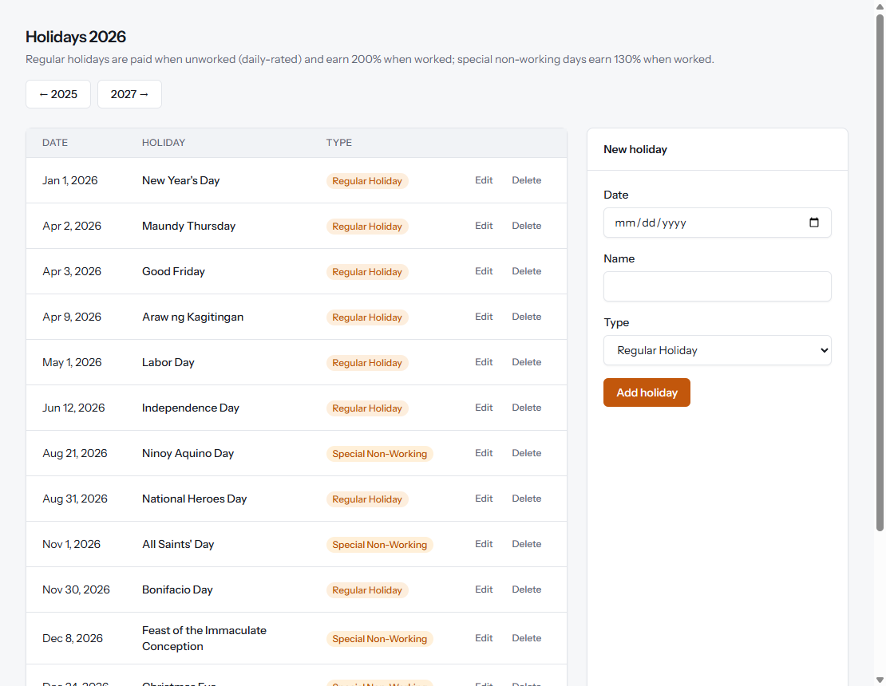
Figure 17. Holidays.

7. Payroll (PMS)
Payroll is semi-monthly. Each cut-off is a payroll period that moves through three stages:
Status | Meaning
Draft | Created; Per Biyahe, earnings and deductions can be uploaded.
Processed | Payslips computed from the current WHS. Can be reprocessed as many times as needed after corrections.
Finalized | Locked. Loan balances are updated and payslips become visible to employees.

7.1 Payroll Periods
Payroll → Payroll Periods lists all cut-offs with the number of employees and total net pay. To create one, enter the start and end dates, pay date, and whether it is the 1st half (government contributions are deducted) or 2nd half (SSS / Pag-IBIG loans are deducted). Overlapping cut-offs are not allowed.
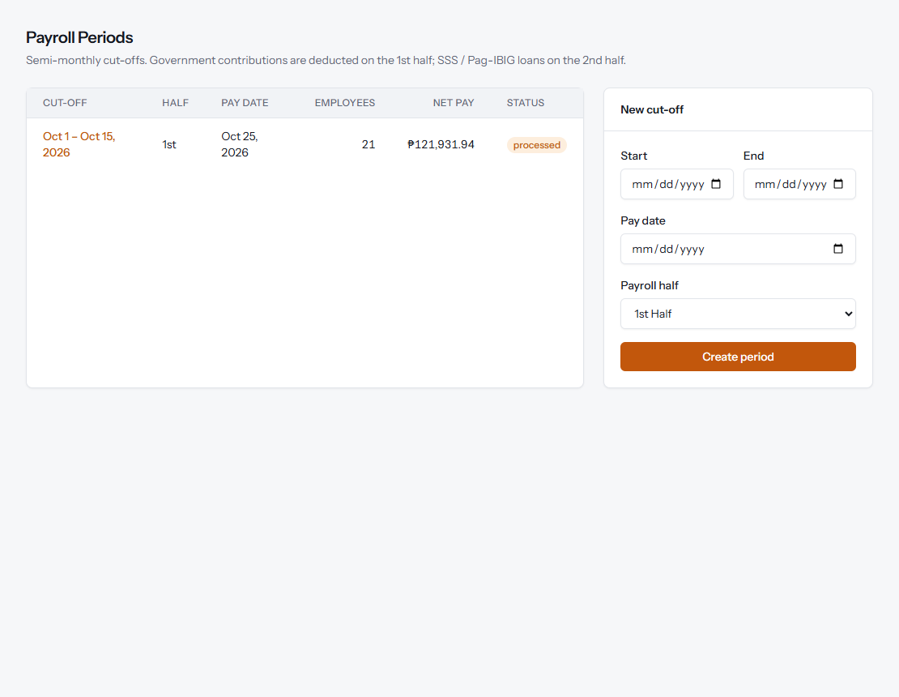
Figure 18. Payroll Periods.

7.2 Payroll Register
Opening a period shows the Payroll Register. The cards at the top give gross pay, deductions and net pay, split into ATM (BDO) and Cash, with buttons to download the BDO payment advice and the cash list for Finance. The register lists every employee's days, basic pay, holiday / overtime pay, Per Biyahe and other earnings, absence and late deductions, gross pay, government contributions, loans and other deductions, and net pay.
Buttons at the top: Process payroll (or Reprocess payroll), Finalize & release, Export register (to Excel) and Delete (only before finalizing).
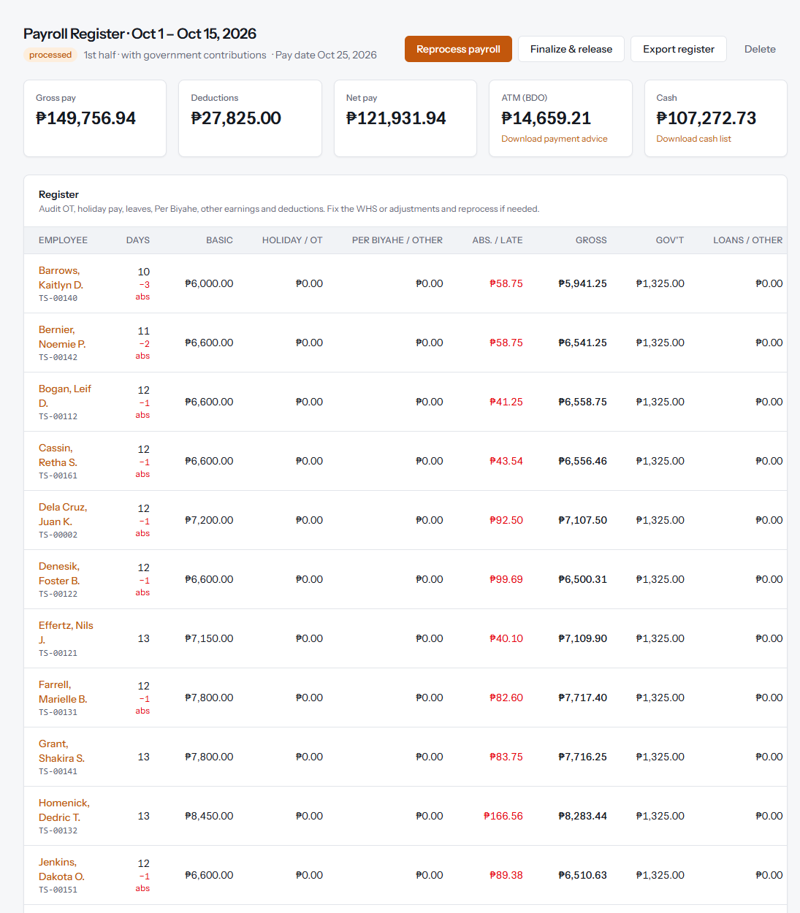
Figure 19. Payroll Register with totals and payment split.
Below the register, Earnings & deductions lists the Per Biyahe trips, other earnings and other deductions for the cut-off. Upload a CSV file (employee number, amount, optional description) — for example the Per Biyahe uploader file or Finance's deduction file — or add a single entry by hand. Reprocess the payroll after any change.
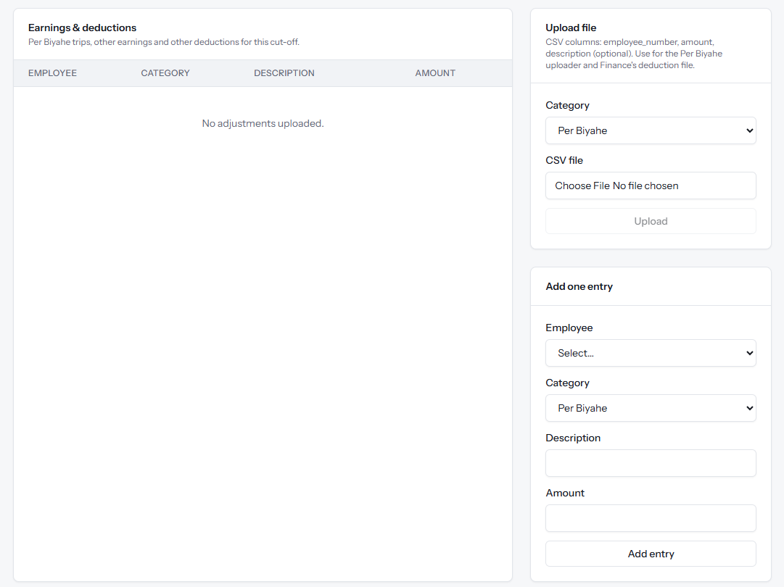
Figure 20. Uploading Per Biyahe, other earnings and deductions.

7.3 How pay is computed
Item | Rule
Basic pay — Daily rate | (Days worked + paid leave days) × daily rate
Basic pay — Monthly rate | Half of the monthly rate, less absences and unpaid leave × daily rate. Daily rate = monthly rate × 12 ÷ 313 working days
Per Biyahe | Sum of uploaded trips only; no daily basic, holiday pay or overtime
Late / undertime | Minutes × (daily rate ÷ shift minutes)
Overtime | Approved hours × hourly rate × 125%
Regular holiday | Paid when not worked (daily-rated); 200% when worked
Special non-working day | No work, no pay; 130% when worked
SSS / PhilHealth / Pag-IBIG | Fixed employee shares from the profile, on the 1st-half payroll, after the first month of service
Loans | Amortization on the 2nd-half payroll, never more than the remaining balance
Net pay | Gross pay − (contributions + loans + other deductions)

7.4 Payslip
Click an employee in the register to open their payslip: earnings, deductions (including each loan), attendance summary and net pay, with the payment method. Use Print / Save PDF to print or save it. After the payroll is finalized, employees can open the same payslip under My Kiosk → My Payslips.
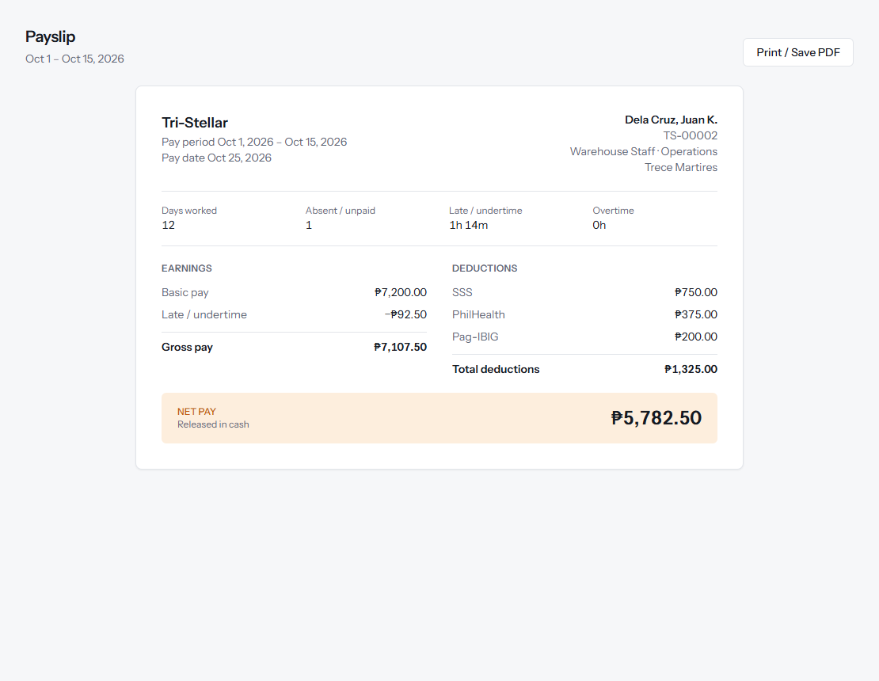
Figure 21. Payslip.

7.5 Loans
Payroll → Loans is the Government Loans Monitoring list: SSS, Pag-IBIG and company loans with the reference number, amortization, remaining balance and first deduction date. Balances go down automatically each time a 2nd-half payroll is finalized; fully paid loans can be shown with Include fully paid.
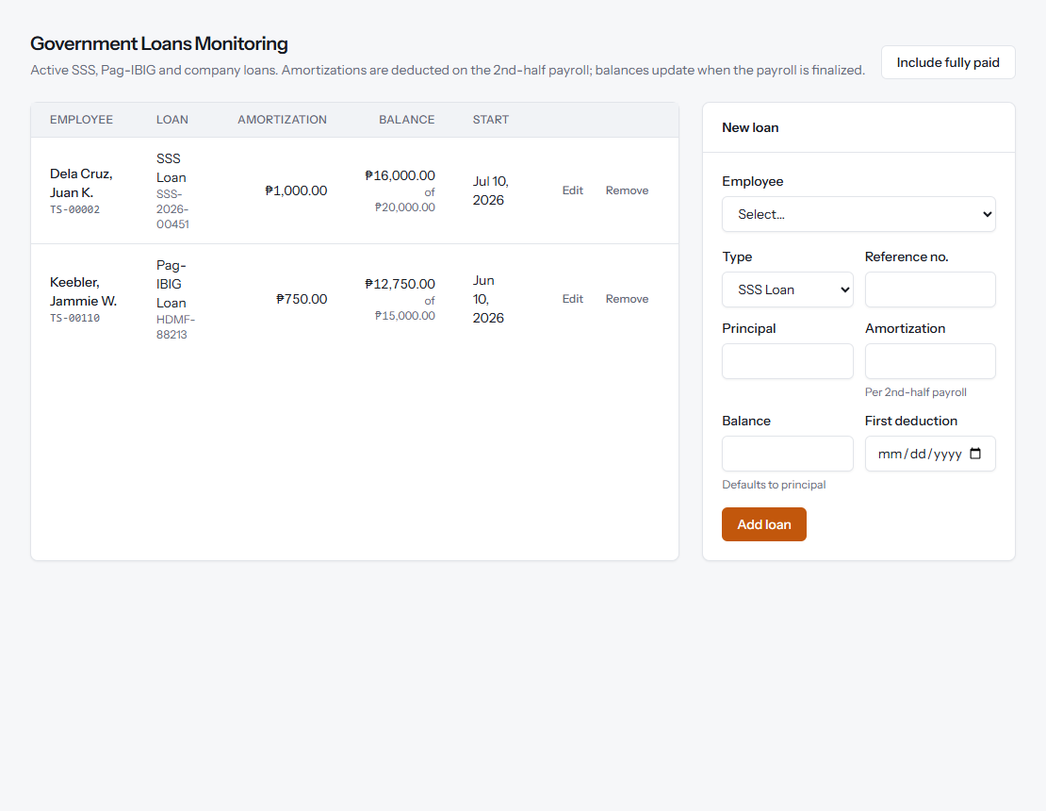
Figure 22. Government Loans Monitoring.

8. User Accounts
Administrators manage staff accounts under Administration → User Accounts: name, email, role and password. Employee kiosk logins are created from the employee record (Kiosk Access section) and appear here linked to the employee number. Administrators cannot remove their own administrator role or delete their own account.
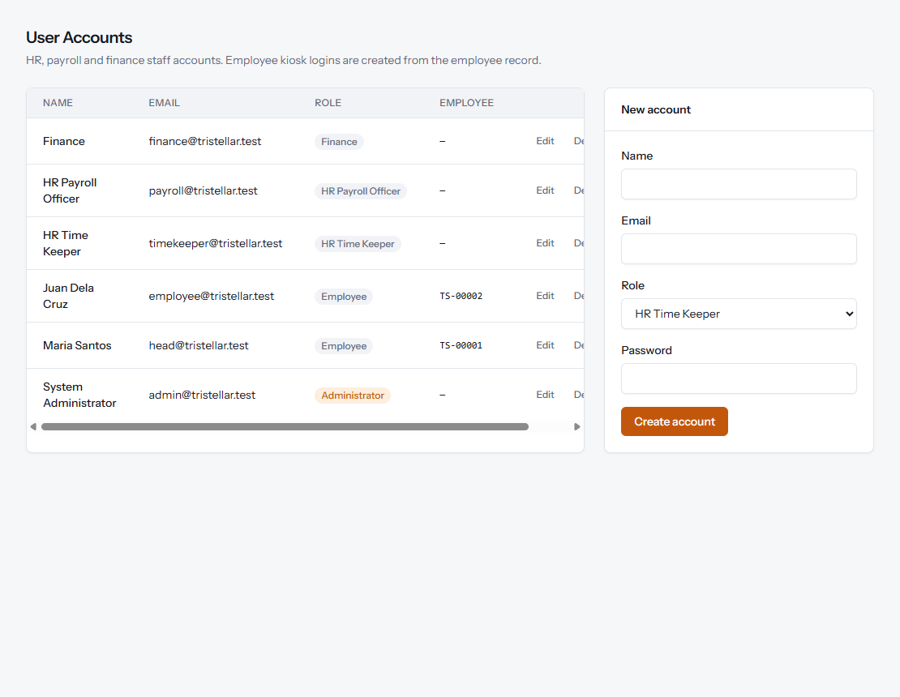
Figure 23. User Accounts.

9. Cut-off Checklist
The typical semi-monthly cycle in the new system:
# | Step | Who | Where in the system
1 | Upload biometric logs (weekly or per cut-off); encode Bundy Clock entries | HR Time Keeper | Timekeeping → Time Logs
2 | Review logs and file missing logs, leave, OT, early out, shift change | Employees | My Kiosk → My Attendance / My Filings
3 | Endorse or deny team filings | Department Head | Dept. Head → Endorsements
4 | Final approval of filings, with remarks | HR Time Keeper | Timekeeping → Filings Approval
5 | Send WHS per department for confirmation | HR Time Keeper | Timekeeping → Work Hours Summary
6 | Create the payroll period | HR Payroll Officer | Payroll → Payroll Periods
7 | Upload Per Biyahe, other earnings and deductions | HR Payroll Officer / Finance | Payroll Register → Earnings & deductions
8 | Process payroll and audit the register; correct and reprocess as needed | HR Payroll Officer | Payroll Register
9 | Finalize and release; download payment advice (ATM / Cash) | HR Payroll Officer / Finance | Payroll Register
10 | Employees view their payslips | Employees | My Kiosk → My Payslips

10. Items for Confirmation
The following settings were based on the old process documents and need confirmation from HR and Finance before going live:
Item | Current setting
Work week used for monthly-rated daily rate | 6-day week (313 working days per year). Use 261 for a 5-day week.
Default cut-off dates | 1st–15th and 16th–end of month (HR can enter any dates per period)
Half-day leave rule | Option 1 from the Per Biyahe Issues sheet: 0.5 worked + 0.5 leave
Biometric export format | CSV with employee number, date and time — to be matched to an actual BIS export
Withholding tax | Not yet computed
Approved Early Out | Undertime is still deducted

Planned next
- Manpower Request Form (MRF).
- Additional profile sections: family, educational background, employment history and pre-employment details.
- 13th-month pay computation.
- Automatic email of the Work Hours Summary to Department Heads.

