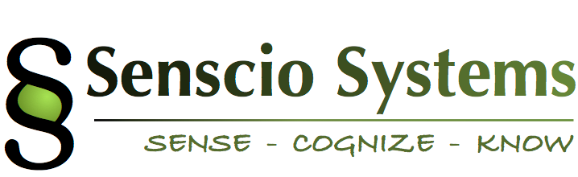June 2, 2016

Senscio Systems

1740 Massachusetts Avenue

Boxborough, MA 01719

Subject: Letter of Intent

This Letter of Intent (LOI) is made by and between Senscio Systems, Inc., having its principal place of business at 1740 Massachusetts Ave., Boxborough, MA 01719, and Southeastern Directions For Life (the “Licensee”), a non-profit corporation organized in South Dakota having its principal place of business at 2000 S. Summit Avenue, Sioux Falls, SD 57105.

Statement of Work:

Senscio Systems will provide equipment, software and support services for a project as outlined below:

* Ibis systems for a minimum of 50 individuals:
  + The Southeastern Directions For Life staff shall select individuals.
  + Onboarding, installation, training and technical support will be provided by Senscio personnel.
    - Senscio will provide onboarding paperwork to the Licensee for each selected client.
    - The Licensee will, after client selection, obtain and return the paperwork to Senscio for entry of the initial care plan into the Ibis system.
    - Senscio will schedule installations with the Licensee and for the installation in the residence, the client and one member of the care team will be present.
  + This project will be based on current capabilities (protocols and alert systems) included in the Ibis system and additional enhancements as detailed below:
    - PHQ-9 patient health questionnaire and related protocol notification
    - Some additional assessment tools, as agreed with notification scenarios
    - De-escalating/soothing protocol
    - Anxiety indicator w/appropriate alert protocol
    - Substance abuse questionnaire/icon to indicate risk
    - Agreed to educational tools
* Senscio will provide analytics on health and behavioral trends for each enrolled individual.
* Senscio will provide Care Navigation support for onboarding and ongoing operations including training for Southeastern Directions For Life staff and selected Care Coordinators.
* The initial system deployments will start on or about 90 days from the signing date of this Letter of Intent and the project will continue for a period of one year, subject to renewal.

The Quote with terms for the Ibis system and associated services is included as an attachment to this letter.

Additional details are:

* Following execution of this LOI, an Agreement containing all required legal documents will be executed and include, but not be limited to:
  + Support Services Agreement
  + Hardware Lease and Software License Addendum
  + Ibis Protocols and Service Support Processes
* The term of the contract is one year from the Agreement effective date and will automatically renew on an annual basis for additional one year terms unless written notification is provided 60 days prior to the applicable expiration date. Any changes in price will be negotiated on a good faith basis.
* Senscio will appoint a project manager to work with your designated project manager to serve as the primary point of contact for all project related issues.
* Customer will appoint a project lead within a week after signature of this LOI.
* Customer will initiate the patient review and selection process with any requested assistance from Senscio staff. The initial phase of patient onboarding will be done within 60 days from Agreement signing.
* A Business Associates Agreement will be executed between parties.
* Licenses will be granted and the product will be delivered as outlined in Exhibit B subject to the payment of fees under Exhibit A and the fulfilment of the terms and conditions of this LOI and the final Agreement.
* If applicable, additional product enhancements will be provided as outlined in Exhibit C.

The parties signify their agreement by signing below:

__________________________ ___________________

XXXXXXXXXX Date

___________________________ ____________________

Senscio Systems Date

Attachments:

Exhibit A: Product Pricing and Payment Schedule

Exhibit B: Product Delivery Schedule

Exhibit C: Product Enhancement Schedule (if applicable)

**Appendix A: Example** **Product Pricing and Payment Schedule**

**(Being Setup on ZOHO to Directly Produce this Exhibit)**

# Onboarding & Subscription:

# Onboarding:

Installation, Registration, Enrollment, Set Up & Training

* + - Up Front Payment (50 @ $395 each) $19,750.

# Software License, Hardware Lease Subscription, Care Navigation Service:

$105/member/month $63,000

Program Total: $82,750

**Terms:**

Note 1: Payment terms will be invoice net 30 days.

Note 2: Licensee will appoint a Project Lead to be the direct liaison with the Senscio Project Manager

Note 3: Onboarding fees ($19,750) will be invoiced upon execution of final agreement.

Note 4: Monthly Software Subscription fees (50 x $105 = $5250) will be invoiced on the first of each month of service after the first in-residence deployment.

Note 5: The number of units may be expanded up to 100, in minimum Lots of 10. Delivery date will be 8 weeks from receipt of order. The incremental upfront payment for hardware onboarding and the per member monthly subscription price will be the same as listed above.

**Appendix B: Product Delivery Schedule**

The Licensor shall make best efforts to deliver the Products, and the Licensee agrees to accept and be subject for payment for, deliveries based on the following schedule.

Item Delivery Date

50 Ibis systems 10/1/16

**Exhibit** **C: Product Enhancement Schedule**

N/A