October 31, 2016

**§ Senscio Systems**

See what's ahead

1740 Massachusetts Ave.
  
Boxborough, MA 01719
  
Tel: (978) 635-9090

Mr. Jim Hardwick

CEO, Rural Health Care Inc. 202 Island Drive, Suite 1 Fort Pierre, SD 57532

Reference(a): Letter of Engagement dated June 29, 2015 and Contract between Senscio Systems, Inc. and Rural Health Care, Inc. dated August 15, 2015.

Jim,

As you are aware, we have experienced very limited progress and success in identifying and enrolling individuals in the pilot project established under the above referenced contract. During a meeting with members of my staff on October 13, 2016, you stated clearly that you **did** not believe you would be able to identify additional users amongst your patient population and that the project would, for most intents and purposes, remain at the low numbers of current users.

Given that perspective, it is not reasonable that either of our organizations will realize benefit from continuation of the pilot project. Therefore, in accordance with the provisions in Ref (a), please accept this notification for termination of the project as of December 31, 2016.

Successful deployments with our other clients have proved the health benefits of Ibis to those managing multiple chronic conditions while living in rural areas. Based on those successful deployments, we are creating a "Center for Personalized Care" in South Dakota. Through this center, we are committed to bringing the benefits of Ibis to both the aging and the disabled population in South Dakota. If any of your current Ibis users wish to remain so after termination of this project, we will continue to support them through our center at no cost to your organization. From your other users, we will recover our CareStations and terminate our service to them over the next two months.

I appreciate the **opportunity to** work with you and your team. It has been a valuable experience.

Sincerely,

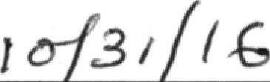

Date

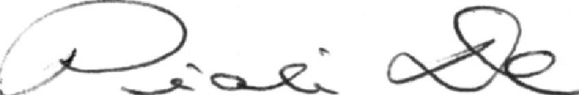

Rural Health Care, Inc. Date

Dr. Piali De

CEO, Senscio Systems

Acknowledged: