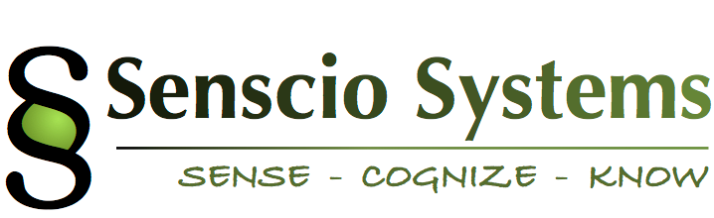

October 20, 2015

Senscio Systems

1740 Massachusetts Avenue

Boxborough, MA 01719

Subject: Letter Contract:

Senscio Systems is pleased to submit this letter contract to Community Support Providers of South Dakota for execution of a series of pilot projects by the member agencies, using the Senscio system “Ibis” to provide service to those individuals they support.

Statement of Work:

Senscio Systems will provide equipment and support for a project as outlined below:

* Ibis systems for a minimum of 50 individuals throughout the agency network:
  + Individuals shall be selected by the appropriate agency staff.
  + Installation, training and technical support will be provided by Senscio personnel.
  + This initial project will be based on current capabilities (protocols and alert systems) included in the Ibis system and any additional enhancements provided over the course of the project by Senscio Systems.
* Routine 24x7 monitoring of each enrolled individual’s health and adherence alerts will be provided by Senscio Systems with notifications and handoffs to the appropriate agency staffs, as agreed.
* Senscio will provide analytics on health and behavioral trends for each enrolled individual.
* The project will start no later than Dec 1, 2015 and continue for a period of one year.

Costs:

* Start-up and initialization fee: $ 5,000.
* Ibis CareStations (50 total @ $300/unit) $15,000

Start-up & Hardware Total: $20,000

* Software License:
  + System license ($85/patient/month) $51,000

Project Total: $71,000

Additional project details:

* Payment terms will be invoice net 30 days for all payments.
* Payment of the start-up and initialization fee will be invoiced upon signature of the letter contract.
* Payment of hardware fees will be invoiced upon shipment
* Payment of monthly software subscription fees will be invoiced at the beginning of each month of service.
* Additional systems may be ordered in minimums of 5 unit orders and have an expected delivery time of 8 weeks from order to delivery date.
* The contract will automatically renew on an annual basis, with any changes in price to be negotiated in good fait unless written notification is provided 60 days prior to the applicable expiration date.
* Each participating agency will appoint a project manager, by name, to serve as the primary point of contact for all project related issues.
* Prior to project start-up with any specific agency, that agency and Senscio Systems will execute an appropriate Business Associates Agreement.
* Following execution of this Letter Contract, a formal contract containing all required legal documents will be executed and include, but not be limited to:
  + Support Services Agreement
  + Hardware and Software License Agreements
  + Agreed Delivery Schedule

The parties signify their agreement by signing below:

__________________________ ___________________

Community Support Providers Date

Of South Dakota

___________________________ ____________________

Senscio Systems Date