**Interface-Homme Machine / Travaux pratiques**

S03 – Générateur de mots de passe –PASTIS  
 Conception d’interfaces / Maquettes





19.05.2015

Adriano De Almeida Silva – T-1f

Alex Travasso – T-1f

**Tables des matières**

1. Introduction 3

2. Programme 3

1.1. Maquette 3

1.2. Modèle 3

1.3. Contrôleur 8

1.4. View 9

1.5. View.fxml 10

3. Conclusion 10

# Introduction

Pour ce travail pratique nous allons devoir créer un générateur de mots de passe qui prendra en compte plusieurs critères selon l’envie de l’utilisateur.

# Programme

## Maquette

Voici la maquette de l’application telle qu’elle a été imaginée au début du travail pratique.

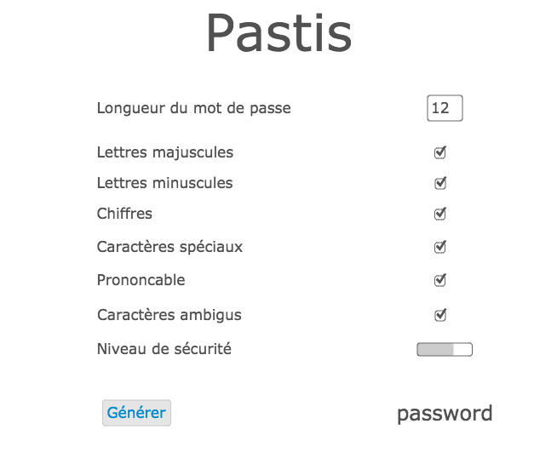

## Modèle

package s03;

import java.util.Random;

import javafx.scene.input.Clipboard;

import javafx.scene.input.ClipboardContent;

public class PastisModel implements IPastisModel {

private Random r = new Random();

private String mdp = new String();

private char[] chars;

// Longueur par defaut

private int length = 12;

private boolean ucLetters;

private boolean lcLetters;

private boolean digits;

private boolean symbols;

private boolean pronounceable;

private boolean unAmbiguous;

// Constructeur

public PastisModel() {

}

public String getNewPassword() {

int count = 0;

// recoit la longueur du mdp

length = pwLength();

chars = new char[length * 4];

// si minuscules

if (withLcLetters()) {

chars = getLcLetters().toCharArray();

count = 26;

}

// si majuscules

if (withUcLetters()) {

String strtemp = getUcLetters();

for (int i = 0; i < chars.length; i++) {

strtemp += chars[i];

count++;

}

char[] temp = strtemp.toCharArray();

chars = temp;

}

// si digits

if (withDigits()) {

String strtemp = getDigits();

for (int i = 0; i < chars.length; i++) {

strtemp += chars[i];

count++;

}

char[] temp = strtemp.toCharArray();

chars = temp;

}

// si symbols

if (withSymbols()) {

String strtemp = getSymbols();

for (int i = 0; i < chars.length; i++) {

strtemp += chars[i];

count++;

}

char[] temp = strtemp.toCharArray();

chars = temp;

}

// creation du mdp

StringBuilder sb = new StringBuilder();

for (int i = 0; i < length; i++) {

char x = '\0';

while (x == '\0') {

x = chars[r.nextInt(chars.length)];

}

char c = chars[r.nextInt(length)];

sb.append(x);

}

mdp = sb.toString();

// si caracteres ambigus

if (isUnambiguous()) {

if (mdp.contains("i") || mdp.contains("I") || mdp.contains("l")

|| mdp.contains("0") || mdp.contains("O")) {

mdp = getNewPassword();

}

}

// insertion dans le clipboard

final Clipboard clipboard = Clipboard.getSystemClipboard();

final ClipboardContent cbContent = new ClipboardContent();

cbContent.putString(mdp);

clipboard.setContent(cbContent);

return mdp;

}

// --------------------------------------------------------------------------

// Getters

// --------------------------------------------------------------------------

public int pwLength() {

return length;

}

@Override

public boolean withUcLetters() {

return ucLetters;

}

@Override

public boolean withLcLetters() {

return lcLetters;

}

@Override

public boolean withDigits() {

return digits;

}

@Override

public boolean withSymbols() {

return symbols;

}

@Override

public boolean isPronounceable() {

return pronounceable;

}

@Override

public boolean isUnambiguous() {

return unAmbiguous;

}

// --------------------------------------------------------------------------

// Setters

// --------------------------------------------------------------------------

public void setLength(int length) {

this.length = length;

}

public void setUcLetters(boolean ucLetters) {

this.ucLetters = ucLetters;

}

public void setLcLetters(boolean lcLetters) {

this.lcLetters = lcLetters;

}

public void setDigits(boolean digits) {

this.digits = digits;

}

public void setSymbols(boolean symbols) {

this.symbols = symbols;

}

public void setPronounceable(boolean pronounceable) {

this.pronounceable = pronounceable;

}

public void setUnAmbiguous(boolean unAmbiguous) {

this.unAmbiguous = unAmbiguous;

}

}

## Contrôleur

package s03;

import javafx.fxml.FXML;

import javafx.scene.control.*;

public class PastisControler {

PastisModel mdl = new PastisModel();

@FXML

private TextField longueur;

@FXML

private CheckBox majuscules;

@FXML

private CheckBox minuscules;

@FXML

private CheckBox chiffres;

@FXML

private CheckBox charSpec;

@FXML

private CheckBox pronon;

@FXML

private CheckBox charAmbigus;

@FXML

private Button generate;

@FXML

private TextField password;

@FXML

private ProgressBar robust;

@FXML

private Tooltip tooltip;

@FXML

public void handleGenerateButton() {

mdl.setLength(Integer.valueOf(longueur.getText()));

mdl.setLcLetters(minuscules.isSelected());

mdl.setUcLetters(majuscules.isSelected());

mdl.setDigits(chiffres.isSelected());

mdl.setSymbols(charSpec.isSelected());

mdl.setPronounceable(pronon.isSelected());

mdl.setUnAmbiguous(charAmbigus.isSelected());

password.setText(mdl.getNewPassword());

robuste(password.getText().length());

}

public void robuste(int longueur){

if (longueur < 5){

robust.setProgress(0.25);

}else if(longueur >=5 && longueur < 8){

robust.setProgress(0.5);

}else if(longueur >=8 && longueur < 10){

robust.setProgress(0.75);

}else if(longueur >10 ){

robust.setProgress(1.0);

}

}

}

## View

package s03;

import javafx.application.Application;

import javafx.fxml.FXMLLoader;

import javafx.scene.Scene;

import javafx.scene.layout.BorderPane;

import javafx.stage.Stage;

public class PastisView extends Application {

PastisControler ctrl = new PastisControler();

IPastisModel mdl = new PastisModel();

@Override

public void start(Stage primaryStage) throws Exception {

FXMLLoader loader = new FXMLLoader(getClass().getResource("PastisView.fxml"));

BorderPane root = loader.load();

loader.setController(ctrl);

Scene scene = new Scene(root);

primaryStage.setScene(scene);

primaryStage.show();

primaryStage.setTitle("Password Generator");

}

public static void main(String[] args) {

Application.launch(args);

}

}

## View.fxml

Voici la vue de l’application.

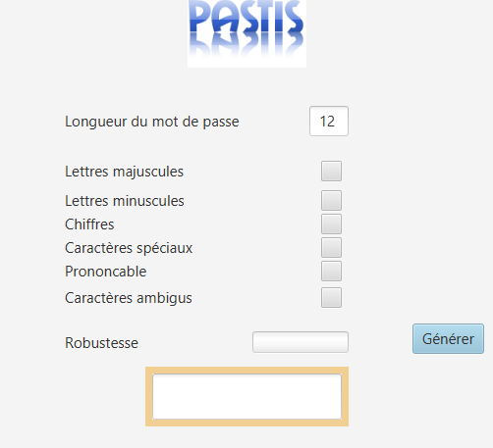

# Conclusion

Le travail pratique s’est bien déroulé en général. Nous avons rencontré des difficultés lors de l’implémentation de la méthode qui génère les mots de passe car nous n’avions pas imaginé correctement la façon dont celle-ci allait fonctionner.