Design Project 2
How to correct syntactical errors
Update 2.0: 9-10-2014

GOAL:
To learn how to correct errors in a C++ program;
PROJECT SPECIFICATION:
Correct the following C++ program with a bunch of errors, so that it can generate the following output. The program with syntactical errors is listed on the following page.

Output Simulation Trace: Constructor
Name: Your name
Course: ELENnnnn-Section Semester Year
Design Project: c1
Project goal: How to correct syntactical errors:

Line 1: Design project with full of errors
Line 2: Correcting syntactical errors
Line 3: This is my first C++ program: Semester Year
Line 4: My name is: Your Name
Line 5: File name is: C1.cpp

End of the output simulation trace: Destructor

STEP-BY-STEP PROCEDURE:
1. Build\Rebuild Solution
-- It displays a bunch of errors under “View\Output window” pane

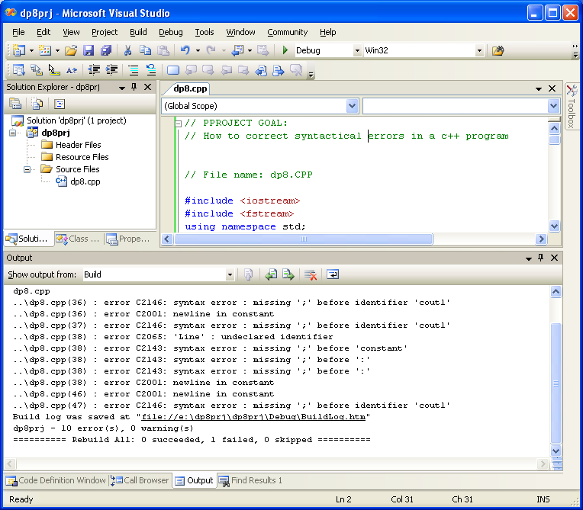

3. Errors are listed in the Message Window (Build/Debug):
-- They are identified with: Filename(Line number)
–- Line number (Ln) and Column number (Col), of the cursor, are
listed on the status bar at the bottom right corner.
-- To identify an error, select the error-line (click on it, so the
cursor is there some where on the line); and then enter or double-
click. It will identify the location of the error.

Note:
You can do all debug operations in debug mode. That will be in a later class.
-- How to correct logical errors

// Source Code Listing

// PPROJECT GOAL:
// How to correct syntactical errors in a c++ program

// File name: c1.CPP

#include <iostream>
#include <fstream>
using namespace std;

class c1 {
public:
ofstream cout1;
public:
c1();
void display();
~c1();
};

c1::c1() // Constructor
{
cout1.open("outfile.txt");
cout1 << "Output Simulation Trace: Constructor" << endl;
cout1 << "Name: Your name" << endl;
cout1 << "Course: ELENnnnn-Section Semester Year" << endl;
cout1 << "Design Project: c1" << endl << endl;
cout1 << "How to correct syntactical errors:" << endl << endl;
}

void c1::display()
{
cout1 << "Line 1: Design project with full of errors" << endl
cout1 << "Line 2: Correcting syntactical errors << endl;
cout1 << "Line 3: This is my first C++ program: Semester Year" << endl;
cout1 << Line 4: My name is: Your Name" endl;
cout1 << Line 5: "File name is: DP02.cpp" >> endl;
}

c1::~c1() // Destructor
{
cout1 << endl
<< "End of the output simulation trace: Destructor endl;
cout1.close();

}

int main()
{
c1 c1x; // class instantiation
c1x.display();
return 0;
}

