Design Project 3: Debug
How to Debug Programs
Update 5.3: 9/11/2014, 2am

GOAL:
How to debug C++ programs – correcting logical errors.
-- Program compiles correctly, but will not produce results as expected.

PROJECT SPECIFICATION:
1. Solve the Problems “Problem-1, Problem-2, and Problem-3” listed under “PROBLEM SET DEBUG” using “MS Visual C++ .NET 2010” DEBUG techniques described in “EXAMPLE DEBUG” in the following pages.

Solve the “Example Debug” problem set “PROBLEM SET: Debug” with the following input file

// infile.txt

6 : imax value
5 : jmax value
4 : kmax value
3 : pmax value

Example Debug
How to Debug
ENGR1301: Introduction to Computers & Programming

1. GOAL:
DEBUG: C++ PROGRAM DEVELOPMENT USING MS VISUAL C++ .NET 2010

2. PROJECT SPECIFICATION:
1. Solve the Problems “Problem-1, Problem-2, and Problem-3” listed using
MS Visual C++ .NET 2005 DEBUG techniques described on the following page.

3. CREATE APPLICATION (*.EXE) WITH DEBUG INFORMATION

1. PROBLEM: -- warnings
--------------------------------------------------
Compile the and run without debug information – ignore warnings
a. Build\Build Solution -- Compile
b. Debub\Start Debugging -- Run
Ignore warnings!
Debugging information for dp3prj.exe cannot be found or does not match. Binary was not built with debug information.
Do you want to continue debugging? No
--------------------------------------------------
2. SOLUTION: for debugging, you need to build the *.exe with debug-information & Symbol tables:
Solution Explorer\dp3prj\Properties\Configuration Properties
or Project\Properties\Configuration Properties
A. \C-C++\
a1. General\Debug Information format =
Program Database for Edit & Continue (/ZI)
a2. Optimization = Disabled(/od)
B. \Linker\
Debugging\General debug Info\ = Yes (DEBUG)
\Apply\ok
C. Check for the binary file creation
Build\Rebuild Solution
This should create E:\dp3prj\debug\dp3prj.exe
--------------------------------------------------
3. Build\Rebuild Solution
Start Debugging
You are still not in debug mode yet, all that it is that your *.exe file is suitable for debugging. Refer to the following pages to know how to get into the debug mode.

4. HOW GET INTO DEBUG MODE

How to get into debug mode
a. Set a break point at line 1 in the “main ()” program
right-click, Breakpoint, Insert Breakpoint
b. Continue

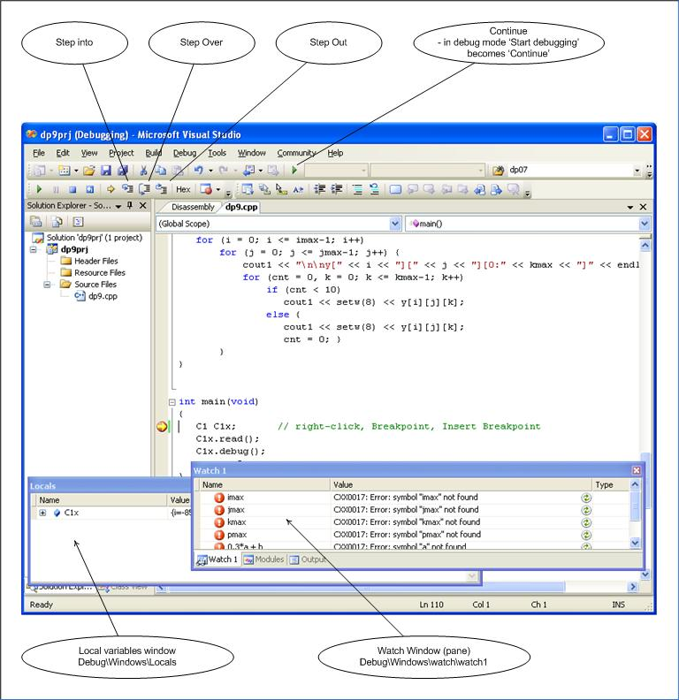

PROBLEM 1: Solution

Run to “// Problem-1”
a. F10 – ‘Step over’ or single line execution
F11 – ‘Step into’ the ‘read ()’ member function
b. Run the program to “// Problem-1”
Set a break point at “// Problem-1”
Continue
c. Type imax, jamx, kmax, pmax in the watch-window and note the values

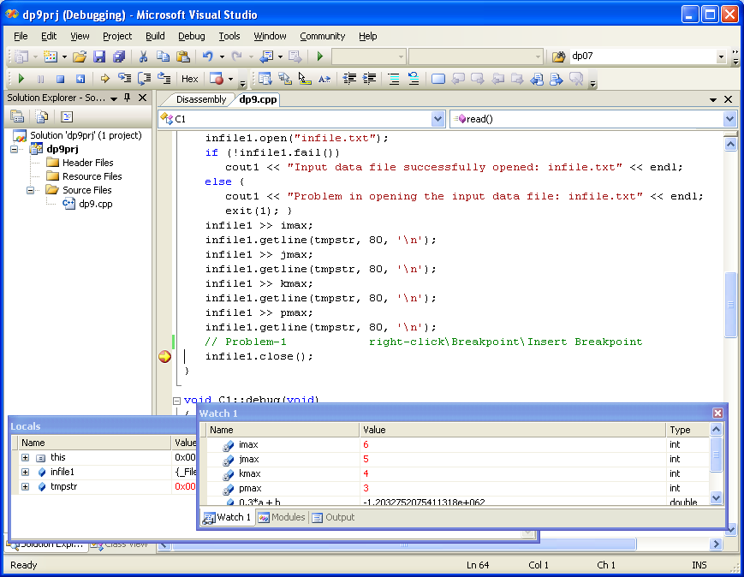

PROBLEM 2: Solution

Run to “// Problem-2”
a. debug\Delete All Breakpoints
b. Run to “// Problem-2”
Set a break point at “// Problem-1”
Continue
c. Type a, b, x, y[i][j][k], i, j, and k
into the watch-window and note the values.

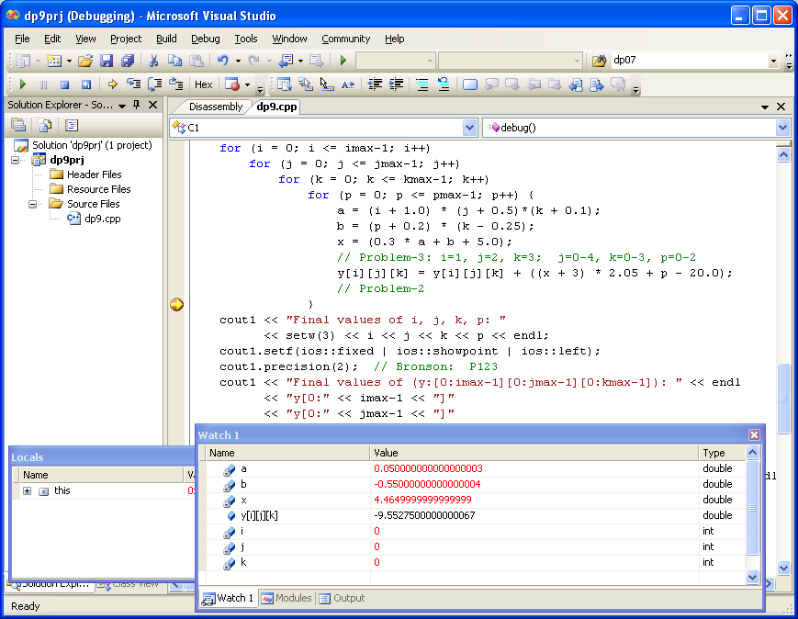

PROBLEM 3: Solution

Run to “// Problem-3”
a. debug\Delete All Breakpoints
b. Run to “// Problem-3”
Set a break point at “// Problem-3”
Continue
c. Type a, b, x, (0.3*a) + b, i, j, k, p
into the watch-window and note the values.

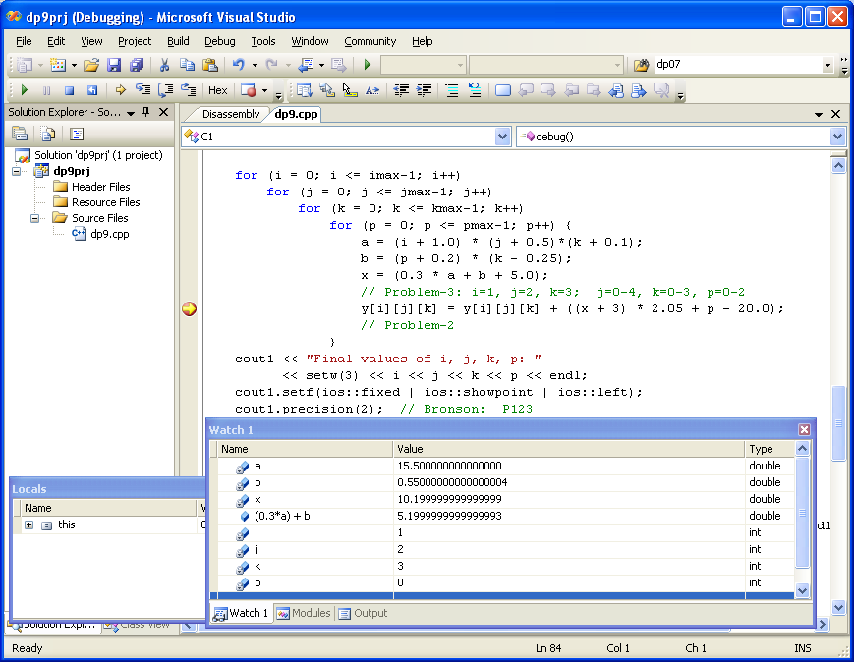

PROBLEM 4: Solution

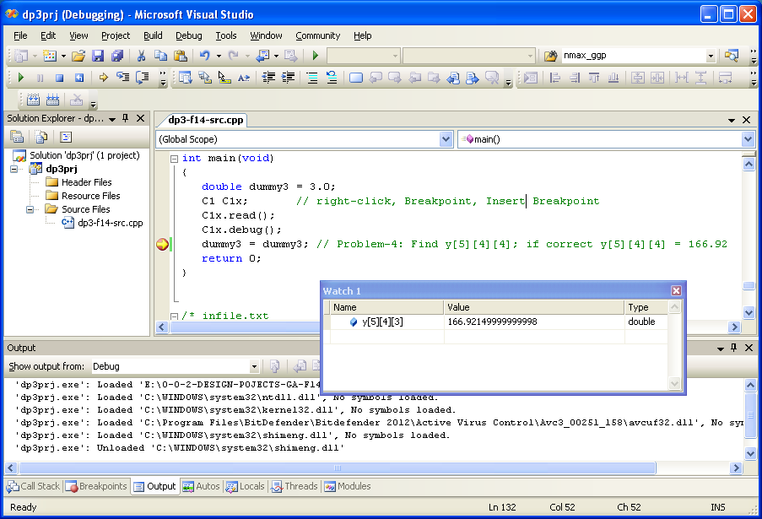

PROBLEM 5: Solution
Run without a breakpoint & find the outfile.txt under the i/o-directory
Debugging the C++ Programs
Using MS Visual C++ .NET 2005

You would debug a program when it compiles without errors but do not produce expected results.

Debug -- Identifying program segments which caused it to generate incorrect results and malfunctions.
* Incorrect Results -- results different from expected
* Malfunctions -- run-time errors such as "hang-ups", "divide-by-zero", "floating point errors"

A. HOW TO GET INTO DEBUG MODE?

Display Debug Command Tool-bar : One-time
Tools\Customize\Toolbars\Debug – select\close

1. Build/Rebuild-all/
Ctrl+F10 : Run to cursor: →{}
F10 : step over {}↓
For line-by-line execution of fns such as
cout1 << “This is test” << endl;
F11 : step into {↓}
For line-by-line execution of assignment stateemnts such as:
c = a + 2*b;

2. This display Debug-Windows: Variable-window & Watch-window
These will appear automatically. If not,
View/debug Windows/Variable-Window,..,Watch-Window
There are six debug-windows; the two windows you most use will be the
Variable-Window & the Watch-Window.

B. HOW TO TRACE THE PROGRAMS

Debug operation | Hot key | Tool-bar | Description | Turbo C++ 3.0 equivt
Execute program | Ctrl+F5 | ! | Run entire program | Ctrl+F9
Run to cursor | Ctrl+F10 | →{} | Run the program up to the current cursor position | F4
Step over | F10 | {}↓ | Run entire function call in one step; this include all file i/o operations and the member function) | F8
Run into | F11 | {↓} | Line by line execution | F7

* Instead of running the whole program (ctrl+F5), in which case wouldn't know where the errors is, execute it as segments.
* The segment can be a single line (F11), multiple lines (ctrl+f10), a member function or a function (F10).

a. Run program line-by-line F11
a1. move the cursor from where you want to trace the program
a2. Press ctrl+f10 or →{}
a3. Press F10 for function calls (such as cout1 << “test”;)
a4. Press F11, F11, ... {↓}, {↓}

b. Run program to upto a desired position ctrl+F10
b1. move the cursor from where you want to trace the program
b2. Press ctrl+F10 or →{}
If you press ctrl+F10 one more time it cycles through the entire
program once.

c. WATCH a variable-value or the value of an expression, as you trace
through the program
c1. click on the “Watch-Window”,
then type a variable-name or an expression to watch
c2. Repeat c1 until all the desired variables or expressions are shown in the "Watch- window"
c3. If you want to DELETE a watch-variable/expression
from watch-window:
click on the variable and then delete/delete
c4. If you want to MODIFY a watch-variable/expression
from watch-window:
click on the variable and then edit it

d. Evaluate/Modify variables and expressions
Expressions which include functions can not be evaluated
d1. Move the cursor to the desired expression, copy it.
d2. paste-it
d3. you can modify expressions and assign new values to the variables in
the variable-window.

e. Setup break points
e1. move cursor to the desired location
e2. ctrl+F8 : with another ctrl+F8 the break point is removed
: ctrl+F8 is a break-point toggle switch
e3. To setup more break points, repeat e1-e2.
e4. You can process all break points at a time
Debug/Breakpoints/...

f. Recompile the program if code is modified
f1. ctrl+F2 : program reset
f2. F4

2. Check corresponding braces
Open brace: {, (, [, /*
Closed brace: }, ), ], */

a. a1. Finding closing brace for an open brace
a11. move cursor to the desired open brace {
a12. find next “}”

a2. Finding a opening brace for a closed brace
a21. move cursor to the desired closed brace }
a22. find next “{”

a3. For other types of braces: repeat a11-a12 or a21-a22 with the appropriate brace

PROBLEM SET: DEBUG
PROBLEM 1:
At line “Problem-1: ”, find the values of the variables
imax, jmax, kmax, and pmax.
Ans: a. imax = ----------
b. jmax = ----------
c. kmax = ----------
d. pmax = ----------
Hint:
a. Build\Rebuild All
b. Place cursor at “Problem-1” line: ctrl+F10
Build\Start_Debug\Run_to_Cursor
Note: “debug” & “Debug_toolbar” should pop-up.
c. Watch variables "imax, jmax, kmax, pmax in the “Variable-Window” or
Type each of them in the “Watch-Window” and find corresponding values.
d. If you do not see “Variable_window” or “Watch_window” or both then do:
View\Debug_Windows\Watch or View\Debug_Windows\Variable or do both

PROBLEM 2:
At line “Problem-2: ”, find the values of the variables
a, b, x, and y[i][j][k] for i = 3; j = 2; k = 1; p = 1
Ans: a. a = ----------
b. b = ----------
c. x = ----------
d. y[i][j][k] = ----------
Hint:
a. Stop Debugging: Shift+F5
b. Run program upto “Problem-2: ”: ctrl+F10
c. Type "a, b, x, y[i][j][k], i, j, and k
in the “Watch-Window” and find corresponding values.

PROBLEM 3:
At line “Problem-3: ” Evaluate the expression
(0.3 * a) + b for i = 1, j = 2, k = 3, p = 0
Ans: 0.3*a + b = ----------
Hint:
a. Stop Debugging: Shift+F5
b. Run program upto “Problem-2: ”: ctrl+F10
c. Type (0.3 * a) + b, i, j, k
in the Watch-Window
d. Execute line-by-line: F10
F10 (for function calls) or F11 (for assignment statements) until
i=1, j=2, k=3

PROBLEM 4:
At line “Problem-4: Find y[5][4][3]
If correct, y[5][4][3] = 166.921; Y has global scope

Problem 5:
4. Execute program “Shift+F5”
This will generate Debug_out.txt
PROBLEM SET: DEBUG -- Solutions

1. a. imax = 6
b. jmax = 5
c. kmax = 4
d. pmax = 3

2. a = 11.0;
b = 0.899;
x = 9.199;
y[i][j][k] = 9.48

3. 0.3*a+b = 5.2 for i=1, j=2, k=3

4. y[5][4][3] = 166.921

5. Refer to the output simulation trace.

// DP-Debug.CPP

// DP-Debug.CPP
// File name: C1.CPP

#include <iostream>
#include <fstream>
#include <stdlib.h>
#include <math.h>
#include <iomanip>
using namespace std;
double y[10][10][10];

class C1 {
private:
int i,j, k, p, cnt, imax, jmax, kmax, pmax;
double x, a, b;
ofstream cout1;
double dummy1, dummy2;
public:
C1();
~C1();
void read();
void debug();
};

C1::C1()
{
cout1.open("outfile.txt");
cout1 << "Output Simulation Trace: DP_DEBUG" << endl;
cout1 << "Name: G. N. Reddy" << endl;
cout1 << "Course: ELENnnnn: Semester Year" << endl;
cout1 << "Design Project: dpnn" << endl << endl;
cout1 << "DEBUGGING: Using MS Visual C++ Programs" << endl;
cout1 << "Update: 9/11/2014, 11am" << endl << endl;
dummy1 = 1.0; dummy2 = 2.0;

// COMPILER SETTINGS: FOR DEBUG
// Explorer\dp3prj\Properties\Configuration Properties or
// Project\Properties\Configuration Properties
// A. \C-C++\
// a1. General\Debug Information format = Program Database for Edit & Continue (/ZI)
// a2. Optimization = Disabled(/od)
// B. \Linker\
// b1. Debugging\Generate debug Info\ = Yes (DEBUG)
// \Apply\ok

// Problem-1: Line 71; Problem-2: Line 99;
// Problem-3: Line 96; Problem-4: Line 134
}

C1::~C1()
{
cout1 << "\nThis is the end of the program:" << endl;
cout1.close();
}

void C1::read(void)
{
// Note !!!
// your infile.txt must be under the i/o-folder: E:\dp3prj\dp3prj
char tmpstr[80];
ifstream infile1;
infile1.open("infile.txt");
if (!infile1.fail())
cout1 << "Input data file successfully opened: infile.txt" << endl;
else {
cout1 << "Problem in opening the input data file: infile.txt" << endl;
exit(1); }
infile1 >> imax;
infile1.getline(tmpstr, 80, '\n');
infile1 >> jmax;
infile1.getline(tmpstr, 80, '\n');
infile1 >> kmax;
infile1.getline(tmpstr, 80, '\n');
infile1 >> pmax;
infile1.getline(tmpstr, 80, '\n');
dummy1 = dummy2; // Problem-1: right-click\Breakpoint\Insert Breakpoint\Start Debugging
// Find find the values of the variables: imax, jmax, kmax, and pmax.
// If correct: imax, jmax, kmax, pmax => 6, 5, 4, 3
infile1.close();
}

void C1::debug(void)
{
cout1 << "How to DEBUG C++ Programs:" << endl;
// Initialize y = 0.0
for (i = 0; i < imax; i++)
for (j = 0; j < jmax; j++)
for (k = 0; k < kmax; k++)
y[i][j][k] = 0.0;

for (i = 0; i < imax; i++) // 0-5
for (j = 0; j < jmax; j++) // 0-4
for (k = 0; k < kmax; k++) // 0-3
for (p = 0; p < pmax; p++) { // 0-2
a = (i + 1.0) * (j + 0.5)*(k + 0.1);
b = (p + 0.2) * (k - 0.25);
x = (0.3 * a + b + 5.0);
dummy1 = dummy2; // Problem-3: i=1, j=2, k=3, p = 0
// Find 0.3 * a + b; If correct, 0.3 * a + b = 5.199
y[i][j][k] = y[i][j][k] + ((x + 3) * 2.05 + p - 20.0);
dummy1 = dummy2; // Problem-2
// Find a, b, x, and y[i][j][k] for i=3; j=2; k=1; p=1
// If correct: a = 11.0; b = 0.899; x = 9.199; y[i][j][k] = 9.48
}

cout1 << "Final values of i, j, k, p: "
<< setw(3) << i << j << k << p << endl;
cout1.setf(ios::fixed | ios::showpoint | ios::left);
cout1.precision(2); // Bronson: P123
cout1 << "Final values of (y:[0:imax-1][0:jmax-1][0:kmax-1]): " << endl
<< "y[0:" << imax-1 << "]"
<< "[0:" << jmax-1 << "]"
<< "[0:" << kmax-1 << "]" << endl;
for (i = 0; i < imax; i++)
for (j = 0; j < jmax; j++) {
cout1 << "\n\ny[" << i << "][" << j << "][0:" << kmax - 1 << "]" << endl;
for (cnt = 0, k = 0; k < kmax; k++)
if (cnt < 10)
cout1 << setw(8) << y[i][j][k];
else {
cout1 << setw(8) << y[i][j][k];
cnt = 0; }
}
}

int main(void)
{
double dummy3 = 3.0;
C1 C1x; // right-click, Breakpoint, Insert Breakpoint
C1x.read();
C1x.debug();
dummy3 = dummy3; // Problem-4: Find y[5][4][3]; if correct y[5][4][3] = 166.92
return 0;
}

/* infile.txt
6 : imax value
5 : jmax value
4 : kmax value
3 : pmax value
*/

// outfile.txt

Output Simulation Trace: DP_DEBUG
Name: G. N. Reddy
Course: ELENnnnn: Semester Year
Design Project: dpnn

DEBUGGING: Using MS Visual C++ Programs
Update: 9/11/2014, 11am

Input data file successfully opened: infile.txt
How to DEBUG C++ Programs:
Final values of i, j, k, p: 6543
Final values of (y:[0:imax-1][0:jmax-1][0:kmax-1]):
y[0:5][0:4][0:3]

y[0][0][0:3]
-9.55 -1.25 7.05 15.35

y[0][1][0:3]
-9.37 0.78 10.93 21.07

y[0][2][0:3]
-9.18 2.81 14.80 26.79

y[0][3][0:3]
-9.00 4.84 18.68 32.51

y[0][4][0:3]
-8.81 6.87 22.55 38.23

y[1][0][0:3]
-9.46 -0.24 8.99 18.21

y[1][1][0:3]
-9.09 3.82 16.74 29.65

y[1][2][0:3]
-8.72 7.88 24.49 41.09

y[1][3][0:3]
-8.35 11.94 32.24 52.53

y[1][4][0:3]
-7.98 16.00 39.99 63.97

y[2][0][0:3]
-9.37 0.78 10.93 21.07

y[2][1][0:3]
-8.81 6.87 22.55 38.23

y[2][2][0:3]
-8.26 12.96 34.17 55.39

y[2][3][0:3]
-7.71 19.04 45.80 72.55

y[2][4][0:3]
-7.15 25.13 57.42 89.71

y[3][0][0:3]
-9.28 1.79 12.86 23.93

y[3][1][0:3]
-8.54 9.91 28.36 46.81

y[3][2][0:3]
-7.80 18.03 43.86 69.69

y[3][3][0:3]
-7.06 26.15 59.36 92.57

y[3][4][0:3]
-6.32 34.27 74.86 115.45

y[4][0][0:3]
-9.18 2.81 14.80 26.79

y[4][1][0:3]
-8.26 12.96 34.17 55.39

y[4][2][0:3]
-7.34 23.10 53.55 83.99

y[4][3][0:3]
-6.42 33.25 72.92 112.59

y[4][4][0:3]
-5.49 43.40 92.29 141.18

y[5][0][0:3]
-9.09 3.82 16.74 29.65

y[5][1][0:3]
-7.98 16.00 39.99 63.97

y[5][2][0:3]
-6.88 28.18 63.23 98.29

y[5][3][0:3]
-5.77 40.35 86.48 132.60

y[5][4][0:3]
-4.66 52.53 109.73 166.92
This is the end of the program:

