**Thunderstorms Set to Threaten Central Plains**

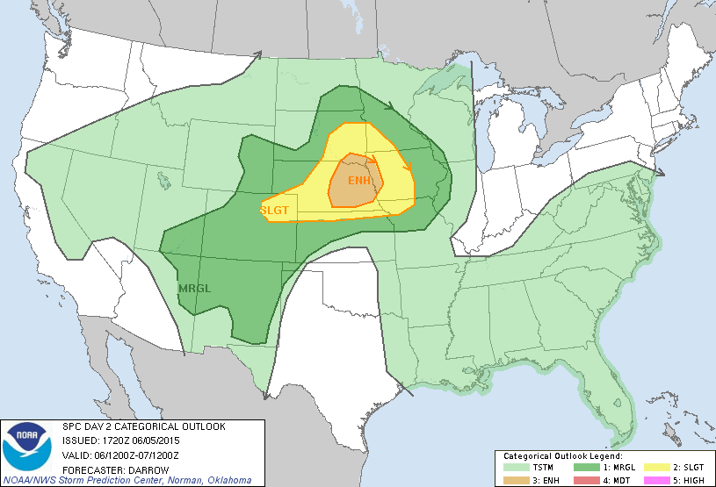 Another potentially active severe weather day is forecast for the central plains on Saturday 6/5. A short wave trough, coupled with strong mid level flow, will initiate strong to severe thunderstorms in an area of instability in the vicinity of an approaching warm front. Sufficient wind shear in the area will be favorable for the development on supercells. Tornadoes are possible, but large hail and wind are the primary threats. Please keep an eye on the sky if you live in any of the shaded areas in the map above. Even mild thunderstorms can pose a threat to life and property if proper safety measures are not taken.

Image Courtesy SPC