**Thunderstorms Set to Threaten Central Plains**

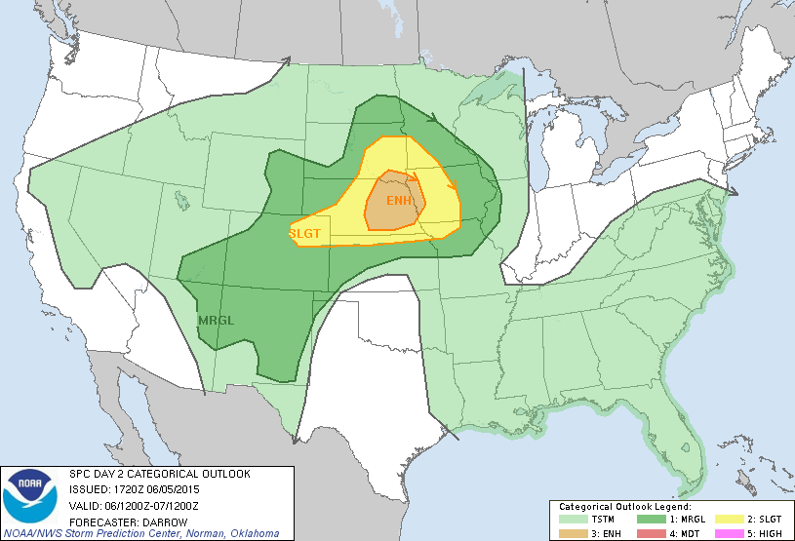 Another potentially active severe weather day is forecast for the central plains on Saturday 6/5. A short wave trough, coupled with strong mid level flow, will initiate strong to severe thunderstorms in an area of instability in the vicinity of an approaching warm front. Sufficient wind shear in the area will be favorable for the development on supercells. Tornadoes

Image Courtesy SPC