Ben Gangl-Lipson

From implementing Blinn-Phong lighting and shadows, my renderer allows for the adjustment of parameters, as well as some new elements to customize the viewing scene. These parameters and elements are ambient color, diffuse color, specular color, specular falloff, lights, directional lights, light source attenuation, shadows, soft shadows, and depth cueing. In this write-up, I will demonstrate the effects of all these new features.

Ambient color controls the base color of an object. In more technical terms, it represents the light that is scattered in all directions. Without any lights in the scene, the object would simply appear that color. This is what the renderer did in assignment 1a. We can control the amount of ambient color included in an object using the Ka (ambient coefficient) parameter. Adjusting this value from minimum to maximum takes it from 3D back to 2D. You can see this shown in figure 1.

Fig-1: Ambient coefficient

Diffuse color is how we can represent objects that aren’t perfectly smooth. In a sphere, for example, the edges of the sphere from our viewpoint will scatter less light than the front of the sphere because they scatter the light at a different, glancing angle. Controlling this with the Kd (diffuse coefficient) parameter gives a realistic, 3D appearance. You can see this shown in figure 2.

Fig-2: Diffuse coefficient

Where diffuse color is great for matte surfaces, specular color shows shiny surfaces particularly well, allowing for mirror-like reflections of light. Adjusting the Ks (specular coefficient) can give the appearance of a glossy 3D material, as shown in figure 3. The specular section of the lighting model also has two other parameters to adjust, color and falloff. Color controls the color of the reflection. Where white light can give the glossy surface the appearance of being made of plastic, other colors of light can look like other materials, like metal or glass. This is shown in figure 4. Falloff controls how large the reflection area is on a given surface, as shown in figure 5.

Fig-3: Specular coefficient

Fig-4: Specular color

Fig-5: Specular falloff

The lights in the scene can also be adjusted to meet the user’s specifications. The above pictures all use point lighting, meaning a light is at a given point in 3D space. My renderer additionally allows for directional lighting, where a light has a direction but is taken to be infinitely far away, and as such will affect all objects in the scene at the same angle. This is shown in figure 6. You’re not limited to a single light either. Multiple lights can be added to brighten the scene, as shown in figure 7.

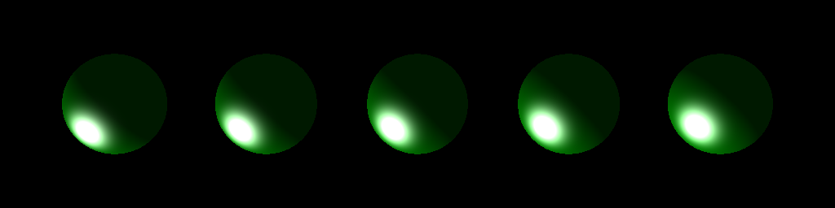

Fig-6: Directional light

Fig-7: Multiple lights

Another feature of the lights that can be toggled on or off is light source attenuation. It controls whether an individual light’s intensity dims over larger distances. Objects close appear brighter whereas objects farther away appear dimmer. With the implementation in my renderer there are 3 coefficients to control, a constant one, a linear one, and a quadratic one. Each subsequent coefficient creates a more extreme attenuation affect when altering it. Figures 8, 9, and 10 show the effects of these coefficients.

Fig-8: Linear light attenuation

Fig-9: Combined light attenuation

Fig 10: Quadratic light attenuation

As one might expect, these lights can cast shadows. If an object sits between another object and a light in 3D space, a shadow will be shown on the second object. This is applicable both in the case of point lighting, as shown in figure 8, and directional lighting, as shown in figure 9. In addition, my renderer allows for “soft” shadowing, where the edges of the shadows can be made blurry to create a more realistic effect. This is shown in figure 10.

Fig-11: Point lighting shadow Fig-12: Directional lighting shadow

Fig-13: Soft shadows

The final feature is depth cueing, which refers to allowing the renderer to show the “depth” of an object by changing the color. It can often have a similar effect as light attenuation, only this time instead of controlling the intensity of the light, it controls the color of the object directly. This allows depth cueing to be implemented with any color. While the typical pattern is to use the background color to allow farther away images to “fade” into the background, other colors may also be used. Figures 14 and 15 show these effects.

Fig-14: Depth cueing Fig-15: Colored depth cueing

As you can see, my renderer contains a full and complete implementation of Blinn-Phong lighting, as well as other features like light source attenuation, soft shadows, and depth cueing. All of these elements combine to form more realistic representations of objects in 3D space.

Fig-16: All of the features in one image