電通二乙微處理器實驗 實驗結報

實驗名稱 | Arduino_Labn01
組別 | 第17組 | 組員 | 曹閎舜

- 實驗目的
利用tinkercad模擬電路圖，使LED燈泡可以一閃一閃的閃爍
- 實驗步驟
先把所有要用到的學習網站帳號辦好
使用桌面上的Arduino
打開後使用範例-Basics-Blink
開啟tinkercad製作電路圖，並將程式碼打上去
觀察到LED閃爍
更改數值在觀察一次
- 程式碼

// the setup function runs once when you press reset or power the board
void setup() {
// initialize digital pin LED_BUILTIN as an output.
pinMode(LED_BUILTIN, OUTPUT);
}

// the loop function runs over and over again forever
void loop() {
digitalWrite(LED_BUILTIN, HIGH); // turn the LED on (HIGH is the voltage level)
delay(1000); // wait for a second
digitalWrite(LED_BUILTIN, LOW); // turn the LED off by making the voltage LOW
delay(1000); // wait for a second
}

- 實驗結果及分析
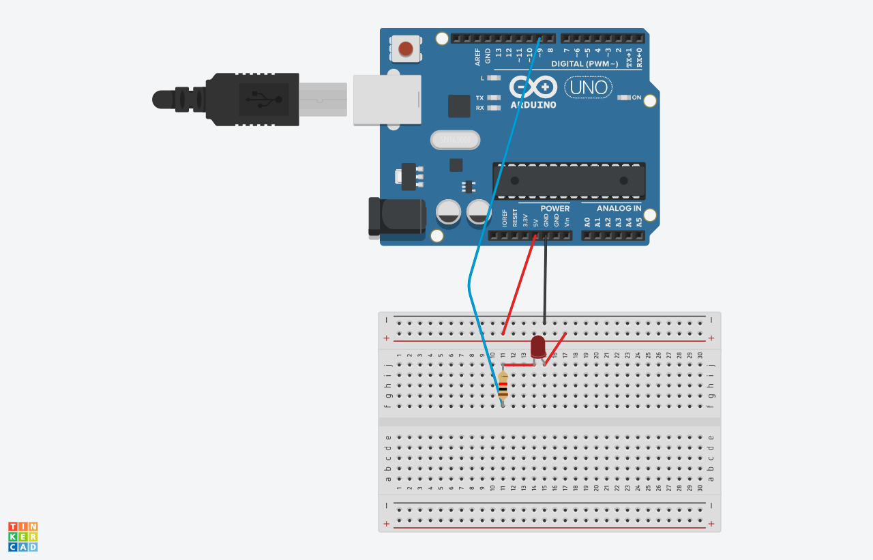

LED有成功閃爍

- 心得討論 學到如何使用tinkercad，還有github的使用，實驗結果都很成功。
- 修正電路圖

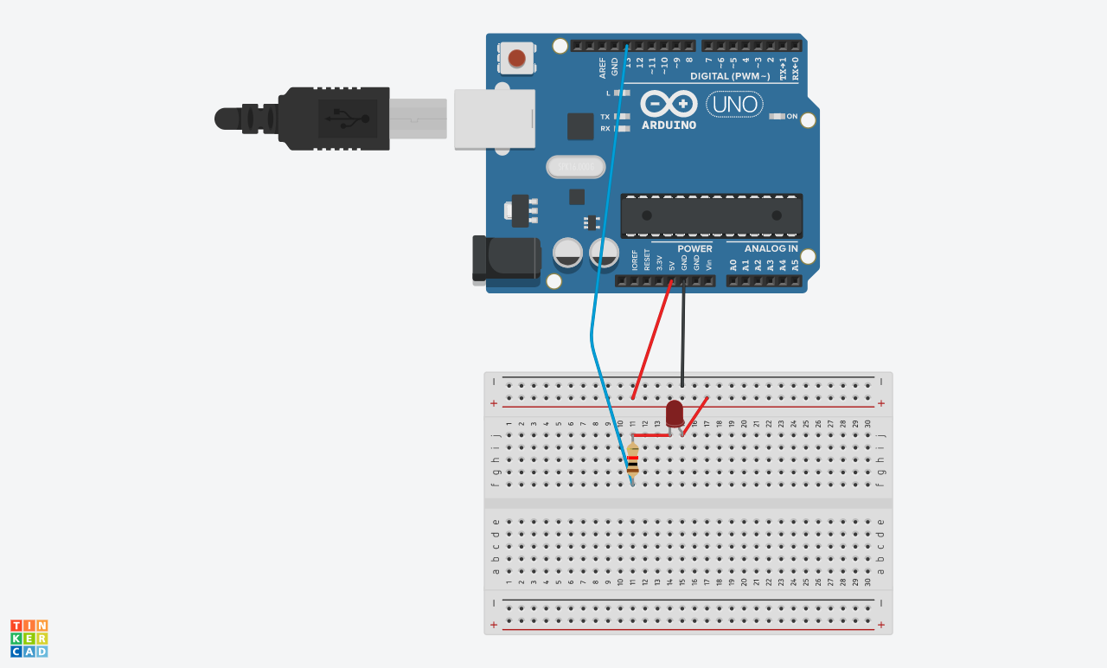
- 修正程式碼

// the setup function runs once when you press reset or power the board
void setup() {
// initialize digital pin LED_BUILTIN as an output.
pinMode(9, OUTPUT);
}

// the loop function runs over and over again forever
void loop() {
digitalWrite(9, HIGH); // turn the LED on (HIGH is the voltage level)
delay(500); // wait for a second
digitalWrite(9, LOW); // turn the LED off by making the voltage LOW
delay(500);

// the setup function runs once when you press reset or power the board
void setup() {
// initialize digital pin LED_BUILTIN as an output.
pinMode(9, OUTPUT);
}

// the loop function runs over and over again forever
void loop() {
digitalWrite(9, HIGH); // turn the LED on (HIGH is the voltage level)
delay(2000); // wait for a second
digitalWrite(9, LOW); // turn the LED off by making the voltage LOW
delay(2000); // wait for a second
}

