

Firefly – T HE P C G A M E

Including…

Blue Sun Rim Expansion*

Kalidasa Rim Expansion

# Overview

The PC Game stays true to the Rulebooks (included) for the most part, however there may be a few liberties taken to improve the PC experience without giving up major elements where possible.

There are a few GUI elements that need explaining to ensure you have full control over your Ship, Crew and Gear.

# The Toolbar

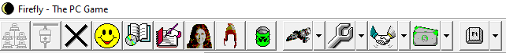

This is your main control panel giving you access to Start/Host(MP) a new Game, Join a Game, Chat (MP) , view Story Info, view Game Log, browse all Crews, Gear, and Ship Upgrades, and toggle the displays for the main Game pages of your Ship, Jobs, Deals and Buys as well as options (via the dropdown menu) to view your opponents in MP (multiplayer).

# Docking the windowed Displays

The multi-document interface allows for the main displays to be docked in a number of ways to the borders of the Main Game Window. See [here](http://www.dsxtech.com/XDockFloat/xdockfloatindex.html) for info.

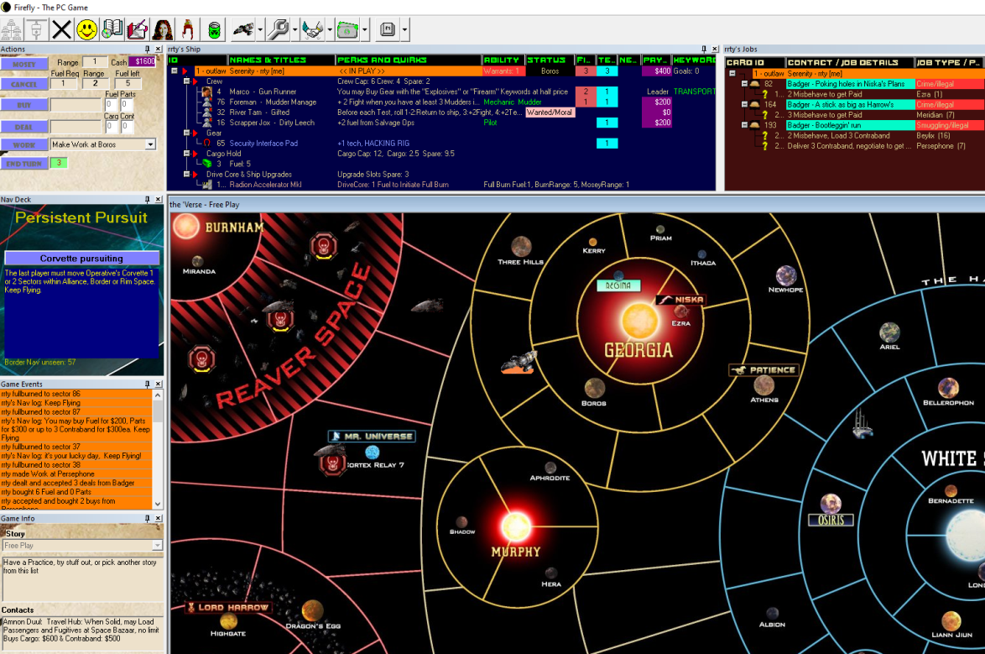

# Starting the Game

For Single or Multiplay, press the Host button to get started. 

NB: For more Multiplay details, see the section below in this Guide.

Select the **auto move** option to have NPC Ships (Cruiser, Corvette,& Cutters) move via the AI, otherwise they will be manually moved by the appropriate player. In Single Play mode, that will be you! So auto move is recommended.

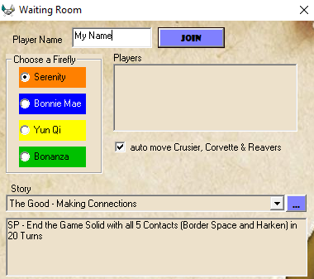

Pick an existing Story, or Add a New one of your making, choosing “Add New” at the end of the dropdown list.

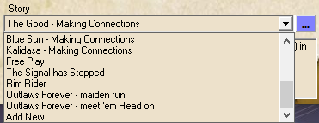

Viewing and Editing Stories is always possible by pressing the ellipsis button:You can peruse the details of the Goals, and if you are making a new story, start adding startup parameters and new Goals. If you are adding special Jobs to a story, they should be setup beforehand. (see Job editing)

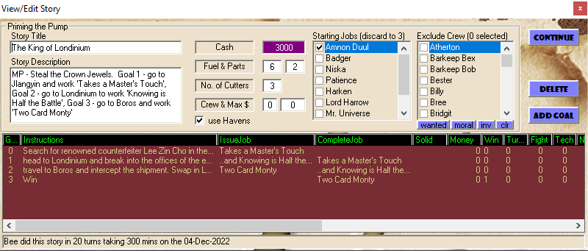

Stories should always have a Goal ‘0’, even if left blank, but it provides a place for **startup instructions** and to provide a specific initial Job where that applies. Dbl-Click on a Goal in the List if you want to view or edit it.

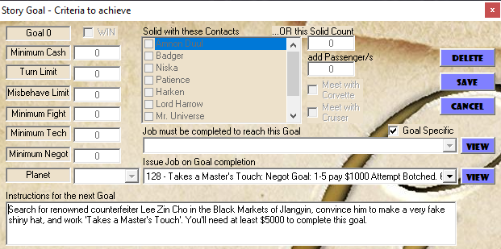

The last Goal should have the Win Flag set to ensure that a logical end occurs.



NB: ‘Goal Specific’ Jobs (ContactID=0) are Jobs that are not available from any in-game Contact. However, it is possible to choose from Contact Jobs by deselecting the ‘Goal Specific’ flag.

Press Continue after Story selection/editing is done to save any changes.

Pressing the Join Button locks in the Player/s and the Start button appears.

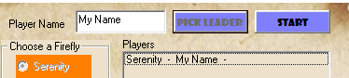

Pressing Start then rolls the ‘dice’ and selects who will get first dibs on a Leader.



Scroll through the Dropdown list to pick a Leader that suits your requirements.

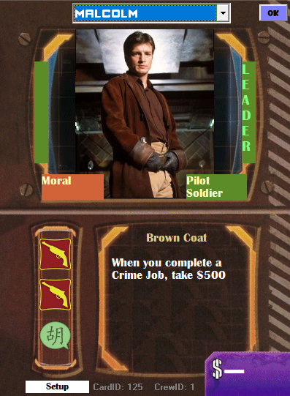

Some Stories will allow you to pick additional Crew from the get-go. There will be a limit on the number you can select and also the overall Hire Cost.

The Hire Cost and skill points are summated at the top of the Pay/Job column once you start selecting crew.

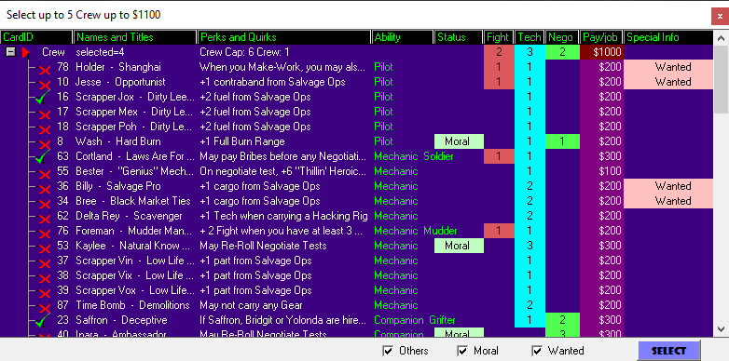

Filters are available on this page to allow you to target a few key groups. Don’t want the Wanted? Remove the tick. 

Press Select once you’re done to continue to the next stage.

In reverse order of players (in Multiplay) you will be asked to select a Sector on the Map.

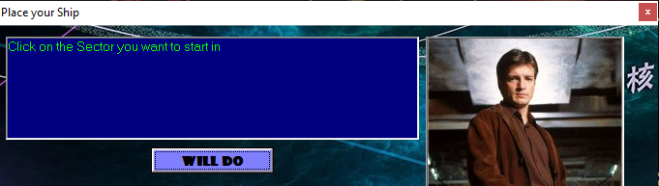

Click “Will Do”, and then click on a Sector on the Map. You can use the Scroll bar at the side and bottom of screen to bring unseen portions of the Map into view.

It is possible to Click and Drag the Map directly to pan it around, however during a map sector selection it is probably best avoided.

# Your Ship Display

Only Gear linked to a Crew member is counted on a Job, therefore be sure to allocate any unlinked Gear to a Crew. To do this, click, then click- **drag** & **drop** the Gear onto the Crew.

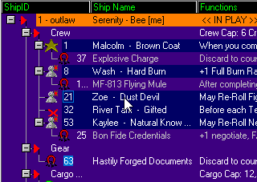 This drag icon will appear 

To remove, click, then click-**drag** & **drop** the Gear back onto the Gear Heading. You can also View, or Discard a Crew member, or their Gear via the Right-Click Menu. Other menu functions will become available as well with gear and goods.

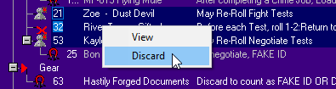

If you are in the Same Sector as another Player’s Ship, you can ‘Trade’ Supplies by Right-Clicking on their Name when viewing ‘All’ Ships. Also, Right-Clicking a disgruntled Crew member to offer them ‘a better deal’ using the ‘Poach’ option.

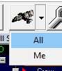

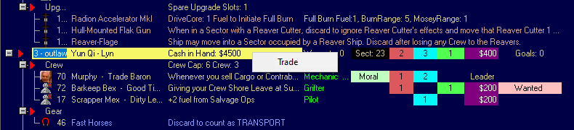

# Your Jobs Display

Inactive Jobs can be discarded using the Right-Click Menu.

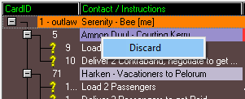

As Jobs parts are completed, the parts are shown with a Tick

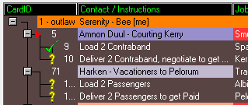

# Your Turn Actions Display

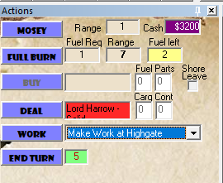  
Each turn, depending on SP or MP mode, you will be able to choose a number of actions that are appropriate to your current location. Eg. If you are at a Contact’s location, the Deal action will be available.

To Mosey or Full Burn, click the button and then click on the adjacent sector on the Map to fly to. Some sectors have a smaller ‘hotspot’ for registering mouse clicks, so it’s always best to click in the centre of the sector.

Also any Job that is workable will appear in the work dropdown list. Pick any one to Work for that action. All Planet Sectors have the ‘Make Work’ Job available.

When appropriate, you can buy or sell Cargo & Contraband as part of a Deal, or Buy Fuel & Parts from a Supply location. The ‘Shore Leave’ option, as per the Rules, takes up a Buy action.

When appropriate, other functions may appear on the Action Display from time to time based on Gear or Crew abilities. (eg. Resolve Alerts, Remove Disgruntled)

You may use End Turn to end the current turn, even before all available actions have been used if appropriate for your situation. In SP, you must press End Turn to cycle the next turn. Whereas in MP the turn automatically ends, in most cases, after 2 Actions have been completed.



The number next to End Turn is the turn counter, used in some gameplays as a target to finish prior to a certain turn count.

# Deals Display

At a Contact’s location, you can use the Deal Action to access a list of Jobs. Sometimes, at the start of a game, the list (i.e. discard pile) will be empty.



The button caption changes to Draw Cards. Press that to reveal 3 Jobs from the deck.

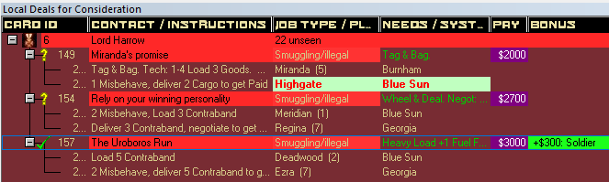

Deals up for Consideration will have been marked with a ? mark. As you select Jobs, they are ticked. Finally pressing Close Deal will add the selected Jobs to your Job Display. Any Cargo or Contraband purchased or sold with Solid Contacts will tally towards the cash amount as part of the overall Deal.

# Buy Display

Hiring Crew and buying Gear & Ship upgrades operates similarly to Deals. As with most displays, you can switch between your own (local), and all players details (in MP) using the toolbars dropdown menu for each display. For the Deals and Buy Displays, ‘All’ shows every Contact or Supply’s ‘discard’ listings.

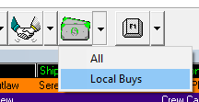

At first, in a Buy action, each item will have a red X. Selecting up to 3 can be done to proceed to the ‘Consideration’ step as marked with a **?.** If 3 are selected Consider takes you to the next step.

Draw Cards will pull any extra cards to make up 3 if appropriate.

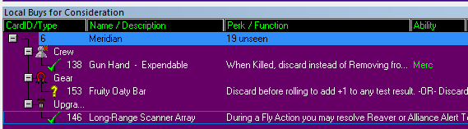

Tick the items you want to buy and choose Close Buy to complete the transaction.



Don’t forget to add any Fuel or Parts *before* you Close the Buy action.

# The Game’s Logbook

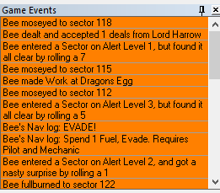

Keeps everyone up with what’s happening with the most recent event always at the top. Can be toggled into view using this toolbar button

# Game & Story Info

Toggled into view via this toolbar button

This provides a quick reminder of the current story objectives, details of Contacts and who you are Solid with. (green highlight)

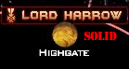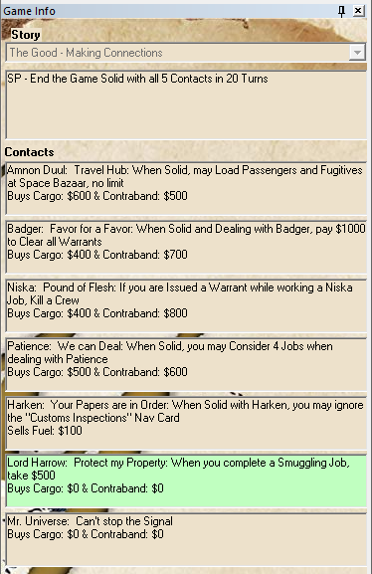 Solid status is also displayed directly on the Map

# Multiplayer Mode (MP)

Up to 4 Players are supported, however the requirements are that they all must have file access to the same Game Database (FireflyKalidasa.mdb). This can be achieved using a File Server on a LAN, or sharing a local folder on the host PC, and then installing the Game to this Shared Folder. All Users should start the FireFlyKalidasa.exe from this shared folder, *after* installing the game on their own PC in order to register the supporting files.

Play over the internet is possible if a good VPN connection is setup to give the same access as mentioned above. Results may vary depending on the quality of VPN Client/Server. The generic Windows built-in VPN is poor in my experience.

The Host sets up the waiting room using this button 

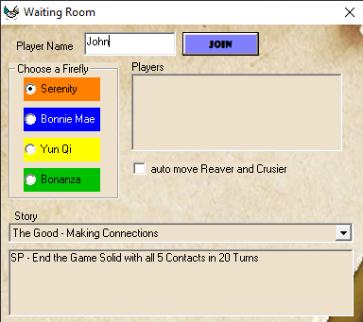

Other Players join using  to get a similar screen.

Once all players have joined and have selected a ship, the Host then presses 

As per the Game Rules, a random roll lets one person at a time select a Leader, and then in reverse order selects a starting Sector on the Map. The Action Window then appears for each player in turn and away you go.

# Multiplayer Mode continued..

When Playing with multiple players, it is possible to all exit the game, and pick up where you left off at another time. Simply have all players close the application  at the start of any players turn. When ready to restart the Game, all players choose the **Join** button and the game will ask you to confirm the re-join.

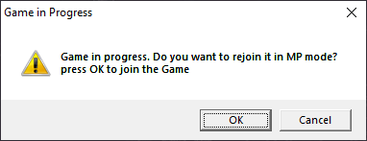

Then select your name from the list to continue where you left off. If it was your go when the game was closed, Actions will be immediately available.

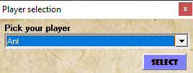

NB: It’s entirely possible that each player could start, rejoin, play their turn on their own, then exit after the turn has passed to the next player. i.e. The Game does not need a “Host” once it has commenced.

Use the ‘**End Game**’ toolbar button  if you wish to **withdraw** from a Game altogether. If it was your turn, the turn will be passed to the next player.

# Saving a Game

There is no “Save” option as such as every action is saved real-time. If you want to preserve a game in progress, and start a fresh game, there is a way. The Game’s database *is* the Save File.

So after you quit a game in progress (just close using Alt-F4 or the top right windows ‘x’ button, *not* the Toolbar End Game ‘X’), go into the Game’s folder and copy/paste the **FireflyKalidasa.mdb** data file, and rename the new copy.

Eg. FireflyKalidasa_GameNightSave.mdb

Then restart a new Game using the Host button as usual – choosing to ‘reset’ the game in progress. Away you go..

When you are ready to resume your ‘GameNightSave’, delete or rename the current data file, then rename the save file back to **FireflyKalidasa.mdb** and start up the game again.

*Alternatively*, you can setup a **new game Application shortcut** for each ‘save’ file, placing the full path to the data file *after* the **FireFlyKalidasa.exe** in the Target.

Eg.

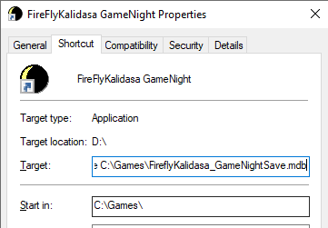

This way you could have many in-progress games available to start.

For MP, all users must have access to start this shortcut, which needs to exist in a shared LAN Folder.

# Job Editing (advanced)

It is possible to add or edit Jobs if you seek some additions or changes.

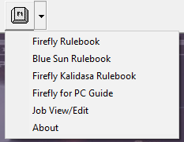

Under the Help dropdown menu, there is an option for Job view/edit.



NB: New Contact or Goal jobs can be added this way. It is recommended to peruse and follow existing Jobs to see common attribute combinations, as choosing unproven combos may have unpredictable results. There is no cross validation in place to prevent conflicting selections.

Using the editor, it would be possible to setup your own custom Jobs for Mr Universe for example, on account that the game’s original “*Big Damn Challenges*” are not supported in this version.

# Dev Notes:

*Mr Universe Deals are not currently supported, specifically the “Big Damn Challenges”. However, 9 “standard” format jobs have been added to this contact.

Motherlode and Uroboros Belts are not supported exactly as mentioned in the Rules, Jobs originally for these are allocated to one of the planets in the belt.

Player Trading and Crew poaching is now supported when in the same sector.

The game uses the ShowCard Gothic Font for some button captions. It is included in the Setup if your PC does not already have it.

*Keep Flying!*



