Nathan George

October 25, 2020

ITEC-410

Design Patterns

Create UML design documents which illustrate the use of specific design patterns intended to meet specific needs in your group project applications. See the accompanying post in this section for resources on identifying and applying design patterns.

The assignment has the following requirements:

1. Select at least 3 design patterns to apply in your application

Observer, Iterator, and State

1. Create a UML diagram and if needed, a mock-up to determine how each pattern will be applied

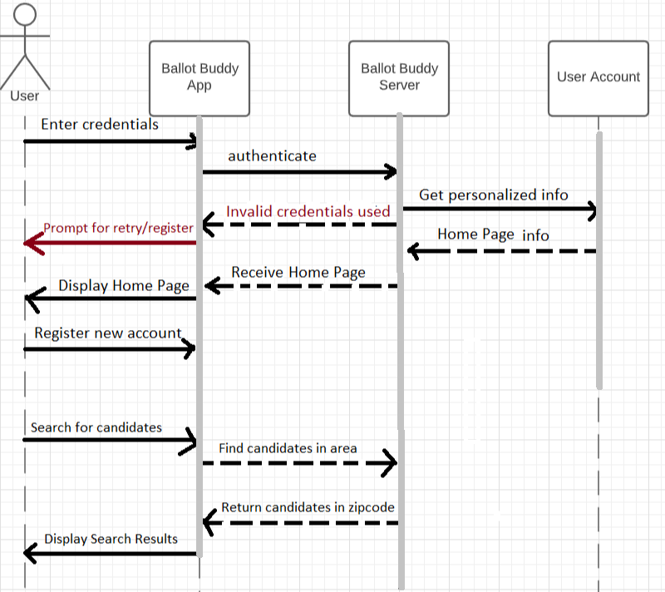

1. Document the need being addressed, name of the selected pattern, and the reason used in each case

This diagram is needed to explain the changes that occur during runtime and show the various states in which the app operates, and the events that causes transitions between the states shown.

**Design Pattern: State**

