Index

SI NO | Program | Date | Page
1 | String handling functions | 03/02/2026 | 3
2 | Odd or Even | 03/02/2026 | 5
3 | Max of 3 numbers | 06/02/2026 | 7
4 | Display day using switch | 06/02/2026 | 9
5 | Fibonacci series using loop | 10/02/2026 | 11
6 | Student grade using if-else | 10/02/2026 | 13
7 | Associative array and sorting the array | 13/02/2026 | 16
8 | Factorial using functions | 13/02/2026 | 18
9 | Leap year or not program | 13/02/2026 | 20
10 | Program to demonstrate class and objects | 17/02/2026 | 22
11 | Program to demonstrate the inheritance | 17/02/2026 | 24
12 | Program to demonstrate interface | 20/02/2026 | 26
13 | Demonstrating Constructor and Destructor | 20/02/2026 | 28
14 | Demonstrating Access Specifiers in PHP | 20/02/2026 | 30
15 | File Handling Functions in php |  | 32
16 | Server side validation process |  | 34
17 | Server side validation (for name exclusively) |  | 39
18 | Server side validation (for url and email exclusively) |  | 43
19
20
21
22
23
24
25
26
27
28
29
30

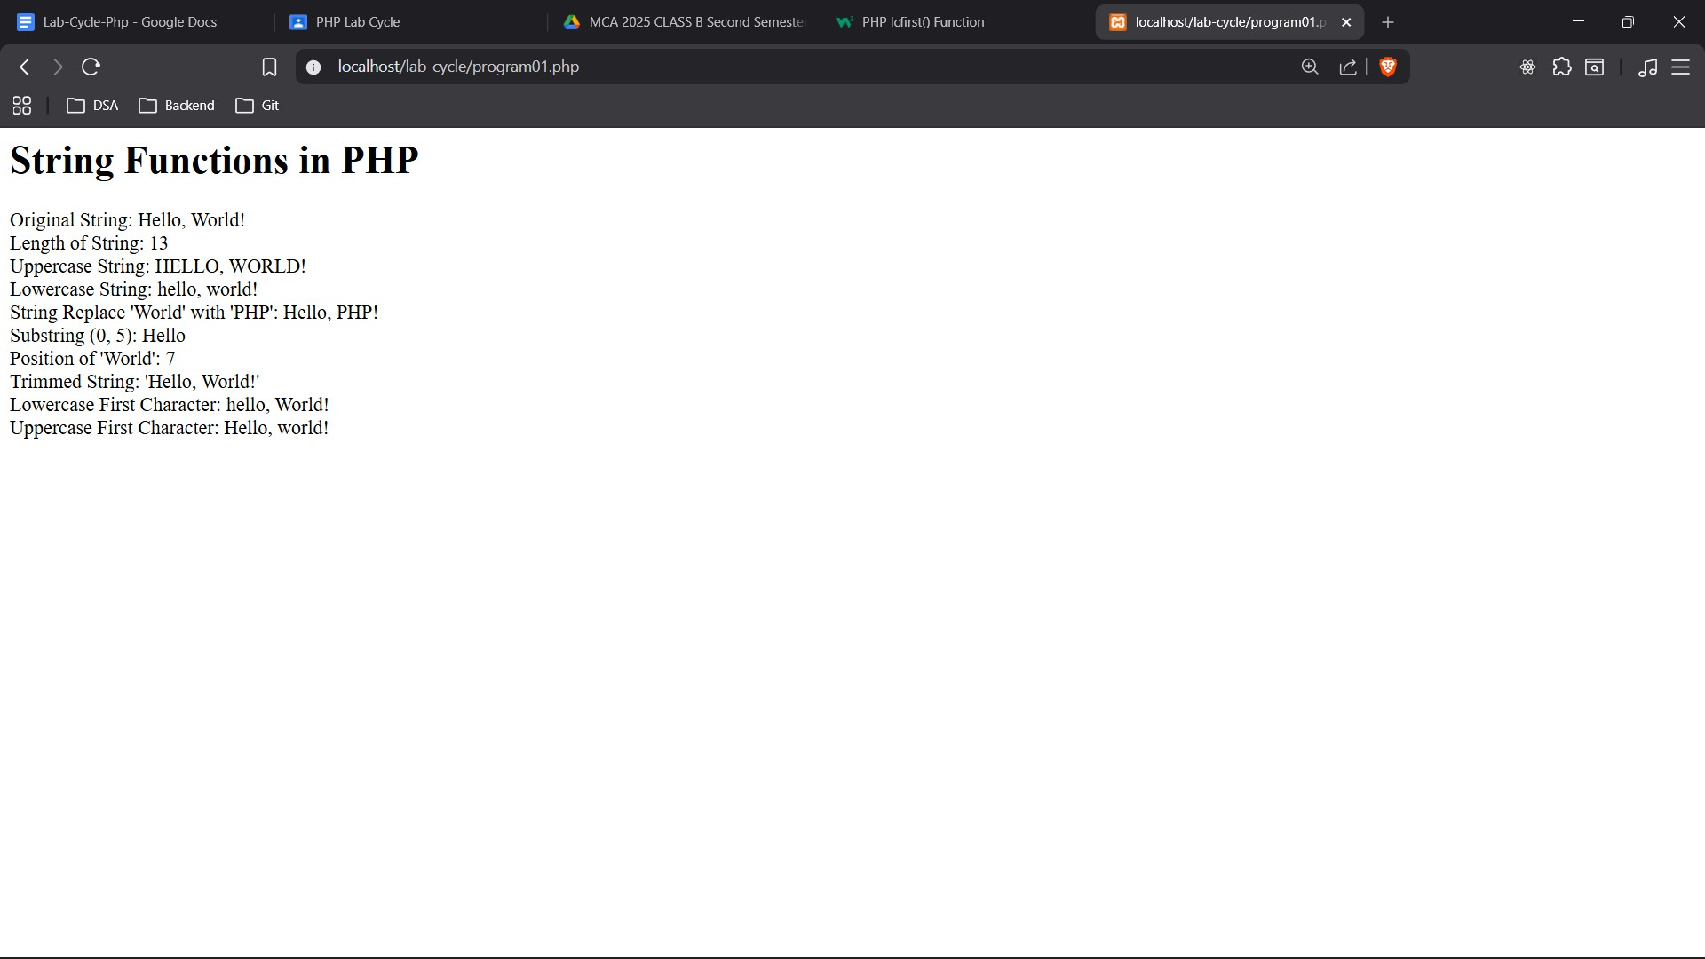

Write a PHP program to show string functions..

<!-- Write a PHP program to show string functions.. -->
<?php
echo "<h1>String Functions in PHP</h1>";
$string = "Hello, World!";
echo "Original String: " . $string . "<br>";
// String Length
echo "Length of String: " . strlen($string) . "<br>";
// String to Uppercase
echo "Uppercase String: " . strtoupper($string) . "<br>";
// String to Lowercase
echo "Lowercase String: " . strtolower($string) . "<br>";
// String Replace
echo "String Replace 'World' with 'PHP': " . str_replace("World", "PHP", $string) . "<br>";
// String Substring
echo "Substring (0, 5): " . substr($string, 0, 5) . "<br>";
// String Position
echo "Position of 'World': " . strpos($string, "World") . "<br>";
// String Trim
$stringWithSpaces = " Hello, World! ";
echo "Trimmed String: '" . trim($stringWithSpaces) . "'<br>";
// String lcfirst
echo "Lowercase First Character: " . lcfirst($string) . "<br>";
// String ucfirst
echo "Uppercase First Character: " . ucfirst(strtolower($string)) . "<br>";
?>

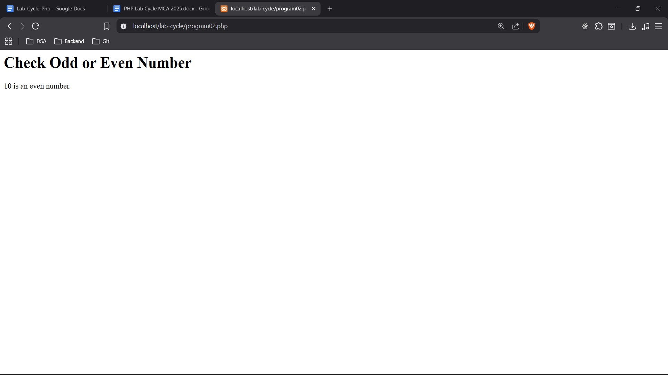

Write a PHP script to check whether the given number is odd or even.

<?php
echo "<h1>Check Odd or Even Number</h1>";
$number = 10;
if ($number % 2 == 0) {
echo $number . " is an even number.";
} else {
echo $number . " is an odd number.";
}
?>

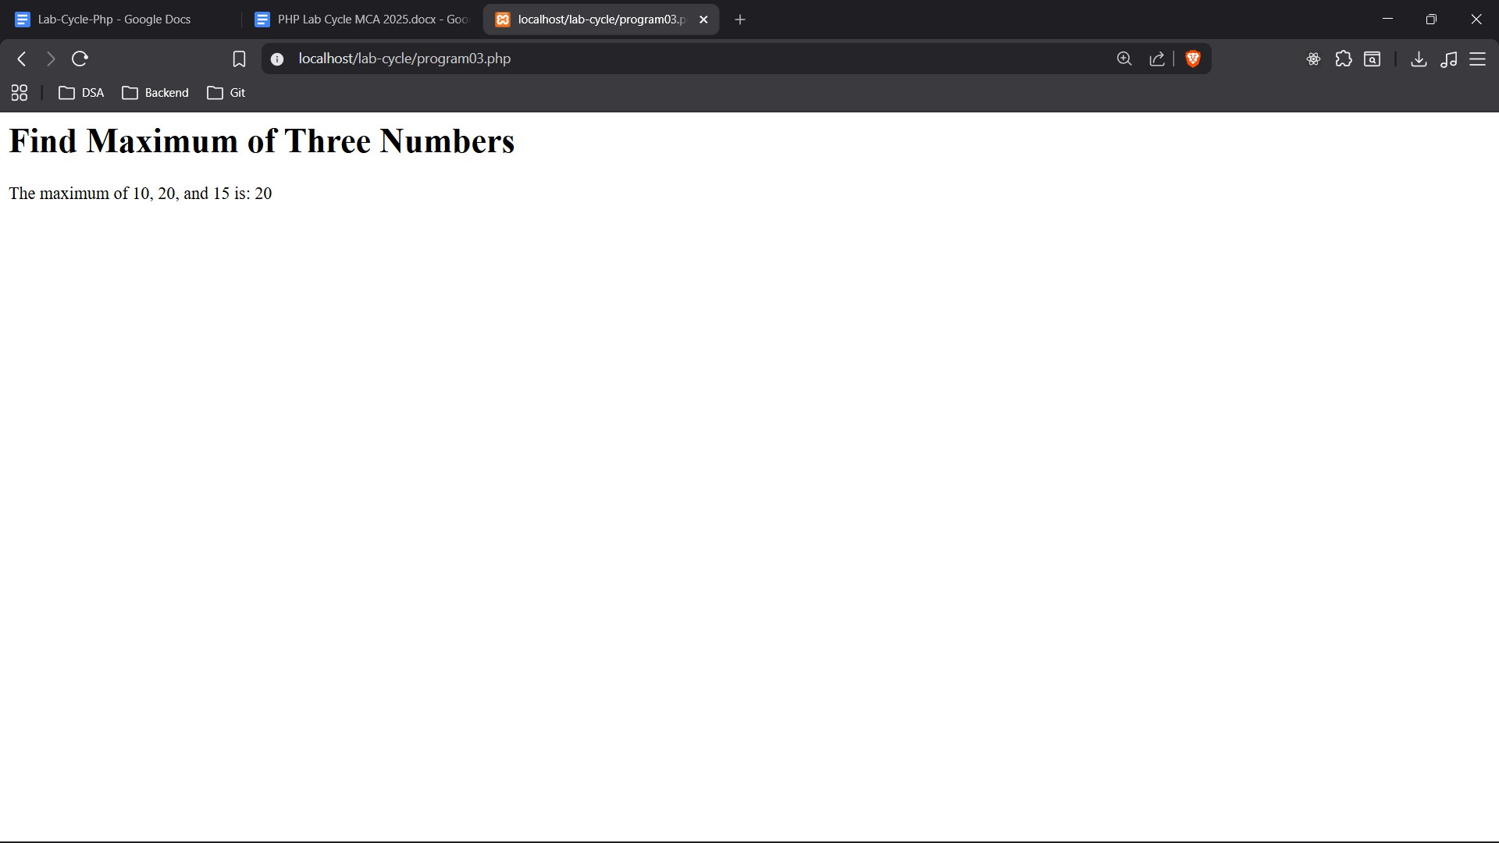

Write a php program to find maximum of three numbers.

<?php
echo "<h1>Find Maximum of Three Numbers</h1>";
$num1 = 10;
$num2 = 20;
$num3 = 15;
$max = $num1;
if ($num2 > $max) {
$max = $num2;
}
if ($num3 > $max) {
$max = $num3;
}
echo "The maximum of $num1, $num2, and $num3 is: " . $max;
?>

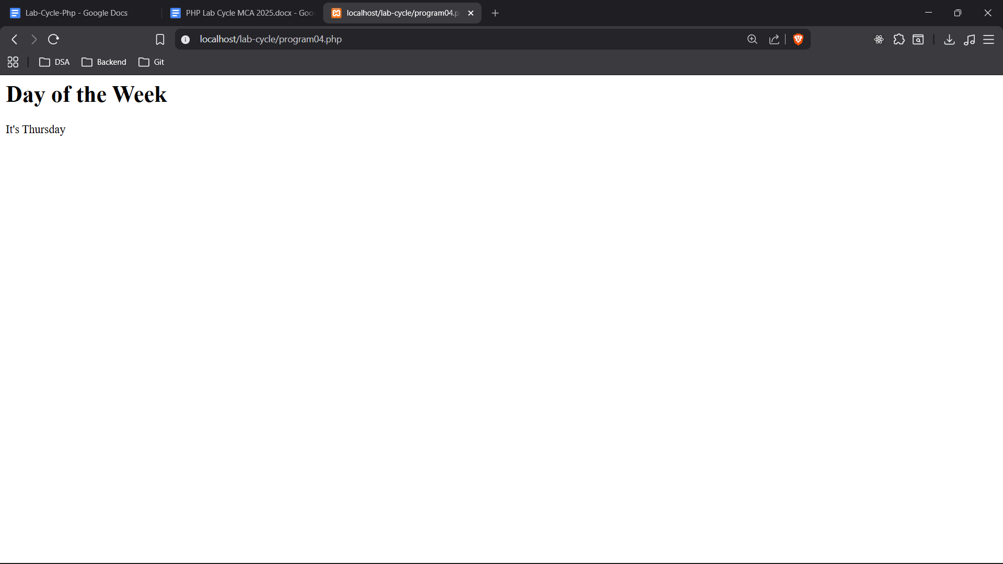

Write a program to show day of the week using switch/case statements.

<?php
echo "<h1>Day of the Week</h1>";
$day = date("D"); switch ($day) {
case "Sun":
echo "It's Sunday"; break;
case "Mon":
echo "It's Monday"; break;
case "Tue":
echo "It's Tuesday"; break;
case "Wed":
echo "It's Wednesday"; break;
case "Thu":
echo "It's Thursday"; break;
case "Fri":
echo "It's Friday"; break;
case "Sat":
echo "It's Saturday"; break;
default:
echo "Invalid day of the week.";
}
?>

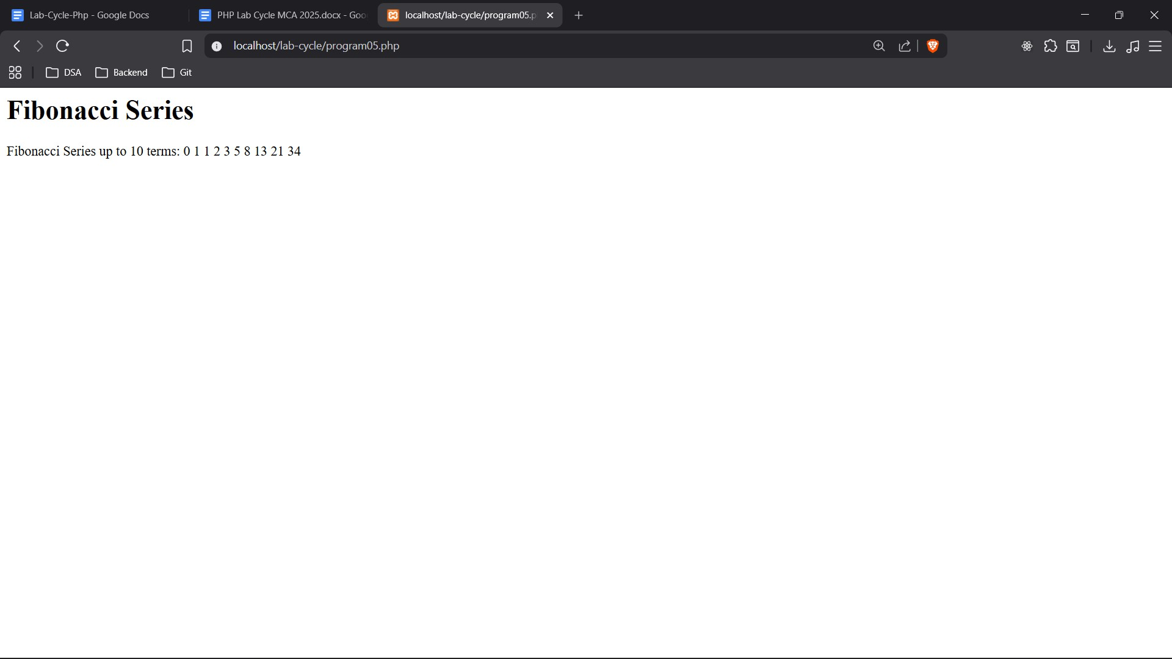

Write a php program to display Fibonacci series up to a particular count using for loop.

<?php
$num1 = 0;
$num2 = 1;
$count = 10; // Change this to display more or less terms echo "<h1>Fibonacci Series</h1>";
echo "Fibonacci Series up to $count terms: "; for ($i = 0; $i < $count; $i++) {
echo $num1 . " ";
$num3 = $num1 + $num2;
$num1 = $num2;
$num2 = $num3;
}
?>

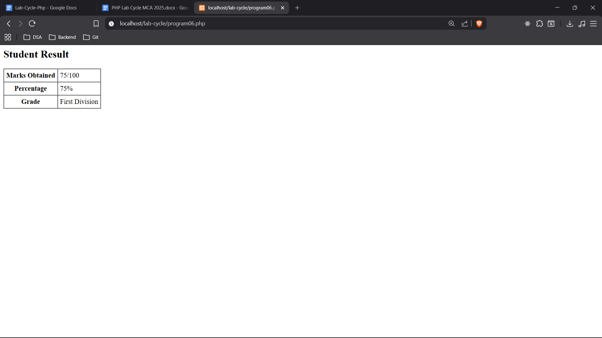

6. Write a program to check student grade based on the marks using if-else statement.
Conditions:
- If marks are 60% or more, grade will be First Division.
- If marks between 45% to 59%, grade will be Second Division.
- If marks between 33% to 44%, grade will be Third Division.
- If marks are less than 33%, student will be Fail.

<?php
$marks = 75; // Input marks
$total_marks = 100;
$percentage = ($marks / $total_marks) * 100;

echo "<h2>Student Result</h2>";
echo "<table border='1' cellpadding='5' cellspacing='0'>";
echo "<tr><th>Marks Obtained</th><td>$marks/$total_marks</td></tr>";
echo "<tr><th>Percentage</th><td>$percentage%</td></tr>";

if ($percentage >= 60) {
$grade = "First Division";
} elseif ($percentage >= 45 && $percentage <= 59) {
$grade = "Second Division";
} elseif ($percentage >= 33 && $percentage <= 44) {
$grade = "Third Division";
} else {
$grade = "Fail";
}

echo "<tr><th>Grade</th><td>$grade</td></tr>";
echo "</table>";
?>

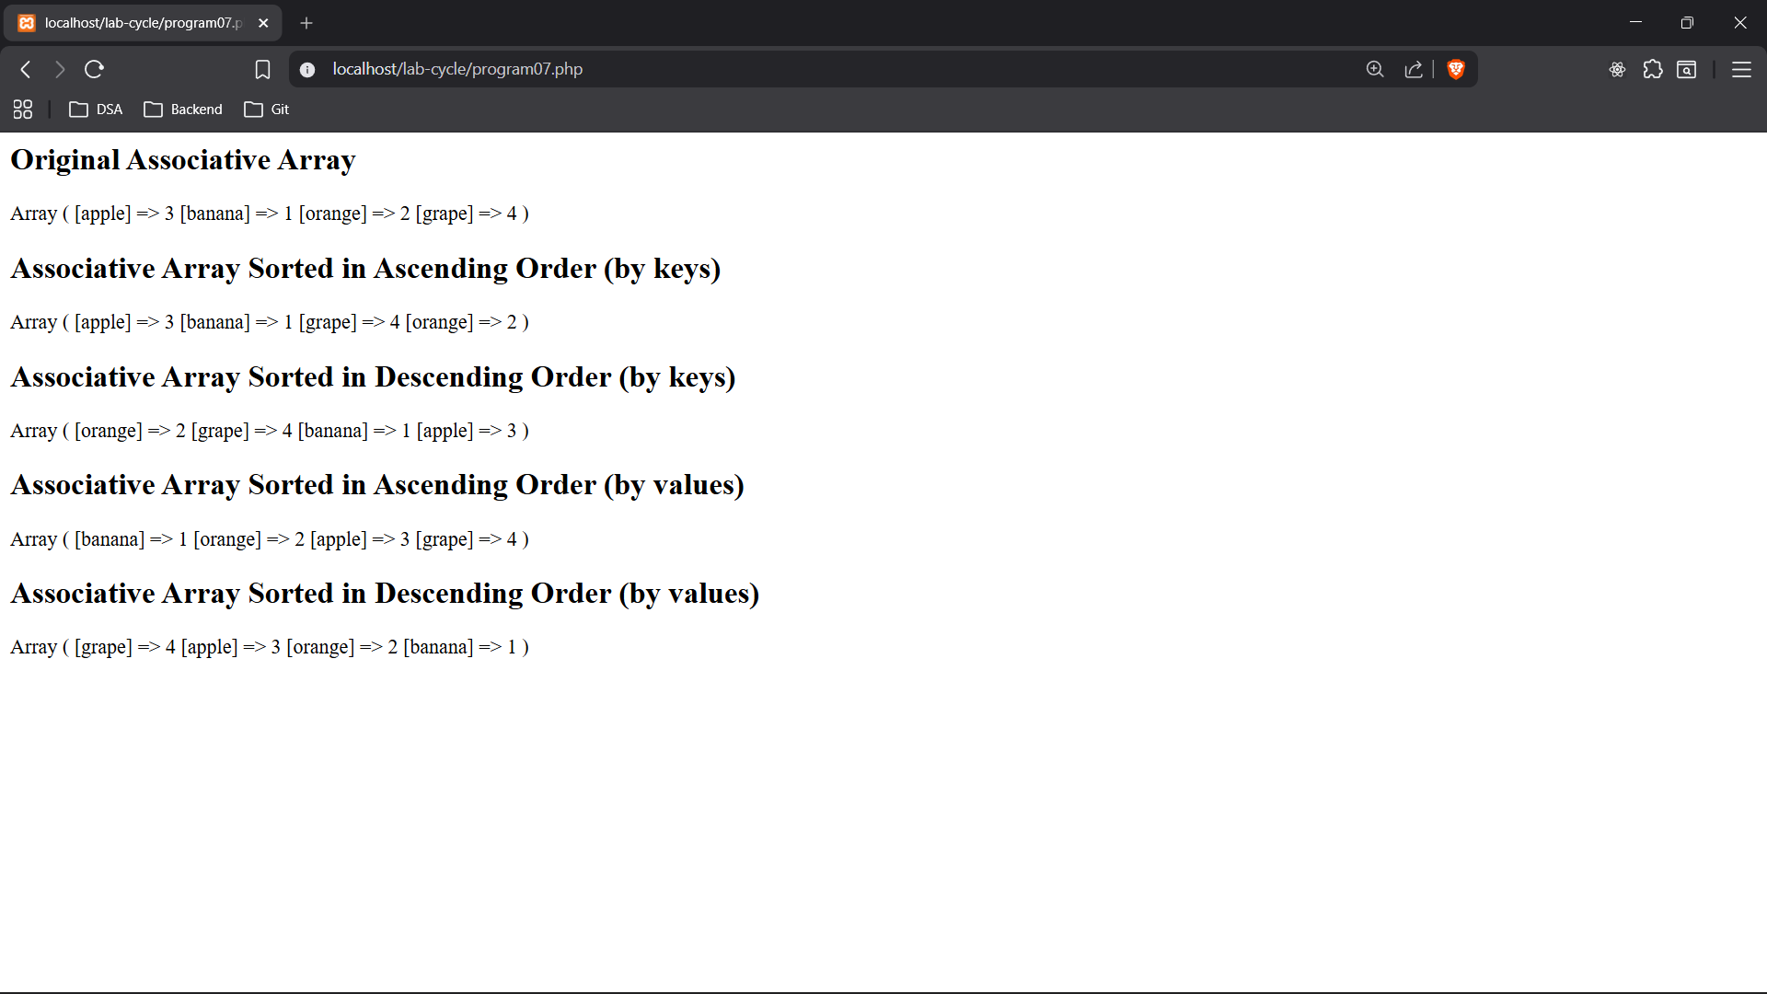

7. Write a program to create an associative array and sort in ascending and descending order w.r.t key & values.

<?php

$fruits = array(
"apple" => 3,
"banana" => 1,
"orange" => 2,
"grape" => 4
);
echo "<h2>Original Associative Array</h2>";

print_r($fruits);

// Sort in ascending order w.r.t keys
ksort($fruits);
echo "<h2>Associative Array Sorted in Ascending Order (by keys)</h2>";

print_r($fruits);

// Sort in descending order w.r.t keys
krsort($fruits);
echo "<h2>Associative Array Sorted in Descending Order (by keys)</h2>";

print_r($fruits);

// Sort in ascending order w.r.t values
asort($fruits);
echo "<h2>Associative Array Sorted in Ascending Order (by values)</h2>";

print_r($fruits);

// Sort in descending order w.r.t values
arsort($fruits);
echo "<h2>Associative Array Sorted in Descending Order (by values)</h2>";

print_r($fruits);

?>

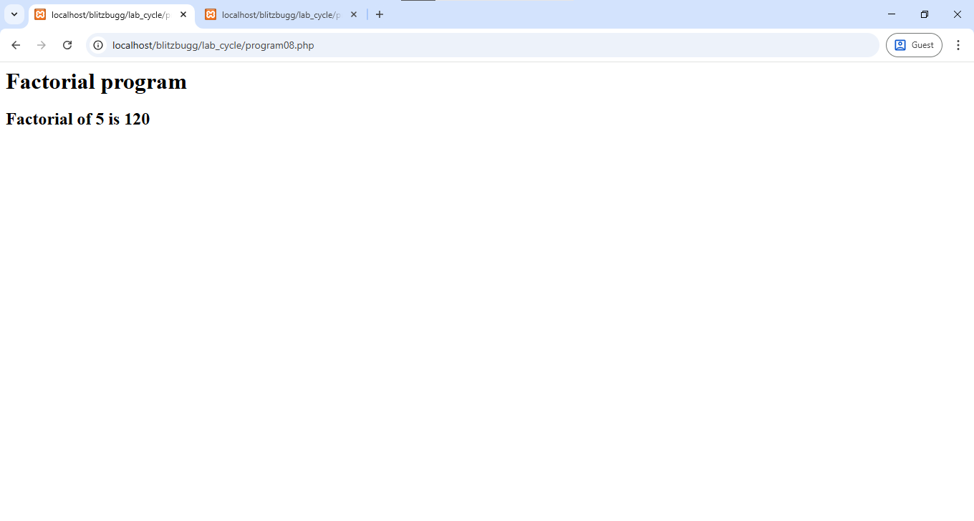
8. Write a PHP program to find factorial of number using function
<?php

echo "<h1>Factorial program </h1>";
function factorial($n) {
if ($n == 0) {
return 1;
}
else {
return $n * factorial($n - 1);
}
}

$number = 5;
echo "<h2> Factorial of $number is " . factorial($number)."</h2>";
?>

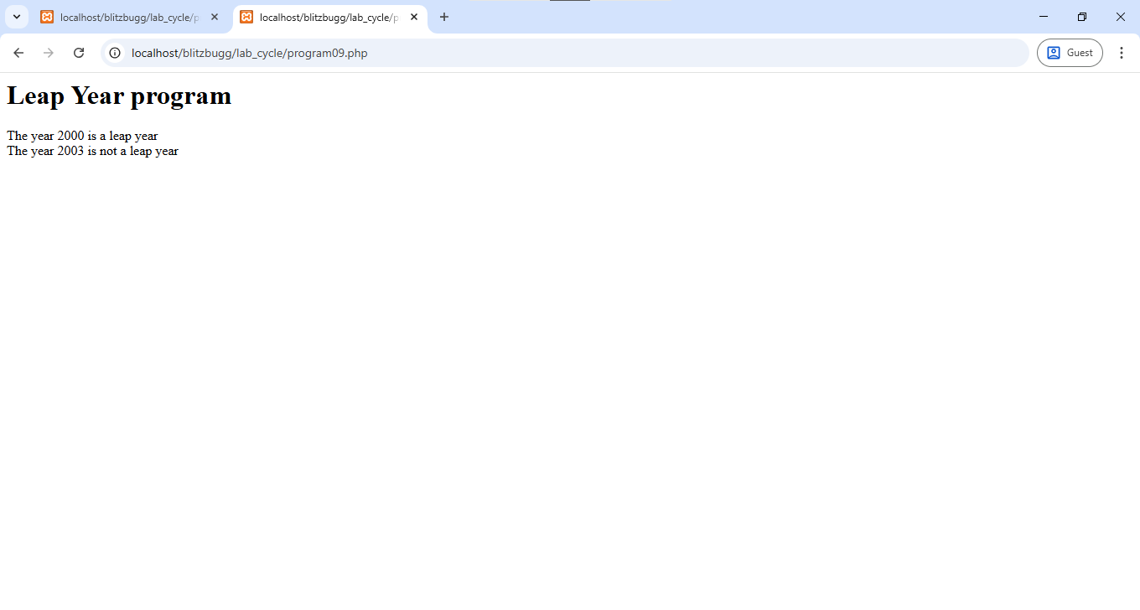

9. Write a PHP program to find whether an entered year is leap year or not using functions

<?php

echo "<h1>Leap Year program </h1>";
function leapyear($year) {
if ($year%4 == 0 || $year%400 == 0) {
echo "The year $year is a leap year <br>";
}
else{
echo "The year $year is not a leap year <br>";
}
}

leapyear(2000);
leapyear(2003);

?>

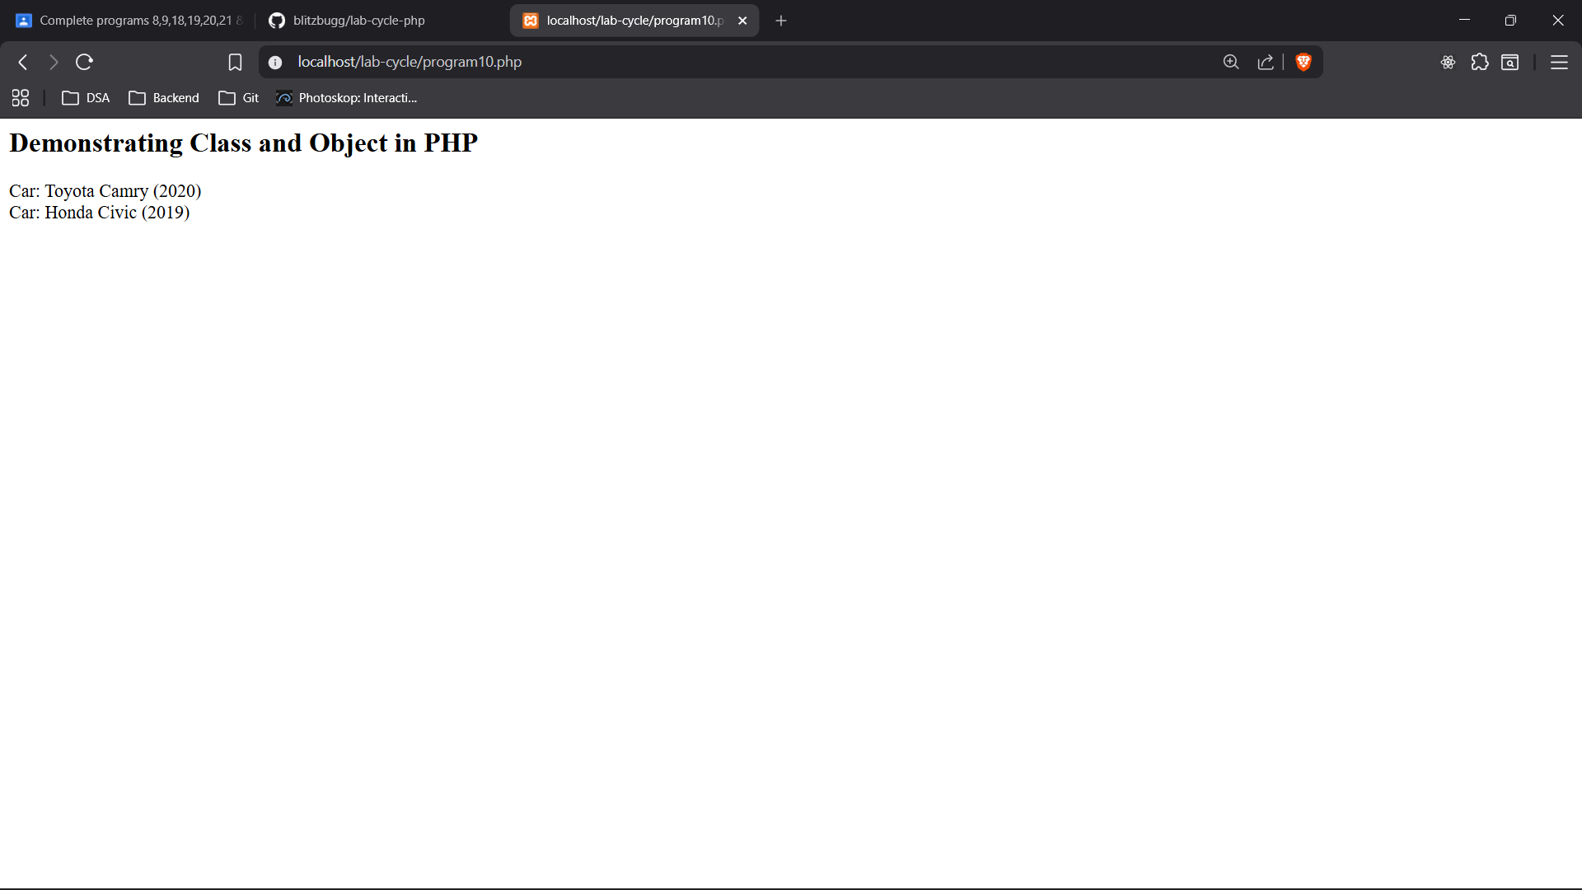

10. Write a PHP script to demonstrate class and object.

<?php
echo "<h2>Demonstrating Class and Object in PHP</h2>";
class Car {
public $make;
public $model;
public $year;

function __construct($make, $model, $year) {
$this->make = $make;
$this->model = $model;
$this->year = $year;
}

function displayInfo() {
echo "Car: " . $this->make . " " . $this->model . " (" . $this->year . ")<br>";
}
}
$car1 = new Car("Toyota", "Camry", 2020);
$car2 = new Car("Honda", "Civic", 2019);
$car1->displayInfo();
$car2->displayInfo();
?>

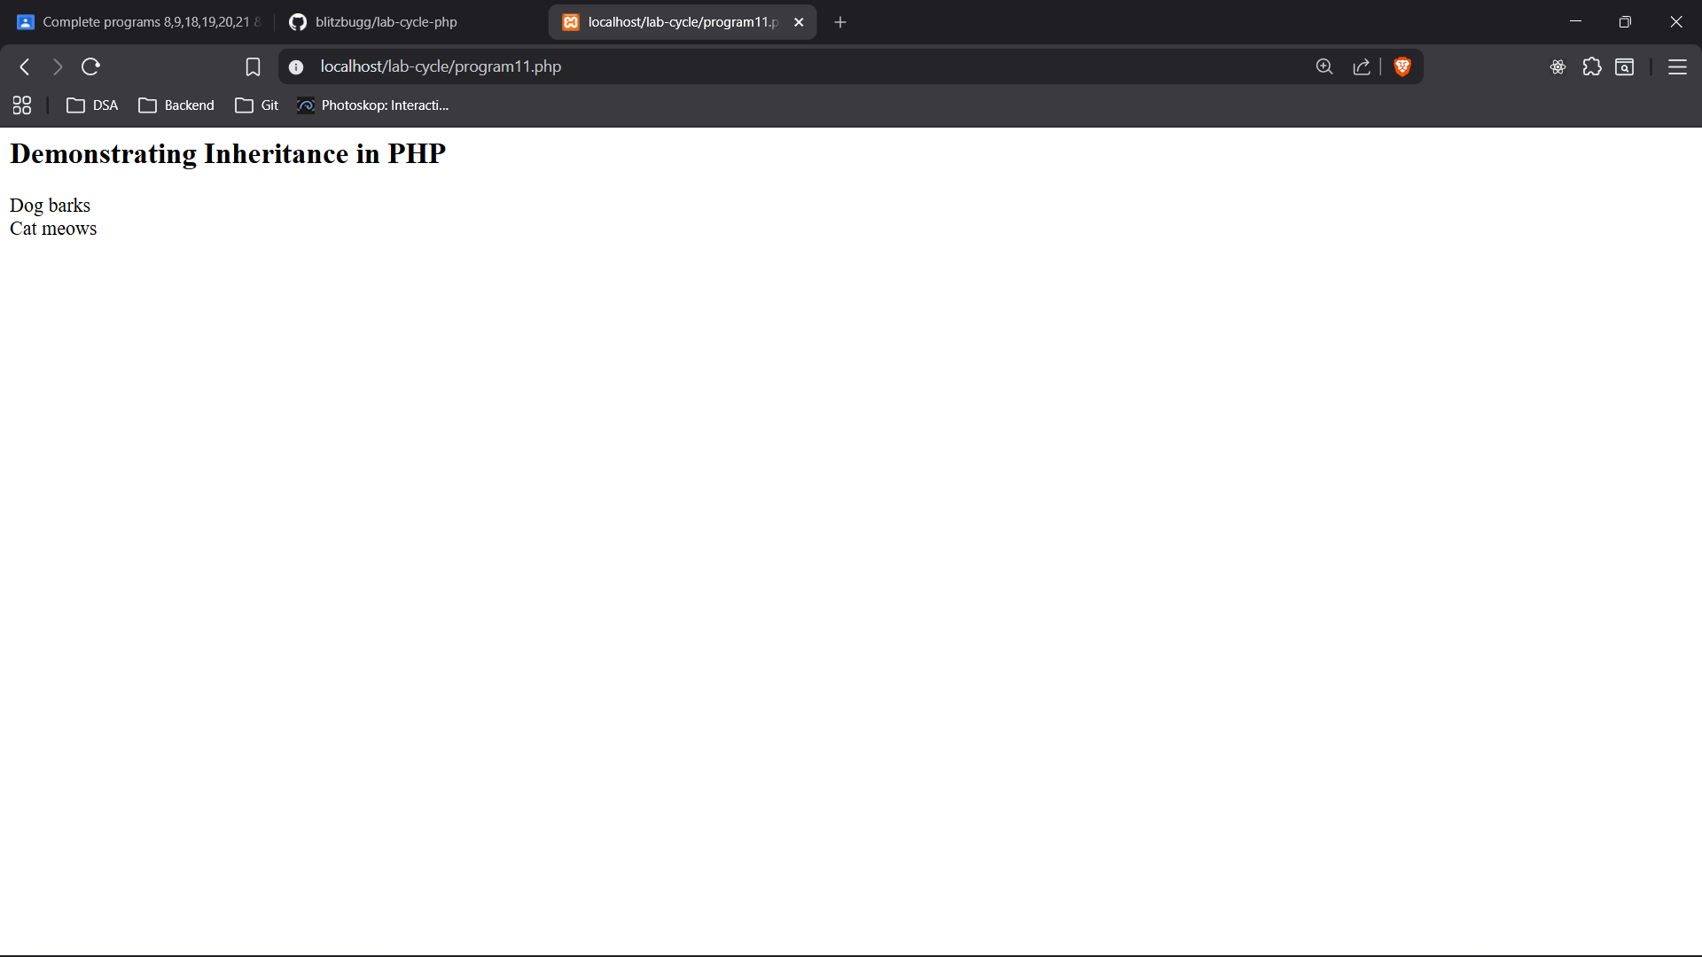
11. Write a PHP script to demonstrate the inheritance.

<?php
echo "<h2>Demonstrating Inheritance in PHP</h2>";
class Animal {
public function makeSound() {
echo "Animal makes a sound <br>";
}
}
class Dog extends Animal {
public function makeSound() {
echo "Dog barks <br>";
}
}
class Cat extends Animal {
public function makeSound() {
echo "Cat meows <br>";
}
}
$dog = new Dog();
$cat = new Cat();
$dog->makeSound();
$cat->makeSound();
?>

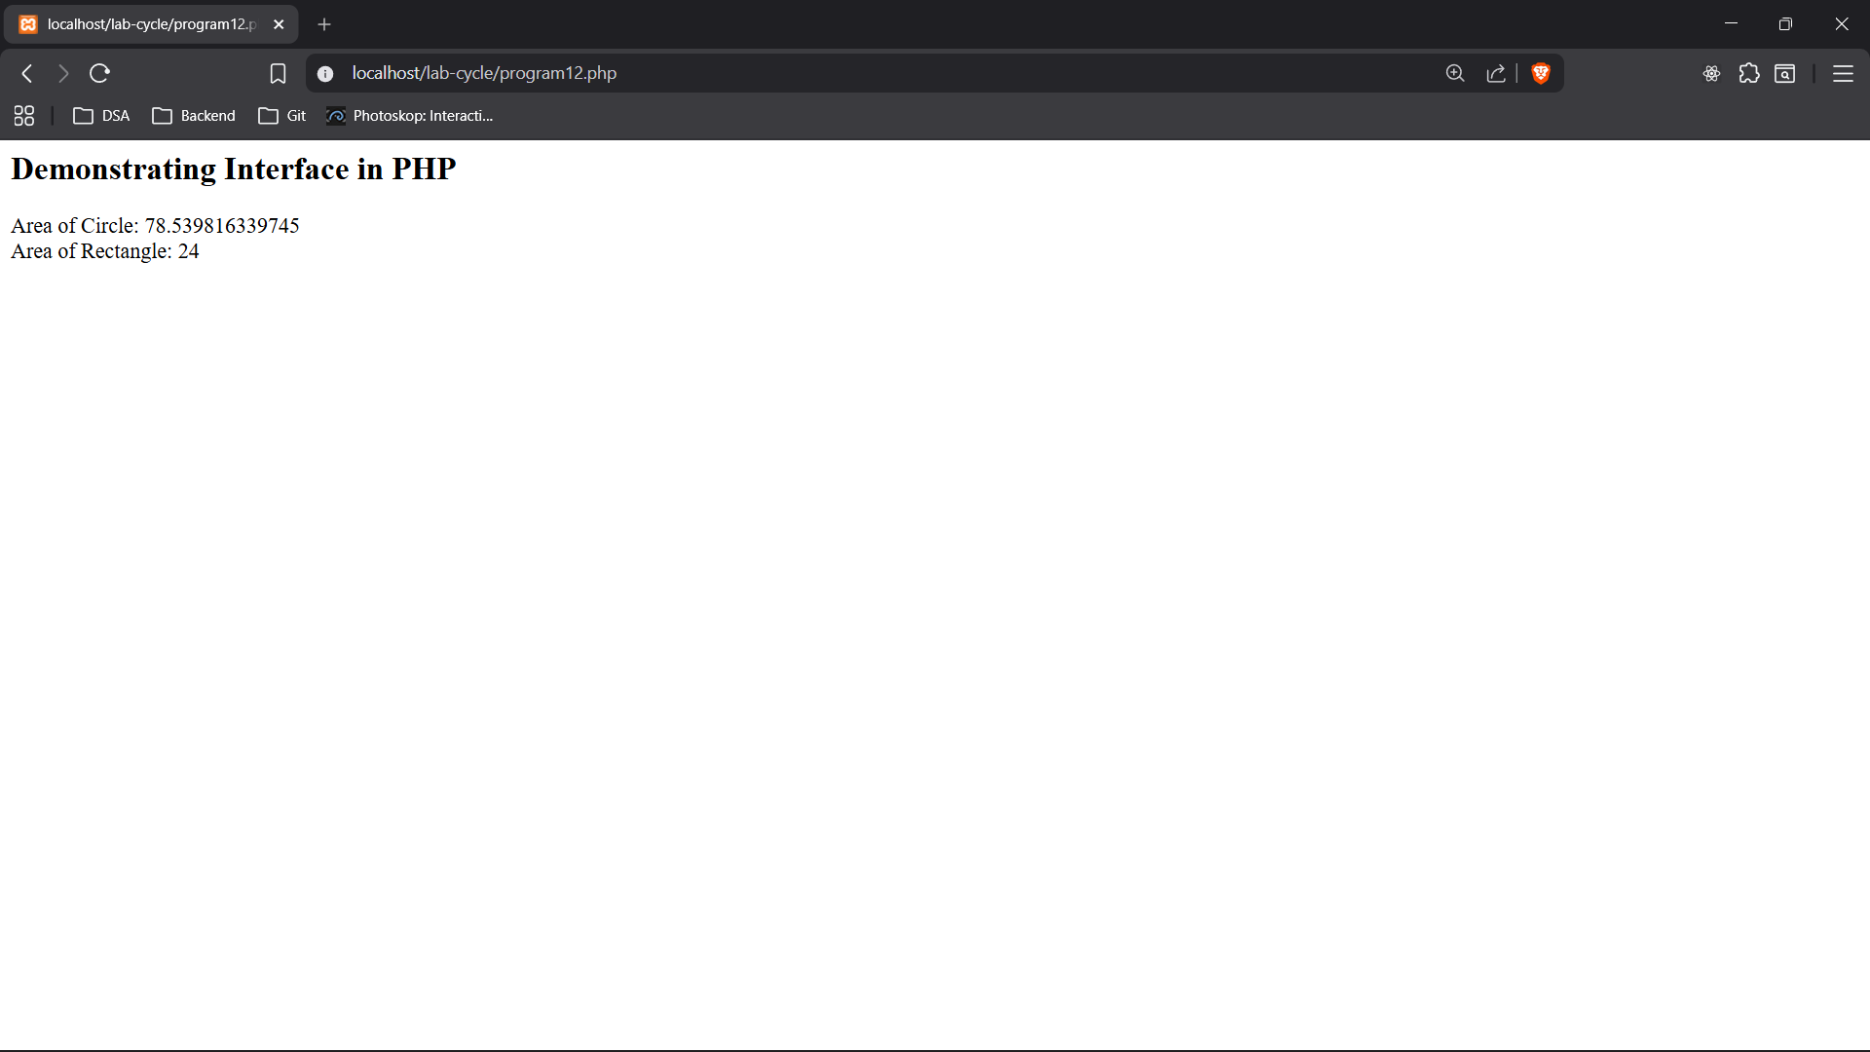

12. Write a PHP script to demonstrate interface.

<?php
echo "<h2>Demonstrating Interface in PHP</h2>";
interface Shape {
public function area();
}
class Circle implements Shape {
private $radius;
public function __construct($radius) {
$this->radius = $radius;
}
public function area() {
return pi() * pow($this->radius, 2);
}
}
class Rectangle implements Shape {
private $width;
private $height;
public function __construct($width, $height) {
$this->width = $width;
$this->height = $height;
}
public function area() {
return $this->width * $this->height;
}
}
$circle = new Circle(5);
$rectangle = new Rectangle(4, 6);
echo "Area of Circle: " . $circle->area() . "<br>";
echo "Area of Rectangle: " . $rectangle->area() . "<br>";
?>
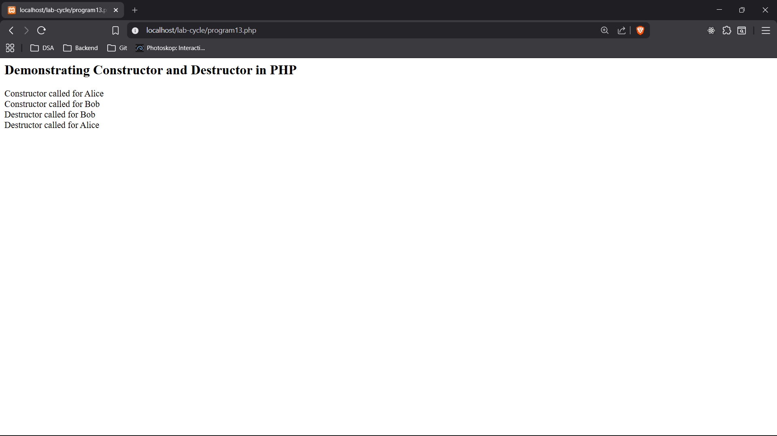

13. Write a PHP script to implement constructor and destructor.

<?php
echo "<h2>Demonstrating Constructor and Destructor in PHP</h2>";
class Person {
public $name;

function __construct($name) {
$this->name = $name;
echo "Constructor called for $name <br>";
}

function __destruct() {
echo "Destructor called for $this->name <br>";
}
}
$person1 = new Person("Alice");
$person2 = new Person("Bob");
?>

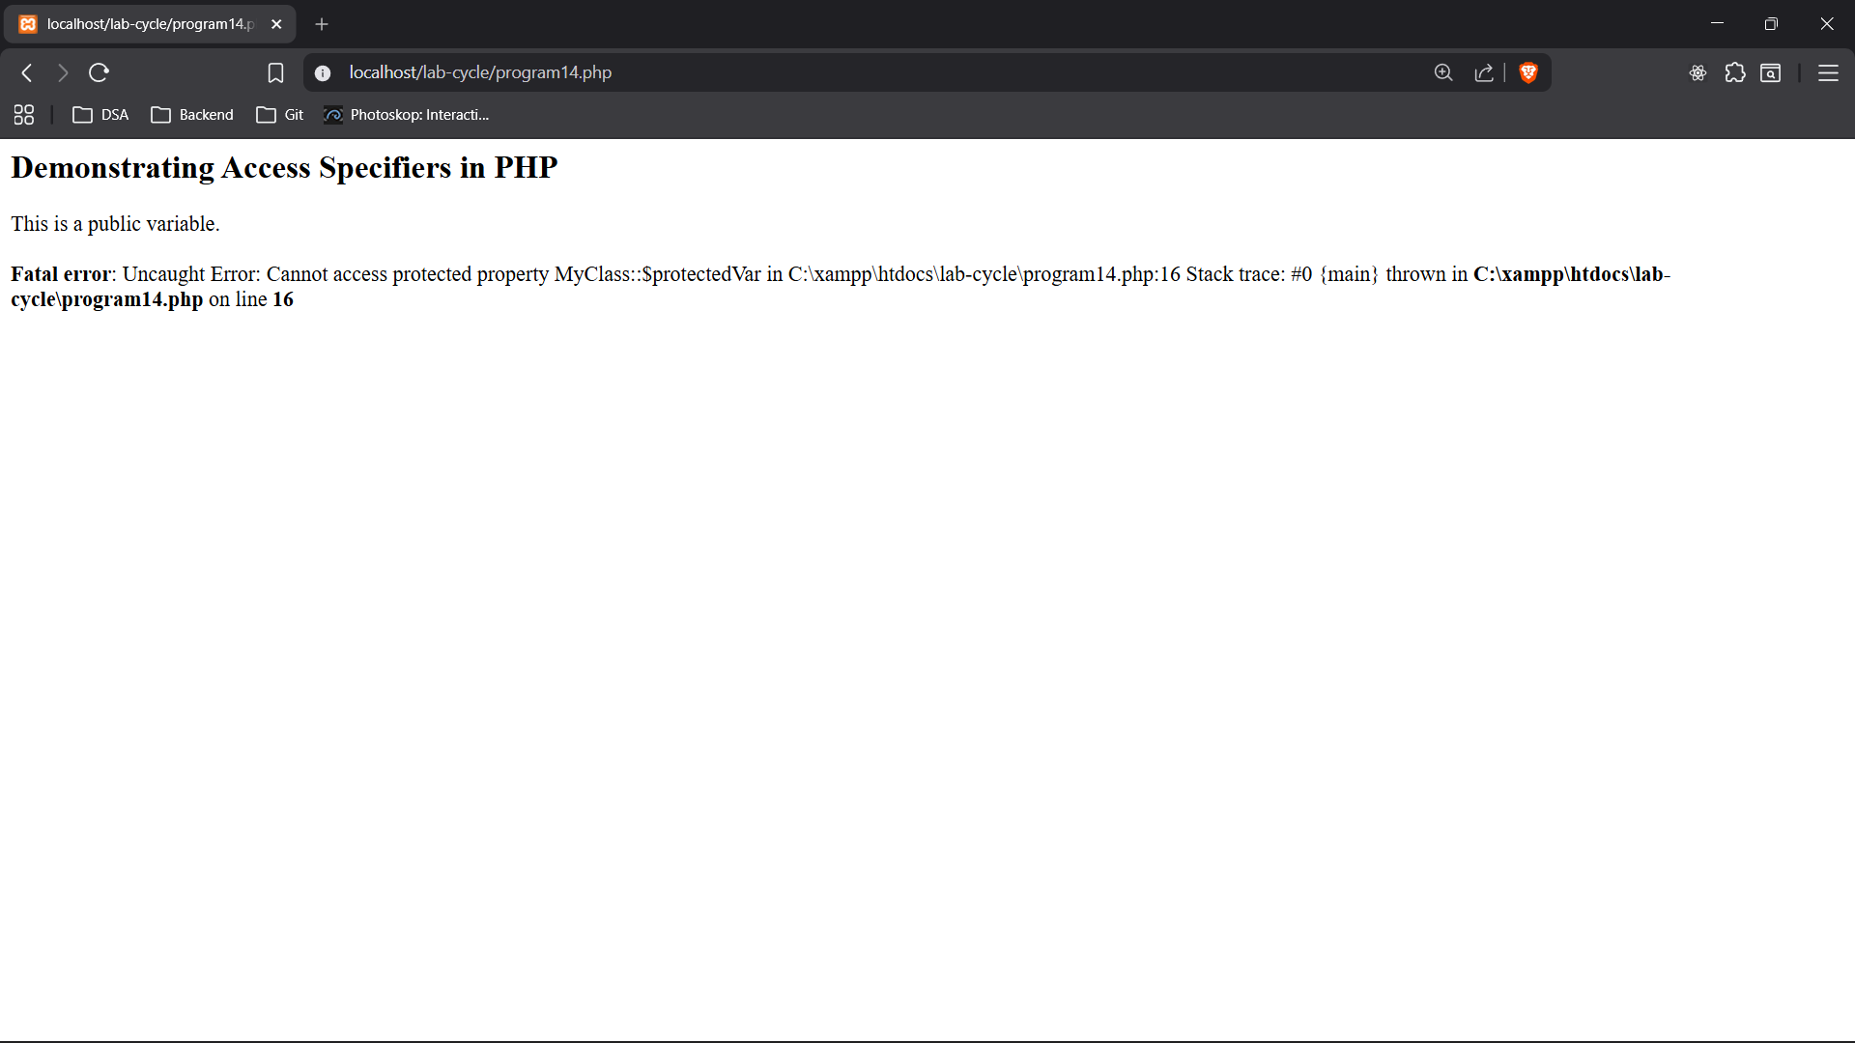
14. Write a PHP program to demonstrate access specifiers.

<?php
echo "<h2>Demonstrating Access Specifiers in PHP</h2>";
class MyClass {
public $publicVar = "This is a public variable.";
protected $protectedVar = "This is a protected variable.";
private $privateVar = "This is a private variable.";
public function showVars() {
echo $this->publicVar . "<br>";
echo $this->protectedVar . "<br>";
echo $this->privateVar . "<br>";
}
}
$obj = new MyClass();
echo $obj->publicVar . "<br>"; // Accessible
echo $obj->protectedVar . "<br>"; // Not accessible, will cause an error
echo $obj->privateVar . "<br>"; // Not accessible, will cause an error
$obj->showVars(); // Accessing all variables through a public method
?>

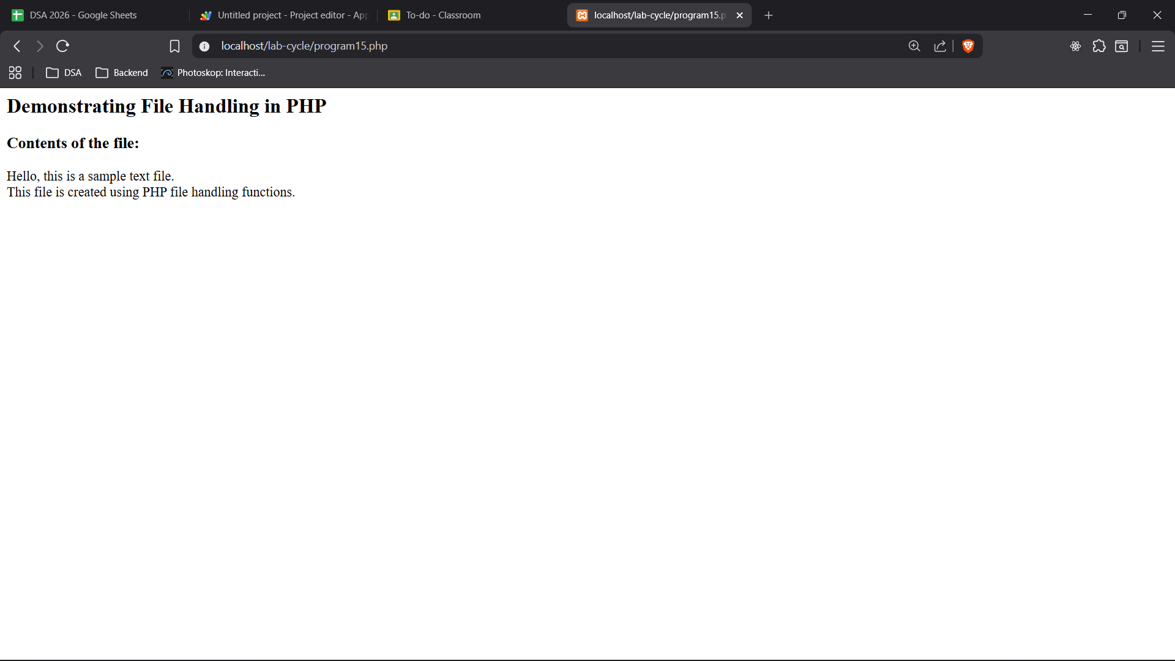

15. write a PHP program to show the use of file handling functions

<?php
echo "<h2>Demonstrating File Handling in PHP</h2>";
$file = fopen("example.txt", "w") or die("Unable to open file!");
$txt = "Hello, this is a sample text file.\n";
fwrite($file, $txt);
$txt = "This file is created using PHP file handling functions.\n";
fwrite($file, $txt);
fclose($file);
$file = fopen("example.txt", "r") or die("Unable to open file!");
echo "<h3>Contents of the file:</h3>";
while(!feof($file)) {
echo fgets($file) . "<br>";
}
fclose($file);
?>

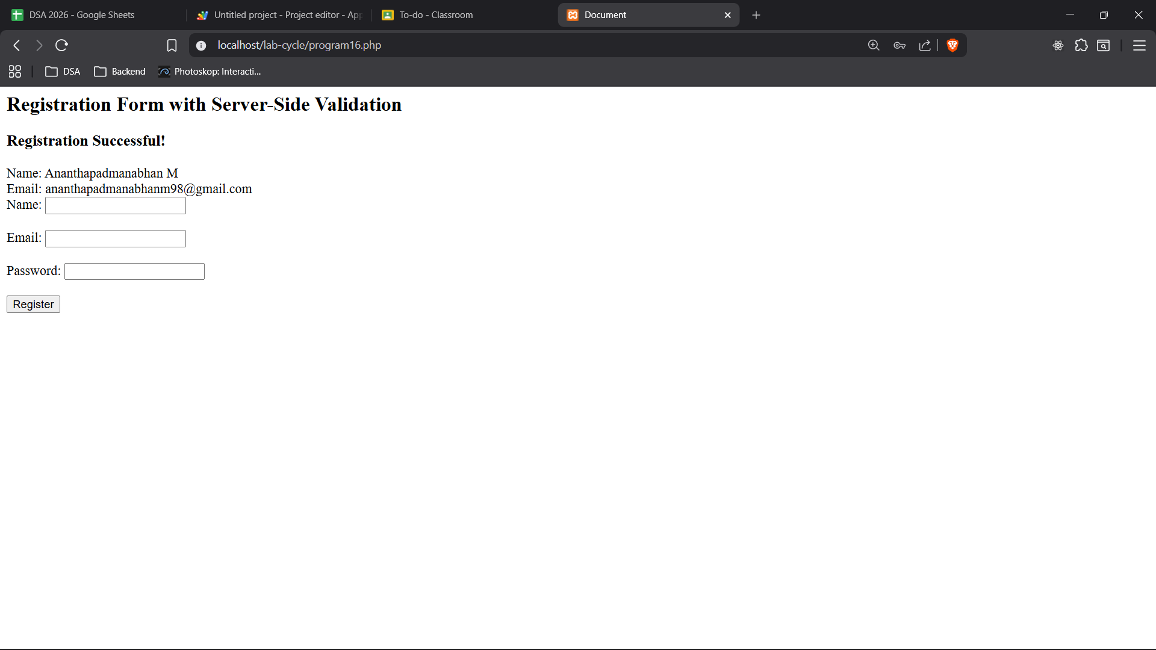

16. Write a PHP program to create a registration form and demonstrate the server side validation process of form elements required.

<?php
echo "<h2>Registration Form with Server-Side Validation</h2>";
if ($_SERVER["REQUEST_METHOD"] == "POST") {
$name = trim($_POST["name"]);
$email = trim($_POST["email"]);
$password = trim($_POST["password"]);

$errors = [];

if (empty($name)) {
$errors[] = "Name is required.";
}
if (empty($email)) {
$errors[] = "Email is required.";
} elseif (!filter_var($email, FILTER_VALIDATE_EMAIL)) {
$errors[] = "Invalid email format.";
}
if (empty($password)) {
$errors[] = "Password is required.";
} elseif (strlen($password) < 6) {
$errors[] = "Password must be at least 6 characters long.";
}

if (empty($errors)) {
echo "<h3>Registration Successful!</h3>";
echo "Name: " . htmlspecialchars($name) . "<br>";
echo "Email: " . htmlspecialchars($email) . "<br>";
} else {
echo "<h3>Errors:</h3><ul>";
foreach ($errors as $error) {
echo "<li>" . htmlspecialchars($error) . "</li>";
}
echo "</ul>";
}
}
?>
<!DOCTYPE html>
<html lang="en">
<head>
<meta charset="UTF-8">
<meta name="viewport" content="width=device-width, initial-scale=1.0">
<title>Document</title>
</head>
<body>

<form method="post" action="<?php echo htmlspecialchars($_SERVER["PHP_SELF"]); ?>">
Name: <input type="text" name="name"><br><br>
Email: <input type="text" name="email"><br><br>
Password: <input type="password" name="password"><br><br>
<input type="submit" value="Register">
</form>
</body>
</html>

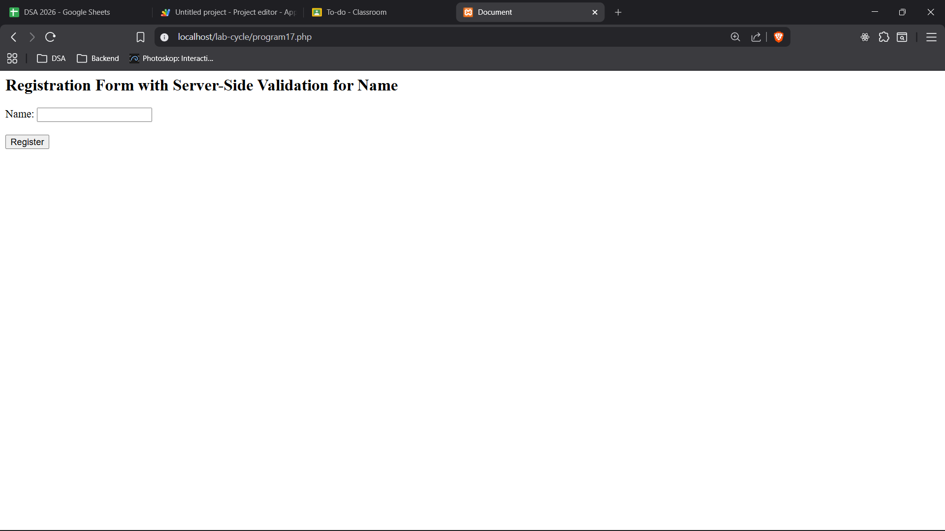

17. Write a PHP program to create a registration form and demonstrate the server side validation process for name exclusively.

<?php
echo "<h2>Registration Form with Server-Side Validation for Name</h2>";
if ($_SERVER["REQUEST_METHOD"] == "POST") {
$name = trim($_POST["name"]);
$errors = [];
if (empty($name)) {
$errors[] = "Name is required.";
}

if (empty($errors)) {
echo "<h3>Registration Successful!</h3>";
echo "Name: " . htmlspecialchars($name) . "<br>";
} else {
echo "<h3>Errors:</h3><ul>";
foreach ($errors as $error) {
echo "<li>" . htmlspecialchars($error) . "</li>";
}
echo "</ul>";
}
}
?>
<!DOCTYPE html>
<html lang="en">
<head>
<meta charset="UTF-8">
<meta name="viewport" content="width=device-width, initial-scale=1.0">
<title>Document</title>
</head>
<body>
<form method="post" action="<?php echo htmlspecialchars($_SERVER["PHP_SELF"]); ?>">
Name: <input type="text" name="name"><br><br>
<input type="submit" value="Register">
</form>
</body>
</html>

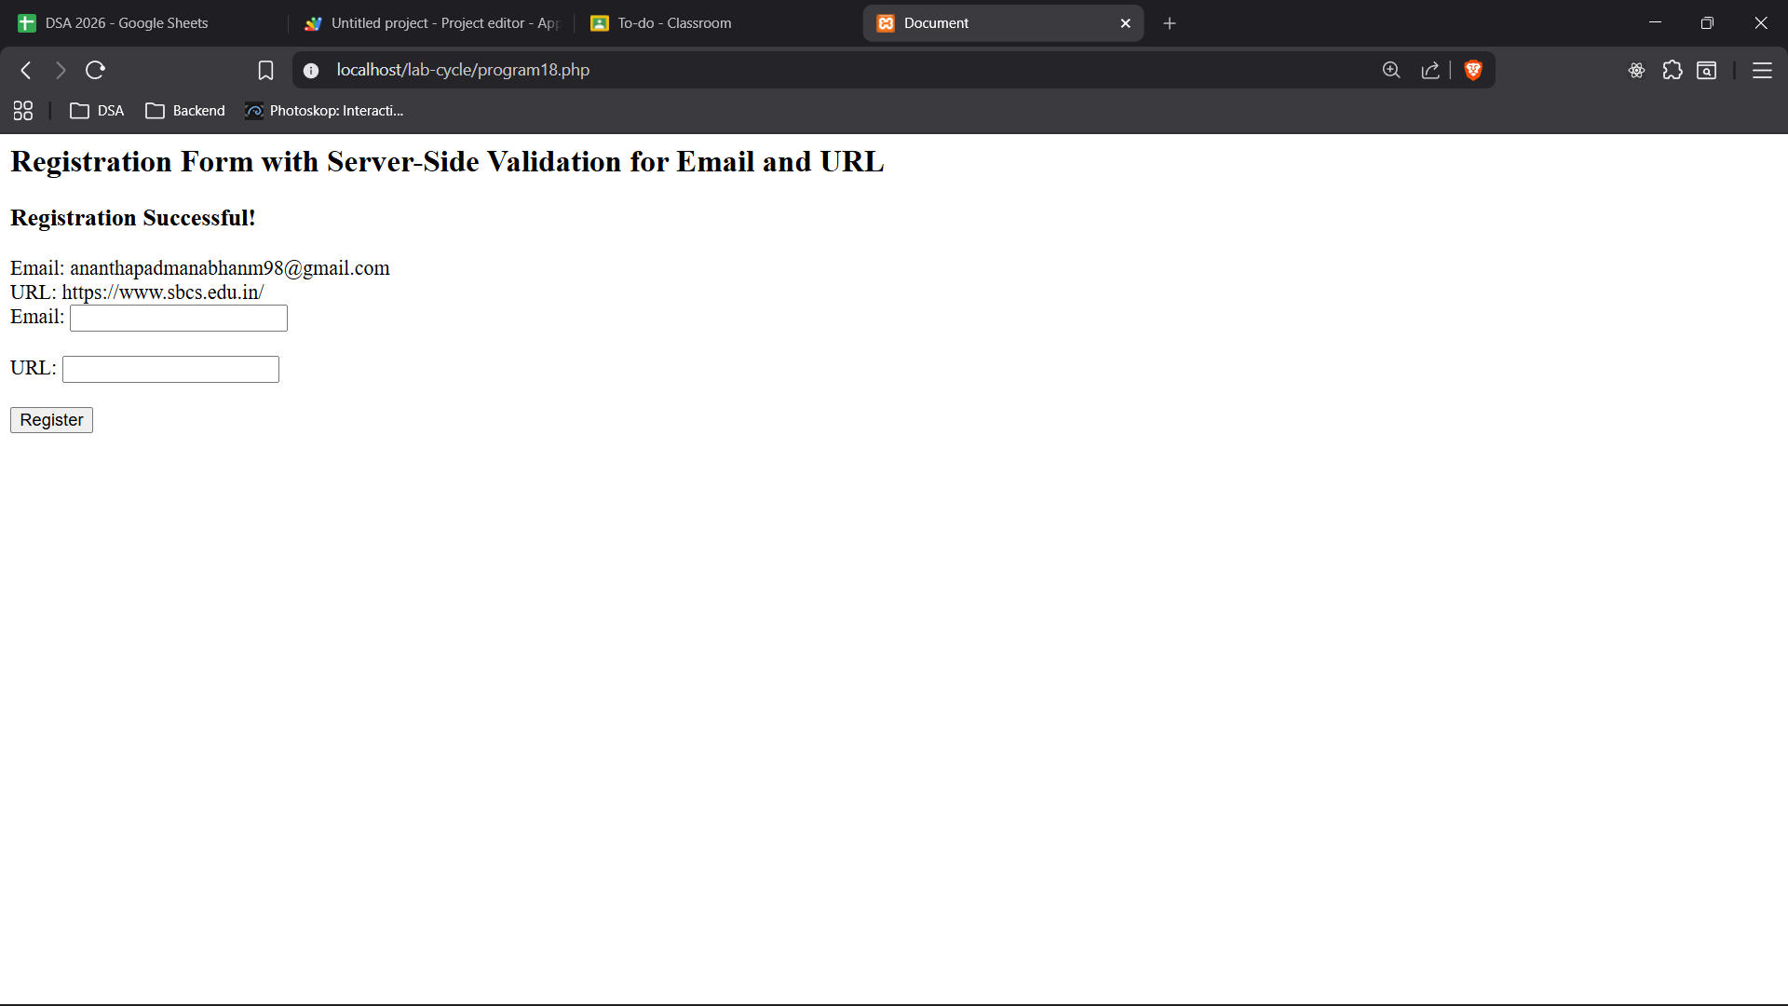

18. Write a PHP program to create a registration form and demonstrate the server side validation process for email and URL exclusively.

<?php
echo "<h2>Registration Form with Server-Side Validation for Email and URL</h2";
if ($_SERVER["REQUEST_METHOD"] == "POST") {
$email = trim($_POST["email"]);
$url = trim($_POST["url"]);

$errors = [];

if (empty($email)) {
$errors[] = "Email is required.";
} elseif (!filter_var($email, FILTER_VALIDATE_EMAIL)) {
$errors[] = "Invalid email format.";
}

if (empty($url)) {
$errors[] = "URL is required.";
} elseif (!filter_var($url, FILTER_VALIDATE_URL)) {
$errors[] = "Invalid URL format.";
}

if (empty($errors)) {
echo "<br><h3>Registration Successful!</h3>";
echo "Email: " . htmlspecialchars($email) . "<br>";
echo "URL: " . htmlspecialchars($url) . "<br>";
} else {
echo "<h3>Errors:</h3><ul>";
foreach ($errors as $error) {
echo "<li>" . htmlspecialchars($error) . "</li>";
}
echo "</ul>";
}
}
?>
<!DOCTYPE html>
<html lang="en">
<head>
<meta charset="UTF-8">
<meta name="viewport" content="width=device-width, initial-scale=1.0">
<title>Document</title>
</head>
<body>
<form method="post" action="<?php echo htmlspecialchars($_SERVER["PHP_SELF"]); ?>">
Email: <input type="text" name="email"><br><br>
URL: <input type="text" name="url"><br><br>
<input type="submit" value="Register">
</form>
</body>
</html>

