**A**

**Smart Sensor Instrumentation Lab Project**

**Report on**

**Piezo Power**

Submitted to

### The Department of Electronics and Communication Engineering

### Bachelor of Technology in

### Computer Science and Engineering (IOT)

### (2022 – 2026)

### G.Tarun Naga Sai 22R11A6949

Under the Guidance of

Mr.P.Chandra Prakash Reddy



### Department of Computer Science and Engineering (IOT)

**Geethanjali College of Engineering and Technology (UGC Autonomous)**

(Affiliated to J.N.T.U.H, Approved by AICTE, New Delhi, Accredited by NBA)

### Cheeryal (V), Keesara (M), Medchal.Dist.-501 301.

**June-2024**

**ABSTRACT**

This abstract explores the innovative application of **piezoelectric technology** in the realm of **footwear**, specifically focusing on the development and implications of **piezoelectric shoes**. These shoes are equipped with **piezoelectric materials** that convert mechanical energy generated during walking or running into **electrical power**. The primary emphasis is on **energy harvesting**, enabling **self-sustaining** or **energy-assisted wearable devices**. This breakthrough not only contributes to the **sustainability** of **wearable technology** but also offers the prospect of reducing reliance on conventional power sources. The integration of **piezoelectric elements** into the sole or other parts of the shoe allows for unobtrusive and efficient **energy capture**. This abstract delves into the potential impact of **piezoelectric shoes** on powering **portable devices**, enhancing **user mobility**, and paving the way for a new era of **self-sufficient** and **eco-friendly footwear**.

**Piezoelectric shoes** represent a **paradigm shift** in the field of **wearable technology** by harnessing energy from **human motion**. The integration of **piezoelectric materials** into **footwear** not only addresses the growing demand for **sustainable energy solutions** but also enhances the practicality and convenience of **wearable devices**. Imagine a future where every step you take contributes to charging your **smartphone** or powering your **fitness tracker**. This **technology** not only reduces **environmental impact** by decreasing reliance on traditional power sources but also promotes a more **active** and **mobile lifestyle** without the constant need for recharging or replacing **batteries.**

Furthermore, the development of **piezoelectric shoes** opens up new avenues for innovation in **design** and **functionality**. Engineers and designers can explore novel ways to optimize **energy conversion efficiency** and **durability** of these materials in different environments and usage scenarios. From improving the **robustness** of the **piezoelectric components** to refining the **ergonomics** and **comfort** of the **footwear**, there are numerous opportunities to advance both the **technology** and **user experience**. This interdisciplinary approach fosters collaboration between **materials science, electronics**, and **fashion design**, potentially leading to customizable shoes that cater to individual **energy needs** and **stylistic preferences**.

Top of Form

Bottom of Form

**INDEX**

1. INTRODUCTION 3
   1. EXISTING SYSTEM 4
   2. PROPOSED SYSTEM 5
2. SYSTEM ANALYSIS 6
   1. SOFTWARE REQUIREMENTS 6
   2. HARDWARE REQUIREMENTS 6
3. SYSTEM DESIGN 7
   1. FLOWCHART DIAGRAM 7
   2. USE CASE DIAGRAM 8
   3. CIRCUIT DIAGRAM 9
4. IMPLEMENTATION 10
5. RESULTS 12
6. CONCLUSION 14
7. FUTURE SCOPE 15
8. REFERENCES 16

# INTRODUCTION

The intersection of wearable technology and sustainable energy solutions has opened new frontiers in innovation, particularly in the realm of footwear. As the demand for portable electronic devices continues to surge, the need for efficient, sustainable power sources becomes increasingly critical. This context sets the stage for the advent of piezoelectric shoes, a novel application of piezoelectric technology that promises to revolutionize how we generate and utilize energy on the go. Piezoelectric materials, which convert mechanical stress into electrical energy, offer a unique opportunity to harness the kinetic energy produced during walking or running. This introduction will explore the concept of piezoelectric shoes, highlighting their potential to power wearable devices, enhance user mobility, and contribute to a greener, more self-sufficient future in wearable technology.

One of the key advantages of piezoelectric shoes lies in their potential to extend the operational lifespan of portable electronic devices. Instead of relying solely on batteries that require frequent recharging or replacement, these shoes can continuously generate electricity as long as the wearer is in motion. This continuous power supply not only enhances the reliability and convenience of wearable devices but also supports the seamless integration of technology into everyday activities without disruption.

Moreover, the development of piezoelectric footwear underscores the importance of interdisciplinary collaboration across fields such as materials science, biomechanics, and electrical engineering. Researchers and innovators are exploring ways to optimize the efficiency of piezoelectric materials, improve their durability under varying conditions, and integrate them seamlessly into shoe designs without compromising comfort or performance. This collaborative effort is crucial in overcoming technical challenges and ensuring that piezoelectric shoes meet the rigorous demands of modern consumers and industries.

## EXISTING SYSTEM

Existing systems for generating piezoelectric electricity leverage the unique properties of piezoelectric materials to convert mechanical energy into electrical energy across various applications. One prominent example is piezoelectric floor tiles, which are installed in high-traffic areas such as shopping malls, airports, and train stations. These tiles capture energy from the pressure and vibrations caused by footsteps, with companies like Pavegen leading the way in developing tiles that convert this kinetic energy into electricity for powering lights and other devices. Another application is in piezoelectric roadways, where sensors embedded in roads and highways generate electricity from the pressure exerted by passing vehicles. This harvested energy can be utilized for street lighting, traffic signals, and other infrastructure needs, showcasing the potential of piezoelectric technology in creating sustainable energy solutions.

One emerging area is in the integration of piezoelectric devices into wearable technology, such as the development of piezoelectric fabrics and garments. These innovations aim to capture mechanical energy from body movements and vibrations, transforming them into electrical power to charge portable devices or even assist in powering embedded sensors for health monitoring or environmental sensing. This intersection of wearables and energy harvesting opens up possibilities for self-sustaining personal electronics that reduce reliance on external power sources and enhance user convenience.

Furthermore, researchers are exploring miniaturized piezoelectric devices for applications in smaller-scale electronics, such as implantable medical devices or sensors in IoT (Internet of Things) devices. These compact, efficient energy harvesters can potentially extend battery life or eliminate the need for batteries altogether, making devices more reliable and environmentally friendly.

## 

## PROPOSED SYSTEM

Our proposed system introduces the innovative concept of piezoelectric shoes, designed to generate electrical power by harnessing the mechanical energy produced during walking or running. By embedding piezoelectric materials within the shoe's sole or other structural components, these shoes can convert the mechanical stress from each step into usable electrical energy. This energy can be used to power small electronic devices, such as fitness trackers, LEDs, or even smartphones, enhancing the functionality of wearable technology while promoting sustainability. The system is designed to be unobtrusive, ensuring that the energy harvesting process does not interfere with the user's natural movements. This approach not only offers a renewable energy solution but also reduces reliance on traditional power.

One significant advantage of piezoelectric shoes lies in their ability to promote energy efficiency and reduce carbon footprints. By generating electricity from the kinetic energy of walking or running, users can effectively supplement or replace the need for disposable batteries or frequent recharging of electronic devices. This not only saves energy costs but also reduces electronic waste, contributing to a more sustainable consumption cycle.

Moreover, the development of piezoelectric shoes opens doors to new innovations in wearable technology. Researchers and designers can explore advancements in materials and manufacturing techniques to enhance the efficiency and durability of piezoelectric elements. For instance, optimizing the placement and arrangement of piezoelectric materials within the shoe can maximize energy conversion rates without compromising comfort or performance. This iterative process of refinement fosters continuous improvement in energy harvesting capabilities and user experience.

# 

# SYSTEM ANALYSIS

## SOFTWARE REQUIREMENTS

* Embedded Development: Arduino IDE or PlatformIO for microcontroller programming.
* Data Analysis: MATLAB or Python with NumPy, Pandas, and Matplotlib for energy data analysis.
* Simulation: COMSOL Multiphysics or ANSYS for simulating piezoelectric material behavior.
* Circuit Design: Eagle or KiCad for designing electronic circuits.
* Power Management: Custom software for efficient energy storage and usage.

## HARDWARE REQUIREMENTS

* Piezoelectric Transducers: Convert mechanical stress into electrical energy.
* Energy Storage: Lithium-Ion Batteries for storing harvested energy.
* Power Conditioning Circuit: Voltage regulators and charge controllers for stable power output.
* Optional Sensors: Accelerometer and temperature sensor for optimizing energy harvesting.
* Prototyping Board and Accessories: Breadboard, jumper wires, and PCB for circuit development.
* Enclosure: Shoe sole or casing to house components.
* Testing Equipment: Multimeter and oscilloscope for measurement and analysis

# SYSTEM DESIGN

## Flow Chart Diagram

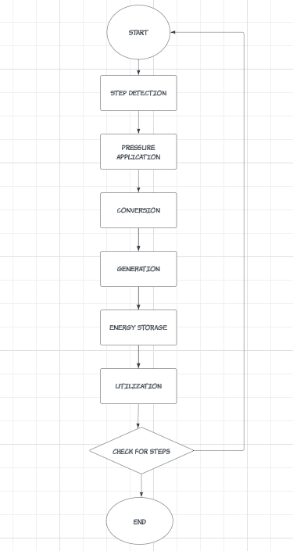

**Use Case Diagram**

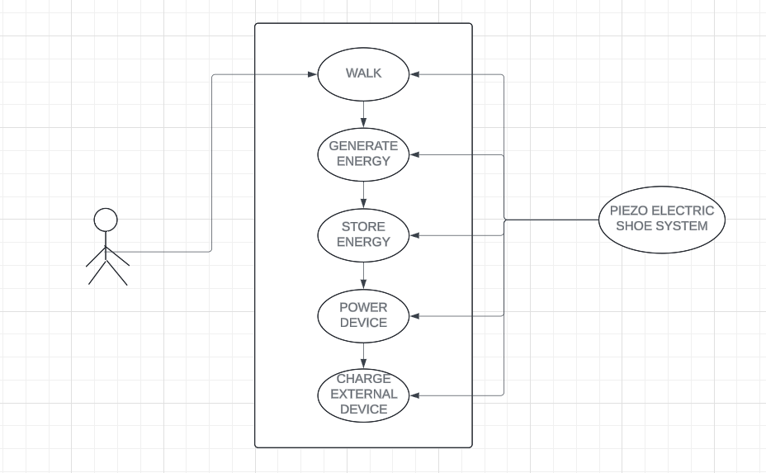

**Circuit Diagram**

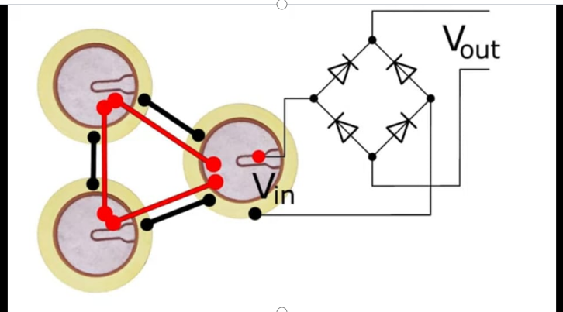

**IMPLEMENTATION**

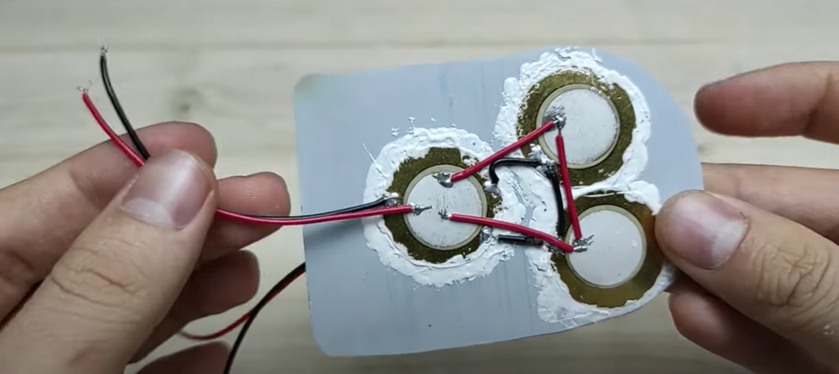

This picture shows a further stage in the construction of piezoelectric shoes. The image highlights the wiring connections of three piezoelectric discs mounted on a flat surface. The red and black wires are soldered to the discs and extend outward, ready to be integrated into the shoe's electrical circuit. These piezoelectric elements will convert the mechanical energy generated from walking into electrical energy, demonstrating the assembly process of energy-harvesting footwear.

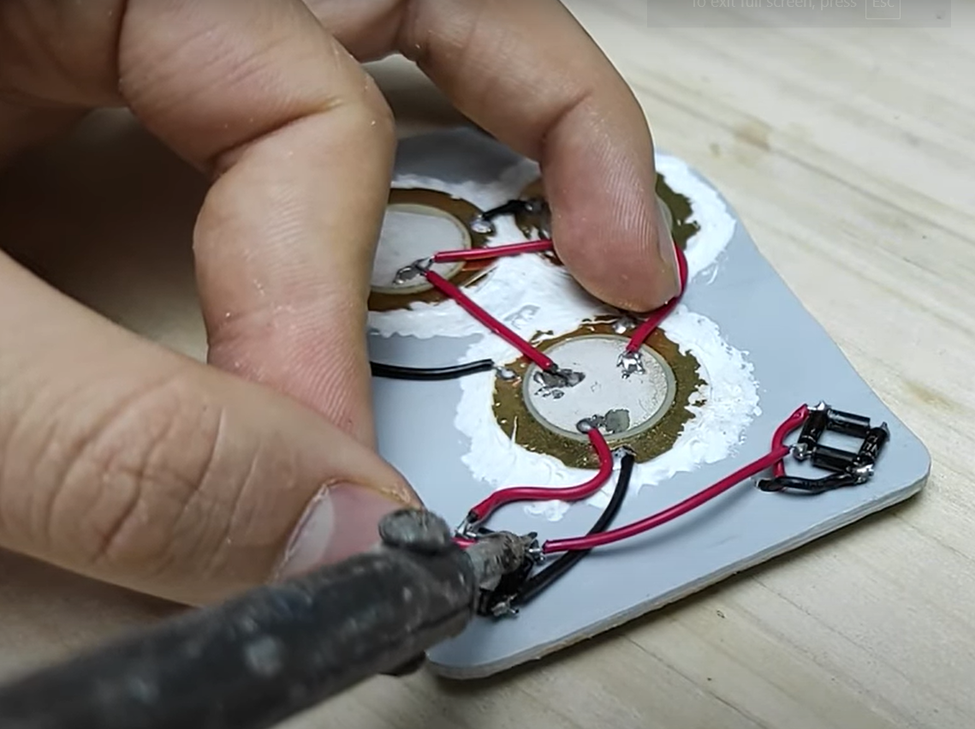

This picture depicts the construction of piezoelectric shoes. soldering red and black wires to piezoelectric discs mounted on a flat surface. These discs are likely part of a system designed to harvest energy from the mechanical stress generated by walking, converting it into electrical energy. The soldering connects the piezoelectric elements, ensuring the electrical circuit is properly formed for energy collection and utilization.

**RESULTS**

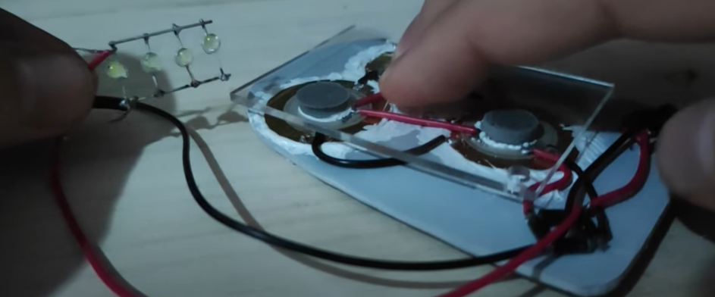

This picture shows the setup of the piezoelectric shoe project before applying pressure to the sensors. The piezoelectric discs are connected to an array of LEDs via red and black wires. The LEDs are not lit, indicating that no pressure has been applied yet to generate electrical energy from the piezoelectric elements. This stage demonstrates the circuit connections and the expected output components, which will light up when mechanical stress is applied to the sensors, converting it into electrical energy.

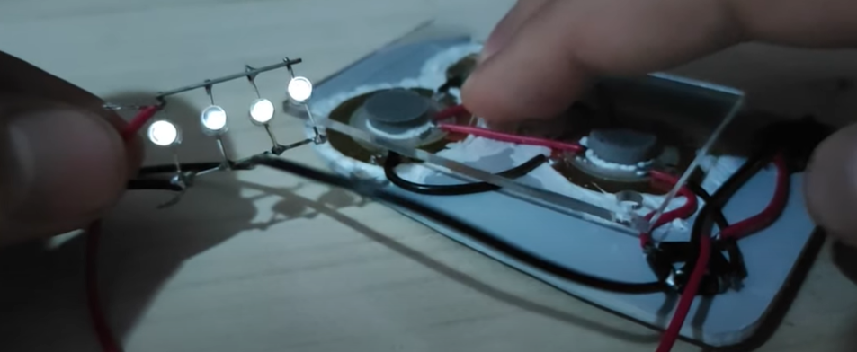

The image shows an arrangement where LEDs are being powered by a piezoelectric device. When pressure is applied to the piezoelectric elements, they generate an electric charge, which then powers the LEDs, causing them to light up. This is a demonstration of how piezoelectric materials can convert mechanical energy (pressure) into electrical energy.

# 

# Screenshot 2024-07-06 162005

# The image displays a multimeter reading 38 volts, produced by piezoelectric shoes. These shoes generate electricity through the piezoelectric effect, converting the mechanical pressure from walking into electrical energy. The substantial 38-volt output highlights the effectiveness of the piezoelectric material used, making these shoes suitable for energy harvesting applications such as powering small devices or sensors.

# CONCLUSION

In conclusion, piezoelectric shoes represent a transformative innovation poised to revolutionize both wearable technology and sustainable energy solutions. By harnessing the mechanical energy generated during walking or running, these shoes can effectively convert kinetic energy into electrical power, powering small electronic devices such as fitness trackers, smartphones, and more. This integration not only enhances the functionality and convenience of wearable devices but also promotes environmental sustainability by reducing reliance on conventional power sources and minimizing electronic waste.

The development of piezoelectric shoes is driven by ongoing advancements in materials science, electronics, and design, aimed at optimizing energy conversion efficiency and user comfort. As these technologies evolve, piezoelectric shoes hold the potential to become a mainstream solution for energy harvesting, offering a practical and unobtrusive way to generate electricity from everyday activities.

Moreover, the adoption of piezoelectric shoes extends beyond personal electronics, with implications for various sectors including healthcare, military, and industrial applications. From powering medical devices for continuous health monitoring to enhancing operational capabilities in remote environments, the versatility of piezoelectric footwear opens doors to innovative solutions that improve quality of life and operational efficiency.

Looking forward, continued research and development will be key in overcoming challenges and refining the performance of piezoelectric shoes. This includes optimizing durability, scalability, and cost-effectiveness to ensure widespread adoption and integration into diverse environments.

In essence, piezoelectric shoes exemplify the convergence of technology and sustainability, illustrating how everyday actions can contribute to a greener future. As these shoes continue to evolve, they promise to play a pivotal role in shaping a more energy-efficient and environmentally conscious societ

# FUTURE SCOPE

In the coming years, piezoelectric shoes are poised to make significant strides in both technology and application. Researchers and engineers will likely explore new materials and designs aimed at improving energy harvesting efficiency and durability. These advancements will pave the way for more robust and reliable wearable devices that can power themselves through everyday activities.

Moreover, the integration of piezoelectric technology into footwear opens doors to diverse applications beyond personal electronics. Industries such as healthcare could benefit from self-powered medical devices and continuous health monitoring systems. In urban environments, piezoelectric shoes could contribute to smart city initiatives by generating electricity for street lighting and public infrastructure, thereby reducing energy costs and promoting sustainability.

Furthermore, as consumer demand for sustainable products continues to rise, piezoelectric shoes offer a compelling solution by reducing reliance on traditional power sources and minimizing electronic waste. This shift towards energy-harvesting footwear aligns with global efforts to mitigate climate change and create more environmentally friendly technologies.

Overall, the future of piezoelectric shoes is not only about advancing technology but also about fostering a more sustainable and interconnected world. By harnessing the power of movement, these shoes represent a step towards innovative solutions that enhance daily life while minimizing environmental impact

# REFERENCES

# Research paper 1 : Development of a Web-Based Student Internship Portal for Students of Health Colleges

1. Research paper 2: Student Industrial Internship Web Portal
2. Website Front End Design Reference <https://www.geeksforgeeks.org/internship-/>
3. HTML and CSS Book for help in coding : <https://www.dcpehvpm.org/E-Content/BCA/BCA-II/Web%20Technology/the-complete-reference-html-css-fifth-edition.pdf>