# Initial situation

The company has various brochures (approx. 1500) from different suppliers in a physical warehouse and uses its own development in Business Central as warehouse management. No digital documents are stored there and the search function is only available to employees.

The project is primarily about digitizing a management module for brochures and adding the following functions:

* Storage of PDFs in the administration tool
* Access for customers to the PDF brochures and the search function

Thus, an external access to the search function should be guaranteed (for customers) and the digital brochures should be stored and accessible via link.

The images below show the physical warehouse and the current software.

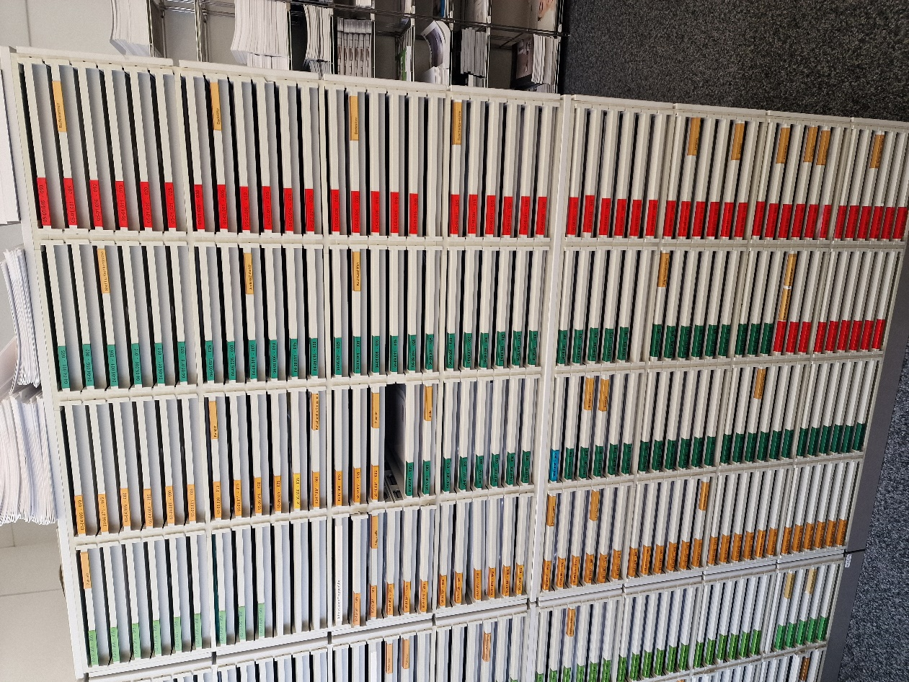

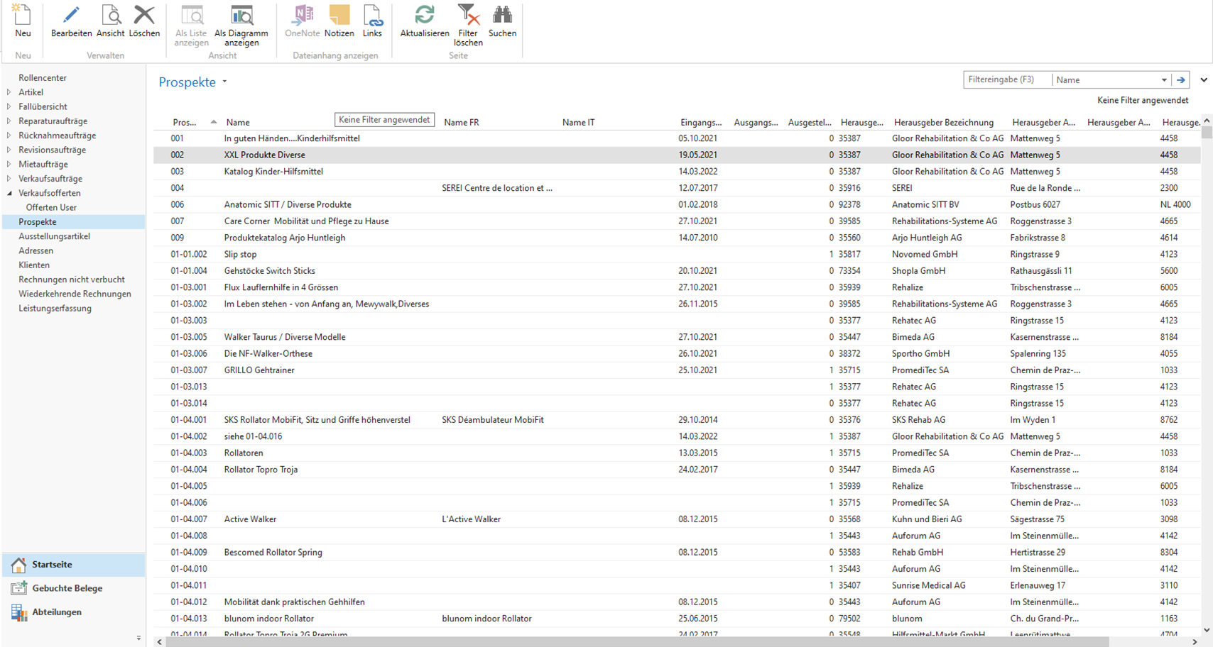

# Actors

## Customer

|  |  |
| --- | --- |
| **Stakeholder** | **Customer** |
| **Position** | Visitors and interested parties, consultants of the company |
| **Role** | Users via web application who use the site |
| **Goals** | Search and download of digital brochures |
| **Knowledge** | No important knowledge |
| **Importance** | medium importance, because they only use the search function of the web application |
| **Influence** | Little influence, as users are not involved in the project |
| **Motivation** | High motivation, as new opportunities are created through digitalization and processes are improved |
| **Comments** | Customers can search and download brochures via the web application |

## Administrators

|  |  |
| --- | --- |
| **Stakeholder** | **Admin** |
| **Position** | Warehouse administrators and possibly advisors of the SAHB |
| **Role** | Users via web application who manage the brochures and use the search function |
| **Goals** | Manage brochures + search and download digital brochures |
| **Knowledge** | Knows all processes and tools related to the brochures |
| **Importance** | High importance, as they use the search function and are responsible for managing the brochures |
| **Influence** | Very high influence, as the administration defines the requirements |
| **Motivation** | Highly motivated, as new opportunities are created by digitalization and processes are improved |
| **Comments** | The administration manages the brochures and the accounts of the administrators in the web application |

# Requirements

## Functional requirements

### UC100User interactions

|  |  |
| --- | --- |
| UC Name | Requirement |
| UC101 Search brochure | The system must offer the customer the possibility to search for the brochures in a list. |
| UC102 Scan QR-Code | The system must offer the customer the possibility to download the linked prospect after scanning the QR code. |
| UC103 Add filters | The system must offer the customer the possibility to filter during the search |
| UC104 Filter by publisher | The system must offer the customer the possibility to filter by publisher |
| UC105 Filter by category | The system must offer the customer the possibility to filter by category and subcategory |
| UC106 Filter by «in showroom» | The system must offer the customer the possibility to filter by "in the showroom". |
| UC107 Sort by | The system must offer the customer the possibility to sort the list |
| UC108 Open brochure | The system must offer the customer the possibility to open / download searched brochures in PDF |

### UC200 Administration

|  |  |
| --- | --- |
| UC Name | Requirement |
| UC201 Login | The system must offer the administrator the possibility to log in and log out |
| UC202 Add new Admin | The system must offer the administrator the possibility to create new administrators |
| UC203 Add new brochure | The system must offer the administrator the possibility to enter brochures |
| UC204 Edit brochure | The system must offer the administrator the possibility to edit brochures |
| UC205 Delete brochure | The system must offer the administrator the possibility to delete brochures |
| UC206 Create QR-Code | The system must offer the administrator the possibility to create QR codes for external access to the brochures |
| UC207 Export brochure-list | The system must offer the administrator the possibility to export the whole or parts of the list as an Excel file |
| UC208 Show old brochure | The system should offer the administrator the possibility to display older brochures in the dashboard. |
| UC209 Edit Admin | The system should offer the administrator the possibility to edit other admins |

## Other Requirements

|  |  |
| --- | --- |
| Languages | Web application should have 3 languages, which can be changed (German, French, Italian) |
| Brochure | Each brochure should have a link that allows you to open the PDF file (also external) |
| Brochure | Upload multiple brochures |
| Admin | Two equal admins not possible |

# Use Cases

## UC100 Benutzerinteraktionen

### UC101 Search brochure

|  |  |  |
| --- | --- | --- |
| **Use Case ID** | **UC101** | |
| **Name** | Search brochure | |
| **Description** | The system must offer the customer the possibility to search for the brochures in a list | |
| **Responsible** | Customer | |
| **Trigger** | User is looking for a brochure | |
| **Preconditions** | - | |
| **Input** | Brochurenumber, Name, Publisher | |
| **Procedure** | **Head** | **Alternative** |
| 1. User goes to the home page |  |
| 1. User clicks on "search" to get to the page |  |
| 1. User enters search term |  |
| 1. User applies filters ("extend" UC103 Add filters) |  |
|  | 1. User opens brochure ("extend" UC108 open brochure) |  |
| **Outputs** | Matching brochures in list | |
| **Post-conditions** | Brochures were found successfully | |

### UC102 Scan QR-Code

|  |  |  |
| --- | --- | --- |
| **Use Case ID** | **UC102** | |
| **Name** | Scan QR-Code | |
| **Description** | The system must offer the customer the possibility to download the linked prospect after scanning the QR code. | |
| **Responsible** | Customer | |
| **Trigger** | Customer is in the showroom and wants to view the digital brochure | |
| **Preconditions** | UC206 QR code has been created | |
| **Input** | - | |
| **Procedure** | **Head** | **Alternative** |
| 1. Customer scans the QR code with a cell phone or tablet. |  |
| 1. Customer opens the file on the device |  |
| **Outputs** | Digital brochure in PDF | |
| **Post-conditions** | Prospectus was successfully downloaded/opened | |

### UC103 Add filters (and UC104, UC105, UC106, UC107)

|  |  |  |
| --- | --- | --- |
| **Use Case ID** | **UC103** | |
| **Name** | Add filters | |
| **Description** | The system must offer the customer the possibility to filter during the search | |
| **Responsible** | Customer | |
| **Trigger** | User wants to apply filters during search (UC101) | |
| **Preconditions** | UC101 Customer searches for brochure | |
| **Input** | - | |
| **Generalization** | UC104, UC105, UC106, UC107 | |
| **Procedure** | **Head** | **Alternative** |
| 1. UC101 «Search brochure» |  |
| 1. Customer selects filter |  |
| 1. Customer can apply the following filters |  |
| 3a. UC104 «Filter by publisher» Dropdow🡪n list with Checkbox |  |
| 3b. UC105 «Filter by category» Dropdown list 🡪with Checkbox |  |
| 3c. UC106 «Filter by «in Showroom»» Checkbox🡪 |  |
|  | 3d. UC107 «Sort by» Number, Category, Name, Date, Publisher🡪 |  |
| **Outputs** | Filtered list with brochures | |
| **Post-conditions** | List with brochures was successfully filtered | |

### UC108 Open brochure

|  |  |  |
| --- | --- | --- |
| **Use Case ID** | **UC108** | |
| **Name** | Open Brochure | |
| **Description** | The system must offer the customer the possibility to open / download searched brochures in PDF | |
| **Responsible** | Customer | |
| **Trigger** | User wants to open the prospectus in PDF | |
| **Preconditions** | UC101 Customer has found the brochure | |
| **Input** | - | |
| **Procedure** | **Head** | **Alternative** |
| 1. Customer clicks on "PDF" at the brochure |  |
| 1. Customer opens the file on the device |  |
| **Outputs** | PDF file | |
| **Post-conditions** | Brochure was opened successfully | |

## UC200 Administration

### UC201 Login

|  |  |  |
| --- | --- | --- |
| **Use Case ID** | **UC201** | |
| **Name** | Login | |
| **Description** | The system must offer the administrator the possibility to log in and log out | |
| **Responsible** | Admin | |
| **Trigger** | Admin wants to log in | |
| **Preconditions** | - | |
| **Input** | Email & Password | |
| **Procedure** | **Head** | **Alternative** |
| 1. Admin goes to the homepage |  |
| 1. Admin clicks on «Login» to get to the page |  |
| 1. Admin enters email and password | 3a. Forgot password  3a1. Ask another admin for a change  3a2. «UC209 Edit Admin» |
| 1. Admin is redirected to the «Dashboard» page |  |
|  |  |  |
| **Outputs** | - | |
| **Post-conditions** | Admin is successfully logged in | |

### UC202 Add new Admin

|  |  |  |
| --- | --- | --- |
| **Use Case ID** | **UC202** | |
| **Name** | Add new Admin | |
| **Description** | The system must offer the administrator the possibility to create new administrators | |
| **Responsible** | Admin | |
| **Trigger** | A new admin wants to be added | |
| **Preconditions** | UC201 Login Admin is successfully logged in🡪 | |
| **Input** | First name, last name, e-mail, password | |
| **Procedure** | **Head** | **Alternative** |
| 1. Admin logs in («include» UC201 Login) |  |
| 1. Admin goes to «Users» |  |
| 1. Admin enters first name, last name and email and creates a new password |  |
| 1. Admin clicks on «add new User» |  |
| **Outputs** | Admin «Name» has been added successfully | |
| **Post-conditions** | New admin has been added | |

### UC203 Add new Brochure

|  |  |  |
| --- | --- | --- |
| **Use Case ID** | **UC203** | |
| **Name** | Add new brochure | |
| **Description** | The system must offer the administrator the possibility to enter brochures | |
| **Responsible** | Admin | |
| **Trigger** | Admin would like to enter new brochures | |
| **Preconditions** | UC201 Login 🡪 Admin is successfully logged in | |
| **Input** | Brochure data and PDF | |
| **Procedure** | **Head** | **Alternative** |
| 1. Admin logs in («include» UC201 Login) |  |
| 1. Admin clicks on «add Brochure» in the header |  |
| 1. Admin enters all data and inserts PDF |  |
| 1. Admin clicks on «add new Brochure» |  |
| **Outputs** | Brochure has been successfully added | |
| **Post-conditions** | New brochure has been added | |

### UC204 Edit brochure

|  |  |  |
| --- | --- | --- |
| **Use Case ID** | **UC204** | |
| **Name** | Edit brochure | |
| **Description** | The system must offer the administrator the possibility to edit brochures | |
| **Responsible** | Admin | |
| **Trigger** | Admin wants to edit/update brochure | |
| **Preconditions** | UC201 Login 🡪 Admin is successfully logged in | |
| **Input** | Brochure data and PDF | |
| **Procedure** | **Head** | **Alternative** |
| 1. Admin logs in («include» UC201 Login) |  |
| 1. Admin searches for brochure («include» UC101 Search brochure) |  |
| 1. Admin clicks on «Edit» |  |
| 1. Admin edits the information in the table |  |
| **Outputs** | Brochure has been successfully modified | |
| **Post-conditions** | Brochure is modified | |

### UC205 Delete brochure

|  |  |  |
| --- | --- | --- |
| **Use Case ID** | **UC205** | |
| **Name** | Delete brochure | |
| **Description** | The system must offer the administrator the possibility to delete brochures | |
| **Responsible** | Admin | |
| **Trigger** | Admin wants to delete brochures | |
| **Preconditions** | UC201 Login Admin is successfully logged in🡪 | |
| **Input** | - | |
| **Procedure** | **Head** | **Alternative** |
| 1. Admin logs in («include» UC201 Login) |  |
| 1. Admin searches for brochures («include» UC101 Search brochure) |  |
| 1. Admin selects the brochures that should be deleted |  |
| 1. Admin clicks on «delete» |  |
| **Outputs** | Brochures have been successfully deleted | |
| **Post-conditions** | Brochures have been deleted | |

### UC206 Create QR-Code

|  |  |  |
| --- | --- | --- |
| **Use Case ID** | **UC206** | |
| **Name** | Create QR-Code | |
| **Description** | The system must offer the administrator the possibility to create QR codes for external access to the brochures | |
| **Responsible** | Admin | |
| **Trigger** | Admin wants to create QR code with link to the digital brochure | |
| **Preconditions** | UC201 Login 🡪 Admin is successfully logged in | |
| **Input** | - | |
| **Procedure** | **Head** | **Alternative** |
| 1. Admin logs in («include» UC201 Login) |  |
| 1. Admin searches for brochure («include» UC101 Search brochure) |  |
| 1. Admin clicks on «open» in column «QR-Code» |  |
| 1. Admin prints QR code |  |
| **Outputs** | QR code created successfully | |
| **Post-conditions** | QR code has been opened | |

### UC207 Export brochure-list

|  |  |  |
| --- | --- | --- |
| **Use Case ID** | **UC207** | |
| **Name** | Export brochure-list | |
| **Description** | The system must offer the administrator the possibility to export the whole or parts of the list as an Excel file | |
| **Responsible** | Admin | |
| **Trigger** | Admin wants to export list of brochures as Excel | |
| **Preconditions** | UC201 Login 🡪 Admin is successfully logged in | |
| **Input** | - | |
| **Procedure** | **Head** | **Alternative** |
| 1. Admin logs in («include» UC201 Login) |  |
| 1. Admin searches for brochures that should be exported («include» UC101 Search brochure) |  |
| 1. Admin clicks on «export list» |  |
| 1. Downloading list |  |
|  |  |
|  |  |  |
| **Outputs** | List successfully exported | |
| **Post-conditions** | List was exported as Excel | |

### UC208 Show old brochure

|  |  |  |
| --- | --- | --- |
| **Use Case ID** | **UC208** | |
| **Name** | Show old brochure | |
| **Description** | The system should offer the administrator the possibility to display older brochures in the dashboard. | |
| **Responsible** | Admin | |
| **Trigger** | Admin wants to have older brochures displayed | |
| **Preconditions** | UC201 Login 🡪 Admin is successfully logged in | |
| **Input** | - | |
| **Procedure** | **Head** | **Alternative** |
| 1. Admin logs in («include» UC201 Login) |  |
| 1. In the dashboard, the number of brochures is displayed in the «old brochure to check» field (older than 1 Year for example) | 2a. Show list of brochures  2a1. Admin searches for brochures («include» UC101 Search brochure)  2a2. Sort by date (UC109 «Sort by») |
| **Outputs** | - | |
| **Post-conditions** | Old brochures were displayed | |

### UC209 Edit Admin

|  |  |  |
| --- | --- | --- |
| **Use Case ID** | **UC209** | |
| **Name** | Edit Admin | |
| **Description** | The system should offer the administrator the possibility to edit other admins | |
| **Responsible** | Admin | |
| **Trigger** | Admin wants to edit another admin's data | |
| **Preconditions** | UC201 Login 🡪 Admin is successfully logged in | |
| **Input** | First name, Last name, e-mail, password | |
| **Procedure** | **Head** | **Alternative** |
| 1. Admin logs in («include» UC201 Login) |  |
| 1. Click on «Users» |  |
| 1. Click on «Edit» for the admin to be edited |  |
| 1. Customizing Data |  |
| 1. Save |  |
|  |  |  |
| **Outputs** | Admin XY was successfully edited | |
| **Post-conditions** | Admin data has been customized | |

# Use Case Diagram

# Wireframes

## Overview

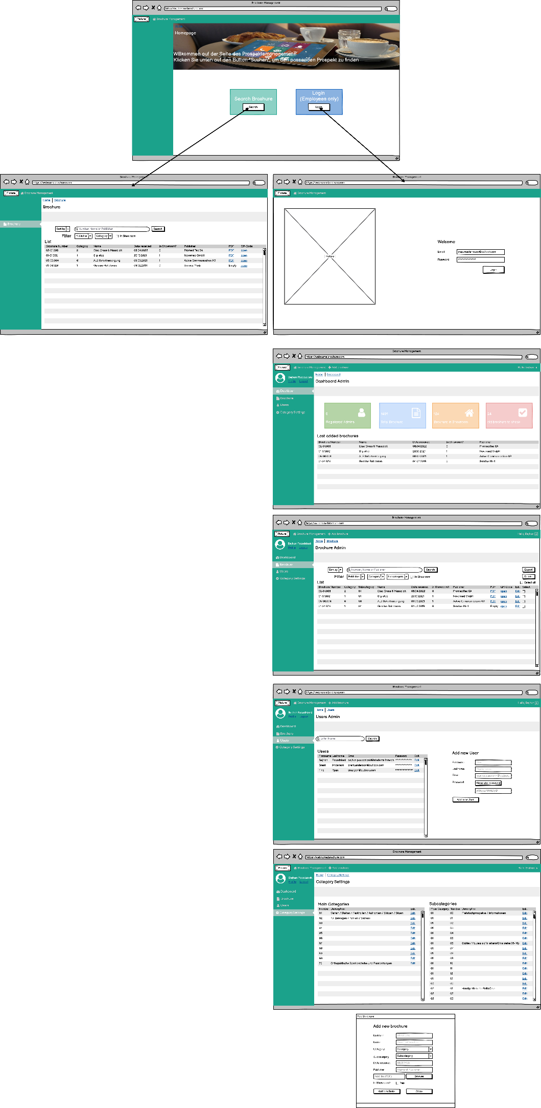

## Home page

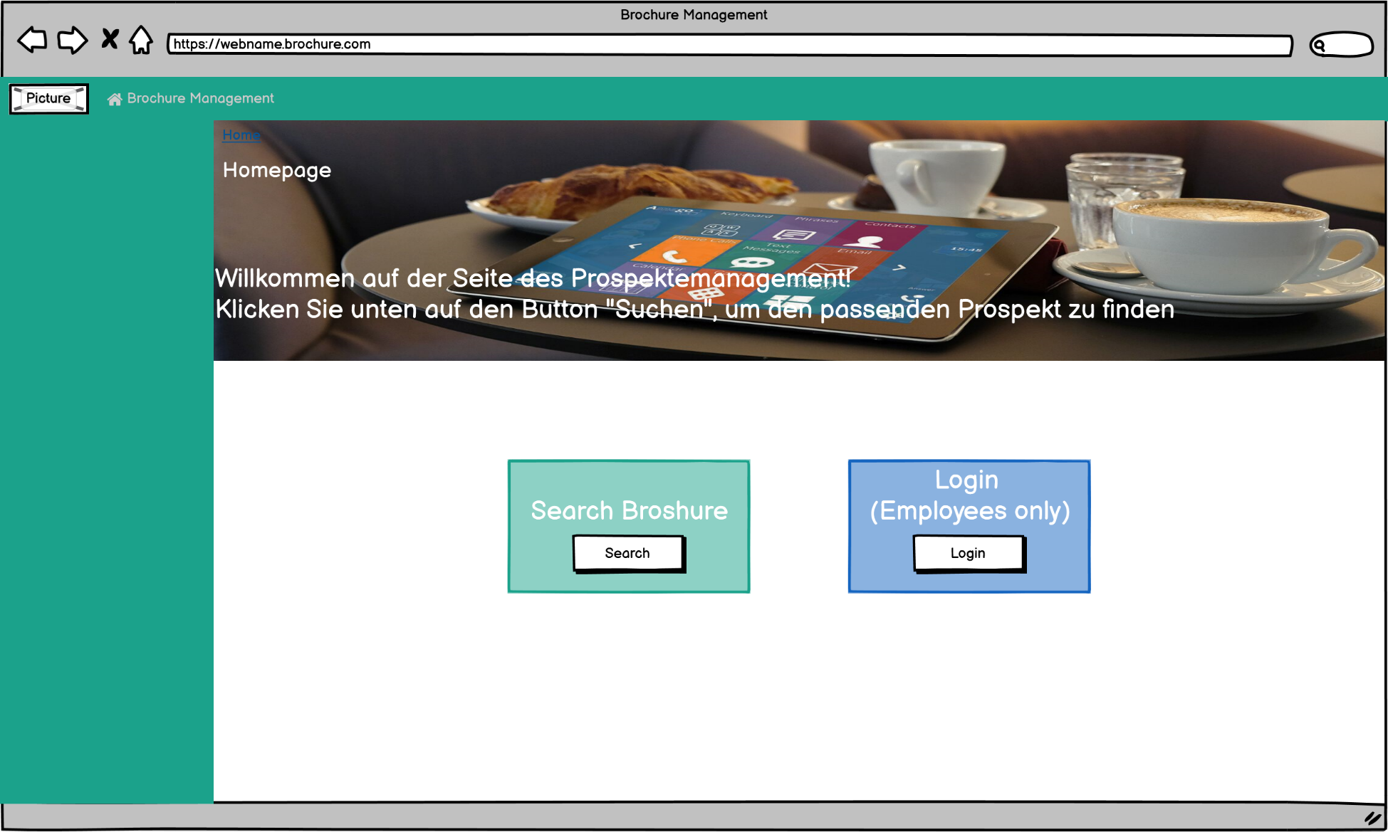

## Customers

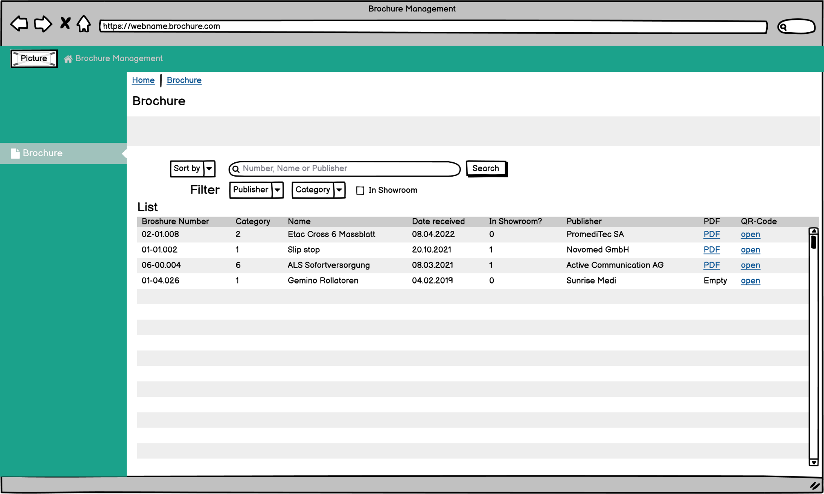

## Administration

### Login Window

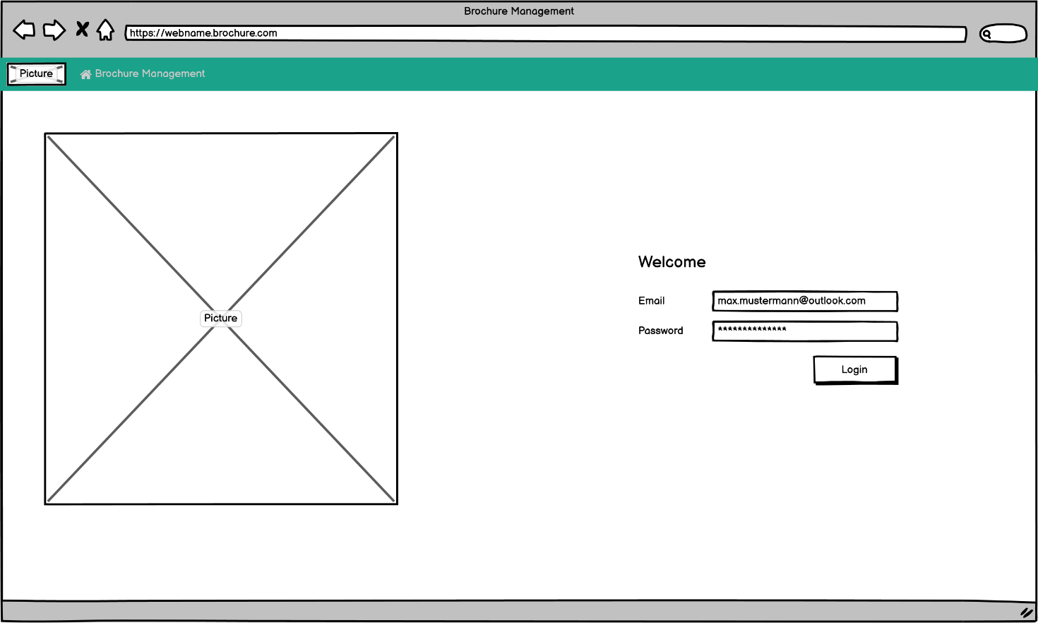

### Dashboard

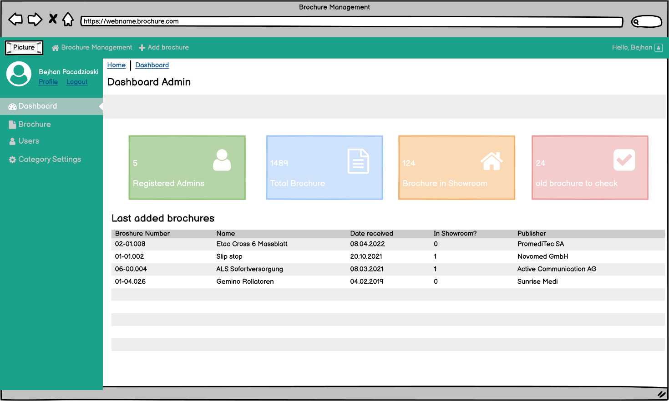

### Brochure search and settings

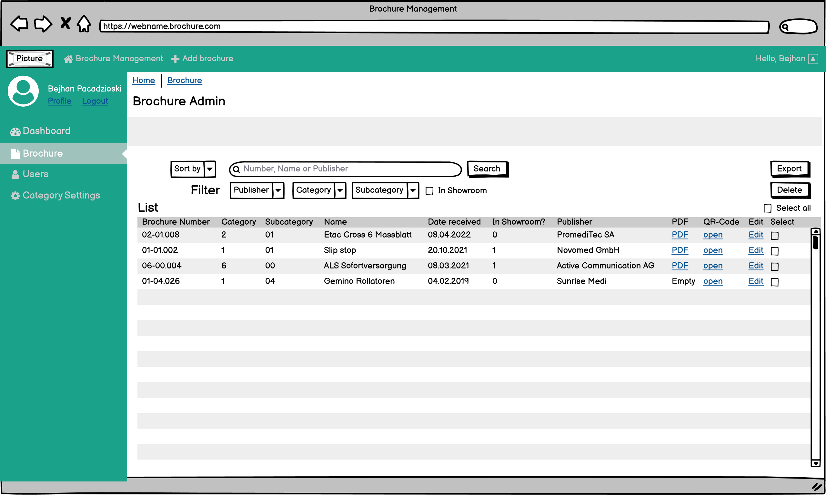

### User settings

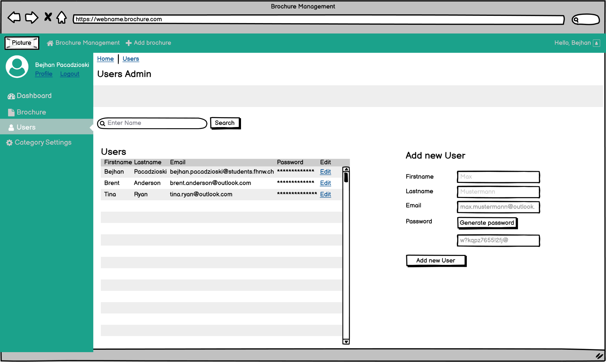

### Category settings

