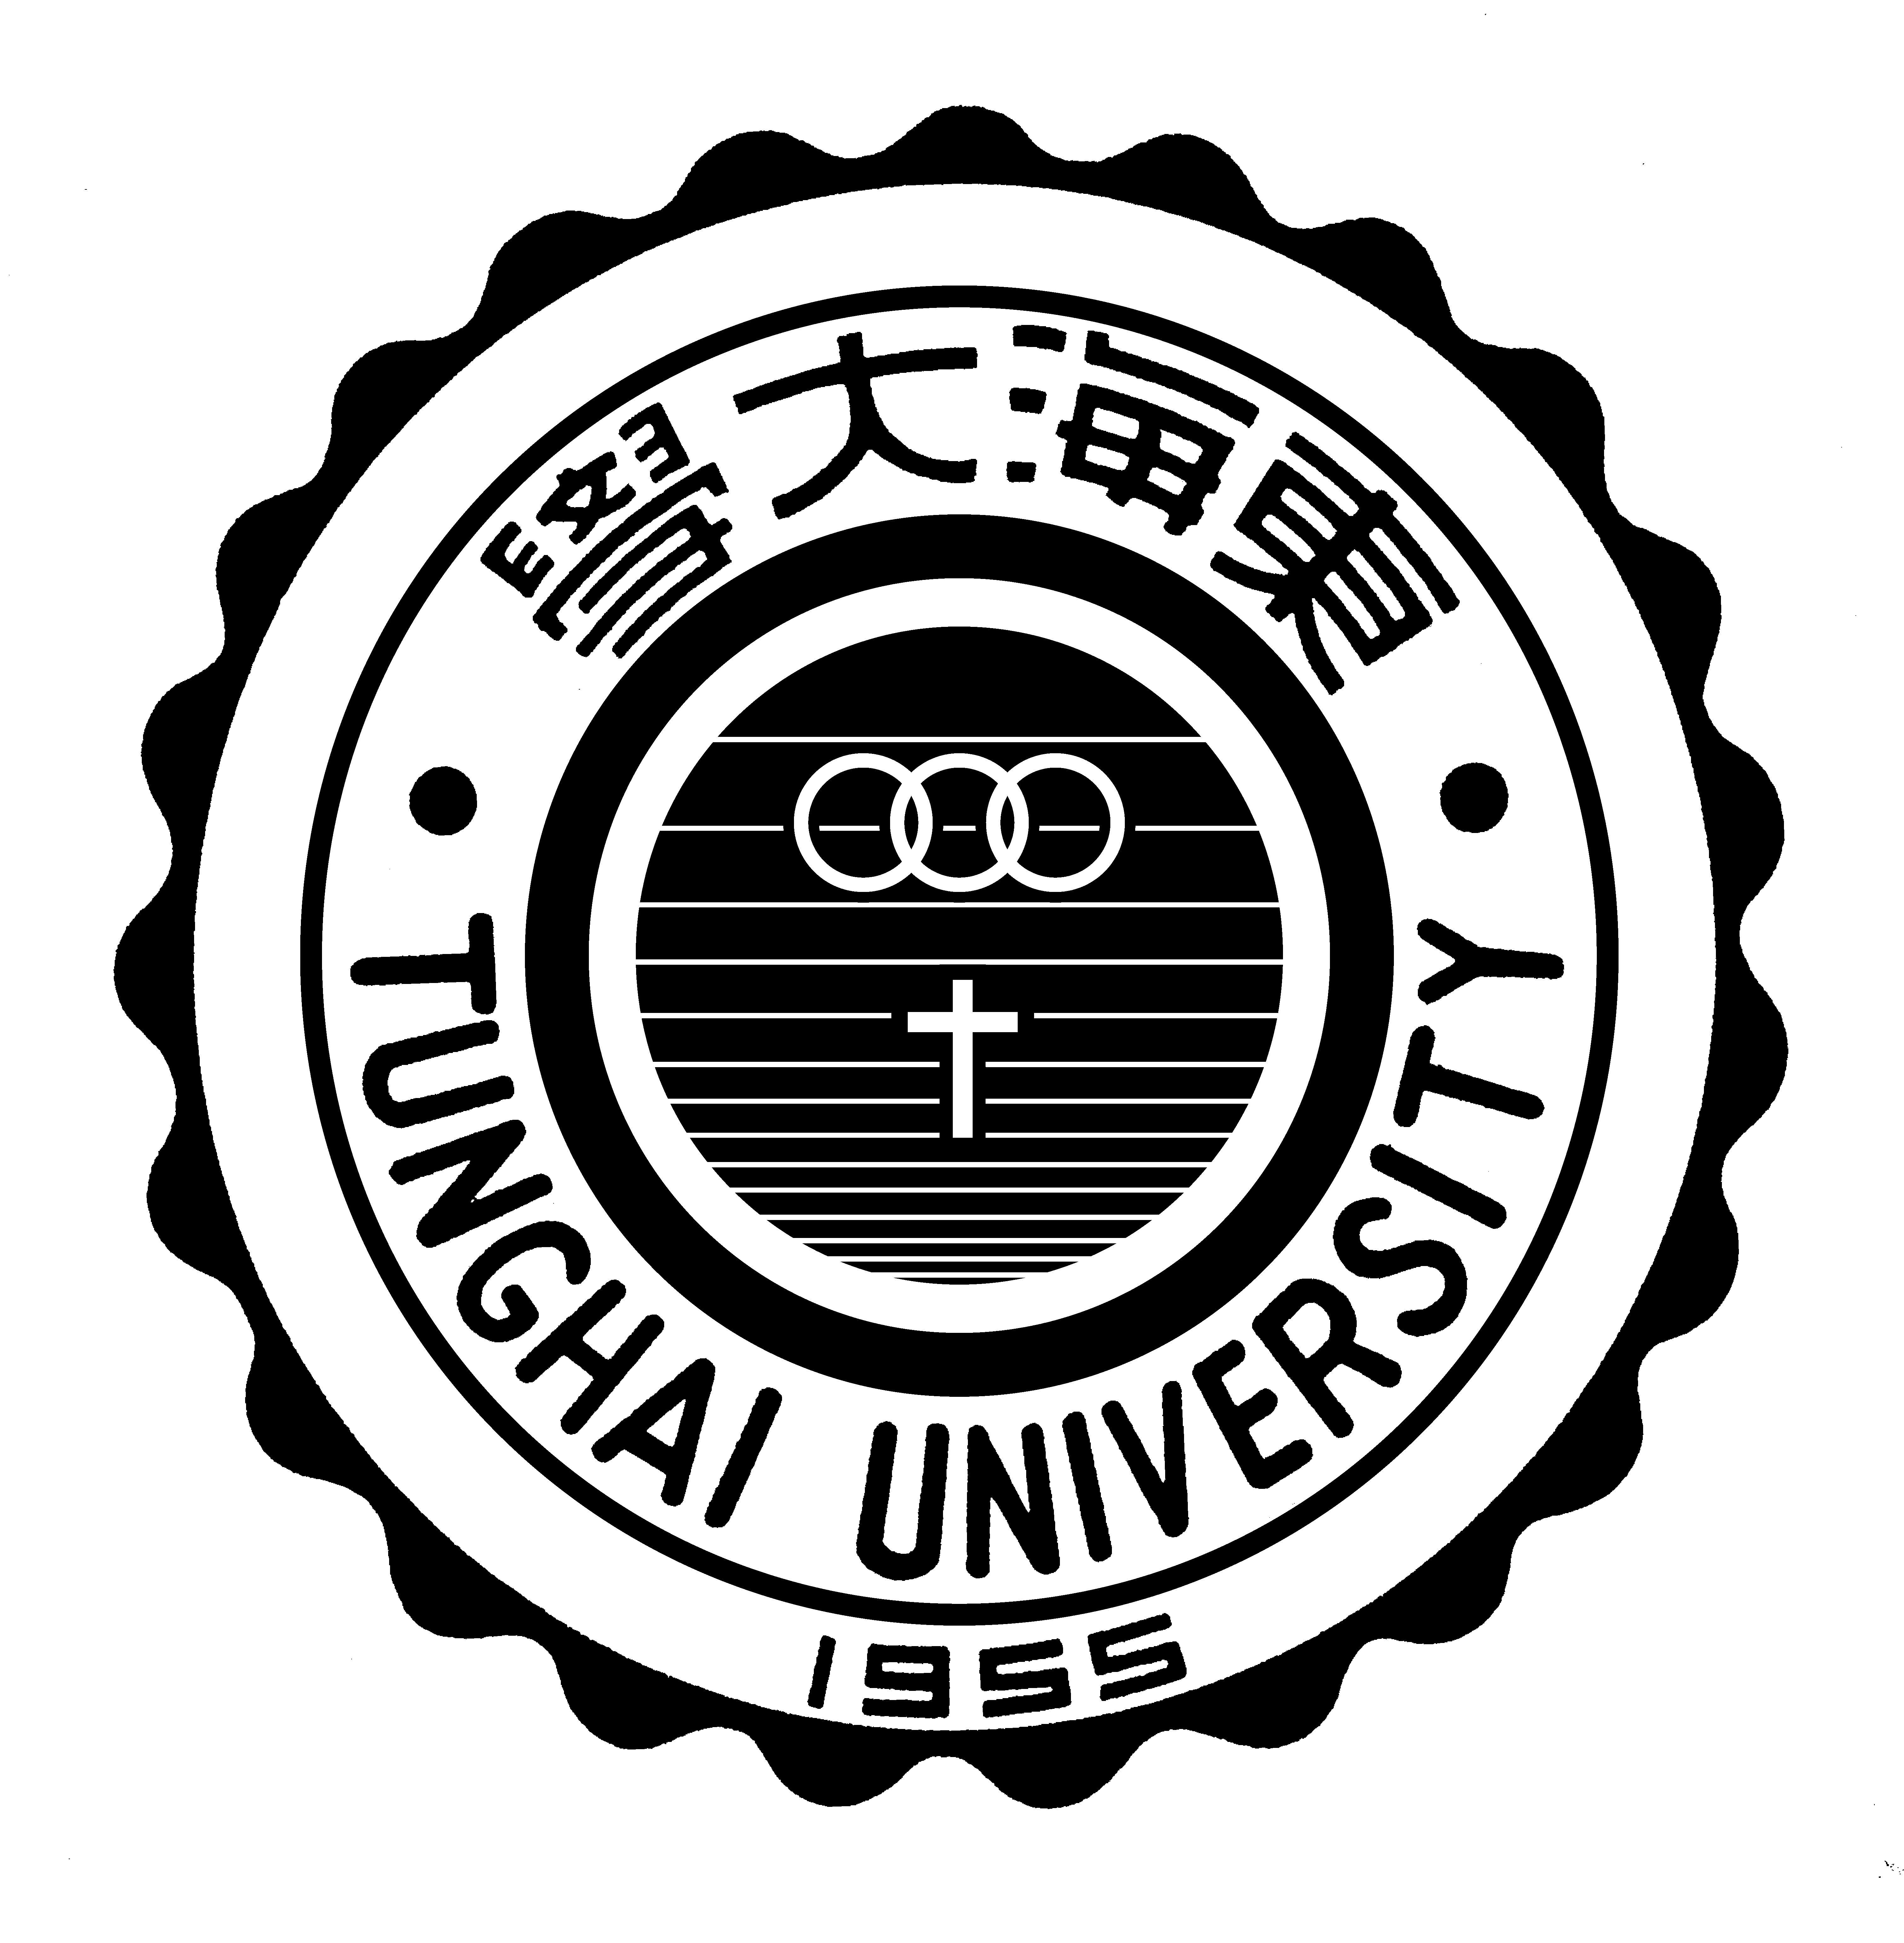
東海大學【長短期交換、雙聯學位計劃】家長(監護人)同意書

敝子弟 ，為貴校 系（所），
年級學生。

本人已確實詳閱本計畫之「推薦資格確認書」。謹此同意敝子弟參加本計畫，並已清楚瞭解計畫相關內容，保證將善盡輔導敝子弟於海外研習期間維護東海大學校譽及遵守東海大學與姊妹校之相關規定。

此致

東海大學

（本同意書確為家長（監護人）親自簽署，如有假冒，願自負一切責任並按校規處置。）

家長（監護人）簽名： 與學生關係 :
緊急連絡電話：
日期： 年 月 日
Tunghai University【Long/Short Term Exchange, Dual Degree Program】Letter of Authorization from Parents/Guardians

I, hereby confirm that (Student Name) is currently enroll in Tunghai University （Department Name） (Grade) Student.

I, hereby confirmed that I have clearly understand the regulation written in the” Confirmation Letter of Qualification” and agree my child to participating in this program. I also hereby confirmed to understand the details of the program and promise to guild my child to obey the regulation of sister school meanwhile maintain the reputation of Tunghai University while study abroad.

(I hereby confirmed this letter is signed by the parents or guardians. Any counterfeit document was found, I shall take my own responsibilities to accept the punishment assign by school according to the school regulations.)

Signature of Parents/Guardians: Relationships:
Emergency Contact Number:
Date: (YYYY/MM/DD)

