PRELAB:

Solder header pins to the RGB led in your kit and wire it into the protoboard as shown below.

**SECTION 1 – Preparing the RGB LED circuit.**

The RGB LED is driven by a constant current driver chip (Ws2801) that receives serial data and stores it in an internal shift register.

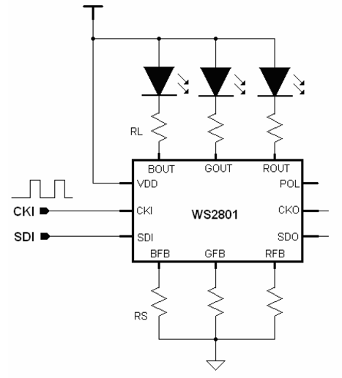 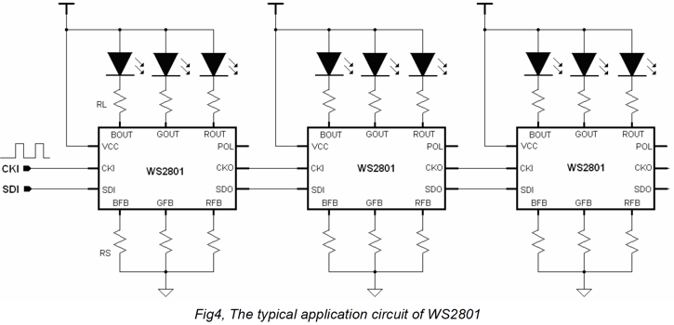

**Procedure:**

1. The RGB LED strip is shown in the picture below. The LED strip is designed to be connected in series so that one serial data line can be used to control hundreds of LEDs and set the color and brightness in each LED to a different value.
   1. The black chip (ws2801) is constant current driver for three LEDs. Note that there is an arrow near the black chip package. Serial data is fed into the SI (Serial In) pin and each data bit is clocked in, one at a time, on the rising edge of the CK (Clock) pin. The serial data into the chip is buffered and sent out to the next LED in the strip.
   2. Three LEDs (RGB) are housed in the white package.
   3. At the top of the picture are solder connection points for passing 5V, ground, serial data and clock signals to the next LED strip.
   4. We will be using just one section of LED strip, but if want to you can connect many LEDs in series.

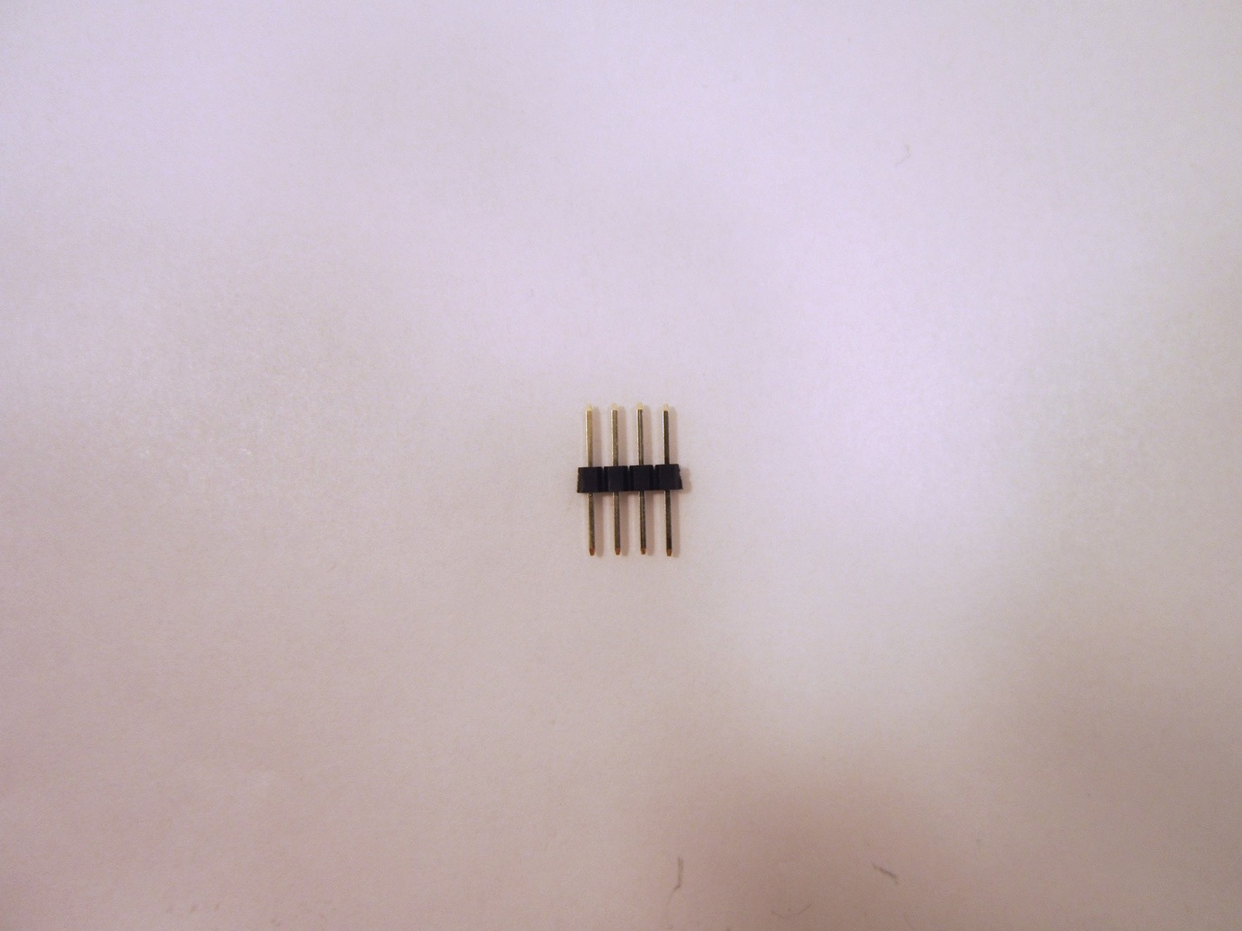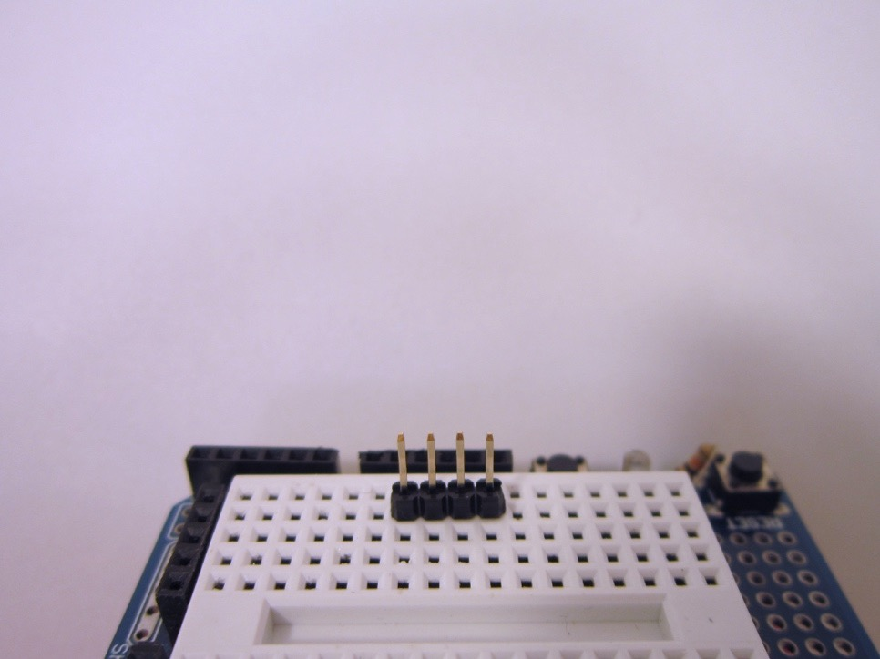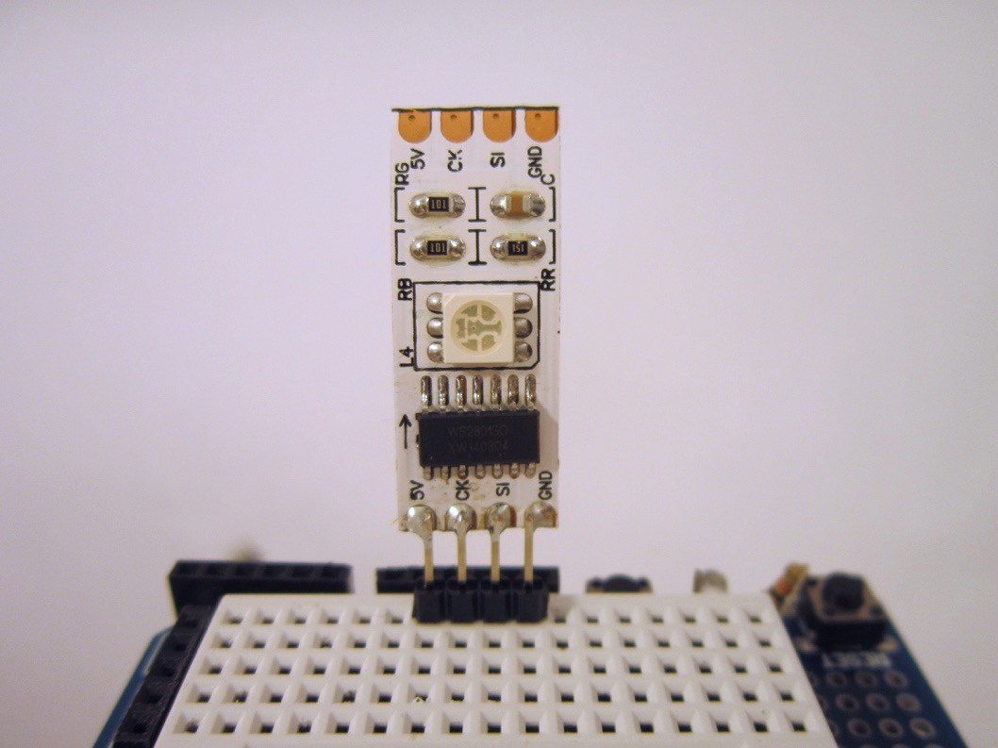

1. Break off a section the header strip that is four pins long. Use the head strip with long pins on each side. These pins will be soldered to the LED strip as shown. Put the header pins into your breadboard to make it easer to solder the LED strip. To solder the LED strip, you may find it helpful to have another person hold the strip while you solder. Start by getting just one pin soldered so that the strip is held in place. Then move on to soldering the other pins.
2. Wire the RGB LED as shown in the figure and in the schematic below. The LED needs 5V and ground. Connect the LED serial data pin SI to Arduino pin 12 and connect the led clock pin CK to Arduino pin 11.

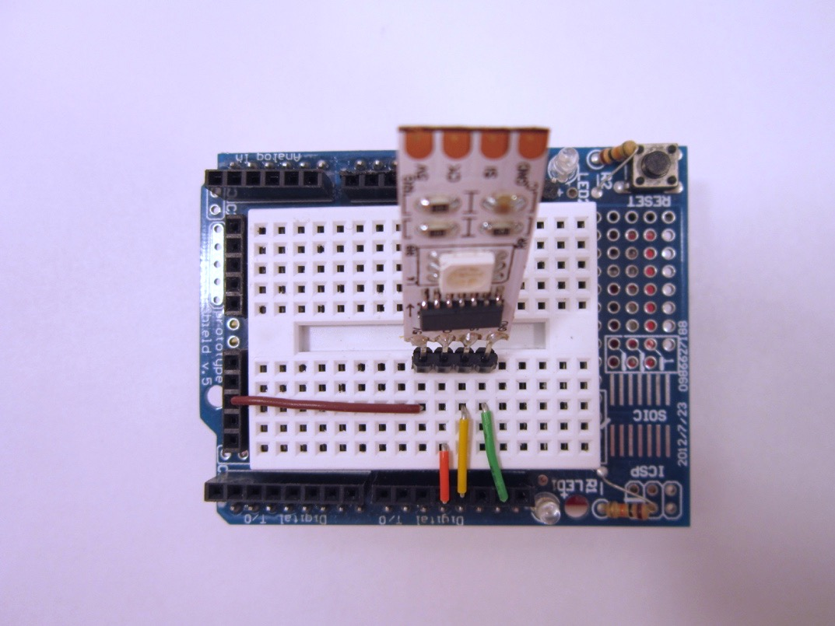

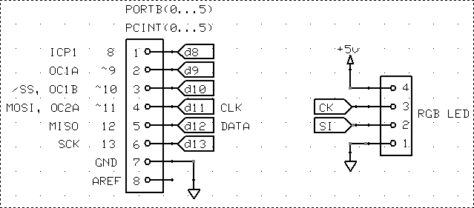

1. Next, add in a switch to ground on digital pin 5 as shown in the schematic below.

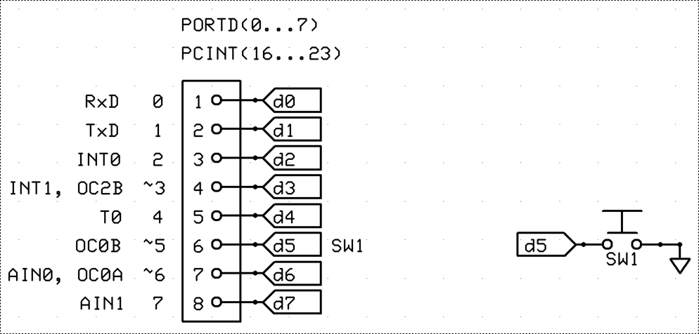

5) Review the datasheet for the LED driver chip WS2801 as posted on myCourses.