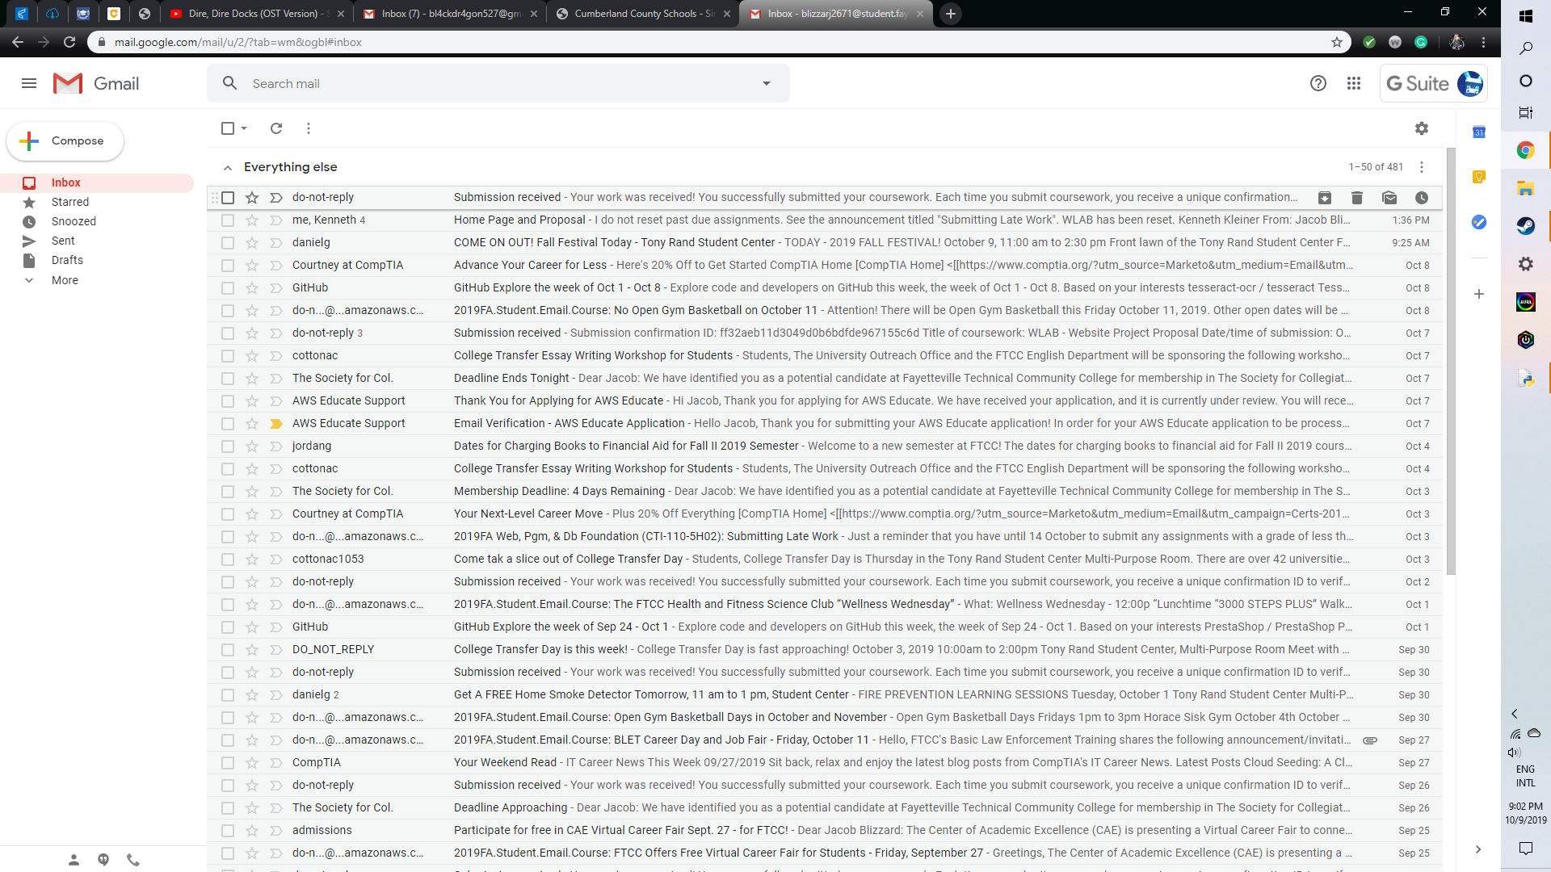

There was no email sent by AWS Educate by 9:21pm, I did what you asked me to do and told you that they didn’t send anything.

-Jacob