* Figure out what the fuck im building?
  + Shell using POSIX system calls
  + Figure out the purpose of a shell? Why is it even a thing?
  + Look at previous shells
    - Korn shell (ksh)
    - TC shell (tcs)
    - Bourne-again shell (bash)
    - Power shell
  + Learn what the dup2(), read(), write(), open(), close()… do
  + Look up libraries
    - 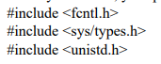
* Tasks
  + 
   