4/26/22 Class

Struggling with OLED and integrating library

4/28/22 Class

Dr. Roberts himself had to help us with OLED

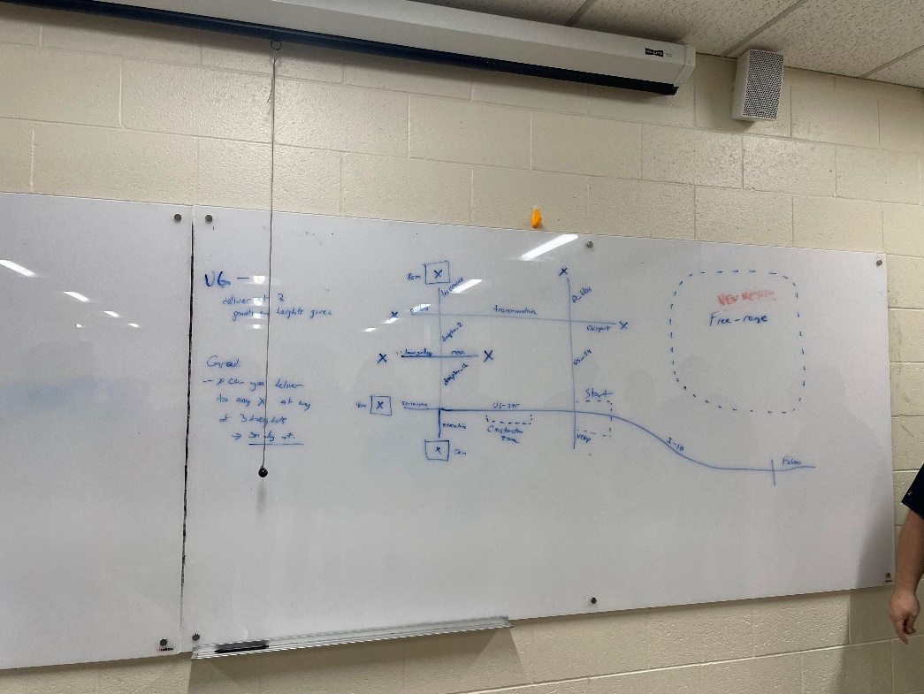

5/1/2022 3:10am – 3:35am

* Write out Algorithms:
  + Place robot facing west
  + Turn around 180
  + Travel on line until intersection
  + Pickup()
    - Sense for pickup
    - Turn around 180
    - Backup
    - Pickup
  + Traveltointersection()
  + If(construction == yes) {go long way}
    - Dropoff8cm()
      * Right turn()
      * Traveltointersection()
      * Left turn()
      * Traveltointersection()
      * Right()
      * Sense & dropoff(int heightcm)
      * ****BACK TO START****
    - Dropoff4cm()
      * Right turn()
      * Traveltointersection()
      * Left turn()
      * Traveltointersection()
      * Left turn()
      * Travel…()
      * Right turn()
      * Sense & dropoff(…)
      * ***CHECK SHORTCUT*** if(available){take it} else{longway}
      * ****BACK TO START****
    - Dropoff0cm()
      * Right turn()
      * Traveltointersection()
      * Left turn()
      * Traveltointersection()
      * Left turn()
      * Travel…()
      * Straight/Continue()
      * Sense & dropoff(…)
      * ***CHECK SHORTCUT*** if(available){take it} else{longway}
      * ****BACK TO START****
  + If(construction == no) {short way}
    - Dropoff0cm()
      * Straight()
      * Traveltointersection()
      * Left()
      * Sense&dropoff()
      * ***CHECK SHORTCUT*** if(available){take it} else{longway}
      * ****BACK TO START****
    - Dropoff4cm()
      * Straight()
      * TraveltoIntersection()
      * Straight()
      * Sense&dropoff()
      * ***CHECK SHORTCUT*** if(available){take it} else{longway}
      * ****BACK TO START****
    - !!!!Dropoff8cm() **same length**
      * Straight()
      * Travel()
      * Right()
      * Travel()
      * Straight()
      * Travel()
      * Straight()
      * Sense&dropoff()
      * !!!!***CHECK SHORTCUT*** if(available){take it} else{longway}
      * !!!!****BACK TO START****
  + Freerange()
    - Spin/Turn/Sense
    - When it senses something (<40cm away) (Has to be closer than the walls)
    - Move 10cm closer slowly
    - Cycle again
    - If(freerange.distance == crane pickup) {pickup()}
* Problems
  + Back to start part, you should have the robot check if there is something in its way before routing back. It could save a lot of time.
    - If it takes the shortcut first, then simply assumes that it goes back with the short cut and construction starts again, then it could fuck up.
    - So once it drops off 4cm & 0 cm, it checks obstruction, then takes the shortcut if good.
  + Free Range pickup?
  + How would we implement a location algorithm?
    - Array [i][j]
    - 0 0  
      0 X  
      0 1
* 5/3/22
* ~5hrs

5/8/22 1:30am – 5:37am

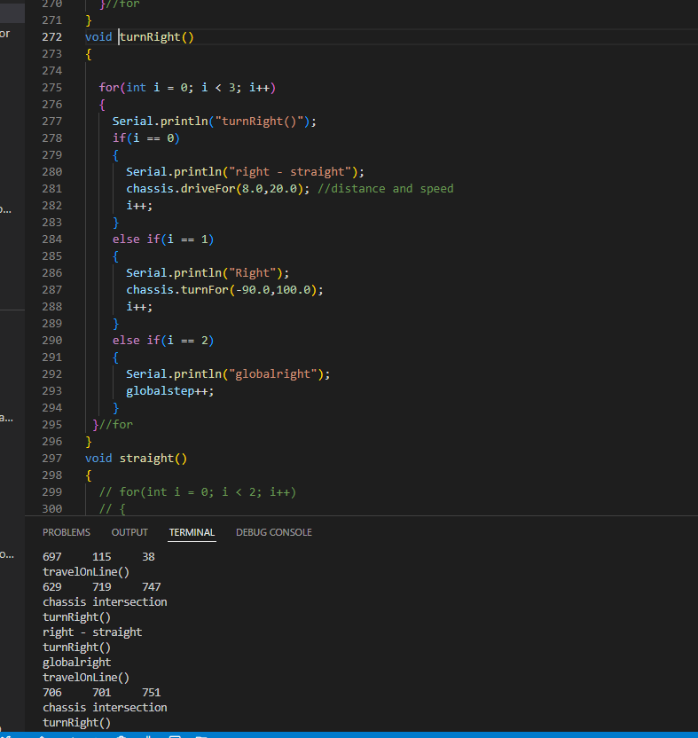

Very solid coding session.

Neext steps, need to focus on the delivery and back to start routes

5/8/22 9:29 pm – 29min

* Goals…
  + Breakdown project
  + Deliever();
  + Pickup();
  + Start();
  + Servo();

Family came back from mothers day party

Friends called

5/9/22 10:00am – 12 pm

While working from home

Plan on combining the deliver and back to start commands into the deliver();

Probably not the best practice but a lot less calls();

Missing the pickup(), free range pickup, and servo dropoff()

5/12/2022 11pm – 1:42am

Figured out a way to combine some commands on the backtostart();

Couldn’t figure out a way to combine all the code. I started making small edits and adjustments

I was thinking in the void loop {}

Case Robot_UBER:

If (DELIVER != NULL

{

}

Else if (START != NULL)

{

}

Else if (Free Range Pickup

{

}

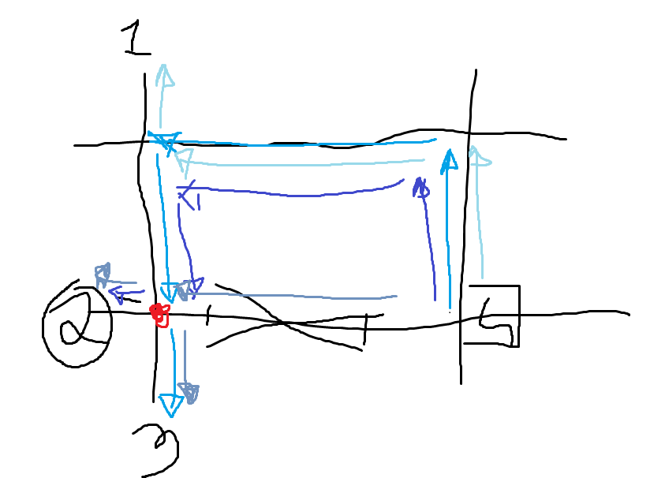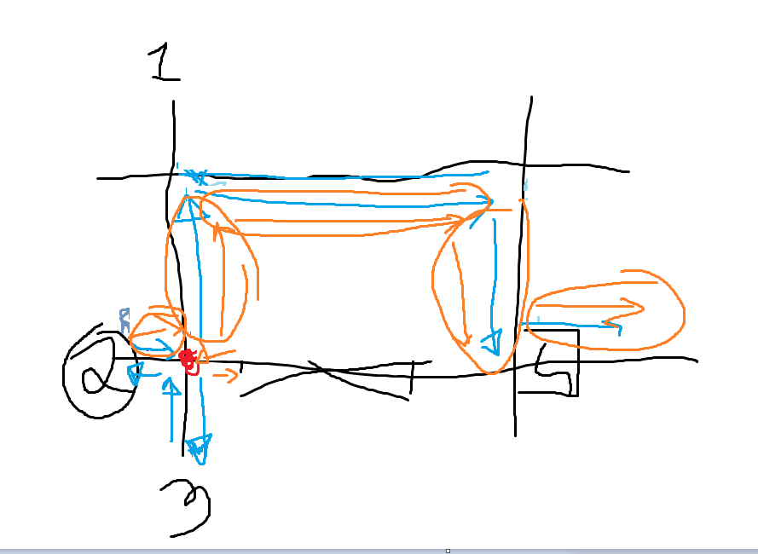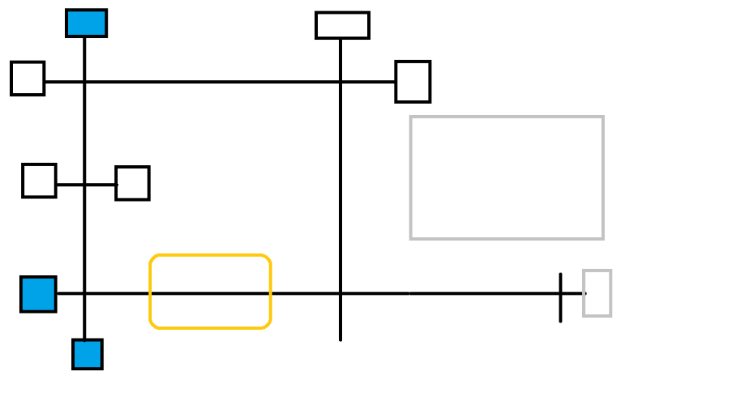

5/12/22 10:00 am – 3:00 pm

Figured out how to make a loop function that steps through and sends the ‘scheduler’ or attention to other functions

Combined the deliver and backtostart into route

Combined the DELIVER and START into UBER_ROUTE ROUTE

* Future project advice:
  + Don’t wait so long to start laying out code
  + Try to look at the code consistently
  + Step up and lead the team
    - Think of it as a project management position
  + KILL THE EGO. YOU CANT DO IT ALL.
  + Coding takes about 2 hrs to ‘breakthrough’ into flow
  + Take silent breaks more often and just breathe while staring at the ceiling.
  + REMEMBER:
    - Don’t panic, break the project down into small goals, then start on the easiest part.
    - DON’T even try to code 5-7 functions, have it autonomous and have everything post in one go.
    - Start with 1 function, and things working off buttons, then 2-5 hours in, you could replace a button with a state, then 5-10hrs you could start manipulating states, 10-15hrs you could start having everything running off pure sensors etc.
  + Don’t try to have the fastest algorithm off the geco.
    - Wasted a lot of time trying to find and work out a CS algorithm
    - Think about small ‘baby’ steps.
  + Buy a whiteboard with pens or carry blank paper
    - Developing code while using Paint was a lot easier!

5/12/2022 5:00pm

* Failed first attempt.
* When integrating code, had a lot of delays from OLED functions
* Struggled with having enough FLASH MEM for OLED “This is Fine” bit map
* Modified platform.ini file, I had copied the wrong info/libraries in it which completely broke the program.
* Second attempt:
  + Was able to navigate and have a displayable location
  + OLED worked and displayed each function
  + Non-usable servo motor
  + 180 turn
  + Was able to go to 3 locations BUT HAD TO USE SHORTCUT to go back.

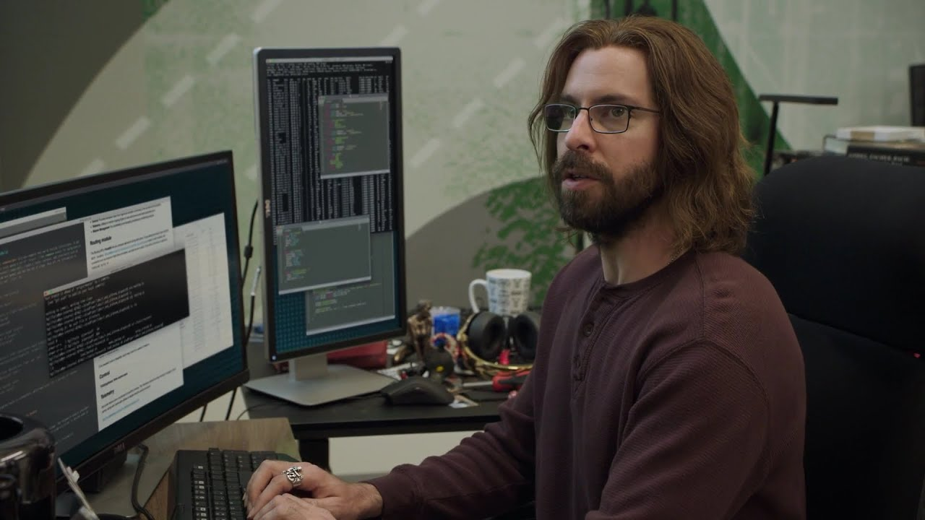

My pronouns are HE/THEM because I will never be HIM [Gilfoyle from Silicon Valley TV show]