1. 步长mu：

|  |  |
| --- | --- |
| 1e-4: |  |
| 1e-5 |  |
| 3e-5 |  |
| 1e-6 |  |
| 2e-6: |  |
| 3e-6 |  |
| 1e-7 |  |
| 2e-7 |  |
| 3e-7 |  |

1月11日（1/5）

问题我用44.1kHz采样率处理，迭代特慢。语音又挺长，导致计算信噪比snr的程序因内存不足出错。

解决办法：应该不是长度的错，是最终生成的增强后语音，没和原始语音统一数据格式

1月12日（2/5）

问题：怎么SNR算出来是负值？加入白噪声测试，SNR值正常，加入混响，SNR就变成负数了？

female1 计算SNR

|  |  |  |  |  |  |  |  |  |  |  |  |  |  |  |  |  |  |  |  |
| --- | --- | --- | --- | --- | --- | --- | --- | --- | --- | --- | --- | --- | --- | --- | --- | --- | --- | --- | --- |
|  | 0.2 | 0.3 |  |  |  |  |  |  |  |  |  |  |  |  |  |  |  |  |  |
| SNR |  |  |  |  |  |  |  |  |  |  |  |  |  |  |  |  |  |  |  |
|  | -18.3568 |  |  |  |  |  |  |  |  |  |  |  |  |  |  |  |  |  |  |
|  | -63.2588 |  |  |  |  |  |  |  |  |  |  |  |  |  |  |  |  |  |  |

=1.4s

mu = 7e-8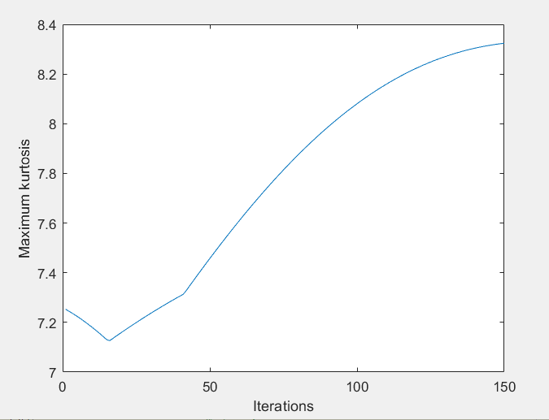

mu = 1e-7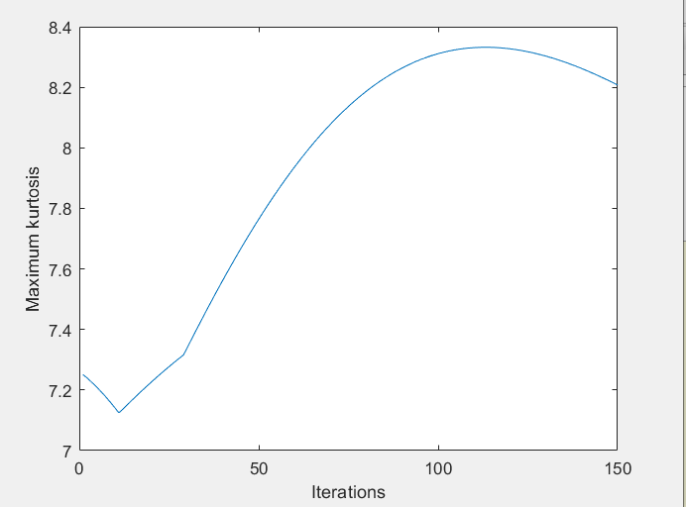

mu = 2e-7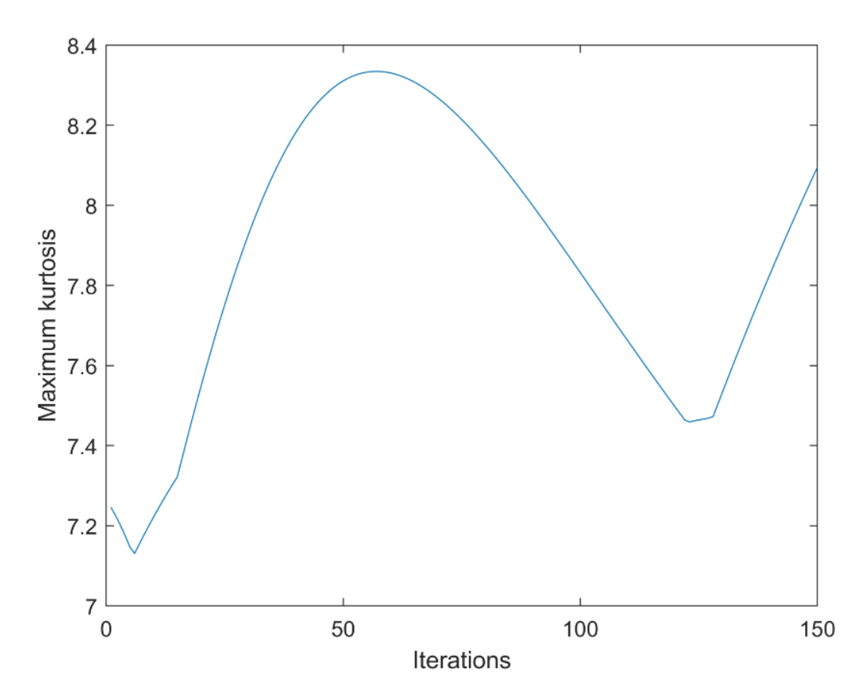

mu = 5e-7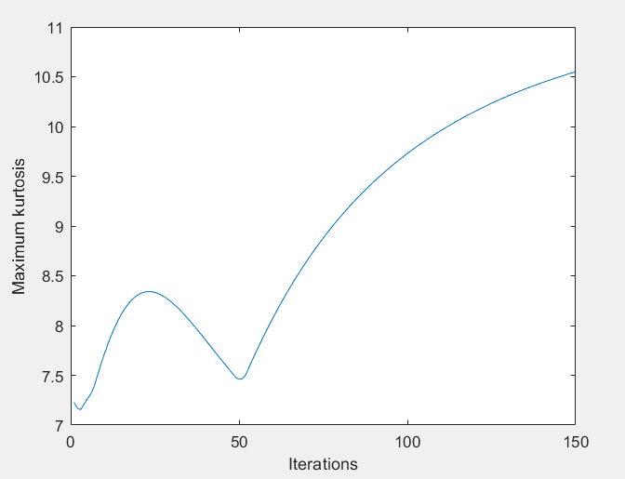

mu = 8e-7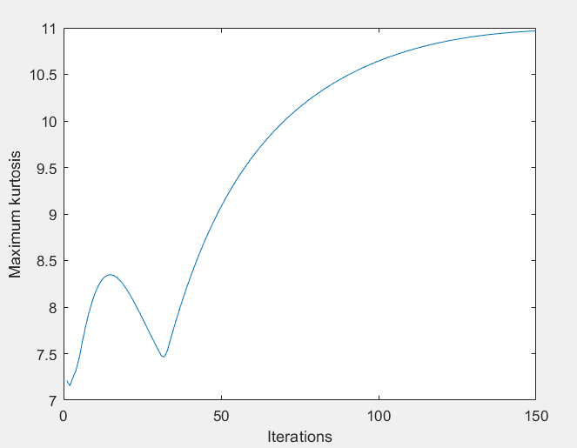

T=0.5s

mu = 8e-7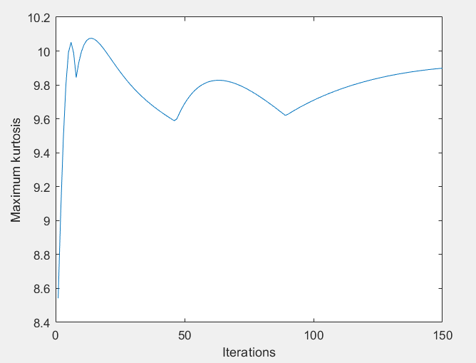

mu = 1e-6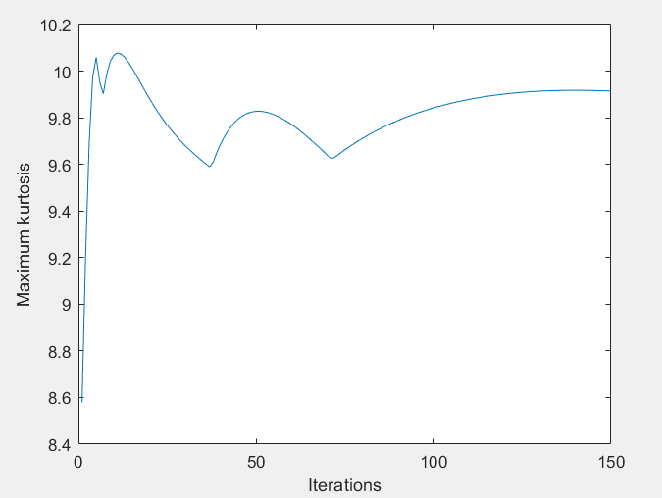

mu = 6e-6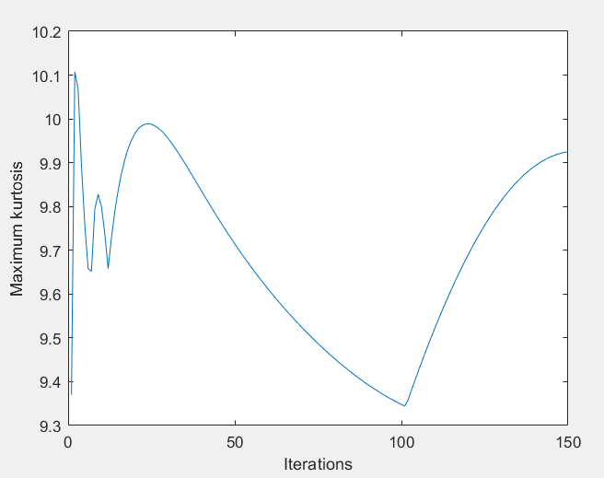

T=0.2s

mu = 1e-6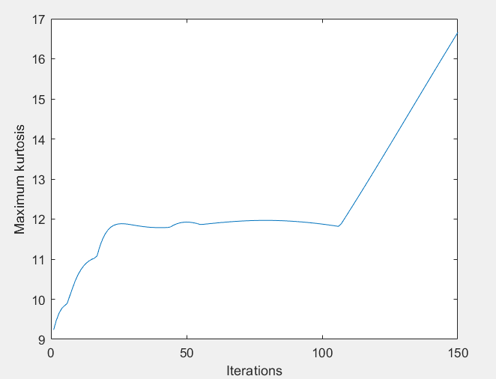

T=1.2s

mu=2e-4 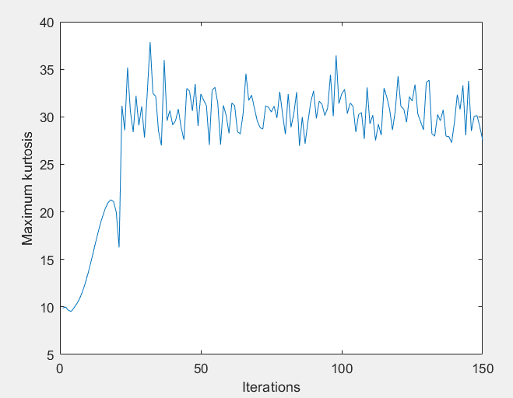

mu = 3e-5 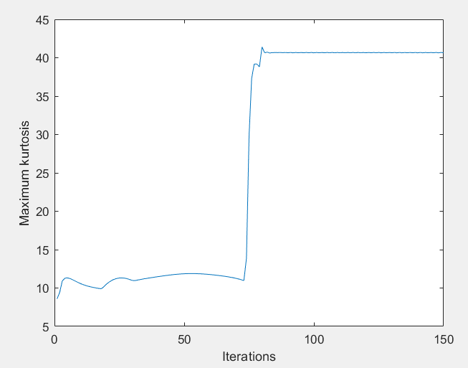

mu = 1e-5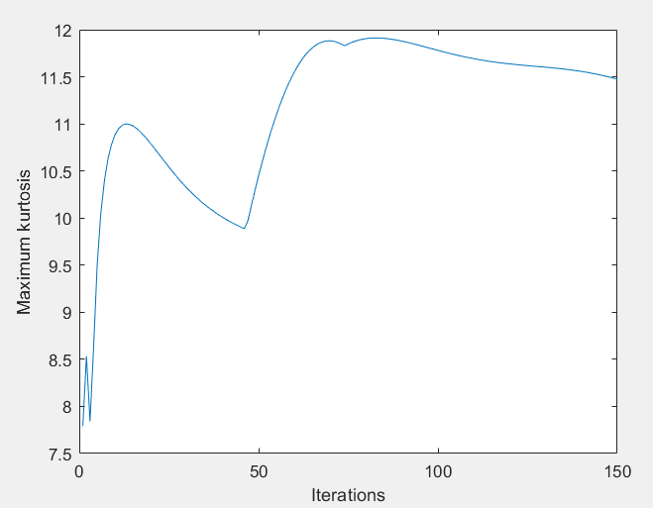

mu = 2e-7 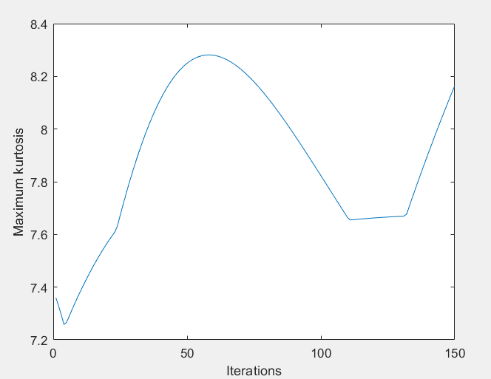

mu = 7e-6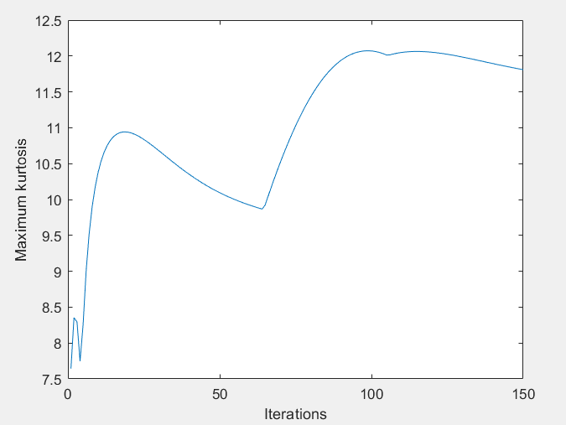

mu = 4e-6 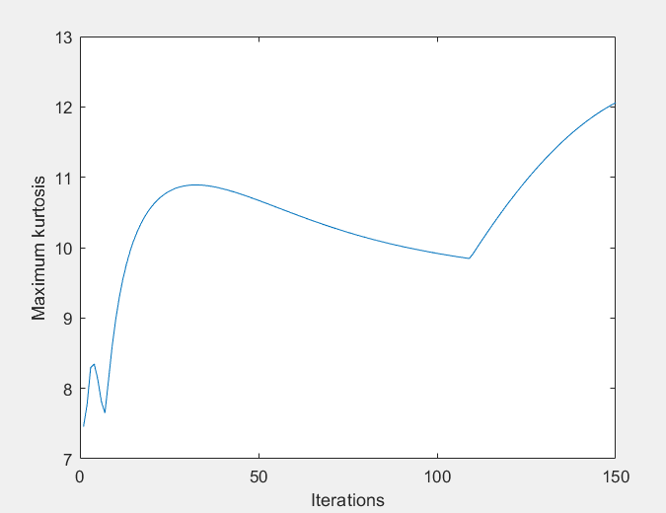

mu =1e-6 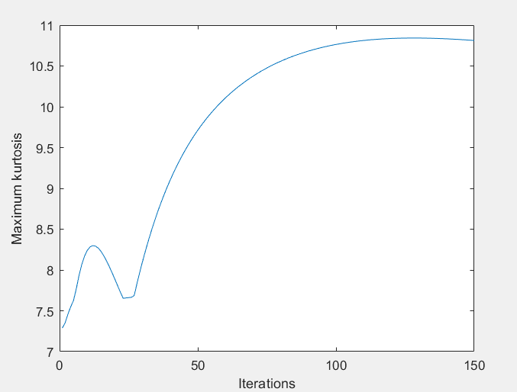

T = 1.3s

mu = 1e-6 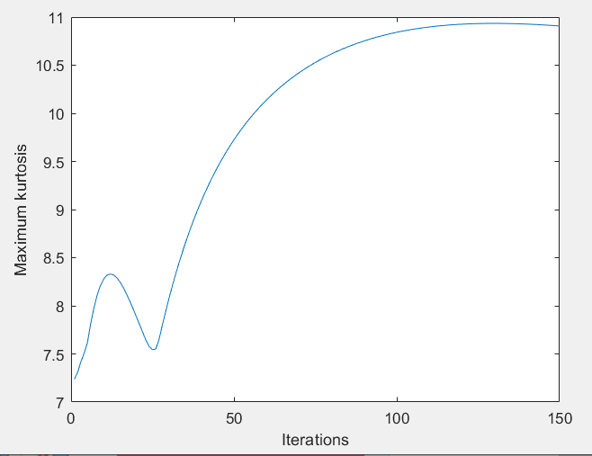

female2 T=0.2s

mu = 1e-6 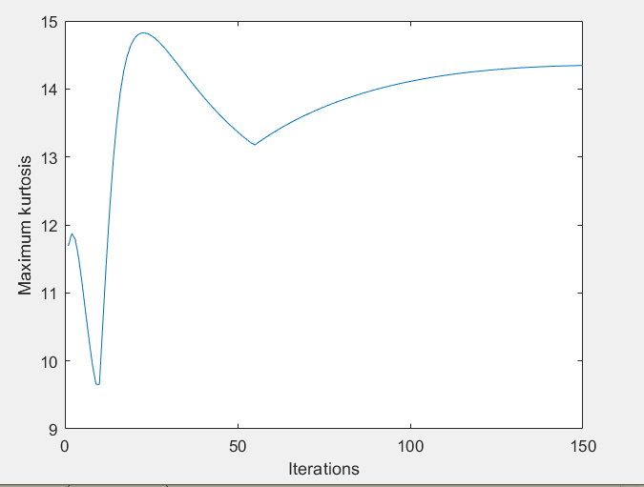

mu = 7e-7 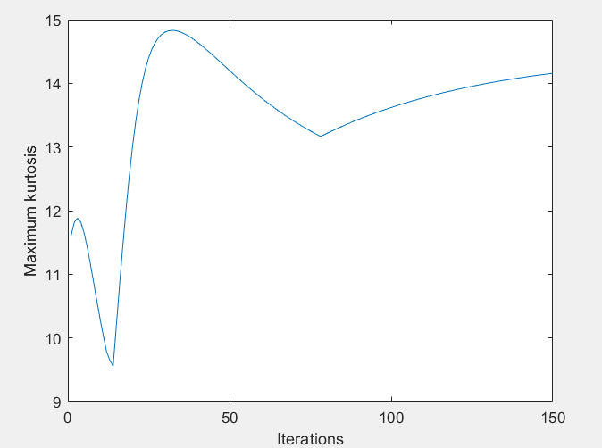

mu = 3e-6 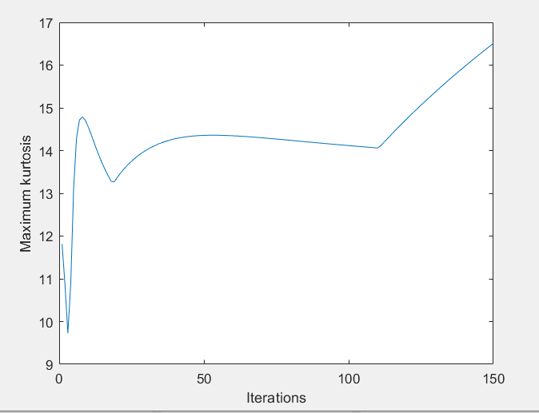

T=0.5

mu = 3e-6 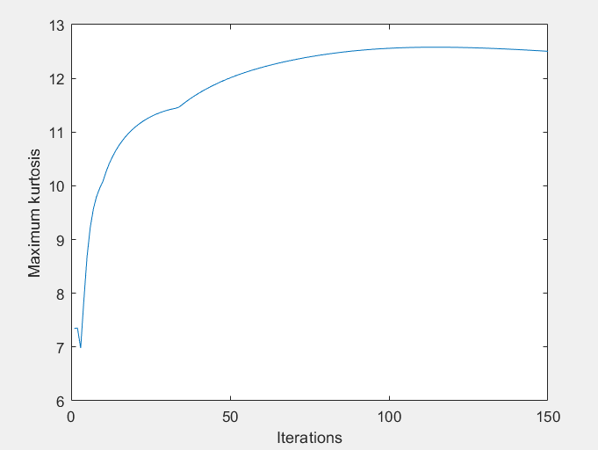

mu = 1e-6 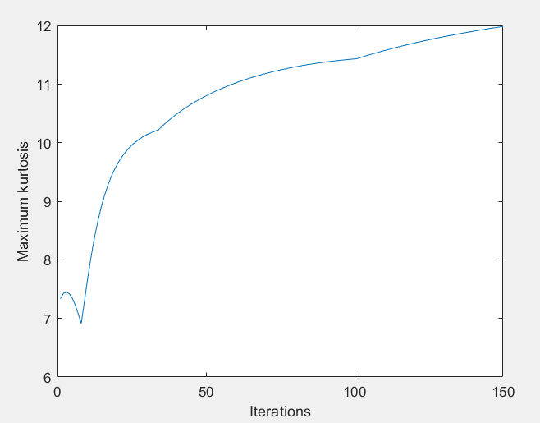

female2 T=0.7s

mu =3e-6 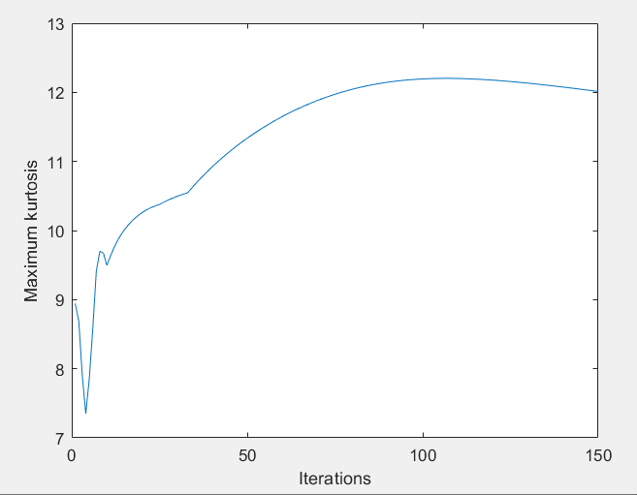

mu=6e-6 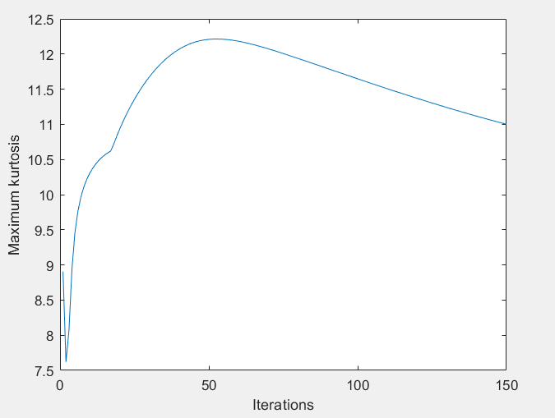

mu = 1e-5 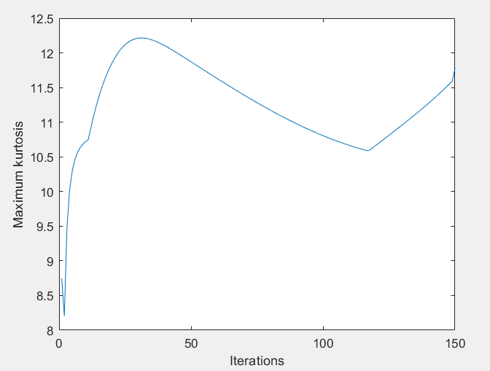

mu = 7e-5 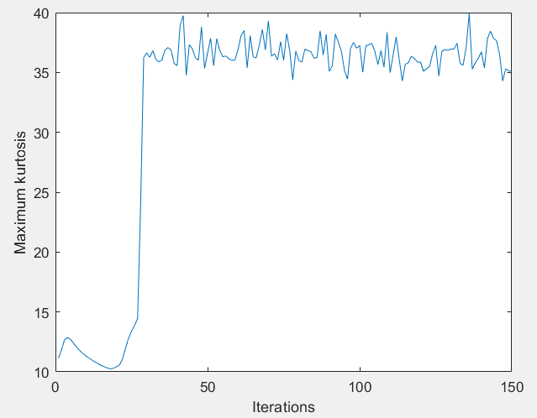

female2 - T=0.8s

6e-6 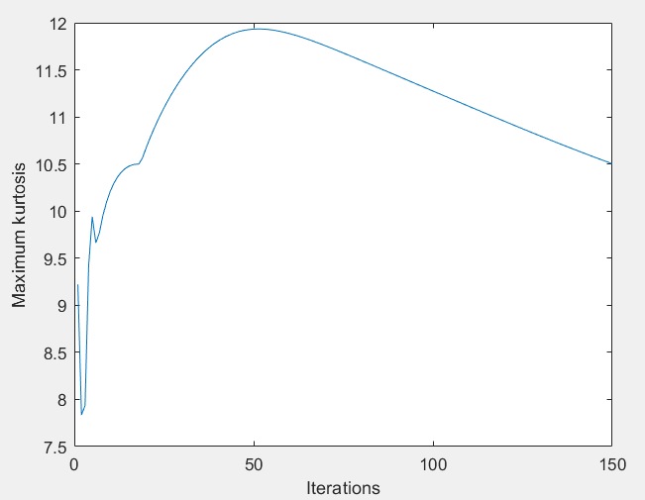

2e-7 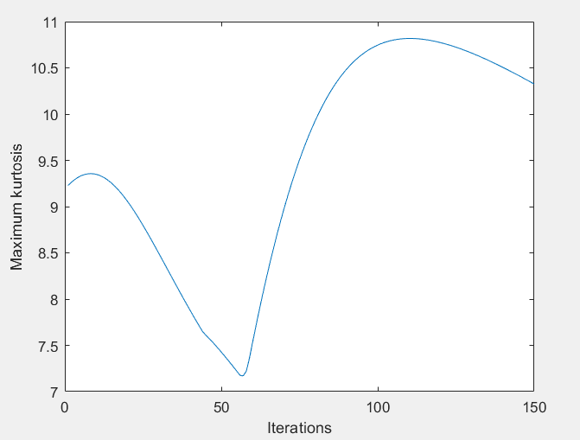

1e-5 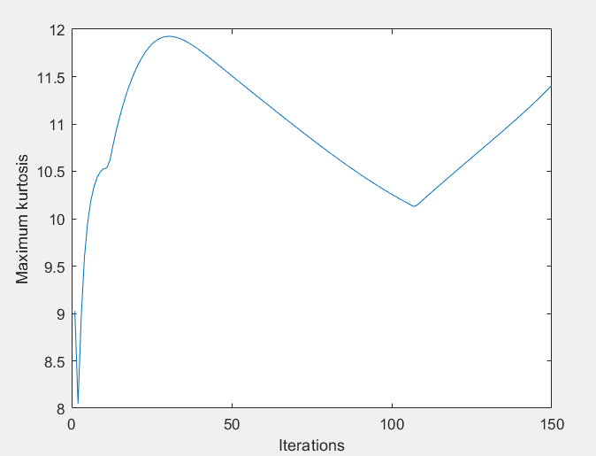

5e-5 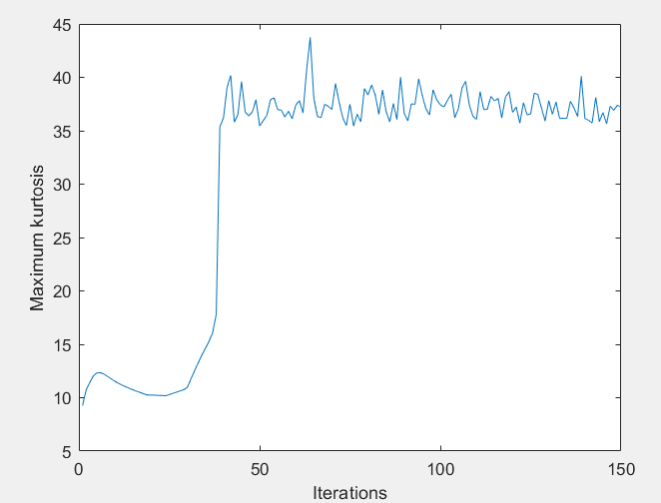

3e-5 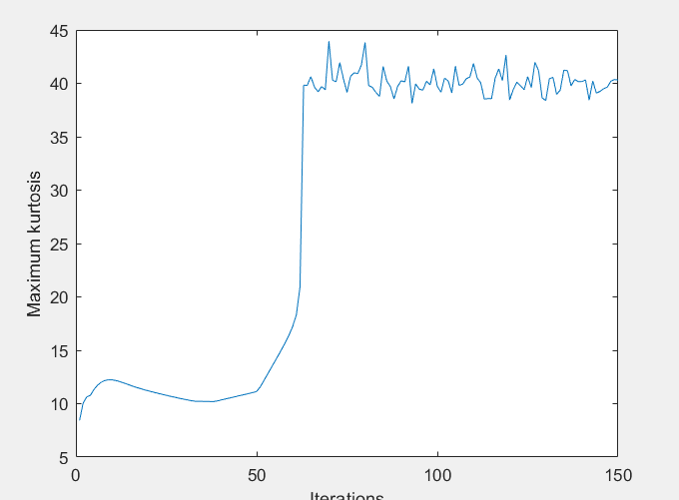

female2 T=1.1s

2e-7 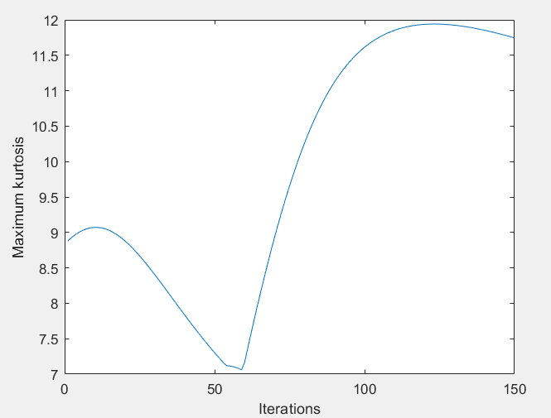

5e-6 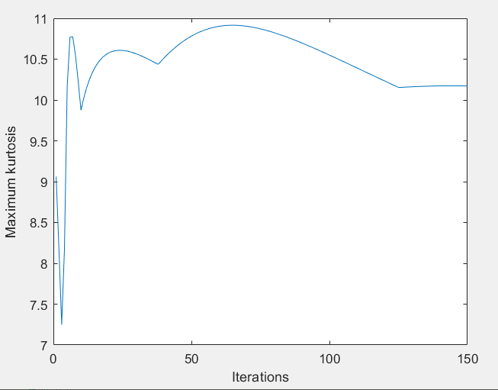

1e-6

1e-5 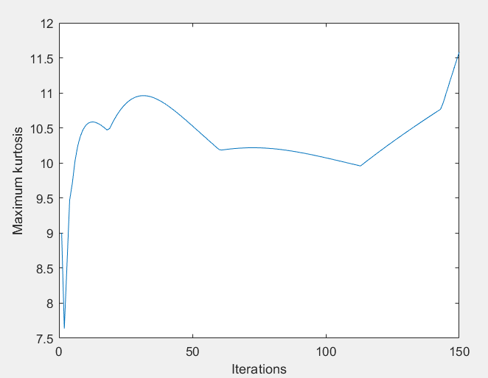

female3

0.2s 4e-6 