Main page displaying Movie list:

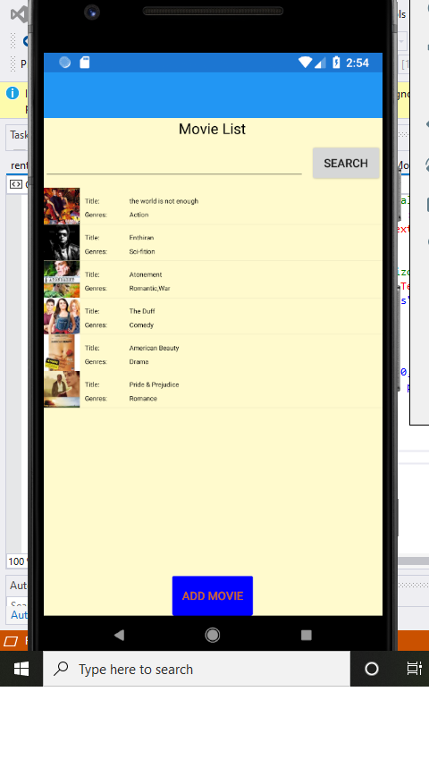

After clicked the movie’s image, it navigates to the Movie’s detail page, which shows the movie’s detail, and allow user to either ORDER the movie by filling personal info or go BACK to the main page:

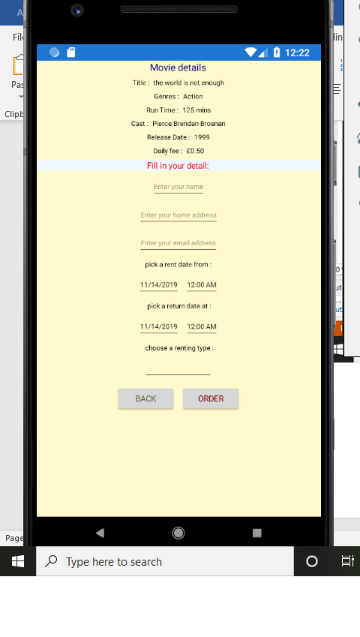

Caution testing, which ensures the input user entered are in correct format or requirements:

* Caution appears when user haven’t fill in all the information required:

* Caution appears when the chosen return date is before start date:

* Caution appears when the name user entered is not in Text format:

After clicked “ORDER” button, it pops up a message to show the order is successfully ,after click “OK”, it navigates to the profile page, which shows user’s order detail, and allow user to go back to the home page by clicking the “GO BACK HOME” button:

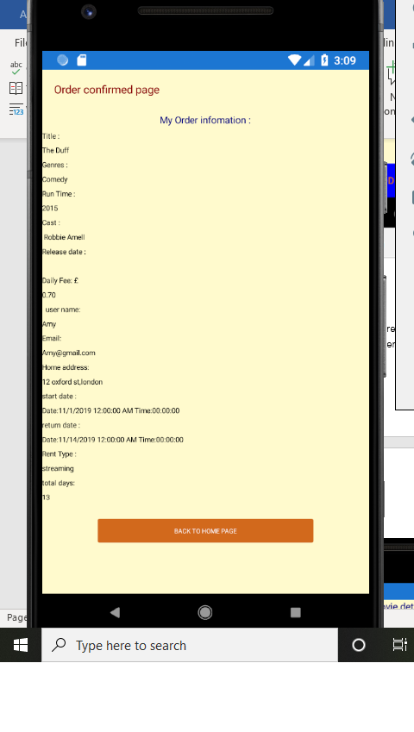

Add Movie detail page:

