**HEALTH CHECK-UP APPLICATION**

**Team Name: Alpha**

**Team Members:**

1. Kishore B
2. Sneha M

**Product Owner: TCS SME**

**Use Case Description:**

Patients at Well care Hospital can schedule an appointment online for a health check-up. Following the patient's appointment, an organisation representative will handle the subsequent steps, and the patient will approve the case in the last step.

**At a high level and with the initial phase I release, this application will:**

1. Allow Patient to apply for health check-up themselves.
2. Allow Patient to map the doctors based on the disease.
3. Allow clinic representative to review the Patient’s details and let to approval or resubmit.
4. Allow Patient to accept or reject the case.

**Application Structure:** Implementation

**Application Name:** WeWellCare

|  |  |  |
| --- | --- | --- |
| **Actors** | **Portals** | **Workbasket** |
| Patient | Patient Portal | NIL |
| Representative | Representative Portal | Representative Workbasket |

**ECS LAYER:**

**WeWellCare**

**Work**

**Data**

**Int**

**Access Group:**

1. WeWellCare:Patient
2. WeWellCare:Representative

**FLOW DIAGRAM:**

**Stage-I Stage-II**

**Appointment**

**Registration**

To Book an appointment Patient will

Patient filling their Details select Disease

Select Disease

Patient’s Details

System will display the doctor based on the

Disease

**Stage-IV Stage-III­**

**Approval**

Routed to patientRouted to Representative

**Acceptance**

Clinic Representative will review and accept

Patient will either accept or resubmit to select alternative doctor

Approval of Appointment

Patient’s confirmation

Or reject the case

Patient’s confirmation Mail

Confirmation Mail

**Case ends**

**List of Case Types used as follows:**

1. **Health Check-up.**

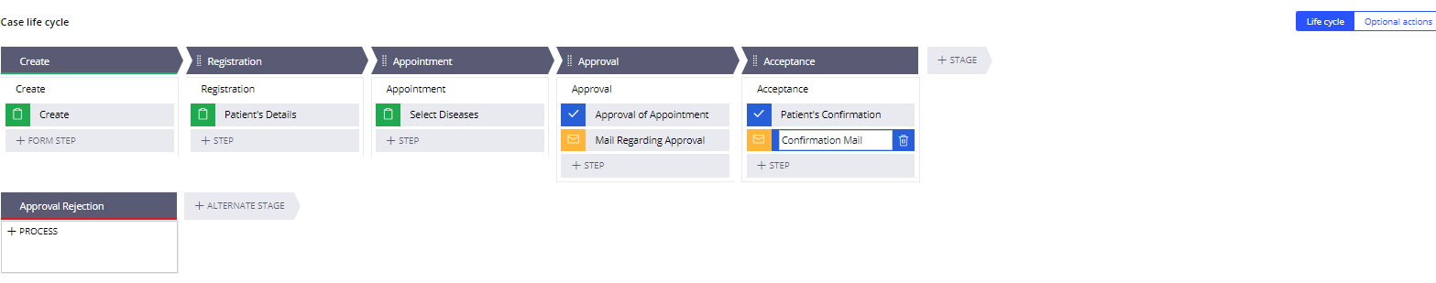

**Data Types used:**

1. Patient Details

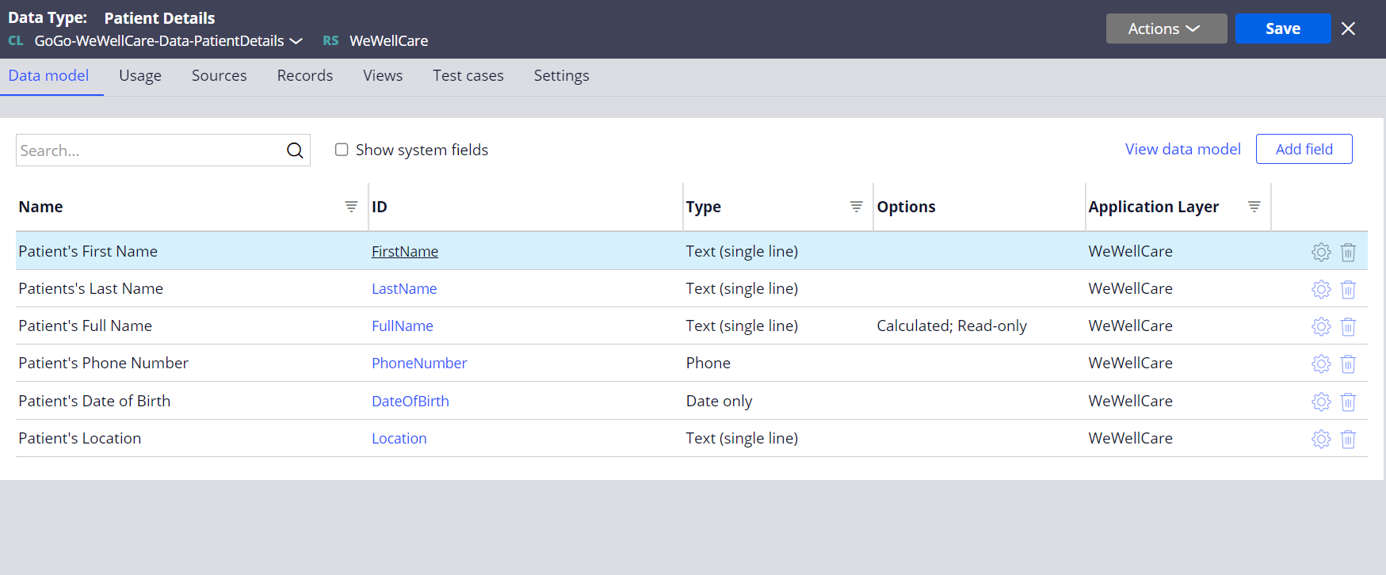

**Sample Operators:**

* [Patient@WeWellCare.com](mailto:Patient@WeWellCare.com)
* [Representative@WeWellCare.com](mailto:Representative@WeWellCare.com)