Instructions

1. Uninstall current Chrome.
2. Download version 90 from here or wherever you find it, make sure to be 64-bit: <https://www.slimjet.com/chrome/google-chrome-old-version.php>
3. Download chromedriver from: <https://chromedriver.chromium.org/downloads>
4. Disable chrome auto update, people say this is a working easy solution: 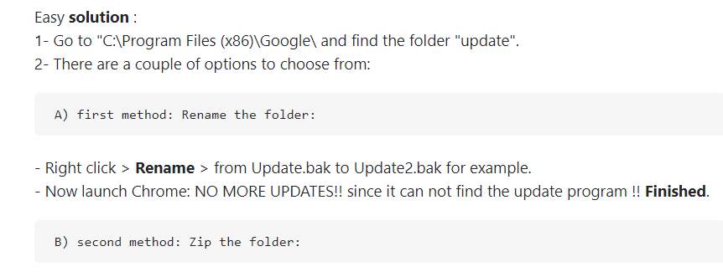
5. Unzip what I send you and run bat. Make sure to check the version of the chrome before that and to have the driver in the folder.