# HW-4

Complete the following –

1. Write logic to –
   * Process the provided **stocks.csv** file (attachment)
   * Implement a function to determine the total purchase price (of the portfolio)
   * Implement another function to determine the profit margin of the portfolio (current price minus purchase price of all stocks)
2. Implement a function, foo, which will determine the number of occurrences of a substring in a string
   * foo(str, “Emma”) where
     + **foo** is the function name
     + **str** is the provided string # input parameter #1
     + “**Emma**” is the substring # input parameter #2
   * Enhance the function or create another function of your choice utilizing any of the concepts that we have learned thus far. You are here to practice coding

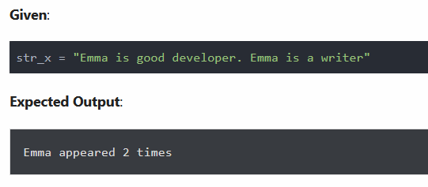

1. **Always Include your name as the author** (in a comment) in all of your coding assignments. This applies to both HWs and projects
2. Test your programs
   * If a program is incomplete or not working, clearly articulate your situation in details in order to potentially earn partial credit
   * No credit (0 points) will be given if your project is not working and I have no idea why it’s not working
3. In a small write-up (several paragraphs will do), discuss your learning experience
   * What did you learn?
   * What challenges did you encounter, if any?
   * Anything else you would like to mention?
   * **If it’s specified, what enhancement(s) did you make? (I will look for this)**
   * Capture screenshots of a few of your test runs in your write-up
     + Convince me that your program (app) is working
   * **Submit your write-up as a PDF file (only)**
4. Compress your code (one or more py files) and the write-up as a zip file
5. Submit your compressed file to the assignment link (do not email it)
6. **I grade each submission by -**
   * **Read your write-up and learning experience**
   * **Randomly test one of the submitted piece of coding on my computer**