Classified Index:

U.D.C:

**Automation Test Tool**

|  |  |
| --- | --- |
| **Author** | **:** Yu Dong Wang (Dom Wang) |
| **Version** | **:** 1.0 |
| **Date** | **:** Feb.8, 2017 |
| **Email** | **:** wangyudongwyd@126.com |

目录

**1.** **Environment** 3

**2.** **Test Directory Tree** 3

**1.1** **Test case directory ‘conf’** 4

**1.1.1** **File ‘AT_Tasks.json’** 4

**1.1.2** **Directory ‘cases’** 7

**1.1.3** **Directory ‘assertions’** 9

**1.1.4** **Directory ‘body’** 9

**1.2** **Test tool ‘autotest-1.0.jar’** 9

**3.** **FAQ** 12

# **Environment**

|  |  |
| --- | --- |
| Java | 1.8 or higher |
| OS | Windows  Linux |
| Browser | IE 9 or higher  Firefox 51.0 or higher  Chrome 53.0 or higher |
| In Scope | RESTful API with JSON Data |

# **Test Directory Tree**

You should first make a directory with name autotest.

Copy file autotest-1.0.jaranddirectoryconf.ziptoautotest

Unzip conf.zip toautotest

**autotest**

├── **autotest-1.0.jar**

└── **conf**

├── **assertions**

│   ├── *assert_case_http_get.json*

│   ├── *assert_case_http_post.json*

│   └── *assert_case_http_put.json*

├── **AT_Tasks.json**

├── **body**

│   ├── *body_case_http_post.json*

│   └── *body_case_http_put.json*

└── **cases**

├── *case_http_delete.json*

├── *case_http_get.json*

├── *case_http_post.json*

└── *case_http_put.json*

**\*Note\***: You must put autotest-1.0.jar and conf in the same directory.

## **Test case directory ‘conf’**

**conf**

├── **assertions**

│   ├── *assert_case_http_get.json*

│   ├── *assert_case_http_post.json*

│   └── *assert_case_http_put.json*

├── **AT_Tasks.json**

├── **body**

│   ├── *body_case_http_post.json*

│   └── *body_case_http_put.json*

└── **cases**

├── *case_http_delete.json*

├── *case_http_get.json*

├── *case_http_post.json*

└── *case_http_put.json*

You should design all your test cases in directory conf.

### **File ‘AT_Tasks.json’**

You can set up your test tasks in the file ‘AT_Tasks.json’.

Automation test tool will load all these tasks to run the cases.

The file content is as bellow:

|  |
| --- |
| {  "tasks": [  {  "tast_id": 1,  "tast_name": "case_http_get",  "case_file": "conf/cases/case_http_get.json",  "detail": "This case is a demo to test a http get method.",  "parallel": false  },  {  "tast_id": 2,  "tast_name": "case_http_post",  "case_file": "conf/cases/case_http_post.json",  "detail": "This case is a demo to test a http post method.",  "parallel": true  },  {  "tast_id": 3,  "tast_name": "case_http_put",  "case_file": "conf/cases/case_http_put.json",  "detail": "This case is a demo to test a http put method.",  "parallel": true  },  {  "tast_id": 4,  "tast_name": "case_http_delete",  "case_file": "conf/cases/case_http_delete.json",  "detail": "This case is a demo to test a http delete method.",  "parallel": true  }  ]  } |

The properties of task are as bellow:

|  |  |
| --- | --- |
| **Properties** | **Details** |
| tast_id | Required，Integer  Test task ID  It must be unique. |
| tast_name | Required，String  Test task name  It should be a short name. |
| case_file | Required，String  Case file  It must be like conf/cases/xxx.json |
| detail | Optional，String  Details  To give an introduction of the task. |
| parallel | Optional, String, default value: false  If want to run standalone cases concurrently, you should set it to be true. |

### **Directory ‘cases’**

You should write your test cases in directory cases.

Here shows some cases demo including HTTP POST, PUT, GET, DELETE in the directory:

**cases**

├── *case_http_delete.json*

├── *case_http_get.json*

├── *case_http_post.json*

└── *case_http_put.json*

You can write your own cases to follow the demo.

The properties of case are as bellow:

|  |  |
| --- | --- |
| **Properties** | **Details** |
| uri | Required，String  URI of RESTful API. |
| http_method | Required，String  HTTP method of RESTful API  Value range: POST, PUT, GET, DELETE |
| request_file | Required for HTTP method POST or PUT，String  HTTP request body file with JSON string.  Suggestion to specify ‘request_file’ instead of ‘request_text’.  It must be like conf/body/XXX.json |
| request_text | Optional for HTTP method POST or PUT，String  HTTP request body text with JSON String.  If specify ‘request_file’, this property will not take effect. |
| assertive_file | Optional, String  Assertive file with JSON string.  Test tool will check whether the response text is equal to its content.  Suggestion to specify ‘assertive_file’ instead of ‘assertive_text’.  It must be like conf/assertions/XXX.json |
| assertive_text | Optional, String  Assertive text with JSON string.  Test tool will check whether the response text is equal to it.  If specify ‘assertive_file’, this property will not take effect. |
| assertive_status | Optional, Integer  Assertive HTTP status  Test tool will firstly check whether the HTTP response status is equal to it. If they are equal, then will compare the response text, if you specify ‘assertive_file’ or ‘assertive_text’. |

### **Directory ‘assertions’**

You should write assertive file with JSON string in the directory, if you want to check whether the HTTP response is correct.

### **Directory ‘body’**

You should write HTTP request body file with JSON string in the directory for HTTP method POST, PUT.

## **Test tool ‘****autotest-1.0.jar’**

It is a runnable JAR, double click it, will show the GUI as bellow:

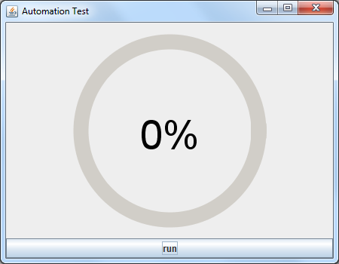

Click button ‘run’, it will run the test cases which you design in directory ‘conf’.

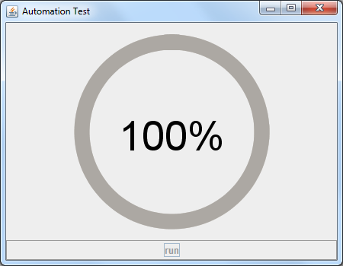

After all the cases are completely done, it will show an automation report on your default browser on Windows platform.

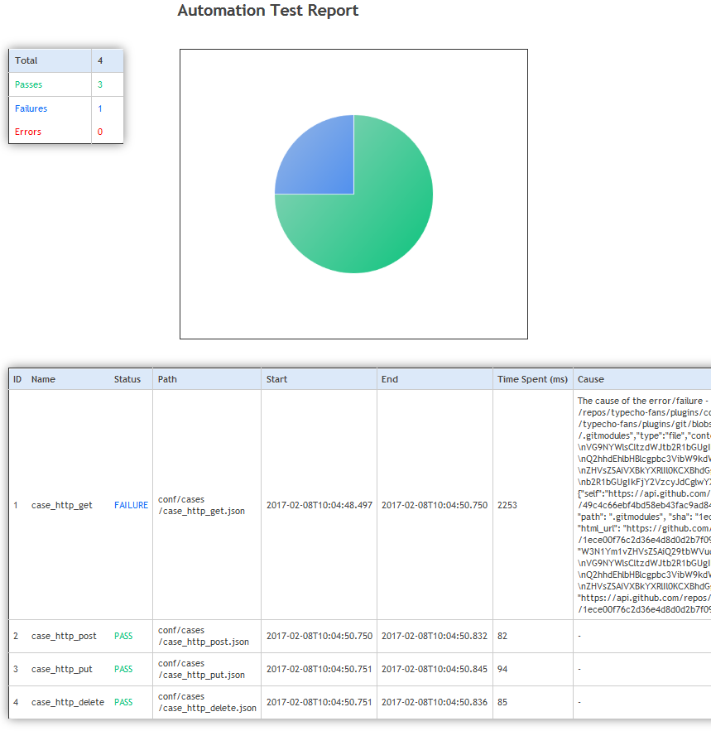

You can also use browser to open the report file:

report/report.html

# **FAQ**

Encounter any problems when you run this tool, you can open the following log file for help:

log/auto-test.log

If you find some bugs when run this automation test tool, welcome to send email to me.

**Email:** wangyudongwyd@126.com

1. No test cases

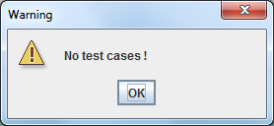

You should put ‘autotest-1.0.jar’ and ‘conf’ in the same directory.

‘AT_Tasks.json’should be exist and its content should be correct.

The directory tree must be like this as bellow:

**autotest**

├── **autotest-1.0.jar**

└── **conf**

├── **assertions**

│   ├── *xxx.json*

│   ├── *xxx.json*

│   └── *xxx.json*

├── **AT_Tasks.json**

├── **body**

│   ├── *xxx.json*

│   └── *xxx.json*

└── **cases**

├── *xxx.json*

├── *xxx.json*

├── *xxx.json*

└── *xxx.json*

1. ---