Toward Modeling and Simulation: From Narrative to Conceptualization.

# Introduction

Large Language Models (LLMs) have showcased remarkable potential across a spectrum of domains, from security to scientific research, mathematics, and education. In the realm of cybersecurity, LLMs have the power to bolster code security by pinpointing vulnerabilities, and they excel in data privacy management, often surpassing traditional security frameworks (Yao et al., 2024). In scientific research, LLMs expedite the discovery process by condensing vast volumes of literature and enhancing the clarity and structure of scientific writing (Boyko et al., 2023). In the field of mathematics, LLMs are on the brink of revolutionizing problem-solving for algebraic equations and calculus, although they do face challenges when it comes to abstract proofs or problems that necessitate higher reasoning (Ahn et al., 2024). In the educational sphere, LLMs are becoming increasingly indispensable for tutoring in subjects like mathematics, programming, and reasoning, while also transforming knowledge-based question-answering systems in online education platforms (Li et al., 2023).

However, despite these advances, challenges persist. LLMs heavily rely on vast datasets for training, which can introduce biases and raise ethical concerns around privacy, fairness, and misinformation (Boyko et al., 2023; Yao et al., 2024). Additionally, LLMs often struggle with producing concise and executable models, especially when tasked with programming languages they are less familiar with (Frydenlund et al., 2024). An example of this limitation is their inability to generate accurate simulation models from a given narrative. Frydenlund et al. (2024) evaluated ChatGPT’s ability to generate simulation models from a narrative about disrupted student transportation during the COVID-19 pandemic, finding that it struggled to produce concise, executable models, mainly when working with unfamiliar programming languages. This highlights the significant limitations in converting descriptive prose into complex simulations. Giabbanelli (2023) further emphasizes that while GPT-based models like ChatGPT show potential in simulation tasks, they encounter significant limitations when attempting to perform complex modeling, such as explaining simulation structures or interpreting dynamic outcomes. This underscores the pressing need for improvements in integrating LLMs with real-world simulation processes.

Despite the strides made with LLMs in tasks such as text generation and code development, there is a glaring gap in integrating LLMs with real-world simulation processes. Current research, including studies by Frydenlund et al. (2024) and Giabbanelli (2023), underscores this. While LLMs show promise in simulating narrative-based phenomena, their inability to generate concise, executable models and accurately interpret dynamic outcomes reveals the limitations of existing models. This gap urgently calls for more advanced frameworks that can effectively bridge narrative understanding and simulation tasks.

# Contribution

## How do we represent a narrative structure?

Narratives convey valuable information and can be coherently conceptualized, capturing key elements such as events, experiences, or real-world phenomena. They are essential for understanding how humans interpret and communicate information, shaping how stories are told and understood. Narratives simplify complex ideas by organizing them into sequences that provide context, purpose, and direction. Ideally, narratives should be modeled to describe real-world problems. However, while LLMs hold promise, they are limited in their ability to model narratives.

To conceptualize a narrative, we begin by identifying its fundamental components: the entities and their relationships. Some studies demonstrate how Natural Language Processing (NLP) can aid in this task. For instance, Holur et al. (2023) extracted aligned actor groups from news articles using question-answering models, identifying key actors and their relationships to reveal dynamics within the narrative and better understand how these actors are positioned within the broader story. Similarly, Soni et al. (2023) extracted spatial relationships between characters and locations within narratives, using techniques like named entity recognition (NER) and semantic role labeling (SRL) to identify critical actors and map their interactions, providing insights into how these elements contribute to the overall structure of the narrative. Likewise, Hsu et al. (2022) used sequence tagging and priming techniques to extract relational structures like events, arguments, and relationships from the text, improving the extraction of entity relationships by integrating priming techniques with pre-trained models.

By organizing these parts into a coherent structure, we gain a deeper understanding of the narrative’s essence. After conceptualizing, narratives can be presented through visual tools, textual formats, simulations, and graphical representations, each offering unique ways to simplify and communicate complex ideas. For instance, Giabbanelli and Witkowicz (2024) developed a GPT-based question-answering system to extract causal relationships from text and visualize them in causal maps, identifying concept nodes and their interactions to represent the narrative structure.

## Narrative Characterization: Actor, Factor, Mechanism

When characterizing a narrative in terms of actor, factor, and mechanism (AFM) involves identifying the main participants (actor), the contributing elements or circumstances (factors), and the processes or actions taken (mechanisms). In the context of a knowledge graph, the nodes represent actors, factors, and mechanisms. At the same time, the edges show the relationships on how actors use mechanisms to interact with factors (actions taken by actors), such as “upheld the redistricting,” “criticized the decision,” and “benefited from redistricting.” Actors can range from governmental bodies to grassroots movements, each playing a distinct role in the narrative construction. Factors encompass the various elements influencing the narrative, such as values, interests, and divergences among stakeholders. Conversely, mechanisms delve into the actors’ actions, strategies, and processes to advance their narratives and agendas. By mapping out these components in a knowledge graph, one can visualize the intricate web of relationships and connections that underpin the storytelling in politics and policymaking. In a simulation process, actors represent entities that perform a function or are impacted by another entity, factors are variables influencing the narrative, and mechanisms refer to actions or effects that occur within the narrative framework Shuttleworth and Padilla (2021).

Shuttleworth and Padilla (2021) used natural language understanding techniques to extract actors, factors, and mechanisms from narratives by applying text processing methods to identify key entities, attributes, and interactions. In contrast, Shuttleworth and Padilla (2022) utilized natural language processing (NLP) techniques, such as dependency parsing and pattern-based grammatical rules. Both studies aimed to transform these components into conceptual models and simulation specifications by identifying the relationships between the entities and then visualizing these relationships through network graphs to represent the narrative structure. Notably, no evidence exists that LLMs have been applied to this specific NER task.

### Experimental Setting by Using LLMs

For instance, we have the following narrative: President Joe Bide criticized the Supreme Court’s decision on the redistricting of the South Carolina district by issuing a public statement highlighting concerns about racial discrimination. To identify what the AFMs are from the text, it could be: “**President Joe Biden** (actor) criticized the **Supreme Court's decision** (factor) on the **redistricting of the South Carolina district** (factor) by issuing a **public statement** (mechanism), highlighting concerns about **racial discrimination** (factor).”

To identify the AFMs from the narrative, large language models (LLMs) can be used for extraction. The advance of LLMs has enabled the automatization of this process. By prompting the LLM (gpt-4o), we can obtain: 1) the characterization of the narrative and 2) extract the nodes and edges for the visualization.

#### Narrative characterization

**System:** You are a helpful assistant who characterizes narratives into actors, factors, and mechanisms. Actors can range from governmental bodies to grassroots movements, each playing a distinct role in the narrative construction. Factors encompass socioeconomic, cultural, and environmental variables, while mechanisms refer to processes or actions taken to generate events, analyze a text, and extract the actors, factors, and mechanisms.

**Prompt:** What are the actors, factors, and mechanisms in the following text

Text: President Joe Biden criticized the Supreme Court’s decision on the redistricting of the South Carolina district by issuing a public statement highlighting concerns about racial discrimination.

|  |  |  |  |
| --- | --- | --- | --- |
| Type/LLMs | gpt-4o | llama3 | mistral |
| Actors | 1. **President Joe Biden** - The individual who issued the public statement. 2. **Supreme Court** - The judicial body that made the decision on the redistricting of the South Carolina district. | 1. President Joe Biden 2. The Supreme Court | 1. President Joe Biden - The individual who issued the public statement regarding the Supreme Court's decision on redistricting in South Carolina. 2. The Supreme Court - The judicial body that made the decision on redistricting in South Carolina. 3. The people of South Carolina - Indirectly, as they are affected by the redistricting decision. |
| Factors | 1. **Redistricting of the South Carolina district** - The specific action or decision made by the Supreme Court that is being criticized. 2. **Racial discrimination** - The concern highlighted by President Biden in his criticism of the Supreme Court's decision. | 1. Racial discrimination 2. Redistricting (redrawing of electoral district boundaries) 3. Political concerns | 1. Redistricting - The process of dividing a region into electoral districts to reflect changes in population. 2. Racial Discrimination - The practice of treating different racial groups unfairly, which is a concern raised by President Biden in this context. 3. Political Boundaries - The geographical boundaries within which political representation occurs. 4. Constitutional Laws and Regulations - The laws and regulations that govern the process of redistricting, including those related to prohibiting racial discrimination. |
| Mechanisms | 1. **Issuing a public statement** - The method used by President Biden to express his criticism and highlight his concerns about the Supreme Court's decision. | 1. Public statement (a formal declaration or announcement made by President Biden) | 1. Public Statement - A means by which President Biden expressed his concerns about the Supreme Court's decision on redistricting in South Carolina, addressing the issue publicly. 2. Judicial Review - The power held by the Supreme Court to review and potentially overturn laws or decisions made by other branches of government (in this case, the legislature responsible for drawing district boundaries). 3. Legal Challenge - If President Biden's concerns about racial discrimination are substantiated, it could lead to a legal challenge against the redistricting decision. 4. Media Dissemination - The process by which the public becomes aware of President Biden's statement and the Supreme Court's decision on redistricting, as well as any subsequent developments or responses. |

#### Extract nodes and edges for the visualization.

**Prompt:** Make a visual representation of the narrative characterization. Consider that the nodes represent actors, factors, and mechanisms in the context of a knowledge graph. At the same time, the edges show the relationships on how actors use mechanisms to interact with factors (actions taken by actors), such as “upheld the redistricting,” “criticized the decision,” and “benefited from redistricting.”

**Output:** Here is the visual representation of the narrative characterization as a knowledge graph. The nodes represent actors, factors, and mechanisms, while the edges show the relationships and how actors use mechanisms to interact with factors. The colors differentiate between actors (skyblue), factors (lightgreen), and mechanisms (lightcoral).

* Actors:
  + President Joe Biden
  + Supreme Court
  + South Carolina district
* Factors:
  + Racial Discrimination
  + Values and Interests
  + Divergences among Stakeholders
* Mechanisms:
  + Public Statement
  + Highlighting Concerns
  + Criticism
* Relationships:
  + President Joe Biden uses a Public Statement to highlight Racial Discrimination.
  + President Joe Biden uses Highlighting Concerns to bring attention to Racial Discrimination.
  + President Joe Biden uses Criticism to challenge the Supreme Court.
  + The Supreme Court influences Values and Interests.
  + The South Carolina district is affected by Racial Discrimination.
  + The Supreme Court creates Divergences among Stakeholders.

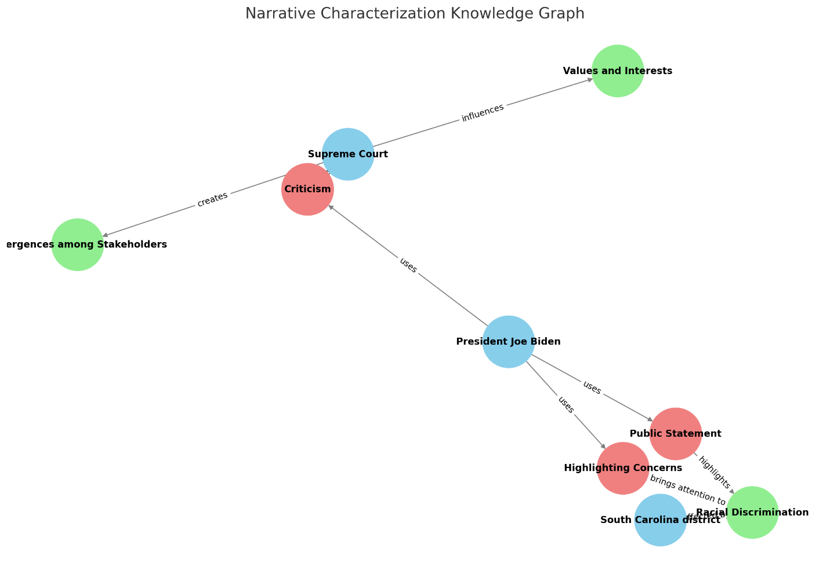

Figure 1. AFM Visual representation of the narrative

## Contribution to M&S and CS

As a first step to conceptualize a narrative and eventually model it in future work, we propose the following contributions to the state of the art: (1) Testing the capabilities of NER models such as Gliner (Zaratiana et al., 2023), NuNER (Bogdanov et al., 2024), and UniversalNER (Zhou et al., 2023) to extract entities and determine which represent actors, factors, or mechanisms; (2) Developing a benchmark dataset for AFM (Actor, Factor, Mechanism); (3) Creating a NER model for AFM; (4) Extracting relationships between entities; and (5) Providing a visual representation of the characterization.

# Reference

Ahn, J., Verma, R., Lou, R., Liu, D., Zhang, R., & Yin, W. (2024). Large language models for mathematical reasoning: Progresses and challenges. *arXiv preprint arXiv:2402.00157*.

Bogdanov, S., Constantin, A., Bernard, T., Crabbé, B., & Bernard, E. (2024). NuNER: Entity Recognition Encoder Pre-training via LLM-Annotated Data. *arXiv preprint arXiv:2402.15343*.

Boyko, J., Cohen, J., Fox, N., Veiga, M. H., Li, J. I., Liu, J., Modenesi, B., Rauch, A. H., Reid, K. N., & Tribedi, S. (2023). An interdisciplinary outlook on large language models for scientific research. *arXiv preprint arXiv:2311.04929*.

Frydenlund, E., Martínez, J., Padilla, J. J., Palacio, K., & Shuttleworth, D. (2024). Modeler in a box: how can large language models aid in the simulation modeling process? *SIMULATION*, 00375497241239360. <https://doi.org/10.1177/00375497241239360>

Giabbanelli, P., & Witkowicz, N. (2024). Generative AI for Systems Thinking: Can a GPT Question-Answering System Turn Text into the Causal Maps Produced by Human Readers?

Giabbanelli, P. J. (2023). GPT-based models meet simulation: how to efficiently use large-scale pre-trained language models across simulation tasks. 2023 Winter Simulation Conference (WSC),

Holur, P., Chong, D., Tangherlini, T., & Roychowdhury, V. (2023). My side, your side and the evidence: Discovering aligned actor groups and the narratives they weave. Proceedings of the 61st Annual Meeting of the Association for Computational Linguistics (Volume 1: Long Papers),

Hsu, I., Huang, K.-H., Zhang, S., Cheng, W., Natarajan, P., Chang, K.-W., & Peng, N. (2022). TAGPRIME: A unified framework for relational structure extraction. *arXiv preprint arXiv:2205.12585*.

Li, Q., Fu, L., Zhang, W., Chen, X., Yu, J., Xia, W., Zhang, W., Tang, R., & Yu, Y. (2023). Adapting large language models for education: Foundational capabilities, potentials, and challenges. *arXiv preprint arXiv:2401.08664*.

Shuttleworth, D., & Padilla, J. (2022). From Narratives to Conceptual Models via Natural Language Processing. 2022 Winter Simulation Conference (WSC),

Shuttleworth, D., & Padilla, J. J. (2021). Towards semi-automatic model specification. 2021 Winter Simulation Conference (WSC),

Soni, S., Sihra, A., Evans, E. F., Wilkens, M., & Bamman, D. (2023). Grounding characters and places in narrative texts. *arXiv preprint arXiv:2305.17561*.

Yao, Y., Duan, J., Xu, K., Cai, Y., Sun, Z., & Zhang, Y. (2024). A survey on large language model (LLM) security and privacy: The Good, The Bad, and The Ugly. *High-Confidence Computing*, *4*(2), 100211. <https://doi.org/https://doi.org/10.1016/j.hcc.2024.100211>

Zaratiana, U., Tomeh, N., Holat, P., & Charnois, T. (2023). Gliner: Generalist model for named entity recognition using bidirectional transformer. *arXiv preprint arXiv:2311.08526*.

Zhou, W., Zhang, S., Gu, Y., Chen, M., & Poon, H. (2023). Universalner: Targeted distillation from large language models for open named entity recognition. *arXiv preprint arXiv:2308.03279*.

# Conferences

1. ACL: Association for Computational Linguistics (deadline Feb 15, 2025?)
   1. Computational Social Science and Cultural Analytics
      1. [Grounding characters and places in narrative texts](https://arxiv.org/pdf/2305.17561)
      2. [My side, your side and the evidence: Discovering aligned actor groups and the narratives they weave](https://aclanthology.org/2023.acl-long.497.pdf)
   2. Information Extraction
      1. [TAGPRIME: A Unified Framework for Relational Structure Extraction](https://arxiv.org/pdf/2205.12585)
   3. Semantics: Sentence-level Semantics, Textual Inference and Other areas
2. ICDAR: The International Conference on Document Analysis and Recognition (deadline Feb 1, 2025?)
   1. Document Representation Modeling,
   2. NLP for document understanding
3. AAAI: Association for the Advancement of Artificial Intelligence

