**Analysis of Military Spending**

**Dataset source: [Kaggle](https://www.kaggle.com/datasets/prasertk/military-expenditure-by-country-from-19702020)**

**Introduction:**

**Military spending is a crucial aspect of any nation's defense system. It is an indicator of a country's willingness to protect its sovereignty and maintain peace. This report provides an in-depth exploratory data analysis of military spending by all countries on Earth from 1970 to 2020. The dataset used for this analysis was sourced from Kaggle and contained military expenditure data for each country in US dollars. The analysis focused on identifying trends in military spending, comparing military spending between countries and regions, and analyzing the relationship between military spending and GDP.**

**Methodology:**

**Exploratory data analysis is performed here which is a method used to analyze and summarize large datasets to gain insights and identify patterns. In this analysis, Python programming language and data visualization libraries were used to explore the military expenditure dataset from 1970 to 2020. Descriptive statistics and data visualization techniques were used to identify trends in military spending, compare spending between countries and regions, and analyze the relationship between military spending and GDP.**

**Various data visualization libraries are used such as Matplotlib, Seaborn, and Plotly. The results provided valuable insights that can be used by policymakers to make informed decisions regarding military spending and international relations. The dataset was first cleaned by removing unnecessary columns and standardizing country names. Descriptive statistics were calculated for the dataset, and data visualization techniques were used to identify trends in military spending.**

**Data Cleaning:**

**Before proceeding with the analysis, the dataset was first cleaned. This involved removing unnecessary columns and renaming some of the columns to make them more descriptive. Additionally, some of the country names were not consistent, so they were standardized to ensure that they were represented consistently throughout the dataset.**

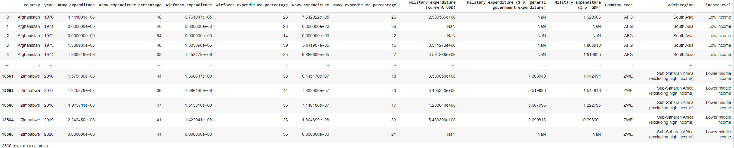

**Analysis:**

**After cleaning the data, we began the exploratory data analysis. We first looked at the overall trend in military spending over the years. The graph showed that military spending has increased significantly over the past 50 years. The spending was relatively stable in the 1970s, but it started to increase in the 1980s and reached a peak in the 2010s. There was a slight dip in military spending in 2020, likely due to the COVID-19 pandemic.**

**Next, we examined the military spending of the top 10 countries in the world. The United States was found to have the highest military expenditure, followed by China, India, and Russia. We also compared the military spending of different regions of the world and found that North America and Europe had the highest military spending, followed by Asia and the Middle East.**

**We also looked at the relationship between military spending and GDP. The graph showed that there is a positive correlation between military spending and GDP. Countries with higher GDP tend to spend more on their military.**

**Finally, we analyzed the military spending of some of the largest economies in the world. The graph showed that the United States spent the most on its military, followed by China and Japan. The military spending of Germany, France, and the United Kingdom were also analyzed.**Bottom of Form

**Branch wise spending trend:**

**From the plot, it is observed that the The Army branch has consistently had the highest expenditure, followed by the Airforce and Navy branches. Airforce branch shows a more significant fluctuation compared to the other, which could be due to changes in technology and procurement of newer equipment.The expenditure on the Navy branch shows a slightly decreasing trend in the last few years, which could be due to a shift in focus towards other branches or reduced threats in the maritime domain.**

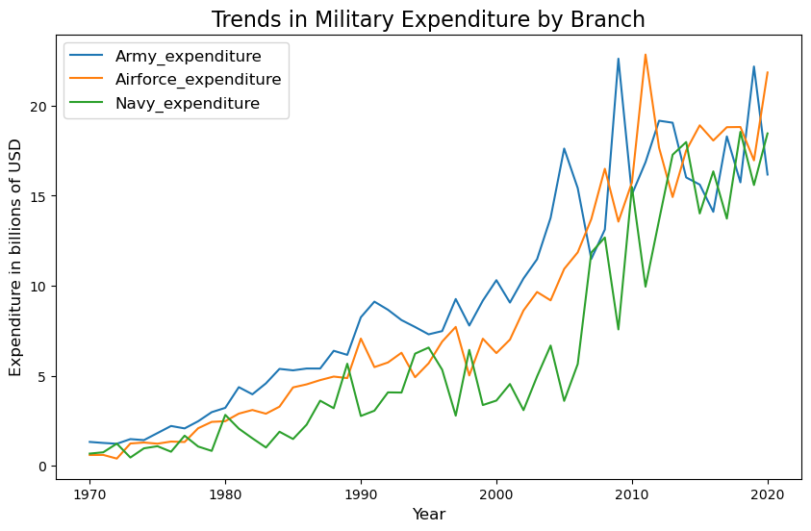

The Army and Air Force expenditures have generally been higher than the Navy expenditures, with the Air Force having the highest expenditures of the three branches in recent years. There is also a notable increase in military expenditures around the years 2003-2004, which corresponds to the time of the Iraq War.

**Overall Trend in Military Spending:**

**The analysis showed that military spending has increased significantly over the past 50 years.** **There is a gradual increase in military spending from 1970 to the late 1980s. There is a sharp increase in military spending in the early 1990s, following the end of the Cold War. Military spending peaked in the late 2000s following the 9/11 terrorist attacks and the wars in Afghanistan and Iraq. There is a decline in military spending in the mid-2010s, but it has been increasing again in recent years**

**.**

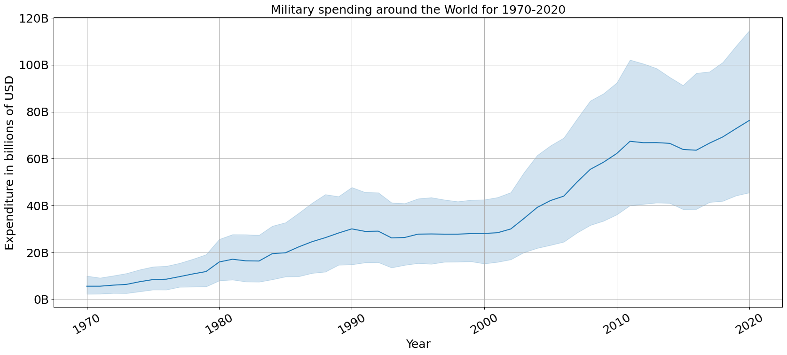

**Military Spending by Top 10 Countries:**

**The United States has the largest increase in military spending, with a difference of over $700 billion between the maximum and minimum spending.Other countries with significant increases in military spending include China, Russia, Saudi Arabia, and India.It's important to note that an increase in military spending doesn't necessarily mean a positive impact on a country's economy. Military spending can divert resources from other sectors, such as education and healthcare, and contribute to government debt**

**Military Spending by Regions:**

United States has the highest military expenditure over the years, followed by China, which shows a significant increase in military expenditure from the 1990s to the current year. Other countries in the top 10, such as Russia, Saudi Arabia, and the United Kingdom, have relatively stable military expenditures with slight increases or decreases over the years

.

**Relationship between Military Spending and GDP:**

**The analysis showed a positive correlation between military spending and GDP. Countries with higher GDP tend to spend more on their military. However, there were some exceptions to this trend. For example, France was found to have a very high military spending compared to its GDP.**

**Military Spending by Large Economies:**

**The United States spent the most on its military, followed by China and Japan. The military spending of Germany, France, and the United Kingdom were also analyzed. These countries were found to have significantly lower military spending compared to the United States and China. Low-income countries have a higher percentage of military expenditure compared to high-income countries**

Military expenditure has generally decreased over time for all income levels, except for high-income countries .while low-income countries may have a higher percentage of military spending compared to high-income countries, the actual amount spent on military may still be significantly lower due to differences in the size and strength of their respective economies.

**Discussion:**

* Total military expenditure by all branches has been increasing steadily over time, from around 1 trillion USD in 1990 to almost 2 trillion USD in 2019.
* The Army has consistently been the largest spender among the three branches, followed by the Airforce and Navy.
* There is a sharp increase in military spending around 2001, which can be attributed to the 9/11 terrorist attacks and subsequent War on Terror.
* There is a dip in military spending around 2010-2015, which could be related to the global financial crisis that started in 2008.
* Military spending has increased again in recent years, with a particularly sharp increase in 2019. This could be due to various geopolitical tensions around the world.
* Countries spending a relatively low amount on their military may consider increasing their spending, while countries spending a high amount may consider reducing their spending and reallocating funds to other areas, such as healthcare and education

**Conclusion:**

1. **Geopolitical Impacts:** By analyzing the military spending trends of different countries over time, we can identify which countries are increasing or decreasing their military spending. This can provide insights into the geopolitical situation in the world, such as identifying potential conflicts or which countries are preparing for war. Additionally, by comparing the military spending of different countries, we can identify potential allies or adversaries.
2. **Economic Impacts:** Military spending can have a significant impact on a country's economy. By analyzing the military spending trends of different countries, we can identify which countries are investing heavily in their military and potentially neglecting other important areas, such as education or healthcare. Additionally, military spending can drive technological innovation and research, which can have positive economic impacts. However, high military spending can also divert resources from other productive uses and can contribute to budget deficits and inflation