Report of Programming Assignment 2

A. Status of Part 1
The code has passed all tested provided through files “input1.txt”, “input2.txt”, etc. and also the accepted by the online judge.
The screenshot of the acceptance of the online judge Is shown in the Figure 1.
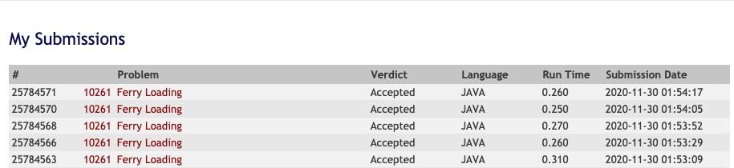
Figure 1 Screenshot of five consecutive submission of the BigTable implementation

B. Status of Part 2
The code has passed all tested provided through files “input1.txt”, “input2.txt”, etc. and also the accepted by the online judge.
The screenshot of the acceptance of the online judge Is shown in the Figure 2.
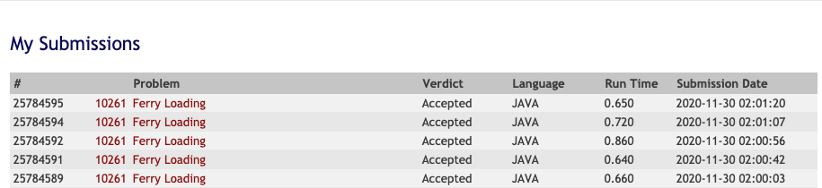
Figure 2 Screenshot of five consecutive submission of the HashTable implementation

C. Details on design of Part 2

Hash function
I first use a string of a combination of currK and currS. But then I found it will exceed the time limit with a HashTable of whatever size. After a few tries, I guess the reason that the process of hashing a string is slow. Then I decided to use integers as keys.

The hash function used in the part 2 is straightforward. The code is

private Integer buildKey(int currK, int currS){
return (currK + 71) * (currS + this.ferryLength);
}

The observation is that while currK is increasing, currS is decreasing. Therefore, it is possible to have a production for two different set of currK and currS. The trick here to deal this problem is to add a prime number 71 to currK, and the ferry length to currS and then use their production as the key in a HashTable. By using the prime number 71, the final production will have a part which consists of times of 71, which is rare to be the same for different currK. Hereby the collision of keys are avoided.

Hash table size
I start with a HashTable whose size equal the production of the number of cars and the ferry length. It passed the online juedge. Then I tried to decrease the size of the HashTable by 20 times, 50 times, 100 time and they all passed.

After all, the HashTable’s length is the same with the number of total cars. That should be enough to leave a slot for each car in the HashTable.

