Transcription as a predictable process:

Integrating high-resolution chromatin signals to accurately model gene expression over time

**Benjamin L. Moore**

**Supervisors: Colin A Semple, Martin S Taylor, Stuart Aitken**

**MRC HGU, IGMM**

**10 week report**

**11/12/2012**

# Introduction

Large-scale chromatin data has recently been produced by multiple consortia, most notably the ENCODE1 and NIH Roadmap Epigenomics2 projects. The breadth and depth of this new data offers unprecedented opportunities to further our understanding regarding the fundamental biology of the chromatin landscape. While many histone modifications can now be quantified experimentally,3,4,5 an integrated understanding of general mechanisms underlying the cause or effect of these marks lags behind. A 2011 opinion piece asked the question “Histone modification: cause or cog? ”6 and speculated that nucleosome modifications could be by-products of transcription machinery, as opposed to the “histone code” hypothesis which suggests that histone modifications are placed to direct alterations in chromatin state. This latter hypothesis is often tacitly invoked in the chromatin literature, wherein a mark may be described as “repressive” or “activating” despite only the observation of a correlative relationship.6 Similarly, the higher-order organisation of chromatin, while known the be an important factor in transcription, remains poorly understood mechanistically.7 However, the recent flood of data from high throughput sequencing technologies have provided fascinating new glimpses of the ways chromatin and transcription are functionally related.

Recent studies have shown convincingly that local chromatin state measurements can accurately predict expression levels of genes on a genome-wide basis. Tippmann *et al.*,8 designed a linear model to predict steady-state mRNA levels in mouse (*Mus musculus*) embryonic stem cells based on just four predictors: 3 histone modifications (H3K36me3, H3K4me2 and H3K27me3) and Pol-II occupancy. Remarkably, the linear model was found to explain 84.6% of an estimated 91% maximal variance that could be explained (as calculated through a detailed determination of noise). An additional finding of this study was that mRNA half-life and microRNA mediated transcript degradation both had relatively minor influence on steady-state mRNA levels, with the authors concluding that“the lion’s share of regulatory contribution is at the level of mRNA synthesis and predictable from chromatin alone.”8 An independent study used a similar regression modelling approach to chromatin and transcription factor data and again concluded that models built with histone modifications and chromatin accessibility data were almost as accurate as those which also included binding data for 12 transcription factors.9

A recent key study from the ENCODE consortium used chromatin (ChIP-seq) datasets to predict gene expression in a range of cell types as measured by a variety of experimental techniques.10 The authors here developed a two-stage model which first attempts to classify each transcription start site (TSS) into an ‘on’ or ‘off’ state using a powerful ensemble classifier technique called Random Forests (RF). The second stage of the model used the same range of histone modifications as regressors in a simple linear modelling framework to quantify predicted expression. This approach proved very successful, producing a median Pearson correlation coefficient (*r*) between predicted and empirical expression levels using 10-fold cross-validation of 0.83 across all cell lines and expression level technologies.10 Additionally, this study highlighted cap analysis of gene expression (CAGE) as the technology, relative to RNA-Seq and RNA-PET, which produced the most predictable expression response. CAGE uses 5 capped transcripts to generate short, specific tags which precisely identify TSS positions as well as quantifying the abundance of a given transcript.11,12

These recent publications highlight the importance and relevance of advancing our understanding of chromatin biology through a model-based approach. Each of these existing models however, treats expression levels as stationary outcome in each cell type and ignores any temporal dynamics. The huge amount of novel timecourse CAGE data produced by the FANTOM5 consortium13 puts us in an ideal position to investigate how chromatin influences transcription beyond a simple single-point response and move towards a more complete understanding of the drivers of transcriptional flux.

# Preliminary data

Following on from Dong *et al.*,10 I first reimplemented the published ENCODE modelling framework to ensure I could replicate their results. In doing so I was also able to analyse the strengths and caveats of their approach; surprisingly the two-step classification then regression (firstly assessing a gene as ‘on’ or ‘off’ and then predicting its expression level) added little additional accuracy relative to a simple linear regression model (Fig. 1).

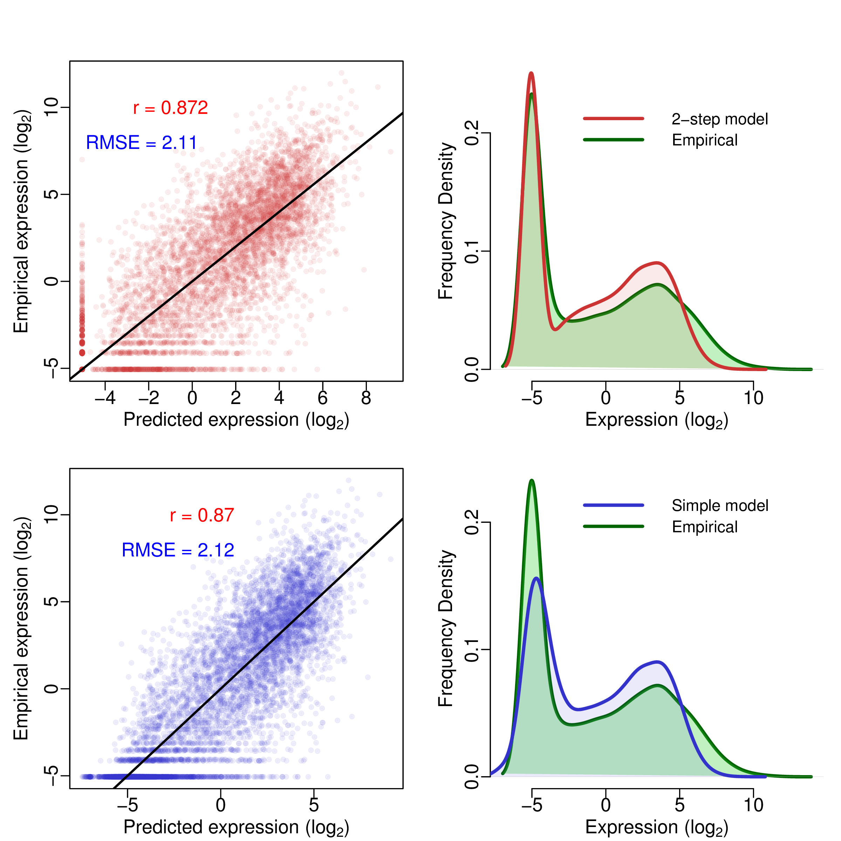

Figure 1: Comparison of classification-regression model (*upper*) with simple linear regression model (*lower*) recalculated following Dong *et al.*10 Scatterplots of predicted against empirical reads per million (RPM) expression values for both methods are shown (*left*) along with frequency distributions of predicted and observed expression levels (*right*). Scatterplots are annotated with Pearson’s correlation coefficient (*r*) and the root mean squared error (RMSE); the black trendlines describe *y*=*x*. Following 10-fold cross validation, overall correlation coefficients were: linear model ; Two-step model . All correlations were statistically significant with under the assumption of a *t*-distributed *r* with *d*.*f*.=7998.

An innovative element of Dong *et al.*’s modelling approach is the ‘bestbin’ method of matching chromatin measurements to the expression of a given TSS. This strategy first bins normalised signal intensities into 40×100 bp bins encompassing 4 kbp around the TSS, and adds an additional bin representing the remaining gene body. Then the correlation between the signal of a given mark and the expression of a TSS across all genes is measured — the bin producing the highest correlation is designated as the ‘bestbin’ and that bin’s normalised ChIP-seq signal intensity in then taken forward for the full model. This was shown to raise the correlation (between predicted and observed expression) by 0.1 in the simple regression model, an increase in accuracy of almost 13%, relative to simply taking the average value across all bins.10

Macintosh HD:Users:benmoore:F5:10wk:figs:Dong_relImp_Horiz.pdf

Figure 2: Relative importance metrics for variables in both the classification (left) and regression (right) stages of my reimplementation of Dong et al.’s two- step model.10 The additional variable ‘ReplicationTiming’ shows the influence of log2(early/late) replication timing ratio measured in the BG02 ESC cell type;14 H1 hESC data was not available but these higher-order measurements appear to be largely conserved across cell-types.[15] For details of CAR R2 decomposition, see Zuber and Strimmer (2010).15

I attempted to improve the accuracy of predicted expression values produced by Dong *et al.* through two methods: increasing the number of informative regressors and increasing the complexity of the model by adding interaction terms and/or non-linear components. While Dong *et al.* included broad coverage of different histone modifications, they did not investigate the impact of higher-order chromatin data. For this reason, I matched the TSS positions used in Dong *et al.* with previously-published genome-wide replication timing ratios measured in BG02 ESCs.16 I then used these values as an additional regressor in both the two-step classification regression model and the simple linear model but saw no significant improvement in either model’s accuracy. The reasons for this are likely that the interaction data were relatively low-resolution (1 megabase blocks) and also that the Dong *et al.* model is already achieving such accurate results that they must already be accounting for most of the maximal explainable variance in gene expression given experimental and biological noise. With this in mind, additional regressors would be expected to yield diminishing returns. However, on closer examination, the Hi-C data appeared only slightly more informative than the control ChIP-seq input measurements when evaluated with relative importance metrics (Fig. 2), implying that large-scale chromatin domains and long range interactions do not have significant influence on the expression of the genes resident within them. It would be of interest to investigate this further should more detailed Hi-C data become available. For example Hi-C interaction matrices have been calculated in the H1 cell line[17] and these could be compressed to principle component eigenvectors as has been done with other cell lines.[18]

## Modelling FANTOM5 CAGE timecourse data

Using unpublished FANTOM5 data and the approach established above, I next attempted to model gene expression at timepoint zero () of a differentiation timecourse of Human H1 embryonic stem cells (H1hESC) to CD34+ hematopoietic stem cells.

The first stage of the analysis was to map each CAGE cluster to a representative TSS. FANTOM5 robust gene mapping13 provided corresponding Entrez Gene IDs for gene-associated CAGE clusters, and I selected the most expressed cluster to represent the expression level of its mapped gene. I then compared these to Ensembl TSS annotations (v69) and discarded those tag clusters centered on a point >50 bp from an annotated TSS associated with the mapped Entrez Gene ID, thereby removing enhancers and other non-genic transcribed regions.

Next I retrieved a number of genome-wide histone modification datasets from the ENCODE and NIH Roadmap consortia which were measured in H1hESC cells, taking these to be reflections of the chromatin state . I implemented the previously-described ‘bestbin’ strategy10 to objectively select the most-correlated binned signal for each chromatin mark. Additionally, I analysed the stability of chosen bestbins by calculating them on 200 sets of 1000 randomly selected TSS samples (with each sample representing approximately 8% of the dataset) and the result is shown in Figure 3.

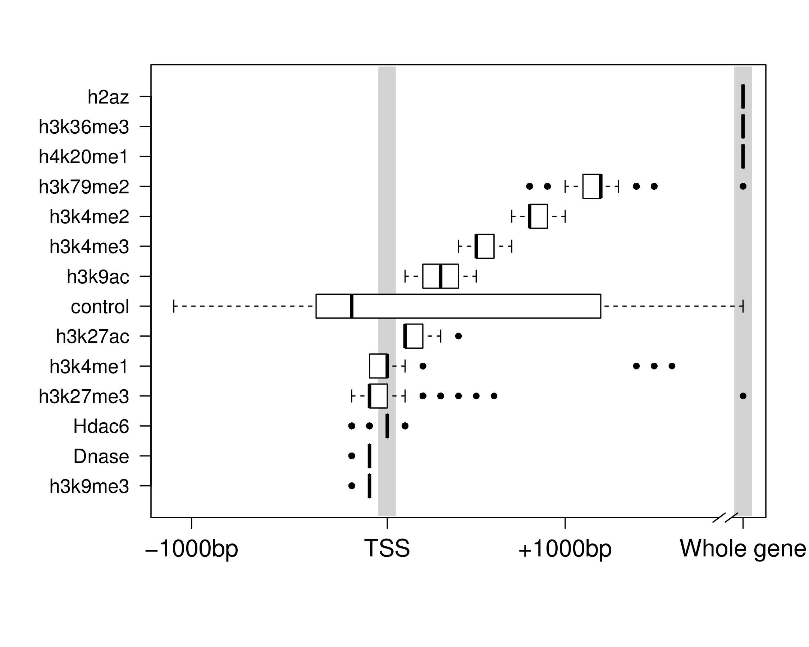Figure 3: Distributions of bestbin locations relative to the TSS. Bestbins were selected for normalised ChIP-seq signal intensities for 10 histone marks, the H2A.Z histone variant, Hdac6 histone deacetylase, Dnase hypersensitivity and a ChIP-seq input chromatin control. Bins analysed extended 2 Kb flanking the TSS, but more distal bins were never selected and hence are not shown. ‘Whole gene‘ represents the averaged signal intensity from TSS to transcript end site, as defined by Ensembl Genes v69.

This result shows that bestbin selections are often consistent, indicating there are predictably informative regions relative to a TSS for each chromatin factor (Fig. 3). Furthermore, the selected bestbins match known biological mechanisms; for example the H3K36me3 mark’s bestbin is consistently the whole gene measurement and this mark is known to be enriched in actively transcribed exons.8,17,18

Having matched a variety of genome-wide H1hESC chromatin datasets to the FANTOM5 timecourse expression data, I then built a regression model using a Random Forest (RF) approach.19 This method outperforms a simple linear model in my initial comparisons and is able to capture non-linear relationships as well as interactions without them being explicitly specified.20 RF works by building an ensemble of decision trees which each perform a succession of binary partitions aimed at maximising the separation between elements of the child nodes.21 Crucially, each branchpoint uses a random subset (size *mtry*) of the available predictors and each tree is fitted to a bootstrapped sample of the training set, allowing the model to be fitted without variable selection or risk of overfitting.20,22 Having grown a large number (*ntrees*) of these trees, continuous dependant variables (gene expression in this case) can be predicted by averaging the leaf-node classifications over all trees. A criticism of RF is that the model itself is less interpretable than a simple linear model, so for this reason linear models as well as other regression techniques will continue to be considered in future applications.

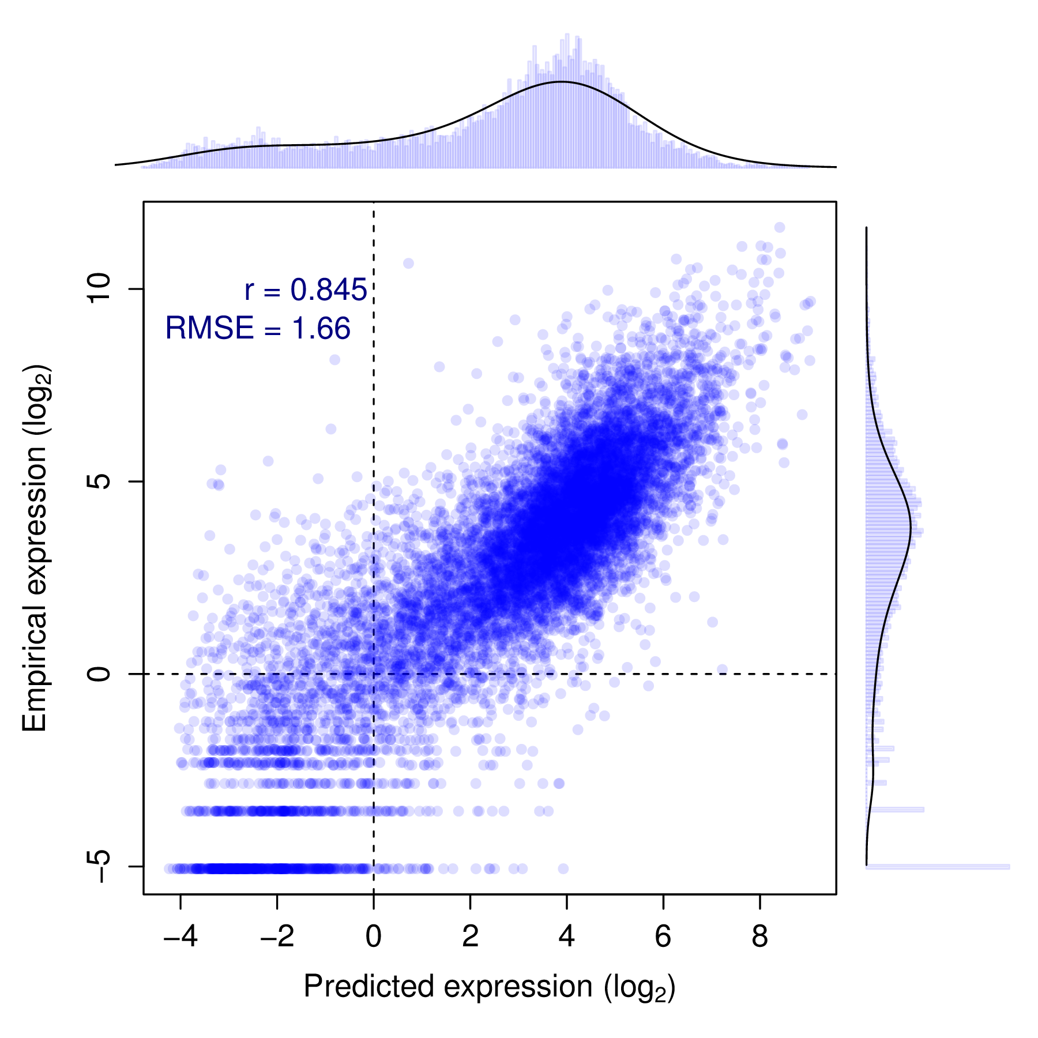

Figure 4: Evaluation of RF model predictions (*x*-axis) against an independent test set (*y*-axis). The distributions of predicted and empirical expression values are shown opposite their respective axes. Pearson’s correlation coefficient (*r*) and the root mean-squared error (RMSE) are also shown (*inset*).

Figure 4 shows the resulting predictions of a preliminary RF model against the actual recorded expression over a test set of approximately 11000 TSS. This model was built with 15 predictors including control ChIP-seq input, though some of these could be removed without loss of accuracy. The model predictions evluated with 10-fold cross validation show a significant correlation with measured CAGE levels (; , ), and the model is able to explain around 71% of the variance in the expression response (for comparison a linear model resulted in ; , ).

This result is worse than that of Dong *et al.* who achieved cross-validated correlation coefficients of up to 0.9, but it is roughly equal to their median test set correlation of 0.83.10 The RMSEs, when normalised by the range of observed values, compare more favourably (0.11, compared with Dong *et al.*’s: 0.14). A possible explanation for this decrease in accuracy is that while both chromatin data and expression timecourse were measured in H1hESC cells, the experiments took place at different institutes and likely using differing protocols and cell cultures. For comparison, a previous study using chromatin measurements from a number of different sources to predict expression in a matched cell-type reported a predictive correlation of 0.77.23 Additionally, Dong *et al.* implemented a pseudocount optimisation step whereby an additional count added to each binned signal intensity prior to log transformation was optimised to maximise expression correlation. In the model presented above, a fixed psuedocount of 1 was used to avoid introducing positive bias towards higher correlation. Another difference between the two approaches is our use of a single-step model; Dong *et al.* found a small increase in correlation using their classification-regression approach but with the model implemented herein (Fig. 4) this approach gave no obvious advantage (for example, *r*=0.834±0.007, *RMSE*=1.77 when applied to the same test and training data used in Fig. 4).

Having built a reasonable model of expression, the next stage of this preliminary analysis was to consider successive timepoints. In the available CD34+ differentiation dataset, this consisted of expression data recorded at three timepoints (days 0, 3 and 9—hereafter , and respectively). However genome-wide expression was highly correlated between each of these timepoints (Pearson correlation coefficients: ), and this high correlation meant that the genome-wide model performed essentially equally well regardless of the expression timepoint it was trained or tested on. In future analyses, higher-resolution timecourses may offer more interesting variation or alternatively genes that remain invariant throughout the timecourse could be filtered out of the dataset.

# Future work

The FANTOM5 consortium has produced numerous high-resolution timecourse CAGE datasets and many of these cell lines have matched ENCODE or NIH Roadmap chromatin data. Of particular interest is the H9 hESC cell line, for which there is detailed chromatin data as well as a 13 point CAGE timecourse results spanning 41 days of human melanocyte differentiation. Additional cell types of interest are the cancer cell lines K562 (ENCODE Tier 1) and MCF-7 (ENCODE Tier 2.5) which both have detailed timecourse expression data. By combining the timecourse and chromatin data, I can compare the predictive power of my chromatin variables with expression levels at subsequent timepoints. This could lend insight to the questions: when do histone modification data lose their predictive power? And how much variability of chromatin state can we infer is occurring over the timecourse? One might assume that the predictive potential of these chromatin data will generally degrade as the timecourse proceeds. On the other hand, if chromatin modifications are directing changes in transcriptional states, we might even expect that measurements would have an increased predictive power of gene expression at subsequent timepoints.

A limitation of this study is that genome-wide chromatin modification datasets are currently only available for a single time point, though depending on the outcomes of this work there may be an opportunity to collaborate with experimental biologists in order to validate a subset of specific predictions.

## Initial aims (1 year of PhD studies)

1. Evaluate the predictive power of chromatin state across expression levels in a fine-grained timecourse analysis.

(a) When is predictive power lost or significantly decreased?

(b) Is there evidence for key chromatin transitions during the timecourse?

(c) Could a model accurately predict a succession of timecourse points?

2. Analyse how higher order chromatin data, such as contact probabilities, relate to locus-level chromatin measurements.

(a) Can higher order structure be predicted from local histone modifications?

3. Examine how different promoter classes respond to local chromatin state.

(a) Is there evidence of distinct transcriptional regulation of different TSS classes (such as coding and non-coding, CpG island and non-CpG island, methylated and unmethylated) and is this predicted by their respective chromatin environments?

(b) How do enhancers, promoters, insulators and other genomic regions differ in their chromatin status?

## Longer term work themes (2 year of PhD and beyond)

1. Investigate the application of non-linear models that have the potential to provide novel biological understanding of how individual chromatin marks can influence gene expression. Additionally, testing explicit interaction terms may highlight cooperativity or redundancy of chromatin features.

2. Explore methods of moving beyond correlative relationships to address the ‘cause or cog’ functional importance of histone modifications.

3. Explore conservation of models across species for orthologous TSSs using matched mouse and human ENCODE and FANTOM5 datasets. Are the behaviours of TSSs conserved where their genomic sequences are different?

Bibliography

[1] Gerstein, M. B, Kundaje, A, Hariharan, M, Landt, S. G, Yan, K.-k, Cheng, C, Mu, X. J, Khurana, E, Rozowsky, J, Alexander, R, Min, R, Alves, P, Abyzov, A, Addleman, N, Bhardwaj, N, Boyle, A. P, Cayting, P, Charos, A, Chen, D. Z, Cheng, Y, Clarke, D, Eastman, C, Euskirchen, G, Frietze, S, Fu, Y, Gertz, J, Grubert, F, Harmanci, A, Jain, P, Kasowski, M, Lacroute, P, Leng, J, Lian, J, Monahan, H, O’Geen, H, Ouyang, Z, Partridge, E. C, Patacsil, D, Pauli, F, Raha, D, Ramirez, L, Reddy, T. E, Reed, B, Shi, M, Slifer, T, Wang, J, Wu, L, Yang, X, Yip, K. Y, Zilberman-Schapira, G, Batzoglou, S, Sidow, A, Farnham, P. J, Myers, R. M, Weissman, S. M, & Snyder, M. (2012) Architecture of the human regulatory network derived from ENCODE data. *Nature* **489**, 91–100.

[2] Bernstein, B. E, Stamatoyannopoulos, J. a, Costello, J. F, Ren, B, Milosavljevic, A, Meissner, A, Kellis, M, Marra, M. a, Beaudet, A. L, Ecker, J. R, Farnham, P. J, Hirst, M, Lander, E. S, Mikkelsen, T. S, & Thomson, J. a. (2010) The NIH Roadmap Epigenomics Mapping Consortium. *Nature biotechnology* **28**, 1045–8.

[3] Nikolov, M & Fischle, W. (2012) Systematic analysis of histone modification readout. *Molecular bioSystems*.

[4] Sajan, S. A & Hawkins, R. D. (2012) Methods for identifying higher-order chromatin structure. *Annual review of genomics and human genetics* **13**, 59–82.

[5] Ernst, J, Kheradpour, P, Mikkelsen, T. S, Shoresh, N, Ward, L. D, Epstein, C. B, Zhang, X, Wang, L, Issner, R, Coyne, M, Ku, M, Durham, T, Kellis, M, & Bernstein, B. E. (2011) Mapping and analysis of chromatin state dynamics in nine human cell types. *Nature* **473**, 43–9.

[6] Henikoff, S & Shilatifard, A. (2011) Histone modification: cause or cog? *Trends in genetics : TIG* **27**, 389–96.

[7] Li, G & Reinberg, D. (2011) Chromatin higher-order structures and gene regulation. *Current opinion in genetics & development* **21**, 175–86.

[8] Tippmann, S. C, Ivanek, R, Gaidatzis, D, Schöler, A, Hoerner, L, van Nimwegen, E, Stadler, P. F, Stadler, M. B, & Schübeler, D. (2012) Chromatin measurements reveal contributions of synthesis and decay to steady-state mRNA levels. *Molecular systems biology* **8**, 593.

[9] McLeay, R. C, Lesluyes, T, Cuellar Partida, G, & Bailey, T. L. (2012) Genome-wide in silico prediction of gene expression. *Bioinformatics (Oxford, England)* **28**, 2789–96.

[10] Dong, X, Greven, M. C, Kundaje, A, Djebali, S, Brown, J. B, Cheng, C, Gingeras, T. R, Gerstein, M, Guigó, R, Birney, E, & Weng, Z. (2012) Modeling gene expression using chromatin features in various cellular contexts. *Genome biology* **13**, R53.

[11] Shiraki, T, Kondo, S, Katayama, S, Waki, K, Kasukawa, T, Kawaji, H, Kodzius, R, Watahiki, A, Nakamura, M, Arakawa, T, Fukuda, S, Sasaki, D, Podhajska, A, Harbers, M, Kawai, J, Carninci, P, & Hayashizaki, Y. (2003) Cap analysis gene expression for high-throughput analysis of transcriptional starting point and identification of promoter usage. *Proceedings of the National Academy of Sciences of the United States of America* **100**, 15776–81.

[12] Kodzius, R, Kojima, M, Nishiyori, H, Nakamura, M, Fukuda, S, Tagami, M, Sasaki, D, Imamura, K, Kai, C, Harbers, M, Hayashizaki, Y, & Carninci, P. (2006) CAGE: cap analysis of gene expression. *Nature methods* **3**, 211–22.

[13] RIKEN Omics Science Center. (2012) FANTOM5. *http://fantom.gsc.riken.jp/*.

[14] Chambers, E. V, Bickmore, W. A, & Semple, C. A. M. (2012) Divergence of mammalian higher order chromatin structure is associated with developmental loci. *PLoS Comp. Biol.* **In press**.

[15] Zuber, V & Strimmer, K. (2011) High-Dimensional Regression and Variable Selection Using CAR Scores. *Statistical Applications in Genetics and Molecular Biology*  **10**, 1–27.

[16] Lieberman-Aiden, E, van Berkum, N. L, Williams, L, Imakaev, M, Ragoczy, T, Telling, A, Amit, I, Lajoie, B. R, Sabo, P. J, Dorschner, M. O, Sandstrom, R, Bernstein, B, Bender, M. A, Groudine, M, Gnirke, A, Stamatoyannopoulos, J, Mirny, L. A, Lander, E. S, & Dekker, J. (2009) Comprehensive mapping of long-range interactions reveals folding principles of the human genome. *Science (New York, N.Y.)* **326**, 289–93.

[17] Kolasinska-Zwierz, P, Down, T, Latorre, I, Liu, T, Liu, X. S, & Ahringer, J. (2009) Differential chromatin marking of introns and expressed exons by H3K36me3. *Nature genetics* **41**, 376–81.

[18] Schaft, D. (2003) The histone 3 lysine 36 methyltransferase, SET2, is involved in transcriptional elongation. *Nucleic Acids Research* **31**, 2475–2482.

[19] Breiman, L. (2001) Random forests. *Machine learning* **45**, 5–32.

[20] Díaz-Uriarte, R & Alvarez de Andrés, S. (2006) Gene selection and classification of microarray data using random forest. *BMC bioinformatics* **7**, 3.

[21] Svetnik, V, Liaw, A, Tong, C, Culberson, J. C, Sheridan, R. P, & Feuston, B. P. (2003) Random forest: a classification and regression tool for compound classification and QSAR modeling. *Journal of chemical information and computer sciences* **43**, 1947–58.

[22] Dasgupta, A, Sun, Y. V, König, I. R, Bailey-Wilson, J. E, & Malley, J. D. (2011) Brief review of regression-based and machine learning methods in genetic epidemiology: the Genetic Analysis Workshop 17 experience. *Genetic epidemiology* **35 Suppl 1**, S5–11.

[23] Karlić, R, Chung, H.-r, Lasserre, J, Vlahovicek, K, & Vingron, M. (2010) Histone modification levels are predictive for gene expression. *Proceedings of the National Academy of Sciences of the United States of America* **107**, 2926–31.