

Management & Science University

University Drive, Off Persiaran Olahraga

Section 13, 40100 Shah Alam

Selangor Darul Ehsan

**THESIS MANAGEMENT & EVALUATION SYSTEM**

(THEMES)

USER MANUAL for EXAMINER

Version 1.0

Document Reference: MSU/THEMES/UM/005

**DOCUMENT DETAILS**

|  |  |
| --- | --- |
| **Effective Date:** | 1st June 2015 |
| **Document Owner:** | Information Technology and Innovation Centre (ITIC) |

**REVISION HISTORY**

|  |  |  |  |
| --- | --- | --- | --- |
| **Date** | **Version** | **Description** | **Author** |
| 18th February 2015 | 0.1 | Document creation | Zuraimi, Amalina |
| 02nd March 2015 | 0.2 | Document review and update | Zuraimi |
| 19th May 2015 | 1.0 | Final | Zuraimi , Nizam |

**TABLE OF CONTENTS**

1 INTRODUCTION 1

1.1 Scope 1

1.2 System Requirement 2

1.2.1 URL 2

1.2.2 Internet Browser 2

1.2.3 User Access 2

1.3 Screen Design 2

2 HIGHLEVEL FLOW 4

2.1 Thesis Proposal Submission Process Flow 4

3 USER LOGIN and LOGOUT 5

3.1 Login 5

3.2 Logout 5

4 CHANGE PASSWORD 6

4.1 Change Password 6

5 VIVA Evaluation 7

5.1 Viva Evaluation 7

6 Message 11

6.1 Inbox 11

6.1.1 View Message 12

6.2 New Message 13

6.2.1 Select Recipient 14

6.2.2 Upload Attachment 15

6.3 Sent 16

6.3.1 Read Message 17

**LIST OF FIGURES**

Figure 1: Manual Structure. 1

Figure 2: THEMES Screen Structure Design 3

Figure 3: Thesis Proposal Submission Process Flow 4

Figure 4: Login Page 5

Figure 5: Logout Page 5

Figure 6: Change Password Page 6

Figure 7: VIVA Evaluation 7

Figure 8: VIVA Evaluation 8

Figure 9: VIVA Evaluation 8

Figure 10: Review Thesis 9

Figure 11: VIVA Evaluation 9

Figure 12: Review Thesis 10

Figure 13: VIVA Evaluation 10

Figure 14: Message 11

Figure 15: Read Message 12

Figure 16: New Message 13

Figure 17: Select Recipient 14

Figure 18: Select Recipient- Next Section 14

Figure 19: Upload Attachment 15

Figure 20: Upload Attachment- Next Section 15

Figure 21: Sent 16

Figure 22: Read Message 17

# INTRODUCTION

Thesis Management and Evaluation System (THEMES) version 1.0.0 is a system for the Student, Supervisor, Faculty and Senate to monitor the status of thesis proposal from its initial stage toward to the end. It is not only use by the respective personnel to control and manage the quality of the thesis to meet the university standard but it also can be used to keep track all the communication between the student and university. If required the history can be retrieved to view the completed work or its progress.

The system contains the main modules which are Thesis Proposal Submission and Approval, Monthly Progress Report Review, Thesis Proposal Defense, Thesis Work Completion, Thesis Evaluation/Viva and Senate Endorsement.

## Scope

The manual will guide the student on how to use the system in every stages starting from the thesis proposal submission, monthly report submission, defence proposal submission, work completion submission, viva evaluation and senate endorsement.

The manual is structured into the following sections:

| **Manual Section** | **Description** |
| --- | --- |
| Prerequisite | This section describes the actions or steps shall be done and in place first before the required steps can be done. |
| Steps | This section describes the steps to follow in order to yield the result for the desired function. |
| Next Action | This section describes the expected next steps to be followed once the above steps have been successfully performed. |
| Warning | This section describes the expected warning triggered by the system if the steps performed violate the business rule validation. |
| Note | This section describes the additional information which may be useful to the user while using the system. |

Figure 1: Manual Structure.

## System Requirement

### URL

The system is available over the internet via the URL <http://themes.msu.edu.my> and accessible only by the registered and authorized postgraduate student and respective MSU’s staff.

### Internet Browser

It is recommended to run the system on the following internet browser

* Mozilla Firefox version 35 and above
* Microsoft Internet Explorer version 8 and above

### User Access

The postgraduate students who have been successfully registered in Campus Management System (CMS) aka KLAS2 will be automatically become THEMES user or otherwise the student needs to check with the CMS admin on his/her credential status. By default the Student Matrix Number will be the user id to access the THEMES system.

The MSU’s staff that has been identified as reviewer, supervisor or co-supervisor can access the THEMES system once the THEMES admin registered him/her into the system. By default Employee ID will be the user id to access the THEMES system.

## Screen Design

The THEMES system screen has been design into the 5 sections namely section A, B, C, D and E.

Section A to contain the THEMES **Header** in which it contains the name of the system, the user name and Logout button

Section B to contain the THEMES **Top Panel** in which it contains the list of functions for the system.

Section C to contain the THEMES **Left Panel** in which it contains the list of sub-functions resulting from the selection in Section B.

Section D to contain the THEMES **Working Area** in which it shows the page for user respond resulting from the selection in Section C.

Section E to contain the THEMES **Footer** in which it contains the university name and its copyright.

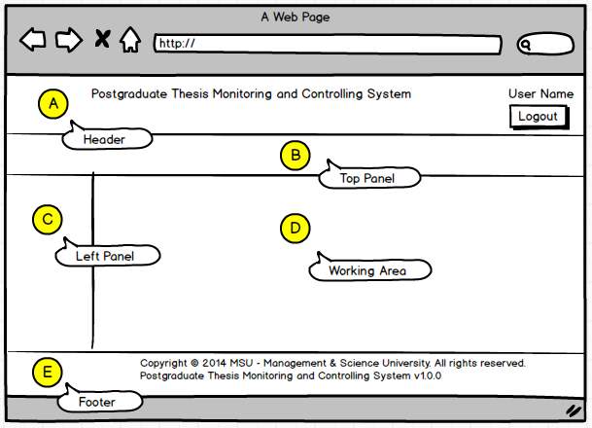

Figure 2: THEMES Screen Structure Design

# HIGHLEVEL FLOW

## Thesis Proposal Submission Process Flow

The figure below depicts the highlevel process flow for the thesis proposal submission which cover from the submission until its get approved by the Senate.

The dotted line as shown below is the focus covered in this manual.

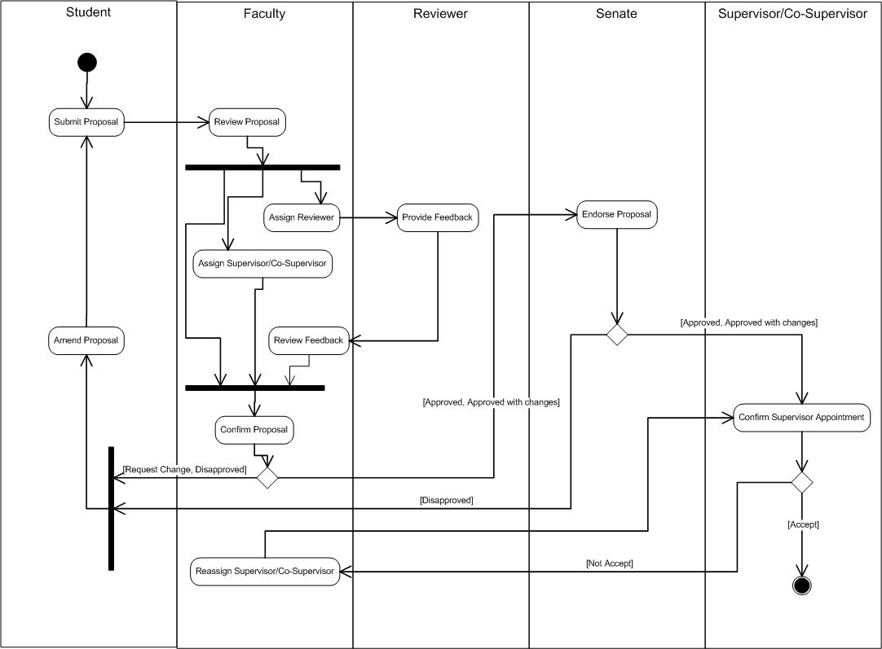

Figure 3: Thesis Proposal Submission Process Flow

# USER LOGIN and LOGOUT

## Login

This is the first page sight by the student to enter the PGTMC system.

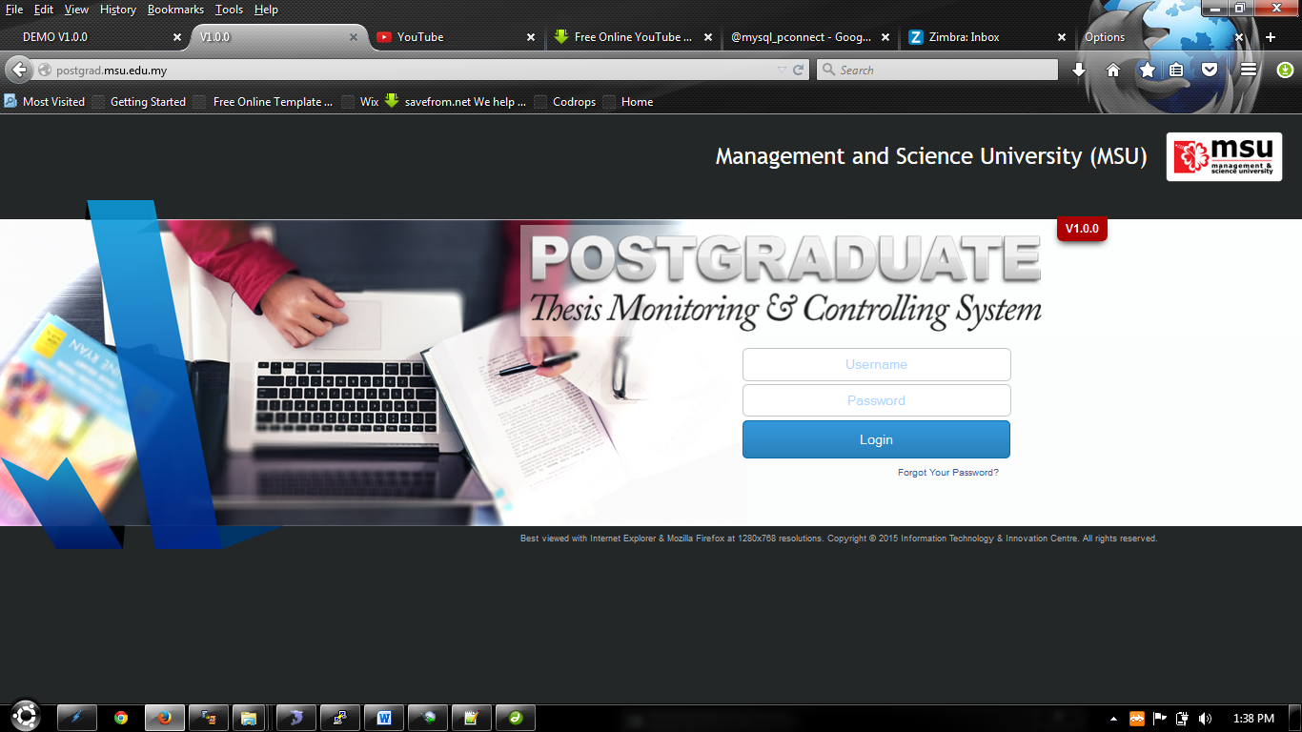

Student need to **login** Postgraduate Thesis System to create a New Proposal.

Figure 4: Login Page

**Steps:-**

1. Open any Internet Browser of your choice either Mozilla Firefox or Microsoft Internet Explorer
2. Enter the URL to access the system as follows <http://postgrad.msu.edu.my/>
3. Login page will be displayed in which the valid user credential needs to be provided i.e. **Username** and **Password**.

## Logout

Once the necessary or required activities has been done or completed, the student can quit from the system by clicking on the **Logout** button.

If the system is keep idle for about 1 minute, the system will logged out the user automatically.

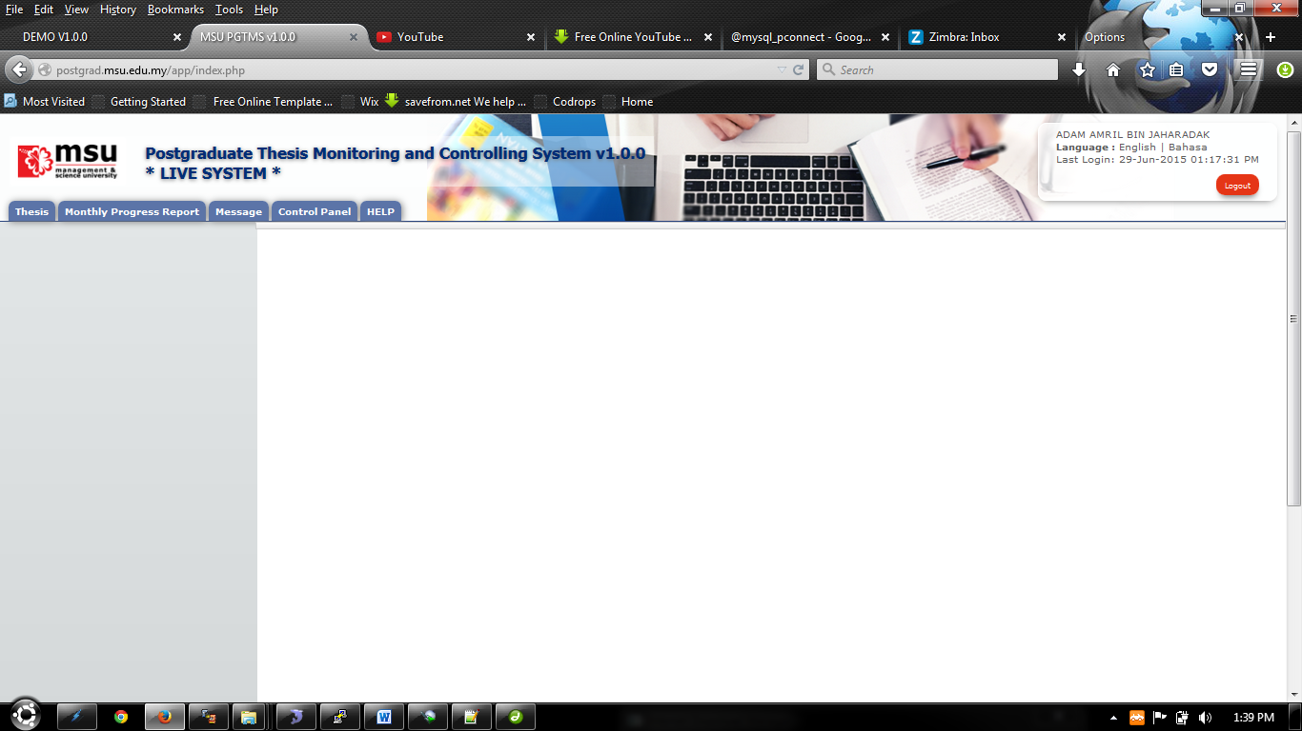

Button **Logout**.

Figure 5: Logout Page

**Steps:-**

1. Find the **Logout** button located on the right top corner of the system **Header** section.
2. Click on it and you will be logout from the system successfully.

# CHANGE PASSWORD

## Change Password

For the security reason, the user is strongly recommended to change the password at first successful login to the system.

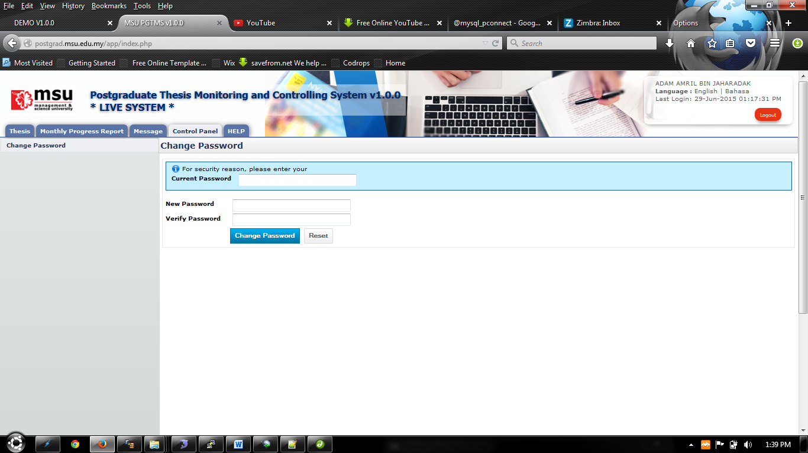

Figure 6: Change Password Page

**Steps:-**

1. Click on the **Control Panel** tab from the system **Top** panel section.
2. The **Change Password** menu will be displayed and click on it.
3. As to ensure the right user able to change the password, the system will ask **Current Password** used before able to change it to the new password.
4. Once the **Current Password** has been provided, the **New Password** and **Verify Password** can be provided afterward.
5. Click **Change Password** button to ensure the new password can be saved into the system successfully.
6. If the **Current Password** is incorrect, the system will prompt an error message and the user needs to redo the same steps above.
7. User can use **Reset** button if wanted to clear the entry on each fields.

# VIVA Evaluation

## Viva Evaluation

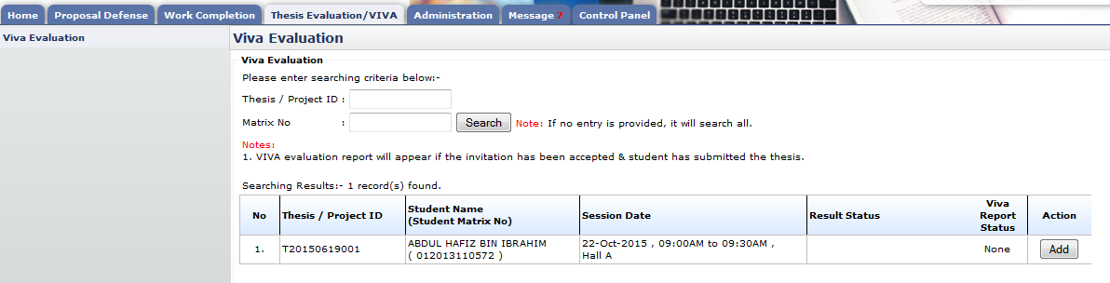

Figure 7: VIVA Evaluation

**Pre-condition**

1. After Supervisor verified thesis for VIVA
2. After Accept Invitation
3. After date of VIVA evaluation

**Post-condition**

1. Can submit viva evaluation report

**Steps:-**

1. Click on the **Thesis Evaluation/VIVA** tab on the **Top** panel
2. Click on the **VIVA Evaluation** menu on the **Left** panel
3. System will display list of evaluation report

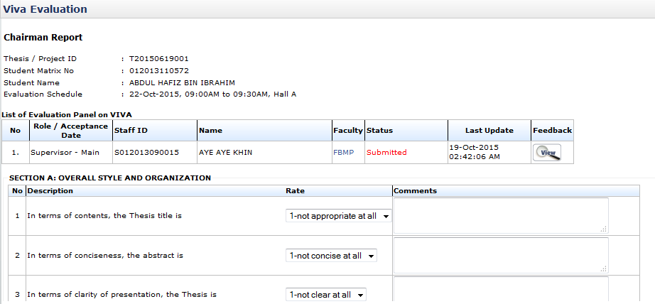

List of evaluation panel

Figure 8: VIVA Evaluation

List of field need to answer

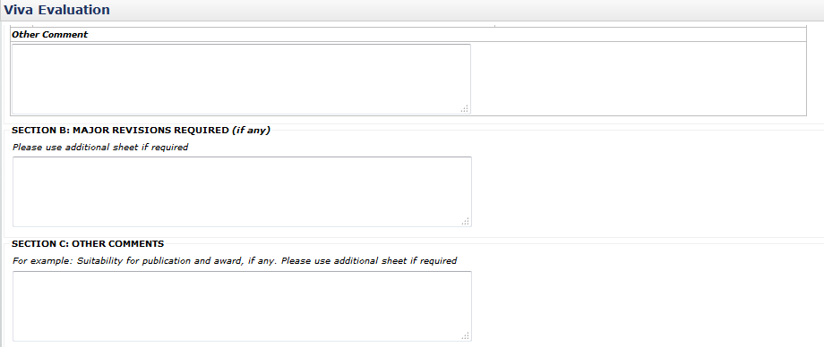

Text field provided for evaluation report

Figure 9: VIVA Evaluation

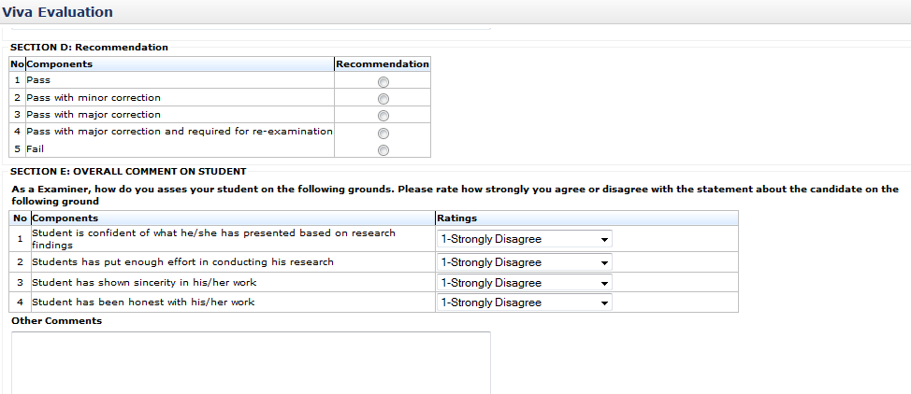

Figure 10: Review Thesis

Recommendation result

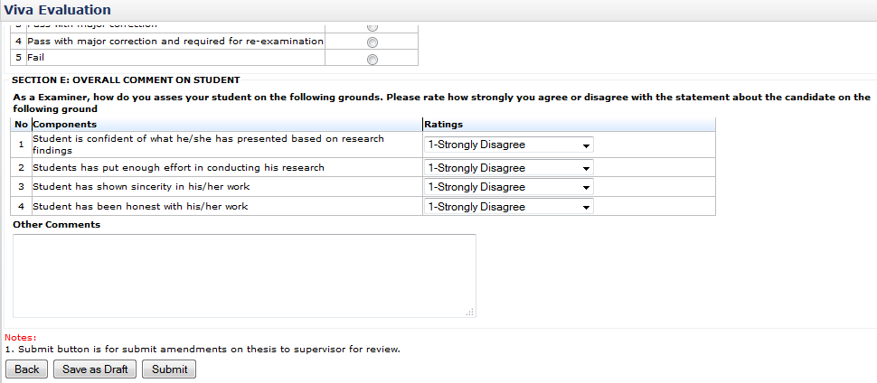

List of field need to be answer

Figure 11: VIVA Evaluation

**Steps:-**

1. Click on **Add** button to proceed (refer figure 6)
2. This page will display every single detail that need to be answer same as report given in VIVA evaluation
3. To view other evaluation report, click. (refer figure 7 and figure 11)
4. To save the detail, click **Save as Draft.** (refer figure 10)
5. To submit evaluation report, click **Submit** button (refer figure 10)

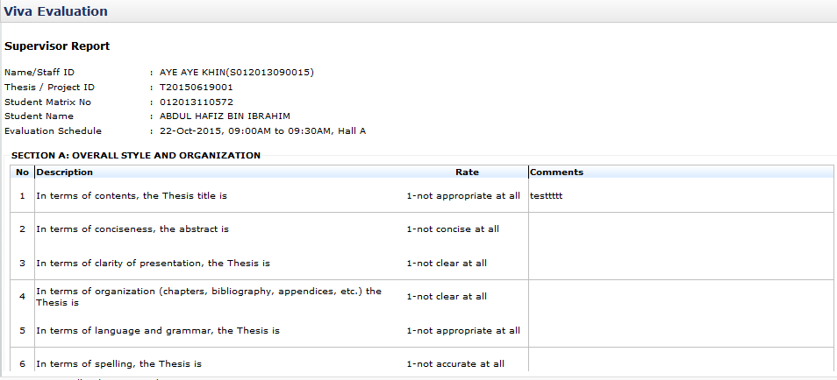

Figure 12: Review Thesis

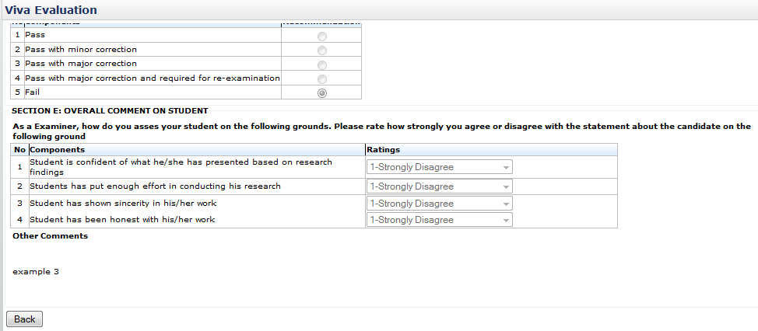

Figure 13: VIVA Evaluation

**Steps:-**

1. This page display others evaluation panel report.
2. To go back to previous page, click **Back** button (refer figure 12)

# Message

## Inbox

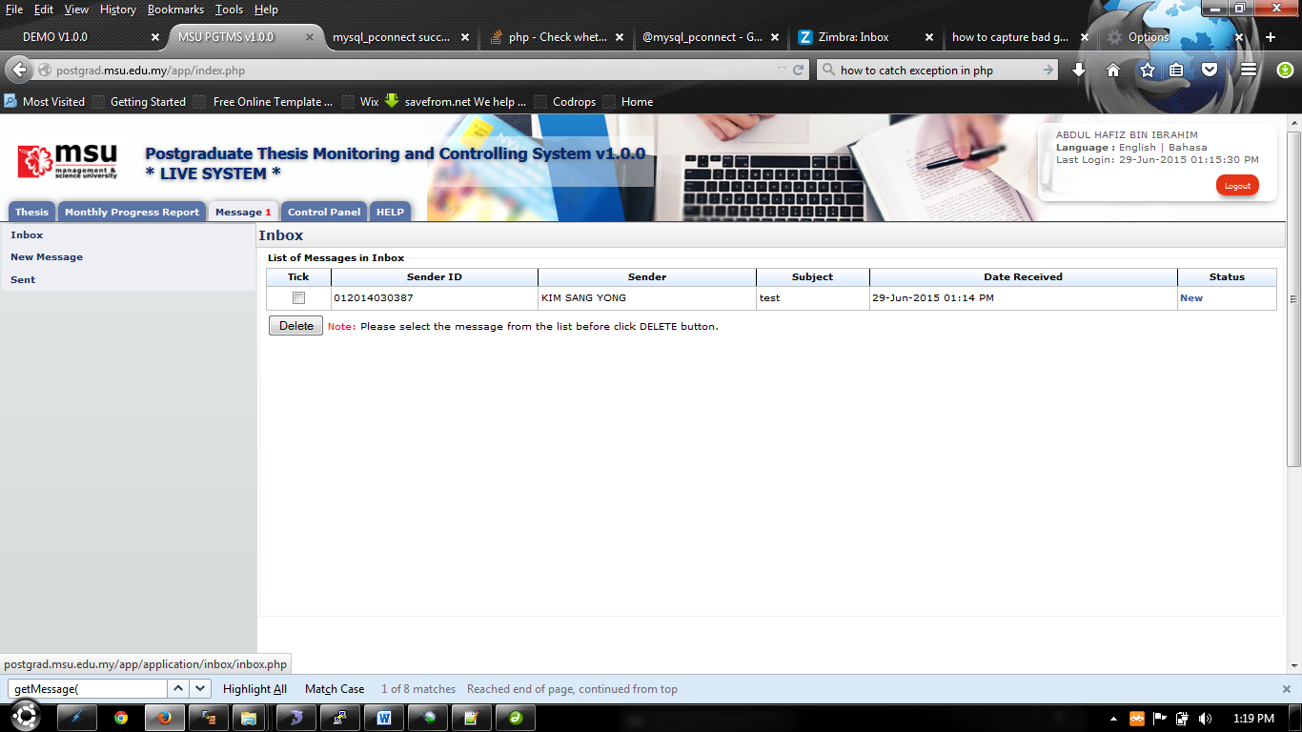

Inbox Menu

Figure 14: Message

**Steps:-**

1. Click on the **Message** tab on the **Top** panel
2. Click on the **Inbox** menu on the **Left** panel
3. System will display the list of message that been receive by user.
4. On the far right side, it will display the status of the message whether is **New** or **Read**
5. To read the message, click on the link on the right side which is in **Status** column. (Refer View Message)
6. To delete message, tick on the checkbox in **Tick** column, and click **Delete** button

### View Message

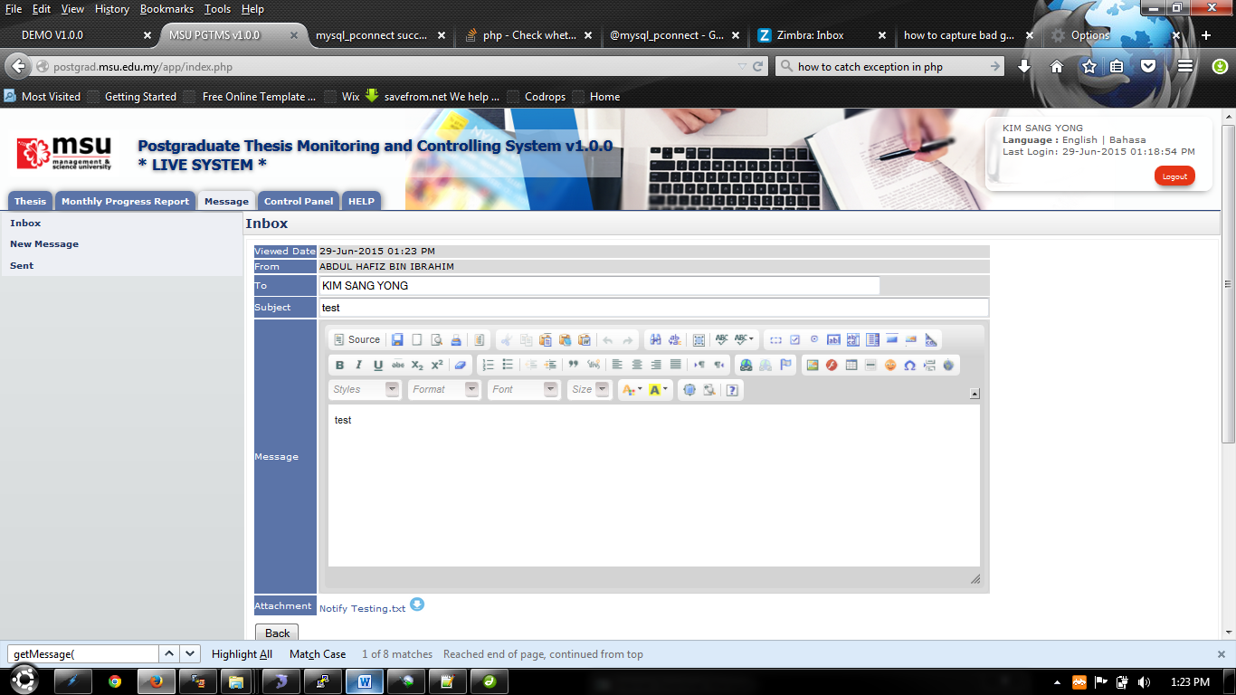

Figure 15: Read Message

**Steps:-**

1. This page only displays the message that has been open by the user.
2. To view or download the attachment that been sent, click 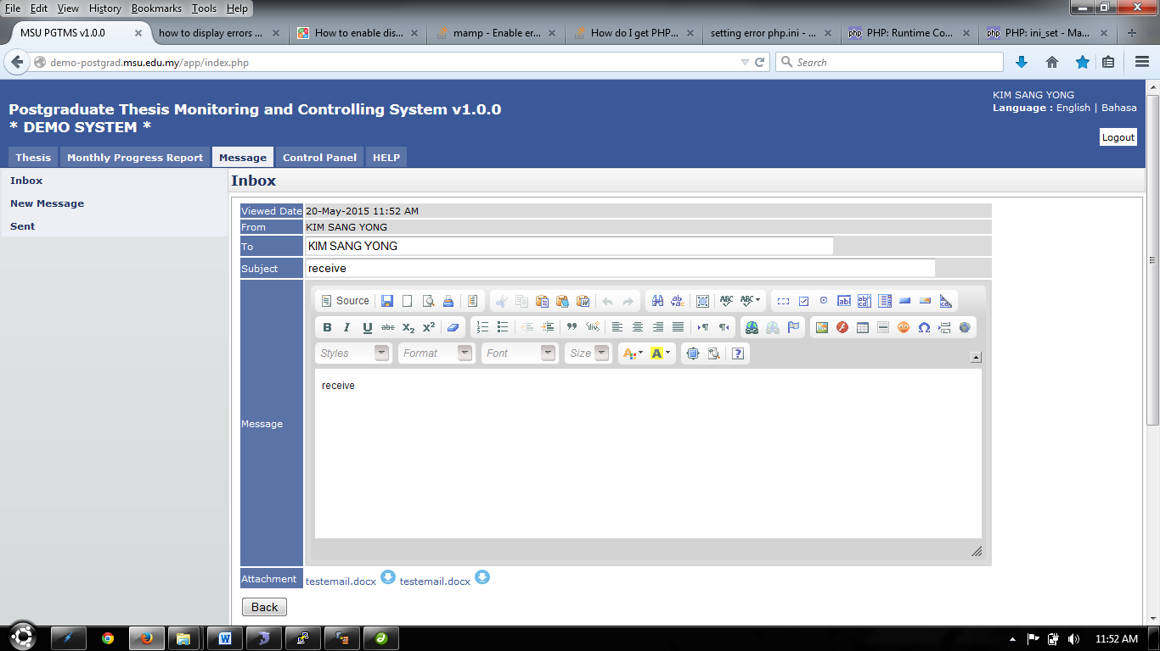 or link shown on figure 74
3. To go back to the previous page, click **Back** button.

## New Message

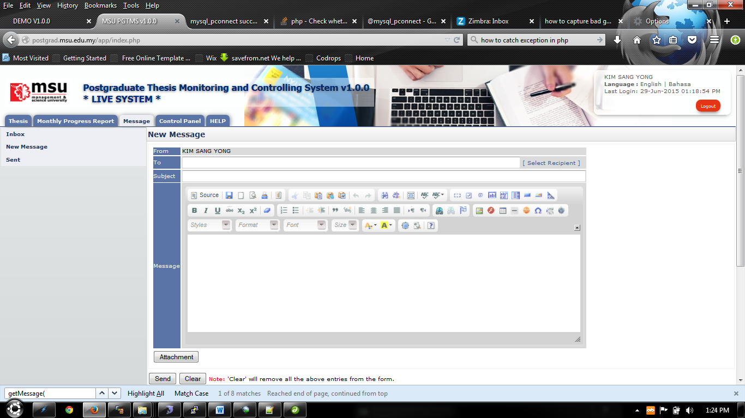

Figure 16: New Message

**Steps:-**

1. Click on the **Message** tab on the **Top** panel
2. Click on the **New Message** menu on the **Left** panel
3. To select recipient, click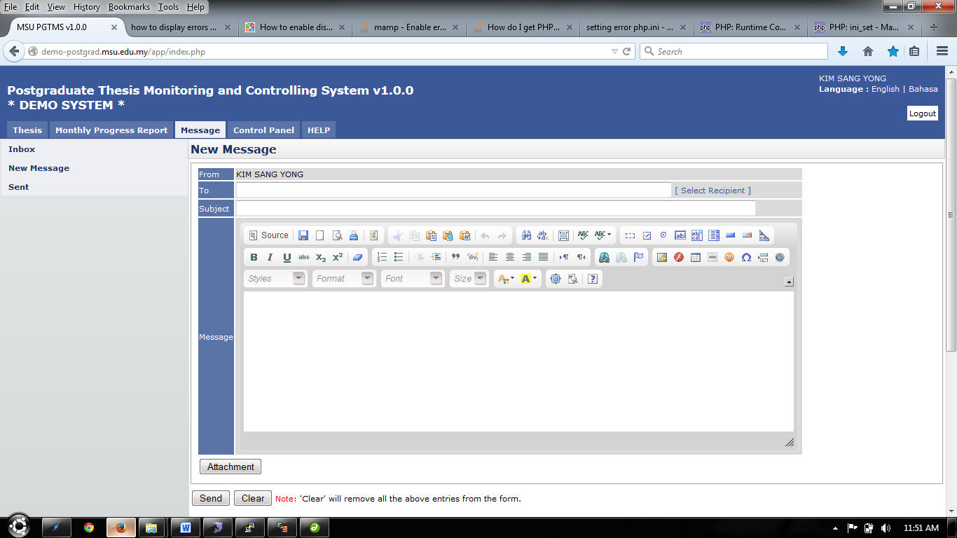. Next step refer Select Recipient
4. Insert or enter necessary detail in **Subject** and **Message**.
5. To upload or include attachment for message, click **Attachment** button. Next step refer Upload Attachment.
6. To erase or clear the entire entries, click **Clear** button.
7. To send the message, click **Send** button.

### Select Recipient

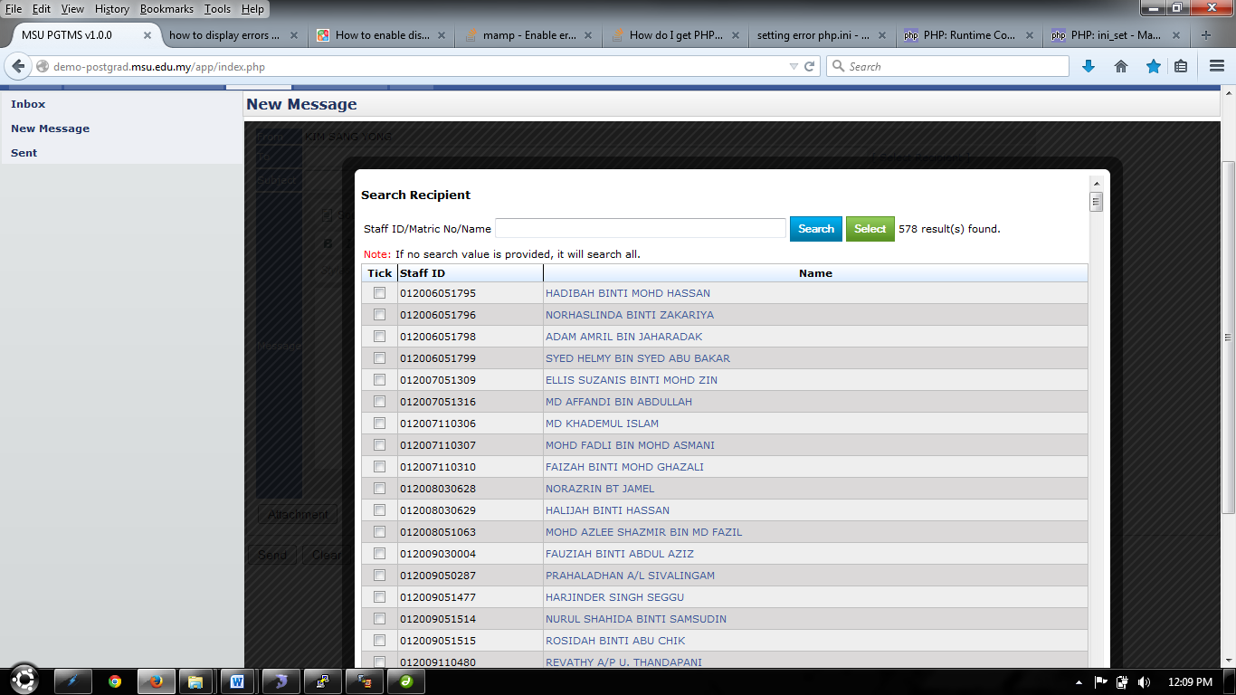

Single recipient can be select by click on the name displayed.

Figure 17: Select Recipient

**Steps:-**

1. Enter or insert **Name** or **Staff ID** or **Matric No** and click **Search** button.
2. The system will display the result based on searching criteria.
3. To select one recipient only, click on the **Name** displayed.
4. To select multiple or single recipient, tick on the checkbox on the left.
5. Then click **Select** button to proceed.
6. To go back to the previous page, click on the **Black** field surrounding the page. Refer Figure 77



Click the **Black** field, to go back to previous page

Figure 18: Select Recipient- Next Section

### Upload Attachment

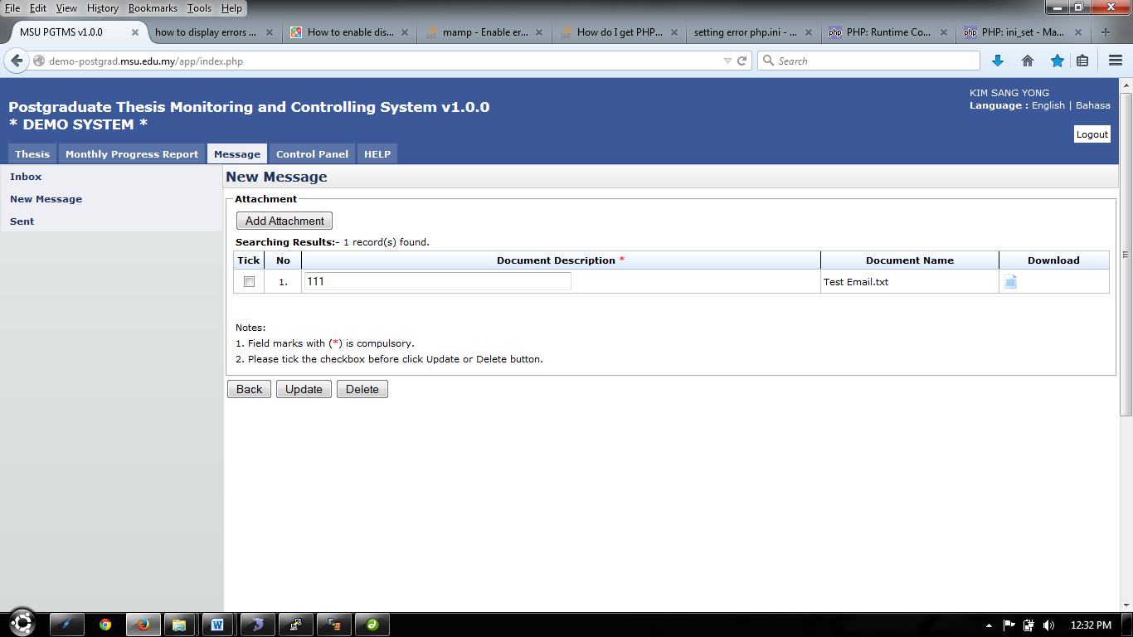

Figure 19: Upload Attachment

**Steps:-**

1. To add attachment, click **Add Attachment** button. (Refer Figure 78)

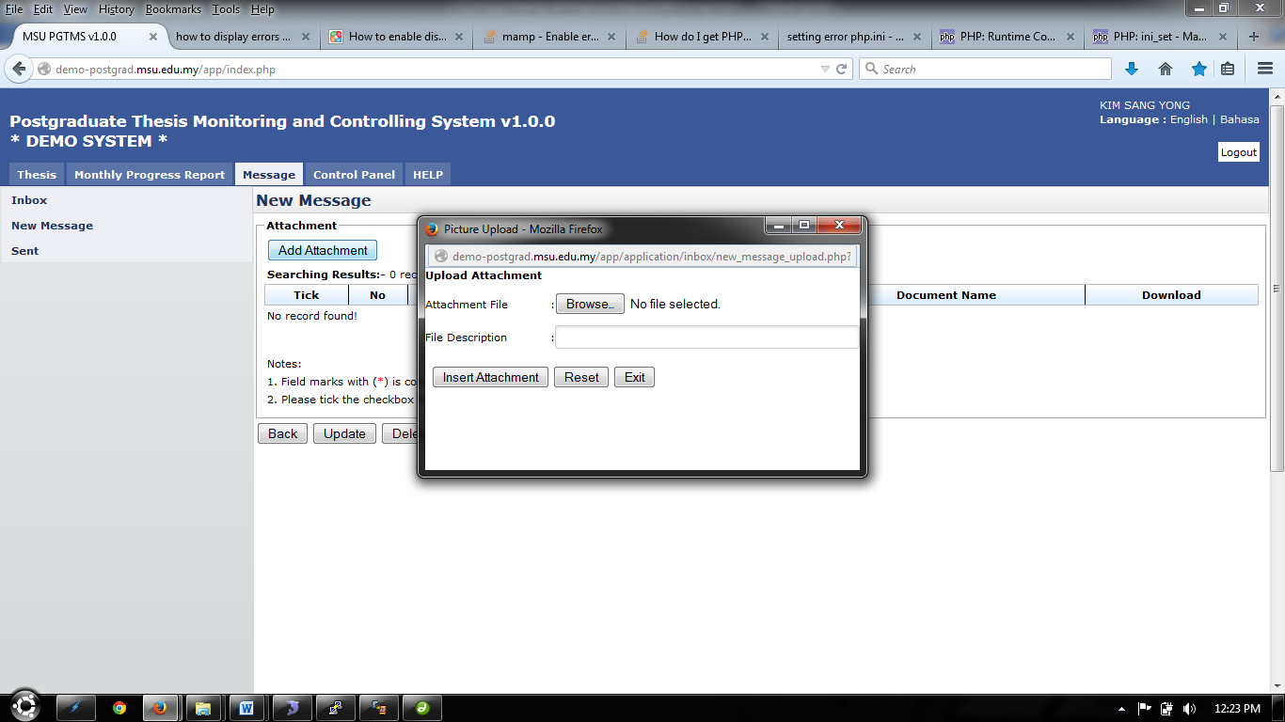

Figure 20: Upload Attachment- Next Section

1. To choose attachment, click Browse.. button and choose the file to upload.
2. To file description can be insert in the field provided.
3. Click Insert Attachment button to proceed.
4. To clear all the entries, click Reset button.
5. To exit or close the popup, click Exit button.
6. To upload more file, repeat step 1 until step 4.
7. To edit file description, change necessary detail, then tick the checkbox and click Update button to proceed.
8. To delete file, tick the checkbox and click Delete button.
9. To download or open the file that has been uploaded, click 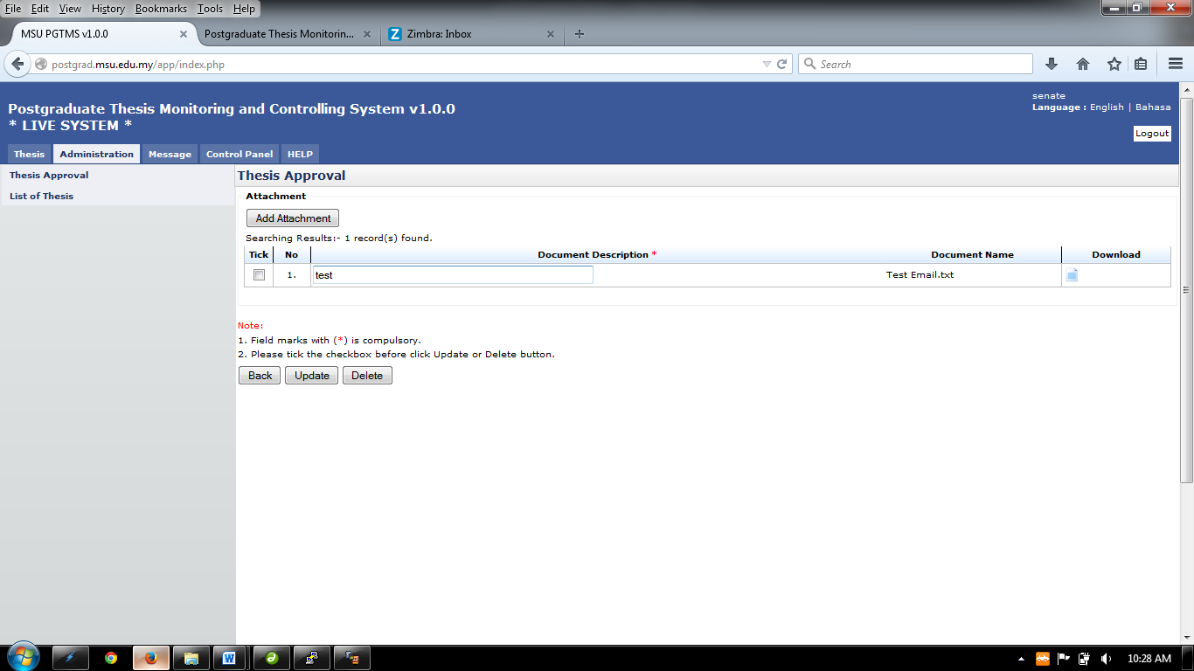on the Download column.
10. To go back to previous page, click Back button

## Sent

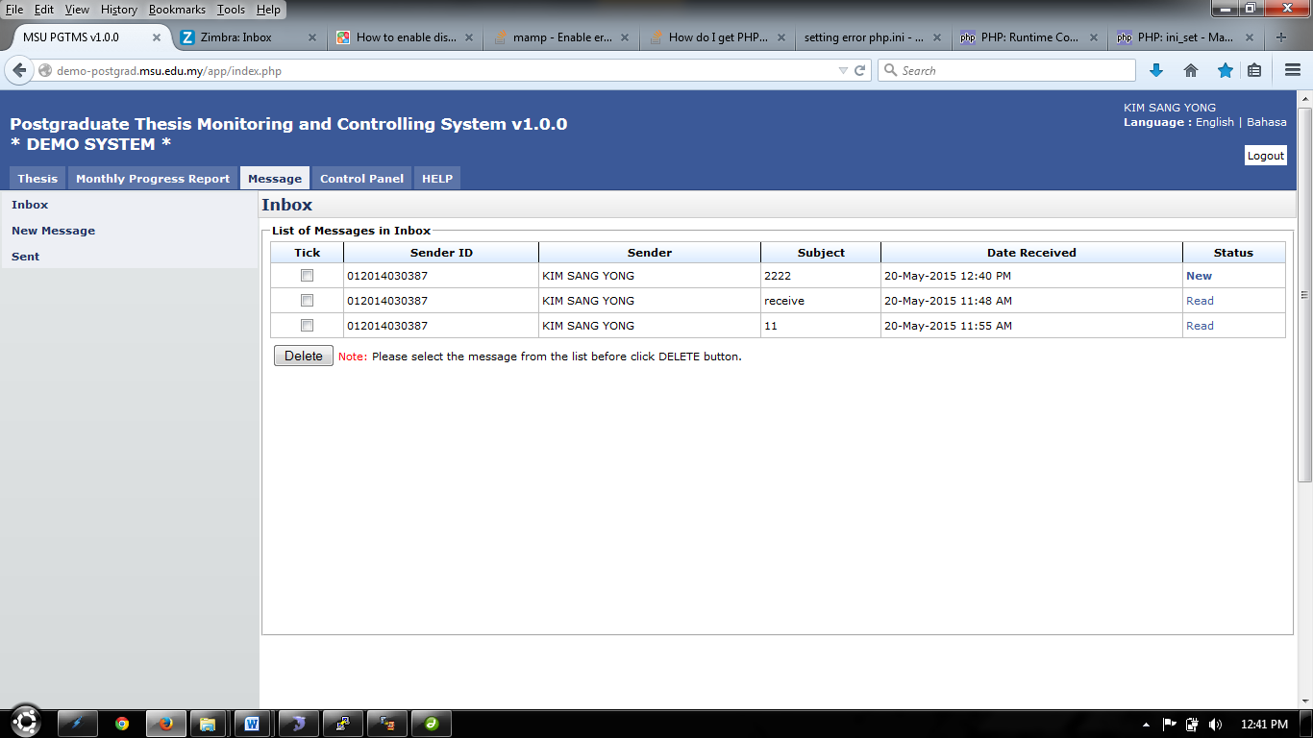

Figure 21: Sent

**Steps:-**

1. After message has been sent, it will be display in **Sent** Left panel
2. Click **Message** tab on **Top** panel
3. Click on the **Sent** on the **Left** panel
4. The system will show the list of message that has been sent by user.
5. The status of the message also had been show on the far right side which is in **Status** column. If the message has been read by recipient, it will display **Read.** If not, it will display **New.**
6. Click the link on the **Status** column to read the message. (Refer Read Message)
7. To delete message, tick the checkbox and click **Delete** button.

### Read Message



Figure 22: Read Message

**Steps:-**

1. This page only displays the message that has been open by the user.
2. To view or download the attachment that been sent, click  or link shown on figure 81.
3. To go back to the previous page, click **Back** button.

APPENDIX

This page is intentionally left blank.