K. L. E. SOCIETY’S
B. V. Bhoomaraddi College of Engineering & Technology, Vidyanagar,
Hubli – 580031
(An Autonomous Institution)



DEPARTMENT OF INFORMATION SCIENCE & ENGINEERING
Synopsis
for
Mystery Doors – the beauty of intelligence
Submitted by
MR.HARISH PATIL 2BV09IS034
MR.PAVANKUMAR.B.L 2BV09IS062
MR.PRADEEP.N.C 2BV09IS067
MS.PRIYANKA PATIL 2BV09IS075

2011 – 2012

- Team Number : A6

- Project Title : Mystery Doors – the beauty of intelligence

- Project Details :
  - Problem Statement: To develop a gaming application which will push the user’s intelligence level to its best. Different levels of puzzles are taken with interesting constraints imposed on the user and will challenge the user to answer those questions to reach the final goal.

  - Abstract : This application is basically a puzzle-based game. The game is made more interesting by adding a catchy storyline and scenarios. In this game there will be four character’s playing – Alex, Maya, Dhaka and David. At the beginning there will be conversations between first three characters which introduce the theme of story. Later fourth character is introduced as player’s instructor. There will be 5 levels of game i.e. 5 doors to be opened in this context. In each level there will be a set of questions or puzzles which needs to be solved by player in order to open the door and move to next level. This level and type of puzzles will be increased as level increments. There will be one puzzle which makes use of accelerometer. Also there will be a surprise or bonus for a player after every door he opens. The game will be having very interesting climax to end.

- This gaming application is very interesting and helpful to increase mental skills of a player.
- The estimated paid downloads per day would be 3 downloads per day.
- The estimated clicks would be more than 20 clicks per day.
- The estimated paid downloads per month would be 90downloads per month.
- The estimated clicks would be more than 600 clicks per month.

  - Main Scenario: The puzzle-based game “Mystery Doors – the beauty of intelligence” has different levels which challenge the user or the player of his abilities. As the player should cross 5 Mystery Doors, there are 5 different levels of puzzles to go through.
The brief description of levels is given below:
- When the player (Alex) gets to the first door, he encounters his mentor, David who helps in solving the mysterious puzzles. This level is used to make the player get acquainted to the game. He should answer 3 different types of questions to open the 1st Mystery Door.
- A General Knowledge- based question, for e.g.:
- The country also known as “country of copper” is?
- A Visual-based question, for e.g.:

- A tricky Riddle, for e.g.: A murder is condemned to death. He has to choose between three rooms. The first is full of raging fires, the second is full of assassins with loaded guns, and the third is full of lions that haven’t eaten for 3 years. Which one should he choose?
- After answering the 3 questions, the first Mystery Door will be unlocked and he reaches to the 2nd door. With the help of David, he gets the questions to unlock the 2nd door. To challenge the user, the questions are made more complicated and tricky.
- A general knowledge-
- A visual based question-
- A riddle-
- When the player reaches the 3rd door, the level of difficulty increases. The player is provided a time constraint and the use of password. The player is provided with a different set of questions, thru’ which he can unveil the password, the password revealed will be used to unlock the 3rd door. The time-constraint is 2min/question. When the player opens the 3rd Mystery Door, he is rewarded with a bonus life to keep him interested and surprised.
- Mathematical puzzle, for e.g.
- A visual based question-
- A riddle
- When the player reaches the 4th door, a different type of question is introduced. A set of different images will be given and David gives a clue, the image which matches the given clue will be the right answer. Time constraint is same as in previous level. The player should answer each question within 2 minutes. For each correct answer ‘two’ letters of password is revealed. After answering all the questions a sequence of revealed letters makes a complete password which is used to unlock the 4th door.
- Mathematical puzzle, for e.g.
  - A rectangular sheet of paper is folded so that two diagonally opposite corners come together. If the crease formed is the same length as the longer side of the sheet, what is the ratio of the longer side of the sheet to the shorter side?

- A symbol matching puzzle, it’s just like “The lost symbol” puzzle
- A riddle
- When the player crosses the 4th door, the villain ‘Dhaka’ gets to know that David, the door keeper is helping Alex, the player. So Dhaka kills David. Alex is on his own in the final level. In 5th level the difficulty of puzzles reaches to its heights and the time constraint is stressed compared to the 2nd and 3rd level. The player should answer each question within 1 minute. The type of questions remains same as in previous level. But for each correct answer two letters of password revealed will not be in sequence at end. Here the last sentence said by David while dying is the major clue for matching jumbled letters of password for final mystery door.
    - Mathematical puzzle
    - A symbol matching puzzle, it’s just like “The lost symbol” puzzle
    - A riddle

In addition to these puzzles we are thinking of introducing a puzzle which makes use of accelerometer which makes game more interesting and real worthy to play.
  - Subject Relevance :
Sl. No. | Subjects | Concepts Used in Brief
1. | Data structures | Concept of stack and queues are used to store images and questions and display them as game progresses
2. | Design and analysis of algorithms | Algorithm for designing and implementation of game
3. | Object oriented programming | Polymorphism and inheritance
4. | Java / C++ / C# / C | C#
5. | Operating System | Platform used is Windows 7, concepts of context switching and memory, process management are used
6. | Fundamentals of software engineering | Evolutionary Development where prototyping model is used for building software
7. | Computer organization | For the concept of memory management
8. | Database management system | To store images and questions and other necessary files
11. | Engineering mathematics | In accelerometer puzzle
12. | Physics | In accelerometer puzzle

  - Application Platform Used :
The platform used is WINDOWS PHONE 7. Windows Phone is a mobile operating system developed by Microsoft, and is the successor to its Windows Mobile platform, although incompatible with it. Unlike its predecessor, it is primarily aimed at the consumer market rather than the enterprise market.

- Team Details :

USN | Roll No. | Name | Contact No. | Signature
2BV09IS034 | 12 | Harish Patil | 9449110329
2BV09IS062 | 23 | Pavankumar B. L. | 9535409796
2BV09IS067 | 26 | Pradeep N. C. | 9738828992
2BV09IS075 | 29 | Priyanka Patil | 8722595546

Staff Incharge
(Name of Staff Incharge)

Probable game screen shots

- Scene showing introductory story
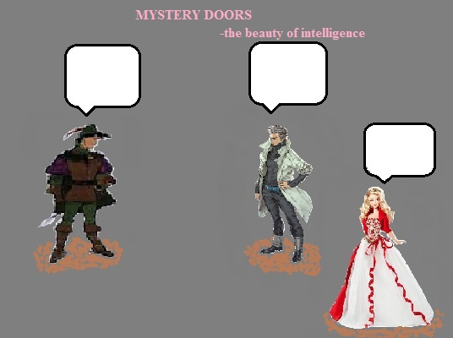

- Scene showing different levels of game
