**Chapter 1**

**INTRODUCTION**

Evaluation of answer sheets is one such field where digitization of answer sheets is very important. We all have faced or heard many mistakes made by evaluators during evaluation of answer sheets. There are so many cases of so called “counting mistakes”, “delaying results”, “tampering the answer sheets” etc.

As technology is seen and implied everywhere in this era, why not the answer sheets should be digitized? This made us come up with an idea of “SMART EVALUATION SYSTEM”, where the answer sheets are digitized and the softcopy is evaluated by the teachers. The entire process is made more transparent, cost-effective, faster and effective. By this system we can save the time of the examination authorities, reduce the effort, and sooner results.

The main purpose of this product is to serve computerized assessment of answer scripts so as to save the time while evaluating the answer scripts. Thus making it easy to evaluate we can remove the redundancy in the manual system. It is also easy to maintain the documentation (i.e., storing the marks sheet and the question papers for references) and accessing the data. By this method we can also facilitate the online results and also the evaluators do not have to travel far places for evaluations.

Till date our product is not a need in the market, it is a want in the market. So this encourages us to fulfill the needs of the customers by building this project. As the product is new to the market, there is no competition in the market.

It has many benefits, including:

* Improving access. Digitized items which are available on the internet can be accessed anywhere at any time.
* Assisting research. For example, by making the text in magazines and newspapers searchable, researchers can quickly identify sections of interest without having to browse through every issue.
* Preserving items. Digitization means that original material may not have to be used as often by researchers. It is also an effective means of preserving sound recordings.
  1. **Existing System**

This type of system has been tried to implement in the VTU centers. Due to too many technical problems the system failed. We have come up with all the solutions for that and are looking forward to build the best system. Some of the problems faced by the VTU are:

* Scanning the answer scripts was a huge challenge, as the soft copy was unclear. But we were able to get clear soft copy by scanning with a high end scanner.
* Another problem with the system was memory handling. Scanning a paper, will result in an image file of the paper, each page of image takes 1.5-2 Mb size. But by creating a .pdf file we will be able to make the whole answer script in 700-800Kb.
  1. **Motivation for the Project**

We are all familiar with the problems dealt in the evaluation of the answer scripts, such as delaying results, malpractice etc. This made us come up with a tamper-proof, fool-proof system called Smart Evaluation System. This system helps us in evaluating the soft-copy of the answer scripts without having the teachers travel around to different places. It also facilitates the online results. By providing a safe login we can ensure a tamper-proof system.

* 1. **Problem Statement**

To develop software to serve computerized assessment of answer scripts which eases the process of evaluation. The software aims at removing the redundancy in manual system, easy to maintain and access the information thereby facilitating online results.

* 1. **Scope**

Smart Evaluation System will be designed to ease the process of evaluation of answer scripts in educational institutions. It ensures conduct of fool proof and tamper proof assessment. The system helps in maintaining the academic details of student which facilitates online results.

**Chapter 2**

**REQUIREMENT ANALYSIS**

The software requirements specification (SRS) provides an overview of the entire SRS with purpose, scope, definitions, acronyms, abbreviations, references and overview of the SRS. The aim of this document is to gather and analyse and give an insight of the Smart Evaluation System by defining problem statement in detail. The detailed requirements of the Smart Evaluation System are provided in this document.

The purpose of the document is to collect and analyse all ideas that have come up to define the system, its requirements with respect to consumers. Also provides a detailed overview of our product, its parameters and goals. This document describes the project target audience and its user interface, hardware and software requirements. It defines how our client, team and audience see the product and its functionality. It will explain the purpose, features and interfaces of the system, what the system will do; constraint under which it will operates. This document is intended for both the developers and the users of the system and it will be proposed to the project review committee for its approval.

**2.1 System Model**

The Web Portal has been designed into two levels. At the first level the focus is on deciding which modules are needed for the system, the specification of these modules and how the modules should be interconnected. This is called as system design or top level design. In the second level, the internal design of the modules or how the specifications of the module can be satisfied is decided. This design level is often called detailed design or logic design. The Fig.2.1 shows the system model of the web portal. When the user visits this portal, the home page will appear. We provide login for two kinds of users, i.e. Administrator and the Evaluator. When the administrator logs into the system, he is authorised to upload the scanned papers. This authorisation is banned for other type of users. Whereas, the Evaluator is authorised to evaluate the answer scripts but cannot upload or delete the answer scripts.The Evaluator has the right to enter the marks. Once the marks have been entered, it cannot be altered. The total marks for the particular answer script will be stored in the Database.

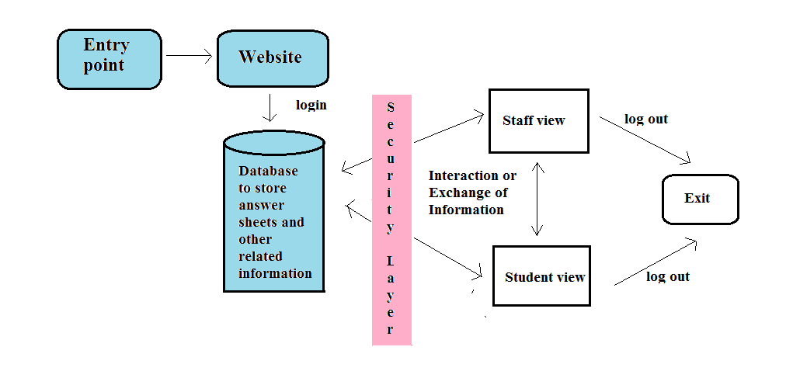

Figure 2.1: System Model

* 1. **Functional Requirements**

This segment defines the capabilities and functions that a system must be able to perform successfully. It describes the relationship between the input and output of the system. Below are use-cases for functional requirements of our system.

**Use Case 1: Home Page**

**Primary actor:** System

**Pre-condition:** The website must be active.

**Main success scenario:**

1. On successful load, the homepage is displayed.

2. The website shall display frames, contents, sections properly.

**Exception scenario:**

1. The page takes long time to load due to server failure.

**Use Case 2: Scanning of answer scripts**

**Primary actor:** Admin

**Pre-condition:** The admin must log in.

**Main success scenario:**

1. On successful login, the admin homepage is displayed. Accessing

the database via PHPs.

2. The admin scans the answer scripts using scanner and the scanned

pdf is stored in local server.

**Exception scenario:**

1. Login fails- Admin must be redirected to the main page and asked to enter his/her credentials again.
2. The scanner is not detected- plug-in and scanner drivers must be installed.

**Use Case 3: Evaluating of answer scripts**

**Primary actor:** Evaluator

**Pre-condition:** The Evaluator must log in.

**Main success scenario:**

1. On successful login, the evaluator homepage is displayed.
2. The evaluator starts evaluation, evaluates and submits the marks for the particular paper

**Exception scenario:**

1. Login fails- Evaluator must be redirected to the main page and asked to enter his/her credentials again.
2. The paper to be evaluated is not displayed due to server failure.

**Use Case 4: Viewing the results**

**Primary actor:** Student

**Pre-condition:** The student must log in.

**Main success scenario:**

1. On successful login, the student homepage is displayed.
2. If not existing user, he/she must be registered.
3. The student views his/her results.

**Exception scenario:**

1. Login fails- Student must be redirected to the main page and asked to enter his/her credentials again.
2. Registration fails if there is existing user: asked to register with unique id.
   * 1. **Interface requirements**

* Digitised answer scripts are uploaded on the Digital Evaluation Server(s).
* Each examiner is issued a user ID and password with which he/she shall login to evaluate the answer scripts allocated by the Chief Coordinator or his/her representatives. Examiner is permitted to change the password, if required.
* Chief Coordinator shall have the authority of restricting an examiner from accessing the answer scripts at any moment, if he deems it fit.
* Examiner shall evaluate the answer scripts on the monitor, and award the marks for all the questions, which have been answered by the candidate as per instructions. Marks shall be input to the system.
* After completing the evaluation of a particular answer script, the examiner shall “submit” the answer script and access the next answer script for evaluation.

**2.2.2 Business Requirements**

* Data must be entered before a request can approved
* Clicking the Approve Button moves the request to the Approval Workflow.
* All personnel using the system will be trained.

**2.2.3 Regulatory/Compliance Requirements**

* The database will have a functional updating.
* The system will limit its access to authorized users.
* The answer scripts can be secured with a password protection.
  + 1. **Security Requirements**
* Members who upload the answer scripts can upload but not approve or delete scripts.
* Members who manage the scripts can upload or approve an uploading request, but not delete the scripts.
* Teachers can view the scripts and evaluate them, but cannot delete the scripts or approve them.
* Students can only view the scripts and the marks if provided, but, of course, cannot make changes to it.
  1. **Software Quality Attributes**

Much of a software architect’s life is spent designing software systems to meet a set of quality attribute requirements. General software quality attributes include scalability, security, performance and reliability. Quality attribute requirements are part of an application’s non-functional requirements, which capture the many facets of how the functional requirements of an application are achieved. All but the most trivial application will have non-functional requirements that can be expressed in terms of quality attribute requirements. To be meaningful, quality attribute requirements must be specific about how an application should achieve a given need.

* **Scalability:** This is useful in an architectural context. It tells us that scalability is about how a design can cope with some aspect of the application’s requirements increasing in size. To become a concrete quality attribute requirement, we need to understand exactly what is expected to get bigger.
* **Response Time:** The system shall respond to the member in few minutes from the time of the request submittal. The system shall be allowed to take more time when doing large processing jobs.
* **Throughput:** The number of transactions is directly dependent on the number of users; the users may be the administrator, evaluator or a student who uses the system for updating the address.
* **User Response:** The system shall take as less time as possible to provide service to the user.
  1. **Database Requirements**

Database plays an important role in our system. A local database such as MYSQL is required to store the information. The answer scripts to be evaluated sand the total marks are all stored in the specific Database. Fig 2.5 shows the ER Diagram of Smart Evaluation System database. This database contains 6 entities- DEPARTMENT, STUDENT, SUBJECT, EVALUATOR, EXAM_SECTION and RESULTS. And the relation between each entity is shown in the figure below.

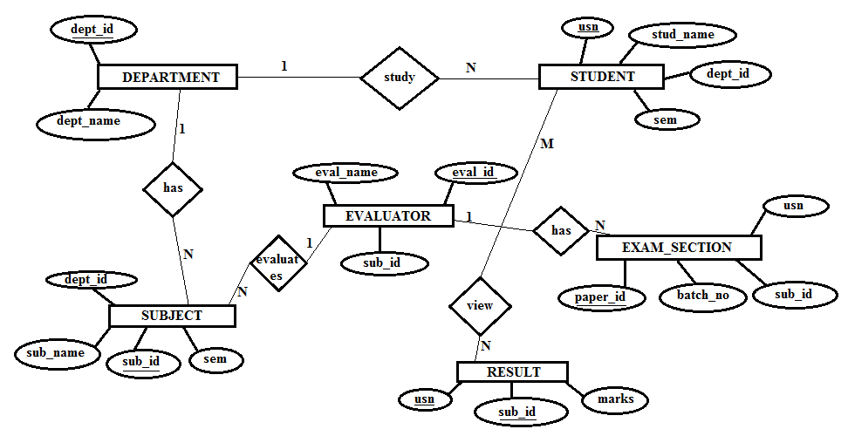

Figure 2.4: ER Diagram for SES Database

* 1. **System Specification**

There are many additional hardware and software which are required for the development of any of the software application; they also constitute a major part in the application. This section provides the overview of the external interfaces used for the development of the Web Portal required for Smart Evaluation System.

**2.5.1 Software Requirements**

To run the application you will need a minimum screen resolution of 1024X768 and the following software installed on your computer:

* Operating system : Microsoft Windows XP or Microsoft Windows 7
* Coding Language: Java.
* Development Environment IDE/tool: Netbeans IDE 6.9.1
* WAMP (Windows Apache Mysql Php) Server- for database communication.
* Plug-in for DynamSoft- interface for the Scanner.

**2.5.2 Hardware Requirements**

The selection of hardware is very important for the proper working of the proposed system. The technologies that we will be using for developing our project depend on the hardware configuration. When selecting hardware, the size and capacity requirement are also important.

* Processor : Pentium IV 2.4 GHz.
* Hard Disk : 40 GB.
* Monitor : 15 VGA Colour.
* Keyboard : Standard 102 keys
* Mouse : Logitech.
* RAM : 512 MB
* Scanner : Brother DCP-J125
  1. **Project Plan**

The key to a successful project is in the planning. Creating a project plan is the first thing you should do when undertaking any kind of project. Often project planning is ignored in favors of getting on with the work. However, many people fail to realize the value of a project plan in saving time, money and many problems. Improper planning leads to failure of the project.

## A project is successful when the needs of the stakeholders have been met. A stakeholder is anybody directly or indirectly impacted by the project. As a first step it is important to identify the stakeholders in your project. It is not always easy to identify the stakeholders of a project, particularly those impacted indirectly. The stakeholders can be project sponsor, customer who receives the deliverables, users of the project output, project manager and the project team.

The next step is to establish their needs. The best way to do this is by conducting stakeholder interviews. Take time during the interviews to draw out the true needs that create real benefits. The next step once you have conducted all the interviews and have a comprehensive list of needs is to priorities them. From the prioritized list create a set of goals that can be easily measured.

A technique or doing this is to review them against the smart principle. This way it will be easy to know when a goal has been achieved. Once you have established a clear set of goals they should be recorded in the project plan. It can be useful to also include the needs and expectations of your stakeholders. This is the most difficult part of the planning process completed. After this it's time to give the project deliverables.

* + 1. **Project Scheduling**

An Activity Network Diagram (AND) is also called an Arrow Diagram is used for identifying time sequences of events which are pivotal to objectives. The below Fig 2.6.1 shows the activity network diagram of overall project and duration is mentioned in terms of weeks. Here each component begins after completion of previous component.

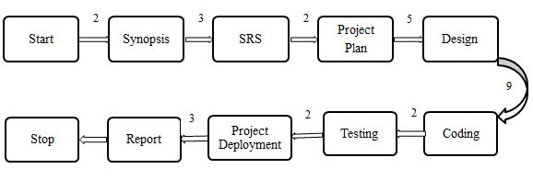

Figure 2.6.1: Activity Network

**2.6.2 Risk Management**

Any software, however carefully designed always has some risks, the risks may be of technical type, where in the risks occur due to some assumptions made or risks may be encountered during development of the project.

Fig 2.6.2 shows the activity network diagram of Design. The duration is specified in terms of hours.

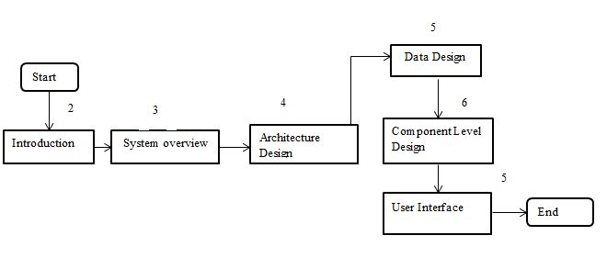

Figure 2.6.2: Activity Diagram for Design

Fig 2.6.3 shows the activity network diagram of Coding. The duration is specified in terms of hours.

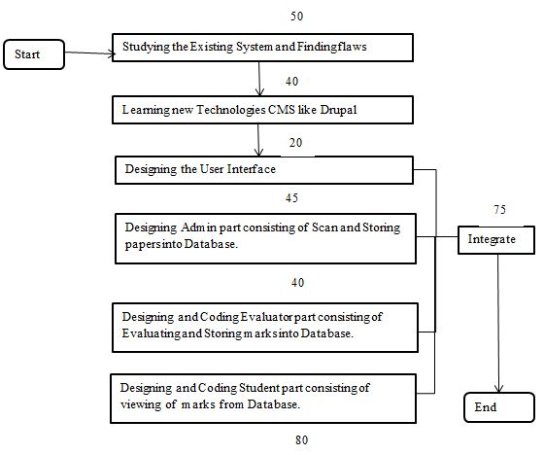

Figure 2.6.3: Activity Diagram for Coding

Fig 2.6.4 shows the activity network diagram of Testing. The duration is specified in terms of hours.

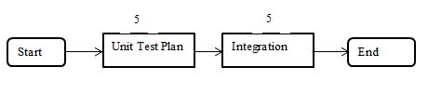

Figure 2.6.4: Activity Diagram for Testing

**Chapter 3**

**SYSTEM DESIGN**

The System Design Document describes the operating environment, system and subsystem architecture, files, input formats, output layouts, human-machine interfaces, detailed design, processing logic, and external interfaces.It is also defined as the process of defining the architecture, components, modules, interfaces, and data for a system to satisfy specified requirements. Systems design could see it as the application of systems theory to product development. There is some overlap with the disciplines of systems analysis, systems architecture and systems engineering.

**3.1 Architecture Design**

The term software architecture intuitively denotes the high level structures of a software system. It can be defined as the set of structures needed to reason about the software system, which comprise the software elements, the relations between them, and the properties of both elements and relations. The term software architecture also denotes the set of practices used to select, define software architecture. Finally, the term often denotes the documentation of a system's "software architecture". Documenting software architecture facilitates communication between stakeholders, captures early decisions about the high-level design, and allows reuse of design components between projects.

The Fig 3.1 shows the detailed architecture design of the system Smart Evaluation System. The Portal provides 3 types of user login, via internet, namely, Admin login, Evaluator login and Student login. All these 3 user profiles are connected to the database server. To authorise the users, we provide a username and a password. These usernames and passwords are stored in the database where the authentication takes place. When the admin logs into the portal, the Admin Home Page is displayed. Here, there are two options, Scanner and Display. When clicked on Scanner, the scanner is connected to the system, were the answer scripts are scanned, converted into softcopy and stored in the local database server. When the Display option is clicked, the answer scripts already uploaded are displayed and thus can verify them. When the Evaluator logs into the portal by authenticating his/her username and password, the list of answer scripts related to his/her subject will be displayed. When he clicks on the particular paper id, the respective answer script will be fetched from the local database server. After evaluation, the evaluator submits the marks and the marks will be stored in the database of the particular subject and the student. When the student logs into the system he/she can view the results.

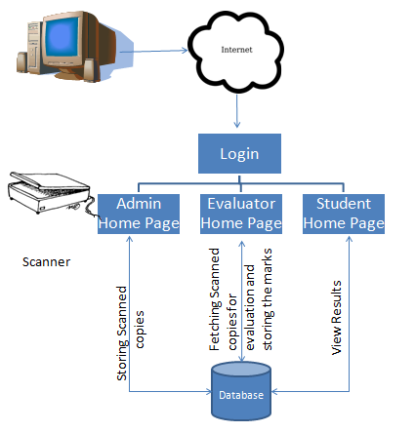

Figure 3.1: Architecture Design for SES

**3.2 Data Design**

**3.2.1 Database Schema**

* DEPARTMENT- this entity has 2 attributes, namely, department name and department id, where, department id is the primary key.

|  |  |
| --- | --- |
| Department_name | Department_id |

* SUBJECT- this entity has 4 attributes, namely, subject name, subject id, department id and semester. Subject id is the primary key, whereas, department id is referencing to department entity.

|  |  |  |  |
| --- | --- | --- | --- |
| Subject_name | Subject_id | Department_id | Semester |

* STUDENT- this entity has 4 attributes, namely, USN, student name, department id and semester. USN is the primary key, whereas, department id is referencing to department entity.

|  |  |  |  |
| --- | --- | --- | --- |
| USN | Student_name | Department_id | Semester |

* EVALUATOR- this entity has 3 attributes, namely, evaluator name, evaluator id and subject id. Evaluator id is the primary key, whereas, subject id is referencing to subject entity.

|  |  |  |
| --- | --- | --- |
| Evaluator_name | Evaluator_id | Subject_id |

* RESULTS- this entity has 6 attributes, namely, USN, subject id, marks, paper id, evaluator id and status. USN and subject id both act as the primary key. USN references to the student entity and subject id references to the subject entity.

|  |  |  |  |  |  |
| --- | --- | --- | --- | --- | --- |
| USN | Sub_id | Marks | Paper_id | Evaluator_id | Status |

* EXAM SECTION- this entity has 5 attributes, namely, paper id, batch number, subject id, USN and path. Paper id is the primary key and subject id references to the subject entity.

|  |  |  |  |  |
| --- | --- | --- | --- | --- |
| Paper_id | Batch_no | Sub_id | USN | Path |

* LOGIN- this entity has 2 attributes, namely user and password. User is the primary key.

|  |  |
| --- | --- |
| User | Password |

**3.2.2 Data Dictionary**

* **Department**

Table 3.1: Data Dictionary of Department Table

|  |  |  |  |
| --- | --- | --- | --- |
| Attribute | Type | Key | Description |
| Department name | Varchar | - | Each department has its specific name |
| Department id | Varchar | Primary Key | Each department has unique id |

* **Subject**

Table 3.2: Data Dictionary of Subject Table

|  |  |  |  |
| --- | --- | --- | --- |
| Attribute | Type | Key | Description |
| Subject name | Varchar | - | Each subject has its specific name |
| Subject id | Varchar | Primary Key | Each subject has unique id |
| Department id | Varchar | Foreign Key | Each subject belongs to particular department |
| Semester | Integer | - | Each subject must be studied in particular semester |

* **Student**

Table 3.3: Data Dictionary of Student Table

|  |  |  |  |
| --- | --- | --- | --- |
| Attribute | Type | Key | Description |
| Student name | Varchar | - | Each student has specific name |
| USN | Varchar | Primary Key | Each student has unique id |
| Department id | Varchar | Foreign Key | Each student belongs to particular department |
| Semester | Integer | - | Each student must be in particular semester |

* **Evaluator**

Table 3.4: Data Dictionary of Evaluator Table

|  |  |  |  |
| --- | --- | --- | --- |
| Attribute | Type | Key | Description |
| Evaluator name | Varchar | - | Each evaluator has specific name |
| Evaluator id | Varchar | Primary Key | Each evaluator has unique id |
| Subject id | Varchar | Foreign Key | Each evaluator teaches particular subject |

* **Results**

Table 3.5: Data Dictionary of Results Table

|  |  |  |  |
| --- | --- | --- | --- |
| Attribute | Type | Key | Description |
| USN | Varchar | Primary Key | Each student has unique id |
| Subject id | Varchar | Primary Key | Each subject has unique id |
| Marks | Integer | - | Each students has marks for particular subject |
| Paper id | Varchar | Foreign Key | Each student has unique paper id |
| Evaluator id | Varchar | Foreign Key | Each paper is evaluated by particular evaluator |
| Status | Integer | - | Status is set to 1 after evaluating paper |

* **Exam Section**

Table 3.6: Data Dictionary of Exam Section Table

|  |  |  |  |
| --- | --- | --- | --- |
| Attribute | Type | Key | Description |
| Paper id | Varchar | Primary Key | Each paper has unique id |
| Batch no | Integer | - | Each paper belongs to particular batch |
| USN | Varchar | Foreign Key | Each paper belongs to particular student |
| Subject id | Varchar | Foreign Key | Each paper is of particular subject |

* **Login**

Table 3.7: Data Dictionary of Login Table

|  |  |  |  |
| --- | --- | --- | --- |
| Attribute | Type | Key | Description |
| User | Varchar | Primary Key | Each user is given with unique name |
| Password | Varchar | - | Password chosen by the user |

**3.3 User Interface Design**

The user screen is divided into two components. The first component consists of detailed specification of our website including recent advertisements. The second component consist of different user logins i.e. admin, evaluator or student. The user needs to enter the login credentials and hence it navigates to the next page. The user interface of the proposed system is shown in Fig 3.3

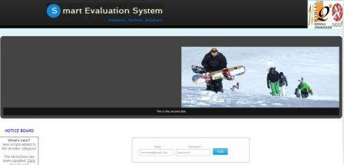

Figure 3.3: User Interface Design for the Proposed System

**3.4 Test Plan**

A test plan documents the strategy that will be used to verify and ensure that a product or system meets its design specification and other requirements. A software project test plan describes the approach and focus of a software testing effort. The process of preparing a test plan is a useful way to think through the efforts needed to validate the acceptability of a software product. It helps people outside the test group understand the ‘why’ and ‘how’ of product validation. The test cases for our program are as follows:

**3.4.1 Scanning the Answer Scripts (Valid and Invalid case)**

Table 3.8 gives the description of valid test case for scanning the answer papers. Initially the admin clicks on scan option provided in main menu. After this the page is redirected to the external scanning module where the hardware interface is provided for scanning the papers.

Table 3.8: Valid test case for scanning of answer scripts

|  |  |
| --- | --- |
| Component | Description |
| Test Case ID | TC1_1 |
| Unit to test | Scanning the papers |
| Test Data | External scanning module |
| Steps to be executed | 1. Select the scanner to be used 2. Click on the scan option |
| Expected result | Scanner is connected and scanning process is started |
| Actual result | The module asks for scanner plug-in |
| Pass/Fail | Fail |
| Comment | The external scanning module requires the plug-in for interfacing the scanner with software. Hence the plug-in must be pre-installed |

Table 3.9 gives the description of invalid test case for scanning the answer papers. Initially the admin clicks on scan option provided in main menu. After this the page is redirected to the external scanning module where the hardware interface is provided for scanning the papers.

Table 3.9: Invalid test case for scanning of answer scripts

|  |  |
| --- | --- |
| Component | Description |
| Test Case ID | TC1_2 |
| Unit to test | Scanning the papers |
| Test Data | External scanning module |
| Steps to be executed | 1. Select the scanner to be used  2. Click on the scan option |
| Expected result | Scanner is connected and scanning process is started |
| Actual result | Scanning is completed and images are saved in .pdf format |
| Pass/Fail | Pass |

**3.4.2 Loading Scanned Answer Scripts on Server (Valid Invalid case)**

Table 3.10 gives the description of valid test case for loading scanned papers on server. After scanning of particular paper is completed the digitalized scripts are stored on local server.

Table 3.10: Valid test case for Loading scanned answer scripts on server

|  |  |
| --- | --- |
| Component | Description |
| Test Case ID | TC2_1 |
| Unit to test | Loading of scripts to server |
| Test Data | Scanned papers |
| Steps to be executed | 1. Complete the process of scanning by clicking on submit button 2. The needs to click on display button to view the papers uploaded |
| Expected result | The scanned scripts are loaded/uploaded to server |
| Actual result | The papers are successfully uploaded |
| Pass/Fail | Pass |

Table 3.11 gives the description of invalid test case for loading scanned papers on server. After scanning of particular paper is completed the digitalized scripts are stored on local server. While saving the scanned papers they should be named in a specific format.

Table 3.11: Invalid test case for Loading scanned answer scripts on server

|  |  |
| --- | --- |
| Component | Description |
| Test Case ID | TC2_2 |
| Unit to test | Loading of scripts to server |
| Test Data | Scanned papers |
| Steps to be executed | 1. Complete the process of scanning by clicking on submit button 2. The needs to click on display button to view the papers uploaded |
| Expected result | The scanned scripts are loaded/uploaded to server |
| Actual result | Error in uploading |
| Pass/Fail | Fail |
| Comment | The file name for the scanned scripts should be named in specific format else the database error is shooted. |

**3.4.3 Display of Papers for Evaluation (Valid and Invalid case)**

Table 3.12 gives the description of valid test case for displaying the stored answer scripts to evaluator. The evaluator after logging into the system will able to see the papers concerned to his subjects. The papers are sorted based on the evaluator id.

Table 3.12: Valid test case for Display of papers for evaluation

|  |  |
| --- | --- |
| Component | Description |
| Test Case ID | TC3_1 |
| Unit to test | Display of papers for evaluation |
| Test Data | Scanned papers stored in database |
| Steps to be executed | 1. Evaluator log in into system 2. After login evaluator clicks on evaluate button |
| Expected result | After clicking on evaluate button, the paper are displayed based on evaluator id |
| Actual result | The answer scripts are displayed |
| Pass/Fail | Pass |

Table 3.13 gives the description of invalid test case for displaying the stored answer scripts to evaluator. The evaluator after logging into the system will able to see the papers concerned to his subjects. The papers are sorted based on the evaluator id.

Table 3.13: Invalid test case for Display of papers for evaluation

|  |  |
| --- | --- |
| Component | Description |
| Test Case ID | TC3_2 |
| Unit to test | Display of papers for evaluation |
| Test Data | Scanned papers stored in database |
| Steps to be executed | 1. Evaluator log in into system  2.After login evaluator clicks on evaluate button |
| Expected result | After clicking on evaluate button, the paper are displayed based on evaluator id |
| Actual result | The papers are not displayed due to database error |
| Pass/Fail | Fail |
| Comment | The evaluator id must be saved in the text file to extract the papers from database. The papers are extracted based on the evaluator id. |

**3.4.4 Display the Papers that are Evaluated (Valid and Invalid case)**

Table 3.14 gives the description of valid test case for displaying the answer scripts that are already evaluated.

Table 3.14: Valid test case for displaying the papers that are evaluated

|  |  |
| --- | --- |
| Component | Description |
| Test Case ID | TC4_1 |
| Unit to test | Display of papers that are evaluated |
| Test Data | Evaluated papers |
| Steps to be executed | 1. Evaluator finishes the evaluation by submitting the final marks 2. The clicks on display button to check the evaluated papers |
| Expected result | After clicking on display button, the paper that are evaluated are displayed |
| Actual result | The answer scripts are displayed |
| Pass/Fail | Pass |

Table 3.15 gives the description of valid test case for displaying the answer scripts that are already evaluated.

Table 3.15: Invalid test case for displaying the papers that are evaluated

|  |  |
| --- | --- |
| Component | Description |
| Test Case ID | TC4_2 |
| Unit to test | Display of papers that are evaluated |
| Test Data | Evaluated papers |
| Steps to be executed | 1. Evaluator finishes the evaluation by submitting the final marks 2. The clicks on display button to check the evaluated papers |
| Expected result | After clicking on evaluate button, the paper are displayed based on evaluator id |
| Actual result | The papers are not displayed due to database error |
| Pass/Fail | Fail |
| Comment | After the evaluation of the answer scripts the specific field in the database is set to indicate the evaluation status |

**3.4.5 Student registration (Valid and Invalid case)**

Table 3.16 gives the description of valid test case for registration of student where he/she enter the necessary details that are stored in database

Table 3.16: Valid test case for student registration

|  |  |
| --- | --- |
| Component | Description |
| Test Case ID | TC5_1 |
| Unit to test | Registration of students |
| Test Data | Details entered by student |
| Steps to be executed | 1. Student clicks on register button 2. Registration form appears where student need to enter the details 3. Press on register button |
| Expected result | The details entered by student are stored in to database |
| Actual result | The details entered by student are stored in to database |
| Pass/Fail | Pass |

Table 3.17 gives the description of valid test case for registration of student where he/she enters the necessary details that are stored in database.

Table 3.17: Invalid test case for student registration

|  |  |
| --- | --- |
| Component | Description |
| Test Case ID | TC5_2 |
| Unit to test | Registration of students |
| Test Data | Details entered by student |
| Steps to be executed | 1. Student clicks on register button 2. Registration form appears where   student need to enter the details  3 Press on register button |
| Expected result | The details entered by student are stored in to database |
| Actual result | Sql query shoots error due to duplicate registration or invalid inputs |
| Pass/Fail | Fail |
| Comment | The student needs to register only once since the duplicate entries are not allowed in database |

**Chapter 4**

**IMPLEMENTATION**

This section deals with all the implementation of Smart Evaluation System.

**4.1 Implementation of Database Connectivity and**

**Interface**

* Admin: The following code shows the interaction between admin and database via PHP and storing of answer scripts to the database.

$rs=mysql_query("select * from login where user='$loginid' and pass='$pass'",$cn) or die(mysql_error());

if(mysql_num_rows($rs)<1)

{

echo "invalid username and password";

exit;

}

$_SESSION[@alogin]="true";

}

else if(!isset($_SESSION[@alogin]))

{

echo "Your are not logged inPlease <a

href=index.php>Login</a><div>";

exit;

}

$dir = opendir('E:/family/fest/New folder (3)');

while ($read = readdir($dir))

{

if ($read!='.' && $read!='..')

{

if ($act[1] == 'rar' || $act[1] == 'zip' || $act[1] == 'pdf' || $act[1]=='jpg') {

$final = explode("_", $ss);

if (count($final) == 3) {

$usn = $final[0];

$course = $final[1];

$paperid = $final[2];

$bno=12;

$uploaddir = "E:/family/fest/New folder (3)/";

$path = $uploaddir . $read;

mysql_query("insert into exam_section (

Paper_id,Batch_no,Sub_id,USN,path) values

('$paperid','$bno','$course','$usn','$path')"));

mysql_query (" insert into

marks(USN,Sub_id,Marks,Paper_id,Evaluator_id,status) values

('$usn','$course',' ','$paperid',' ',0)")

* Evaluator: The following code shows the interaction between evaluator and database via PHP, evaluation of answer scripts and storing of marks for the particular answer scripts to the database.

$file = fopen("test.txt", "r") or exit("Unable to open file!");

$r=mysql_query( ("SELECT DISTINCT

exam_section.Paper_id,Batch_no,path

FROM `exam_section` , `evaluator` , `marks`

WHERE exam_section.Sub_id = evaluator.Sub_id

AND evaluator.evaluator_id = '$qq' AND

marks.Paper_id=exam_section.Paper_id

AND marks.status =0") )

mysql_query("update marks set Marks=$marks where Paper_id='$qq'") or die("<div class=wrapper col6>

<div id=copyright><h1> Error </h1> <br class=clear />

</div>

</div>");

mysql_query("update marks set Evaluator_id='$qq1' where Paper_id='$qq'")

mysql_query("update marks set status=1 where Paper_id='$qq'")

$result = mysql_query("select Paper_id,Sub_id,Marks from marks where Evaluator_id='$qq1'")

* Student: The following code shows the interaction between student and database via PHP, registration, viewing of marks and details.

$result = mysql_query("SELECT DISTINCT subjects.sub_id,marks.marks

FROM `subjects` , `students` , `marks`

WHERE subjects.dept_id = students.dept_id

AND subjects.sem = students.semester AND marks.sub_id=subjects.sub_id

AND students.usn = '$qq5'");

$sl1=0;

$r=mysql_query("insert into

students(USN,Stud_name,Dept_id,Semester,dob,password) values

('$number','$name','$dept','$sem','$dob','$password')")

**Chapter 5**

**RESULTS AND DISCUSSION**

Fig 5.1 depicts the main home page of our Web Portal Smart Evaluation System. The basic information for the product is provided in this home page. We have provided an login option which allows the users to authenticate themselves to use the system.

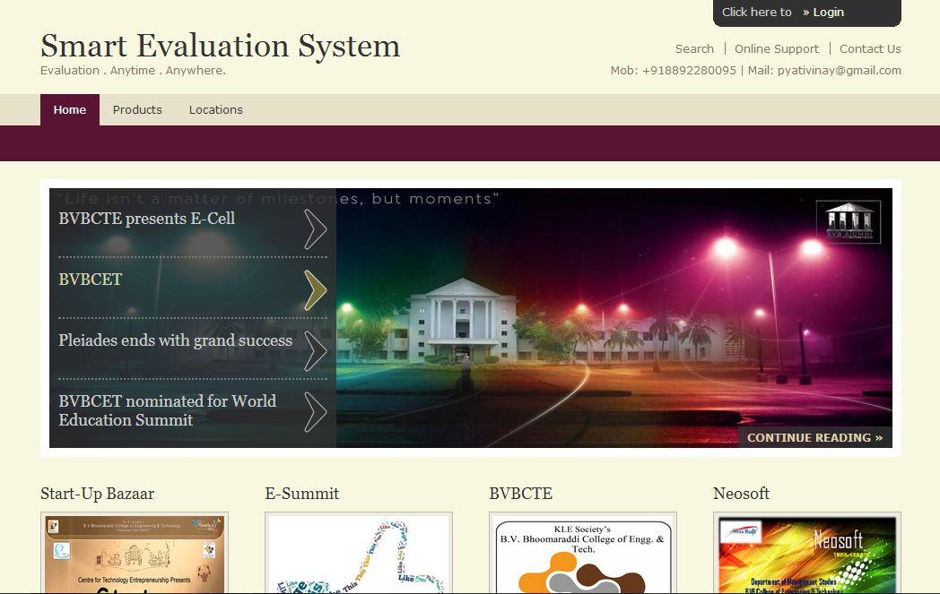

Figure 5.1: Home page of Smart Evaluation System

Fig 5.2 shows login page. This login page is provided for 3 different users- Administrator, Evalutaor and Student. These 3 users are authorised to different functionalities.

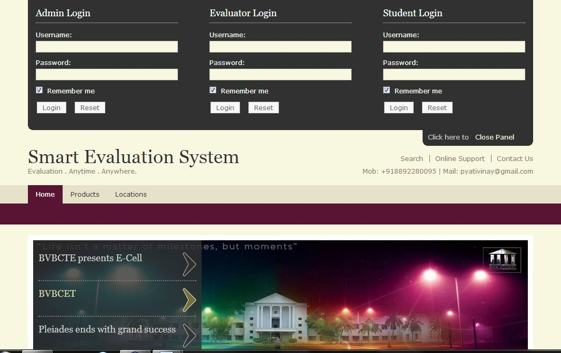

Figure 5.2: Log in

Fig 5.3 shows the homepage of the admin. This contains two main options- Scan and Display. When the Scan option is clicked, the Scanner connected as shown in Fig 5.4 and is activated and the sheets are scanned. The Display option displays the already uploaded answer scripts.



Figure 5.3: Admin Home Page

When the Scan option is clicked, the process of scanning starts via an interface called as DynamSoft, where the scanned copies are converted into PDF format and are manually named.

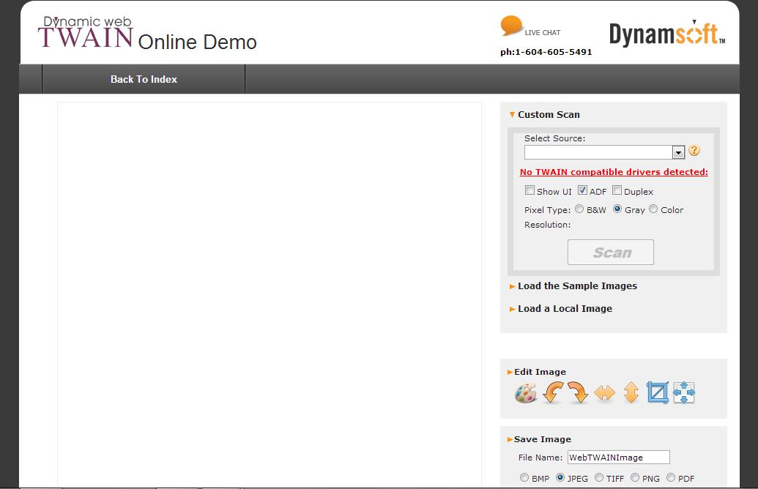

Figure 5.4: Scanner Interface

Fig 5.5 shows home page of the evaluator which has two main options- Evaluate and Display. On clicking the evaluate button the numbers of papers uploaded are displayed for evaluation.



Figure 5.5: Evaluator Home Page

Onclicking evaluate, the number of papers scanned and uploaded are displyed along with the status of the paper as shown in fig 5.6. If the paper is to be evaluated then the status shows “evalute”.

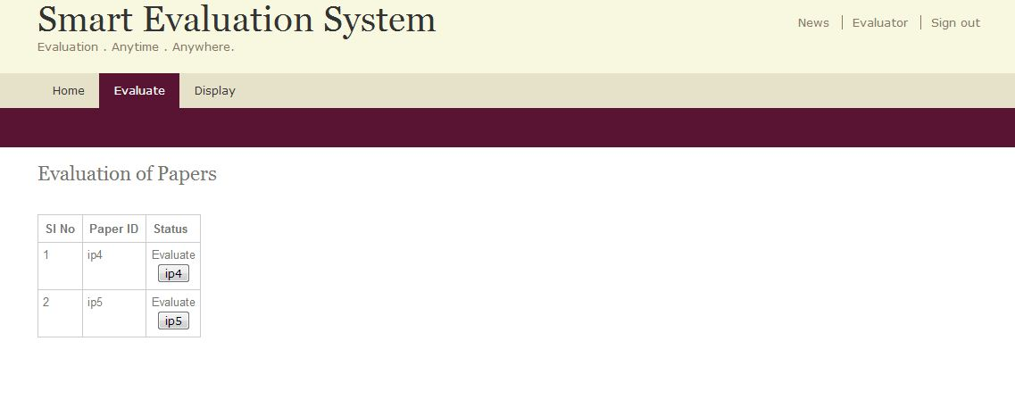

Figure 5.6: List of Papers to be Evaluated

When the evaluate button is clicked, the respective paper will be displayed with the text boxes provided beside to enter the marks as shown in fig 5.7

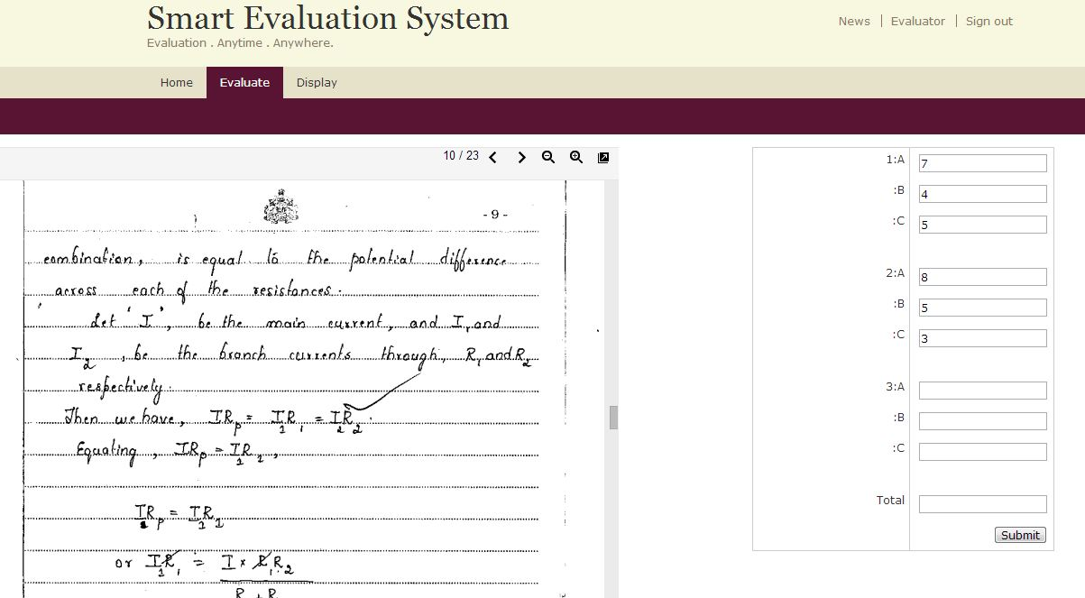

Figure 5.7: Answer Script to be evaluated and Form to enter the marks

Onclicking Display, the papers that are already evaluated are displayed as shown in fig 5.8. So each evaluator can check the papers he/she has evaluated.

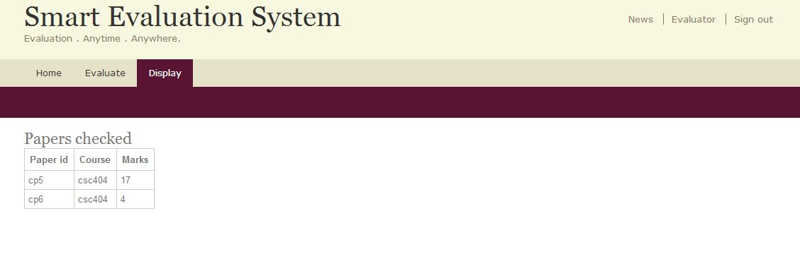

Figure 5.8: Display of papers that are evaluated

The students who want to view their marks online should initially register at this portal. A form will appear when he/she clicks on ‘register’ as shown in fig 5.9. The USN acts as the username for the student which is unique for every individual

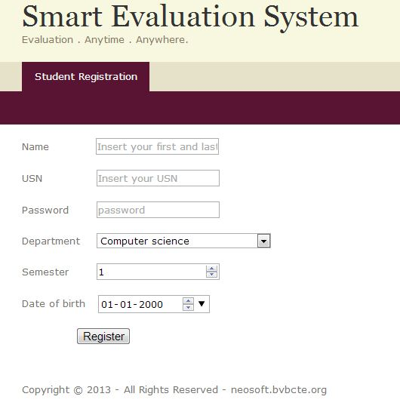

Figure 5.9: Student Registration Form

When the student authorizes himself/herself with their unique username (USN) and password. Then automatically their respective marks will be displayed. An example is shown in fig 5.10

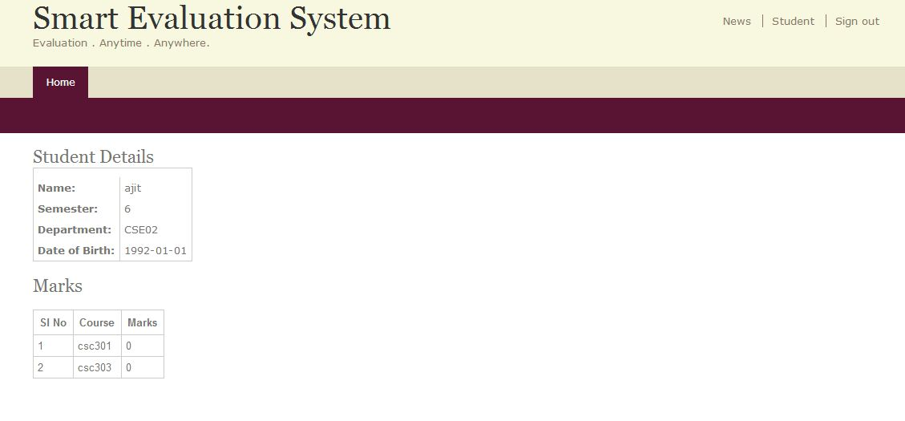

Figure 5.10: View of Result for the particluar Student

**Chapter 6**

**CONCLUSION AND FUTURE SCOPE**

This chapter mentions about goals and objectives of the project stated will be met and the learning that has happened in trying to achieve the goals of the project and the technology learnt during this course learning.

**6.1 Conclusion**

Smart Evaluation System, aims to provide education institutions an easy way to evaluate the answer scripts and facilitate the online results. This also helps the institutions in speedy results. It is very easy to use, and also helps the evaluators to conveniently evaluate the answer scripts without having to travel long distances. This system will effectively help in reducing the cost and time spent on the evaluation of the answer scripts.

This product is marketable to any educational institutions. As the competitors for this product are rarely found, it is easy to market. Just by changing the functionalities or the pattern of the question paper, any institution from schools to colleges can make efficient use of Smart Evaluation System.

**6.2 Future Work**

As this product is new to the market, the future scope of this product is excellent. The information stored in the system can be used to provide different views of the database, one of them could be placement view where the placement officer is able to view the academic details of students. While the evaluation process is carried out the results of the students can be used to plot the performance graph, which helps in improving the objectives of the teaching methods. The system can also help in delivering the rubrics/the evaluation scheme during evaluation.

**References**

[1] www.shruthandsmithfoundation.org/roundtablediscussion.html

[2] www.vtualerts.com/vtu-alerts/vtu-digital-evaluation-of-answer-scripts

[3] Jennifer Hodgdon- “A Programmer’s Guide to Drupal- Principles, Practices

and Pitfalls”. O’Reilly Media Publications, 2nd Edition.

[4] Addison Berry, Angela Byron and Bruno De Bondt- “Using Drupal”. O’Reilly

Media Publications, 2nd Edition, 2012.