Data Analytics – Exercises

(Week 05)

In these exercises, you will learn:

* how to geocode address data
* basic GIS functionalities of QGIS
* how to perform point-in-polygon analysis
* how to perform a nearest neighbor analysis

In the data analytics process model, these exercises cover part of the steps “Preparing & storing data” and “Exploratory Data Analysis (EDA)” (see figure 1). Results of the exercises must be uploaded as separate files (no .zip files) by each student on Moodle. Details on how to submit the results can be found in the tasks below.

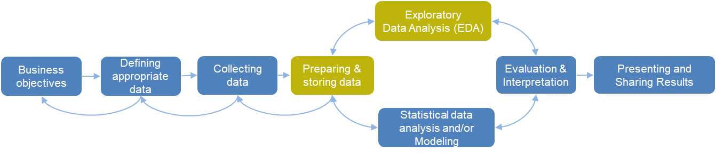

**Figure 1:** Data analytics process model (see slides of week 01)

# Task 1

In this exercise, you will learn to geocode address data using Python. The tasks are:

1. Go to the web page <https://tools.retorte.ch/map>, search for an address and look at the coordinates on the left site. You can find Swiss coordinates as well as World Geodetic System 1984 (WGS84) coordinates of this address.
2. Run the Jupter notebook ‘geocoding_addresses.ipynb’ step by step and try to understand what the code does.
3. In the section ‘Geocoding a single address’ of the Jupyter notebook, change the address "8400 Winterthur, Theaterstrasse 17" to an address of your choice, then geocode the address in section ‘Server request & response’ of the Jupyter notebook.
4. In the section ‘Intersect municipality polygon-map with lat and lon …’ of the Jupyter notebook, you can find the following table, which is a merge of the geocoded address data with a map of municipalities. Look at the following table.

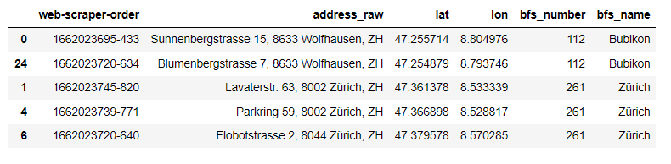

1. In the table above, the first address ‘Sunnenbergstrasse 15, 8633 Wolfhausen, ZH’ contains ‘Wolfhausen’ as residence, but the municipality from the merge is ‘Bubikon’. Find out, whether this is an error by going to <https://tools.retorte.ch/map>, search the address and make a screenshot of the area around the address. If this is not an error, the municipality of Bubikon should also be on the map. Info for all exchange students: In Switzerland we have municipalities (administrative units) and residences (parts of a municipality).
2. Create an Excel-file with 5 different addresses in the canton of Zuerich analog to the field address_raw in the table above. The address string must contain street name, street number, zip code and the municipality name. If you don’t know how to find addresses, look in the supermarket.json file from the previous exercises.
3. Import the Excel-file to your Jupyter notebook, geocode the addresses and show it on the map.

**To be submitted on Moodle:**

* A screenshot of your own geocoded address as ‘address_geocoded.png’ analog to the example from the Jupyter notebook below:

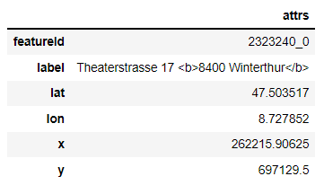

* A screenshot of the map according to e)
* An html-file ‘geocoding_addresses.html’ of the Jupyter notebook with your changes from f) and g)

# Task 2

In this exercise, you will learn basic GIS functionalities of QGIS and how to intersect spatial points (apartment data) with spatial polygons (municipality data). The tasks are:

1. Open QGIS, then look at the video provided on Moodle: ‘qgis_tutorial_01.mp4’.
2. Import the municipality layer (polygon map) and the geocoded address data to QGIS as shown in the video. Choose your own color of municipality polygon-lines and points.
3. Perform a point-in-polygon intersection as shown in the video.

**To be submitted on Moodle:**

* A screenshot of your QGIS environment with the municipality map and the apartment data as points as ‘municipalities_and_points_map.png’.
* A screenshot of your QGIS environment with the attribute table showing the result of the point-in-polygon intersection as ‘table_point_in_polygon_intersection.png’.

# Task 3

In this exercise, you will learn to create a colored map in QGIS and to perform nearest neighbor analysis. The tasks are:

1. Open QGIS, then follow the instructions in the video ‘qgis_tutorial_02.mp4’.
2. Create a colored map as shown in the videos. Choose your own color-range for the map.
3. Add the names of municipalities to the map as shown in the video.
4. Add transparency to the map as shown in the video.
5. Perform nearest-neighbor analysis based on the apartment data and supermarket data as shown in the video ‘qgis_tutorial_03.mp4’.

**To be submitted on Moodle:**

* A screenshot of your QGIS environment with the colored municipality map (choropleth map) as ‘screenshot_choropleth_map.png’.
* A screenshot of the table with the results of the nearest-neighbor analysis as ‘table_ nearest_neighbor_analysis.png’.