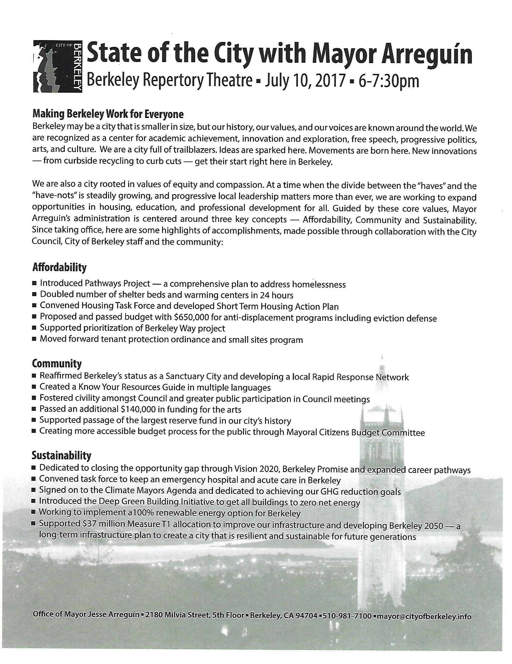



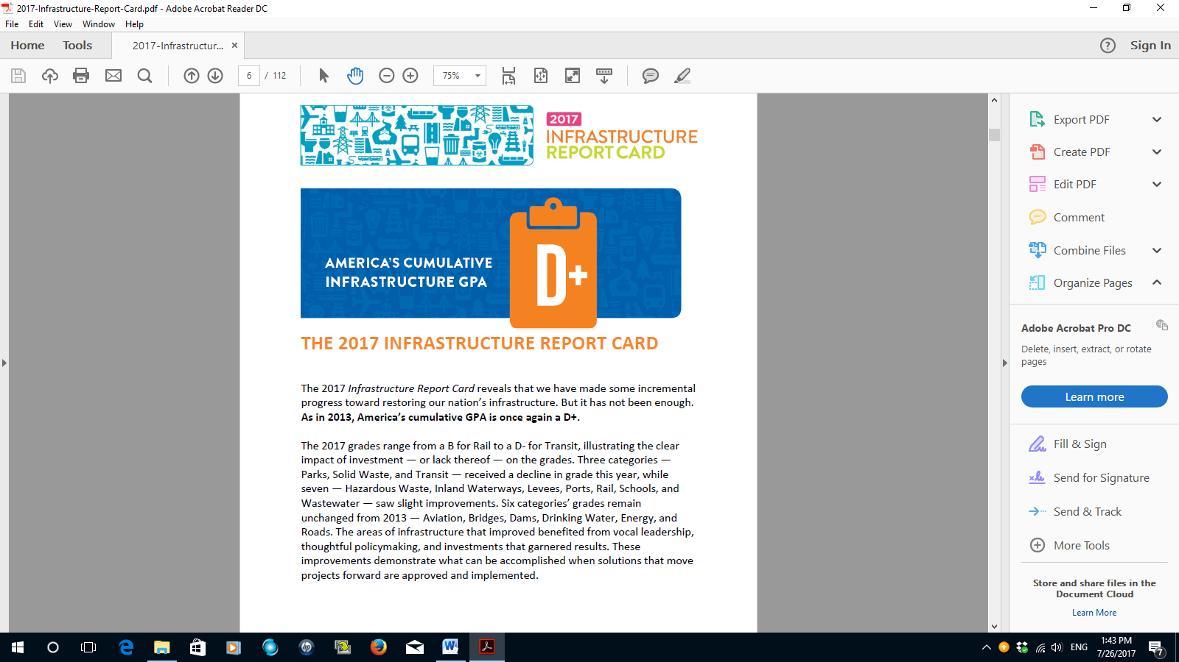

INFRASTRUCTURE TODAY

The American Society of Civil Engineers (ASCE) released their Infrastructure Scorecard for 2017 and gave America infrastructure a grade of D+. Many cities across the U.S., including Berkeley, are faced with infrastructure that is approaching the end of their useful life and are in need of repair or replacement.

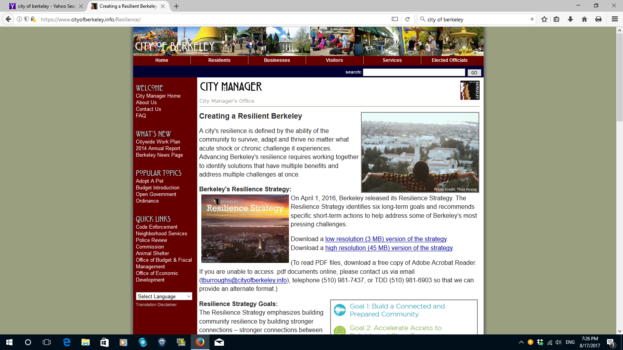
The Works Projects Administration, more than 70 years ago, had the foresight to build much of the City of Berkeley’s infrastructure—many of its parks, the marina, roads, schools, public buildings and even the art we see on downtown buildings such as the Berkeley Community Theater. Due to age, extensive use and changing technologies, we are now faced with close to $1 billion in infrastructure needs.

At the same time, we are faced with the challenges of climate change and the need to have infrastructure that is more sustainable and resilient. We also have technology that is rapidly changing and we need to have infrastructure systems that are flexible and can adapt to future needs.

WHERE WE WANT TO BE IN 2050

- Berkeley’s infrastructure will provide effective service for the next 100 years
- Our infrastructure will be an integral part of our sustainable and resilient community
- We will have flexibility to incorporate new technologies
- Our community will be involved to determine our future needs
- We will implement the improvements with equity across all of Berkeley

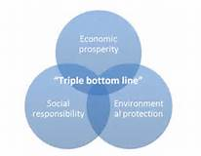
TRIPLE BOTTOM LINE APPROACH
The Triple Bottom Line (TBL) is a type of analysis that considers three areas of benefits and costs: financial,
social, and environmental. Triple bottom line analysis differs from typical financial analysis because it considers benefits and costs accruing to the community as a whole and assigns (where possible) dollar values to non-market priced social and environmental impacts. Berkeley will benefit from using TBL in developing Vision 2050. It will ensure a balanced approach to evaluating technical solutions. Berkeley is a diverse community and values environmental protection and social responsibility along with the cost of infrastructure solutions.

PROPOSED FIRST YEAR ACTIVITIES
- Mayor launches Vision 2050 with:
- Vision and objective statement
- Study approach, schedule, and community engagement process
- Organize approach to study team
- Mayor to announce the program

- Gain public support
- Plan on a November 2018 ballot measure to gain voter mandate to improve Berkeley’s infrastructure

- Form a collaborative between the City of Berkeley and U.C. Berkeley.

- Make better use of Berkeley’s property transfer tax

WE ARE READY TO SUPPORT YOU

A citizens committee of Gordon Wozniak, John Gage, Margo Schueler, Larry Henry, Ray Yep, Jim McGrath, and Victoria Legg are ready to provide our expertise and time to assist the Mayor with launching Vision 2050. Our experience includes work on Measure F, Measure M, Measure T1, capital improvement planning, program implementation, and working with our community.

