Attached is two avatars, the name and bio is:  
  
LMD (David image)  
Creator, artist, golf enthusiast  
LMD has been involved in the golf industry for the last 12 years. Knows what is involved in creating an awesome golf club but will take advice from all of its members.



RKS ( Sanjay image)  
Advisor, financer, golf enthusiast  
20 year career in investment management. RKS has founded many successful companies and is the director of a highly successful financial services firm.



Example images

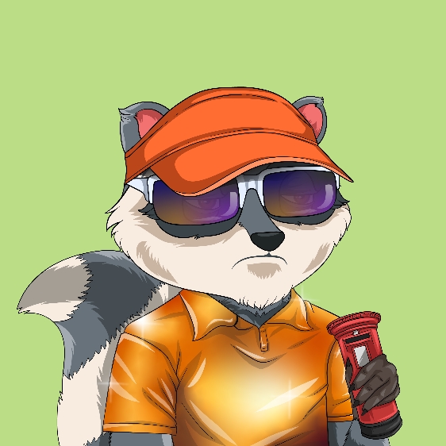

Banner

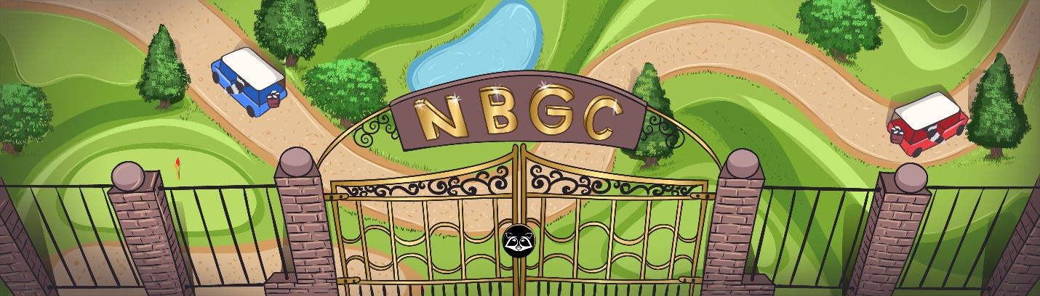

Logo

